**Module 2 Activity 1: Basic Static Web Project Using Node.JS and EJS**

**Submitted By: Praveen Kumar Siddela**

**IFT 458 & IFT 554: Middleware Programming & Database Security**

**Dinesh Sthapit**

**Due Date: 02/04/2024**

**Installation of Express.js and EJS**

**Screenshot 1:**

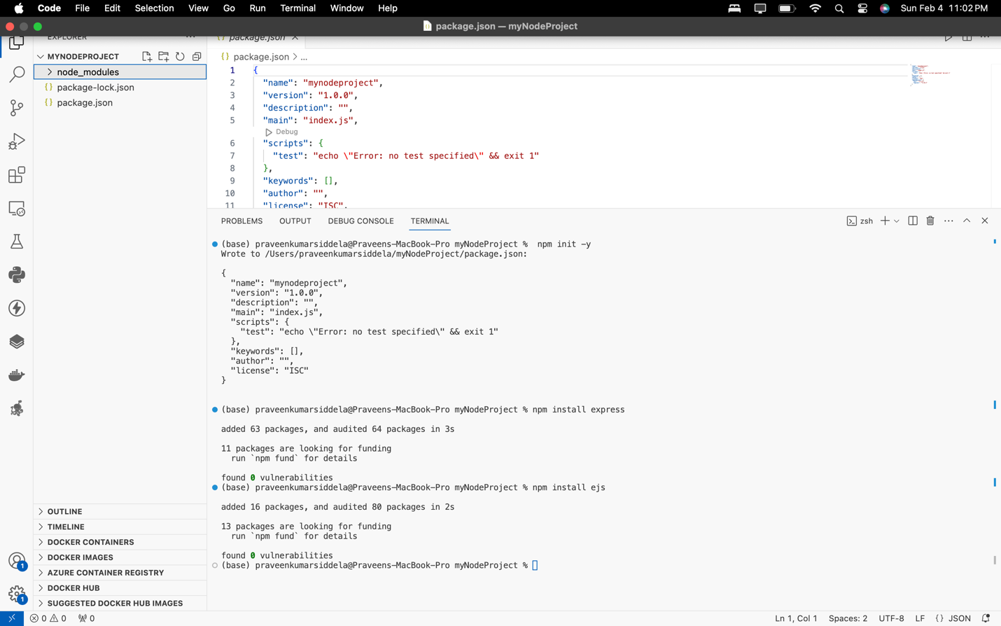

**Setup of Express.js Server and File Creation**

**Screenshot 2:**

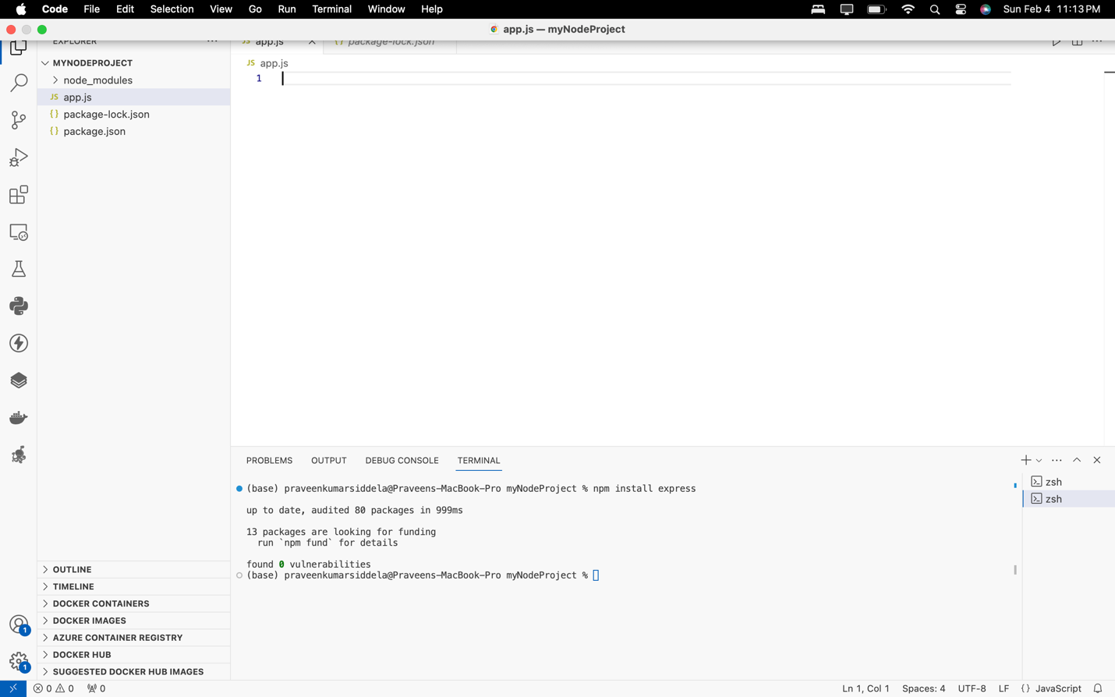

**Screenshot 3:**

**Creation of HTML Form Using EJS**

**Screenshot 4:**

**Screenshot 5:**

**Configuration for Handling Form Submissions**

**Screenshot 6:**

**Execution of Node.js Web Application**

**Screenshot 7:**



