**Module 2 Lab 1: Building a Simple Web Application Using Node.js and EJS**

**Submitted By: Praveen Kumar Siddela**

**IFT 458 & IFT 554: Middleware Programming & Database Security**

**Dinesh Sthapit**

**Due Date: 02/04/2024**

**Project Initialization**

**Screenshot 1:**

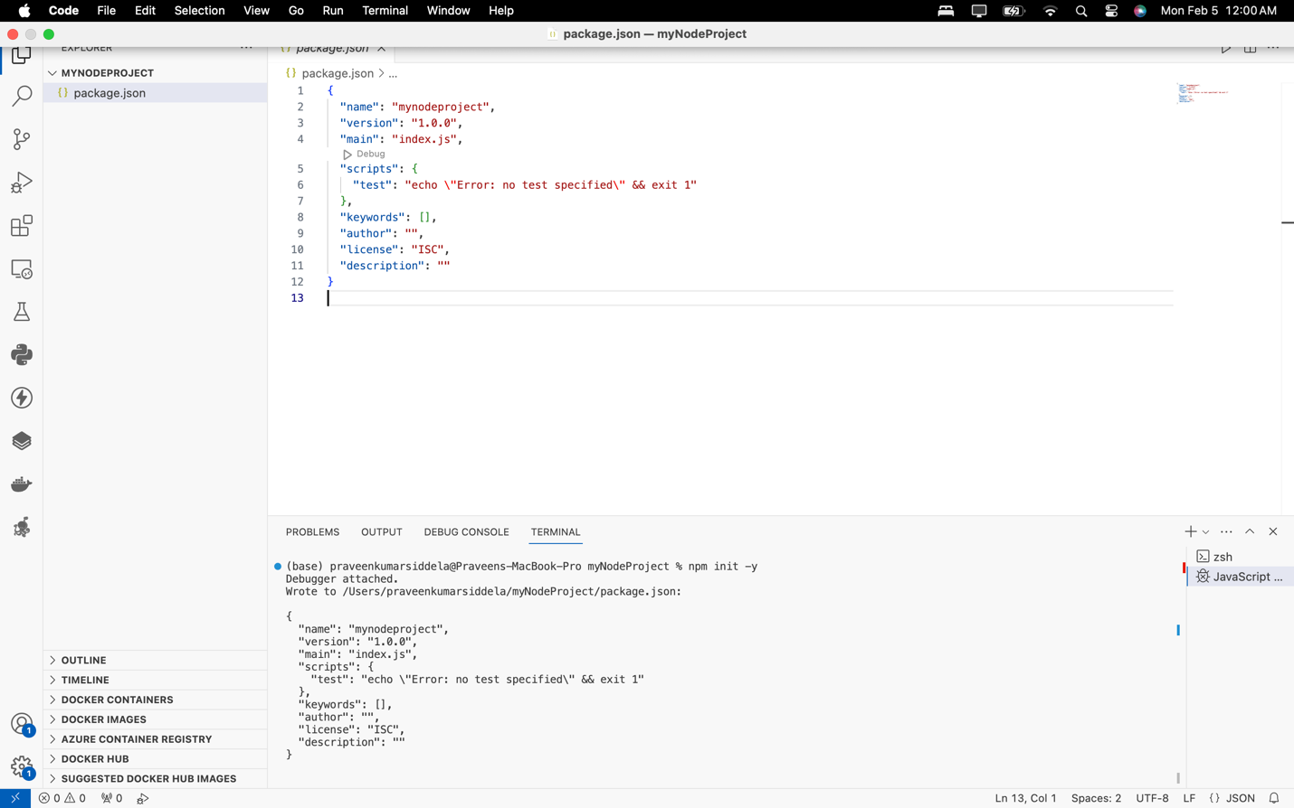

**Installation of Express.js and EJS**

**Screenshot 2:**

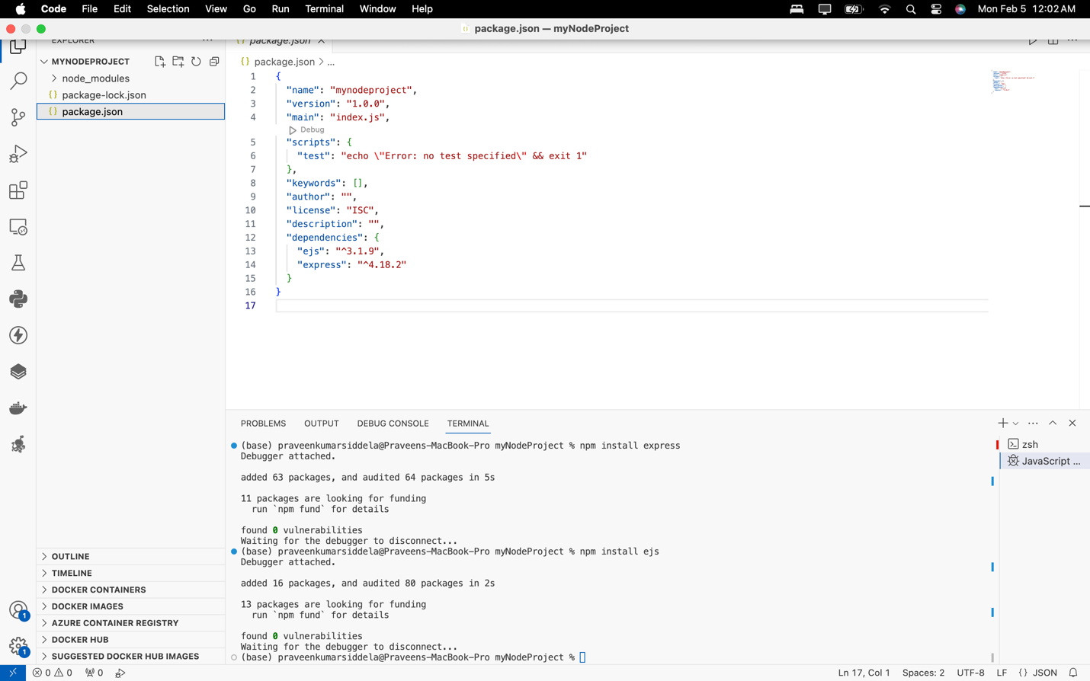

**app.js File Creation and Setup**

**Screenshot 3:**

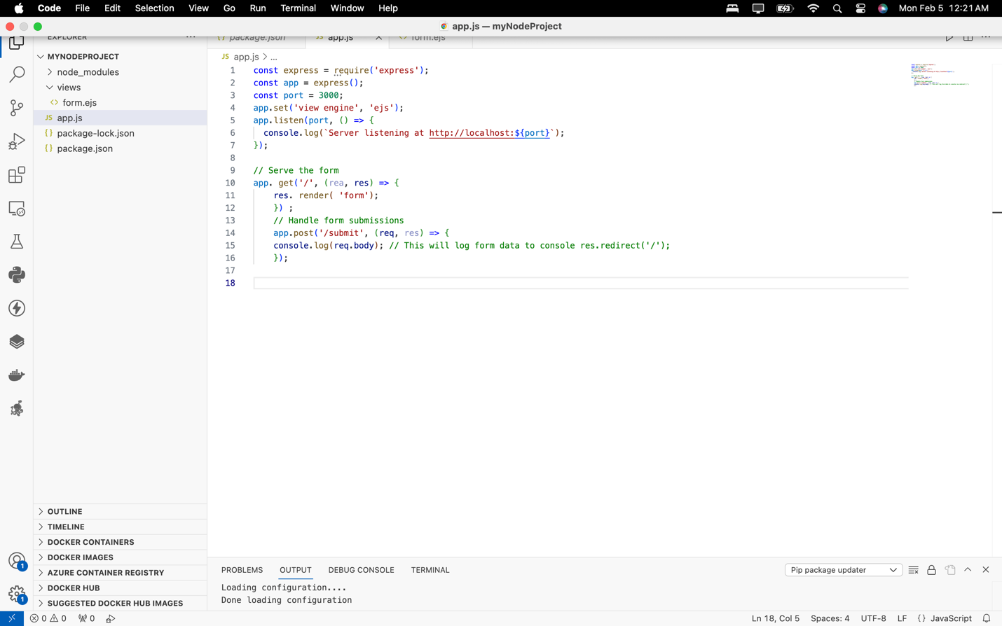

**Screenshot 4:**

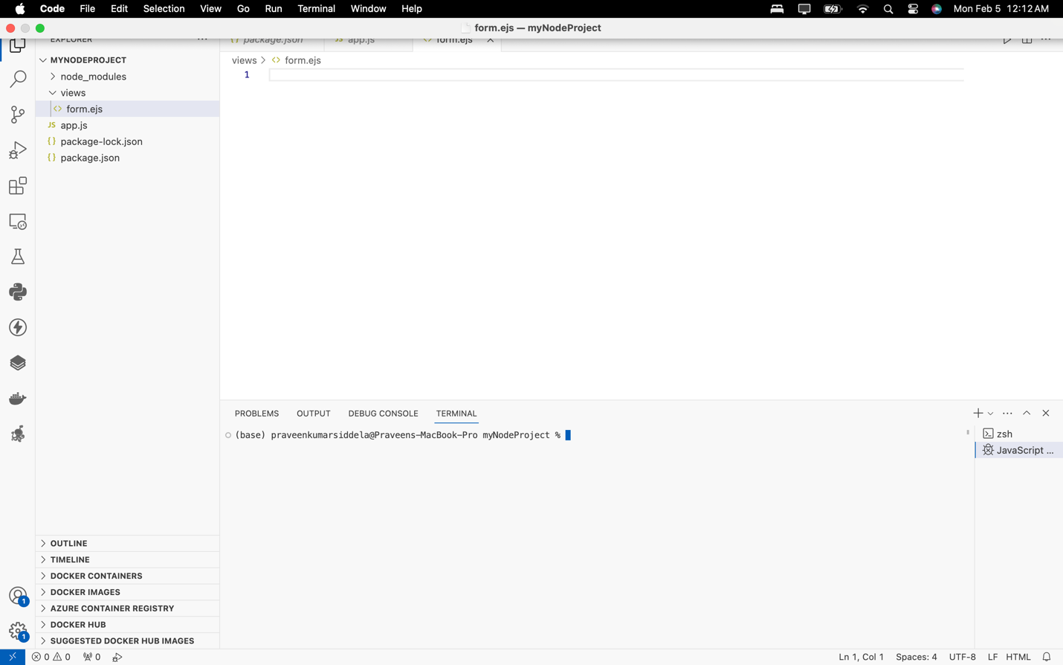

**Screenshot 5:**

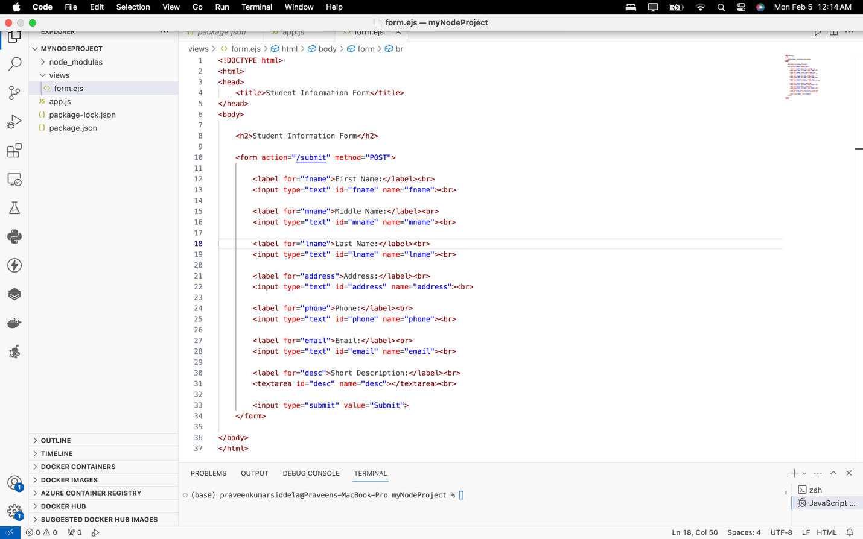

**Form Submission Handling in app.js**

**Screenshot 6:**

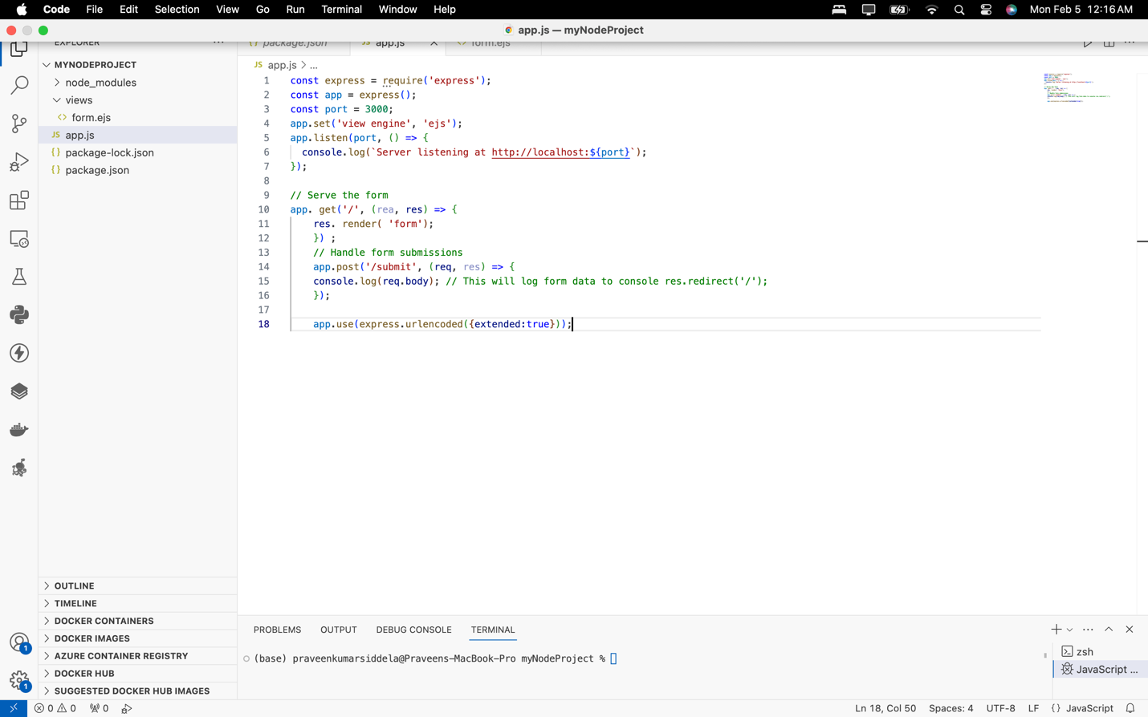

**Running Node.js Server**

**Screenshot 7:**

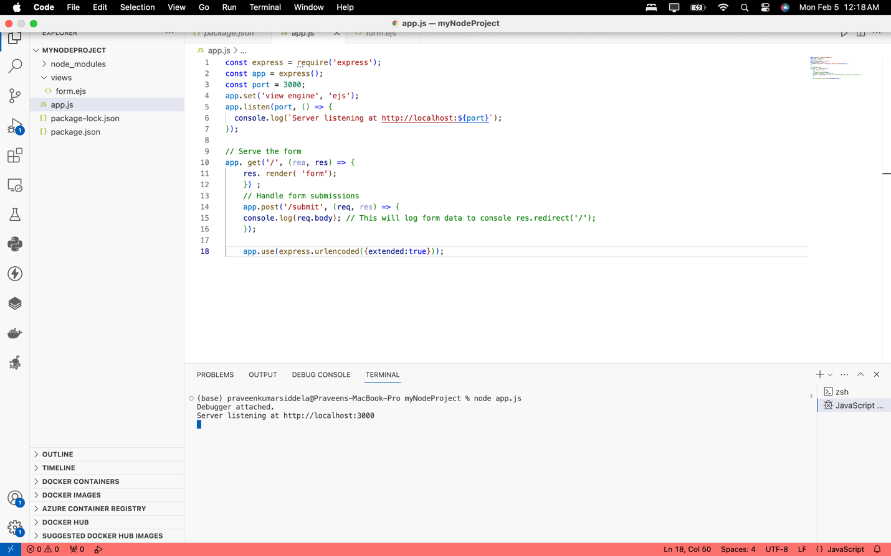

**Screenshot 8:**

