White-Label Casino Player
Mobile App Platform

MVP Analysis & End-to-End Delivery Plan
Loyalty • Offers & Promotions • Reservations • Valet • Digital Key • Cardless/Cashless Play • CMS-Driven • Multi-Tenant
Prepared for Sridhar — Player Mobile App initiative
Scope Super-Admin control plane, Tenant CMS portal, React Native app, FastAPI backend, PostgreSQL
Integration posture Adapter-ready with mocked / sandbox implementations for regulated systems
Reference vendors JoinGO (Sightline/NRT), Light & Wonder (Universe / Patron), Playerhub.ai
Date July 2026

Contents

(In Word: right-click the table above → Update Field to populate page numbers.)

1. Executive Summary
The goal is a white-label, multi-tenant mobile platform that lets a casino operator (tenant) ship a fully branded loyalty and guest-experience app to its players, with all content — theme, copy, offers, promotions — controlled from a CMS portal, and the whole tenant estate governed by a super-admin control plane. The mobile app spans everyday loyalty (account, points, tier, offers, promotions, reservations, valet) plus two high-value, hardware-adjacent capabilities: a digital room key for casino-hotel guests and cardless / cashless slot play over Bluetooth.
This document analyzes what it takes to reach a demonstrable MVP with real front-end-to-back-end integration across all surfaces — the unified admin console, the React Native mobile app, and the FastAPI backend. It is deliberately layered: this summary and Sections 2–3 are readable by non-technical stakeholders; Sections 4–13 are the engineering build plan.

The core insight that shapes the plan
Roughly 80% of the feature surface — loyalty, offers, promotions, account, reservations, valet, CMS, super-admin, push — is standard, buildable software you fully control. The remaining ~20% — cardless/cashless play, digital key, KYC, geolocation, payments — are regulated, vendor- and hardware-dependent integrations that require commercial partnerships and, in the cardless case, laboratory certification (GLI-16) and jurisdictional approval. These cannot be genuinely completed inside an MVP timeline.
The strategy, therefore, is the adapter (ports-and-adapters) pattern: every regulated capability sits behind a stable internal interface. For the MVP we ship mock / sandbox adapters that make the full experience demonstrable end-to-end — a player can “fund” a wallet, “pair” with a slot, “unlock” a room — while the real vendor implementation is swapped in during Phase 2 without touching the app, CMS, or core services.
Bottom line: A cross-functional team of ~8–10 can deliver a polished, investor- and operator-demoable MVP in ~18–22 weeks. Real cardless play and digital key (with certification and vendor contracts) are a gated Phase 2 of an additional ~4–6 months.

What the MVP proves
- One codebase, many brands: spin up a new tenant from the admin console, set its theme/fonts/URLs and feature flags, and the same React Native binary renders as that brand.
- CMS-driven everything: a tenant admin publishes an offer, promotion, or push in the CMS portal and it appears in the app in near-real-time.
- Full guest journey: enrol/login, view account & tier, browse and redeem offers, book a reservation, request valet, receive targeted push.
- Flagship demos: cardless wallet + BLE slot pairing simulation, and a mobile digital key flow — both real UX, mocked hardware — proving the architecture is integration-ready.

2. Product Vision & Competitive Landscape
The market for casino player-engagement apps is established and consolidating. Understanding the incumbents clarifies both the table-stakes feature set and where an independent white-label platform can differentiate.
Vendor | Ownership / Stack | Strengths | Implication for us
JoinGO | Built by Joingo; acquired by Sightline Payments, now under NRT Technology.  Cloud SaaS; “preferred” app for IGT casino management. | Mature loyalty + cashless, digital player card, geofenced offers, ID verification, payment storage, valet, dining/hotel reservations, analytics. | Broad and proven, but tied to the Sightline/NRT payments ecosystem. Validates our full feature list.
Light & Wonder | L&W (Universe platform / “Patron” mobile app); runs on any casino management system. | Cardless play via Bluetooth or QR, resort/digital wallet, facial-recognition KYC, RAPIDPLAY cashless (Trustly). L&W also builds the EGMs. | Deepest EGM/floor integration because they make the machines. Hard to beat on cashless depth; differentiate on flexibility and price.
Playerhub.ai | Independent; AWS; ~4 years in market. | AI-driven “super app” combining payments, KYC, engagement, win/loss statements, points/tier tracking, hotel & valet reservations, shareability. | Closest analogue to our positioning and the most direct competitor for an independent white-label play.

Where a new white-label platform differentiates
- Operator-owned branding & data: true white-label (their brand, their app-store listing) rather than a vendor-branded shell, with tenant-isolated data.
- Payments-agnostic: incumbents are anchored to a payments arm (Sightline, Trustly). A clean PSP adapter lets each operator keep their processor and cashless host.
- CMS-first configurability: non-technical operator staff control theme, content, offers, and notifications without a vendor ticket.
- Modern, portable stack: FastAPI + React Native + React, containerized and cloud-portable — lower TCO and no proprietary lock-in.
Terminology note: “CMS” is overloaded in this domain. In this document CMS Portal = our Content Management System (the React admin app). The casino floor system that talks to slot machines is the Casino Management System (referred to as the CMP / host, e.g., IGT Advantage or L&W). They are different systems and both appear below.

3. Feature Scope — MVP vs. Later Phases
Every requested capability is in the MVP experience. The distinction is whether the MVP ships a real implementation or a demonstrable mock behind a production-grade interface. “Mock” never means fake UI — it means the app, API, and data model are real; only the external vendor/hardware call is simulated.
Capability | In MVP | MVP implementation approach
Onboarding / login / enrolment | Yes — real | OTP/email + password; JWT sessions; profile. Loyalty link via Casino Management System adapter (mock).
Account, points, tier, benefits | Yes — real | Real screens & API; player/loyalty data seeded via the CMP adapter (mock) with a realistic dataset.
Offers & promotions | Yes — real | Authored in CMS Portal → API → rendered and redeemed in-app; redemption ledger persisted.
Content & theming (CMS-driven) | Yes — real | Theme colors, fonts, logos, banners, screens all resolved from tenant config at runtime.
Push notifications | Yes — real | Compose & segment in CMS → APNs/FCM → deep-link into app. Real end-to-end.
Reservations (hotel / dining / nightlife) | Yes — real UI | Full booking UX + API + persistence; PMS/booking adapter mocked (confirmation refs simulated).
Valet request | Yes — real UI | Request/status flow + API; valet-system adapter mocked.
Super-admin (tenants, users, URLs, flags) | Yes — real | Full control-plane CRUD; provisioning; per-tenant configuration and feature flags.
Account KYC status | Yes — real UI | KYC state machine & screens; Jumio/Sumsub adapter in sandbox/mock.
Digital key (room unlock) | Demo in MVP | Real issue/display/“unlock” UX; ASSA ABLOY / Salto mobile-access SDK stubbed. Real hardware = Phase 2.
Cardless / cashless BLE slot play | Demo in MVP | Real wallet, fund/transfer/cash-out UX + BLE pairing simulation; GLI-16 cashless host mocked. Real = Phase 2.
Geolocation gating (on-property / jurisdiction) | Yes — adapter | GeoComply-style adapter; mock verifier in MVP, real SDK in Phase 2.
Geofenced offers & location triggers | Yes — real UX | Admin-configured zones (GPS or BLE beacon) with enter/dwell rules; trigger engine + push. Beacons for indoor venues are Phase-2 hardware.
Fund wallet (payments) | Demo in MVP | PSP sandbox or mock; tokenized card capture UX; no real settlement until Phase 2.
Why cardless & digital key are Phase-2 for real: Cardless play moves money on a live casino floor and is governed by GLI-16 (Cashless Systems and Technologies) plus GSA machine protocols (G2S/S2S/SAS) and state approvals; digital key requires a signed integration with a lock vendor (ASSA ABLOY/Salto) and their certified SDK/keys. Both need commercial contracts and lab/field certification that sit outside an MVP window — but the MVP architecture is built to accept them.

4. System Architecture
The platform presents two client applications — a unified admin console and the React Native mobile app — over one FastAPI backend and a multi-tenant data core, with all external/regulated systems reached through an adapter layer.
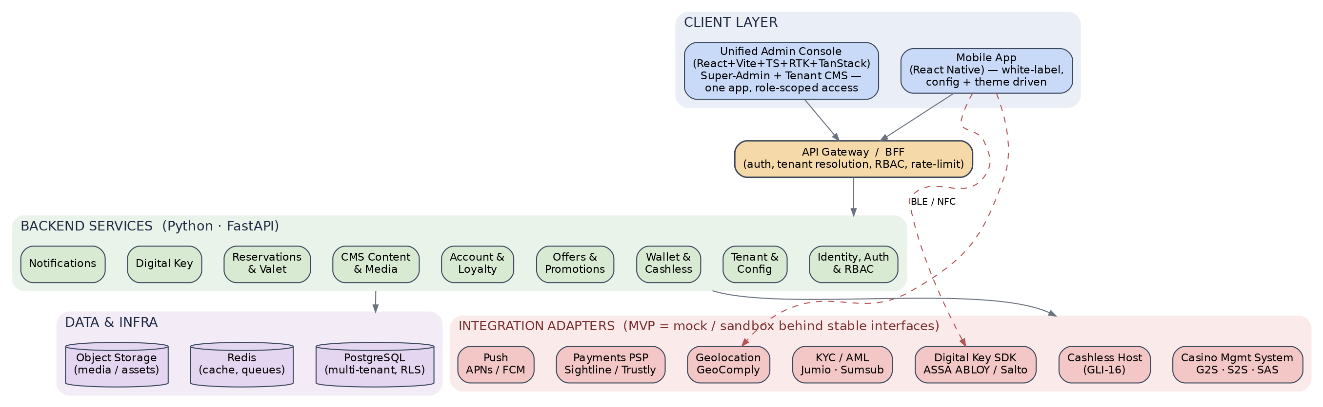
Figure 1 — High-level architecture: client surfaces, FastAPI services, data/infra, and the mock-first integration adapter layer.

4.1 Components
- Unified Admin Console (React + Vite + TS + Redux Toolkit + TanStack Router + Tailwind + Lucide): one web app serving both the tenant CMS and the super-admin control plane, with what each user sees governed entirely by role-based permissions. Tenant staff manage theme, content, offers, promotions, push, and reservations/valet config for their property; super-admins provision tenants, users, URLs, feature flags, and API keys — and a super-admin's reach can itself be restricted to a subset of clients. Detailed in Section 9.
- Mobile App (React Native): a single white-label binary per tenant (or a flavor build). On launch it resolves tenant config and theme, then renders brand-specific UI. Hosts native modules for BLE, push, secure storage, and the digital-key SDK.
- API Gateway / BFF (FastAPI): single entry point handling authentication, tenant resolution, rate-limiting, request validation, and versioning; fans out to domain services.
- Domain services (FastAPI): Identity & Auth, Tenant & Config, CMS Content & Media, Offers & Promotions, Account & Loyalty, Wallet & Cashless, Reservations & Valet, Digital Key, Notifications. Modular monolith for the MVP (one deployable, clear module boundaries) — extractable to services later.
- Data & infra: PostgreSQL (multi-tenant with row-level security), Redis (cache, sessions, job queues), object storage (media/assets), and an analytics/event pipeline.
- Integration adapters: Casino Management System (G2S/S2S/SAS), Cashless Host (GLI-16), Digital Key SDK, KYC/AML, Geolocation, Payments PSP, Push (APNs/FCM). Each is an interface with a mock and a real implementation, selectable per environment/tenant.

4.2 Multi-tenancy model
Recommended for the MVP: a shared database with a mandatory tenant_id on every tenant-owned row, enforced by PostgreSQL Row-Level Security (RLS). A session variable (app.current_tenant) set by the gateway scopes every query automatically, so a coding mistake cannot leak cross-tenant data. This is simpler and cheaper to operate than database-per-tenant while remaining secure, and it can graduate to schema- or database-per-tenant for large/regulated operators later.
- Tenant resolution: derived from the authenticated token (mobile) or the admin's tenant binding (CMS); super-admins can assume a tenant context explicitly.
- Isolation extras: per-tenant encryption keys for sensitive fields, per-tenant object-storage prefixes, and per-tenant API keys for outbound adapters.

4.3 Config-driven theming (how the CMS drives the app)
The app ships no hard-coded brand values. On launch (and on a refresh signal) it fetches a tenant manifest — a versioned JSON document of design tokens (color palette, typography, radii, logos, splash, icon set), enabled features, screen layout/ordering, and content endpoints. A ThemeProvider maps those tokens to every component; a feature-flag provider shows/hides modules (e.g., hide Digital Key for a tenant with no hotel). CMS edits bump the manifest version and invalidate a CDN-cached copy, so changes propagate in near-real-time without an app-store release.
Design principle: Branding and enabled features are data, not code. The same binary + a different manifest = a different casino's app. This is the heart of “white-label.”

5. Integration Strategy (Adapter-Ready + Mocked)
Each external capability is defined by a Python Protocol/interface in the backend (and a TypeScript interface for any on-device SDK). The MVP wires the mock; Phase 2 wires the vendor. Contract tests run against both so the swap is low-risk.
Capability | Real vendor(s) | MVP approach (mock / sandbox) | Interface | Go-live
Casino Management System | IGT Advantage, L&W, Konami (G2S/S2S/SAS) | In-memory CMP simulator: loyalty accounts, points, tier, EGM credit events. | LoyaltyPort / EgmPort | Phase 2
Cashless host | GLI-16 certified host / PSP wallet | Simulated ledger with realistic latency & failure cases. | CashlessPort | Phase 2
Digital key | ASSA ABLOY (Vostio/Mobile Access), Salto (JustIN) | Stub SDK issues a signed pseudo-key; UI shows “unlock” success. | DigitalKeyPort | Phase 2
KYC / AML | Jumio, Sumsub, Onfido | Sandbox tenant or scripted verifier returning pass/refer/fail. | KycPort | Phase 1.5
Geolocation | GeoComply (Core / on-property geofencing) | Mock verifier + spoof/allow toggles for QA. | GeoPort | Phase 2
Payments | Sightline, Trustly, Stripe (out-of-gaming) | PSP sandbox or mock; tokenized cards; no settlement. | PaymentPort | Phase 1.5
Push | APNs, FCM | Real from day one (free, no certification). | PushPort | Phase 1

5.1 Cardless / cashless play — how it really works
The phone is the wallet. Money never flows phone-to-machine directly; the transfer is mediated by the cashless host and the Casino Management System over gaming protocols. The MVP simulates the host and CMP while keeping the exact call sequence, so Phase 2 is a substitution, not a redesign.
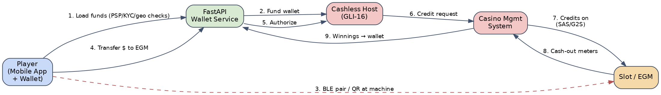
Figure 2 — Cardless/cashless slot play. Steps 3–7 are the funds-to-machine path; 8–9 return winnings. GLI-16 governs the host; SAS/G2S carry credits to the EGM.
- Load funds into the wallet after KYC, geolocation, and payment checks.
- Pair at the machine via BLE (with a QR-code fallback for device/BLE issues).
- Transfer to EGM: the app asks the backend, which authorizes with the cashless host; the host instructs the CMP, which credits the machine over SAS/G2S.
- Cash out: remaining credits meter back through the CMP to the host and into the wallet.

5.2 Digital key — how it really works
Modern hotel/casino locks (ASSA ABLOY VingCard, Salto) are BLE/NFC-capable and paired with a vendor mobile-access cloud. Our app embeds the vendor's mobile SDK; on a valid reservation the backend requests a mobile key from the vendor cloud, the SDK stores it securely, and tapping “Unlock” opens the door over BLE/NFC. The MVP embeds a stub SDK behind DigitalKeyPort so the issue → store → unlock UX is real while the physical lock is simulated.

5.3 Compliance-gated capabilities
KYC, geolocation, and payments are lighter to integrate than cardless (sandbox accounts exist), so they can go live earlier (Phase 1.5) if commercial access is available — but they still require signed agreements, so the MVP defaults to mock and treats real credentials as a configuration change.

6. Data Model
A single PostgreSQL schema with tenant-scoped tables (RLS-enforced) and player-scoped tables beneath them. Below is the MVP core; JSONB is used for flexible, CMS-authored structures (theme tokens, feature flags, content payloads).
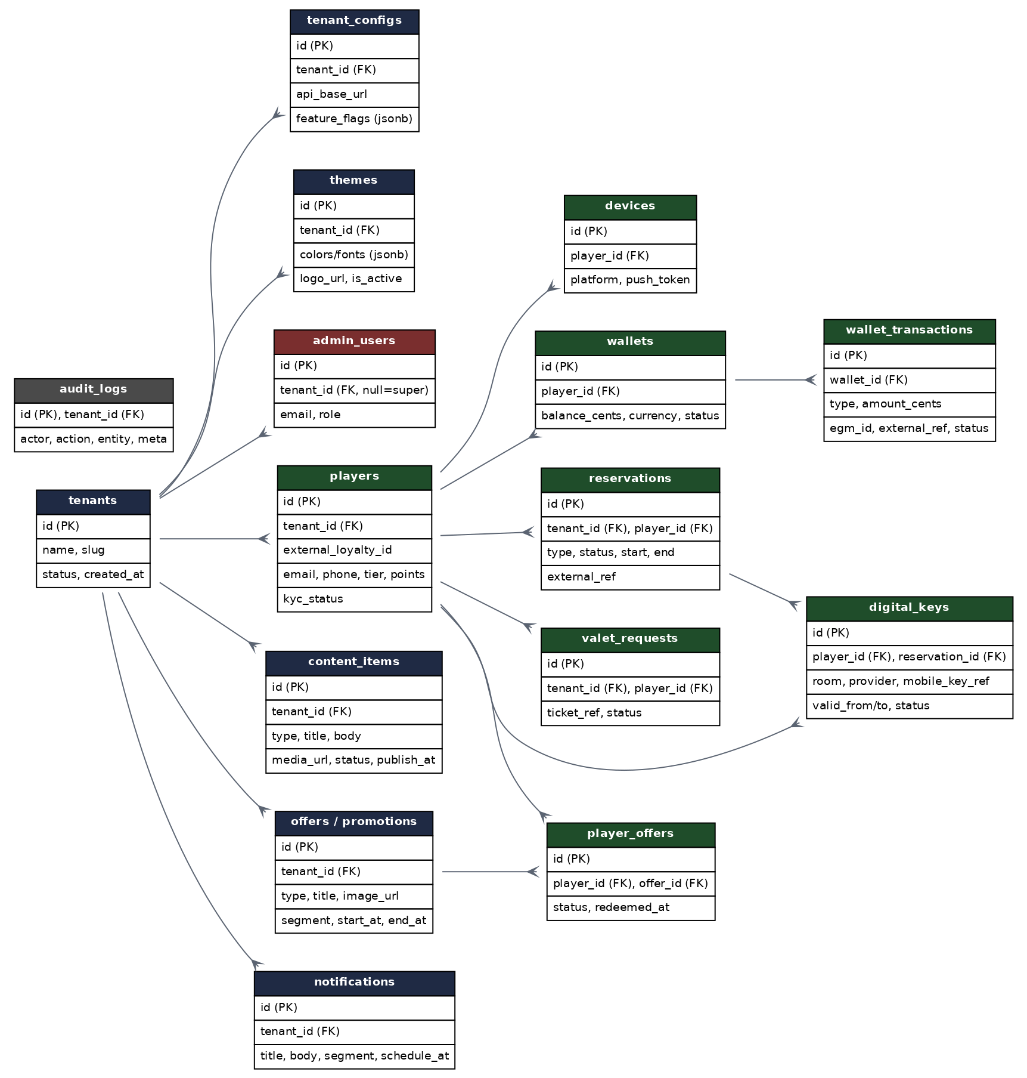
Figure 3 — Core ERD. Navy = tenant/config & content, green = player-scoped, red = admin identity, grey = audit. Every tenant-owned row carries tenant_id under RLS.

6.1 Table groups
- Tenant & config: tenants, tenant_configs (URLs, feature flags), themes (design tokens, logos). Drive white-labeling.
- Identity: admin_users (tenant_id null = super-admin) with role-based access; players (tenant-scoped) linked to the loyalty account via external_loyalty_id.
- Content: content_items (generic typed CMS content), offers/promotions, and player_offers (redemption ledger).
- Wallet: wallets and wallet_transactions (fund, transfer-to-EGM, cash-out, refund) with external_ref for host reconciliation.
- Guest services: reservations, valet_requests, and digital_keys (tied to a reservation, carrying the vendor mobile_key_ref and validity window).
- Messaging & governance: notifications (+ per-recipient delivery records) and audit_logs for every privileged action.
- Location & triggers: geofence_zones (point + radius or polygon), beacons (UUID/major/minor mapped to a named place), location_triggers (rule: zone, enter/dwell, dwell_seconds, offer/promotion, schedule, frequency cap), and location_events (audit of enter/dwell/exit). Detailed in Section 10.
Money & audit integrity: Wallet transactions are an append-only ledger (no in-place balance edits); balances are derived/materialized. Every admin and financial action writes an immutable audit row — essential for the eventual GLI-16 and AML posture.

7. API Design (FastAPI)

7.1 Conventions
- Base & versioning: /api/v1/... ; JSON; snake_case payloads; cursor pagination; RFC-7807 problem+json errors.
- Auth: OAuth2/OIDC + JWT access/refresh; players and admins are separate audiences; short-lived tokens; refresh rotation.
- Tenant routing: tenant derived from the token (mobile) or admin binding (CMS); super-admin passes an explicit X-Tenant context; gateway sets the RLS session variable.
- Docs & types: OpenAPI auto-generated by FastAPI/Pydantic; typed clients generated for the CMS and mobile app.

7.2 Representative endpoints
Endpoint | Method | Purpose
/auth/login, /auth/refresh, /auth/otp | POST | Player & admin authentication; OTP enrolment.
/me, /me/devices | GET/POST | Profile, tier, KYC status; register device push token.
/config/manifest | GET | Resolved tenant manifest: theme tokens, feature flags, endpoints.
/offers, /offers/{id}/redeem | GET/POST | List targeted offers; redeem (writes ledger).
/promotions | GET | Active promotions for the player's segment.
/account/points, /account/activity | GET | Loyalty balance, tier progress, win/loss & activity.
/wallet, /wallet/fund, /wallet/transfer, /wallet/cashout | GET/POST | Wallet balance and cashless money movement (mock host in MVP).
/egm/pair | POST | Begin BLE/QR session with a slot (simulated in MVP).
/reservations, /reservations/{id} | GET/POST | Hotel/dining/nightlife booking + status.
/valet/request, /valet/status | POST/GET | Request vehicle and track readiness.
/keys, /keys/{id}/unlock | GET/POST | Issue and exercise a digital room key (stub SDK in MVP).
/admin/tenants, /admin/users, /admin/config | GET/POST/PATCH | Super-admin: provision tenants, users, URLs, flags.
/cms/content, /cms/offers, /cms/themes, /cms/push | GET/POST/PATCH | Tenant CMS authoring for content, offers, theme, campaigns.
/cms/push/send | POST | Segment + dispatch a push campaign (APNs/FCM).
/geo/zones, /geo/triggers | GET/POST/PATCH | Admin CRUD for geofence zones/beacons and location trigger rules.
/geo/sync, /geo/events | GET/POST | Mobile fetches active zones/beacons; posts enter/dwell/exit events.

8. Mobile App (React Native)

8.1 White-label build & theming
- Single codebase, per-tenant flavors: iOS schemes / Android product flavors generate each branded binary (app name, icon, bundle id, signing) from a tenant build config; runtime theme still comes from the manifest so most changes need no rebuild.
- Design tokens: a ThemeProvider consumes manifest tokens; components read tokens, never literals. Feature flags gate whole modules.
- Build automation: EAS Build / Fastlane in CI loops over tenants to produce IPAs/APKs and submit to stores.

8.2 Native capabilities
- BLE: react-native-ble-plx for slot pairing (simulated peripheral in MVP); QR fallback via camera.
- Push: Firebase Messaging + APNs; deep links route to offers/reservations.
- Secure storage & digital key: Keychain/Keystore for tokens and mobile-key material; vendor lock SDK (stubbed) behind a bridge.
- Location: geolocation adapter for on-property/jurisdiction checks.
- Geofencing & beacons: OS region monitoring (iOS Core Location, Android Geofencing) for GPS zones plus iBeacon/Eddystone ranging for indoor dwell detection; background events wake the app to evaluate dwell and fire triggers.

8.3 MVP screen inventory
Onboarding/login; Home (brandable hero, tiles); Offers & detail/redeem; Promotions; Account (points, tier, activity, win/loss); Wallet (fund, transfer, cash-out, history); Slot pairing; Reservations (browse/book/manage); Valet; Digital Key; Notifications/inbox; Profile & KYC; Settings. All rendered through the tenant theme.

9. Admin Console (Unified CMS + Super-Admin)
The tenant CMS and the super-admin control plane are a single React application, not two. Stack as specified: React + Vite + TypeScript + Redux Toolkit (RTK Query for data/caching) + TanStack Router + Tailwind CSS + Lucide icons. What any user can see and do is decided entirely by role-based access control (RBAC), enforced at the API and reflected in the UI — the same build serves a property marketer and a platform super-admin, showing each only what their role permits.
Super-admin scope is itself a permission. An operator can grant super-admin (or a narrower account-manager/support role) access to every tenant or only an assigned subset of clients. This keeps one codebase, one deployment, and one login surface while preserving strict separation between operators — and lets support staff be scoped to just the clients they manage.

9.1 Roles & permissions (illustrative)
Role | Scope | Representative permissions
Super-Admin | All tenants (or a restricted set) | Create/suspend tenants; set slugs, domains, base URLs; provision admins; global feature-flag & adapter/credential config; cross-tenant oversight & audit; assume a tenant context.
Account Manager (scoped super-admin) | Assigned clients only | Super-admin capabilities limited by permission to a whitelist of tenants — e.g., onboarding/support staff who must not see other operators.
Tenant Admin | Single tenant | Manage that tenant's users & roles, theme, content, offers, promotions, push, and reservations/valet config; view analytics.
Marketer / Content Editor | Single tenant (subset) | Author, schedule, and target content, offers, and push; no user management or platform config.
Why one app works: Because tenant isolation is already enforced in the data layer (RLS + tenant_id) and at the gateway, the admin UI is just another RBAC-governed client. Merging the two consoles removes a whole app to build, deploy, and secure — the separation that matters lives in permissions and the database, not in having two front-ends.

9.2 Tenant (CMS) capabilities
- Branding studio: edit colors, fonts, logos, splash, icons with a live preview of the app manifest.
- Content & campaigns: author offers, promotions, banners, and screens; schedule and target by segment; publish to bump the manifest.
- Push composer: build, segment, schedule, and send notifications; view delivery/engagement.
- Ops config: reservations/valet options, feature toggles within tenant-permitted bounds, and analytics dashboards.

9.3 Platform (super-admin) capabilities
- Tenant lifecycle: create/suspend tenants; set slugs, custom domains, and base URLs.
- Users & roles: provision admins, assign roles/permissions (including per-client scoping), reset access.
- Global config: feature-flag defaults, adapter/API credentials per tenant, rate limits, and environment URLs.
- Oversight: cross-tenant health, usage, and audit-log search.

10. Geofencing & Location-Triggered Campaigns
A core engagement capability: when a player enters (or lingers in) a defined location, the platform automatically triggers a targeted offer or promotion. Casino admins define the locations and rules themselves in the console — no engineering involved — and the mobile app plus a backend trigger engine do the rest.
Worked example: “When a player enters the steakhouse and stays 10 minutes, send the surf-and-turf promo.” The admin drops a point on the steakhouse (or assigns its beacon), sets the rule to a dwell of 10 minutes or more, attaches the promotion, sets a frequency cap of once per day, and publishes. The next qualifying visit fires the push.
Figure 4 — Location-trigger flow. Steps 3–4 detect entry and dwell on-device; the backend trigger engine applies rules, caps, consent, and quiet hours before sending.

10.1 GPS geofences vs. indoor beacons (why both)
GPS geofencing works well for large or outdoor zones (the property, a pool deck, a parking structure) but is unreliable indoors, where walls and multiple floors defeat it. A restaurant inside the casino needs indoor-grade precision, best delivered by BLE beacons (iBeacon/Eddystone) placed at the venue. The platform supports both zone types behind one rule model, and the admin simply picks the type per location.
- GPS geofence: a point (lat/lng) + radius, or a polygon. Good for property-scale and outdoor zones; monitored by the OS.
- BLE beacon zone: one or more beacons (UUID/major/minor) mapped to a named place (e.g., “Steakhouse”). Gives reliable indoor enter/dwell detection.

10.2 What the admin configures (in the portal)
- Zones / points: drop a pin on a map and set a radius, draw a polygon, or register beacons to a named place — all editable per tenant.
- Trigger rules: event type (enter, exit, or dwell), dwell threshold (e.g., 10 minutes), the offer/promotion to send, target segment, active schedule (days/hours), and frequency cap (e.g., once per day).
- Guardrails: quiet hours, a maximum number of notifications per player per day, and consent requirements — so location marketing stays welcome and compliant.

10.3 How it runs (mobile + trigger engine)
- Sync: on launch/refresh the app pulls the tenant's active zones and beacon IDs, syncing the nearest/most-relevant zones to respect the OS limit on simultaneously monitored regions.
- Detect: the OS wakes the app on region enter/exit; for dwell, the app confirms continuous presence for the threshold (beacon ranging or repeated location checks) before qualifying.
- Evaluate: a qualifying event goes to the backend trigger engine, which matches the rule, applies frequency caps, consent, and quiet hours, dispatches the promotion via the notification service, and logs the event and delivery.
Design choice: Detection happens on-device (low latency, uses the OS background wake-ups); the rule decision happens server-side. That keeps caps, targeting, consent, and audit centralized — and lets admins change rules without an app release.

10.4 Data & privacy
- New entities: geofence_zones, beacons, location_triggers (the rules), and location_events (append-only audit of enter/dwell/exit and any resulting send). All tenant-scoped under RLS.
- Consent-first: location and background-location require explicit opt-in with a clear purpose; players can withdraw consent; location events are minimized and retention-limited. Background-location use must be justified for app-store review.

11. Security, Compliance & Responsible Gaming
Even though regulated integrations are mocked in the MVP, the architecture is built to their standards so Phase 2 is a certification exercise, not a rebuild.
Area | Approach
Cashless standard (GLI-16) | Append-only wallet ledger, transaction meters, reconciliation refs, strong auth on money movement — aligned to GLI-16 Cashless Systems & Technologies for Phase-2 certification.
Gaming protocols (GSA) | EGM interaction abstracted to G2S/S2S/SAS-shaped calls behind EgmPort; the mock mirrors real message semantics.
KYC / AML | Identity verification (Jumio/Sumsub), risk flags, transaction monitoring hooks, and audit trails; sanctions/PEP screening in Phase 2.
Geolocation | GeoComply-style on-property/jurisdiction checks before money movement; spoof detection in Phase 2.
Responsible gaming | Deposit/time limits, self-exclusion checks (state-DB integration in Phase 2), cool-off, and visible RG resources.
Location privacy & consent | Explicit opt-in for location/background tracking; purpose disclosure; data minimization and retention limits on location events; honoring consent and quiet hours; store-policy-compliant background-location justification.
Payments / PCI | Tokenization; no PAN storage; PSP-hosted capture to minimize PCI-DSS scope.
App & data security | TLS everywhere, JWT with rotation, per-tenant RLS + encryption, secrets manager, OWASP MASVS for mobile, pen test before Phase-2 go-live.
Auditability | Immutable audit logs for all privileged/financial actions; exportable for regulators.
Not legal advice: Gaming regulation is highly jurisdiction-specific (state/tribal/national). Engage a licensed gaming compliance advisor and the relevant regulator/test lab (e.g., GLI) before any real-money or cardless launch.

12. Non-Functional Requirements & DevOps
- Environments: local, dev, staging, prod; adapters default to mock in non-prod; per-tenant config isolates data.
- CI/CD: GitHub Actions; containerized FastAPI (Docker) to ECS/Kubernetes; DB migrations via Alembic; EAS/Fastlane for mobile.
- Observability: OpenTelemetry traces, structured logs, metrics dashboards, Sentry for mobile/back-end crash reporting, uptime/synthetic checks.
- Performance & scale: stateless services behind a load balancer, Redis caching of manifests/offers, CDN for media, async workers for push and reconciliation.
- Reliability: idempotent money endpoints, retries with backoff, circuit breakers around adapters, graceful BLE/QR fallback.
- IaC: Terraform for reproducible, per-environment infrastructure.

13. Delivery Roadmap & Estimates
Two-week sprints, ~8–10 people. Calendar time assumes committed vendor sandbox access lands during Phase 1.5. Figures are planning indicative, not a fixed quote.

13.1 Phases
Phase | Duration | Outcome | Integrations
Phase 0 — Foundations | 3–4 wks | Monorepo, CI/CD, auth, tenant model + RLS, theming pipeline, super-admin skeleton, adapter interfaces + mocks. | All mocked
Phase 1 — Core MVP | 12–16 wks | Full guest journey: CMS-driven offers/promotions, account/loyalty, reservations, valet, push; cardless & digital-key demos. | Mock / sandbox
Phase 1.5 — Sandbox real | overlaps | Swap KYC and payments to sandbox vendors where access is available. | KYC, PSP (sandbox)
Phase 2 — Regulated go-live | 16–26 wks | Real cardless (GLI-16 cert), digital-key vendor integration, real geo/KYC/payments, pen test, store launch. | Live vendors + cert

13.2 Phase-1 sprint outline
Sprint | Focus
S1 | Foundations: repo, CI/CD, auth, tenant + RLS, base theming, adapter interfaces + mocks.
S2 | Admin console shell with RBAC; tenant/user/URL/flag CRUD + CMS content service.
S3 | Mobile shell: white-label build, manifest theming, navigation, login/enrolment.
S4 | Offers & promotions end-to-end (CMS author → API → render → redeem).
S5 | Account & loyalty (points, tier, activity, win/loss) + KYC status (mock).
S6 | Reservations + Valet (real UX + adapter mocks).
S7 | Push notifications: compose/segment/schedule → APNs/FCM → deep links.
S8 | Cardless wallet + BLE pairing demo; digital-key demo; geofenced offer (enter/dwell) trigger demo.
S9 | Hardening, analytics, accessibility, UAT, store-submission prep.

13.3 Team & indicative effort
Role | Count | Focus
Product Manager | 1 | Scope, backlog, vendor coordination, UAT.
Tech Lead / Architect | 1 | Architecture, adapters, code quality, security.
Backend (FastAPI) | 2 | Services, data model, integrations, money ledger.
Mobile (React Native) | 2 | App, theming, BLE, push, digital key.
Frontend (React) | 1–2 | Unified admin console (tenant CMS + super-admin, RBAC).
UI/UX Designer | 1 | Design system, tenant theming, flows.
QA Engineer | 1 | Test plans, contract tests, device matrix.
DevOps / SRE | 0.5 | CI/CD, infra, observability.
MVP (Phase 0 + 1): ~18–22 weeks calendar; roughly 120–170 person-weeks of effort. Indicative external build cost commonly lands in the $350K–$650K range depending on rates and polish. Phase 2 adds ~4–6 months and is gated on vendor contracts and certification. (Cost is a rough planning band, not financial advice or a fixed quote.)

14. Risks & Mitigations
Risk | Severity | Mitigation
Regulatory / certification for cardless (GLI-16, GSA, state/tribal) | High | Adapter pattern; treat as gated Phase 2; engage GLI and regulators early; pilot one property.
Vendor partnerships & lead times (lock SDK, GeoComply, PSP, CMP) | High | Stable interfaces; start commercial + sandbox conversations in Phase 0; avoid lock-in.
Casino Management System variance (SAS/G2S differ by floor/vendor) | Med–High | EgmPort abstraction; certify against one CMP first; config per property.
Multi-tenant data isolation / breach | High | RLS + per-tenant keys, least privilege, secrets manager, pen test before go-live.
BLE reliability across device matrix | Med | QR fallback; broad device testing; timeouts/retries.
Indoor location accuracy & background-location opt-in | Med | Use BLE beacons indoors (GPS is unreliable inside); graceful degradation; clear opt-in; respect iOS's ~20 monitored-region limit by syncing nearest zones.
App-store review for gambling/financial apps | Med | Age & geo gating, RG disclosures, correct entitlements, follow Apple/Google gambling policies.
Scope creep ('partial requirements') | Med | Phase gating, change control, MVP feature freeze.
Money-movement correctness | High | Append-only ledger, idempotency, reconciliation, audit; finance review.

15. Recommended Next Steps
- Confirm the MVP feature freeze using Section 3 as the contract; explicitly mark cardless and digital key as “demo”.
- Stand up Phase 0 (repo, CI/CD, auth, tenant + RLS, theming pipeline, adapter interfaces + mocks).
- Open vendor conversations in parallel (lock vendor, GeoComply, KYC, PSP, and a Casino Management System partner) to unblock Phase 1.5/2.
- Design the tenant manifest schema early — it is the backbone of white-labeling and CMS-driven theming.
- Engage a gaming-compliance advisor to scope GLI-16 and jurisdictional requirements before Phase 2.
- Build the demo script for investors/operators: provision a tenant, theme it live, publish an offer, run a cardless + digital-key demo.

Appendix A — Glossary
EGM — Electronic Gaming Machine (slot).
Casino Management System (CMP / host) — Floor system tracking play, accounts, and credits (e.g., IGT Advantage, L&W).
CMS Portal — Our Content Management System — the React admin app tenants use to control the app.
G2S / S2S — Gaming Standards Association protocols: Game-to-System and System-to-System.
SAS — Slot Accounting System — de facto protocol for metering, player tracking, and cashless.
GLI-16 — GLI standard for Cashless Systems and Technologies (governs cardless play).
BLE / NFC — Bluetooth Low Energy / Near-Field Communication — used for pairing and digital keys.
Geofence — A virtual boundary (point + radius or polygon) that triggers an action on enter, exit, or dwell.
Beacon (iBeacon) — A small BLE transmitter giving precise indoor proximity where GPS is unreliable.
Dwell time — How long a player must stay inside a zone before a trigger fires (e.g., 10 minutes).
RLS — Row-Level Security — PostgreSQL feature enforcing per-tenant data isolation.
KYC / AML — Know Your Customer / Anti-Money-Laundering identity and monitoring requirements.
RG — Responsible Gaming — limits, self-exclusion, and player-protection features.
PMS — Property Management System — hotel booking/reservation backbone.
PSP — Payment Service Provider.
BFF — Backend-for-Frontend — API tailored to client needs.

Appendix B — References
• JoinGO / Sightline / NRT — casino mobile engagement & cashless: https://ggbmagazine.com/articles/mobile-powered-by-joingo/
• Sightline acquires JoinGO: https://sightlinepayments.com/news/sightline-payments-acquires-casino-mobile-app-developer-joingo
• Light & Wonder Universe — cardless via Bluetooth/QR: https://gaming.lnw.com/Games/Systems/Marketing/Light-and-Wonder-Universe-18441
• Light & Wonder Patron mobile app: https://cdcgaming.com/focus-on-light-wonder-patron-mobile-app-enhances-customers-bond-with-casino/
• Light & Wonder + Trustly cashless (RAPIDPLAY): https://www.trustly.com/us/press/light-wonder-trustly-cashless-payments-casinos
• Playerhub.ai — player loyalty super app: https://www.playerhub.ai/
• IGT Resort Wallet — cashless gaming: https://www.igt.com/products-and-services/gaming/systems/cashless/resort-wallet
• Acres — cashless casino: https://acresmanufacturing.com/cashless-casino/
• GLI-16 — Cashless Systems and Technologies (public RFC v3.0): https://gaminglabs.com/wp-content/uploads/2024/04/GLI-16-v3.0-Cashless-Systems-and-Technologies-Public-RFC.pdf
• GSA G2S communication protocol overview: https://www.comtradegaming.com/resource-library/g2s-communication-protocol
• GeoComply — gaming geolocation & on-property geofencing: https://www.geocomply.com/industries/gaming/
• ASSA ABLOY Hospitality Mobile Access (BLE): https://play.google.com/store/apps/details?id=com.assaabloy.hospitality.mobileaccess.hospitalitymobileaccess
• Multi-tenant white-label React Native architecture: https://mcro.tech/blog/multi-tenant-architecture-in-react-native/
• Casino AML/KYC & responsible gaming guide: https://sumsub.com/blog/a-complete-guide-to-casino-compliance-aml-responsible-gambling-and-data-protection/
• Apple Core Location — region monitoring & beacon ranging: https://developer.apple.com/documentation/corelocation
• Android Geofencing API: https://developer.android.com/develop/sensors-and-location/location/geofencing

Appendix C — Permissions Matrix (Admin Console)
Authorization is enforced server-side at the API; the console UI mirrors it. Non-super roles are automatically scoped to their tenant(s) by row-level security, so “Tenant Admin” always means “within their own tenant.” A super-admin can be scoped to a subset of clients (the Account Manager pattern). Treat this as the baseline for the backend RBAC implementation.
Legend: C = create · R = read · U = update · D = delete · P = publish/send · A = assign roles · — = no access.
Resource | Super-Admin | Account Mgr (scoped) | Tenant Admin | Marketer / Editor
Tenants (create/suspend) | C R U D | R | — | —
Platform config & adapter credentials | C R U D | R | — | —
Admin users & role assignment | C R U D · A | C R U D · A | C R U · A | —
Tenant config, URLs & domains | C R U D | R U | R U | —
Theme / branding | C R U D | C R U D | C R U D | R
Content items | C R U D · P | C R U D · P | C R U D · P | C R U · P
Offers | C R U D · P | C R U D · P | C R U D · P | C R U · P
Promotions | C R U D · P | C R U D · P | C R U D · P | C R U · P
Push campaigns | C R U D · P | C R U D · P | C R U D · P | C R U · P
Geofence zones (points/beacons) | C R U D | C R U D | C R U D | R
Location triggers (rules) | C R U D · P | C R U D · P | C R U D · P | C R U · P
Reservations / valet config | C R U D | C R U D | C R U D | R
Players / PII | R | R | R | —
Wallet & transactions (view) | R | R | R | —
Analytics & reports | R | R | R | R
Audit logs | R | R | R | —
Note: the mobile player is a separate identity audience with its own token and no console access; player PII and wallet data are read-only in the console and export is gated behind elevated permission and audit.

