
HOUSING PRICES IN METROPOLITAN AREAS OF INDIA
GOVERNMENT ARTS COLLEGE (AUTONOMOUS) – KARUR
639005
FACULTY MENTOR
Mr.S.VASANTHAKUMAR.,M.Sc.,NET
GUEST LECTURER IN STATISTICSGOVT ARTS
COLLEGE (A), KARUR



MEMBERS
TEAM
TEAM MEMBER
–
D. KAVIPRIYA
TEAM MEMBER
–
S. NITHYA SRI
MEMBER
TEAM
–
M. DEEPAK PRABHU
TEAM LEADER
–
A. PRAVEEN

urban planning, and people's lives.
House prices have profound implications for the economy,
•
metropolitan areas.
The cost of housing is a major concern for millions of people in
•
witnessed significant changes in recent years.
The Indian real estate market, especially in major cities, has
•
in metropolitan areas of India.
Welcome to our presentation on the dynamics of house prices
•
INTRODUCTION
implications for various stakeholders.
regulations impact home prices in metropolitan areas and their
Policy Implications: Discuss how government policies and
•
that make it an attractive or risky proposition.
investment in Indian metropolitan areas, discussing the factors
Investment Analysis: Analyze the potential for real estate
•
market dynamics.
Include data on price trends, factors influencing prices, and
Indian real estate market, with a focus on metropolitan areas.
Informative: Provide an overview of the current state of the
•
PURPOSE
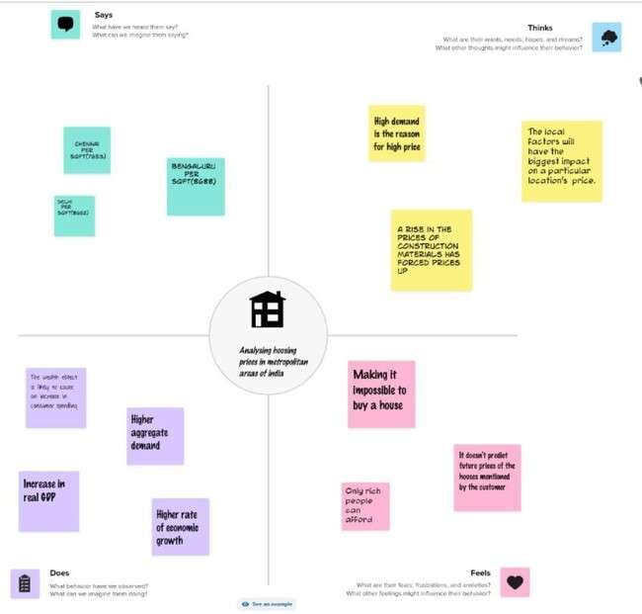
EMPATHY MAP
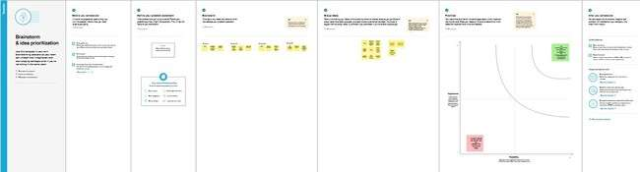
BRAINSTROM
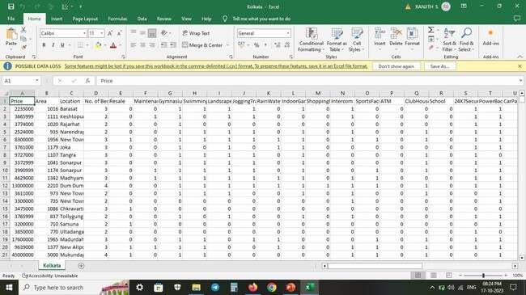
DATA SET
by property type (apartments, houses, etc.).
city in the dataset for the specified years. You can break this down
Average Home Price: Provide the average home prices for each
•
2021).
-
2010
Year: Include the years or time period for which you have data (e.g.,
•
Delhi, Bangalore, Chennai).
metropolitan areas in India that you want to analyze (e.g., Mumbai,
City/Metropolitan Area: List the names of the major cities or
•
ABOUT DATA SET
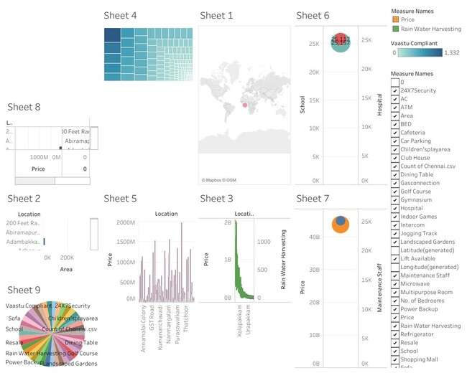
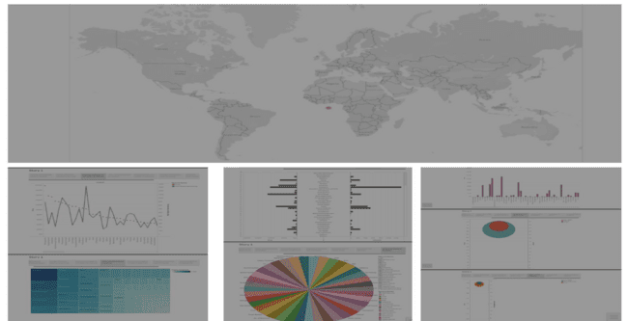
DO

Dashboard link: https://public.tableau.com/views/Book1_16975264363720/Dashboard1?:language=en-US&publish=yes&:display_count=n&:origin=viz_share_link
Story link: https://public.tableau.com/views/Book1_16975264363720/story1?:language=en-US&publish=yes&:display_count=n&:origin=viz_share_link
economic conditions, and government policies
factors that drive home prices, such as demand, supply,
Understanding Factors: Explore and explain the various
•
metropolitan areas.
the current state of home prices in India, especially in
Provide the audience with comprehensive information on
•
INFORMING THE AUDIENCE

This leads to higher property prices and better rental income.
for houses and commercial properties is higher than others.
As there are more people living in these areas, the demand
•
which include physical conditions, concept and location.
There are three factors that influence the price of a house
•
the right time to purchase a house.
selling price of a house and can help the customer to arrange
House price prediction can help the developer determine the
•
ADVANTAGES

being.
-
This can result in a decrease in living conditions and overall well
•
with multiple families sharing limited space.
Overcrowding: High demand for housing can lead to overcrowding,
•
This results in increased traffic congestion and longer commutes.
•
search of more affordable housing.
can lead to urban sprawl as people move to outlying areas in
Urban Sprawl: As housing prices increase in metropolitan areas, it
•
DISADVANTAGES

income segments.
-
particularly for the middle and lower
Housing affordability remains a substantial challenge,
•
regulatory policies significantly impact housing prices.
Factors like land scarcity, construction costs, and
•
rapid urbanization, job opportunities, and migration.
The demand for housing in Indian metros is driven by
•
CONCLUSION

more accurate information on this topic.
It's best to consult local real estate experts and market trends for
•
economic, demographic, and market factors.
Real estate prices are influenced by a complex interplay of
•
I can't predict future home prices in Indian metropolitan areas.
•
FUTURE HOPE

THANK YOU

