SOFTWARE REQUIREMENTS SPECIFICATION
Hyperlocal Peer-to-Peer Doubt Resolution
and Mentorship Network

Prepared by:
Praveen Manoj & Team

Hackathon:
24-Hour Innovation Challenge

1. Introduction

1.1 Purpose
The Hyperlocal Peer-to-Peer Doubt Resolution and Mentorship Network is a cross-platform mobile application that connects students with nearby verified peer mentors for academic doubt resolution. Students can post academic doubts using text and optional image attachments. The system intelligently matches students with suitable mentors based on the selected subject, location, availability, and reputation score. Doubts can be resolved through real-time chat or scheduled live audio mentoring sessions.

1.2 Scope
The application enables users to:
- Register and log in securely.
- Create and manage user profiles.
- Post academic doubts with subject selection and image attachments.
- Discover nearby verified mentors.
- Communicate through real-time chat.
- Schedule live audio mentoring sessions.
- Rate mentors and build a trusted reputation system.

1.3 Objectives
The primary objectives of the system are:
- Reduce the time required to resolve academic doubts.
- Encourage peer-to-peer collaborative learning.
- Connect students with nearby verified mentors.
- Improve mentoring quality through a reputation-based system.
- Build a secure, reliable, and scalable educational platform.
- Phase 1 Requirement Analysis Problem Statement, Target Users, Functional Requirements, Core Features, Technology Stack
- Phase 2 System Design User Flow, UI/UX Design, ER Diagram, Database Design, Architecture Diagram
- Phase 3 Core Feature Development User Registration, Student & Mentor Profiles, Post Doubts, Doubt Feed, Mentor Request System
- Phase 4 Hyperlocal & Mentorship Module Nearby Student Matching, Subject-wise Matching, Chat Module, Doubt Resolution, Notifications
- Phase 5 Integration & Testing Frontend-Backend Integration, API Testing, Bug Fixes, End-to-End Testing, Performance Optimization
- Phase 6 Final Deployment & Presentation APK Build, Live Demo, Project Documentation, Architecture Explanation, Future Enhancements

2. Overall Description

2.1 Product Overview
The proposed system is a mobile application designed for students and peer mentors within educational institutions. Instead of manually searching for academic help, students can post doubts, and the application automatically connects them with suitable nearby mentors.

Mentor matching is performed using the following criteria:
- Selected subject
- Current location
- Selected proximity radius
- Mentor availability
- Mentor reputation score

Students and mentors communicate through asynchronous chat. If further clarification is required, they can schedule a live audio mentoring session.

2.2 User Roles

Student
Students can:
- Register and log in.
- Create and edit their profile.
- Post academic doubts.
- Select subjects while posting doubts.
- Upload supporting images.
- View nearby verified mentors.
- Chat with mentors.
- Schedule live audio sessions.
- Rate mentors.
- View previous doubt history.

Mentor
Mentors can:
- Register and log in.
- Complete profile verification.
- Specify subject expertise.
- Set their availability.
- Accept or reject doubt requests.
- Answer student doubts.
- Conduct live audio mentoring sessions.
- View ratings and reputation scores.

Administrator
Administrators can:
- Verify mentor accounts.
- Manage user accounts.
- Moderate inappropriate content.
- Review and resolve user reports.

2.3 Core Features
The application includes the following major features:
- User Authentication
- Profile Management
- Subject Selection
- Doubt Posting
- Image Upload
- Hyperlocal Mentor Matching
- Real-Time Chat
- Live Audio Mentoring
- Push Notifications
- Rating and Reputation System

2.4 Overall System Flow
The overall workflow of the application is as follows:
- The user registers as either a Student or Mentor.
- Mentors complete the verification process.
- Students post a doubt by:
  - Selecting the subject.
  - Writing the question.
  - Uploading an image (optional).
- The system searches for suitable mentors based on:
  - Subject
  - Current location
  - Selected search radius
  - Availability
  - Reputation score
- Matching mentors receive notifications.
- A mentor accepts the request and begins communication through chat.
- If required, the student schedules a live audio mentoring session.
- After the doubt is resolved, the student rates the mentor.
- The mentor's reputation score is automatically updated.

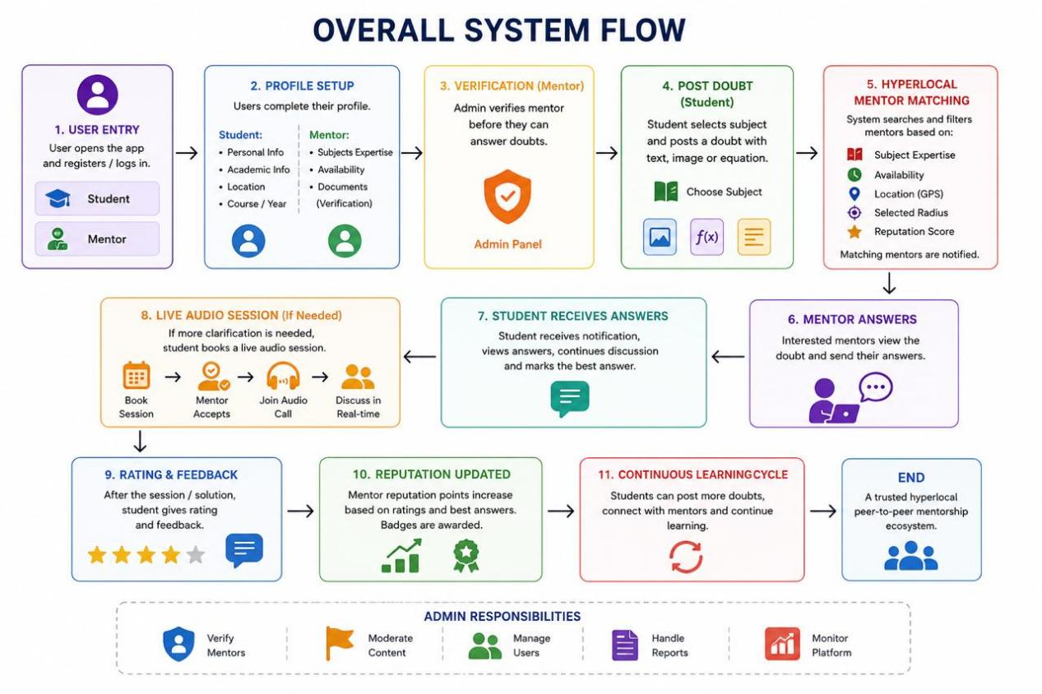

3. Functional Requirements

3.1 Student Module
The system shall allow students to:
- Register and log in.
- Create and edit their profile.
- Select subjects while posting doubts.
- Upload images related to doubts.
- View nearby verified mentors.
- Chat with mentors.
- Schedule live audio sessions.
- View previous doubts.
- Rate mentors after doubt resolution.

3.2 Mentor Module
The system shall allow mentors to:
- Register and log in.
- Submit verification details.
- Specify subject expertise.
- Set availability.
- Accept or reject doubt requests.
- Answer student doubts.
- Conduct live audio mentoring sessions.
- View ratings and reputation.

3.3 Administrator Module
The system shall allow administrators to:
- Verify mentor accounts.
- Manage user accounts.
- Moderate inappropriate content.
- Review reports submitted by users.

3.4 Notification Module
The system shall notify users regarding:
- New doubt requests.
- New replies.
- Audio session reminders.
- Booking confirmations.

4. Technology Stack and Non-Functional Requirements4. Technology Stack and Non-Functional Requirements

4.1 Technology Stack

Component | Technology
Frontend | React Native (Expo)
Programming Language | TypeScript
Backend | Supabase
Database | PostgreSQL
Authentication | Supabase Auth
Storage | Supabase Storage
Location Services | Expo Location
Maps | Google Maps API
Audio Calls | ZegoCloud SDK
Notifications | Firebase Cloud Messaging
Navigation | React Navigation
State Management | Zustand
UI Design | React Native (Expo)
Version Control | Git & GitHub
IDE | Visual Studio Code

4.2 Non-Functional Requirements

Performance
- Mentor matching should complete within 3 seconds.
- Chat messages should update in real time.
- The application should support at least 100 concurrent users during the hackathon demonstration.

Security
- Secure authentication for all users.
- HTTPS communication for all network requests.
- Protection of user information and personal data.
- User location should only be used for mentor matching.

Reliability
- Stable application performance during demonstrations.
- Automatic recovery from temporary network interruptions.

Usability
- Simple and intuitive user interface.
- Easy navigation for first-time users.

Scalability
- Modular architecture to support future enhancements.
- Ability to accommodate increasing numbers of users and mentors.

5. Database Overview, Deliverables and Future Scope

5.1 Main Database Entities
The primary database entities include:
- Users
- Mentor Profiles
- Doubts
- Replies
- Audio Sessions
- Ratings
- Notifications

5.2 Expected Deliverables
The project deliverables include:
- A fully functional cross-platform mobile application.
- Complete source code repository.
- Software Requirements Specification (SRS) document.
- Demonstration of the complete workflow, including:
  - User registration
  - Doubt posting
  - Mentor matching
  - Chat communication
  - Live audio mentoring session
  - Rating and reputation update

5.3 Future Enhancements
Future versions of the application may include:
- Video mentoring sessions.
- Group study rooms.
- College-wise mentor communities.
- PDF and notes sharing.
- Mentor leaderboard and achievement badges.
- Calendar integration for scheduled sessions.
- Student learning progress dashboard.
- Multi-language support.

Conclusion

The Hyperlocal Peer-to-Peer Doubt Resolution and Mentorship Network provides a secure, efficient, and scalable platform for academic collaboration by connecting students with nearby verified peer mentors. Through intelligent location-based mentor matching, real-time chat, scheduled live audio mentoring, and a reputation-based evaluation system, the application promotes collaborative learning while ensuring trust, accessibility, and an enhanced educational experience for all users.

— End of Document —

