Beyond the Rank Order: Quantifying Uncertainty in Physical-Test Rankings for Football Player Selection

Paper Track: Soccer
Paper ID: 268
github.com/praveenmaths89/athlete-ranking-uncertainty

- Introduction

Soccer academies and national talent programs select a few young players from a much larger pool and then invest years of coaching in them. In India, schemes such as Khelo India and the All India Football Federation's Blue Cubs league follow this pattern, and physical testing is one of the few objective inputs available at scale. The usual workflow is simple: test every player on a battery, convert the results into z-scores or percentiles, combine them into a composite score, and select the top k from the resulting leaderboard. A player ranked 36th is selected and a player ranked 38th is not.
That workflow treats small differences in rank as real, and its choices are rarely examined: which metrics to keep, how to weight them, whether a 12-year-old should be compared with a 25-year-old, and how to combine several visits. Talent research has long shown that relative age and biological maturation inflate the scores of older and earlier-maturing players [1–4], that talent identification has limited predictive validity [5, 6], and that soccer talent studies often ignore measurement error [7]. Outside sport, league tables of hospitals and schools change substantially once sampling error is considered [8], and statistical methods now exist to put confidence sets around ranks [9, 10]. Yet physical-test leaderboards in youth soccer are still reported as bare rank orders. How uncertain those ranks are at the selection cut-off, and how many selections they get wrong, remains unmeasured.
This paper quantifies that uncertainty for force-plate jump testing and turns it into a selection rule. Our contributions are:
1. A benchmark of 15 combinations of ranking method and weighting scheme for building a composite from repeated tests, evaluated against a simulated ground truth and against players' unseen later visits.
2. An estimate of how much age adjustment, using growth-reference (LMS) scores, changes who is selected.
3. Rank uncertainty for every player, expressed as a 95% rank confidence set and the probability of being in the top k, together with the expected number of wrong selections at realistic cut-offs.
4. A three-tier decision rule (select, retest, do not select) and a single open-source R script that runs from the raw force-plate export to every number in this paper.
We analyze 2,652 jump attempts from 190 male soccer players tested in Mumbai, India. Section 2 describes the data and methods, Section 3 reports the results in the order of the contributions, Section 4 applies the method to a selection decision, and Sections 5 and 6 discuss limitations and conclude.
- Data and Methods

Every result reported here comes from a single R script (ranking.R in the repository) that runs from the raw force-plate export to the final tables and figures.
Data. The data are routine force-plate assessments (ForceDecks, VALD Performance) of male soccer players at a single testing center in Mumbai. The battery comprised a countermovement jump (CMJ), a drop jump (DJ) and a single-leg jump (SLJ, both legs). We defined a visit as a day on which a player completed the whole battery. In total, 190 players had at least one visit (292 visits; 2,652 attempts; 152,027 trial-level metric values; ages 9.1 to 37.9 years), and 79 players had two or more visits. We used only size-independent metrics, such as times, heights, ratios and values per kilogram of body mass, so that body size does not drive the ranking [11]. In the released data, players carry anonymous codes, calendar dates are replaced by days since each player's first visit, and age is rounded to 0.1 year. [Ethics approval and the consent or assent procedure for players under 18 to be confirmed by the authors.]
Quality control and KPI selection. We judged each attempt only against the same player's other attempts in the same test, leg and visit, so that an exceptional performance is never removed for being unusual relative to other players. An attempt was removed if any of its three jump-height calculations was physically impossible (above 80 cm or at most 0 cm), or if its jump height was less than half or more than twice the player's median for that test, leg and visit. The same consistency rule was then applied to each metric value, removing only the affected value, and ranking used complete attempts only.
Candidate metrics then passed four filters. They had to be (a) relevant, which excluded protocol settings, body-weight duplicates, landing metrics and strategy measures with no agreed better direction; (b) available for at least 95% of players at their first visit, with at most 5% of values removed by quality control; (c) reliable, with an intraclass correlation (ICC) of the player's trial mean of at least 0.75 [12, 13]; and (d) not redundant: working from the most to the least reliable metric, a metric was kept only if its absolute correlation with every metric already kept was below 0.70 [14]. The ICC was computed from first-visit trials as one minus the ratio of the within-player variance of the trial mean to the between-player variance [15].
Age-relative scores. Each key performance indicator (KPI) was scored in two ways. The current score standardizes a value against the first-visit mean and standard deviation of the whole cohort, which is what a raw leaderboard does. The age-relative score compares the value with players of the same age using the LMS method [16], fitted in GAMLSS as a Box–Cox Cole–Green distribution with penalized splines in age [17]:
 | $$z_{ij}=\frac{{\left(y_{ij}/M_{j}(a_{i})\right)}^{L_{j}}−1}{L_{j} S_{j}(a_{i})}$$ | (1)
Here y_{ij} is the value of KPI j for player i aged a_{i}, and M, S and L are the age-specific median, coefficient of variation and skewness. Scores were sign-flipped where lower is better (for example, concentric duration) and were not capped.
Current ability from repeated visits. To combine a player's visits into one estimate of current ability, we fitted a linear mixed model to each KPI [18]:
 | $$z_{ivr}=β_{0}+β_{1}t_{iv}+b_{0i}+b_{1i}t_{iv}+u_{iv}+ε_{ivr}$$ | (2)
where z_{ivr} is the score of trial r at visit v of player i, t_{iv} is the time in years before the player's latest visit, b_{0i} and b_{1i} are the player's random intercept and slope, u_{iv} is a visit effect and ε_{ivr} is trial-to-trial error. Because time is centered at the latest visit, β₀ + b_{0i} estimates the player's level at the latest visit. In plain terms, a player tested once with inconsistent jumps is pulled toward the cohort average, while a player tested repeatedly and consistently keeps an estimate close to their own data.
Ranking methods and validation without ground truth. The matrix of estimated KPI levels was aggregated with five methods, a weighted mean, TOPSIS [19], SPOTIS [20], MARCOS [21] and PROMETHEE II [22], each with three weighting schemes: equal, entropy [23] and MEREC [24]. This gives 15 rankers. Because a player's true ability is never observed, we validated the rankers in two complementary ways. In Test A, a simulation study [25] generated 200 cohorts with the real visit pattern, the fitted variance components and the observed correlation between KPIs, under three definitions of true ability (mean KPI level, weakest KPI, and random positive weights). We measured agreement with the true ranking by Spearman's correlation and by normalized discounted cumulative gain over the top 10 (NDCG@10), which rewards getting the best players right [26]. In Test B, we held out the latest visit of each player with at least two visits and compared the ranking predicted from earlier visits with the ranking observed at the held-out visit (73 players with complete data). Rankers were ranked within each check and the two tests weighted equally; the best ranker was used for all later steps.
Rank uncertainty and selection error. We estimated uncertainty with a nonparametric bootstrap [27]. In each of B = 200 replicates, whole attempts were resampled with replacement within each player, visit, test and leg; the mixed models were refitted and the players re-ranked. The probability that player i is truly in the top k is
 | $${\hat{P}}_{i}(k)=\frac{1}{B}\sum_{b=1}^{B}{1}\left[ R_{i}^{(b)}≤k \right]$$ | (3)
where R_{i}^{(b)} is the player's rank in replicate b. Players with P̂ ≥ 0.90 were classed as select, those with P̂ < 0.10 as do not select, and the rest as borderline (retest). We also computed formal 95% confidence sets for each rank with the method of Mogstad et al. [10]. Finally, the expected number of wrong selections among the k players ranked in the top k is
 | E[Wk]=i: Ri≤k​1−Pi(k) | (4)
which is a lower bound because the bootstrap captures trial-to-trial variation only. Cut-offs of 10%, 20% and 30% of the 183 ranked players give k = 19, 37 and 55; we use 20% as the main case.
- Results

Quality control removed 42 attempts (31 physically impossible and 11 inconsistent with the player's own attempts) and 2,987 individual metric values. Of 122 candidate metrics, 42 were not performance KPIs, 6 failed coverage, 3 were unstable and 60 were redundant; none failed the reliability threshold. The 11 KPIs retained (Appendix Table A1) had ICCs of 0.77 to 0.98. After 83 incomplete attempts were excluded, 183 players (median age 14.1 years; 140 or 77% under 18) had an estimate for every KPI and were ranked.
The ranking method matters little. Fourteen of the 15 rankers recovered simulated true ability with Spearman correlations of 0.81 to 0.83 (Figure 1). Entropy-weighted TOPSIS was the clear outlier at 0.78. On the held-out visit, correlations ranged from 0.65 to 0.74. Averaged over both tests, the best ranker was the Weighted average, equal weights (simulated Spearman 0.825; NDCG@10 0.62), but its lead was small: on the point estimates, every other ranker placed at least 33 of the same 37 players in the top 20% (median 36), and all rankings correlated with it at ρ ≥ 0.95. SPOTIS with equal weights produced the same ranking as the equal-weight average. Entropy weights were not aligned with reliability (rank correlation with ICC 0.13); the second-largest entropy weight went to the least reliable KPI, CMJ eccentric peak force (ICC 0.77; weight 0.126; Appendix Table A1).
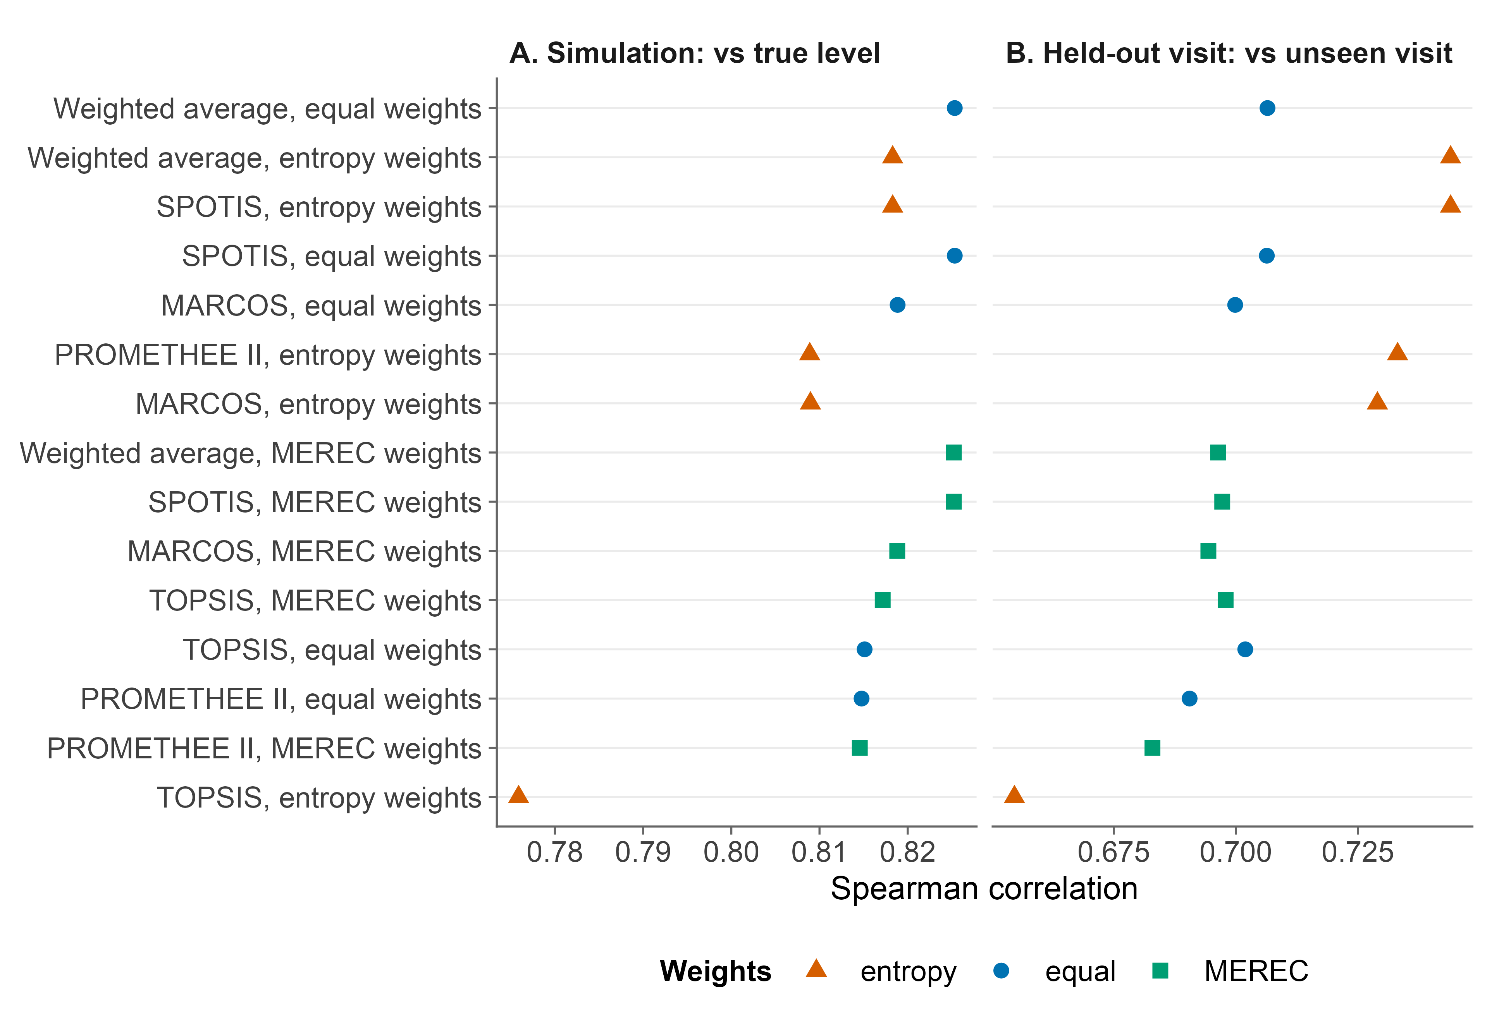
Figure 1. Agreement of the 15 ranking methods with the simulated true ranking (A) and with the ranking at an unseen later visit (B). Methods are ordered by their mean rank across both tests, best at the top. Apart from entropy-weighted TOPSIS, the methods differ by at most 0.02 in simulation.
Age adjustment changes who is selected. Age adjustment mattered far more than the method (Figure 2). Of the 37 players in the top 20% on current scores, only 14 remained there after age adjustment, and the median age of the top 20% fell from 20.5 to 13.6 years. The 23 players who dropped out had a median age of 22.0 years. Conversely, 22 players outside the current top 20% had at least an even chance of being in the age-adjusted top 20%; their median age was 12.7 years and 21 were under 18. The rank correlation between the current and age-adjusted rankings was only 0.54.
Ranks are uncertain where decisions are made. The ranking is clear at the extremes but uncertain near the cut-off (Figure 3). The median width of the 95% rank confidence set was 65 places across all players and 31 places within the top 20%. At the 20% cut-off, 29 players had P̂ ≥ 0.90, 138 had P̂ < 0.10, and 16 (9% of the cohort) were borderline; only 16 players had a formal 95% rank set lying entirely inside the top 20%. Even with the best method, the expected number of wrong selections was at least 2.2 of 37. The pattern was the same at 10% and 30% (Table 1).
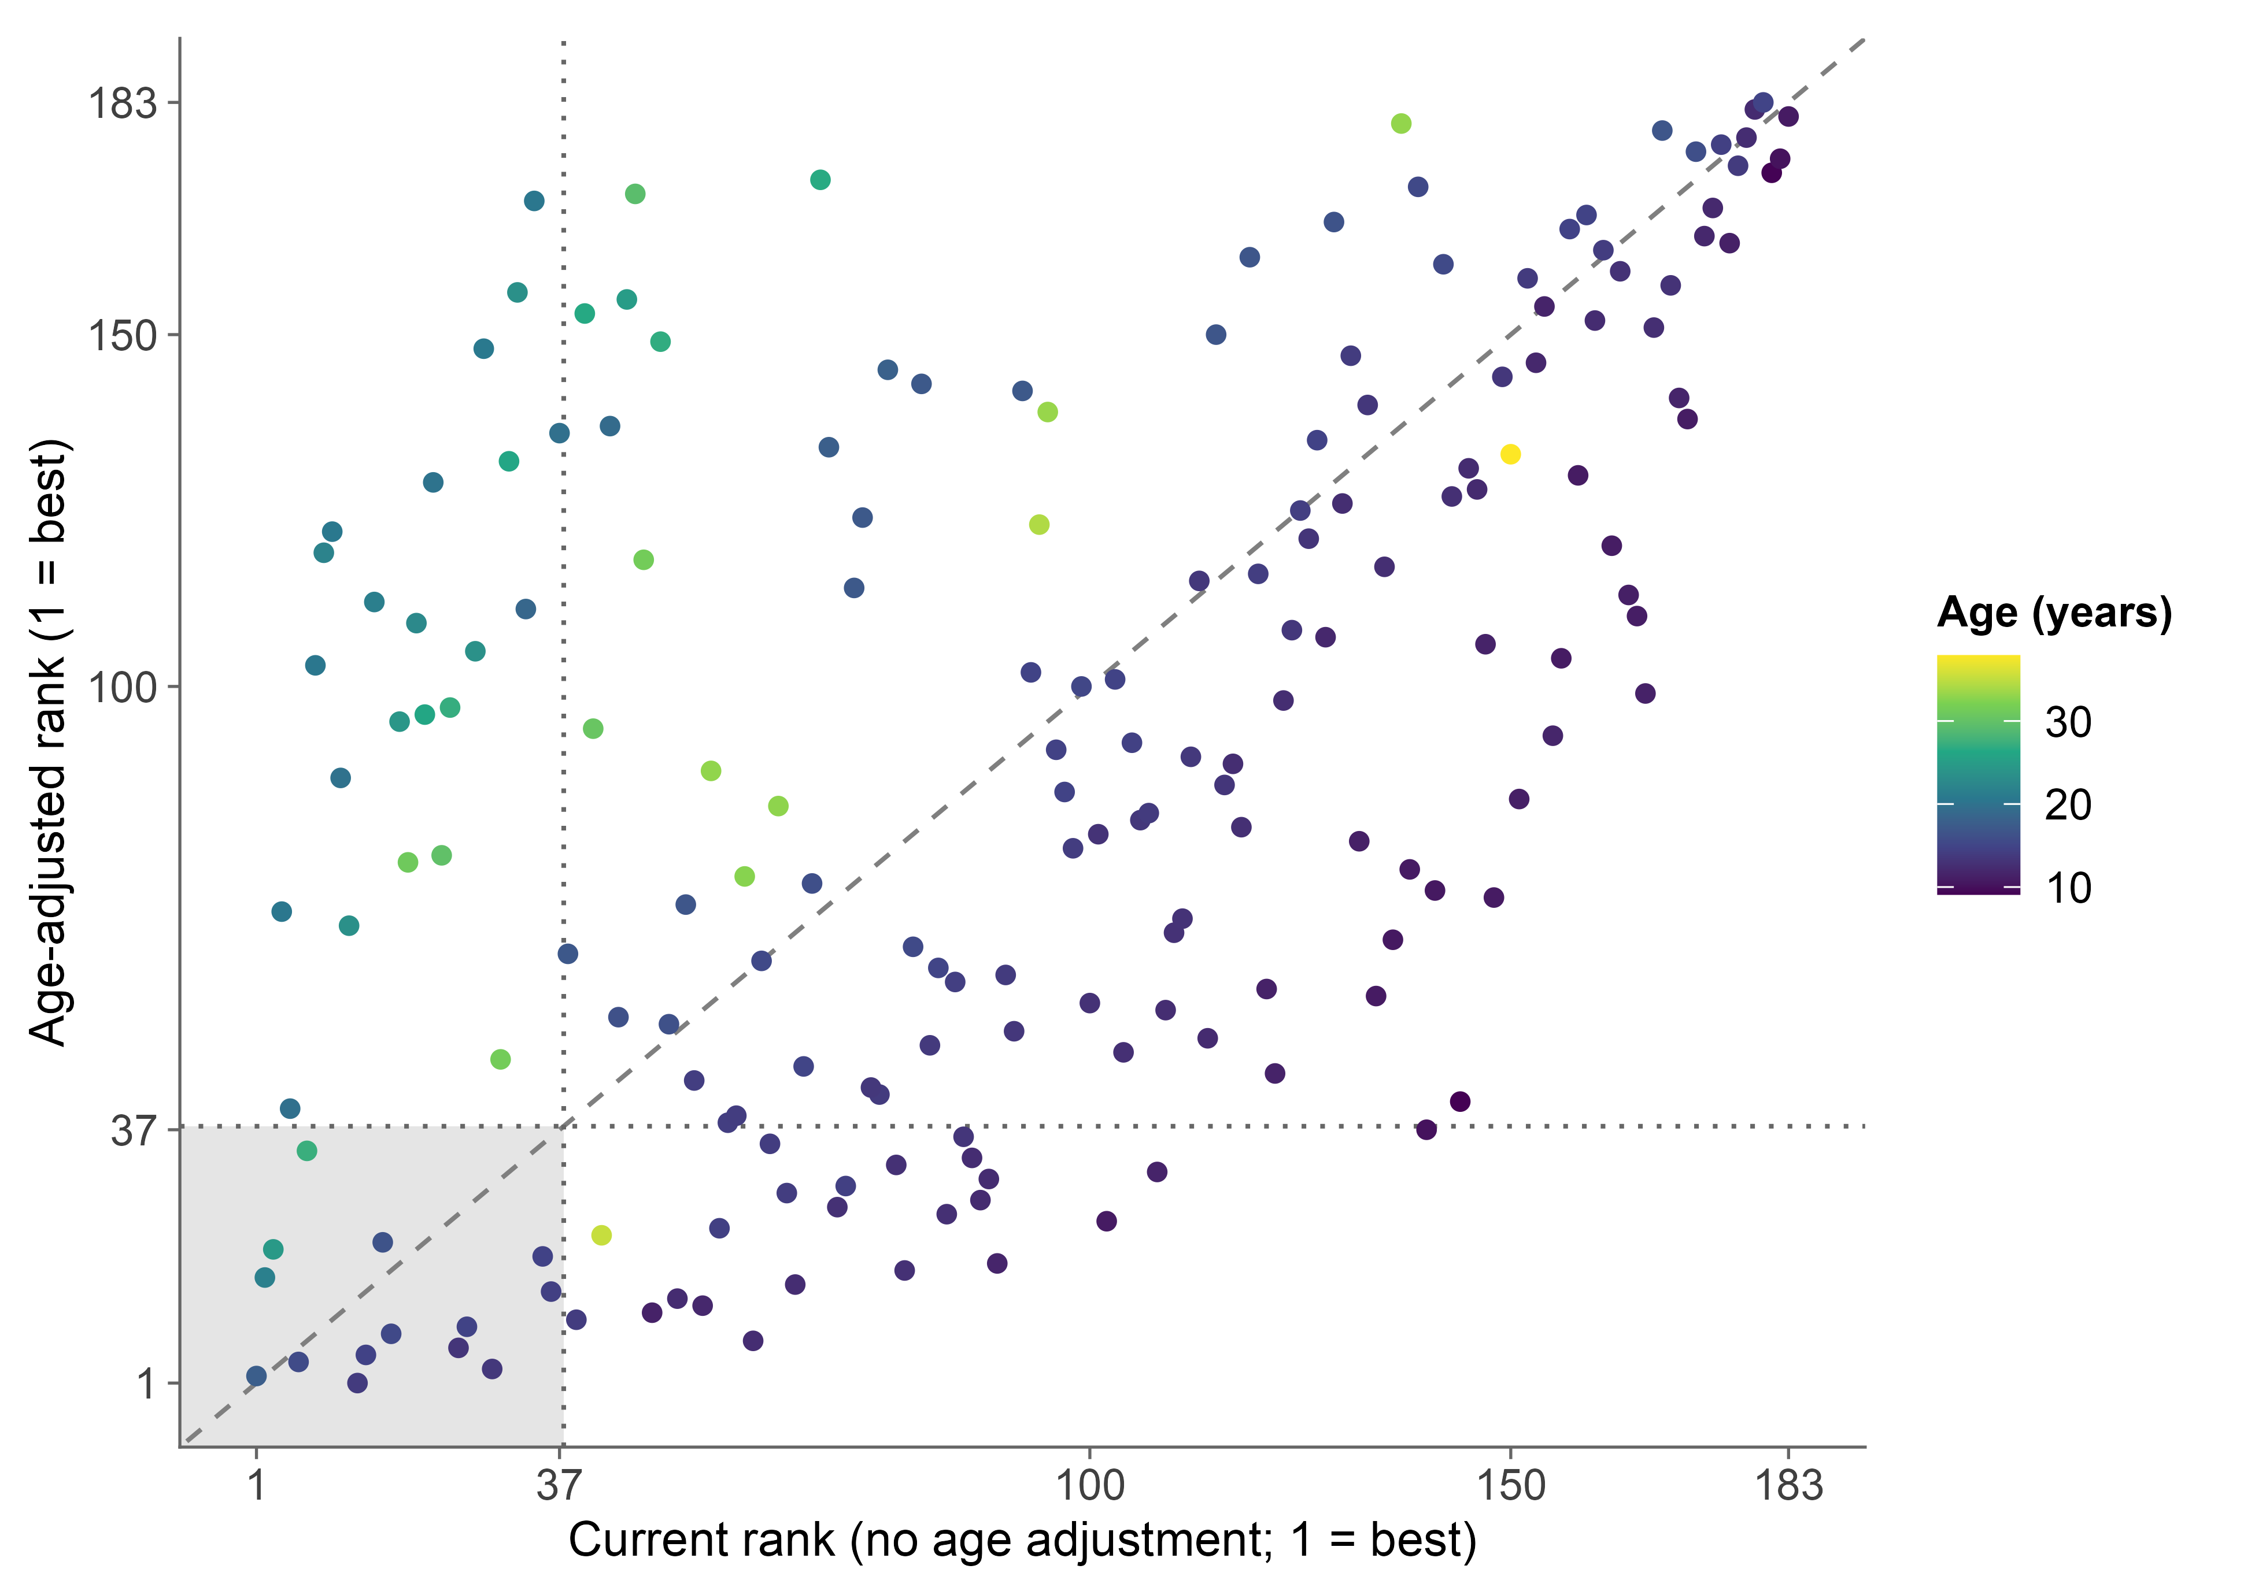
Figure 2. Current rank versus age-adjusted rank for every player, colored by age. The shaded square holds players in the top 20% on both rankings. Older players (top left) lose their places once compared with same-age peers, and younger players (bottom right) gain them.
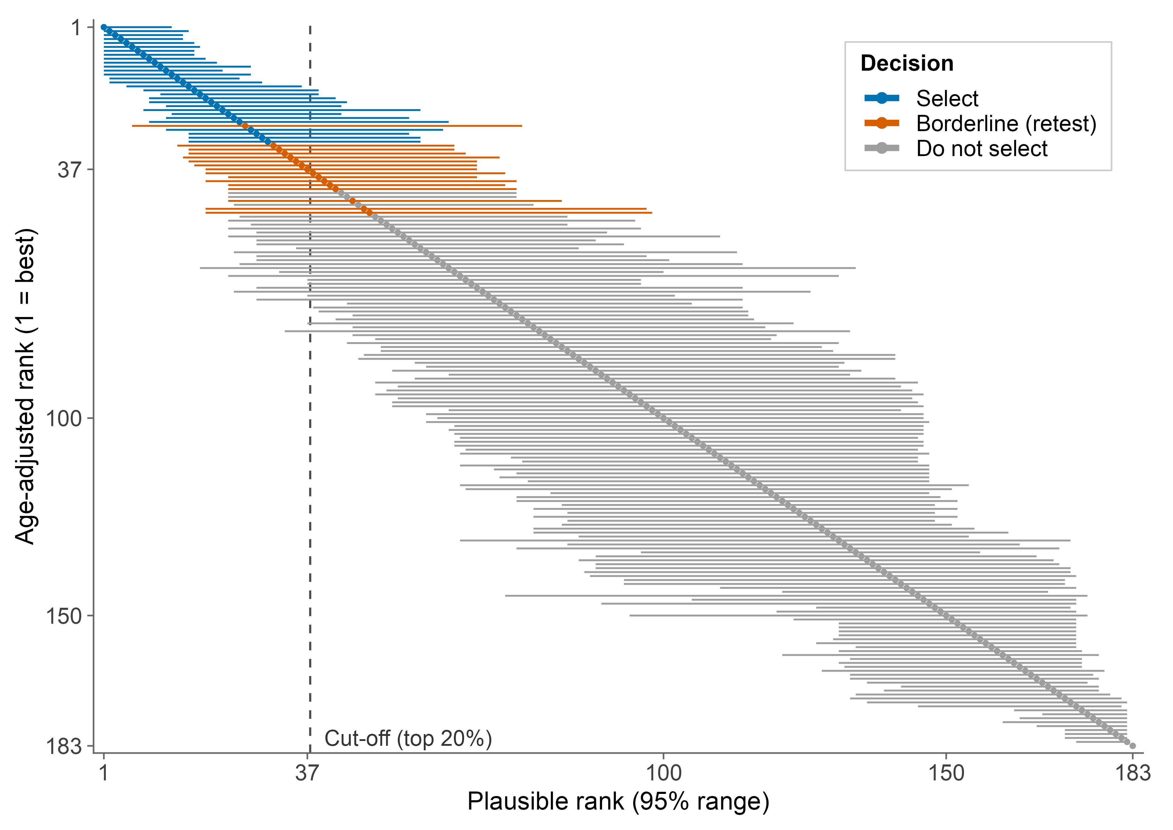
Figure 3. Age-adjusted rank of every player (dot) with its 95% rank confidence set (bar), colored by the decision at the top-20% cut-off (dashed line). Bars that cross the cut-off identify players whose selection is not supported by the data.
Table 1. Selection decisions by cut-off for the age-adjusted ranking. Wrong selections are a lower bound on the expected number of selected players who are not truly in the top k.
Cut-off | Places | Select | Borderline | Do not select | Clearly top (95% set) | Median 95% range width | Expected wrong selections (≥)
Top 10% | 19 | 15 | 9 | 159 | 9 | 65 | 1.4
Top 20% | 37 | 29 | 16 | 138 | 16 | 65 | 2.2
Top 30% | 55 | 45 | 22 | 116 | 24 | 65 | 3.4

Sensitivity. The conclusions were robust to the main analysis choices. Without age adjustment, the 20% cut-off gave 30 select, 14 borderline and at least 2.2 expected wrong selections, so uncertainty near the cut-off is not an artifact of age scoring. Combining visits with the mixed model did not predict the held-out visit better than the latest single visit (age-relative Spearman 0.62 versus 0.64; current 0.79 versus 0.77), but it was slightly better in simulation (0.82 versus 0.80), so its main value is to use every visit without discarding data. Finally, we reran the full pipeline on two computing platforms and two versions of the mixed-model software (four runs, listed in the repository). The top-ranked method alternated among near-tied equal-weight and entropy-weight methods (Figure 1), but the 20% decisions were identical in every run (29 select, 16 borderline, 138 do not select), with 2.19 to 2.22 expected wrong selections.
- Application: Reading a Leaderboard with Uncertainty

Table 2 shows how the method changes a selection meeting. It lists the players around the 20% cut-off with their current rank, their age-adjusted rank, its 95% rank set and the probability of being in the top 37. A raw leaderboard would draw a line under rank 37. Our leaderboard instead gives three groups. Players marked select are in the top 37 in at least 90% of bootstrap replicates and can be offered places now. Players marked do not select are almost never in the top 37 and can be offered a development pathway instead. The borderline group, which reaches from rank 26 to rank 48, should be retested before any decision. Rank alone hides this: the players ranked 38th and 39th have probabilities of 0.31 and 0.39 of truly belonging in the top 37, while the player ranked 26th has only 0.80 and is not yet a safe selection. Retesting concentrates staff time on 16 players rather than the whole pool.
Table 2. Case-study leaderboard around the 20% cut-off (k = 37), age-adjusted ranking. Player codes are anonymous.
Player | Age | Visits | Current rank | Age-adjusted rank | 95% rank set | P(top 37) | Decision
AID040 | 12.9 | 1 | 70 | 26 | 6–75 | 0.80 | Borderline (retest)
AID183 | 12.3 | 2 | 87 | 27 | 12–61 | 0.94 | Select
AID165 | 14.1 | 3 | 64 | 28 | 16–55 | 1.00 | Select
AID008 | 14.4 | 3 | 71 | 29 | 16–57 | 1.00 | Select
AID033 | 12.4 | 2 | 88 | 30 | 16–57 | 0.99 | Select
AID159 | 11.6 | 2 | 108 | 31 | 14–63 | 0.83 | Borderline (retest)
AID064 | 12.9 | 2 | 77 | 32 | 16–63 | 0.88 | Borderline (retest)
AID118 | 12.5 | 2 | 86 | 33 | 16–65 | 0.86 | Borderline (retest)
AID065 | 27.3 | 1 | 7 | 34 | 15–71 | 0.73 | Borderline (retest)
AID019 | 14.1 | 1 | 62 | 35 | 16–67 | 0.71 | Borderline (retest)
AID082 | 13.4 | 2 | 85 | 36 | 17–67 | 0.61 | Borderline (retest)
AID025 | 10.1 | 1 | 140 | 37 | 19–67 | 0.49 | Borderline (retest)
AID178 | 14.2 | 1 | 57 | 38 | 19–72 | 0.31 | Borderline (retest)
AID105 | 14.1 | 1 | 58 | 39 | 23–67 | 0.39 | Borderline (retest)
AID069 | 19.7 | 2 | 5 | 40 | 19–74 | 0.27 | Borderline (retest)
AID085 | 9.1 | 1 | 144 | 41 | 23–72 | 0.16 | Borderline (retest)
AID041 | 13.9 | 1 | 75 | 42 | 23–74 | 0.26 | Borderline (retest)
AID172 | 13.6 | 2 | 74 | 43 | 23–74 | 0.03 | Do not select
AID160 | 14.2 | 1 | 53 | 44 | 23–74 | 0.04 | Do not select
AID135 | 11.5 | 2 | 122 | 45 | 23–82 | 0.13 | Borderline (retest)
AID001 | 15.0 | 1 | 66 | 46 | 24–77 | 0.01 | Do not select
AID023 | 31.4 | 1 | 30 | 47 | 19–97 | 0.19 | Borderline (retest)
AID050 | 12.8 | 2 | 104 | 48 | 19–98 | 0.14 | Borderline (retest)

The table also shows what age adjustment does for scouts. Most of the selected and borderline players have current ranks well outside the top 37, so a raw leaderboard would never have brought them to the meeting; the 10.1-year-old ranked 140th on current scores is 37th once compared with peers. Conversely, the 19.7-year-old ranked 5th on current scores is 40th after age adjustment and borderline. The full leaderboard for all 183 players is in the repository and is regenerated by rerunning the script.
- Discussion

In these data, how the composite is built was the least important choice: once KPIs were chosen for reliability and non-redundancy, the simplest equal-weight average was among the best of 15 rankers. The one poor performer, entropy-weighted TOPSIS, pairs weights that reward dispersion, which in repeated testing partly reflects measurement noise [15], with a distance-based method sensitive to extreme values. Age adjustment mattered far more; without it, the leaderboard mainly selected the oldest players, echoing the relative-age and maturation biases documented in youth soccer [1, 2, 4]. Most importantly, uncertainty is largest exactly where decisions are made. As with institutional league tables [8, 10], players far from the cut-off can be classified with confidence but a sizable middle group cannot, and even a well-designed ranking is expected to make at least 2.2 wrong selections out of 37.
We therefore recommend three practices for talent programs. First, choose KPIs for reliability and non-redundancy and combine them with equal weights. Second, rank players against same-age peers whenever the pool spans several ages. Third, report every rank with its uncertainty and use select, retest and do-not-select groups instead of a single line.
Limitations. The data come from male players at one testing center, and the age models are fitted to this cohort rather than to external norms. Jump tests capture only part of soccer performance, and no measure of later success was available, so the analysis shows how certain a ranking is, not whether it predicts careers. Retesting in this center was unrelated to first-visit scores (AUC 0.49 among 177 players with a year of possible follow-up), so later attendance cannot validate the ranking. Maturity status was not measured, so age-relative scores do not remove maturation differences within an age [3, 28]. The bootstrap ignores day-to-day variation, so the true selection error is larger than our lower bound, and the 0.90 and 0.10 thresholds are conventions that programs may change. Future work should add maturity offset, technical and tactical assessments, female players and several centers, and link rankings to later selection and match performance.
- Conclusion

We have shown how to turn a physical-test leaderboard into a selection rule that respects measurement error and age. In 183 male soccer players, the choice among 15 ranking methods mattered little, age adjustment replaced most of the top 20%, and at a 20% cut-off only 29 players could be selected with confidence, 16 needed retesting and at least 2.2 wrong selections were expected from a single ranking.
Coaches, scouts and sport scientists who rank players on physical tests can use the framework directly: combine reliable KPIs with equal weights, compare players with same-age peers, and retest the borderline group before committing long-term support. The code, the de-identified data and the variable dictionary needed to apply it to another test battery are available at https://github.com/praveenmaths89/athlete-ranking-uncertainty.
References

[1] Cobley, S., Baker, J., Wattie, N., & McKenna, J. (2009). Annual Age-Grouping and Athlete Development: A Meta-Analytical Review of Relative Age Effects in Sport. Sports Medicine, 39(3), 235–256. https://doi.org/10.2165/00007256-200939030-00005
[2] Helsen, W. F., van Winckel, J., & Williams, A. M. (2005). The relative age effect in youth soccer across Europe. Journal of Sports Sciences, 23(6), 629–636. https://doi.org/10.1080/02640410400021310
[3] Malina, R. M., Rogol, A. D., Cumming, S. P., Coelho e Silva, M. J., & Figueiredo, A. J. (2015). Biological maturation of youth athletes: assessment and implications. British Journal of Sports Medicine, 49(13), 852–859. https://doi.org/10.1136/bjsports-2015-094623
[4] Hill, M., Scott, S., Malina, R. M., McGee, D., & Cumming, S. P. (2020). Relative age and maturation selection biases in academy football. Journal of Sports Sciences, 38(11-12), 1359–1367. https://doi.org/10.1080/02640414.2019.1649524
[5] Vaeyens, R., Lenoir, M., Williams, A. M., & Philippaerts, R. M. (2008). Talent Identification and Development Programmes in Sport: Current Models and Future Directions. Sports Medicine, 38(9), 703–714. https://doi.org/10.2165/00007256-200838090-00001
[6] Johnston, K., Wattie, N., Schorer, J., & Baker, J. (2018). Talent Identification in Sport: A Systematic Review. Sports Medicine, 48(1), 97–109. https://doi.org/10.1007/s40279-017-0803-2
[7] Bergkamp, T. L. G., Niessen, A. S. M., den Hartigh, R. J. R., Frencken, W. G. P., & Meijer, R. R. (2019). Methodological Issues in Soccer Talent Identification Research. Sports Medicine, 49(9), 1317–1335. https://doi.org/10.1007/s40279-019-01113-w
[8] Goldstein, H., & Spiegelhalter, D. J. (1996). League Tables and Their Limitations: Statistical Issues in Comparisons of Institutional Performance. Journal of the Royal Statistical Society. Series A (Statistics in Society), 159(3), 385–443. https://doi.org/10.2307/2983325
[9] Hall, P., & Miller, H. (2009). Using the bootstrap to quantify the authority of an empirical ranking. The Annals of Statistics, 37(6B), 3929–3959. https://doi.org/10.1214/09-AOS699
[10] Mogstad, M., Romano, J. P., Shaikh, A. M., & Wilhelm, D. (2024). Inference for Ranks with Applications to Mobility across Neighbourhoods and Academic Achievement across Countries. Review of Economic Studies, 91(1), 476–518. https://doi.org/10.1093/restud/rdad006
[11] Jaric, S. (2002). Muscle Strength Testing: Use of Normalisation for Body Size. Sports Medicine, 32(10), 615–631. https://doi.org/10.2165/00007256-200232100-00002
[12] Weir, J. P. (2005). Quantifying Test-Retest Reliability Using the Intraclass Correlation Coefficient and the SEM. The Journal of Strength and Conditioning Research, 19(1), 231–240. https://doi.org/10.1519/15184.1
[13] Koo, T. K., & Li, M. Y. (2016). A Guideline of Selecting and Reporting Intraclass Correlation Coefficients for Reliability Research. Journal of Chiropractic Medicine, 15(2), 155–163. https://doi.org/10.1016/j.jcm.2016.02.012
[14] Dormann, C. F., Elith, J., Bacher, S., Buchmann, C., Carl, G., Carré, G., Marquéz, J. R. G., Gruber, B., Lafourcade, B., Leitão, P. J., Münkemüller, T., McClean, C., Osborne, P. E., Reineking, B., Schröder, B., Skidmore, A. K., Zurell, D., & Lautenbach, S. (2013). Collinearity: a review of methods to deal with it and a simulation study evaluating their performance. Ecography, 36(1), 27–46. https://doi.org/10.1111/j.1600-0587.2012.07348.x
[15] Hopkins, W. G. (2000). Measures of Reliability in Sports Medicine and Science. Sports Medicine, 30(1), 1–15. https://doi.org/10.2165/00007256-200030010-00001
[16] Cole, T. J., & Green, P. J. (1992). Smoothing reference centile curves: The LMS method and penalized likelihood. Statistics in Medicine, 11(10), 1305–1319. https://doi.org/10.1002/sim.4780111005
[17] Rigby, R. A., & Stasinopoulos, D. M. (2005). Generalized Additive Models for Location, Scale and Shape. Journal of the Royal Statistical Society Series C: Applied Statistics, 54(3), 507–554. https://doi.org/10.1111/j.1467-9876.2005.00510.x
[18] Bates, D., Mächler, M., Bolker, B., & Walker, S. (2015). Fitting Linear Mixed-Effects Models Using
lme4. Journal of Statistical Software, 67(1). https://doi.org/10.18637/jss.v067.i01
[19] Hwang, C. L., & Yoon, K. (1981). Multiple Attribute Decision Making. Springer Berlin Heidelberg. https://doi.org/10.1007/978-3-642-48318-9
[20] Dezert, J., Tchamova, A., Han, D., & Tacnet, J. M. (2020). The SPOTIS Rank Reversal Free Method for Multi-Criteria Decision-Making Support. In 2020 IEEE 23rd International Conference on Information Fusion (FUSION) (pp. 1–8). IEEE. https://doi.org/10.23919/FUSION45008.2020.9190347
[21] Stević, Ž., Pamučar, D., Puška, A., & Chatterjee, P. (2020). Sustainable supplier selection in healthcare industries using a new MCDM method: Measurement of alternatives and ranking according to COmpromise solution (MARCOS). Computers & Industrial Engineering, 140, 106231. https://doi.org/10.1016/j.cie.2019.106231
[22] Brans, J. P., & Vincke, P. (1985). Note—A Preference Ranking Organisation Method. Management Science, 31(6), 647–656. https://doi.org/10.1287/mnsc.31.6.647
[23] Zhu, Y., Tian, D., & Yan, F. (2020). Effectiveness of Entropy Weight Method in Decision-Making. Mathematical Problems in Engineering, 2020, 1–5. https://doi.org/10.1155/2020/3564835
[24] Keshavarz-Ghorabaee, M., Amiri, M., Zavadskas, E. K., Turskis, Z., & Antucheviciene, J. (2021). Determination of Objective Weights Using a New Method Based on the Removal Effects of Criteria (MEREC). Symmetry, 13(4), 525. https://doi.org/10.3390/sym13040525
[25] Morris, T. P., White, I. R., & Crowther, M. J. (2019). Using simulation studies to evaluate statistical methods. Statistics in Medicine, 38(11), 2074–2102. https://doi.org/10.1002/sim.8086
[26] Järvelin, K., & Kekäläinen, J. (2002). Cumulated gain-based evaluation of IR techniques. ACM Transactions on Information Systems, 20(4), 422–446. https://doi.org/10.1145/582415.582418
[27] Efron, B., & Tibshirani, R. (1994). An Introduction to the Bootstrap. Chapman and Hall/CRC. https://doi.org/10.1201/9780429246593
[28] Cumming, S. P., Lloyd, R. S., Oliver, J. L., Eisenmann, J. C., & Malina, R. M. (2017). Bio-banding in Sport: Applications to Competition, Talent Identification, and Strength and Conditioning of Youth Athletes. Strength & Conditioning Journal, 39(2), 34–47. https://doi.org/10.1519/SSC.0000000000000281
Appendix

Table A1. The 11 selected KPIs with their reliability (ICC), the share of variance between players in the age-relative mixed model, and the entropy and MEREC weights.
Test | KPI | Better | ICC | Between-athlete share | Entropy weight | MEREC weight
CMJ | Jump Height (Flight Time) | higher | 0.98 | 0.62 | 0.102 | 0.090
Drop Jump | Jump Height (Imp-Mom) | higher | 0.98 | 0.51 | 0.102 | 0.085
Single-Leg Jump | Peak Power / BM | higher | 0.96 | 0.54 | 0.079 | 0.091
Single-Leg Jump | Concentric RPD / BM | higher | 0.96 | 0.35 | 0.056 | 0.096
CMJ | Concentric Mean Power / BM | higher | 0.96 | 0.61 | 0.094 | 0.091
Drop Jump | RSI (JH (Flight Time)/Contact Time) | higher | 0.95 | 0.66 | 0.101 | 0.092
Single-Leg Jump | Concentric Impulse (Abs) / BM | higher | 0.89 | 0.48 | 0.131 | 0.088
Drop Jump | Concentric Impulse (Abs) / BM | higher | 0.88 | 0.52 | 0.085 | 0.091
CMJ | Concentric Duration | lower | 0.87 | 0.45 | 0.077 | 0.093
CMJ | Flight Time:Contraction Time | higher | 0.85 | 0.36 | 0.047 | 0.095
CMJ | Eccentric Peak Force / BM | higher | 0.77 | 0.34 | 0.126 | 0.087

