Revealing hidden jump strategies beyond conventional force-plate metrics
Short title: Hidden strategies in jump curves

Abstract
Force-plate software summarises each countermovement jump (CMJ) with a few vendor metrics, and athletes with similar values are treated as equivalent. We tested this assumption on 805 routinely collected CMJ trials from 212 male footballers in India. Principal component analysis of body-weight-normalised take-off and landing force–time curves retained four components (74.8% of variance), located almost entirely in the landing phase. Trials matched on jump height or relative peak force varied almost as much as the full sample, and vendor metrics, age and body mass explained only 2.7–13.1% of each component. Routine force-plate data therefore hold unused information for athlete-monitoring decisions.
Keywords: Countermovement jump; Principal component analysis; Force–time curve; Force plates; Athlete monitoring; Landing; Sports analytics; Football

Extended summary
High-performance centres invest in force plates and test athletes routinely, yet decisions about those athletes usually rest on a handful of vendor-computed numbers such as jump height and peak force. Athletes with similar numbers are then treated as if they had jumped in the same way. We ask whether this holds, and how much recorded information those numbers leave unused.
We analysed 805 countermovement jumps from 212 male football players tested during routine monitoring at a high-performance centre in Thane, Mumbai. Each force–time curve was normalised to body weight, take-off and landing phases were each time-normalised and joined, and principal component analysis was used to find the main patterns of variation. We then compared the spread of curve shapes among jumps matched on jump height or on relative peak force with the spread in the whole sample, and measured how much of each pattern four vendor metrics, age and body mass explain.
Four components explained 74.8% of curve variance, and all four lay almost entirely in the landing phase; the first described how quickly the athlete arrested the fall. Jumps matched on jump height were scarcely more alike in shape than jumps in general, and matching on relative peak force had no effect. The conventional metrics, age and body mass explained only 2.7–13.1% of each component (0.3–11.8% out of sample). Between-athlete differences accounted for 10.0–29.6% of component variance, so much of the variation was trial-specific. With a fixed 1-s landing window, a take-off component appeared that the metrics largely explained.
For managers of sports-science programmes, the landing is recorded in every jump at no extra cost; simple landing descriptors could be added to routine reports, and decisions should rest on several trials rather than a single landing. Dimensionality reduction can extract additional, decision-relevant information from data that organisations already collect.

Introduction
The countermovement jump (CMJ) performed on force platforms has become one of the most widely used tests in team sports. It is quick, places little demand on the athlete and is sensitive to training and to neuromuscular fatigue (Claudino et al., 2017; Gathercole et al., 2015). Commercial systems now detect the phases of the jump automatically and return dozens of variables for every trial, among them jump height, peak forces, phase impulses and phase durations (McMahon et al., 2018). In routine practice, however, decisions rest on a handful of these values. Practitioners are advised to choose a small set of metrics that suits the question being asked, whether it concerns performance profiling, fatigue monitoring or return to sport (Bishop et al., 2023). Athletes with similar values on those metrics are then treated, implicitly, as having jumped in a similar way.
That assumption sits uneasily with what is known about movement. The same outcome can be achieved through different coordinative solutions, and variability in how a task is executed is a functional property of the neuromusculoskeletal system rather than mere noise (Bartlett et al., 2007; Davids et al., 2003; Preatoni et al., 2013). For the vertical jump in particular, no single kinetic or temporal variable fully accounts for performance (Dowling & Vamos, 1993). Athletes of different jumping ability differ in how force is distributed across the unweighting, braking and propulsion phases (Sole et al., 2018), force–time characteristics differ by sex and sport (Laffaye et al., 2014), and the way force is produced within individual sub-phases relates to performance (Harry et al., 2018). Performance metrics are increasingly distinguished from strategy variables, such as countermovement depth and phase durations (Harry et al., 2024). Analyses of whole force–, velocity– and power–time curves have described training-induced changes across the curve rather than at single points (Cormie et al., 2009), and alternative, strategy-based CMJ variables can detect fatigue when jump height does not (Gathercole et al., 2015).
Waveform methods offer a way to describe the whole curve without choosing variables in advance. Principal component analysis (PCA) of time-normalised waveforms, and its functional counterpart, decompose a set of curves into a small number of orthogonal modes of variation, each with a score for every trial (Jolliffe, 2002; Jolliffe & Cadima, 2016; Ramsay & Silverman, 2005). In biomechanics these methods have described gait waveforms associated with knee osteoarthritis (Deluzio & Astephen, 2007), knee kinematics in the vertical jump (Ryan et al., 2006), running kinematics in Achilles tendinopathy (Donoghue et al., 2008) and on-water rowing (Warmenhoven et al., 2019), and principled ways of interpreting the components have been proposed (Brandon et al., 2013). For vertical jumps, dimensionality-reduction techniques describe performance-related aspects of the curve better than discrete points do (Richter et al., 2014b), principal component waveform analysis identifies improvements in jump performance (Floría et al., 2019), and alignment of the curves on biomechanical events improves the information that can be extracted from them (Moudy et al., 2018; Richter et al., 2014a).
Two gaps remain. First, the landing that follows every CMJ is usually discarded, even though it is recorded on the same plates in the same trial. Landing kinetics are of independent interest: stiff landings with high vertical forces have been associated with anterior cruciate ligament injury risk in young female athletes (Leppänen et al., 2017), jumping and landing variables have some utility as predictors of injury (Pedley et al., 2020), and CMJ landing characteristics change with the effort that athletes perceive themselves to be making (Hite et al., 2025). Second, although waveform studies show that curves carry information beyond discrete variables, the extent to which the metrics reported in routine monitoring fail to capture curve shape has rarely been quantified directly, and never, to our knowledge, by asking whether jumps matched on those metrics have matched curves. Routinely collected data from youth football, in which large numbers of tests are performed under field conditions, provide an opportunity to answer this question on a realistic scale.
The present study therefore analysed the concatenated take-off and landing force–time curves of male footballers, with three aims: (i) to identify the principal modes of variation of the curve and to interpret them biomechanically; (ii) to test whether trials matched on jump height, or on relative concentric peak force, show less curve-shape variation than the sample as a whole; and (iii) to quantify how much of each mode of variation is explained by four conventional vendor metrics together with age and body mass, using evaluation schemes that respect the repeated trials of each athlete. In addition, the partition of curve-shape variation between athletes, sessions and trials, and the sensitivity of the conclusions to the definition of the landing phase, were examined.

Materials and methods

Study design and overview
This was a retrospective, cross-sectional analysis of routinely collected force-plate data. The analysis followed the pipeline in Figure 1. Quality-control rules, phase definitions, the number of retained components and the matched-band definition were fixed before any result was examined; the analysis does not include any data-driven tuning of these choices.
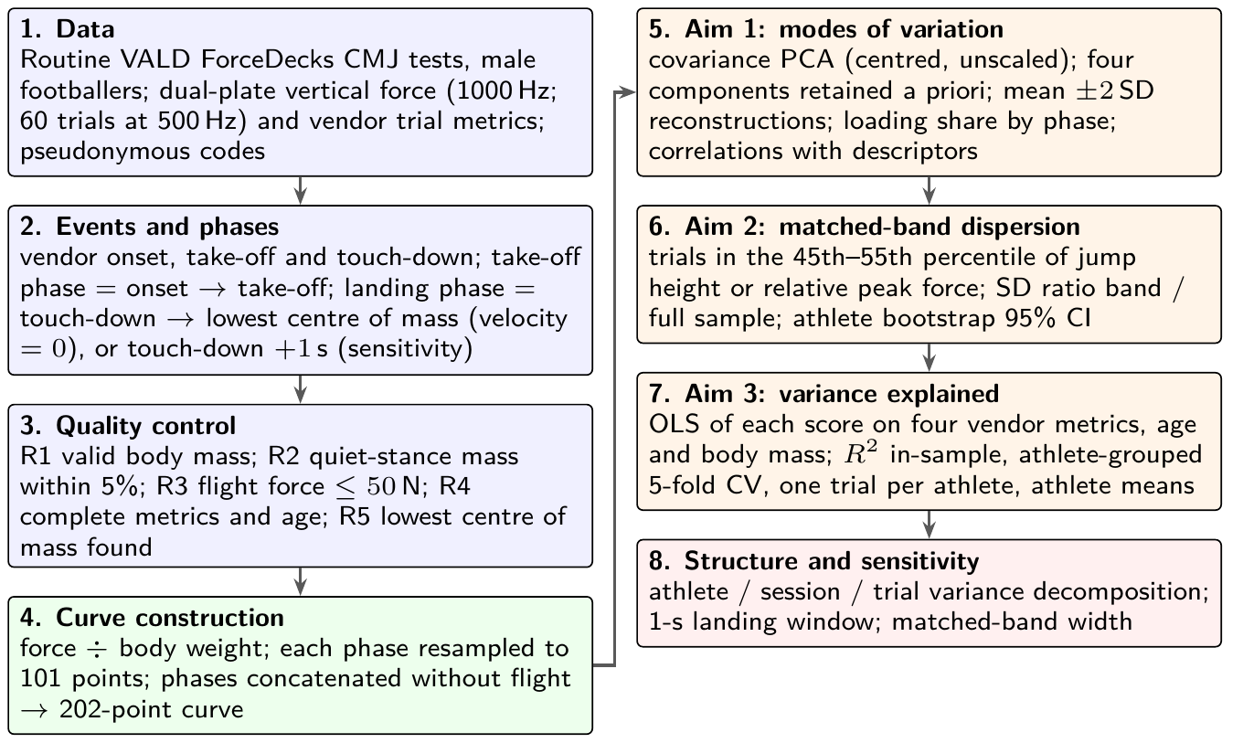
Analysis pipeline. Steps 1–4 build one 202-point, body-weight-normalised force–time curve per trial; steps 5–7 address the three aims; step 8 examines the structure of the repeated measurements and the sensitivity of the conclusions to analytical choices. All decision rules were fixed before the results were examined. CMJ, countermovement jump; PCA, principal component analysis; OLS, ordinary least squares; CV, cross-validation; CI, confidence interval.

Participants and data source
Data were countermovement jumps performed by male football players during routine testing at a high-performance centre in Thane, Mumbai, India [AUTHORS TO COMPLETE: name or describe the centre or programme, the testing period, and the data-sharing agreement]. All CMJ trials of male football players available through the VALD ForceDecks external application programming interface were extracted (833 trials from 215 athletes in 333 sessions). Before analysis, athletes, tests and trials were replaced by pseudonymous codes; the analysis files contain no names, team names, dates of birth, test dates or vendor identifiers, and the key linking codes to athletes is held separately by the first author. Age at test was computed before de-identification and rounded to 0.1 year. Of the 212 analysed athletes, 164 (77%) were under 18 years of age at their first analysed test. [AUTHORS TO COMPLETE: ethics committee, approval number, consent of athletes and parental or guardian consent for those under 18 years, or the waiver of consent for the secondary use of routine monitoring data, and a statement that the study conformed to the Declaration of Helsinki].

Instrumentation and test protocol
Trials were recorded on VALD ForceDecks dual force platforms (VALD Performance, Brisbane, Australia), which record the vertical ground reaction force under each foot. Total vertical force was the sum of the two plates. Most trials were sampled at 1000 Hz; 60 trials were recorded at 500 Hz, which does not affect the analysis because every phase was resampled to a common grid (Section 2.6). Each session contained one or more trials (median 2 per session), and athletes contributed a median of 1 session (maximum 6). [AUTHORS TO COMPLETE: warm-up, instructions given to athletes (including arm position and landing instructions), number of trials requested, rest between trials, and the criteria used by the testers to accept a trial]. The vendor software identified movement onset and returned, for every trial, the four metrics used in this study: jump height (from flight time), concentric peak force, eccentric braking impulse and concentric impulse over the first 100 ms of the concentric phase, together with contraction time, flight time, countermovement depth and peak landing force, which were used only for interpretation.

Event detection and phase definitions
Three events were taken from the vendor output: movement onset $t_{on}$, take-off $t_{to}=t_{on}+T_{c}$, where $T_{c}$ is the contraction time, and touch-down $t_{td}=t_{to}+T_{f}$, where $T_{f}$ is the flight time (Harry et al., 2020; McMahon et al., 2018; Owen et al., 2014). The take-off phase ran from $t_{on}$ to $t_{to}$. In the main analysis the landing phase ran from touch-down to the lowest point of the centre of mass (COM), the instant at which the downward velocity acquired during the fall is first brought to zero, which marks the end of impact absorption. The vertical velocity of the COM was obtained by integrating the impulse–momentum relationship from touch-down (Linthorne, 2001; Street et al., 2001),
$$v(t)=−\frac{g T_{f}}{2}+\int_{t_{td}}^{t}{\frac{F(s)−mg}{m}} ds, t_{lc}=min\{ t>t_{td}:v(t)≥0 \},$$
where F is the total vertical force, m the body mass, g = 9.81 m s⁻² and the initial value is the touch-down velocity implied by a symmetrical flight. The landing phase in the main analysis was $[t_{td},t_{lc}]$. Because no consensus definition of the end of the CMJ landing exists, a sensitivity analysis used a fixed window from touch-down to 1 s after touch-down, which is the end of the vendor’s trial record.

Quality control
Five rules were applied in order (Table 1). Trials were excluded if the vendor body mass was missing or invalid (R1), because every curve is divided by body weight; if the mass estimated from quiet stance before the jump differed from the vendor body mass by more than 5% (R2), which indicates an incorrectly entered mass or an athlete who was not still; if the mean force recorded during flight exceeded 50 N (R3), which indicates contact with the plate during flight or an event-detection error; if any of the four metrics or age was missing (R4); or, in the main analysis only, if the lowest point of the COM could not be identified within the recorded landing (R5).
Quality-control flow (main analysis).
Step | Trials | Sessions | Athletes
All male football CMJ trials | 833 | 333 | 215
R1: valid body mass | 828 | 329 | 212
R2: quiet-stance mass within 5% of body mass | 813 | 328 | 212
R3: no force on plate during flight | 811 | 327 | 212
R4: complete metrics and age | 811 | 327 | 212
R5: end of landing (lowest COM) found | 805 | 327 | 212

Note. Rules R1–R4 were fixed before any result was examined; R5 applies only to the main landing definition (touch-down to the lowest point of the centre of mass), and the 1-s landing window therefore retained 811 trials. Sessions, test occasions on which an athlete performed one or more trials. COM, centre of mass.

Curve construction
Force was expressed in multiples of body weight, $\tilde{F}(t)=F(t)/(mg)$, so that curves of athletes of different mass are directly comparable and a value of one corresponds to quiet standing. Each phase $[t_{a},t_{b}]$ was then resampled by linear interpolation at 101 equally spaced instants,
$${\tilde{F}}_{k}^{(p)}=\tilde{F}​\left(t_{a}+k/{100} (t_{b}−t_{a})\right), k=0,1,…,100,$$
which aligns take-off at the end of the first block and touch-down at the start of the second, a simple form of landmark registration (Moudy et al., 2018; Ramsay & Silverman, 2005; Richter et al., 2014a). Time-normalising the whole trial to a single scale was rejected because the same event would then fall at different percentages in different trials, and timing differences would be confounded with differences in shape. The flight phase was omitted: during flight the force is zero, so this portion of the curve carries no information about force production except its duration, which determines flight-time jump height (Linthorne, 2001); retaining it would allow the analysis to recover a conventional metric from the length of a block. Each trial was therefore represented by the vector $x_{i}∈R^{202}$ formed by the take-off block followed by the landing block.

Principal component analysis
PCA was applied to the $n×202$ matrix of curves (Jolliffe, 2002; Jolliffe & Cadima, 2016). Because all points share the same unit, the analysis used the covariance matrix of the centred curves, without scaling,
$$S=\frac{1}{n−1}\sum_{i=1}^{n}{(}x_{i}−\overset{‾}{x})(x_{i}−\overset{‾}{x})^{⊤}=VΛV^{⊤}, z_{ik}=v_{k}^{⊤}(x_{i}−\overset{‾}{x}),$$
where $v_{k}$ is the kth loading vector (unit length), $λ_{k}$ its eigenvalue and $z_{ik}$ the score of trial i on component k; the proportion of variance explained by component k is λk/j​λj. Four components were retained, as specified before the analysis. The sign of each loading vector was fixed so that its largest absolute element was positive. Components were interpreted in three ways: by reconstructing the curves $\overset{‾}{x}±2\sqrt{λ_{k}} v_{k}$, which show the effect of a two-standard-deviation change in the score (Brandon et al., 2013; Warmenhoven et al., 2019); by the share of each component located in the landing phase, j∈L​vjk2, where $L$ indexes the 101 landing points; and by Pearson correlations of the scores with interpretable descriptors (peak landing force relative to body weight, landing duration $t_{lc}−t_{td}$, contraction time, countermovement depth, the four vendor metrics, age and body mass).

Matched-band dispersion
To test whether equal conventional scores imply equal curves (aim ii), trials between the 45th and 55th percentiles of jump height were selected, and, separately, trials between the same percentiles of concentric peak force relative to body weight. For each component, the dispersion ratio
$$ρ_{k}=\frac{SD(z_{k}∣i∈B)}{SD(z_{k})}$$
compares the standard deviation of the score among trials in band $B$ with that in the full sample. A ratio close to one indicates that fixing the metric does not make curves more alike; a ratio well below one indicates that the metric constrains curve shape. The same comparison was made for the whole curve as $ρ=\{tr(S_{B})/tr(S)\}^{1/2}$, where $S_{B}$ is the covariance matrix within the band. Because athletes contributed several trials, 95% confidence intervals for $ρ_{k}$ were obtained from 2,000 bootstrap resamples of athletes, each resample including all trials of the selected athletes, with band limits held fixed (Efron & Tibshirani, 1993).

Variance explained by conventional metrics
For aim (iii), each component score was regressed by ordinary least squares on the four vendor metrics and on age and body mass,
$$z_{ik}=β_{0k}+\sum_{q=1}^{6}{β_{qk}} w_{iq}+ε_{ik},$$
and the coefficient of determination R²_{k} was taken as the share of the component explained; 1 − R²_{k} is the share left unexplained. Because in-sample R² is optimistic and trials of the same athlete are not independent, three further evaluations were made. In athlete-grouped five-fold cross-validation, athletes rather than trials were allocated to folds (Roberts et al., 2017), and the out-of-sample coefficient was computed as 1−i​(zik−zik(−f))2/i​(zik−zk)2, where ${\hat{z}}_{ik}^{(−f)}$ is the prediction from the model fitted without the fold containing trial i. The regressions were also refitted with one randomly selected trial per athlete and with athlete means of all variables.

Structure of repeated measurements
To establish whether component scores describe stable characteristics of athletes or vary from trial to trial, each score was decomposed with a three-level random-intercept model,
$$z_{ajt}=μ+a_{a}+b_{aj}+e_{ajt}, a_{a}∼N(0,σ_{A}^{2}), b_{aj}∼N(0,σ_{S}^{2}), e_{ajt}∼N(0,σ_{T}^{2}),$$
for trial t of session j of athlete a, fitted by restricted maximum likelihood (Pinheiro & Bates, 2000). The shares $σ_{A}^{2}$, $σ_{S}^{2}$ and $σ_{T}^{2}$ of the total variance were reported; the between-athlete share is an intraclass correlation coefficient for a single trial (Hopkins, 2000; Koo & Li, 2016).

Sensitivity analyses
The complete analysis was repeated with the 1-s landing window. The width of the jump-height band was varied (40th–60th percentile, and median ± 1 cm and ± 2 cm).

Software and reproducibility
All analyses were run by a single R script in R 4.5.3 (R Core Team, 2026) with the packages dplyr, tidyr, ggplot2 (Wickham, 2016), patchwork and nlme (Pinheiro & Bates, 2000); every random step (cross-validation folds, the one-trial selection and the bootstrap) used seed 2026. The script writes every table, figure and number reported in this article. A preliminary version of this analysis was summarised in a conference report; rerunning the script from the de-identified data reproduced all 42 values checked against that report. Statistical reporting followed recommendations for sports medicine and exercise science (Hopkins et al., 2009). [AUTHORS TO COMPLETE: repository URL or DOI once public].

Results

Sample
Of 833 trials, 805 trials from 212 athletes in 327 sessions met all quality-control criteria (Table 1); the 1-s landing window retained 811 trials, because the lowest point of the COM could not be identified in 6 trials. Athletes were 14.1 years of age at their first analysed test (median; interquartile range 12.0–16.8; range 8.8–37.9) and contributed 3.8 trials on average (maximum 16). Mean jump height was 28.2 ± 8.4 cm, and peak landing force ranged from 2.19 to 14.88 times body weight (Table 2).
Characteristics of the analysed sample (805 trials, 212 athletes).
Variable | n | Mean ± SD | Median (IQR) | Range
Age at first test (years) | 212 | 16.01 ± 5.94 | 14.10 (12.00 to 16.80) | 8.80 to 37.90
Body mass at first test (kg) | 212 | 53.31 ± 15.90 | 51.73 (40.86 to 64.03) | 25.03 to 95.97
Jump height, flight time (cm) | 805 | 28.19 ± 8.43 | 26.96 (21.62 to 34.69) | 8.54 to 51.47
Concentric peak force (N) | 805 | 1269.26 ± 420.74 | 1227.01 (923.47 to 1582.99) | 473.52 to 3073.22
Concentric peak force (× BW) | 805 | 2.35 ± 0.38 | 2.29 (2.11 to 2.51) | 1.65 to 4.70
Eccentric braking impulse (N s) | 805 | 27.80 ± 15.43 | 24.60 (16.59 to 35.70) | 0.00 to 95.18
Concentric impulse, first 100 ms (N s) | 805 | 62.24 ± 26.66 | 58.70 (41.76 to 79.14) | 1.51 to 187.93
Peak landing force (× BW) | 805 | 5.39 ± 1.97 | 4.97 (3.88 to 6.67) | 2.19 to 14.88
Contraction time (s) | 805 | 0.78 ± 0.19 | 0.77 (0.66 to 0.90) | 0.31 to 1.48
Countermovement depth (cm) | 805 | −26.55 ± 9.90 | −27.13 (−33.55 to −20.71) | −52.39 to 0.00
Touch-down to lowest COM (s) | 805 | 0.25 ± 0.11 | 0.24 (0.15 to 0.31) | 0.07 to 0.93
Trials per athlete | 212 | 3.80 ± 2.28 | 3.00 (2.00 to 5.00) | 1.00 to 16.00
Trials per session | 327 | 2.46 ± 0.78 | 2.00 (2.00 to 3.00) | 1.00 to 7.00
Sessions per athlete | 212 | 1.54 ± 0.80 | 1.00 (1.00 to 2.00) | 1.00 to 6.00

Note. Age and body mass are per athlete at the first analysed trial; all other rows are per trial unless stated. Jump height, from flight time. Countermovement depth is the vendor estimate of centre-of-mass displacement (negative downwards). Touch-down to lowest COM, duration of the landing phase in the main analysis. BW, body weight; COM, centre of mass; IQR, interquartile range.

Modes of variation of the force–time curve (aim i)
The mean curve showed the expected unweighting, braking and propulsion pattern in the take-off phase and a large, variable force peak in the landing phase (Figure 2A). Point-wise dispersion was much greater during landing than during take-off. The first component explained 37.3% of the variance, and the four retained components together explained 74.8% (Figure 2B); ten components were needed to explain 93.8%.
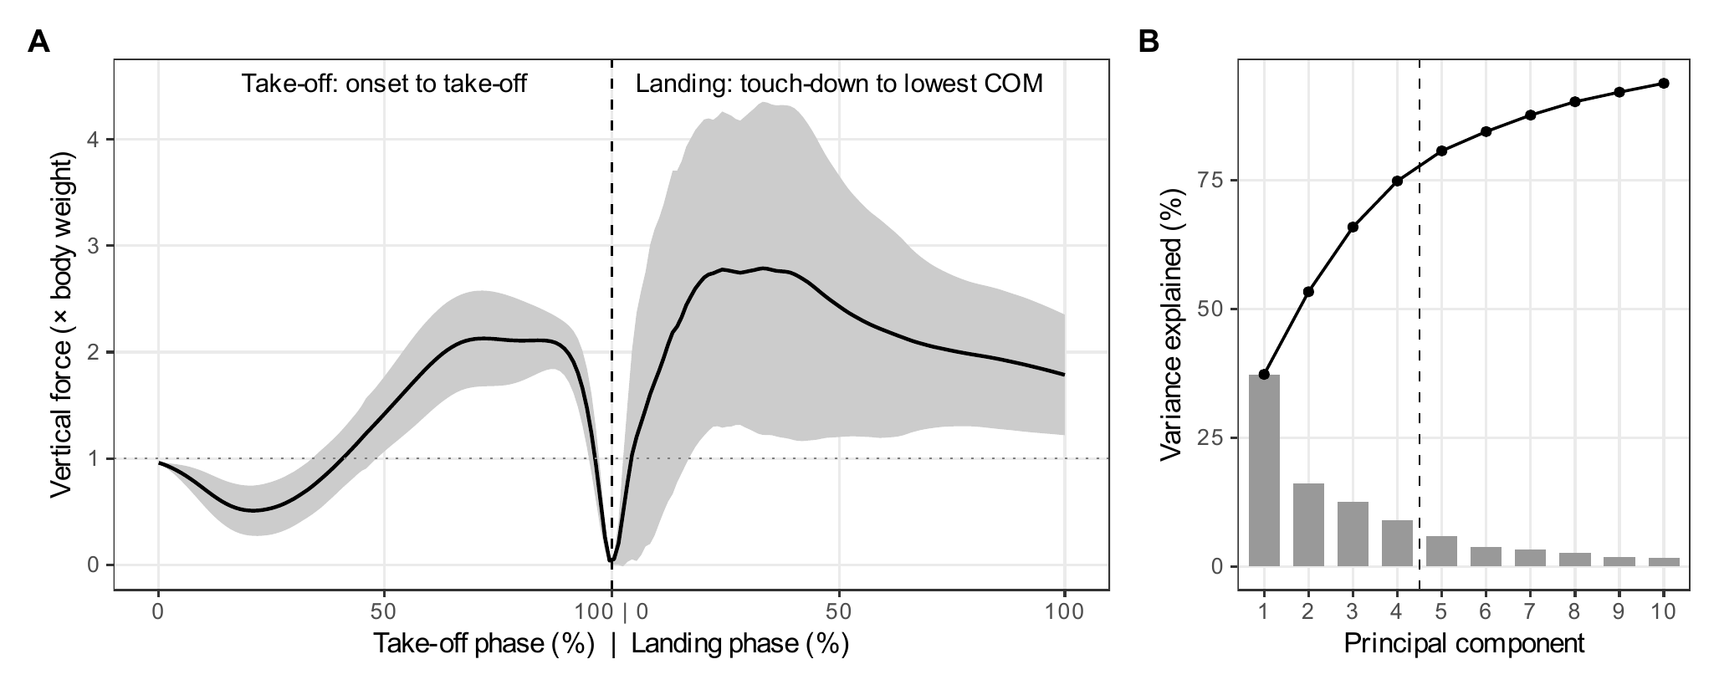
(A) Mean body-weight-normalised vertical force (line) ± 1 SD (shaded) of the 805 analysed countermovement jumps. The take-off phase (movement onset to take-off) and the landing phase (touch-down to the lowest point of the centre of mass, COM) were each time-normalised to 0–100% and concatenated; flight is omitted. The dotted line marks body weight. (B) Variance explained by each of the first ten principal components (bars) and cumulatively (line); the dashed line marks the four retained components.
All four retained components were located almost entirely in the landing phase, which held 99.3–99.9% of their squared loadings (Table 3). PC1 (37.3%) contrasted landings in which force rose to a large peak at about 40% of the landing phase and remained well above body weight until the lowest point of the COM with landings in which force peaked early and then declined (Figure 3). Its strongest correlate was landing duration (r = −0.75): high scores denote short, stiff landings in which the downward momentum is arrested quickly. PC1 was moderately related to peak landing force (r = 0.39) and essentially unrelated to contraction time (r = −0.04) and countermovement depth (r = 0.01). PC2 to PC4 (16.0%, 12.6% and 8.9%) described the timing and number of landing force peaks, contrasting single early peaks, single later peaks and double-peaked landings, with their largest loadings at 26%, 16% and 9% of the landing phase. Peak landing force correlated with every component (r = 0.22–0.45), whereas the correlations with contraction time and countermovement depth did not exceed 0.15 and 0.18 in absolute value, and those with the vendor metrics did not exceed 0.34.
Retained principal components of the concatenated take-off and landing curve (main analysis).
 | Variance | Cumulative | Landing share | Largest | Pearson r with
Component | (%) | (%) | of loading (%) | loading at | LPF | JH | CT | CMD | LD
PC1 | 37.3 | 37.3 | 99.7 | Landing 40% | 0.39 | 0.13 | −0.04 | 0.01 | −0.75
PC2 | 16.0 | 53.3 | 99.9 | Landing 26% | 0.22 | 0.13 | 0.02 | 0.00 | −0.14
PC3 | 12.6 | 65.9 | 99.5 | Landing 16% | 0.39 | 0.34 | 0.00 | −0.14 | −0.32
PC4 | 8.9 | 74.8 | 99.3 | Landing 9% | 0.45 | 0.24 | 0.15 | −0.18 | −0.04

Note. Landing share of loading, percentage of the squared loading vector that falls in the landing block (the remainder falls in the take-off block). Largest loading at, phase and percentage of the phase at which the loading has its largest absolute value. LPF, peak landing force ( × BW); JH, jump height; CT, contraction time; CMD, countermovement depth; LD, landing duration (touch-down to lowest COM). Signs are fixed so that the largest absolute loading is positive.
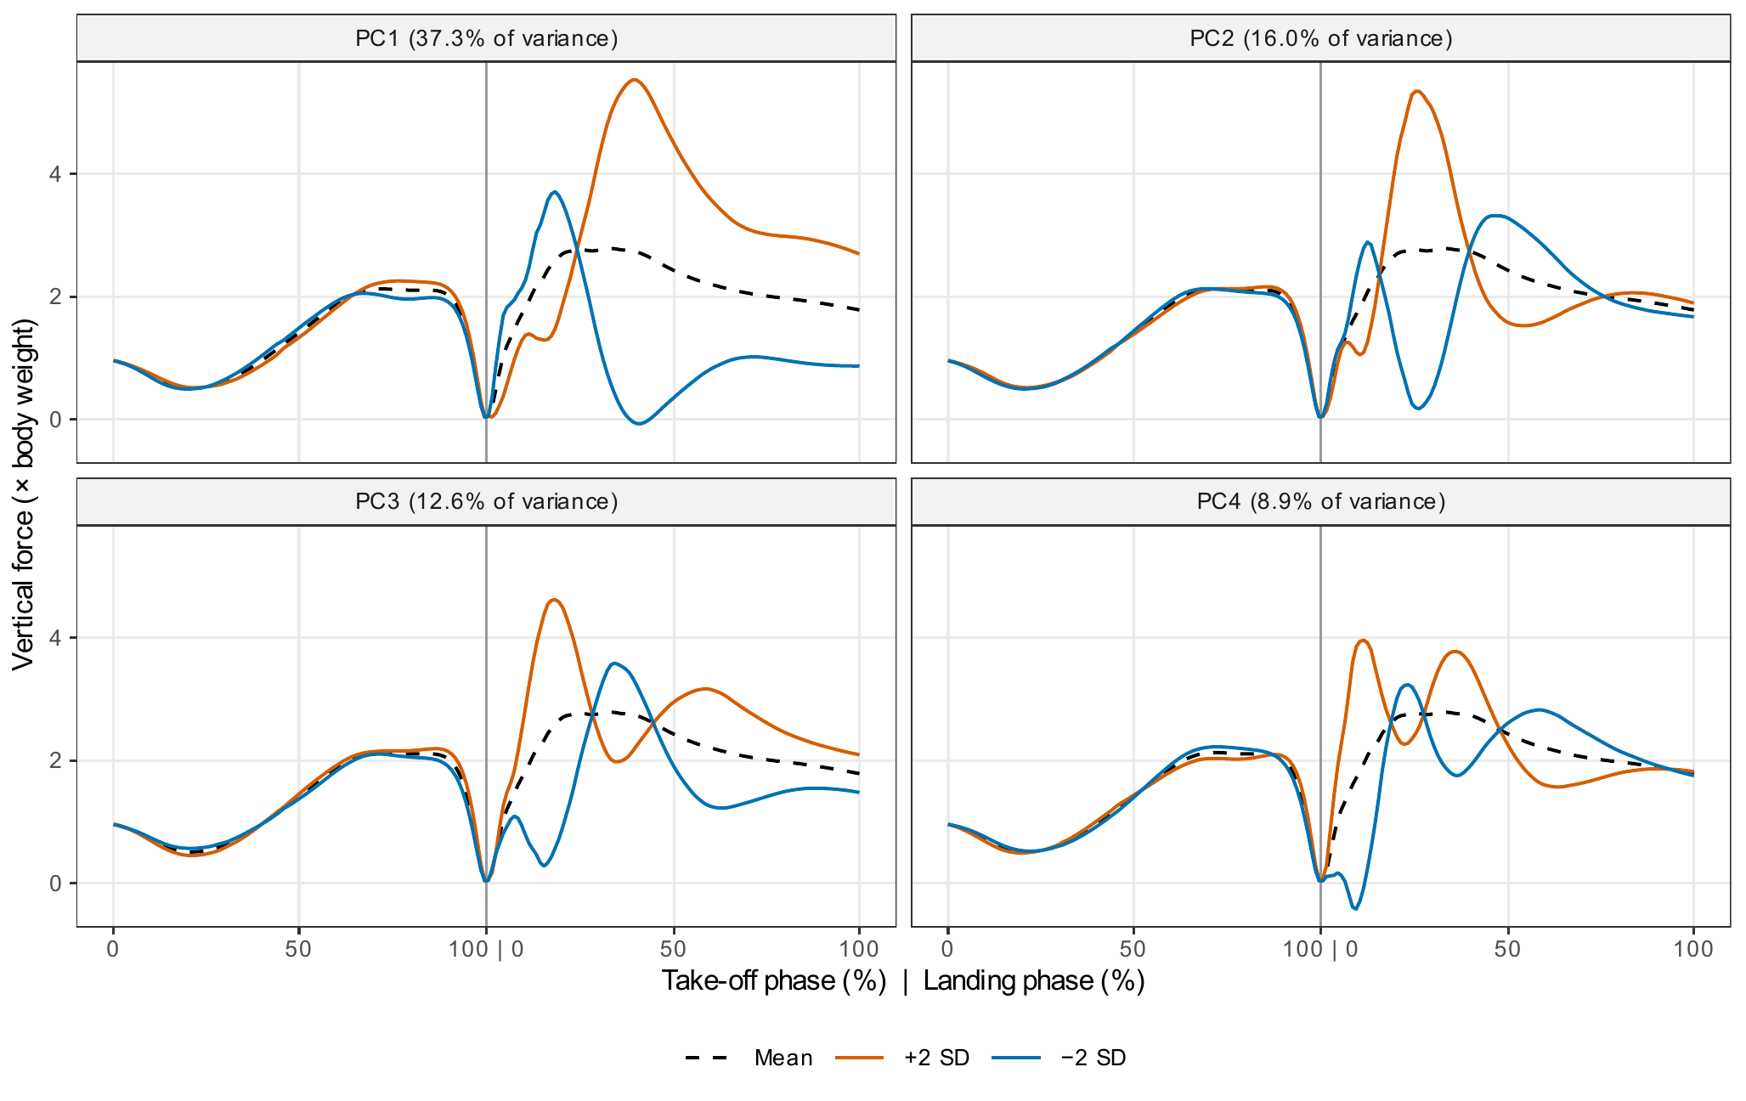
Interpretation of the four retained principal components (main analysis). Each panel shows the mean curve (dashed) and the mean curve plus (vermillion) or minus (blue) two standard deviations of the component score. Values below zero in the reconstructions are an artefact of adding a linear component to the mean and do not correspond to observed trials. The vertical line separates the take-off and landing phases.

Curve shape among trials matched on conventional metrics (aim ii)
The jump-height band contained 82 trials from 51 athletes with a jump height of 27.1 ± 0.65 cm, a standard deviation 13 times smaller than that of the full sample. Within this band, take-off curves were similar but landing curves differed widely (Figure 4A). Matching on jump height reduced the dispersion of PC1 only modestly (ratio 0.89, 95% CI 0.70–1.06), and the ratios for the other components ranged from 0.95–1.17; every confidence interval included one (Table 4, Figure 4B). The dispersion of the whole curve was unchanged (ratio 1.01). Matching on relative concentric peak force had no discernible effect (component ratios 1.00–1.05; whole curve 1.00). The result did not depend on the width of the band: across four band definitions the PC1 ratio ranged from 0.87–0.89, and all ratios from 0.84–1.17.
Dispersion of component scores in the full sample and among trials matched on jump height or on relative concentric peak force (main analysis).
 | SD, full | Jump-height band |  | Relative peak-force band
Component | sample | SD | Ratio (95% CI) | SD | Ratio (95% CI)
PC1 | 7.28 | 6.45 | 0.89 (0.70–1.06) | 7.33 | 1.01 (0.77–1.16)
PC2 | 4.77 | 4.62 | 0.97 (0.77–1.16) | 5.01 | 1.05 (0.82–1.24)
PC3 | 4.22 | 4.03 | 0.95 (0.74–1.13) | 4.25 | 1.00 (0.81–1.17)
PC4 | 3.56 | 4.16 | 1.17 (0.81–1.44) | 3.75 | 1.05 (0.87–1.23)
Whole curveª | 11.92 | 11.99 | 1.01 | 11.95 | 1.00

Note. Matched bands comprise trials between the 45th and 55th percentiles of jump height (26.0–28.2 cm; 82 trials, 51 athletes) or of concentric peak force relative to body weight (2.25–2.32 BW; 81 trials, 58 athletes). Ratio, SD in the band divided by SD in the full sample; 95% CI from 2,000 athlete-level bootstrap resamples. Component SDs depend on the number of grid points and are comparable only within this table; ratios are scale-free. ªSquare root of the summed point-wise variance of the 202-point curve.
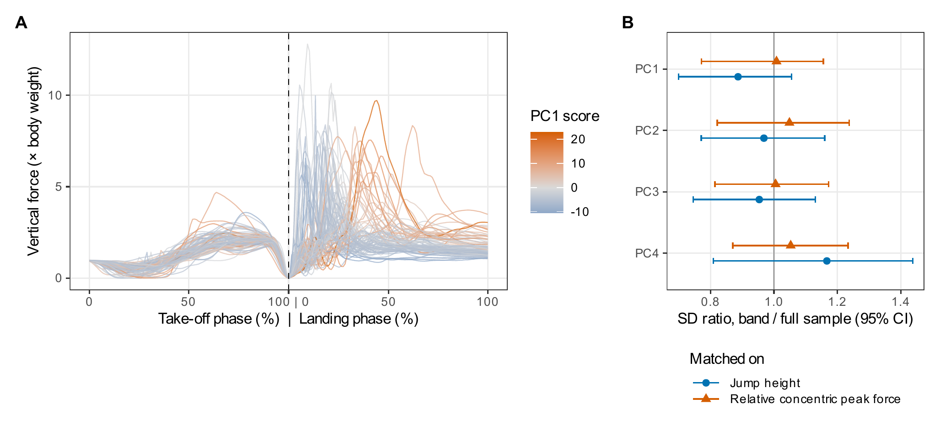
Trials matched on jump height do not share a common force–time curve. (A) Curves of the 82 trials between the 45th and 55th percentiles of jump height (27.1 ± 0.65 cm), coloured by their PC1 score. (B) Ratio of the standard deviation of each component score among trials matched on jump height (circles) or on relative concentric peak force (triangles) to that in the full sample, with athlete-level bootstrap 95% confidence intervals. A ratio of 1 indicates that matching on the metric leaves curve-shape variation unchanged.

Variance explained by conventional metrics (aim iii)
The four vendor metrics, age and body mass explained 2.7–13.1% of the variance of the retained components, leaving 86.9–97.3% unexplained (Table 5, Figure 5). Explained variance was lower under athlete-grouped cross-validation (0.3–11.8%), and similar when one trial per athlete (4.3–17.8%) or athlete means (5.4–21.2%) were analysed, so the low values were not a consequence of treating repeated trials as independent.
Variance of each component score explained by the four vendor metrics, age and body mass, and decomposition of component-score variance (main analysis).
 | R² of component score on metrics, age and body mass (%) |  |  |  |  | Variance of component score (%)
Component | In-sample | Adjusted | Athlete CV | One trial | Athlete | Between | Between | Within
 |  |  |  | per athlete | means | athletes | sessions | session
PC1 | 7.7 | 7.0 | 4.0 | 10.0 | 11.1 | 29.6 | 34.9 | 35.5
PC2 | 2.7 | 2.0 | 0.3 | 4.3 | 5.4 | 21.4 | 17.0 | 61.6
PC3 | 13.1 | 12.4 | 11.8 | 17.8 | 21.2 | 22.9 | 2.3 | 74.8
PC4 | 9.1 | 8.4 | 6.3 | 11.1 | 13.8 | 10.0 | 20.3 | 69.6

Note. Predictors: jump height, concentric peak force, eccentric braking impulse, concentric impulse over the first 100 ms, age and body mass (ordinary least squares). In-sample and adjusted, all 805 trials. Athlete CV, out-of-sample R² from five-fold cross-validation with athletes, not trials, allocated to folds. One trial per athlete, one randomly drawn trial per athlete (212 trials). Athlete means, scores and predictors averaged within athlete. Variance shares from a three-level random-intercept model (athlete, session within athlete, trial within session) fitted by restricted maximum likelihood.
Between-athlete differences accounted for 10.0–29.6% of the variance of the component scores, differences between sessions of the same athlete for 2.3–34.9%, and differences between trials within a session for 35.5–74.8% (Table 5). PC1 was the most athlete-specific component (29.6% between athletes, 34.9% between sessions); for PC2 to PC4, 61.6%, 74.8% and 69.6% of the variance arose between trials of the same session.
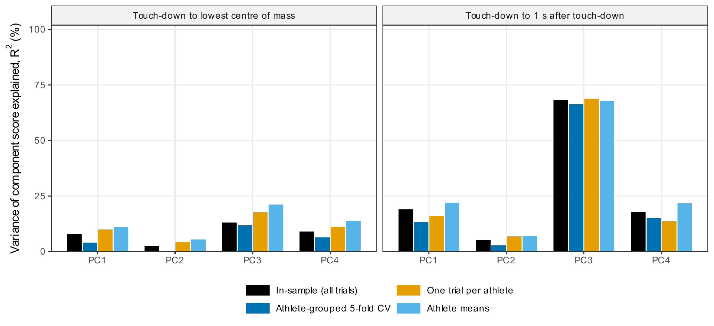
Proportion of the variance of each component score explained by the four vendor metrics, age and body mass, under four evaluation schemes, for the main landing definition (left) and the 1-s landing window (right). CV, cross-validation with athletes allocated to folds.

Sensitivity to the definition of the landing phase
With the landing phase ending 1 s after touch-down, the impact occupied only the first few per cent of the landing block and the remainder approximated quiet standing (Figure 6). The four components then explained 62.2% of the variance, and PC3 became a take-off component (96.3% of its squared loading in the take-off phase) that was strongly related to contraction time (r = −0.79) and relative concentric peak force (r = 0.77). This component was largely explained by the conventional metrics (R² = 68.3%; 66.4% under cross-validation), whereas the three landing components remained poorly explained (R² = 5.3–19.1%; Table 6, Figure 5). PC1 was again a landing component related to peak landing force (r = 0.71) and landing duration (r = −0.57). Matching on jump height reduced PC1 dispersion somewhat more under this definition (ratio 0.82, 95% CI 0.69–0.96), but the dispersion of the whole curve was again unchanged (ratio 1.01).
Main analysis compared with the sensitivity analysis in which the landing phase ended 1 s after touch-down.
Quantity | Main: landing to lowest COM | Sensitivity: 1-s landing
Trials / athletes after QC | 805 / 212 | 811 / 212
Variance explained, PC1–PC4 (%) | 37.3, 16.0, 12.6, 8.9 | 20.2, 16.6, 15.1, 10.2
Cumulative, PC1–PC4 (%) | 74.8 | 62.2
Landing share of loading, PC1–PC4 (%) | 99.7, 99.9, 99.5, 99.3 | 96.4, 92.5, 3.7, 80.2
PC1 SD ratio, jump-height band (95% CI) | 0.89 (0.70–1.06) | 0.82 (0.69–0.96)
Whole-curve SD ratio, jump-height band | 1.01 | 1.01
In-sample R², PC1–PC4 (%) | 7.7, 2.7, 13.1, 9.1 | 19.1, 5.3, 68.3, 17.8
Athlete-CV R², PC1–PC4 (%) | 4.0, 0.3, 11.8, 6.3 | 13.4, 2.8, 66.4, 15.1
Between-athlete variance, PC1–PC4 (%) | 29.6, 21.4, 22.9, 10.0 | 45.3, 18.7, 26.5, 31.6
r(PC1, landing peak force) | 0.39 | 0.71
r(PC3, contraction time) | 0.00 | −0.79

Note. COM, centre of mass; CI, confidence interval; CV, cross-validation. Between-athlete variance from the three-level random-intercept model. In the 1-s window PC3 is a take-off component (Figure 6), which explains its correlation with contraction time.
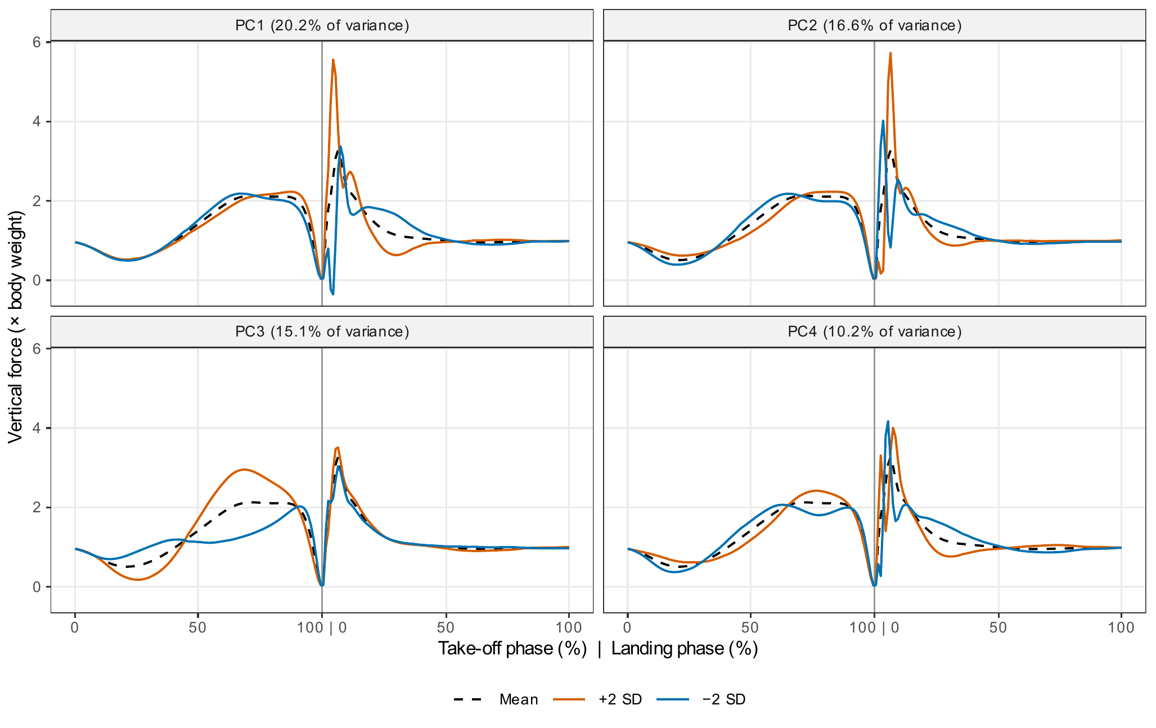
Sensitivity analysis with the landing phase ending 1 s after touch-down: mean curve (dashed) ± two standard deviations of each retained component (vermillion, +2 SD; blue, −2 SD). Under this definition PC3 is located almost entirely in the take-off phase (96.3% of its squared loading) and describes the duration and amplitude of the propulsive force.

Discussion and implications

Principal findings
This study asked whether countermovement jumps that score alike on conventional force-plate metrics also look alike, and how much of the shape of the force–time curve those metrics capture. Three findings stand out. First, when take-off and landing are analysed together, the dominant modes of variation lie in the landing, and the first describes how quickly the athlete arrests the fall. Second, jumps matched closely on jump height, or on relative peak force, were scarcely more alike in curve shape than jumps in general. Third, jump height, concentric peak force, eccentric braking impulse, early concentric impulse, age and body mass together explained no more than 13.1% of the variance of any landing component, and less under cross-validation. Equal scores on these metrics therefore do not imply an equal jump. A further finding qualifies the interpretation of the components as strategies: most of their variance arose within athletes, between sessions and between trials of the same session.

Comparison with previous work
The results extend earlier evidence that discrete force-plate variables summarise the jump incompletely. Dowling & Vamos (1993) found that no single kinetic or temporal variable explained vertical jump performance well, Richter et al. (2014b) showed that dimensionality-reduction techniques captured performance-related features of the jump better than discrete points, and principal component waveform analysis has been used to identify the features of the curve associated with improvements in jump performance (Floría et al., 2019). These studies, like most CMJ waveform analyses (Cormie et al., 2009; Harry et al., 2018; Sole et al., 2018), examined the propulsive part of the jump and asked how curve features relate to performance. The present study reverses the question and asks how much of the curve the performance metrics account for; the matched-band analysis gives a direct and intuitive answer, because it holds jump height almost constant and observes what remains.
The sensitivity analysis clarifies where the unexplained variation lies. With the 1-s landing window a take-off component emerged that described the duration and amplitude of the propulsive force and was explained to about two-thirds by the conventional metrics. This agrees with the close relationships between contraction time, relative peak force, impulse and jump height that follow from impulse–momentum mechanics (Linthorne, 2001; McMahon et al., 2018), and with the distinction now drawn between performance metrics and strategy variables (Harry et al., 2024). The metrics that practitioners usually report are therefore reasonable summaries of the take-off, but they are almost silent about the landing. This is not surprising, because the four vendor metrics describe propulsion, and the result should not be read as a failure of those metrics. Rather, it shows that the landing recorded in every trial contains substantial information that routine reports omit.
The importance of the landing is consistent with the wider literature. Landings that arrest the body quickly with high forces have been linked to injury risk in young female athletes (Leppänen et al., 2017), and landing kinetics have some utility as predictors of injury (Pedley et al., 2020). PC1, which separated short, stiff landings from longer, more compliant ones, corresponds closely to this construct. Its relation to landing duration follows from impulse–momentum: because the landing phase in the main analysis ends when the downward velocity reaches zero, the mean force over the phase is fixed by the touch-down velocity and the duration of the landing, so a shorter landing must be accompanied by higher forces. The weaker correlations with peak landing force indicate that the component describes the time course of force rather than its maximum alone.

Trial-to-trial variability and the interpretation of strategies
Between-athlete differences accounted for at most 29.6% of the variance of any component, which corresponds to poor single-trial reliability by conventional benchmarks (Koo & Li, 2016), and for PC2 to PC4 most of the variance arose between trials of the same session. The landing differences among jumps matched on jump height therefore reflect, to a large extent, how a given athlete landed on a given trial rather than a fixed characteristic of the athlete. This is in keeping with the view that movement variability is an intrinsic and often functional feature of skilled performance (Bartlett et al., 2007; Davids et al., 2003; Preatoni et al., 2013), and with the known sensitivity of CMJ variables to the number of trials and to protocol details (Cormack et al., 2008; Heishman et al., 2020). Landing behaviour is also likely to depend on instructions and perceived effort (Hite et al., 2025), which were not standardised for landing in routine testing. The word strategy should therefore be understood here as the way in which a trial was executed; whether athletes have stable landing strategies can be judged only from repeated, standardised landings.

Methodological implications
Two analytical choices had a large influence on the results and should be reported in any similar study. The first is the definition of the end of the landing. Ending the landing at the lowest point of the COM confines the landing block to impact absorption and makes landing timing comparable across trials; a fixed window spends most of the block on quiet standing and compresses the impact into a few points, which lowered the variance captured by four components from 74.8% to 62.2% and changed the composition of the components. The second is the scaling of the curve. Covariance PCA of body-weight-normalised force gives weight to each part of the curve in proportion to its variance, and because landing forces are larger and more variable than take-off forces, the take-off contributes little to the leading components unless the landing is short or analysed separately. Neither choice is right or wrong, but they answer different questions, and the matched-band and regression results should be interpreted with them in mind. Alignment on further events, such as the landing force peak (Moudy et al., 2018), functional PCA (Ramsay & Silverman, 2005; Warmenhoven et al., 2019) and statistical parametric mapping (Pataky et al., 2013) are natural extensions.

Practical and managerial implications
For practitioners, the results have four implications. First, two athletes with the same jump height may land very differently, so ranking or grouping athletes on jump height alone conceals differences in landing mechanics. Second, the landing is recorded in every CMJ at no additional cost, and simple landing descriptors, in particular landing duration to the lowest point of the COM and peak landing force relative to body weight, capture much of the dominant landing component and could be added to routine reports. Third, because landing shape varies considerably between trials, decisions should be based on the mean of several trials, or on repeated sessions, rather than on a single landing. Fourth, unusual landing curves should prompt closer observation of how an athlete lands, under standardised instructions, rather than a diagnosis; their relationship with injury in footballers has not been established.

Strengths and limitations
The strengths of the study include a large set of routinely collected trials analysed in full, the inclusion of the landing phase, a direct test of the equivalence of matched jumps, evaluation schemes that respect the repeated structure of the data, explicit sensitivity analyses of the main analytical choices, and a single script that reproduces every reported result from the de-identified data.
Several limitations should be noted. The landing was not standardised in routine testing, so part of its variation may reflect instructions, habits or effort rather than neuromuscular capacity. The end of the landing depends on the body mass and on a velocity estimated from flight time, both of which carry error (Street et al., 2001), and could not be found in 6 trials. The sample comprised male footballers from a single centre over a wide age range (8.8–37.9 years), most of them adolescents; maturity status was not recorded, although growth and maturation affect jump performance in youth athletes (Lloyd & Oliver, 2012; Malina et al., 2015), and the results may not generalise to female athletes, other sports or other age groups. The regressions were linear and used four metrics; other vendor variables, including landing variables, would explain more of the landing components, and non-linear models might explain somewhat more, although the weak correlations suggest that the gain would be limited. PCA on linearly time-normalised curves combines differences in timing and in amplitude. Finally, the number of components was fixed in advance rather than chosen from the data, which avoids tuning but means that the remaining components, which together explained about a quarter of the variance, were not interpreted.

Future work
Future studies should test whether landing components are stable when landings are standardised and repeated, relate them to injury, fatigue and return-to-play outcomes in prospective designs, and examine female athletes and other sports. Separate analysis of the take-off and landing, registration on additional events and functional or multivariate methods that combine curve shape with timing would help to separate strategy from execution variability. Establishing reference values for landing components across age and maturity would make the information usable in routine monitoring.

Conclusion
In male footballers, countermovement jumps matched closely on jump height, or on relative peak force, differed almost as much in the shape of their force–time curves as jumps in general. The dominant differences lay in how athletes absorbed the landing, above all in how quickly the fall was arrested, and the four conventional vendor metrics, together with age and body mass, explained little of them. These differences were, however, largely trial-specific. The landing phase of the CMJ, which is recorded in every trial but rarely reported, adds information that conventional take-off metrics do not provide, and it deserves a place in routine force-plate reports, provided that it is interpreted over repeated trials.

Declaration of competing interest
The authors report there are no competing interests to declare. [AUTHORS TO COMPLETE: confirm]

Funding
[AUTHORS TO COMPLETE: funding source and grant number, or state that no funding was obtained]

Data availability statement
The de-identified trial data (curves and vendor metrics keyed by pseudonymous codes), the analysis script and all output tables are available in the project repository [AUTHORS TO COMPLETE: URL or DOI]. The raw ForceDecks exports and the key linking codes to athletes are not shared [AUTHORS TO COMPLETE: state the data owner and the terms under which raw data may be requested].

Declaration of generative AI and AI-assisted technologies in the writing process
[AUTHORS TO COMPLETE: The authors must state whether and how generative AI was used. Suggested wording, to be confirmed: an AI assistant was used to help write and run the analysis code and to draft the manuscript text; the authors reviewed all code, results and text and take full responsibility for the content.]

References
Bartlett, R., Wheat, J., & Robins, M. (2007). Is movement variability important for sports biomechanists? Sports Biomechanics, 6(2), 224–243. https://doi.org/10.1080/14763140701322994
Bishop, C., Jordan, M., Torres-Ronda, L., Loturco, I., Harry, J., Virgile, A., Mundy, P., Turner, A., & Comfort, P. (2023). Selecting metrics that matter: Comparing the use of the countermovement jump for performance profiling, neuromuscular fatigue monitoring, and injury rehabilitation testing. Strength and Conditioning Journal, 45(5), 545–553. https://doi.org/10.1519/SSC.0000000000000772
Brandon, S. C. E., Graham, R. B., Almosnino, S., Sadler, E. M., Stevenson, J. M., & Deluzio, K. J. (2013). Interpreting principal components in biomechanics: Representative extremes and single component reconstruction. Journal of Electromyography and Kinesiology, 23(6), 1304–1310. https://doi.org/10.1016/j.jelekin.2013.09.010
Claudino, J. G., Cronin, J., Mezêncio, B., McMaster, D. T., McGuigan, M., Tricoli, V., Amadio, A. C., & Serrão, J. C. (2017). The countermovement jump to monitor neuromuscular status: A meta-analysis. Journal of Science and Medicine in Sport, 20(4), 397–402. https://doi.org/10.1016/j.jsams.2016.08.011
Cormack, S. J., Newton, R. U., McGuigan, M. R., & Doyle, T. L. A. (2008). Reliability of measures obtained during single and repeated countermovement jumps. International Journal of Sports Physiology and Performance, 3(2), 131–144. https://doi.org/10.1123/ijspp.3.2.131
Cormie, P., McBride, J. M., & McCaulley, G. O. (2009). Power-time, force-time, and velocity-time curve analysis of the countermovement jump: Impact of training. Journal of Strength and Conditioning Research, 23(1), 177–186. https://doi.org/10.1519/JSC.0b013e3181889324
Davids, K., Glazier, P., Araújo, D., & Bartlett, R. (2003). Movement systems as dynamical systems: The functional role of variability and its implications for sports medicine. Sports Medicine, 33(4), 245–260. https://doi.org/10.2165/00007256-200333040-00001
Deluzio, K. J., & Astephen, J. L. (2007). Biomechanical features of gait waveform data associated with knee osteoarthritis: An application of principal component analysis. Gait & Posture, 25(1), 86–93. https://doi.org/10.1016/j.gaitpost.2006.01.007
Donoghue, O. A., Harrison, A. J., Coffey, N., & Hayes, K. (2008). Functional data analysis of running kinematics in chronic Achilles tendon injury. Medicine and Science in Sports and Exercise, 40(7), 1323–1335. https://doi.org/10.1249/MSS.0b013e31816c4807
Dowling, J. J., & Vamos, L. (1993). Identification of kinetic and temporal factors related to vertical jump performance. Journal of Applied Biomechanics, 9(2), 95–110. https://doi.org/10.1123/jab.9.2.95
Efron, B., & Tibshirani, R. J. (1993). An introduction to the bootstrap. Springer. https://doi.org/10.1007/978-1-4899-4541-9
Floría, P., Sánchez-Sixto, A., & Harrison, A. J. (2019). Application of the principal component waveform analysis to identify improvements in vertical jump performance. Journal of Sports Sciences, 37(4), 370–377. https://doi.org/10.1080/02640414.2018.1504602
Gathercole, R., Sporer, B., Stellingwerff, T., & Sleivert, G. (2015). Alternative countermovement-jump analysis to quantify acute neuromuscular fatigue. International Journal of Sports Physiology and Performance, 10(1), 84–92. https://doi.org/10.1123/ijspp.2013-0413
Harry, J. R., Barker, L. A., & Paquette, M. R. (2020). A joint power approach to define countermovement jump phases using force platforms. Medicine and Science in Sports and Exercise, 52(4), 993–1000. https://doi.org/10.1249/MSS.0000000000002197
Harry, J. R., Barker, L. A., Tinsley, G. M., Krzyszkowski, J., Chowning, L. D., McMahon, J. J., & Lake, J. (2024). Relationships among countermovement vertical jump performance metrics, strategy variables, and inter-limb asymmetry in females. Sports Biomechanics, 23(8), 1009–1027. https://doi.org/10.1080/14763141.2021.1908412
Harry, J. R., Paquette, M. R., Schilling, B. K., Barker, L. A., James, C. R., & Dufek, J. S. (2018). Kinetic and electromyographic subphase characteristics with relation to countermovement vertical jump performance. Journal of Applied Biomechanics, 34(4), 291–297. https://doi.org/10.1123/jab.2017-0305
Heishman, A. D., Daub, B. D., Miller, R. M., Freitas, E. D. S., Frantz, B. A., & Bemben, M. G. (2020). Countermovement jump reliability performed with and without an arm swing in NCAA Division 1 intercollegiate basketball players. Journal of Strength and Conditioning Research, 34(2), 546–558. https://doi.org/10.1519/JSC.0000000000002812
Hite, M. D., Simms, A. J., Stewart, M. J., Chowning, L. D., & Harry, J. R. (2025). Differences in countermovement jump landing characteristics and joint works across levels of perceived effort. Journal of Biomechanics, 184, 112645. https://doi.org/10.1016/j.jbiomech.2025.112645
Hopkins, W. G. (2000). Measures of reliability in sports medicine and science. Sports Medicine, 30(1), 1–15. https://doi.org/10.2165/00007256-200030010-00001
Hopkins, W. G., Marshall, S. W., Batterham, A. M., & Hanin, J. (2009). Progressive statistics for studies in sports medicine and exercise science. Medicine and Science in Sports and Exercise, 41(1), 3–12. https://doi.org/10.1249/MSS.0b013e31818cb278
Jolliffe, I. T. (2002). Principal component analysis (2nd ed.). Springer. https://doi.org/10.1007/b98835
Jolliffe, I. T., & Cadima, J. (2016). Principal component analysis: A review and recent developments. Philosophical Transactions of the Royal Society A: Mathematical, Physical and Engineering Sciences, 374(2065), 20150202. https://doi.org/10.1098/rsta.2015.0202
Koo, T. K., & Li, M. Y. (2016). A guideline of selecting and reporting intraclass correlation coefficients for reliability research. Journal of Chiropractic Medicine, 15(2), 155–163. https://doi.org/10.1016/j.jcm.2016.02.012
Laffaye, G., Wagner, P. P., & Tombleson, T. I. L. (2014). Countermovement jump height: Gender and sport-specific differences in the force-time variables. Journal of Strength and Conditioning Research, 28(4), 1096–1105. https://doi.org/10.1519/JSC.0b013e3182a1db03
Leppänen, M., Pasanen, K., Kujala, U. M., Vasankari, T., Kannus, P., Äyrämö, S., Krosshaug, T., Bahr, R., Avela, J., Perttunen, J., & Parkkari, J. (2017). Stiff landings are associated with increased ACL injury risk in young female basketball and floorball players. The American Journal of Sports Medicine, 45(2), 386–393. https://doi.org/10.1177/0363546516665810
Linthorne, N. P. (2001). Analysis of standing vertical jumps using a force platform. American Journal of Physics, 69(11), 1198–1204. https://doi.org/10.1119/1.1397460
Lloyd, R. S., & Oliver, J. L. (2012). The youth physical development model: A new approach to long-term athletic development. Strength and Conditioning Journal, 34(3), 61–72. https://doi.org/10.1519/SSC.0b013e31825760ea
Malina, R. M., Rogol, A. D., Cumming, S. P., Coelho e Silva, M. J., & Figueiredo, A. J. (2015). Biological maturation of youth athletes: Assessment and implications. British Journal of Sports Medicine, 49(13), 852–859. https://doi.org/10.1136/bjsports-2015-094623
McMahon, J. J., Suchomel, T. J., Lake, J. P., & Comfort, P. (2018). Understanding the key phases of the countermovement jump force-time curve. Strength and Conditioning Journal, 40(4), 96–106. https://doi.org/10.1519/SSC.0000000000000375
Moudy, S., Richter, C., & Strike, S. (2018). Landmark registering waveform data improves the ability to predict performance measures. Journal of Biomechanics, 78, 109–117. https://doi.org/10.1016/j.jbiomech.2018.07.027
Owen, N. J., Watkins, J., Kilduff, L. P., Bevan, H. R., & Bennett, M. A. (2014). Development of a criterion method to determine peak mechanical power output in a countermovement jump. Journal of Strength and Conditioning Research, 28(6), 1552–1558. https://doi.org/10.1519/JSC.0000000000000311
Pataky, T. C., Robinson, M. A., & Vanrenterghem, J. (2013). Vector field statistical analysis of kinematic and force trajectories. Journal of Biomechanics, 46(14), 2394–2401. https://doi.org/10.1016/j.jbiomech.2013.07.031
Pedley, J. S., Lloyd, R. S., Read, P. J., Moore, I. S., De Ste Croix, M., Myer, G. D., & Oliver, J. L. (2020). Utility of kinetic and kinematic jumping and landing variables as predictors of injury risk: A systematic review. Journal of Science in Sport and Exercise, 2(4), 287–304. https://doi.org/10.1007/s42978-020-00090-1
Pinheiro, J. C., & Bates, D. M. (2000). Mixed-effects models in S and S-PLUS. Springer. https://doi.org/10.1007/b98882
Preatoni, E., Hamill, J., Harrison, A. J., Hayes, K., Van Emmerik, R. E. A., Wilson, C., & Rodano, R. (2013). Movement variability and skills monitoring in sports. Sports Biomechanics, 12(2), 69–92. https://doi.org/10.1080/14763141.2012.738700
R Core Team. (2026). R: A language and environment for statistical computing (version 4.5.3). R Foundation for Statistical Computing. https://www.R-project.org/
Ramsay, J. O., & Silverman, B. W. (2005). Functional data analysis (2nd ed.). Springer. https://doi.org/10.1007/b98888
Richter, C., O’Connor, N. E., Marshall, B., & Moran, K. (2014a). Analysis of characterizing phases on waveforms: An application to vertical jumps. Journal of Applied Biomechanics, 30(2), 316–321. https://doi.org/10.1123/jab.2012-0218
Richter, C., O’Connor, N. E., Marshall, B., & Moran, K. (2014b). Comparison of discrete-point vs. Dimensionality-reduction techniques for describing performance-related aspects of maximal vertical jumping. Journal of Biomechanics, 47(12), 3012–3017. https://doi.org/10.1016/j.jbiomech.2014.07.001
Roberts, D. R., Bahn, V., Ciuti, S., Boyce, M. S., Elith, J., Guillera-Arroita, G., Hauenstein, S., Lahoz-Monfort, J. J., Schröder, B., Thuiller, W., Warton, D. I., Wintle, B. A., Hartig, F., & Dormann, C. F. (2017). Cross-validation strategies for data with temporal, spatial, hierarchical, or phylogenetic structure. Ecography, 40(8), 913–929. https://doi.org/10.1111/ecog.02881
Ryan, W., Harrison, A., & Hayes, K. (2006). Functional data analysis of knee joint kinematics in the vertical jump. Sports Biomechanics, 5(1), 121–138. https://doi.org/10.1080/14763141.2006.9628228
Sole, C. J., Mizuguchi, S., Sato, K., Moir, G. L., & Stone, M. H. (2018). Phase characteristics of the countermovement jump force-time curve: A comparison of athletes by jumping ability. Journal of Strength and Conditioning Research, 32(4), 1155–1165. https://doi.org/10.1519/JSC.0000000000001945
Street, G., McMillan, S., Board, W., Rasmussen, M., & Heneghan, J. M. (2001). Sources of error in determining countermovement jump height with the impulse method. Journal of Applied Biomechanics, 17(1), 43–54. https://doi.org/10.1123/jab.17.1.43
Warmenhoven, J., Cobley, S., Draper, C., Harrison, A., Bargary, N., & Smith, R. (2019). Considerations for the use of functional principal components analysis in sports biomechanics: Examples from on-water rowing. Sports Biomechanics, 18(3), 317–341. https://doi.org/10.1080/14763141.2017.1392594
Wickham, H. (2016). ggplot2: Elegant graphics for data analysis (2nd ed.). Springer. https://doi.org/10.1007/978-3-319-24277-4

