Exhibits (tables and figures) for: Revealing hidden jump strategies beyond conventional force-plate metrics

Tables
Table 1. Quality-control flow
Step | Trials | Removed | Sessions | Athletes
Exported CMJ trials | 833 |  | 333 | 215
R1 Body mass recorded | 828 | 5 | 329 | 212
R2 Quiet-stance mass within 5% of recorded mass | 813 | 15 | 328 | 212
R3 No plate force during flight | 811 | 2 | 327 | 212
R4 Vendor metrics and age complete | 811 | 0 | 327 | 212
R5 Lowest COM point reached$​^{a}$ | 805 | 6 | 327 | 212
Note. Rules were applied in order; each row gives the sample remaining after that rule. Removed = trials excluded by the rule. R1–R4 apply to both landing definitions. $​^{a}$Main analysis only; the 1-s landing window does not need R5 and kept 811 trials. A session is one test visit. CMJ = countermovement jump; COM = centre of mass.
Table 2. Sample characteristics
 |  |  |  | Quartiles |  | Range
Variable | Mean | SD | Median | Q1 | Q3 | Min | Max
Athletes (n = 212)
Age at first test (years) | 16.0 | 5.9 | 14.1 | 12.0 | 16.8 | 8.8 | 37.9
Body mass at first test (kg) | 53.3 | 15.9 | 51.7 | 40.9 | 64.0 | 25.0 | 96.0
Trials per athlete | 3.8 | 2.3 | 3 | 2 | 5 | 1 | 16
Sessions per athlete | 1.5 | 0.8 | 1 | 1 | 2 | 1 | 6
Sessions (n = 327)
Trials per session | 2.5 | 0.8 | 2 | 2 | 3 | 1 | 7
Trials (n = 805)
Jump height (cm) | 28.2 | 8.4 | 27.0 | 21.6 | 34.7 | 8.5 | 51.5
Concentric peak force (N) | 1269 | 421 | 1227 | 923 | 1583 | 474 | 3073
Concentric peak force (BW) | 2.35 | 0.38 | 2.29 | 2.11 | 2.51 | 1.65 | 4.70
Eccentric braking impulse (N s) | 27.8 | 15.4 | 24.6 | 16.6 | 35.7 | 0.0 | 95.2
Concentric impulse, 100 ms (N s) | 62.2 | 26.7 | 58.7 | 41.8 | 79.1 | 1.5 | 187.9
Peak landing force (BW) | 5.39 | 1.97 | 4.97 | 3.88 | 6.67 | 2.19 | 14.88
Contraction time (s) | 0.78 | 0.19 | 0.77 | 0.66 | 0.90 | 0.31 | 1.48
Countermovement depth (cm)$​^{a}$ | -26.6 | 9.9 | -27.1 | -33.5 | -20.7 | -52.4 | 0.0
Landing duration (s)$​^{b}$ | 0.25 | 0.11 | 0.24 | 0.15 | 0.31 | 0.07 | 0.93
Note. Age and body mass are per athlete at the first analysed trial. Jump height is computed from flight time; concentric impulse is taken over the first 100 ms of the concentric phase. BW = multiples of body weight. $​^{a}$Vendor estimate of centre-of-mass displacement, negative downwards; one trial with zero depth and zero braking impulse passed all rules and was kept. $​^{b}$Touch-down to the lowest point of the centre of mass (main landing definition).
Table 3. Retained principal components (main analysis)
 | Variance | Cumulative | Landing | Peak | Pearson r with
Component | (%) | (%) | share (%) | at (%) | LPF | JH | CT | CMD | LD
PC1 | 37.3 | 37.3 | 99.7 | 40 | 0.39 | 0.13 | -0.04 | 0.01 | -0.75
PC2 | 16.0 | 53.3 | 99.9 | 26 | 0.22 | 0.13 | 0.02 | 0.00 | -0.14
PC3 | 12.6 | 65.9 | 99.5 | 16 | 0.39 | 0.34 | 0.00 | -0.14 | -0.32
PC4 | 8.9 | 74.8 | 99.3 | 9 | 0.45 | 0.24 | 0.15 | -0.18 | -0.04
Note. Landing share = percentage of the squared loading vector that lies in the landing block (the rest is in take-off). Peak at = position of the largest absolute loading, in % of the landing phase. Signs are set so that the largest absolute loading is positive. LPF = peak landing force relative to body weight; JH = jump height; CT = contraction time; CMD = countermovement depth; LD = landing duration (touch-down to lowest COM).
Table 4. Score dispersion among trials matched on jump height or relative peak force
 | Full sample | Jump-height band |  |  | Relative peak-force band
Component | SD | SD | Ratio | 95% CI | SD | Ratio | 95% CI
PC1 | 7.28 | 6.45 | 0.89 | [0.70, 1.06] | 7.33 | 1.01 | [0.77, 1.16]
PC2 | 4.77 | 4.62 | 0.97 | [0.77, 1.16] | 5.01 | 1.05 | [0.82, 1.24]
PC3 | 4.22 | 4.03 | 0.95 | [0.74, 1.13] | 4.25 | 1.00 | [0.81, 1.17]
PC4 | 3.56 | 4.16 | 1.17 | [0.81, 1.44] | 3.75 | 1.05 | [0.87, 1.23]
Whole curve$​^{a}$ | 11.92 | 11.99 | 1.01 |  | 11.95 | 1.00
Note. Bands contain the trials between the 45th and 55th percentiles of jump height (26.0–28.2 cm; 82 trials, 51 athletes) or of concentric peak force relative to body weight (2.25–2.32 BW; 81 trials, 58 athletes). Ratio = SD in the band divided by SD in the full sample; a ratio of 1 means that matching left the spread unchanged. CIs are percentile intervals from 2,000 athlete-level bootstrap resamples, conditional on the estimated components. Component SDs are in score units and are comparable only within this table. $​^{a}$Square root of the summed point-wise variance of the 202-point curve.
Table 5. Variance of each component explained by vendor metrics, age and body mass (R², %)
 | All 805 trials |  |  | Reduced data
Component | In-sample | Adjusted | Athlete CV | One trial | Athlete
 |  |  |  | per athlete | means
PC1 | 7.7 | 7.0 | 4.0 | 10.0 | 11.1
PC2 | 2.7 | 2.0 | 0.3 | 4.3 | 5.4
PC3 | 13.1 | 12.4 | 11.8 | 17.8 | 21.2
PC4 | 9.1 | 8.4 | 6.3 | 11.1 | 13.8
Note. Ordinary least squares with six predictors: jump height, concentric peak force, eccentric braking impulse, concentric impulse over the first 100 ms, age and body mass. Athlete CV = out-of-sample R² from five-fold cross-validation with athletes allocated to folds. One trial per athlete uses one randomly drawn trial per athlete (212 trials); athlete means average scores and predictors within athlete.
Table 6. Variance of component scores between athletes, sessions and trials (%)
 | Between athletes |  | Between sessions |  | Within session |  | Between athletes,
Component | Share | 95% CI | Share | 95% CI | Share | 95% CI | age-adjusted
PC1 | 29.6 | [13.0, 47.4] | 34.9 | [15.8, 53.3] | 35.5 | [26.4, 46.2] | 28.2
PC2 | 21.4 | [4.1, 36.6] | 17.0 | [2.5, 36.4] | 61.6 | [50.4, 72.9] | 20.6
PC3 | 22.9 | [11.6, 31.4] | 2.3 | [0.0, 14.2] | 74.8 | [63.3, 84.7] | 15.9
PC4 | 10.0 | [0.0, 23.0] | 20.3 | [9.4, 31.9] | 69.6 | [59.1, 79.5] | 7.1
Note. Shares of total score variance from a three-level random-intercept model (athlete, session within athlete, trial within session) fitted by restricted maximum likelihood. The between-athlete share equals the single-trial intraclass correlation. CIs are percentile intervals from 2,000 athlete-level bootstrap resamples. Only 83 of the 212 athletes had more than one session, so the between-session share is imprecise. Age-adjusted = the same model with age at test as a fixed effect.
Table 7. Main analysis compared with the 1-s landing window
 | Main analysis$​^{a}$ |  |  |  | 1-s landing window
 | PC1 | PC2 | PC3 | PC4 | PC1 | PC2 | PC3 | PC4
Panel A. By component
Variance explained (%) | 37.3 | 16.0 | 12.6 | 8.9 | 20.2 | 16.6 | 15.1 | 10.2
Landing share of loading (%) | 99.7 | 99.9 | 99.5 | 99.3 | 96.4 | 92.5 | 3.7 | 80.2
In-sample R² (%) | 7.7 | 2.7 | 13.1 | 9.1 | 19.1 | 5.3 | 68.3 | 17.8
Athlete-CV R² (%) | 4.0 | 0.3 | 11.8 | 6.3 | 13.4 | 2.8 | 66.4 | 15.1
Between-athlete variance (%) | 29.6 | 21.4 | 22.9 | 10.0 | 45.3 | 18.7 | 26.5 | 31.6
Panel B. Summary measures
Trials / athletes after quality control | 805 / 212 |  |  |  | 811 / 212
Cumulative variance, PC1–PC4 (%) | 74.8 |  |  |  | 62.2
PC1 SD ratio, jump-height band [95% CI] | 0.89 [0.70, 1.06] |  |  |  | 0.82 [0.69, 0.96]
PC3 SD ratio, relative-peak-force band [95% CI] | 1.00 [0.81, 1.17] |  |  |  | 0.74 [0.57, 0.87]
Whole-curve SD ratio, jump-height band | 1.01 |  |  |  | 1.01
r(PC1, peak landing force) | 0.39 |  |  |  | 0.71
r(PC3, contraction time) | 0.00 |  |  |  | −0.79
Note. $​^{a}$Landing from touch-down to the lowest COM point. Between-athlete variance is from the three-level random-intercept model (Table 6). Under the 1-s window PC3 is a take-off component (Fig. 5), which explains its correlation with contraction time and its narrower spread among trials matched on relative peak force. CI = confidence interval; COM = centre of mass; CV = cross-validation; QC = quality control.

Figures
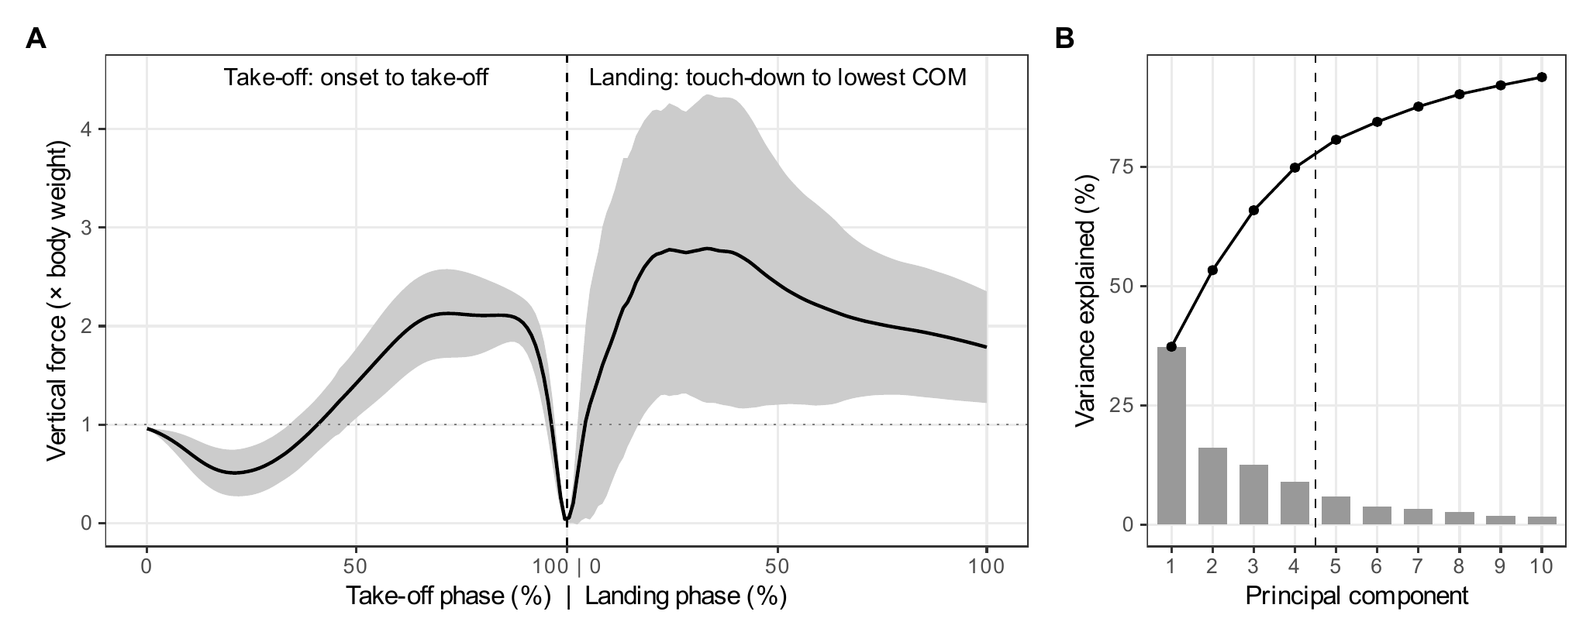
Fig. 1. Mean curve and explained variance (main analysis). (A) Force in multiples of body weight, averaged over the 805 analysed jumps (line), with a band of ± 1 SD (shaded). Take-off runs from movement onset to take-off and landing from touch-down to the lowest centre-of-mass (COM) position; each phase is rescaled to 0–100% and the two are joined, without the flight phase. The dotted line is body weight. (B) Share of variance for each of the first ten principal components (bars) and the running total (line). The dashed line marks the four components retained.
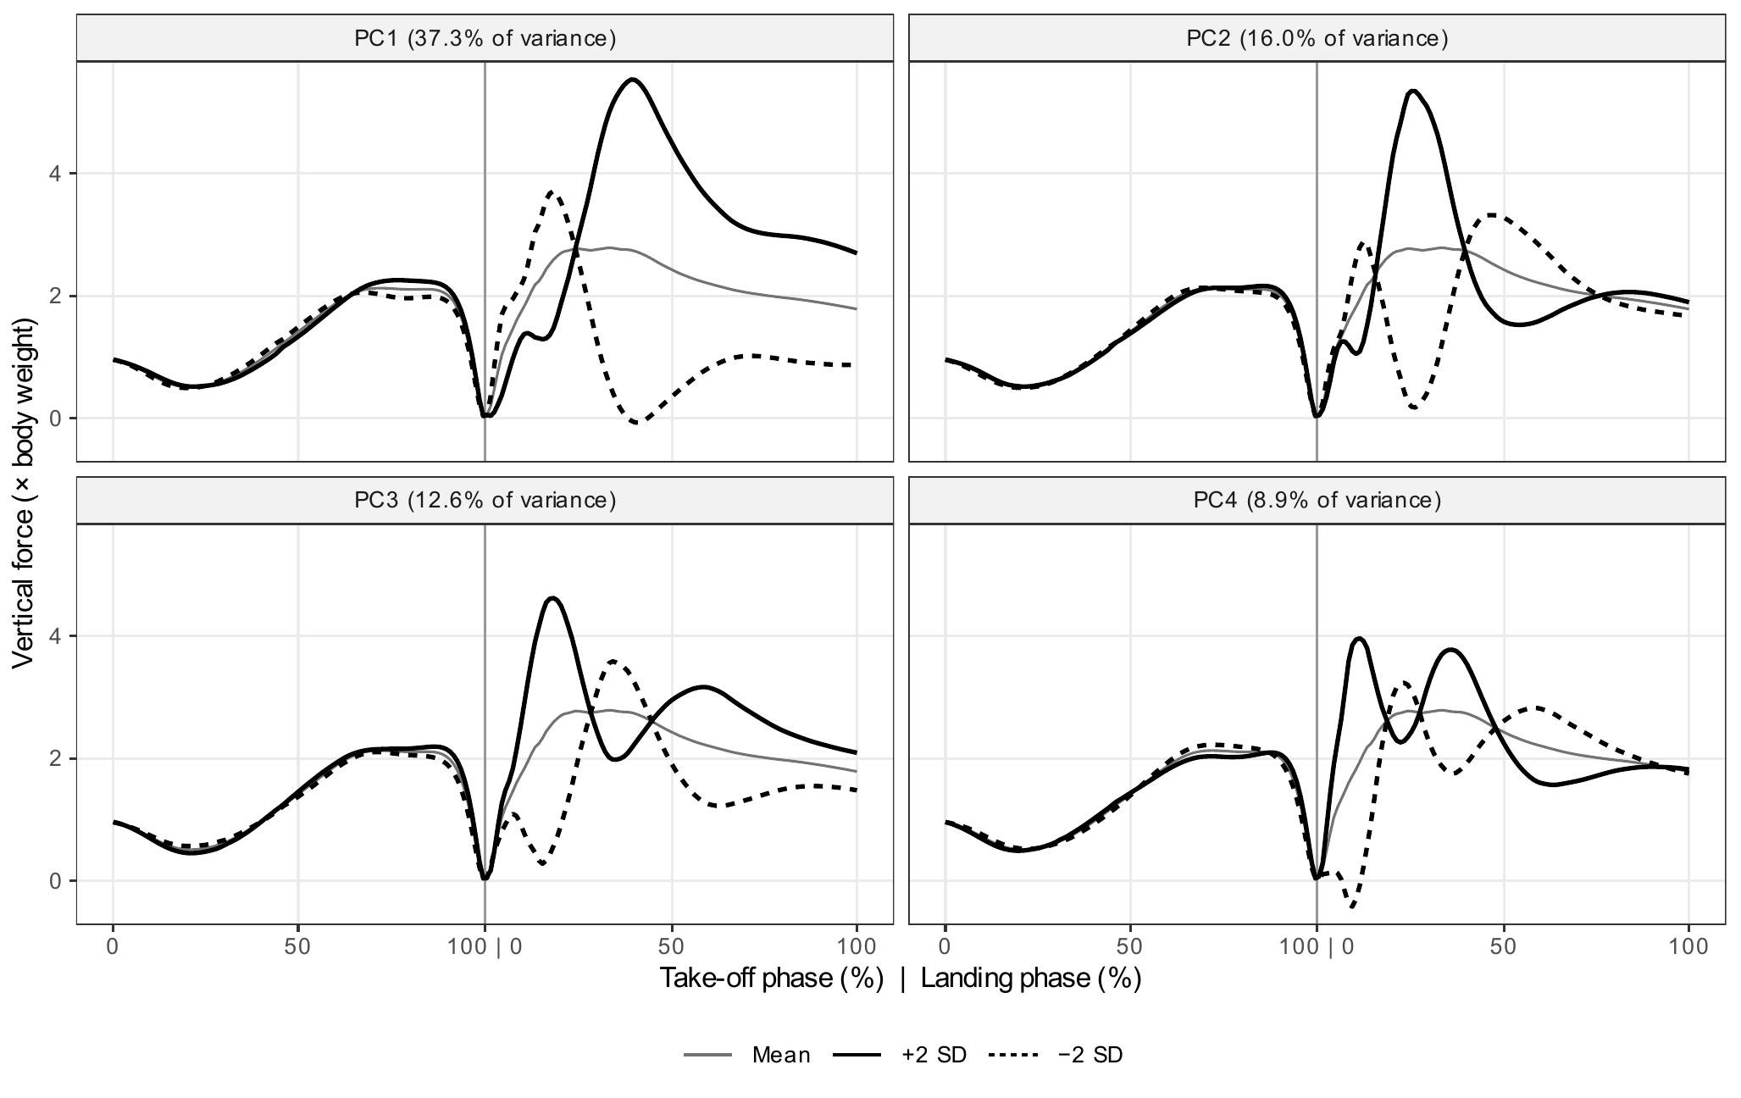
Fig. 2. What each retained component describes (main analysis). In every panel the thin grey line is the mean curve, and the solid and dashed black lines add and subtract two SDs of that component’s score. Reconstructed force can dip below zero because a component is added linearly to the mean; no recorded trial does this. A vertical line marks the boundary between take-off and landing.
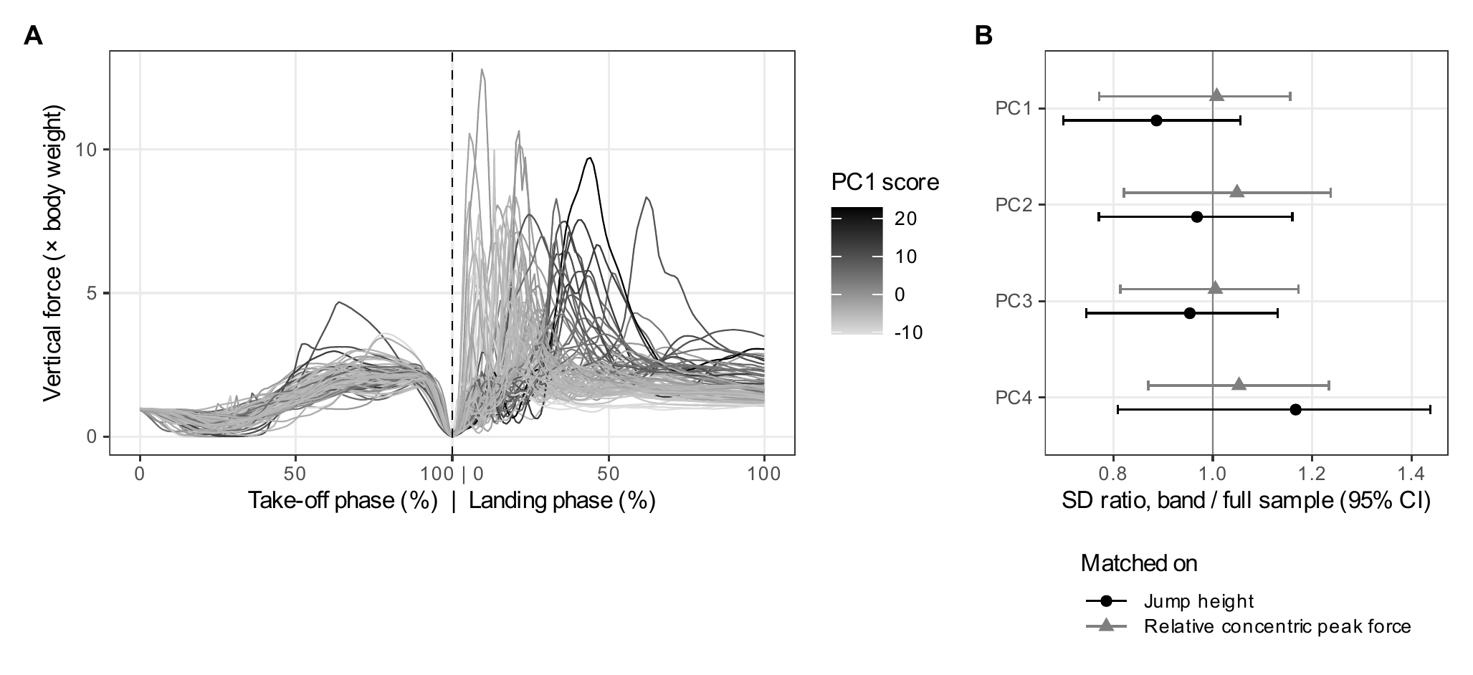
Fig. 3. Jumps of almost equal height still differ in shape. (A) The 82 trials whose jump height lay between the 45th and 55th percentiles (27.1 ± 0.65 cm). Shading runs from light grey to black as the PC1 score rises. (B) For each component, the SD of the score inside the band divided by its SD in all trials, for the jump-height band (black circles) and the relative-concentric-peak-force band (grey triangles). Whiskers are 95% confidence intervals from resampling athletes. A value of 1 means that matching removed none of the variation.
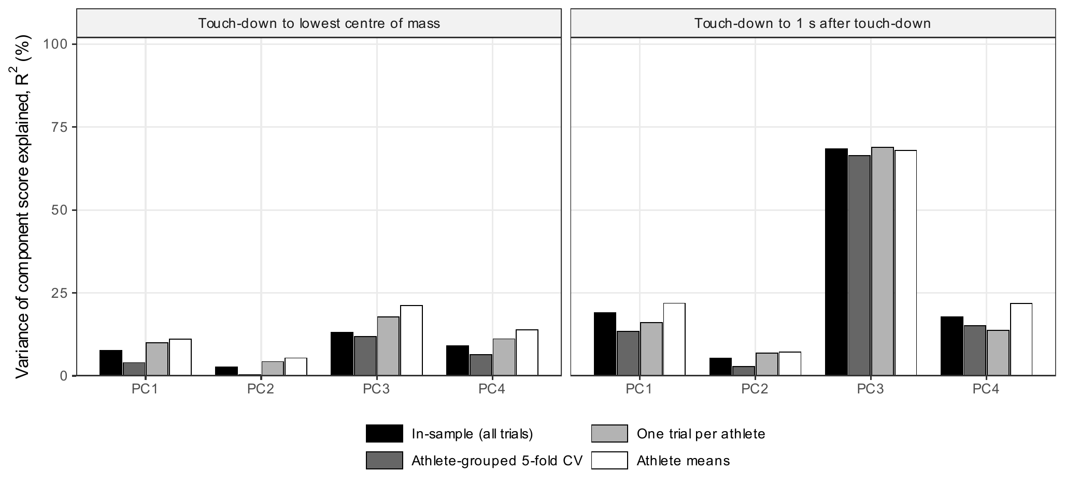
Fig. 4. Share of each component score explained by the four vendor metrics, age and body mass. Bars, shaded from black to white, give the in-sample value, the cross-validated value (CV; folds formed by athlete), the value from one trial per athlete and the value from athlete means. Left: landing ending at the lowest COM point. Right: landing ending 1 s after touch-down.
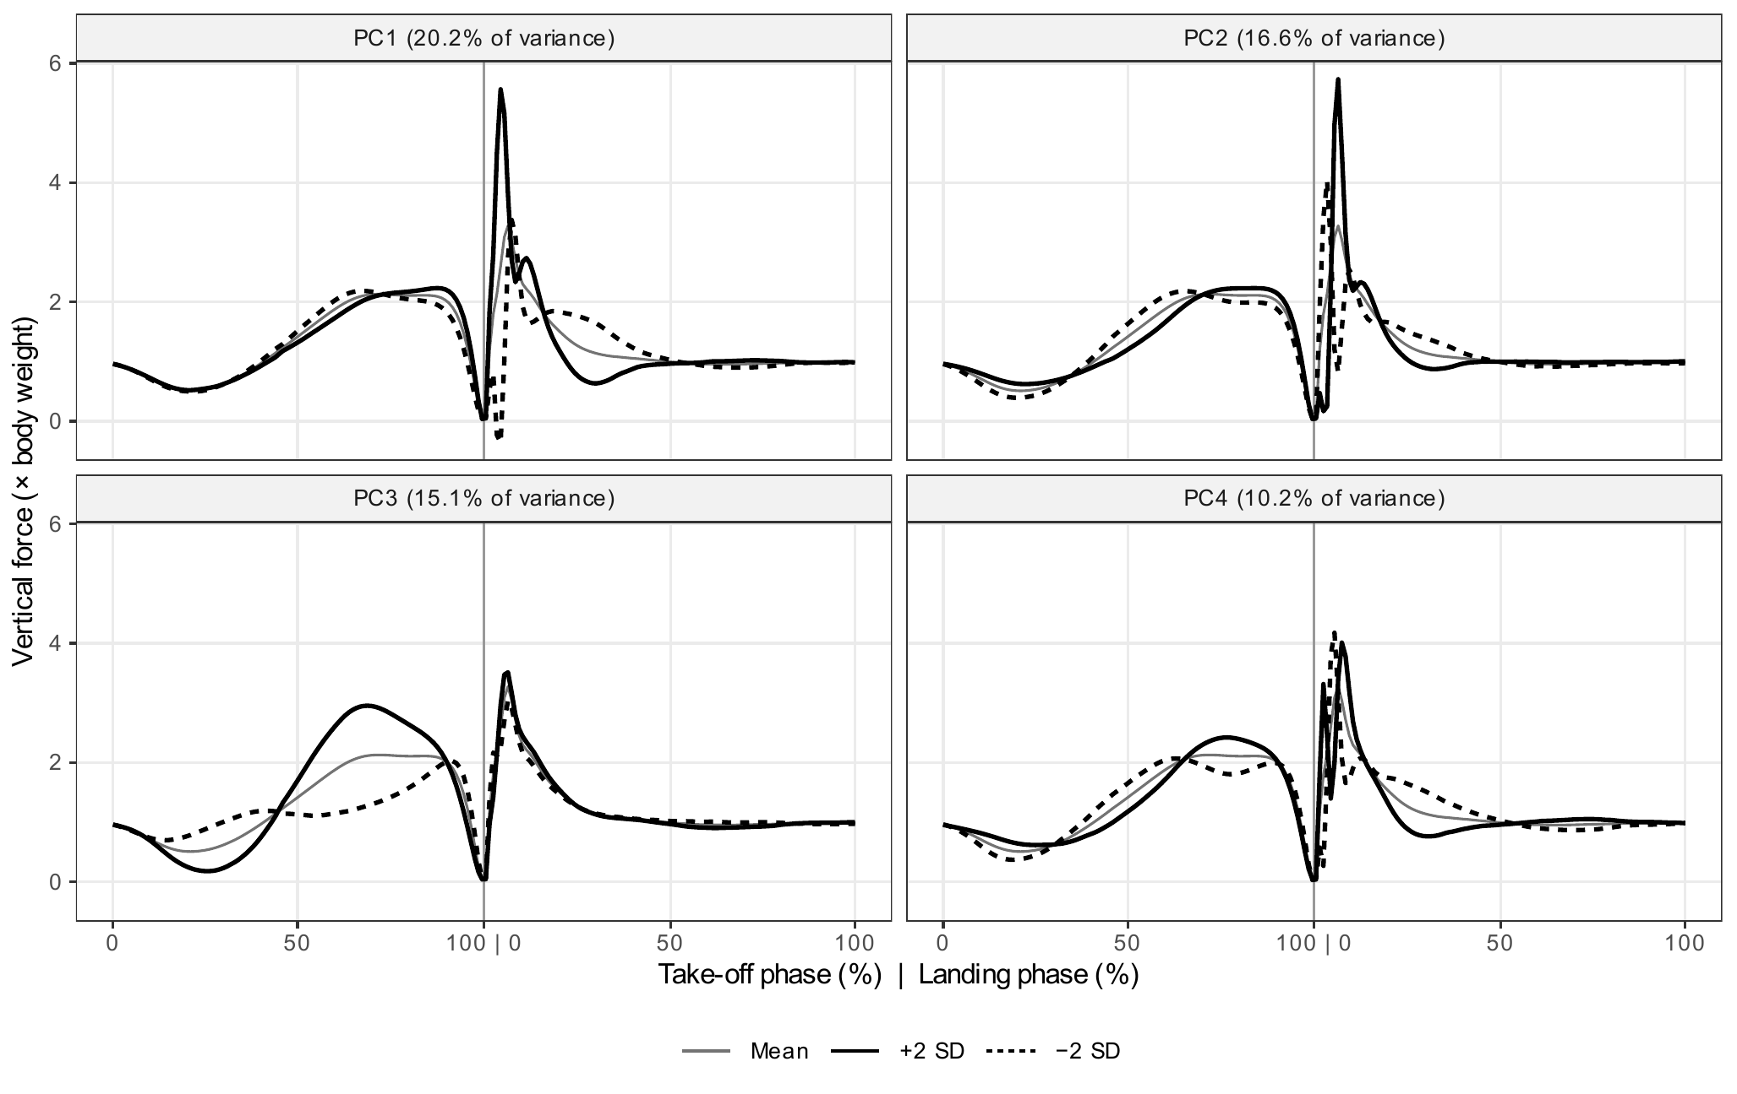
Fig. 5. Components when the landing is taken as the first second after touch-down. Line styles are as in Fig. 2. With this window PC3 sits almost wholly in take-off, which holds 96.3% of its squared loading, and it reflects how long and how hard the athlete pushes off.

