Exhibits (tables and figures) for: Revealing hidden jump strategies beyond conventional force-plate metrics

Tables
Table 1
Sample characteristics
Variable | M | SD | Mdn | Min | Max
Panel A. Athletes (n = 212)
Age at first test (years) | 16.0 | 5.9 | 14.1 | 8.8 | 37.9
Body mass at first test (kg) | 53.3 | 15.9 | 51.7 | 25.0 | 96.0
Trials per athlete | 3.8 | 2.3 | 3.0 | 1.0 | 16.0
Sessions per athlete | 1.5 | 0.8 | 1.0 | 1.0 | 6.0
Panel B. Trials (n = 805)
Jump height (cm) | 28.2 | 8.4 | 27.0 | 8.5 | 51.5
Concentric peak force (BW) | 2.35 | 0.38 | 2.29 | 1.65 | 4.70
Peak landing force (BW) | 5.39 | 1.97 | 4.97 | 2.19 | 14.88
Eccentric braking impulse (N s) | 27.8 | 15.4 | 24.6 | 0.0 | 95.2
Concentric impulse, first 100 ms (N s) | 62.2 | 26.7 | 58.7 | 1.5 | 187.9
Take-off duration (ms)ª | 782 | 190 | 774 | 306 | 1484
Landing duration (ms)^{b} | 247 | 114 | 235 | 70 | 928
Note. Values describe the analysed sample after quality control. Decimal places are fixed within each variable. M = mean; Mdn = median; BW = multiples of body weight. Trials were recorded at 1000 Hz (746) or 500 Hz (59).
ªMovement onset to take-off. ^{b}Touch-down to the lowest position of the centre of mass.
Table 2
Regions of each phase where force was associated with jump height, age and body mass
Predictor | Region (% of phase)ª | Peak (%) | Effect | 95% CI
Panel A. Take-off, effect in BW per SD of the predictor
Jump height | 14–30, 66–68, 72–84, 88–98 | 95 | 0.25 | [0.22, 0.29]
Age | 98 | 98 | 0.09 | [0.06, 0.12]
Body mass | 2–6, 98–100 | 98 | -0.06 | [−0.09, −0.03]
Panel B. Landing, effect in BW per SD of the predictor
Jump height | 4–28 | 14 | 0.36 | [0.21, 0.52]
Age | – | – | – | –
Body mass | 76–82 | 78 | -0.18 | [−0.30, −0.06]
Panel C. Jump height split within and between athletes, effect in BW per cm^{b}
Take-off, between athletes | 18–29, 67–99 | 95 | 0.031 | [0.026, 0.035]
Take-off, within athlete | 3–29, 46–63, 92–99 | 58 | 0.029 | [0.017, 0.042]
Landing, between athletes | 9–15, 18–25 | 24 | 0.039 | [0.016, 0.061]
Landing, within athlete | 2–16, 23 | 13 | 0.115 | [0.074, 0.164]
Note. Function-on-scalar regression of body-weight-normalised force on jump height, age and body mass, each standardised (1 SD = 8.4 cm, 5.7 years and 15.8 kg). Effect is the coefficient at the peak of the region, with a pointwise 95% confidence interval (CI) from 2000 bootstrap resamples of athletes. BW = multiples of body weight; dash = no region.
ªPanels A and B: nodes where the simultaneous 95% bands of both the athlete-bootstrap least-squares fit and the functional mixed model (athlete and session random curves) exclude zero. ^{b}Athlete-mean jump height and the trial’s deviation from it entered together; region from the athlete-bootstrap simultaneous band.
Table 3
Group differences in athlete-mean force curves
 |  |  |  | Difference (BW) |  | Hedges’ g
Phase | Region (%) | p | Peak (%) | Value | 95% CI | Value | 95% CI
Panel A. Top vs bottom tertile of jump height (71 vs 71 athletes)
Take-off | 81–99 | <.001 | 93 | 0.55 | [0.48, 0.61] | 2.63 | [2.31, 2.94]
Landing | 2–56 | .003 | 15 | 0.75 | [0.45, 1.04] | 0.83 | [0.50, 1.15]
Adjusted for age and body massª
Take-off | 12–32 | .021 | – | – | – | – | –
 | 66–99 | <.001 | – | – | – | – | –
Landing | 19–40 | .043 | – | – | – | – | –
Panel B. Aged 18 or over vs under 18 (48 vs 164 athletes)
Take-off | 87–99 | <.001 | 96 | 0.47 | [0.36, 0.56] | 1.60 | [1.25, 1.92]
Landing | none | .069^{c} | – | – | – | – | –
Adjusted for body mass and jump heightª
Take-off | none | .123^{c} | – | – | – | – | –
Landing | none | .226^{c} | – | – | – | – | –
Note. One mean curve per athlete. Region = cluster of adjacent nodes (% of the phase) where the groups differed; p from 5000 permutations of the largest cluster mass, controlling the family-wise error rate over the phase^{b}. Peak = node of the largest |t| in the region, where the difference (first group minus second; BW = multiples of body weight) and Hedges’ g are given with 95% confidence intervals (CIs) from 2000 bootstrap resamples of athletes within groups. Bonferroni threshold for the four primary tests: p < .0125.
ªFreedman–Lane permutation of residuals. ^{b}Nodes with $|t|$ above the two-sided 5% threshold form clusters. ^{c}No significant region; smallest cluster p shown.
Table 4
Take-off and landing curve profiles: characteristics, evidence for distinct groups and stability
 | Take-off profile |  | Landing profile
 | 1 | 2 | 1 | 2
Panel A. Characteristics
Trials (n) | 329 | 476 | 560 | 245
Share of all trials (%) | 41 | 59 | 70 | 30
Share of matched-height trials (%)ª | 35 | 65 | 74 | 26
Jump height (cm), mean^{b} | 29.6 | 27.2 | 28.4 | 27.7
Take-off duration (ms), mean | 649 | 875 | 790 | 764
Landing duration (ms), mean | 240 | 252 | 293 | 141
Panel B. Evidence for distinct groups
Mean silhouette width (0 to 1) | 0.30 |  | 0.37
Groups preferred by the gap statistic^{c} | 1 |  | 6
Dip test of unimodality, p | .741 |  | .978
Lowest bootstrap Jaccard similarity | 0.93 |  | 0.97
Panel C. Stability within athletes (83 athletes tested in two or more sessions)
Same profile in every session (%) | 55 |  | 70
Expected by chance (%) | 43 |  | 51
Permutation p | .007 |  | <.001
Same profile for two trials in a session (%) | 76 |  | 80
Expected by chance (%) | 52 |  | 58
Agreement after elastic alignment^{d} | – |  | 0.17
Note. Profiles from k-means clustering (k = 2) of functional principal component scores covering at least 90% of variance, separately for each phase. Dash = not applicable.
ªJump height between the 45th and 55th percentiles (26.0–28.2 cm; 82 trials). ^{b}Difference between profiles in a linear mixed model with an athlete random intercept: take-off p < .001, landing p = .017. ^{c}Candidates 1 to 6; 1 indicates no cluster structure. ^{d}Adjusted Rand index between profiles from aligned and unaligned landing curves (1 = identical, 0 = chance).

Figures
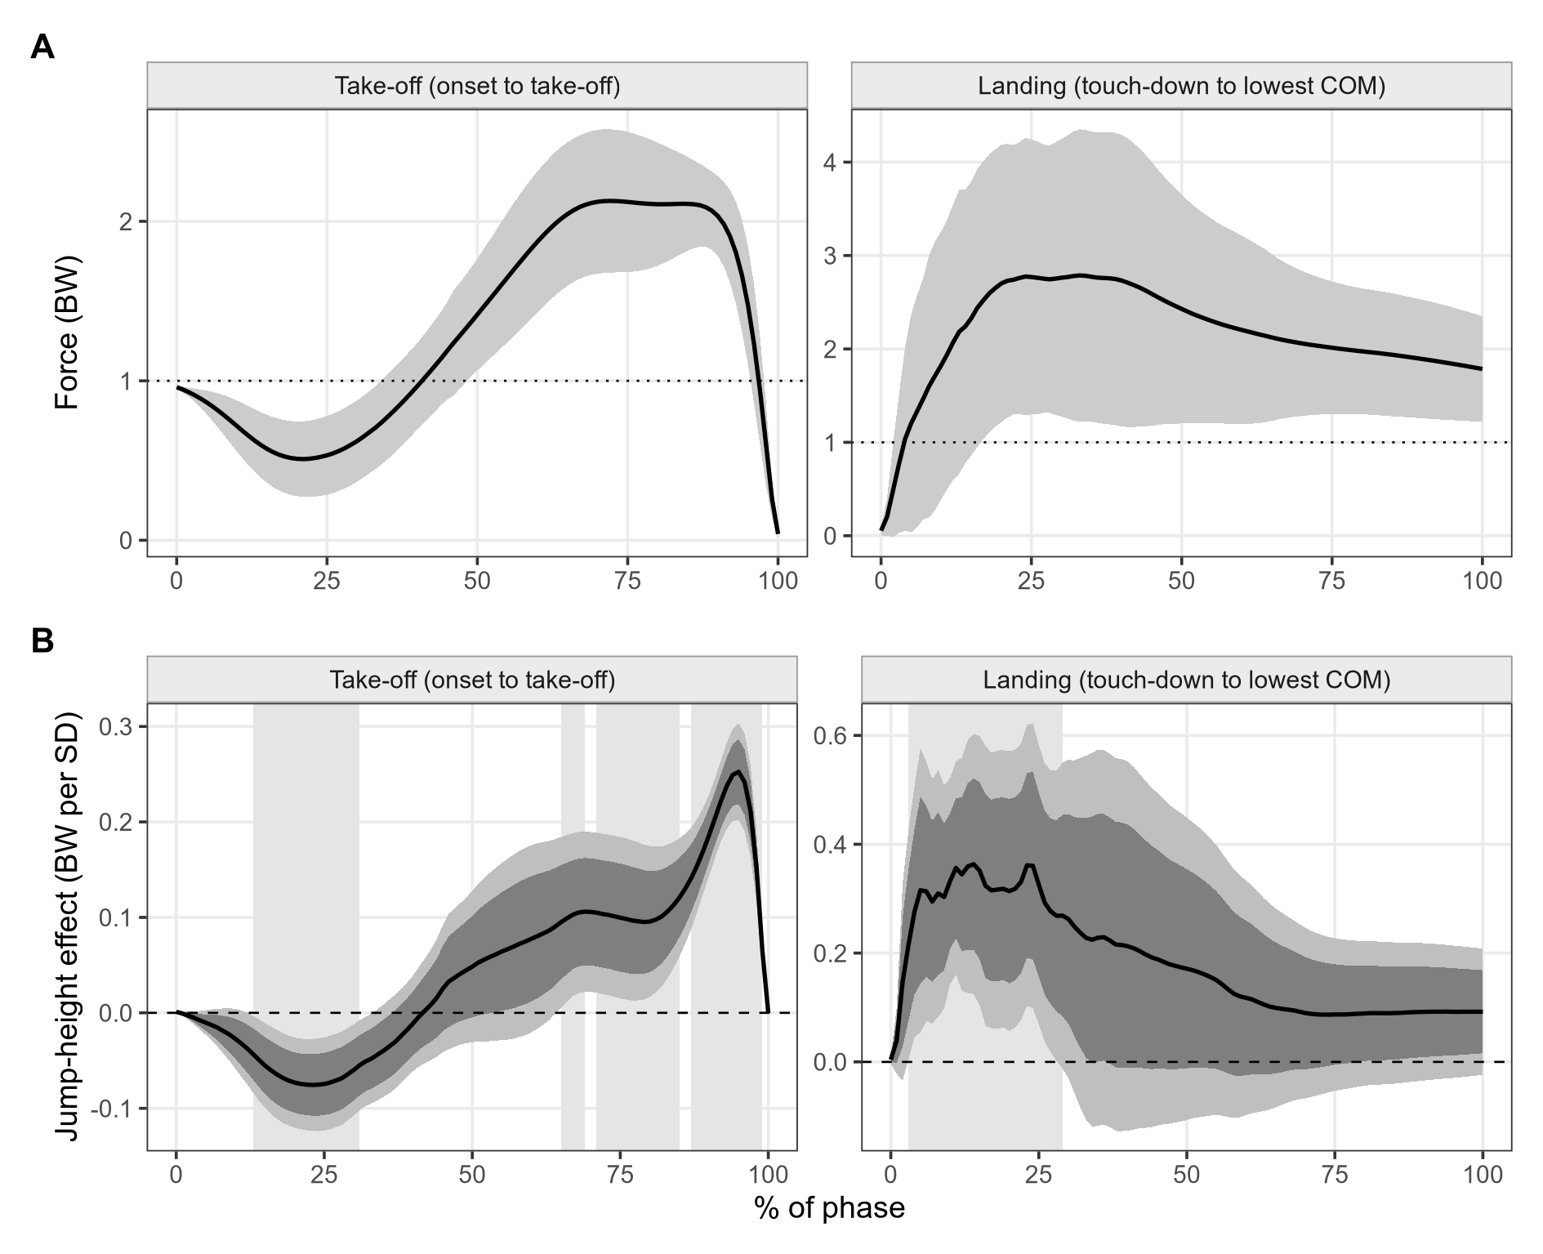
Fig. 1. Average curves and where jump height matters. (A) Mean force in multiples of body weight (BW) over the 805 analysed trials (line) with ± 1 SD (shaded); the dotted line is body weight. Take-off runs from movement onset to take-off and landing from touch-down to the lowest centre-of-mass (COM) position, each rescaled to 0–100%. (B) Jump-height coefficient from function-on-scalar regression (BW per SD of jump height, adjusted for age and body mass) with pointwise (dark) and simultaneous (light) 95% bands from resampling athletes. Pale background shading marks the regions where both estimation approaches agree.
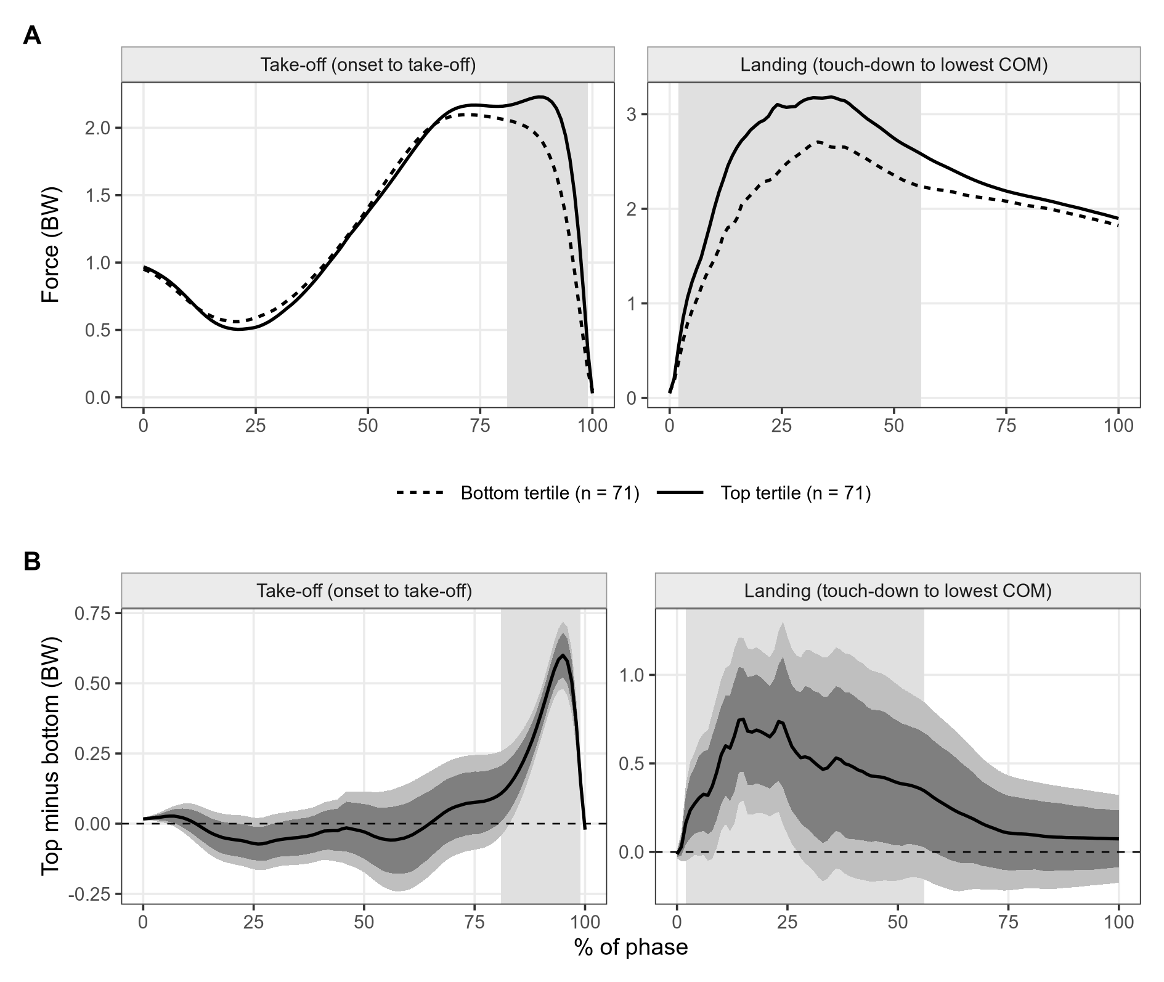
Fig. 2. Top versus bottom jump-height tertile, one mean curve per athlete. (A) Group mean curves. (B) Difference (top minus bottom) with pointwise (dark) and simultaneous (light) 95% bootstrap bands. Background shading marks clusters significant in the permutation test with family-wise error control.
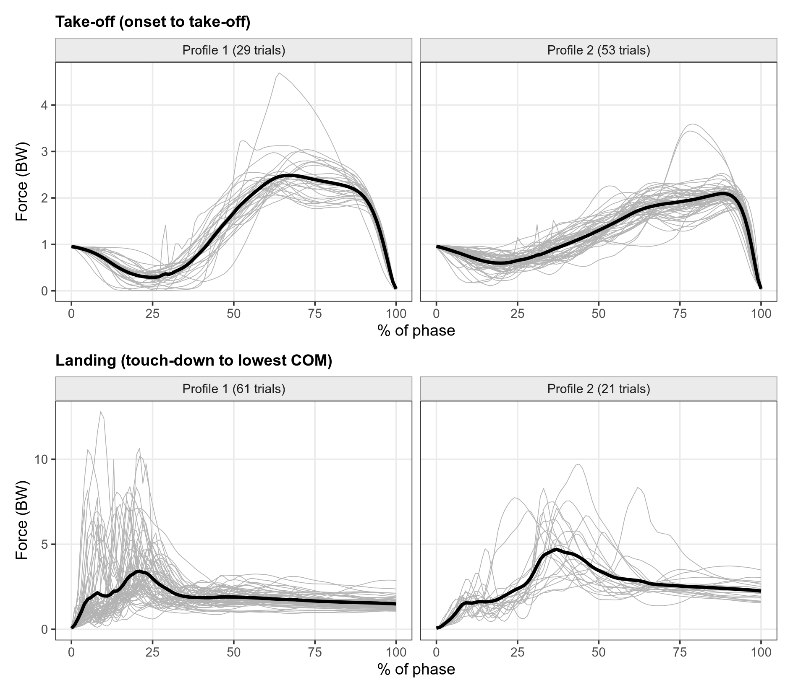
Fig. 3. Jumps of almost equal height (26.0–28.2 cm, 82 trials) still differ in shape. Thin grey lines are individual trials, split by curve profile; the thick black line is the profile mean. Top: take-off. Bottom: landing.
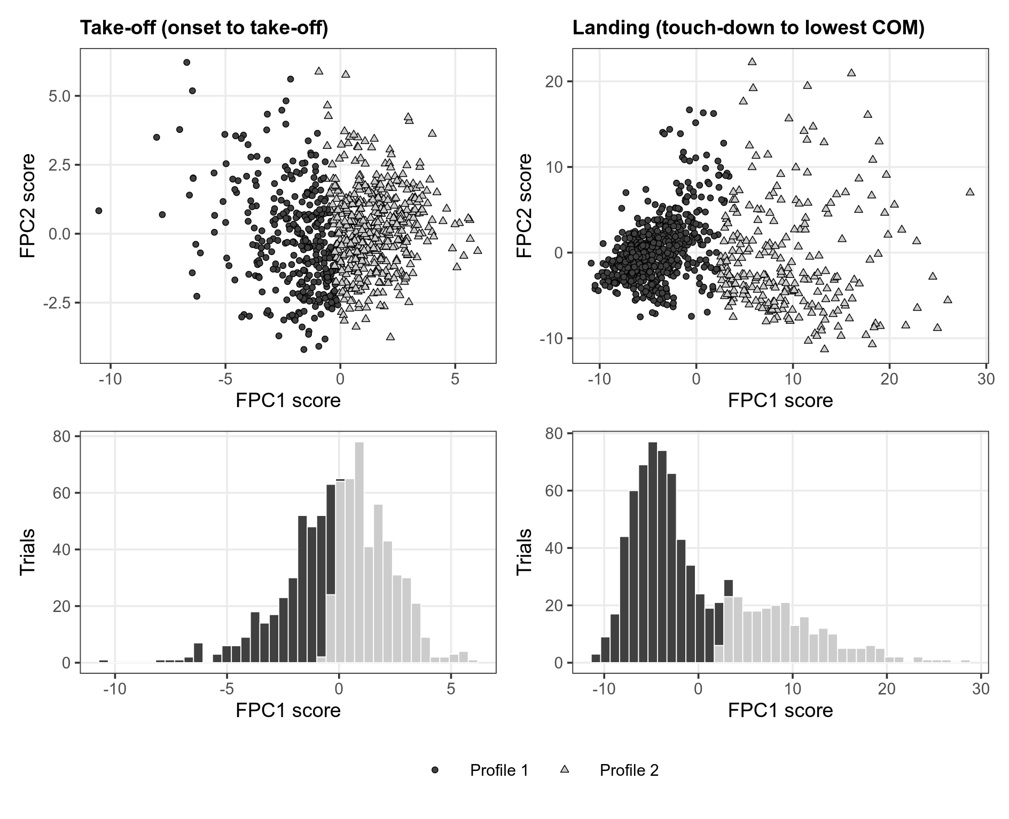
Fig. 4. Curve profiles form a continuum. For each phase, the scatter plot shows the first two functional principal component (FPC) scores of every trial, with symbols for the two k-means profiles, and the histogram shows the distribution of the first score shaded by profile. There is no gap between the profiles and no second mode.

