Revealing hidden jump strategies beyond conventional force-plate metrics
Short title: Curve shape beyond jump metrics
Abstract
Force-plate reports reduce each countermovement jump to a few numbers. Using 805 routine jumps from 212 male football players, mostly adolescents, we located where along take-off and landing force curves differ. Function-on-scalar regression and athlete-level permutation tests showed that better jumpers push harder in the final third of take-off; elsewhere jump height, age and body mass explained little. Jumps of equal height varied almost as much as the whole sample. Age differences reflected size and performance. Landing profiles formed a continuum but persisted across sessions, so curve features add information that conventional metrics miss.
Keywords: Countermovement jump; Force plates; Functional data analysis; Statistical parametric mapping; Athlete monitoring; Landing; Youth football; Sports analytics
Extended summary
Sports organisations test athletes on force plates routinely, but decisions usually rest on a few software-generated numbers such as jump height and peak force. This paper asks what those numbers leave out: at which points along the take-off and the landing of a countermovement jump do athletes differ, and do athletes with the same jump height move in the same way?
We analysed 805 jumps from 212 male football players, most of them adolescents, tested during routine monitoring at a private sports physiotherapy and performance centre in India. Each phase was expressed as a body-weight-normalised force curve. Function-on-scalar regression, estimated in two independent ways with athlete-level uncertainty, located where force relates to jump height, age and body mass. Permutation tests on athlete-mean curves compared high and low jumpers and adults with under-18 players while controlling false positives over the whole curve. Matched-height comparisons, validated clustering and curve alignment followed.
Better jumpers produced more force in the final third of take-off: in the top versus bottom tertile the peak difference was 0.55 body weights, a standardised effect of 2.63. Outside the last tenth of take-off the conventional variables explained little of the curve, and jumps of the same height were nearly as varied as the whole sample. Apparent age differences disappeared once body mass and jump height were taken into account. Landing differences were weaker in standardised terms and largely a matter of timing. Curve profiles formed a continuum rather than distinct strategies, yet 70% of athletes kept the same landing profile across sessions, against 51% expected by chance.
For managers, the implications are to target the late push when training for height, report curve features beside single numbers, watch landing load in young players, adjust youth benchmarks for size and track landing habits. Any link to injury remains a hypothesis.

1 Introduction
Sports organisations now collect force-plate data as routinely as they collect attendance. A squad can be put through a set of countermovement jumps (CMJs) in a few minutes, the software returns jump height, peak force, impulses and phase durations within seconds, and those numbers flow into dashboards that coaches and physiotherapists use to plan training, judge readiness and decide when an injured player can return (Claudino et al., 2017; Cormack et al., 2008; Gathercole et al., 2015). The appeal is obvious. A handful of numbers can be tracked over a season, compared between players and set against targets.
What the dashboard does not show is the force–time curve from which those numbers were taken. Each jump produces thousands of force samples, and every summary metric is a single point, an area or a duration read off that curve. Two athletes can reach the same height with different patterns of force: one sinks quickly and pushes hard for a short time, the other descends slowly and pushes for longer. If such differences are common, a report built on jump height and peak force treats as equivalent athletes who are not, and a coach who wants to change how an athlete jumps receives no guidance on where in the movement to look (Floría et al., 2019; McMahon et al., 2018). The same concern applies to the landing, which the plates record in every trial but which most monitoring reports reduce to one peak value or ignore.
Waveform studies have begun to show where along the take-off better jumpers differ (Floría et al., 2019; Parker & Lundgren, 2018; Richter et al., 2014), but they have mostly used small laboratory samples, treated each trial as an independent observation and stopped at the moment of take-off. Routine monitoring records, in which the same athletes are tested repeatedly and every landing is captured, have rarely been analysed in this way. This paper addresses that gap. Using routine CMJ records from male football players at a private performance centre in India, it asks at which points along take-off and landing jumps differ systematically, and what the conventional metrics fail to capture. Each phase is treated as a curve and analysed with methods from functional data analysis that test every instant of the movement while controlling the error rate over the whole curve (Pataky et al., 2015; Ramsay & Silverman, 2005). Because most of the players are adolescents, a related question is whether differences between younger and older players reflect age itself or the size and jump height that come with it.
The contribution lies in the evidence rather than in new statistics. The analysis reads a dataset of the kind many organisations already hold, with the athlete rather than the trial as the unit of evidence, so that frequently tested players do not dominate the conclusions. It shows where along the curve better jumpers differ, that jumps of the same height can be produced with different curves, that the apparent groups of ‘jump strategies’ are better described as a continuum, and that the landing carries information no take-off metric supplies. Section 2 reviews the relevant literature, Section 3 describes the data and methods, Section 4 presents the findings, and Section 5 sets out the conclusions, implications and limitations.

2 Literature review
Studies of the CMJ have long tried to find which discrete variables separate good and poor jumpers. No single variable has emerged. A high peak force is necessary but not sufficient for a good jump, and athletes with similar peaks can jump very different heights because they apply force differently (Dowling & Vamos, 1993); the variables that vendors report are also correlated with one another and with jump height itself (Laffaye et al., 2014), and force values depend on body mass unless normalised (McMahon et al., 2018). Their reliability also varies: peak force, power and velocity are highly repeatable within a session, whereas rate of force development and time to peak force are not (Hori et al., 2009). For monitoring, the practical consequence is that a change in one metric can arise from several different changes in the way the athlete moved.
Waveform analysis was proposed as a way around the choice of variables. Analysing the whole time-normalised curve, through principal components or functional principal components, lets the data reveal which parts of the movement vary (Ramsay & Silverman, 2005; Warmenhoven et al., 2019). Applied to the CMJ, these methods have shown that higher jumps come from applying more force for longer during propulsion (Richter et al., 2014), that training-induced gains in height arise from changes in the countermovement and braking as well as in propulsion (Floría et al., 2019), and that whole-curve features capture differences between athletes that jump height alone does not (Parker & Lundgren, 2018). In on-water rowing, Warmenhoven et al. (2018) applied functional data analysis, statistical parametric mapping (SPM) and its non-parametric counterpart to the same force profiles and found that all three located the same regions of difference, so that the choice between them rests on their assumptions and the research question. Reviews of functional methods in biomechanics now treat function-on-scalar regression and SPM as complementary tools (Gunning et al., 2024; Morris, 2015): the first estimates how a scalar such as jump height relates to force at each instant, the second tests group differences at each instant with control of the family-wise error rate (Nichols & Holmes, 2002; Pataky, 2012; Pataky et al., 2015).
Three methodological issues recur in this literature and shape the present design. The first is time. CMJ phases differ in duration between and within athletes, so curves must be brought to a common time base before they can be compared. Linear normalisation to a fixed number of nodes is the usual choice, but it mixes differences in timing with differences in force; landmark registration and elastic alignment separate the two, and the choice alters how well curve features predict jump height (Moudy et al., 2018; M. White et al., 2020; M. G. E. White et al., 2022) and how effects divide between amplitude and timing (Pataky et al., 2022). Registration is not neutral either, because the warping itself may carry performance information. The second issue is dependence. Monitoring data contain several trials per session and several sessions per athlete, and treating trials as independent inflates the evidence. Functional mixed models with athlete-level random curves (Di et al., 2009; Goldsmith et al., 2011; Morris & Carroll, 2006; Scheipl et al., 2015) and resampling of athletes rather than trials address this, but few CMJ studies have used them. The third is grouping. Clustering curves is an appealing way to sort athletes into ‘strategies’ (Jacques & Preda, 2014), and the principal component structure of CMJ curves can itself shift over a season (Kipp et al., 2015). Yet clustering algorithms return groups whether or not any exist, so evidence for discrete strategies depends on validation that is often missing (Hennig, 2007; Tibshirani et al., 2001).
The landing has received far less attention. It is recorded in every trial and loads the lower limb more heavily than take-off, yet even injury-related waveform work has looked at take-off: in elite athletes tested before and after anterior cruciate ligament reconstruction, SPM found force deficits at the end of propulsion that discrete values missed (França et al., 2025). Whether landing curves differ with performance or with age in young players has not, to our knowledge, been examined with whole-curve methods. Youth samples bring a further difficulty: age, body mass and jump height rise together during adolescence, and strength qualities develop unevenly with maturation (Lloyd & Oliver, 2012; Malina et al., 2015), so an apparent age effect on the curve may reflect size or performance rather than age itself.
This study therefore draws on the waveform literature but applies it to a routine monitoring dataset, with athlete-level inference throughout, two independent estimation approaches for every curve-wide claim, explicit checks of the time-normalisation choices, and validation before any clustering result is interpreted.

3 Methodology

3.1 Data and quality control
The data are CMJ trials recorded during routine assessment of male football players at a private sports physiotherapy and performance centre in India between November 2022 and April 2026, shared with the authors under a non-disclosure and data-sharing agreement. All such trials in the centre’s account were exported, giving 833 trials from 215 athletes in 333 sessions, where a session is one visit at which an athlete jumped once or more. Identifiers were replaced by pseudonymous codes before analysis, and age at test was derived before dates were removed. The study was approved by [Ethics committee name, approval number and date to be inserted]. [Written informed consent was obtained from adult athletes, and written consent from a parent or guardian, together with the athlete’s assent, was obtained for athletes under 18 years.] / [The committee waived the requirement for consent for the secondary use of de-identified routine monitoring data.] [Delete the option that does not apply.] The study conformed to the Declaration of Helsinki.
Jumps were performed on dual force plates (VALD ForceDecks, VALD Performance, Brisbane, Australia) sampling at 1000 Hz (746 analysed trials) or 500 Hz (59). Testing followed the centre’s routine, so warm-up, instructions and rest intervals were not recorded and no landing technique was prescribed. The software supplied jump height from flight time, concentric peak force, eccentric braking impulse, the concentric impulse over the first 100 ms, peak landing force, contraction time and flight time; these are the conventional metrics against which the curves are compared. Five quality-control rules removed trials with a missing or invalid body mass (R1), a quiet-stance mass more than 5% away from the recorded mass (R2), mean force above 50 N during flight (R3), a missing metric or age (R4), or no identifiable lowest centre-of-mass position after touch-down (R5). The rules removed 28 trials and 3 athletes, leaving 805 trials from 212 athletes in 327 sessions (Table 1). Ages ranged from 8.8 to 37.9 years (median 14.2), 74% of trials came from players under 18, and 83 athletes were tested in two or more sessions.
Table 1
Sample characteristics
Variable | M | SD | Mdn | Min | Max
Panel A. Athletes (n = 212)
Age at first test (years) | 16.0 | 5.9 | 14.1 | 8.8 | 37.9
Body mass at first test (kg) | 53.3 | 15.9 | 51.7 | 25.0 | 96.0
Trials per athlete | 3.8 | 2.3 | 3.0 | 1.0 | 16.0
Sessions per athlete | 1.5 | 0.8 | 1.0 | 1.0 | 6.0
Panel B. Trials (n = 805)
Jump height (cm) | 28.2 | 8.4 | 27.0 | 8.5 | 51.5
Concentric peak force (BW) | 2.35 | 0.38 | 2.29 | 1.65 | 4.70
Peak landing force (BW) | 5.39 | 1.97 | 4.97 | 2.19 | 14.88
Eccentric braking impulse (N s) | 27.8 | 15.4 | 24.6 | 0.0 | 95.2
Concentric impulse, first 100 ms (N s) | 62.2 | 26.7 | 58.7 | 1.5 | 187.9
Take-off duration (ms)ª | 782 | 190 | 774 | 306 | 1484
Landing duration (ms)^{b} | 247 | 114 | 235 | 70 | 928
Note. Values describe the analysed sample after quality control. Decimal places are fixed within each variable. M = mean; Mdn = median; BW = multiples of body weight. Trials were recorded at 1000 Hz (746) or 500 Hz (59).
ªMovement onset to take-off. ^{b}Touch-down to the lowest position of the centre of mass.

3.2 Curve construction and time normalisation
The take-off phase runs from movement onset $t_{on}$ to take-off $t_{to}=t_{on}+T_{c}$, where $T_{c}$ is contraction time. The landing phase runs from touch-down $t_{td}=t_{to}+T_{f}$, with $T_{f}$ the flight time, to the lowest point of the centre of mass, the first instant after touch-down at which vertical velocity, obtained by integrating net force from an initial value of $−gT_{f}/2$, returns to zero (Linthorne, 2001; McMahon et al., 2018; Street et al., 2001). Force was divided by body weight and each phase was linearly resampled to 101 equally spaced nodes,
$$y_{ij}(s)=\frac{F_{ij}\{t_{0,ij}+s (t_{1,ij}−t_{0,ij})\}}{m_{i} g}, s∈\{0,0.01,…,1\},$$
where $F_{ij}$ is the summed vertical force in trial j of athlete i, $m_{i}$ the body mass recorded with the trial, g = 9.81 m s$​^{−2}$, and $[t_{0,ij},t_{1,ij}]$ the phase limits. Results are expressed in multiples of body weight (BW) at a given percentage of the phase (Richter et al., 2014; Warmenhoven et al., 2019).
The node count was chosen from the data rather than by convention. Take-off phases contained between 180 and several thousand native samples (median 762), so 101 nodes downsample every take-off. Landings were much shorter (median 223 samples), and 43 landings (5.3%) had fewer than 101, so for them the grid interpolates rather than samples. Resampling at 101 nodes kept a median of 0.997 of the native peak landing force, whereas a 51-node grid would have lost up to 20% of the peak in the worst 1% of landings. Three checks showed that the choice did not drive the results. Re-interpolating the stored curves to 51 and 201 nodes, with linear or spline interpolation, and repeating the main analyses moved the boundaries of significant regions by one or two percentage points, left the landing group comparison identical, and changed cumulative component variance by at most 0.4 percentage points; linear and spline values at grid midpoints differed by a median of 0.001 BW. A velocity check confirmed the event definitions: take-off velocity integrated from the force record correlated $r=0.96$ with the value implied by flight time.
Linear normalisation treats a difference in timing as a difference in force. We examined this in two ways. Landmark registration added minimum and zero centre-of-mass velocity as interior landmarks in take-off, and peak landing force in landing, warping each curve piecewise-linearly so that landmarks coincide (Moudy et al., 2018; M. G. E. White et al., 2022). Elastic alignment of landing curves used the square-root velocity framework (Srivastava et al., 2011; Tucker et al., 2013), in which each curve f is represented by $q(s)=sign\{\dot{f}(s)\}\sqrt{|\dot{f}(s)|}$ and aligned to a Karcher mean by a warping function $γ$ that minimises $\left\|q_{μ}−(q∘γ)\sqrt{\dot{γ}}\right\|$. This splits variation into amplitude (aligned curves) and phase (the warps), which can then be analysed separately (Pataky et al., 2022).

3.3 Statistical analysis
The main model is a function-on-scalar regression,
$$y_{ij}(s)=β_{0}(s)+β_{JH}(s) z_{ij}^{JH}+β_{age}(s) z_{ij}^{age}+β_{BM}(s) z_{ij}^{BM}+b_{i}(s)+c_{ij}(s)+ε_{ij}(s),$$
where the z are jump height, age and body mass standardised to one SD (8.4 cm, 5.7 years and 15.8 kg), $b_{i}(s)$ and $c_{ij}(s)$ are athlete and session random curves, and $ε_{ij}(s)$ is residual error. Each coefficient function $β_{p}(s)$ is the change in force, in BW, at instant s for a one-SD difference in the predictor with the others held fixed. Body mass is in the model because heavier players jump differently in absolute terms and are, in this sample, older.
Equation (2) was estimated in two ways, and a region is reported only when both agree. The first fits the fixed part by ordinary least squares at each node, leaves the dependence to the resampling and builds simultaneous 95% bands from 2000 bootstrap resamples of athletes, so that all trials and sessions of an athlete are resampled together (Efron & Tibshirani, 1993). The band is ${\hat{β}}_{p}(s)±\hat{q} \hat{se}(s)$, where $\hat{q}$ is the 95th percentile over resamples of $\max_{s}|{\hat{β}}_{p}^{*}(s)−{\hat{β}}_{p}(s)|/\hat{se}(s)$; it covers the whole function with 95% probability rather than each node separately (Ruppert et al., 2003). The critical values ranged from 2.90 to 3.12. The second approach fits the functional mixed model directly with penalised splines and athlete and session random curves (Goldsmith et al., 2011; Scheipl et al., 2015), on every second node to keep the computation feasible, with simultaneous bands from the posterior covariance. The two approaches fail differently. The bootstrap is honest about dependence between trials but ignores smoothness; the mixed model uses smoothness, but its residuals were strongly autocorrelated along the curve (lag-one correlation 0.94–0.97), so its bands are too narrow and it tends to find more regions. Requiring agreement guards against both.
To separate athletes who jump higher from jumps that are higher, jump height was also split into its athlete mean and the trial’s deviation from it,
$${JH}_{ij}={\overline{JH}}_{i}+({JH}_{ij}−{\overline{JH}}_{i}),$$
and both parts entered the bootstrap model in place of jump height. The between-athlete term describes how better jumpers differ from poorer ones; the within-athlete term describes how the same athlete’s curve changes on a better day.
Group differences were tested with a permutation version of SPM applied to one mean curve per athlete, so that each athlete contributes once. At each node a Welch t statistic compared the groups; adjacent nodes whose $|t|$ exceeded the two-sided 5% threshold formed clusters, and each cluster’s mass s∈c​|t(s)| was compared with the permutation distribution of the largest cluster mass over the whole phase,
$$p_{c}=\frac{1+\#\{ k:\max_{c^{′}}M_{c^{′}}^{(k)}≥M_{c} \}}{1+K}, K=5000,$$
which controls the family-wise error rate over all 101 nodes (Maris & Oostenveld, 2007; Nichols & Holmes, 2002; Pataky et al., 2015). Two contrasts were examined: athletes in the top versus the bottom tertile of mean jump height (71 versus 71), and athletes aged 18 or over versus under 18 (48 versus 164). Because size and performance are confounded with group, each contrast was repeated after adjusting for the other two variables (age and body mass for the tertile contrast; body mass and jump height for the age contrast) by Freedman–Lane permutation of residuals (Winkler et al., 2014). Effect sizes are the mean difference and Hedges’ g at the node of largest $|t|$, both with 95% intervals from 2000 bootstrap resamples of athletes within groups. With four primary tests, a Bonferroni threshold of .0125 is also reported.
A matched-height comparison asked the question managers most often ask of these data: if two players jump equally high, do they jump in the same way? Trials whose jump height lay between the 45th and 55th percentiles were compared with the whole sample on the spread of their curves and on the mix of curve profiles defined next.
Profiles were obtained by k-means clustering on functional principal component scores covering at least 90% of variance, separately for take-off and landing (Jacques & Preda, 2014). Because k-means always returns groups, the clustering was treated as exploratory and validated with the mean silhouette width (Kaufman & Rousseeuw, 1990), the gap statistic with $k=1$ allowed (Tibshirani et al., 2001), a dip test of unimodality of the leading score (Hartigan & Hartigan, 1985), and bootstrap cluster-wise Jaccard similarity (Hennig, 2007). The stability of profiles within athletes was measured as the share of athletes with two or more sessions whose profile was the same in every session, and compared with the share expected if profiles were assigned at random in proportion to their frequency, obtained by permuting labels within the sample. Profiles were not used to define the groups in the SPM tests, which avoids testing a difference created by the clustering itself. All analyses used R (R Core Team, 2026) with a fixed random seed.

4 Findings

4.1 Performance, age and the force curve
Force rose to a first peak late in take-off and to a larger, more variable impact peak early in landing (Fig. 1A). Jump height was associated with force in two parts of take-off on which both estimation approaches agreed: early, at 14–30% of the phase, where higher jumpers unweighted more deeply (a negative coefficient), and late, from 66% to 98%, where they pushed harder (Table 2; Fig. 1B). The mixed model’s band touched zero in two short stretches of the late window, which we do not claim. The largest effect was 0.25 BW per SD of jump height at 95% of take-off (95% CI [0.22, 0.29]). Age added almost nothing once jump height and body mass were in the model; its supported region was confined to about 98% of take-off, a coefficient of 0.09 BW per SD.
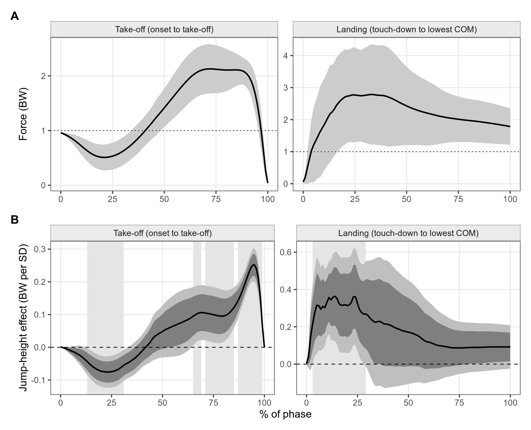
Fig. 1. Average curves and where jump height matters. (A) Mean force in multiples of body weight (BW) over the 805 analysed trials (line) with ± 1 SD (shaded); the dotted line is body weight. Take-off runs from movement onset to take-off and landing from touch-down to the lowest centre-of-mass (COM) position, each rescaled to 0–100%. (B) Jump-height coefficient from function-on-scalar regression (BW per SD of jump height, adjusted for age and body mass) with pointwise (dark) and simultaneous (light) 95% bands from resampling athletes. Pale background shading marks the regions where both estimation approaches agree.
Table 2
Regions of each phase where force was associated with jump height, age and body mass
Predictor | Region (% of phase)ª | Peak (%) | Effect | 95% CI
Panel A. Take-off, effect in BW per SD of the predictor
Jump height | 14–30, 66–68, 72–84, 88–98 | 95 | 0.25 | [0.22, 0.29]
Age | 98 | 98 | 0.09 | [0.06, 0.12]
Body mass | 2–6, 98–100 | 98 | -0.06 | [−0.09, −0.03]
Panel B. Landing, effect in BW per SD of the predictor
Jump height | 4–28 | 14 | 0.36 | [0.21, 0.52]
Age | – | – | – | –
Body mass | 76–82 | 78 | -0.18 | [−0.30, −0.06]
Panel C. Jump height split within and between athletes, effect in BW per cm^{b}
Take-off, between athletes | 18–29, 67–99 | 95 | 0.031 | [0.026, 0.035]
Take-off, within athlete | 3–29, 46–63, 92–99 | 58 | 0.029 | [0.017, 0.042]
Landing, between athletes | 9–15, 18–25 | 24 | 0.039 | [0.016, 0.061]
Landing, within athlete | 2–16, 23 | 13 | 0.115 | [0.074, 0.164]
Note. Function-on-scalar regression of body-weight-normalised force on jump height, age and body mass, each standardised (1 SD = 8.4 cm, 5.7 years and 15.8 kg). Effect is the coefficient at the peak of the region, with a pointwise 95% confidence interval (CI) from 2000 bootstrap resamples of athletes. BW = multiples of body weight; dash = no region.
ªPanels A and B: nodes where the simultaneous 95% bands of both the athlete-bootstrap least-squares fit and the functional mixed model (athlete and session random curves) exclude zero. ^{b}Athlete-mean jump height and the trial’s deviation from it entered together; region from the athlete-bootstrap simultaneous band.
In landing, higher jumps were followed by larger forces early in the phase, at 4–28% (largest effect 0.36 BW per SD at 14%; 95% CI [0.21, 0.52]), and age had no supported effect anywhere. The model explained little of the landing curve: the pointwise R² lay between 3% and 8%. Take-off was different. At 94% of nodes between 5% and 89% of the phase, jump height, age and body mass together explained less than 10% of the variance, but in the last tenth of take-off they explained up to 55%. The conventional metrics are therefore informative about the end of the push and say little about the rest of the movement.
The split of jump height in Equation (3) showed that the early-landing effect is largely a within-athlete matter. When an athlete jumped higher than his own average, early landing force rose by 0.115 BW per cm (95% CI [0.074, 0.164]; significant mainly at 2–16% of the phase), about three times the between-athlete effect of 0.039 BW per cm. Within-athlete variation in jump height was small (SD 2.3 cm against 8.0 cm between athlete means), but each extra centimetre on a given day came with a markedly harder landing. In take-off, within- and between-athlete effects were of similar size per centimetre (Table 2).
The group comparison of athlete-mean curves confirmed the late-push window (Table 3; Fig. 2). Athletes in the top jump-height tertile produced more force than those in the bottom tertile from 81–99% of take-off (p < .001). At 93% the means were 2.06 and 1.52 BW, a difference of 0.55 BW (95% CI [0.48, 0.61]) and Hedges’ g of 2.63 [2.31, 2.94]. After adjustment for age and body mass the difference remained, at 12–32% ($p$ = .021) and 66–99% ($p$ < .001). In landing the top tertile showed higher force over 2–56% of the phase (p = .003; difference 0.75 BW [0.45, 1.04] at 15%, g = 0.83 [0.50, 1.15]), but after adjustment only 19–40% remained, at p = .043, which does not pass the Bonferroni threshold. The landing difference between good and poor jumpers is thus weaker and partly explained by size.
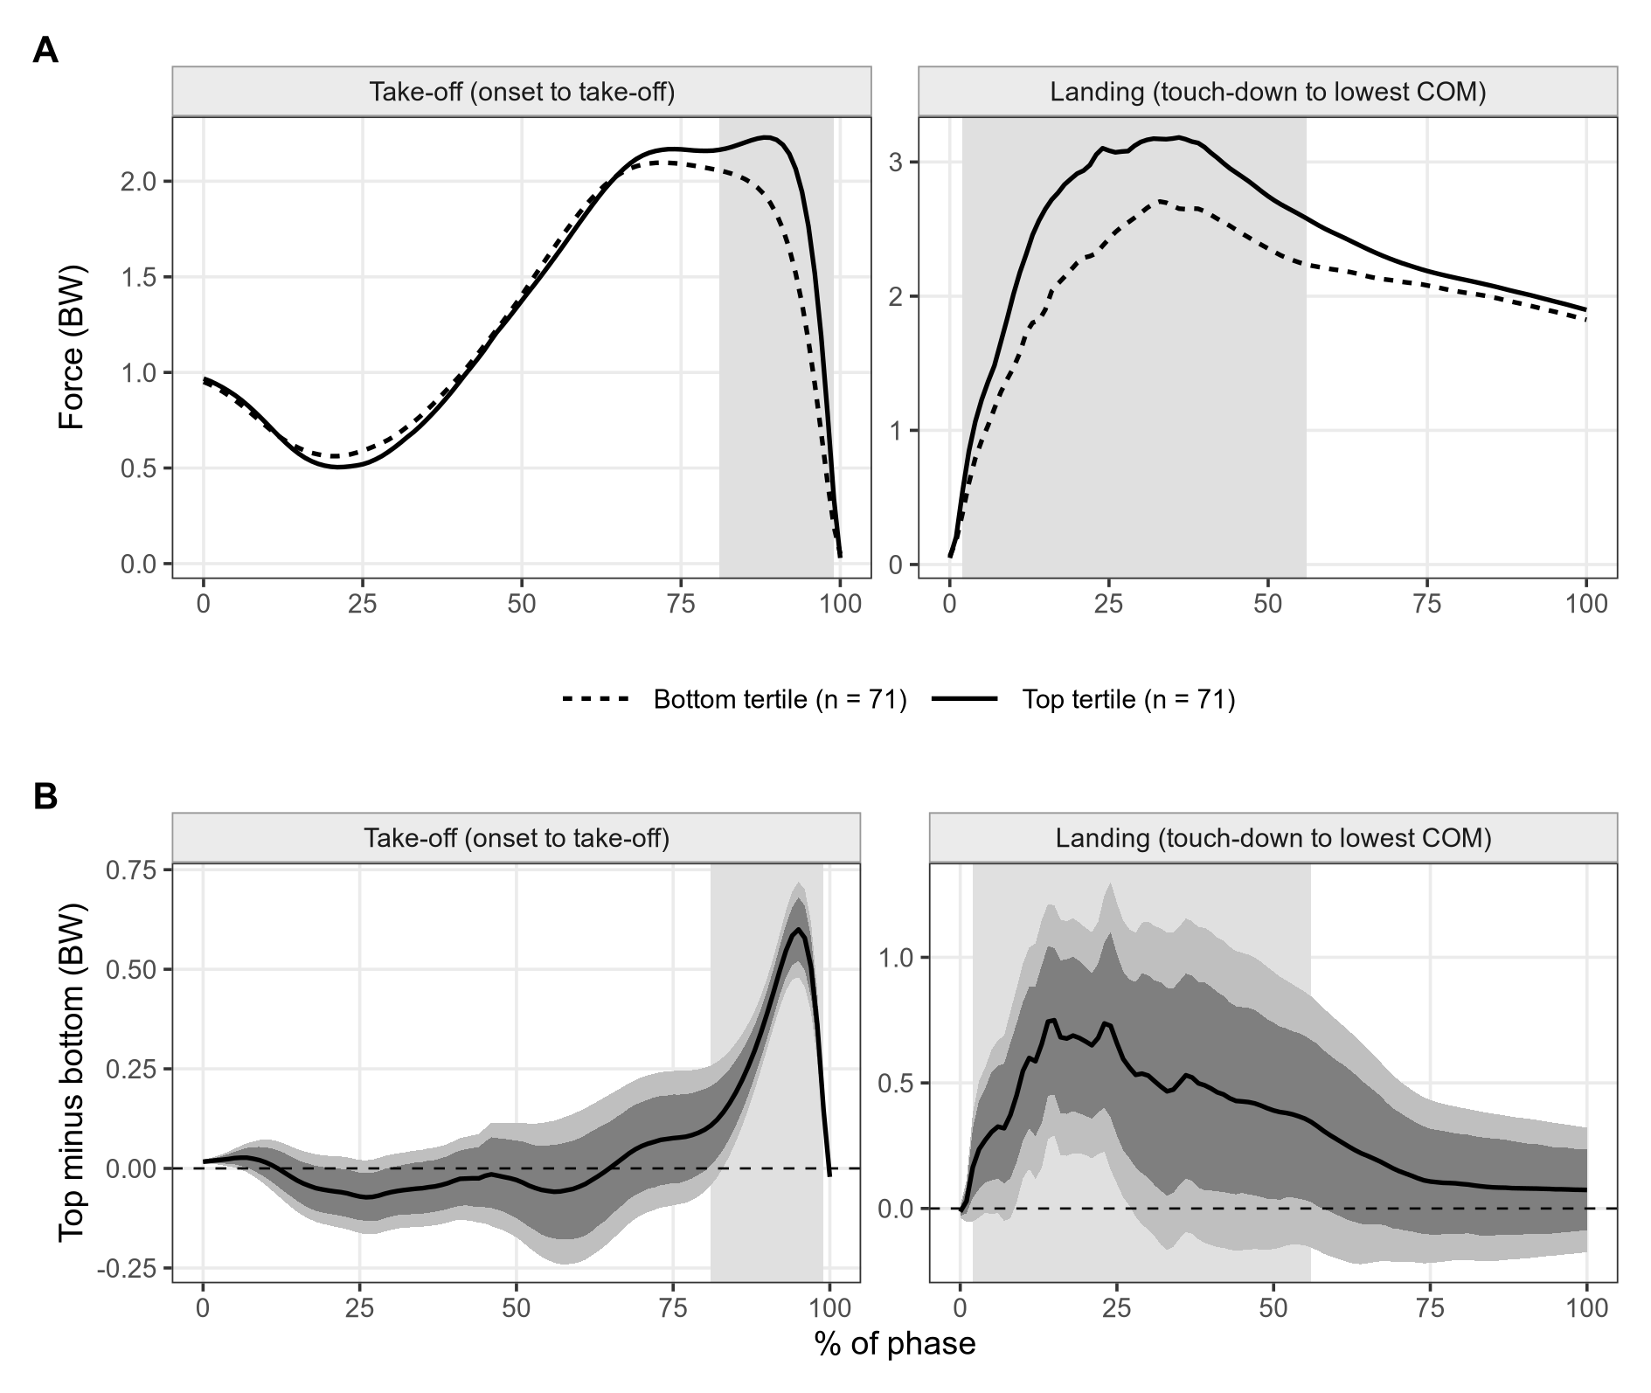
Fig. 2. Top versus bottom jump-height tertile, one mean curve per athlete. (A) Group mean curves. (B) Difference (top minus bottom) with pointwise (dark) and simultaneous (light) 95% bootstrap bands. Background shading marks clusters significant in the permutation test with family-wise error control.
Table 3
Group differences in athlete-mean force curves
 |  |  |  | Difference (BW) |  | Hedges’ g
Phase | Region (%) | p | Peak (%) | Value | 95% CI | Value | 95% CI
Panel A. Top vs bottom tertile of jump height (71 vs 71 athletes)
Take-off | 81–99 | <.001 | 93 | 0.55 | [0.48, 0.61] | 2.63 | [2.31, 2.94]
Landing | 2–56 | .003 | 15 | 0.75 | [0.45, 1.04] | 0.83 | [0.50, 1.15]
Adjusted for age and body massª
Take-off | 12–32 | .021 | – | – | – | – | –
 | 66–99 | <.001 | – | – | – | – | –
Landing | 19–40 | .043 | – | – | – | – | –
Panel B. Aged 18 or over vs under 18 (48 vs 164 athletes)
Take-off | 87–99 | <.001 | 96 | 0.47 | [0.36, 0.56] | 1.60 | [1.25, 1.92]
Landing | none | .069^{c} | – | – | – | – | –
Adjusted for body mass and jump heightª
Take-off | none | .123^{c} | – | – | – | – | –
Landing | none | .226^{c} | – | – | – | – | –
Note. One mean curve per athlete. Region = cluster of adjacent nodes (% of the phase) where the groups differed; p from 5000 permutations of the largest cluster mass, controlling the family-wise error rate over the phase^{b}. Peak = node of the largest |t| in the region, where the difference (first group minus second; BW = multiples of body weight) and Hedges’ g are given with 95% confidence intervals (CIs) from 2000 bootstrap resamples of athletes within groups. Bonferroni threshold for the four primary tests: p < .0125.
ªFreedman–Lane permutation of residuals. ^{b}Nodes with $|t|$ above the two-sided 5% threshold form clusters. ^{c}No significant region; smallest cluster p shown.
Age told a simpler story. Adult players produced more force than under-18 players at the very end of take-off (87–99%, p < .001; difference 0.47 BW [0.36, 0.56], g = 1.60 [1.25, 1.92]), and showed no landing difference that survived family-wise control (the largest cluster, at 10–22%, had p = .069). Once body mass and jump height were adjusted for, the take-off difference disappeared (smallest p = .123). Older players push harder at the end of take-off because they are heavier and jump higher, not because of age as such.

4.2 Matched jump height and curve profiles
The 82 trials from 51 athletes with jump height between 26.0 and 28.2 cm were almost as varied in shape as the full sample: the pointwise SD of their curves was 0.97–0.98 times that of all trials (Fig. 3). Fixing jump height therefore removed almost none of the variation in how force was produced. Both take-off profiles and both landing profiles were present in the band in roughly their overall proportions (Table 4). Two players with the same jump height on a report may thus have produced it with a short, forceful take-off or a long, slower one, and absorbed the landing over a short or a long phase.
Table 4
Take-off and landing curve profiles: characteristics, evidence for distinct groups and stability
 | Take-off profile |  | Landing profile
 | 1 | 2 | 1 | 2
Panel A. Characteristics
Trials (n) | 329 | 476 | 560 | 245
Share of all trials (%) | 41 | 59 | 70 | 30
Share of matched-height trials (%)ª | 35 | 65 | 74 | 26
Jump height (cm), mean^{b} | 29.6 | 27.2 | 28.4 | 27.7
Take-off duration (ms), mean | 649 | 875 | 790 | 764
Landing duration (ms), mean | 240 | 252 | 293 | 141
Panel B. Evidence for distinct groups
Mean silhouette width (0 to 1) | 0.30 |  | 0.37
Groups preferred by the gap statistic^{c} | 1 |  | 6
Dip test of unimodality, p | .741 |  | .978
Lowest bootstrap Jaccard similarity | 0.93 |  | 0.97
Panel C. Stability within athletes (83 athletes tested in two or more sessions)
Same profile in every session (%) | 55 |  | 70
Expected by chance (%) | 43 |  | 51
Permutation p | .007 |  | <.001
Same profile for two trials in a session (%) | 76 |  | 80
Expected by chance (%) | 52 |  | 58
Agreement after elastic alignment^{d} | – |  | 0.17
Note. Profiles from k-means clustering (k = 2) of functional principal component scores covering at least 90% of variance, separately for each phase. Dash = not applicable.
ªJump height between the 45th and 55th percentiles (26.0–28.2 cm; 82 trials). ^{b}Difference between profiles in a linear mixed model with an athlete random intercept: take-off p < .001, landing p = .017. ^{c}Candidates 1 to 6; 1 indicates no cluster structure. ^{d}Adjusted Rand index between profiles from aligned and unaligned landing curves (1 = identical, 0 = chance).
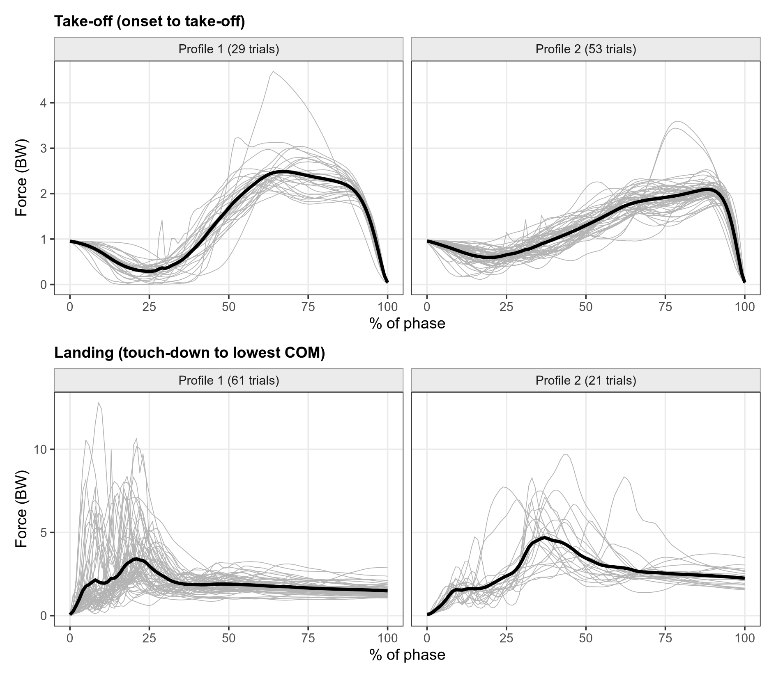
Fig. 3. Jumps of almost equal height (26.0–28.2 cm, 82 trials) still differ in shape. Thin grey lines are individual trials, split by curve profile; the thick black line is the profile mean. Top: take-off. Bottom: landing.
The two-profile solution separated take-offs mainly by duration (mean 649 versus 875 ms) and landings by how quickly the impact was absorbed (mean landing duration 293 versus 141 ms). The validation did not support discrete strategies (Table 4; Fig. 4). Silhouette widths were low (0.30 and 0.37), the gap statistic preferred a single group for take-off and gave no clear answer for landing (6 groups, the largest number allowed), and the dip test found no departure from unimodality in either phase (p = .74 and .98). The profiles were reproducible in the sense that bootstrap resamples recovered them (mean Jaccard similarity 0.93–0.99), but a reproducible cut of a continuum is still a cut. We therefore read the profiles as the two ends of a continuous spectrum.
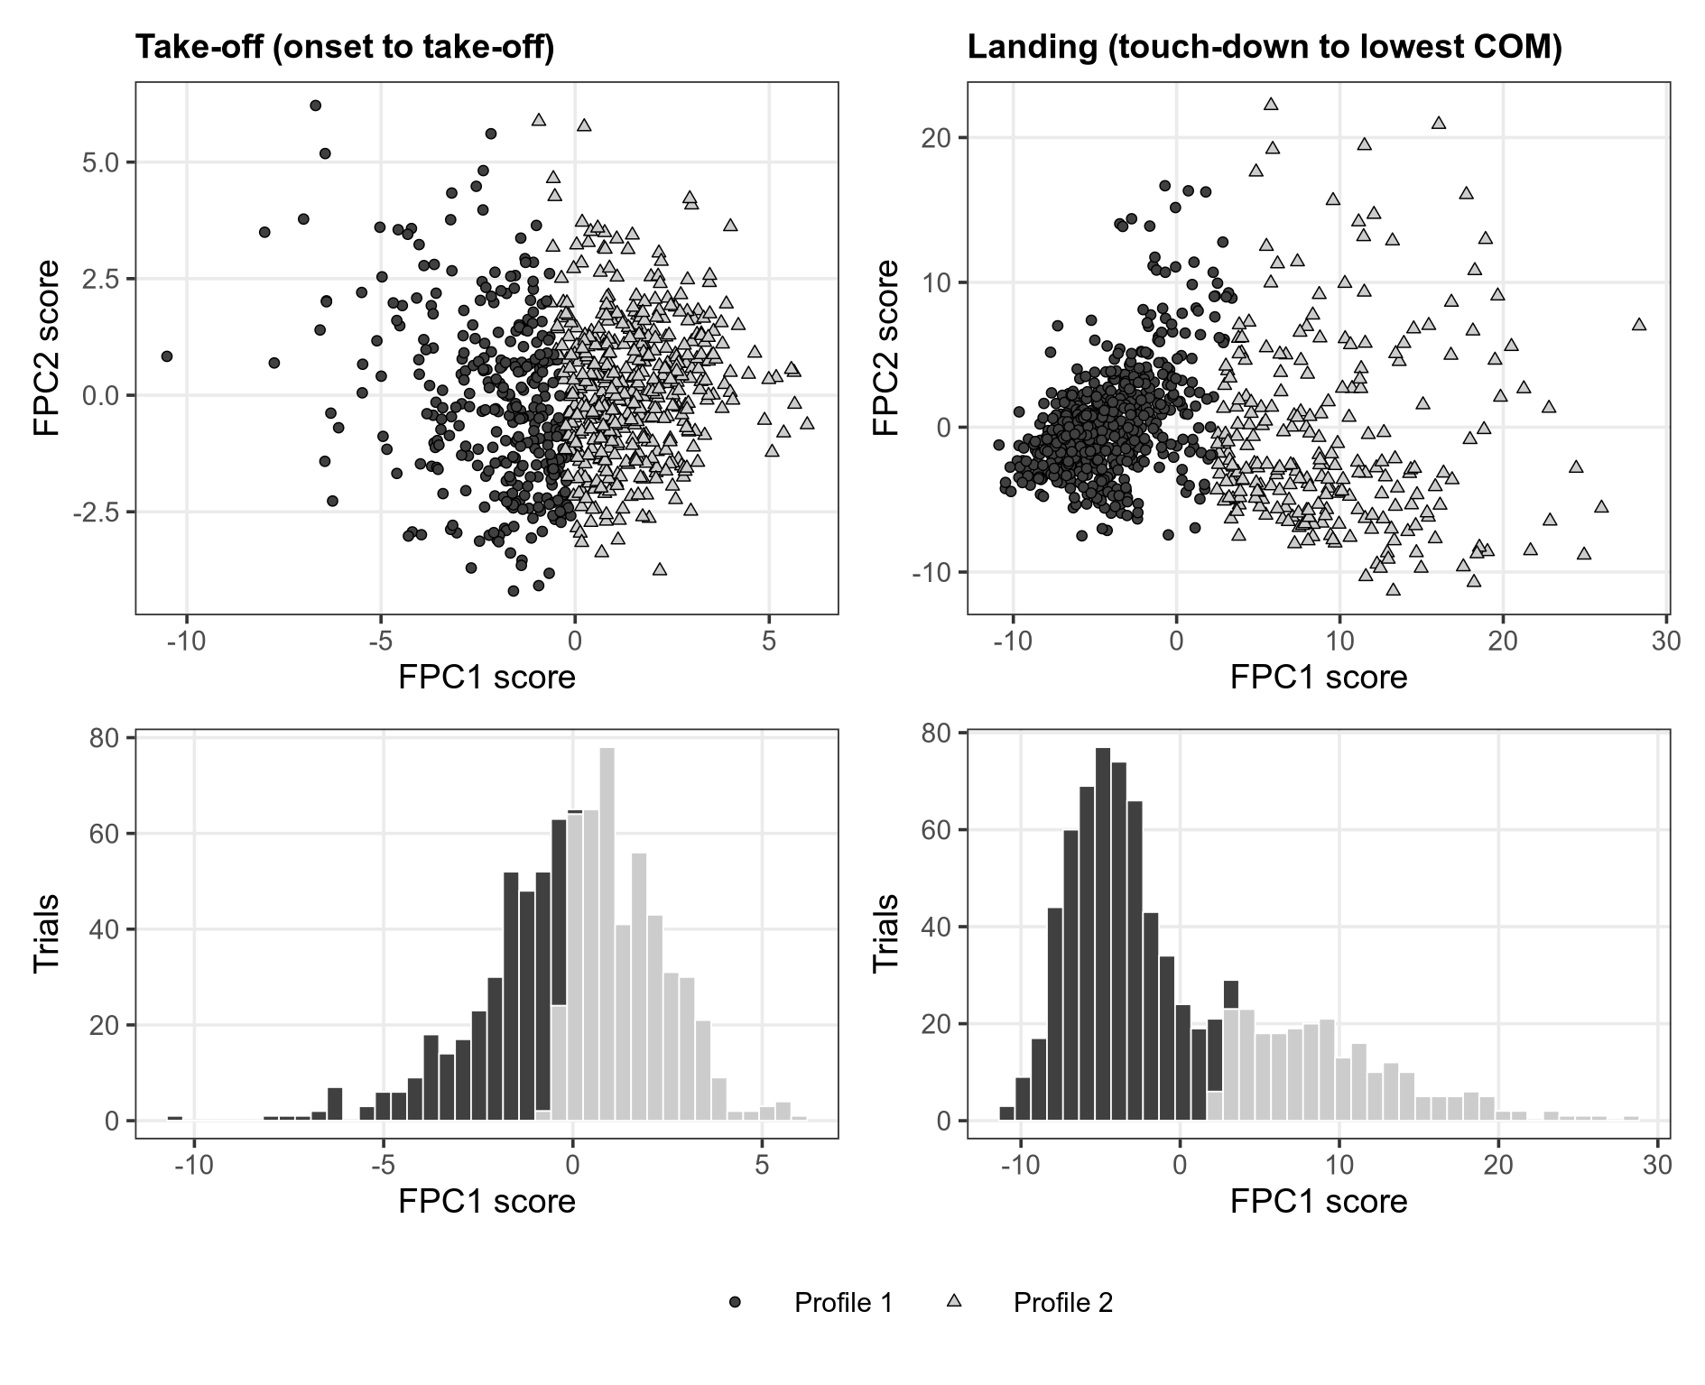
Fig. 4. Curve profiles form a continuum. For each phase, the scatter plot shows the first two functional principal component (FPC) scores of every trial, with symbols for the two k-means profiles, and the histogram shows the distribution of the first score shaded by profile. There is no gap between the profiles and no second mode.
Where an athlete sat on that spectrum was nonetheless partly a stable trait, more so in landing than in take-off. Among the 83 athletes tested more than once, 70% kept the same landing profile in every session against 51% expected by chance (p < .001); for take-off the figures were 55% and 43% (p = .007). Elastic alignment showed why landing profiles should not be over-interpreted. Phase accounted for about 53% of landing variance, the spread of peak timing fell from 15% to 5% of the phase after alignment, and profiles re-derived from aligned curves agreed only weakly with the original ones (adjusted Rand index 0.17). Much of what separates the landing profiles is therefore timing. The tertile difference in landing survived alignment (2–45%, p = .003), while the phase functions showed no group difference. Landmark registration gave the same picture: higher jumpers reached peak landing force earlier (−2.3% of the phase per SD; 95% CI [−4.0, −0.7]), and the landing tertile difference remained at 4–33% (p = .016).

5 Conclusion and implications
The question was where along take-off and landing jumps differ, and what conventional metrics miss. The answer from these routine records is fairly clear. Better jumpers differ most in the late push, from about two-thirds of take-off to the moment of leaving the ground, with a second, earlier difference in the unweighting; these regions were found by two estimation approaches, survived adjustment for age and body mass and were large in standardised terms. Outside the last tenth of take-off, jump height, age and body mass explained very little of the curve, and jumps of the same height came in shapes as varied as the whole sample. Landing differences were weaker in standardised terms, partly explained by size and largely a matter of timing, but the way an athlete lands was a more stable habit than the way he takes off. Apparent age differences reflected size and performance.
These findings agree with waveform studies that place performance differences in the propulsive phase (Floría et al., 2019; Richter et al., 2014), and they add evidence from a youth-dominated monitoring sample analysed at the athlete level. They temper the language of distinct ‘jump strategies’: with validation, the profiles in our data looked like regions of a continuum, a result that warns against reading cluster labels as athlete types (Hennig, 2007). The within-athlete landing effect, which is about three times the between-athlete effect per centimetre, suggests that on days when an athlete jumps higher he also lands harder, a pattern that day-to-day monitoring could follow.
The findings carry four implications for managers of high-performance programmes. The first concerns training emphasis. If force in the final third of take-off is what separates better jumpers, programmes that aim to raise jump height should target the ability to keep producing force as the legs extend, and progress should be judged by changes in that window rather than in jump height alone. The second concerns reporting. A single number hides how it was achieved, so the curve, or at least a late-push and an early-landing summary taken from it, should sit beside jump height in athlete reports. The cost is negligible, because the plates already record the full curve. Third, in youth programmes landing load rises with jump height within the same athlete; coaches who push a young player for height should watch how that player lands, and the persistence of landing profiles across sessions suggests that landing habits can be identified and tracked. Whether a short, stiff landing raises injury risk is a hypothesis that these data cannot test, and it should not be used for selection decisions. Fourth, benchmarks for young players should be adjusted for body size and performance; comparing a 14-year-old with an adult on unadjusted curve features will mostly measure growth (Lloyd & Oliver, 2012; Malina et al., 2015). More broadly, the analysis shows what a performance organisation can learn by reading data it already owns at a finer grain, without new equipment or testing.
The study has limitations, most of which follow from its use of routine data. Testing was not standardised for research, filtering applied by the vendor software is unknown, and low-pass filtering is known to alter CMJ metrics (Harry et al., 2022). Short landings were interpolated rather than sampled: 5.3% had fewer than 101 native samples, and resampling cut the native peak landing force by more than 2% in 10% of trials. Quality control was not neutral, as the dropped trials came from lighter athletes (mean 40.8 versus 54.9 kg, p = .002) with lower jumps (24.9 versus 28.2 cm, p = .044), so the smallest players are slightly under-represented. Trials per athlete were uneven, with the most-tested tenth of athletes contributing 24% of trials; athlete-level resampling and athlete-mean comparisons limit their influence, and trial- and athlete-weighted estimates of the jump-height effect correlated at 0.98 in take-off and 0.97 in landing. The sample is male, mostly adolescent and from one centre, maturation status was not recorded, and the design is cross-sectional, so causal and injury-related claims are beyond its reach. Future work should link curve features to training interventions and injury records over time.

Declarations
Data and code availability. The R code that reproduces every reported result, and the de-identified trial-level data, are available in a public repository (link withheld for blind review; see title page). The raw force–time recordings are held by the testing centre under a non-disclosure agreement and cannot be shared.
Funding. This research did not receive any specific grant from funding agencies in the public, commercial or not-for-profit sectors.
Declaration of competing interest. The authors declare that they have no known competing financial interests or personal relationships that could have appeared to influence the work reported in this paper.
Declaration of generative AI and AI-assisted technologies in the writing process. During the preparation of this work, the authors used AI tools to assist with language editing and code review. After using these tools, the authors reviewed and edited the content as needed and take full responsibility for the content of the publication.

References
Claudino, J. G., Cronin, J., Mezêncio, B., McMaster, D. T., McGuigan, M., Tricoli, V., Amadio, A. C., & Serrão, J. C. (2017). The countermovement jump to monitor neuromuscular status: A meta-analysis. Journal of Science and Medicine in Sport, 20(4), 397–402. https://doi.org/10.1016/j.jsams.2016.08.011
Cormack, S. J., Newton, R. U., McGuigan, M. R., & Doyle, T. L. A. (2008). Reliability of measures obtained during single and repeated countermovement jumps. International Journal of Sports Physiology and Performance, 3(2), 131–144. https://doi.org/10.1123/ijspp.3.2.131
Di, C.-Z., Crainiceanu, C. M., Caffo, B. S., & Punjabi, N. M. (2009). Multilevel functional principal component analysis. The Annals of Applied Statistics, 3(1), 458–488. https://doi.org/10.1214/08-aoas206
Dowling, J. J., & Vamos, L. (1993). Identification of kinetic and temporal factors related to vertical jump performance. Journal of Applied Biomechanics, 9(2), 95–110. https://doi.org/10.1123/jab.9.2.95
Efron, B., & Tibshirani, R. J. (1993). An introduction to the bootstrap. Springer. https://doi.org/10.1007/978-1-4899-4541-9
Floría, P., Sánchez-Sixto, A., & Harrison, A. J. (2019). Application of the principal component waveform analysis to identify improvements in vertical jump performance. Journal of Sports Sciences, 37(4), 370–377. https://doi.org/10.1080/02640414.2018.1504602
França, C. de, Jordan, M. J., Botha, T., & Bayne, H. (2025). Countermovement jump kinetic impairments in elite athletes before and after ACL injury: Force-time waveform versus discrete kinetic analysis. Translational Sports Medicine, 2025. https://doi.org/10.1155/tsm2/1176787
Gathercole, R., Sporer, B., Stellingwerff, T., & Sleivert, G. (2015). Alternative countermovement-jump analysis to quantify acute neuromuscular fatigue. International Journal of Sports Physiology and Performance, 10(1), 84–92. https://doi.org/10.1123/ijspp.2013-0413
Goldsmith, J., Bobb, J., Crainiceanu, C. M., Caffo, B., & Reich, D. (2011). Penalized functional regression. Journal of Computational and Graphical Statistics, 20(4), 830–851. https://doi.org/10.1198/jcgs.2010.10007
Gunning, E., Warmenhoven, J., Harrison, A. J., & Bargary, N. (2024). Functional data analysis in biomechanics: A concise review of core techniques, applications and emerging areas. In SpringerBriefs in Statistics. https://doi.org/10.1007/978-3-031-68862-1
Harry, J. R., Blinch, J., Barker, L. A., Krzyszkowski, J., & Chowning, L. (2022). Low-pass filter effects on metrics of countermovement vertical jump performance. Journal of Strength & Conditioning Research, 36(5), 1459–1467. https://doi.org/10.1519/jsc.0000000000003611
Hartigan, J. A., & Hartigan, P. M. (1985). The dip test of unimodality. The Annals of Statistics, 13(1), 70–84. https://doi.org/10.1214/aos/1176346577
Hennig, C. (2007). Cluster-wise assessment of cluster stability. Computational Statistics & Data Analysis, 52(1), 258–271. https://doi.org/10.1016/j.csda.2006.11.025
Hori, N., Newton, R. U., Kawamori, N., McGuigan, M. R., Kraemer, W. J., & Nosaka, K. (2009). Reliability of performance measurements derived from ground reaction force data during countermovement jump and the influence of sampling frequency. Journal of Strength and Conditioning Research, 23(3), 874–882. https://doi.org/10.1519/jsc.0b013e3181a00ca2
Jacques, J., & Preda, C. (2014). Functional data clustering: A survey. Advances in Data Analysis and Classification, 8(3), 231–255. https://doi.org/10.1007/s11634-013-0158-y
Kaufman, L., & Rousseeuw, P. J. (1990). Finding groups in data: An introduction to cluster analysis. Wiley. https://doi.org/10.1002/9780470316801
Kipp, K., Kiely, M. T., & Geiser, C. F. (2015). Changes in principal component structure of countermovement jumps after a volleyball season. 33rd International Conference of Biomechanics in Sports (ISBS Proceedings Archive). https://ojs.ub.uni-konstanz.de/cpa/article/view/6581
Laffaye, G., Wagner, P. P., & Tombleson, T. I. L. (2014). Countermovement jump height: Gender and sport-specific differences in the force-time variables. Journal of Strength and Conditioning Research, 28(4), 1096–1105. https://doi.org/10.1519/JSC.0b013e3182a1db03
Linthorne, N. P. (2001). Analysis of standing vertical jumps using a force platform. American Journal of Physics, 69(11), 1198–1204. https://doi.org/10.1119/1.1397460
Lloyd, R. S., & Oliver, J. L. (2012). The youth physical development model: A new approach to long-term athletic development. Strength and Conditioning Journal, 34(3), 61–72. https://doi.org/10.1519/SSC.0b013e31825760ea
Malina, R. M., Rogol, A. D., Cumming, S. P., Coelho e Silva, M. J., & Figueiredo, A. J. (2015). Biological maturation of youth athletes: Assessment and implications. British Journal of Sports Medicine, 49(13), 852–859. https://doi.org/10.1136/bjsports-2015-094623
Maris, E., & Oostenveld, R. (2007). Nonparametric statistical testing of EEG- and MEG-data. Journal of Neuroscience Methods, 164(1), 177–190. https://doi.org/10.1016/j.jneumeth.2007.03.024
McMahon, J. J., Suchomel, T. J., Lake, J. P., & Comfort, P. (2018). Understanding the key phases of the countermovement jump force-time curve. Strength & Conditioning Journal, 40(4), 96–106. https://doi.org/10.1519/ssc.0000000000000375
Morris, J. S. (2015). Functional regression. Annual Review of Statistics and Its Application, 2(1), 321–359. https://doi.org/10.1146/annurev-statistics-010814-020413
Morris, J. S., & Carroll, R. J. (2006). Wavelet-based functional mixed models. Journal of the Royal Statistical Society Series B: Statistical Methodology, 68(2), 179–199. https://doi.org/10.1111/j.1467-9868.2006.00539.x
Moudy, S., Richter, C., & Strike, S. (2018). Landmark registering waveform data improves the ability to predict performance measures. Journal of Biomechanics, 78, 109–117. https://doi.org/10.1016/j.jbiomech.2018.07.027
Nichols, T. E., & Holmes, A. P. (2002). Nonparametric permutation tests for functional neuroimaging: A primer with examples. Human Brain Mapping, 15(1), 1–25. https://doi.org/10.1002/hbm.1058
Parker, J., & Lundgren, L. E. (2018). Surfing the waves of the CMJ; are there between-sport differences in the waveform data? Sports, 6(4), 168. https://doi.org/10.3390/sports6040168
Pataky, T. C. (2012). One-dimensional statistical parametric mapping in Python. Computer Methods in Biomechanics and Biomedical Engineering, 15(3), 295–301. https://doi.org/10.1080/10255842.2010.527837
Pataky, T. C., Robinson, M. A., Vanrenterghem, J., & Donnelly, C. J. W. (2022). Simultaneously assessing amplitude and temporal effects in biomechanical trajectories using nonlinear registration and statistical nonparametric mapping. Journal of Biomechanics, 136, 111049. https://doi.org/10.1016/j.jbiomech.2022.111049
Pataky, T. C., Vanrenterghem, J., & Robinson, M. A. (2015). Zero- vs. One-dimensional, parametric vs. Non-parametric, and confidence interval vs. Hypothesis testing procedures in one-dimensional biomechanical trajectory analysis. Journal of Biomechanics, 48(7), 1277–1285. https://doi.org/10.1016/j.jbiomech.2015.02.051
R Core Team. (2026). R: A language and environment for statistical computing (Version 4.5.3) [Computer software]. R Foundation for Statistical Computing. https://www.R-project.org/
Ramsay, J. O., & Silverman, B. W. (2005). Functional data analysis. In Springer Series in Statistics. https://doi.org/10.1007/b98888
Richter, C., O’Connor, N. E., Marshall, B., & Moran, K. (2014). Analysis of characterizing phases on waveforms: An application to vertical jumps. Journal of Applied Biomechanics, 30(2), 316–321. https://doi.org/10.1123/jab.2012-0218
Ruppert, D., Wand, M. P., & Carroll, R. J. (2003). Semiparametric regression. Cambridge University Press. https://doi.org/10.1017/CBO9780511755453
Scheipl, F., Staicu, A.-M., & Greven, S. (2015). Functional additive mixed models. Journal of Computational and Graphical Statistics, 24(2), 477–501. https://doi.org/10.1080/10618600.2014.901914
Srivastava, A., Wu, W., Kurtek, S., Klassen, E., & Marron, J. S. (2011). Registration of functional data using Fisher-Rao metric. https://arxiv.org/abs/1103.3817
Street, G., McMillan, S., Board, W., Rasmussen, M., & Heneghan, J. M. (2001). Sources of error in determining countermovement jump height with the impulse method. Journal of Applied Biomechanics, 17(1), 43–54. https://doi.org/10.1123/jab.17.1.43
Tibshirani, R., Walther, G., & Hastie, T. (2001). Estimating the number of clusters in a data set via the gap statistic. Journal of the Royal Statistical Society Series B: Statistical Methodology, 63(2), 411–423. https://doi.org/10.1111/1467-9868.00293
Tucker, J. D., Wu, W., & Srivastava, A. (2013). Generative models for functional data using phase and amplitude separation. Computational Statistics & Data Analysis, 61, 50–66. https://doi.org/10.1016/j.csda.2012.12.001
Warmenhoven, J., Cobley, S., Draper, C., Harrison, A., Bargary, N., & Smith, R. (2019). Considerations for the use of functional principal components analysis in sports biomechanics: Examples from on-water rowing. Sports Biomechanics, 18(3), 317–341. https://doi.org/10.1080/14763141.2017.1392594
Warmenhoven, J., Harrison, A., Robinson, M. A., Vanrenterghem, J., Bargary, N., Smith, R., Cobley, S., Draper, C., Donnelly, C., & Pataky, T. (2018). A force profile analysis comparison between functional data analysis, statistical parametric mapping and statistical non-parametric mapping in on-water single sculling. Journal of Science and Medicine in Sport, 21(10), 1100–1105. https://doi.org/10.1016/j.jsams.2018.03.009
White, M. G. E., Neville, J., Rees, P., Summers, H., & Bezodis, N. (2022). The effects of curve registration on linear models of jump performance and classification based on vertical ground reaction forces. Journal of Biomechanics, 140, 111167. https://doi.org/10.1016/j.jbiomech.2022.111167
White, M., Bezodis, N., Neville, J., & Summers, H. (2020). Force-time curve alignment for functional principal component analysis in vertical jumping. ISBS Proceedings Archive, 38. https://commons.nmu.edu/isbs/vol38/iss1/82/
Winkler, A. M., Ridgway, G. R., Webster, M. A., Smith, S. M., & Nichols, T. E. (2014). Permutation inference for the general linear model. NeuroImage, 92, 381–397. https://doi.org/10.1016/j.neuroimage.2014.01.060

