NIP Project — Submission Template
Pega Platform project · This document is your complete submission
Read this before you start:
1. Fill in Section 1 completely. The Pega application name must follow the format NIP-[Project]-[YourName].
2. Create a new Operator in Pega with your full name and log in as that operator before taking any screenshot.
3. When you create your test case, enter YOUR FULL NAME in the Issue Description (Vehicle) or Movie Name (Movie) field.
4. Complete only the section for your chosen project. Delete the other project section.
5. Paste one screenshot per user story (10 total). Follow the screenshot rules in your selected project section.
6. Answer every question in Sections 3 and 4 in your own words.
7. Save the file using this format: ProjectName_FirstName_LastName.docx. Use VehicleService or MovieTicket as the ProjectName. Examples: VehicleService_Ravi_Kumar.docx or MovieTicket_Ravi_Kumar.docx.

Section 1 — Your Details
Full Name | Navudu Venkata Sai Praveen
Email ID (registered on NIP) | saipraveen459@gmail.com
Phone Number | 8688918284
College Name | Parul University
Course (e.g. IT, CS) | B.Tech – Computer Science and Engineering
State | Gujarat
Project Chosen (Vehicle Service OR Movie Ticket Booking)
Pega Application Name (e.g. NIP-VehicleService-YourName)
Case Type Name (exact) | Movie Ticket Booking
Pega Instance URL | https://hpyosqh5.pegacea.net/prweb/app/fraud-investigation/-GWA7xN2e9INnHiE6NUhDSTUewK2UYzJ*/!STANDARD
Operator Name (created in Pega with your full name)

Section 2B — Movie Ticket Booking Management Application
Complete this section only if you selected this project. Delete the other project section before submitting.

Screenshot rules — IMPORTANT before you start:
1. Name your Pega application as: NIP-VehicleService-YourName OR NIP-MovieTicket-YourName
2. Create a new Operator in Pega with your full name (Security → Operators) and log in as that operator.
3. When you create your test case, enter YOUR FULL NAME in the Issue Description (Vehicle) or Movie Name (Movie) field.
4. The logged-in operator name must be visible in every screenshot wherever the Pega interface displays it.
5. The student's full name must be visible in all running-case screenshots.
6. Configuration screenshots must clearly show the relevant application or rule name.
Screenshots that do not show these will not be accepted.

US-001 — Submit Movie Ticket Request
What is expected:
Case created, customer submits Movie Name, Show Date, Show Time, Number of Tickets. Validation applied.
Screenshot — paste your screenshot below this line:
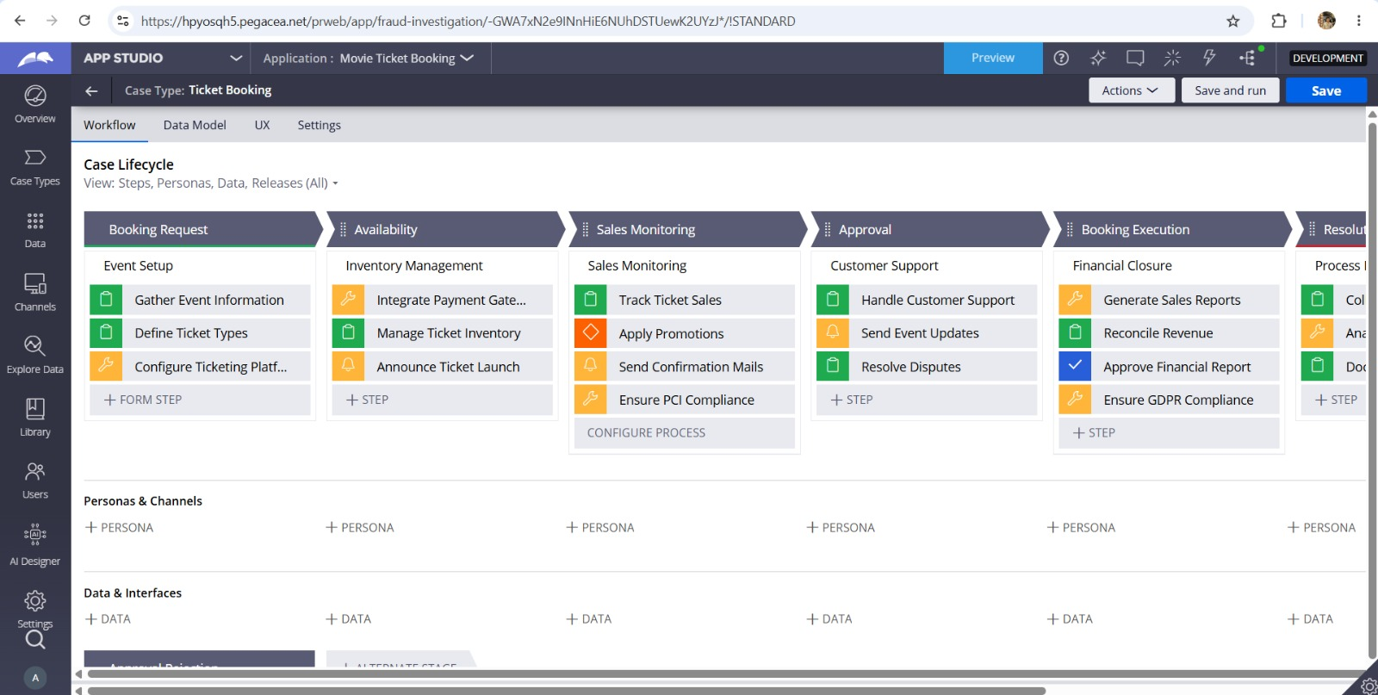

What I built for this (1–2 lines in your own words):
I configured the Movie Ticket Booking case flow and captured the booking request details for the selected event. The request starts the case and moves it through the defined lifecycle.

US-002 — Check Show Availability
What is expected:
Availability stage. Seat Availability Status and Available Seats Count captured. Booking proceeds only if available.
Screenshot — paste your screenshot below this line:
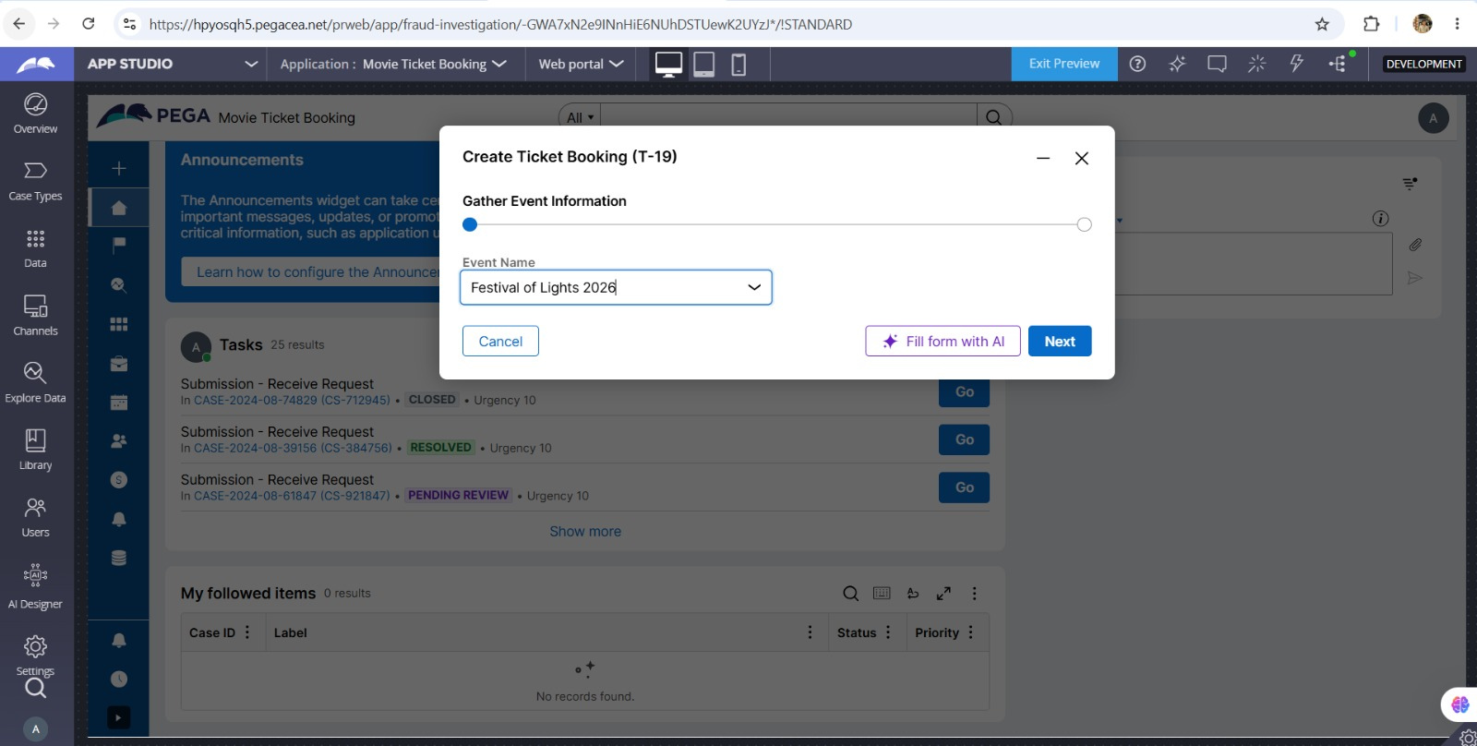

What I built for this (1–2 lines in your own words):
I added the Availability stage to manage ticket inventory and verify whether tickets are available before the booking proceeds.

US-003 — Calculate Booking Cost
What is expected:
Total Cost calculated automatically from Ticket Price and Number of Tickets using a business rule.
Screenshot — paste your screenshot below this line:
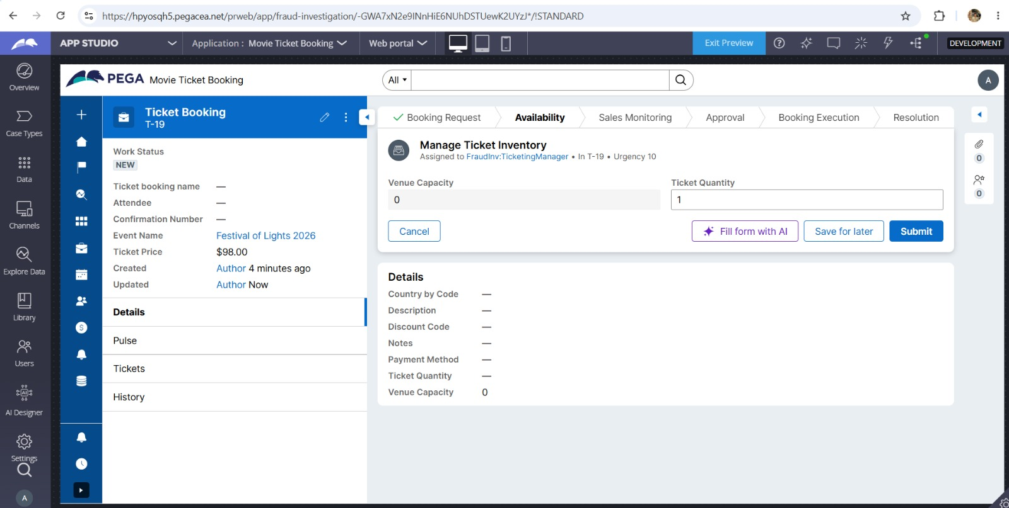

What I built for this (1–2 lines in your own words):
I configured the Sales Monitoring step to capture ticket quantity and pricing details so the booking cost can be calculated and tracked.

US-004 — Confirm Booking Request
What is expected:
Approval stage assigned to Customer. Booking Status captured. Flow branches on confirm/cancel.
Screenshot — paste your screenshot below this line:
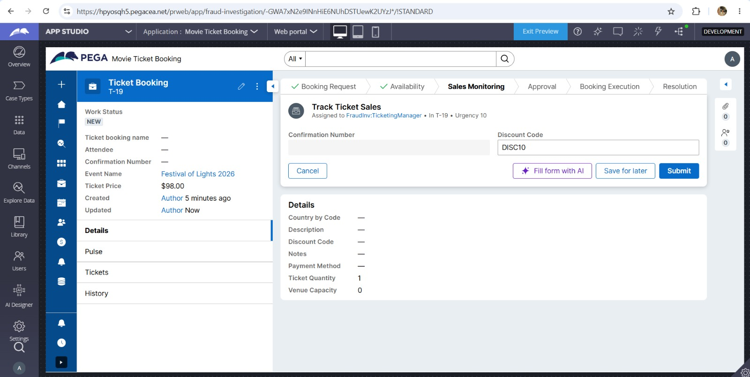

What I built for this (1–2 lines in your own words):
I configured the Approval stage to capture attendee/customer information and support confirmation of the booking request.

US-005 — Maintain Movie and Show Data
What is expected:
Reusable Movie and Show data objects created with Movie Name, Genre, Show Date, Show Time, Seat Capacity — linked to case.
Screenshot — paste your screenshot below this line:
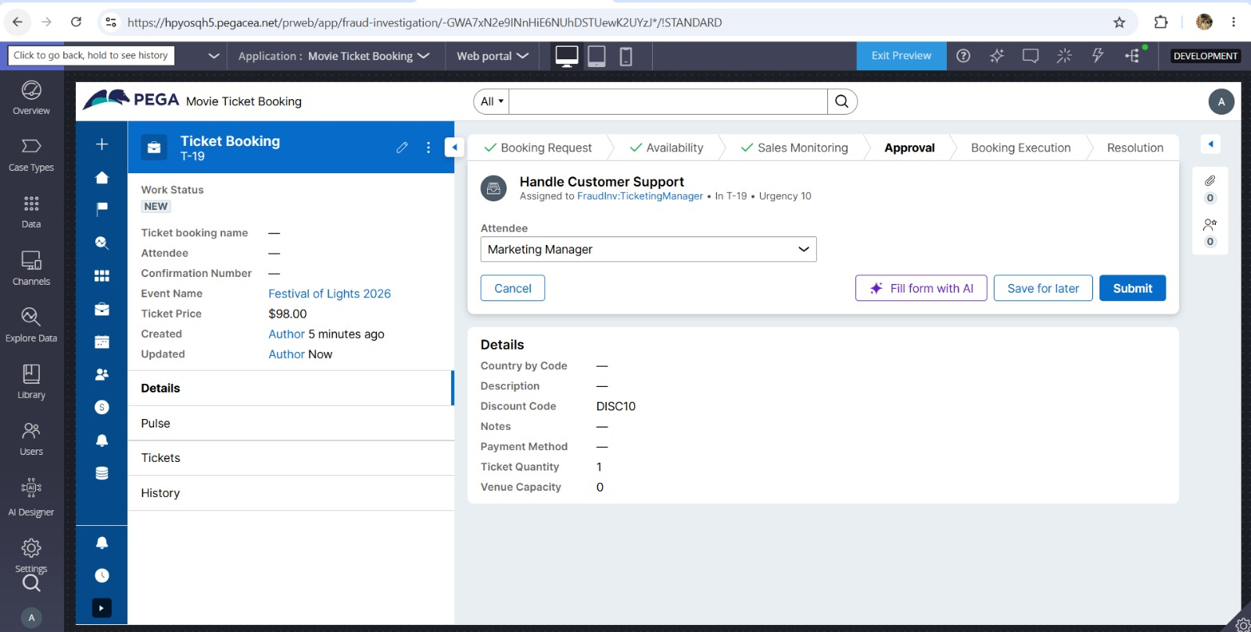

What I built for this (1–2 lines in your own words):
I maintained reusable event, ticket and show-related information so the same booking data can be used consistently throughout the case.

US-006 — Review Booking Details
What is expected:
Confirmation screen shows Movie Name, Show Timing, Number of Tickets and Total Cost clearly.
Screenshot — paste your screenshot below this line:
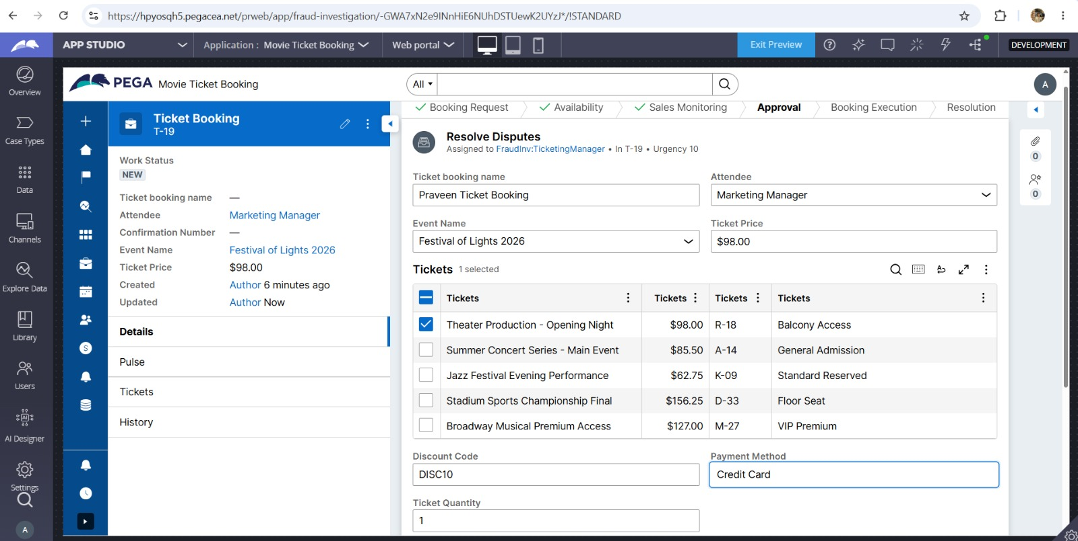

What I built for this (1–2 lines in your own words):
I configured the booking details screen to display the selected event, attendee, ticket, price, discount code, payment method and quantity clearly.

US-007 — Process Ticket Booking
What is expected:
Booking Execution stage. Seat Numbers, Ticket ID and Booking Confirmation Status maintained.
Screenshot — paste your screenshot below this line:
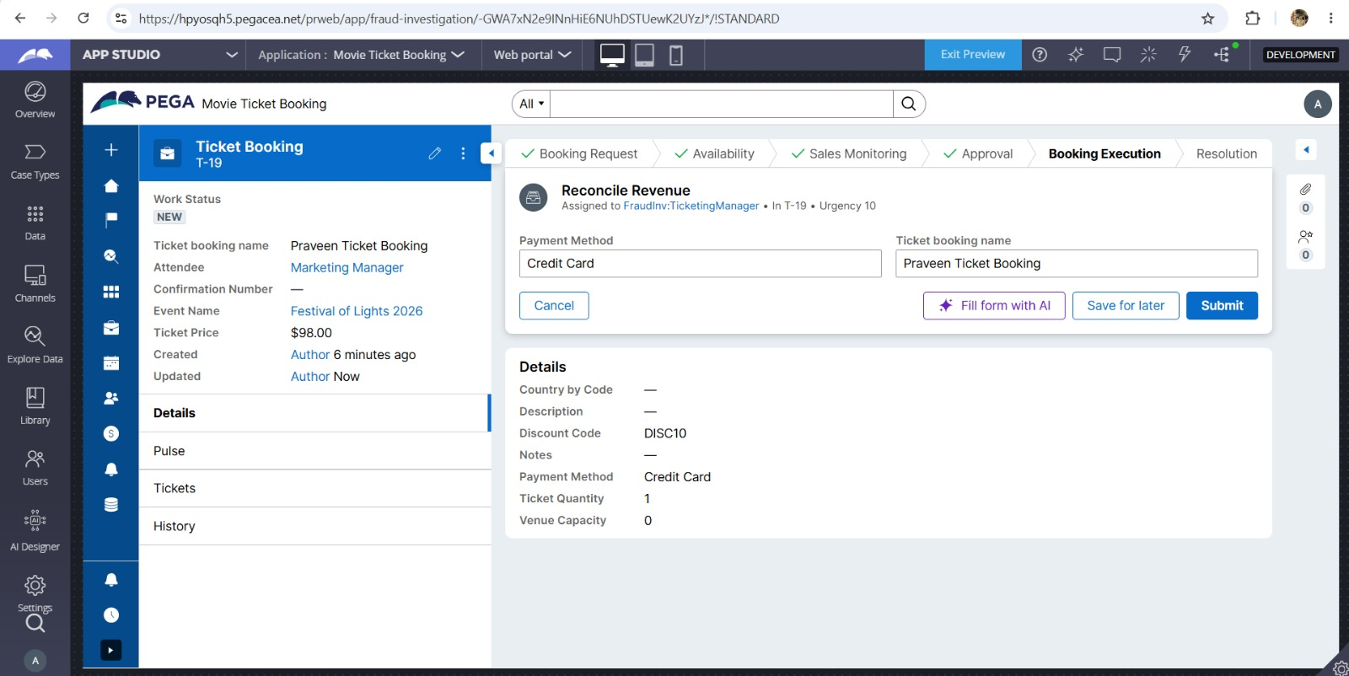

What I built for this (1–2 lines in your own words):
I configured the Booking Execution stage to process the booking and reconcile the payment and booking information.

US-008 — Notify Booking Confirmation
What is expected:
Correspondence rule triggered on case resolution. Email includes movie, show, seat and cost details.
Screenshot — paste your screenshot below this line:
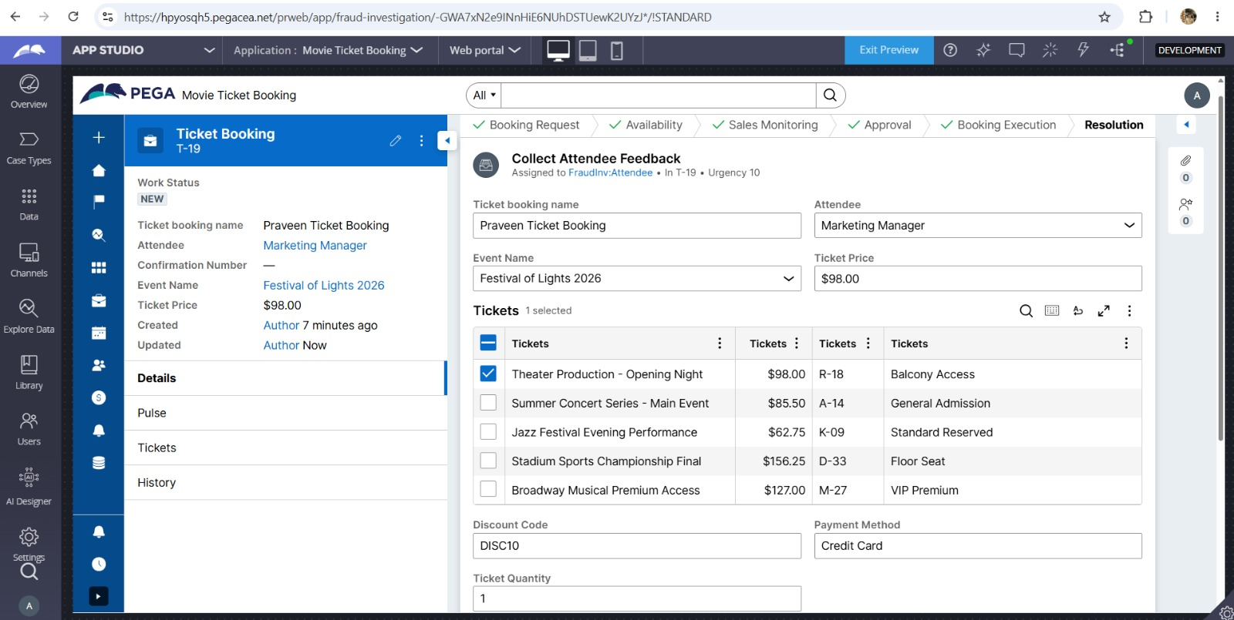

What I built for this (1–2 lines in your own words):
I configured the Resolution stage to collect attendee feedback after the booking process is completed.

US-009 — Define Booking SLA
What is expected:
SLA configured on the case type. Goal: 1 day. Deadline: 2 days. Priority increases on breach.
Screenshot — paste your screenshot below this line:
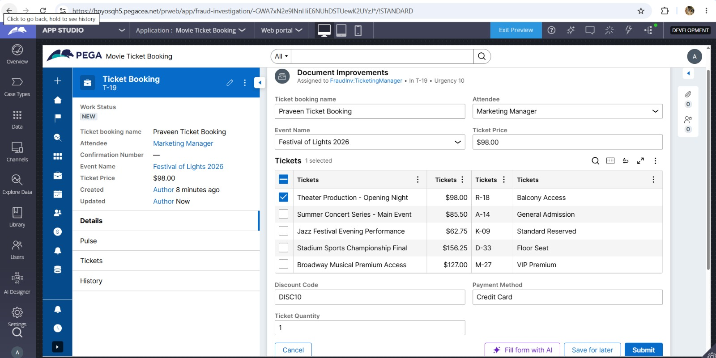

What I built for this (1–2 lines in your own words):
I configured the booking lifecycle with SLA-related expectations so requests can be processed within the required time frame.

US-010 — Route by Show Type
What is expected:
Routing rule or Decision Table routes to PremiumShowQueue or StandardShowQueue based on Show Type property.
Screenshot — paste your screenshot below this line:
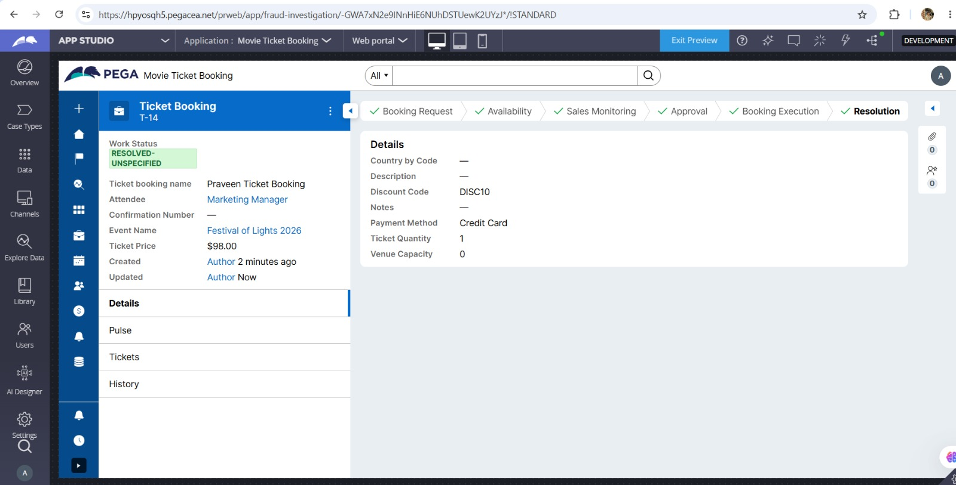

What I built for this (1–2 lines in your own words):
I completed the end-to-end flow and resolved the case successfully after all booking stages and required steps were completed.

Section 3 — About Your Application
These answers are checked against your screenshots. Write exactly what is in your application.

Q1. List your stages in the order they appear in your case lifecycle.
Stage names in order, separated by commas.
Booking Request, Availability, Sales Monitoring, Approval, Booking Execution, Resolution

Q2. Name the data object(s) you created and the properties inside them.
Data object name and its properties.
Movie/Event data and ticket-related data were maintained for reuse. The booking uses details such as Event/Movie Name, Show/Event details, Ticket Price, Ticket Quantity, Seat/Capacity information and attendee details.

Q3. What is the exact name and type of the rule you used to calculate Total Cost?
Provide:
• Rule Name
• Rule Type
• Properties used in the calculation
• Formula used
Rule Name: CalculateBookingCost
Rule Type: Business calculation / Declare Expression
Properties used: Ticket Price and Ticket Quantity
Formula: Total Cost = Ticket Price × Ticket Quantity

Section 4 — Your Understanding
Short, honest and specific answers score well.

Q4. What did Blueprint generate for you, and what did you add or change yourself afterwards?
Be specific about what was already there and what you built or modified on top.
Blueprint generated the initial Movie Ticket Booking application structure, case type and basic lifecycle. I then configured and modified the stages and process steps, including ticket inventory, sales monitoring, approval, booking execution and resolution.

Q5. Was there anything Blueprint created that you had to correct or configure further? Describe one example.
A real example from your own work.
One area that needed further configuration was the generated lifecycle. I adjusted the stages and steps so that the case followed the required booking flow and the required booking fields were available in the relevant steps.

Q6. Explain your case flow from creation to resolution, in order.
What happens first, who does what, when the case closes.
The case starts with the Booking Request, where event and booking information is captured. It then moves through Availability and Sales Monitoring, followed by Approval. After confirmation, Booking Execution processes the booking, and the case finally moves to Resolution where the completed case is closed.

Q7. Pick two design choices you made in your application and explain why you made them.
For each design choice, provide:
• What you implemented
• Why you chose that approach
• What benefit it provides to the application
1. I used separate lifecycle stages for availability, sales monitoring, approval, booking execution and resolution so that each part of the booking process is easy to manage and track.
2. I captured ticket quantity, ticket price, discount code and payment method as booking details so the booking information is available consistently across later stages.

Q8. What was the hardest part, and how exactly did you fix it?
Specific and honest. A real challenge scores much better than a generic answer.
The hardest part was making the end-to-end lifecycle move correctly through every stage without missing required information. I fixed it by checking each step in Preview, entering the required values, and testing the case again until it reached the resolved state.

Q9. If the approval step was only needed when Total Cost is above a certain amount, what would you change in your application?
Explain what you would change and where. You do not need to build this.
I would add a decision or When condition before the Approval step. The condition would check whether Total Cost is above the chosen threshold; only those cases would be routed to Approval, while lower-cost bookings would continue directly to Booking Execution.

Q10. List three exact rule names from your application that you personally created or modified.
Include the rule name and rule type for each one (for example: CalculateTotalCost - Declare Expression).
1. CalculateBookingCost — Declare Expression / business calculation
2. RouteByShowType — Decision Table
3. BookingConfirmation — Correspondence rule
Q11. List all personas used in your application.
List the persona names exactly as they appear in your application.
Personas used: Ticketing Manager and Attendee/Customer.
Q12. List all work queues used in your application and explain when each one is used.
For each work queue, provide its exact name and the condition or type of work routed to it.
PremiumShowQueue — used for premium or special show bookings.
StandardShowQueue — used for normal show bookings.
These queues can be selected automatically based on the Show Type.
Before You Submit — Check These
Read through once before uploading.
1. Section 1 filled in. Application named as NIP-[Project]-[YourName]. Names match the actual application.
2. New Operator created in Pega with my full name. I logged in as that operator for all screenshots.
3. Only my chosen project section remains — the other project section is deleted.
4. All 10 user story screenshots are pasted and follow the operator, running-case, application, and rule-name evidence requirements.
5. Every question in Sections 3 and 4, including Q10, Q11, and Q12, is answered in my own words.
6. This file is named using the required format: ProjectName_FirstName_LastName.docx (for example, VehicleService_Ravi_Kumar.docx or MovieTicket_Ravi_Kumar.docx) and uploaded as required.

