Experiment -3
Flight Reservation System Using Zoho One (SaaS)
Aim
To create a Flight Reservation System using Zoho One as a cloud-based Software as a Service (SaaS) application.
Procedure
- Log in to the Zoho One cloud platform.
- Open Zoho Creator from the Zoho One applications.
- Create a new application named Flight Reservation System.
- Create a new form named Flight Reservation.
- Add the required field.
- Configure the field types according to the data required.
- Add One Way and Round Trip options under Trip Type.
- Add Domestic and International options under Flight Type.
- Add Economy, Premium Economy, Business, and First Class options under Class.
- Add Regular, Student, and Senior Citizen options under Fare Type.
- Add suitable departure and destination locations.
- Configure the Departure Date and Return Date fields.
- Add the required number of travelers.

- Design and arrange the form for easy user interaction.
- Save and publish the form.
- Enter sample flight reservation details into the form.
- Submit the form and verify that the entered data is stored in the cloud.
- Open the report and verify the submitted flight reservation record.
- Test the application by entering different One Way, Round Trip, Domestic, and International flight details.
- Verify that the Flight Reservation System works successfully as a SaaS application.

Input:
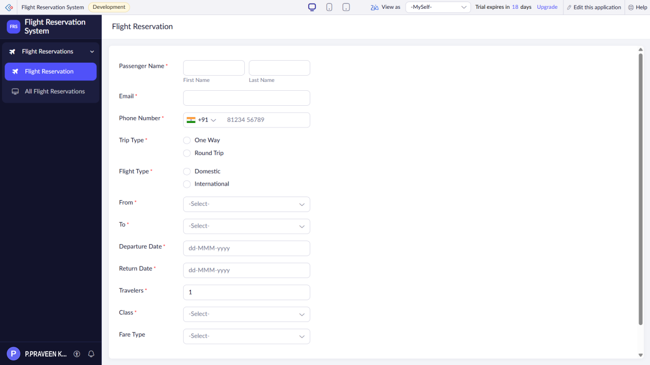

Output:
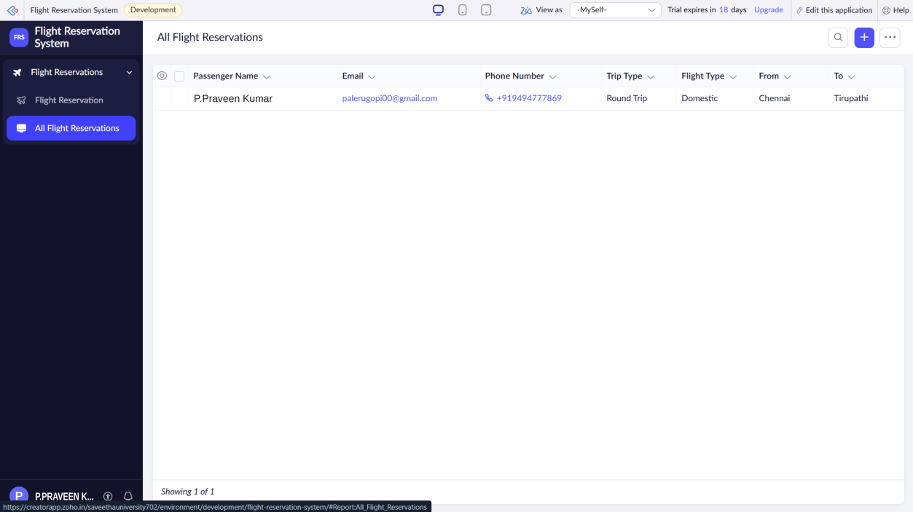
Result
Thus, a Flight Reservation System was successfully created using Zoho One and demonstrated as a Software as a Service (SaaS) application.

