Experiment -4
Library Book Reservation System Using Zoho One (SaaS)
Aim
To design and develop a Library Book Reservation System for the SIMATS Library using Zoho One / Zoho Creator, deployed as a cloud-based Software as a Service (SaaS) application.
Procedure
- Sign in to the Zoho One cloud platform.
- Launch Zoho Creator from the list of Zoho One applications.
- Create a new application and name it Library Book Reservation System.
- Inside the application, create a new form called Library Book Details.

- Set the appropriate field type for each field based on the data it will hold.
- Use text fields to record the book title, author name, publication house, and year of publication.
- Include the Edition and Number of Copies fields to keep track of each book’s details and stock.
- Add the Rack Number field so the shelf location of every book can be identified.
- Add a Book Status field with the choices Available, Taken, and Returned.
- Arrange the fields neatly so the form is simple and convenient to use.
- Save the form and publish it.
- Fill in sample library book details in the form.

- Submit the form and confirm that the data is saved in the cloud.
- Open the report view and check that the submitted book record is listed.
- Test the application with different book entries and update their status to check that changes are reflected.
- Confirm that the Library Book Reservation System runs successfully as a SaaS application.

Input:
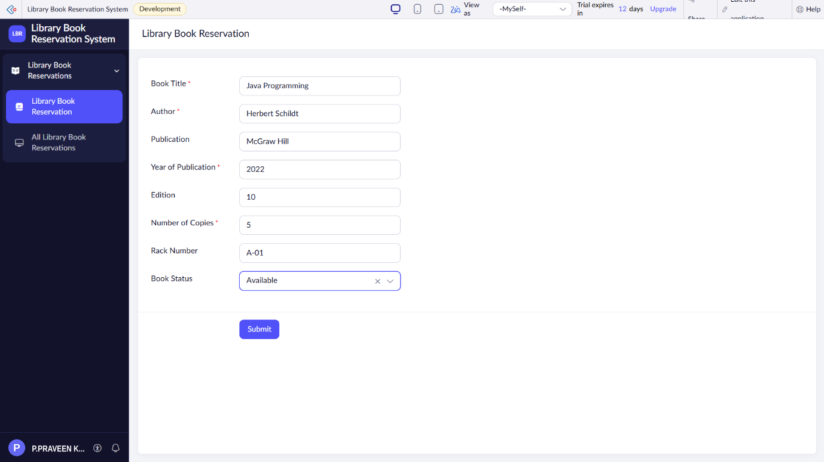

Output:
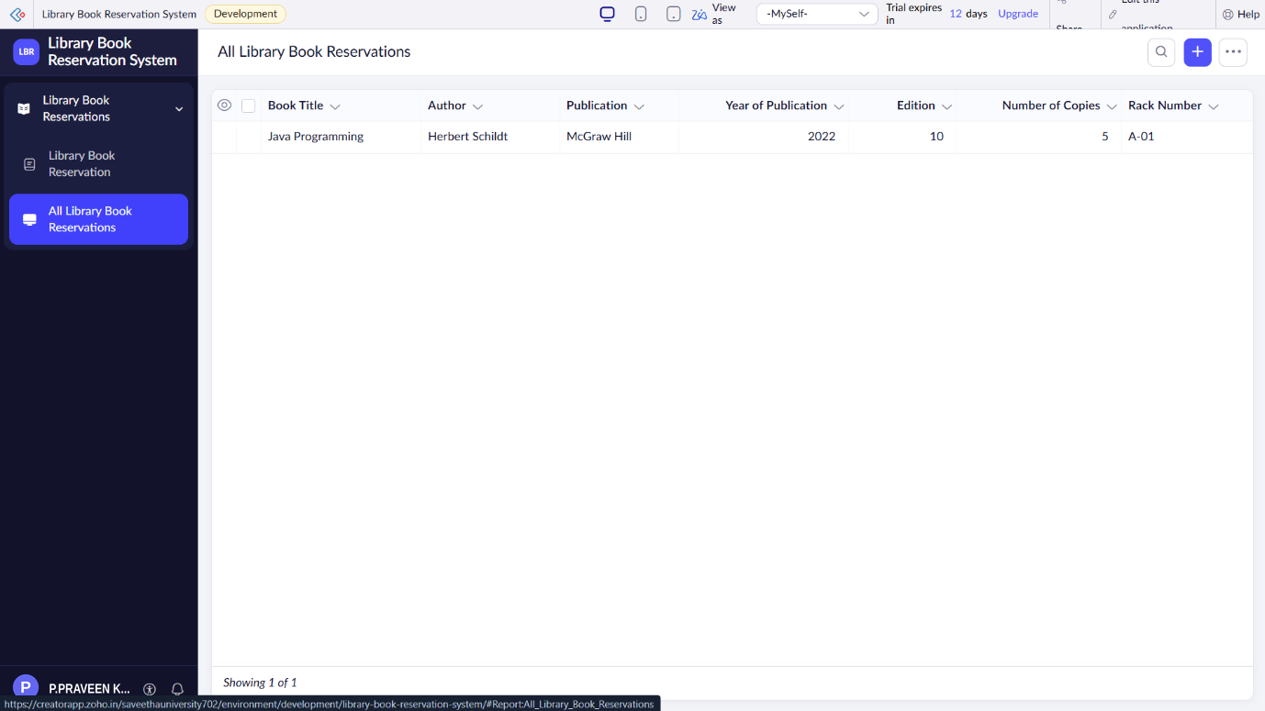
Result
Thus, a Library Book Reservation System for SIMATS Library was successfully created using Zoho One / Zoho Creator and demonstrated as a Software as a Service (SaaS) application.

