Experiment - 7
Students Attendance System Using Zoho One (SaaS)
Aim
To develop a cloud-based Students Attendance System using Zoho One / Zoho Creator for recording and managing student attendance details, and to demonstrate the Software as a Service (SaaS) model.
Procedure
- Sign in to your Zoho One account.
- Launch Zoho Creator from the applications menu.
- Create a new application and name it Students Attendance System.
- Inside the application, create a form called Student Attendance Details.
- Add the following fields to the form, choosing the field type shown for each:
- Student Name – Single Line
- Registration Number – Single Line
- Department – Dropdown
- Year of Study – Dropdown
- Date – Date
- Subject – Single Line
- Attendance Status – Dropdown
- Remarks – Multi Line
- Set up the Department dropdown with choices such as CSE, AIML, IT, ECE, and EEE.
- Set up the Year of Study dropdown with choices such as First Year, Second Year, Third Year, and Fourth Year.
- Set up the Attendance Status dropdown with the choices Present, Absent, and On Duty.
- Organize the fields in a clear order so the form is easy to fill in.
- Save the form and publish it.
- Fill in sample student attendance details.
- Submit the form and confirm that the attendance data is saved in the cloud.
- Go to the report section and check that the submitted attendance record appears.
- Test the form again with attendance entries for different students and dates.
- Confirm that the system can be accessed online through Zoho Creator.

Implementation
Input:
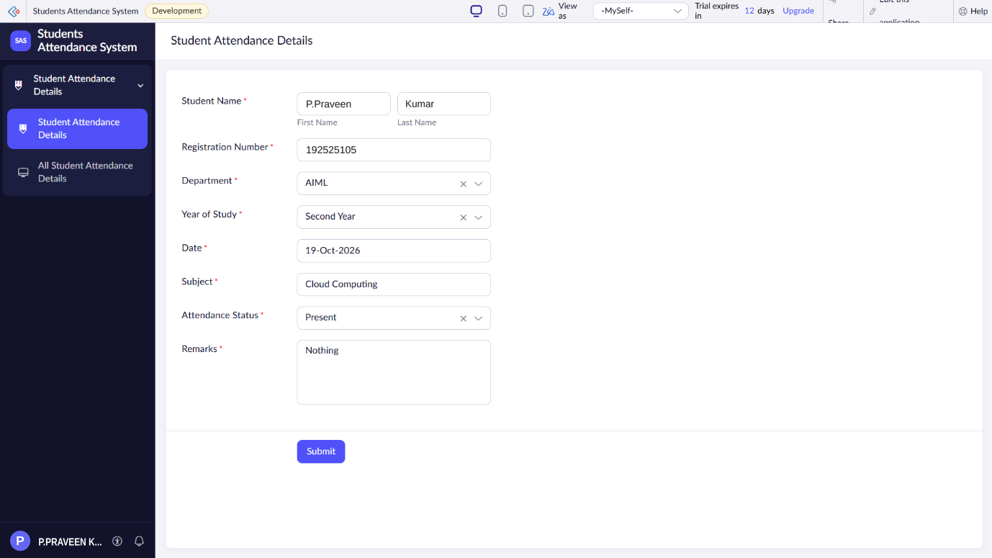
Output:
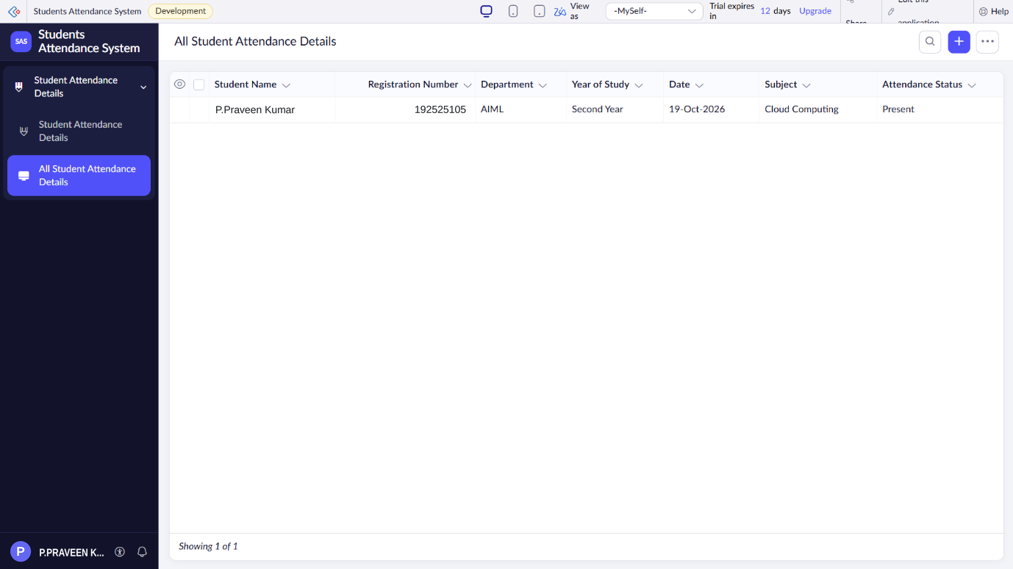
Result
Thus, the Students Attendance System was successfully created using Zoho One / Zoho Creator. The application records and manages student attendance details in the cloud, demonstrating the Software as a Service (SaaS) model.

