Experiment - 8
Student Counselling System Using Zoho One (SaaS)
Aim
To develop a cloud-based Student Counselling System using Zoho One / Zoho Creator for recording and managing student counselling details, and to demonstrate the Software as a Service (SaaS) model.
Procedure
- Sign in to your Zoho One account.
- Launch Zoho Creator from the applications menu.
- Create a new application and name it Student Counselling System.
- Inside the application, create a form called Student Counselling Details.
- Add the following fields to the form, choosing the field type shown for each:
- Student Name – Single Line
- Registration Number – Single Line
- Department – Dropdown
- Year of Study – Dropdown
- Counselling Date – Date
- Counsellor Name – Single Line
- Counselling Type – Dropdown
- Reason for Counselling – Multi Line
- Follow-up Required – Dropdown
- Remarks – Multi Line
- Set up the Department dropdown with choices such as CSE, AIML, IT, ECE, and EEE.
- Set up the Year of Study dropdown with First Year, Second Year, Third Year, and Fourth Year.
- Set up the Counselling Type dropdown with Academic, Career Guidance, Personal Guidance, and Behavioural Guidance.
- Set up the Follow-up Required dropdown with the choices Yes and No.
- Organize the fields in a clear order so the form is easy to fill in.
- Save the application and publish it.
- Fill in sample student counselling details.
- Submit the form and confirm that the details are saved in the cloud.
- Go to the report section and check that the submitted counselling record appears.
- Test the system again with entries for different students and counselling dates.
- Confirm that the application can be accessed online through Zoho Creator as a cloud-based SaaS application.

Implementation
Input:
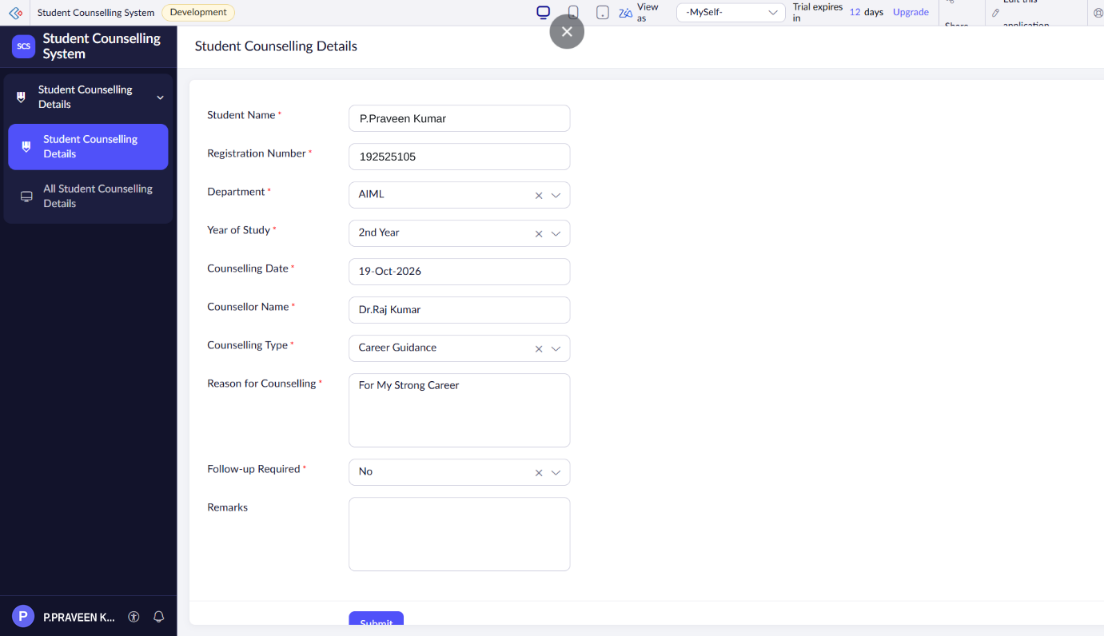
Output:
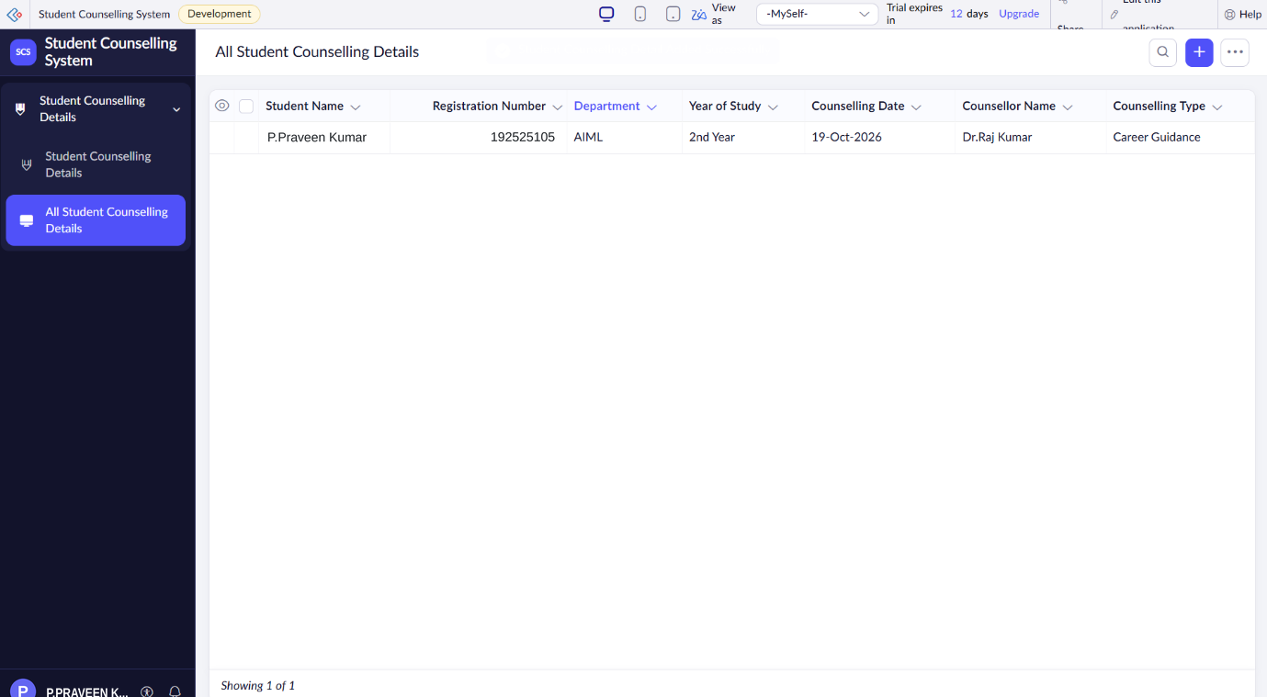
Result
Thus, the Student Counselling System was successfully created using Zoho One / Zoho Creator. The application records and manages student counselling details in the cloud, demonstrating the Software as a Service (SaaS) model.

