Experiment - 9
Hospital Information System Using Zoho One (SaaS)
Aim
To develop a cloud-based Hospital Information System using Zoho One / Zoho Creator for recording and managing patient, doctor, and appointment details, and to demonstrate the Software as a Service (SaaS) model.
Procedure
- Sign in to your Zoho One account.
- Launch Zoho Creator from the applications menu.
- Create a new application and name it Hospital Information System.
- Inside the application, create a form called Patient Information.
- Add the following fields to the form, choosing the field type shown for each:
- Patient Name – Single Line
- Patient ID – Single Line
- Age – Number
- Gender – Dropdown
- Phone Number – Phone
- Address – Multi Line
- Doctor Name – Single Line
- Department – Dropdown
- Appointment Date – Date
- Appointment Time – Time
- Appointment Status – Dropdown
- Set up the Gender dropdown with the choices Male, Female, and Other.
- Set up the Department dropdown with General Medicine, Cardiology, Orthopaedics, Neurology, and Paediatrics.
- Set up the Appointment Status dropdown with the choices Scheduled, Completed, and Cancelled.
- Organize the fields in a clear order so the form is easy to fill in.
- Save the application and publish it.
- Fill in sample patient and appointment details.
- Submit the form and confirm that the information is saved in the cloud.
- Go to the report section and check that the submitted patient record appears.
- Test the form again with details for different patients and appointments.
- Confirm that the application can be accessed online through Zoho Creator as a cloud-based SaaS application.

Implementation
Input:
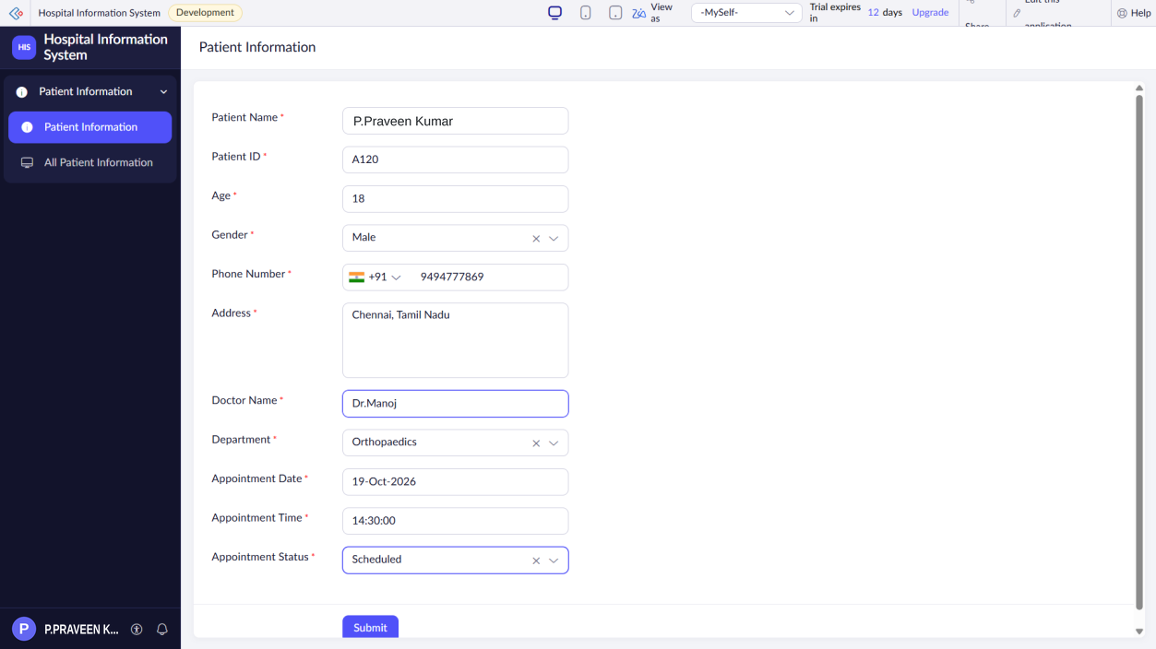
Output:
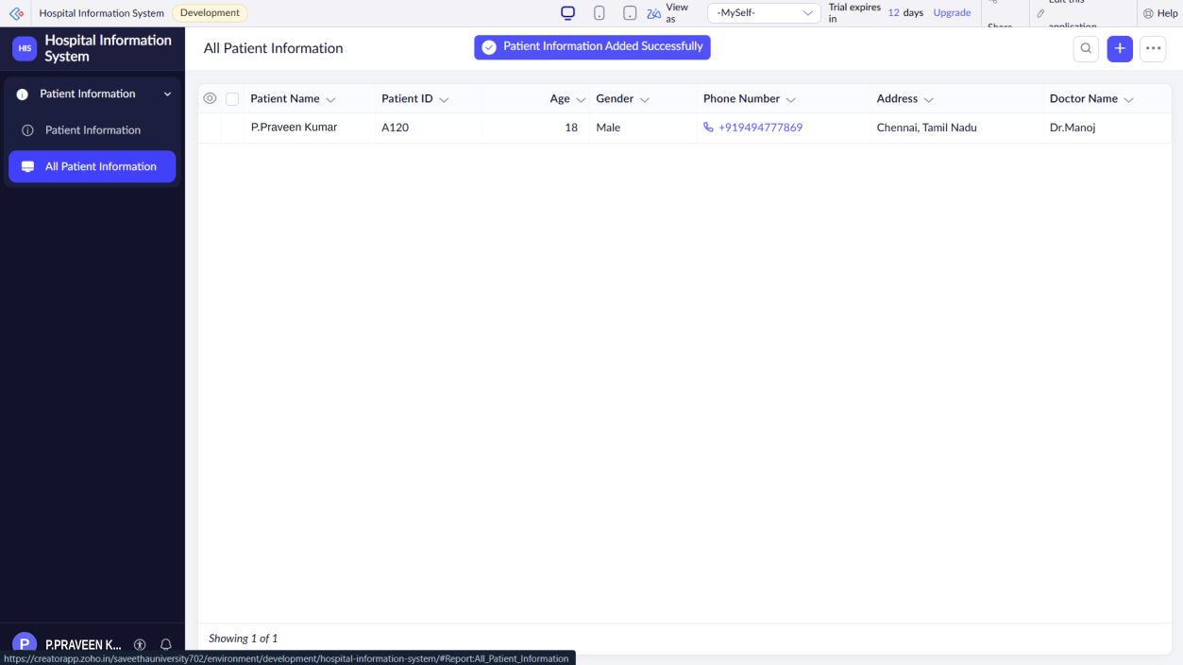
Result
Thus, the Hospital Information System was successfully created using Zoho One / Zoho Creator. The application records and manages patient information and appointment details in the cloud, demonstrating the Software as a Service (SaaS) model.

