**HomePage**

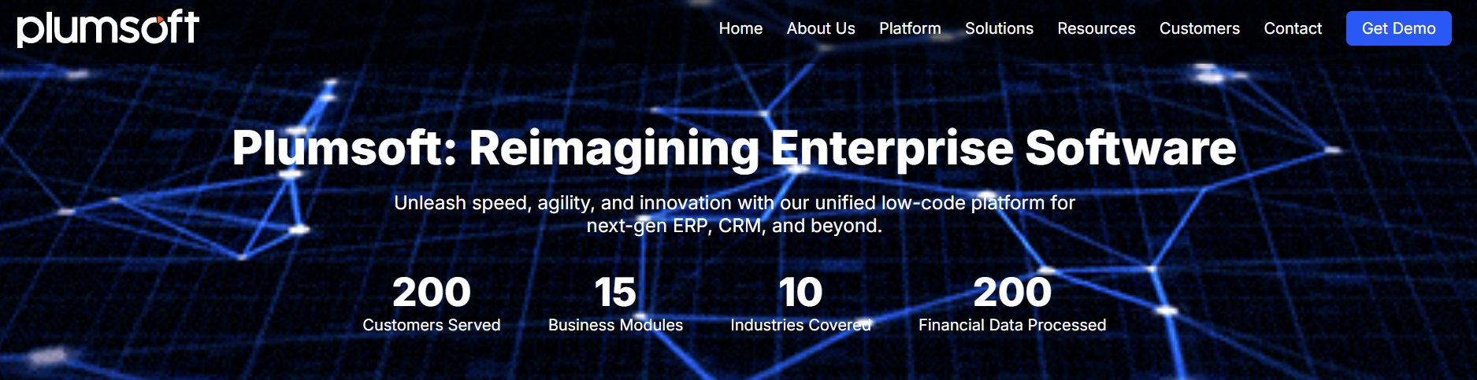



**Powerful Enterprise Solutions.**

**No Code. No Clutter.**

**A lightning-fast, web-based platform that lets you design, customize, and deploy business applications and workflows with ease.**

**KNOW MORE**

**Meet PLUM – Your Enterprise’s Digital Core**

Discover **PLUM** — the coolest way to build or buy your enterprise applications.

Whether it’s a ready-to-go ERP/CRM or a no-code platform to craft your own, Plum puts ***YOU*** in control. Lightning-fast, web-based, and brilliantly simple — it’s power without complexity.  
Say goodbye to cluttered code-heavy systems — say Hello to agility, freedom, and innovation with PLUM.

FLAGSHIP PRODUCTS

PLATFORM

ERP

TESTIMONIALS