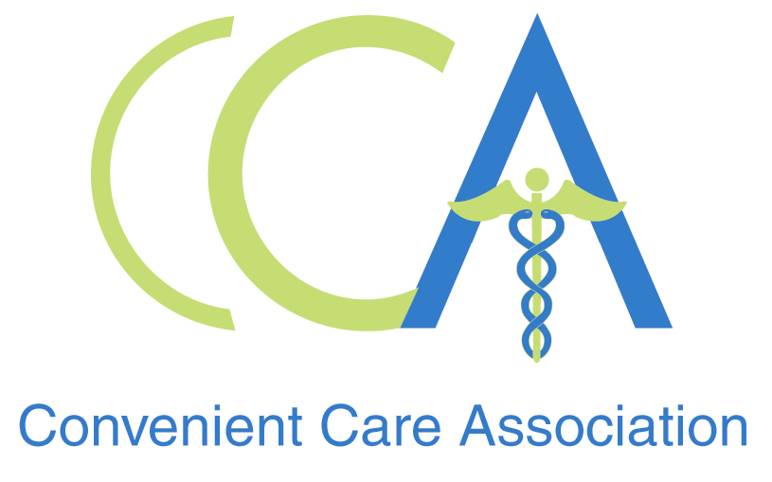

FOR IMMEDIATE RELEASE CONTACT: Kimberley Collins
Oct. 7, 2008 904-280-2773
kcollins@golinharris.com

RETAIL HEALTH CLINICS PROVIDE CRITICAL ACCESS POINT FOR FLU SHOTS
Record Number of Flu Shots Expected This Season

PHILADELPHIA—The healthcare industry is prepared to provide an all-time record number of flu shots this year, according to the Centers for Disease Control and Prevention (CDC), and retail-based convenient care clinics (CCCs) expect to administer millions of them. With 1,000 locations in high-traffic retail outlets in 30 states, CCCs are one of the safest, most convenient, and affordable ways for consumers to get vaccinated.

Retail health clinics provide routine care for common illnesses, including prescriptions when appropriate, and offer a range of preventive services including immunizations, health screenings and basic physical exams. They are open seven days a week, including extended weekday hours, and are located adjacent to pharmacies in retail locations. No appointment is necessary and most visits last less than 15 minutes. These clinics can make getting a flu shot very simple for patients who may already be visiting retail outlets for grocery shopping and other needs.

“For those consumers who cite inconvenience or trouble getting an appointment as a barrier to getting a flu shot, convenient care clinics can be a great alternative to traditional healthcare settings,” said Tine Hansen-Turton, executive director of the Convenient Care Association. “The certified nurse practitioners, physician assistants and physicians at convenient care clinics stand ready to help protect Americans from the flu this year.”

Many senior citizens are already turning to CCCs for their shots, as evidenced by a new report from the RAND Corporation which showed that 74 percent of clinic visits among patients age 65 and older were for immunizations.

According to the Advisory Committee on Immunization Practices, other people who are at high risk of having serious flu complications are:
- Children and teens between six months and 19 years old
- Pregnant women
- People 50 years of age and older
- People of any age with certain chronic medical conditions
- People who live in nursing homes and other long-term care facilities
- People who live with or care for those at high risk for complications from flu, including these:
    - Health care workers
    - Household contacts of persons at high risk for complications from the flu
    - Household contacts and out of home caregivers of children less than six months of age

The CDC has noted that this year a record amount of flu vaccine is being manufactured. Between 143 and 146 million doses of influenza vaccine are being shipped for use in the United States during the 2008-09 influenza season. Yearly flu vaccination should begin now and continue into peak flu season in January or February. While it is ideal to get a shot early in the season, consumers can still benefit from a vaccination throughout the winter.

About the Convenient Care Association
The Convenient Care Association is a national non-profit organization comprised of leaders of the retail-based convenient care industry. CCA members operate more than 95 percent of the convenient care clinics in the United States, which today includes nearly 1,000 clinics in 30 states. For more information or to find a clinic near you, please visit www.ccaclinics.org.

###

