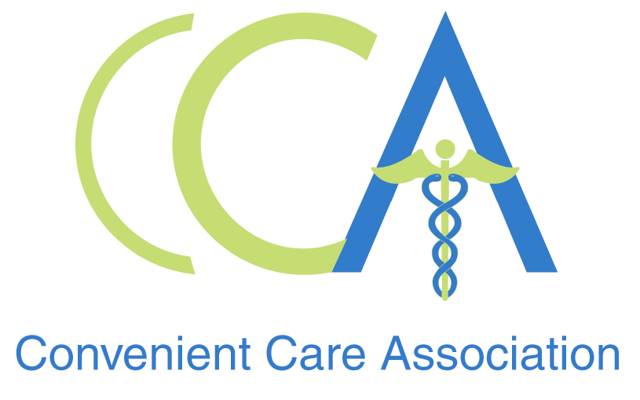

FOR IMMEDIATE RELEASE CONTACT: Kimberley Collins
Nov. 24, 2008 904-280-2773
kcollins@golinharris.com

RETAIL HEALTH CLINICS offer CONVENIENT OPTIONs for holiday health care

Quality, Convenient, Affordable Care When You Can’t Get to Your Doctor

PHILADELPHIA — Away from home and caught a sniffle? Have house guests who have come down with a sore throat? With 1,060 locations in high-traffic retail outlets in 30 states, convenient care clinics (CCCs) can be your answer for quality, convenient and affordable care for illnesses that develop at inopportune times this holiday season.

Retail health clinics provide routine care for common illnesses, including prescriptions when appropriate. They are open seven days a week, including extended weekday hours, and are located near pharmacies in retail locations. No appointment is necessary and most visits last less than 20 minutes. These clinics are the ideal option to keeping you healthy, especially when you’re away from home.

All clinics that are members of the Convenient Care Association use electronic medical records (EMRs), which is an additional benefit when you are traveling. All CCCs share records of your visit with your primary care provider upon your request.

“Consumers may not realize that nearly all major clinic operators currently accept insurance and more and more insurance companies are supporting retail health clinics, an added convenience for our patients,” said Tine Hansen-Turton, executive director of the Convenient Care Association, the industry’s member-based organization, representing 95 percent of the retail clinics in the United States.

The demand for affordable, accessible health care is why CCCs have provided more than 3.5 million patients with assistance related to common ailments and preventive care. If a patient has a condition that is outside the scope of conditions treated at a CCC, staff will refer to them to another medical professional.

About the Convenient Care Association
The Convenient Care Association is a national non-profit organization comprised of leaders of the retail-based convenient care industry. CCA members operate more than 95 percent of the convenient care clinics in the United States, which today includes more than 1,000 clinics in 30 states. For more information or to find a clinic near you, please visit www.ccaclinics.org.

###

