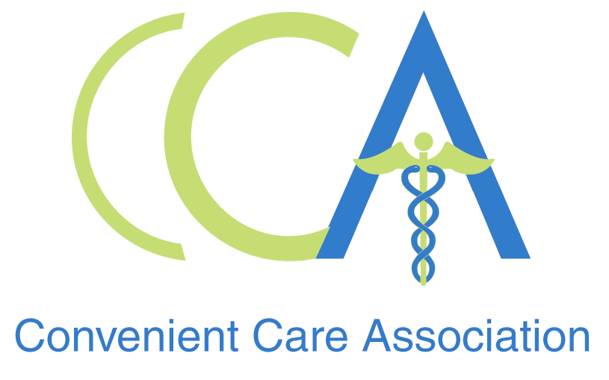

EMBARGOED FOR RELEASE
12:01 a.m. EDT Sept. 10, 2008

STATEMENT FROM THE CONVENIENT CARE ASSOCIATION: New RAND Health Report Dispels Several Myths About Retail Health Care
Statement by Tine Hansen-Turton, Executive Director, Convenient Care Association

PHILADELPHIA-- A new study by RAND Health released today in the September/October issue of Health Affairs is the latest validation of the Convenient Care industry coming from a respected independent third party organization. The RAND report, using data from 2000-2007 from established retail health clinic organizations, compares demographics and reasons for visits in retail clinics, primary care settings and emergency departments. The study, Retail Clinics, Primary Care Physicians, And Emergency Departments: A Comparison of Patients’ Visits, dismisses many myths that have been circulated about the Convenient Care industry following the rapid growth and expansion of retail clinics throughout the country.

Myth: People do not understand when or how to use a convenient care clinic (CCC).
- The study found that only 2.3 percent of CCC patients were triaged to an emergency department or physician’s office, indicating that the vast majority of consumers understand that CCCs are meant for simple episodic and preventive care.

Myth: CCCs disrupt the “medical home,” especially for the young and the elderly.
- The authors report that patients between the ages of 18 and 44 tend to use CCCs frequently, but that patients in the younger and older age groups were less likely to visit retail clinics than they were to visit PCPs or emergency departments.
- Among patients age 65 and older, 73.6 percent of retail clinic visits were for immunizations.
- The report also concluded that as many as 60 percent of CCC patients do not have a PCP, meaning “There was no (PCP) relationship to disrupt.” CCCs connect patients who have out-of-scope conditions and those who need ongoing care with local primary care physicians, making retail-based clinics an important portal for connecting patients into the
health care delivery system.

Myth: Some people question whether CCCs are sticking to a limited scope of practice.
- Only 10 simple treatments and services accounted for more than 90 percent of the CCC visits assessed in the study, all well within nurse practitioners’ skill sets and training levels.

An increasing volume of patients are paying for their CCC visits with insurance as opposed to cash. Only 15.9 percent paid out-of-pocket in 2007, a significant change from 2000 when convenient care was an all-cash model. Despite the wide acceptance of insurance by CCCs, the services provided are cost-effective if paying with cash, making the clinics accessible to all segments of the population. CCC visits typically range between $40 and $70, which is far less than would be billed for care at most other healthcare delivery outlets. RAND researchers also concluded that CCC visits average about 15 minutes.

Collectively, the data reported by RAND Health support the Convenient Care Association’s assertions that this model of care provides consumers with easier access to high quality care, particularly for those without insurance. Considering the percentage of patients with no PCP or otherwise compromised access to care, CCCs offer these individuals a viable and accessible option. An extension to primary care, CCCs have provided treatment of common ailments, physical exams, health screenings, vaccinations, and preventive care services to more than 3.5 million people. All CCC data in RAND’s study originated with companies that are members of the Convenient Care Association, which represents 95 percent of the CCCs in the country. Today there are 1,000 CCCs located in high-traffic retail outlets, open extended hours seven days a week, and are co-located with pharmacies. The number of clinics has more than tripled during the period in which this data was being collected, which reinforces the fact that CCCs are providing more consumers than ever before with access to quality, convenient healthcare.

About the Convenient Care Association
The Convenient Care Association is a national non-profit organization comprised of leaders of the convenient care industry. CCA members represent more than 95 percent of the industry and operate more than 950 CCCs in 28 states. www.ccaclinics.org
About the RAND Corporation
The RAND Corporation is a nonprofit research organization providing objective analysis and effective solutions that address the challenges facing the public and private sectors around the world.

For interviews/further comment with Tine Hansen-Turton, please call:
Kimberley Collins
904-280-2773
kcollins@golinharris.com ###

