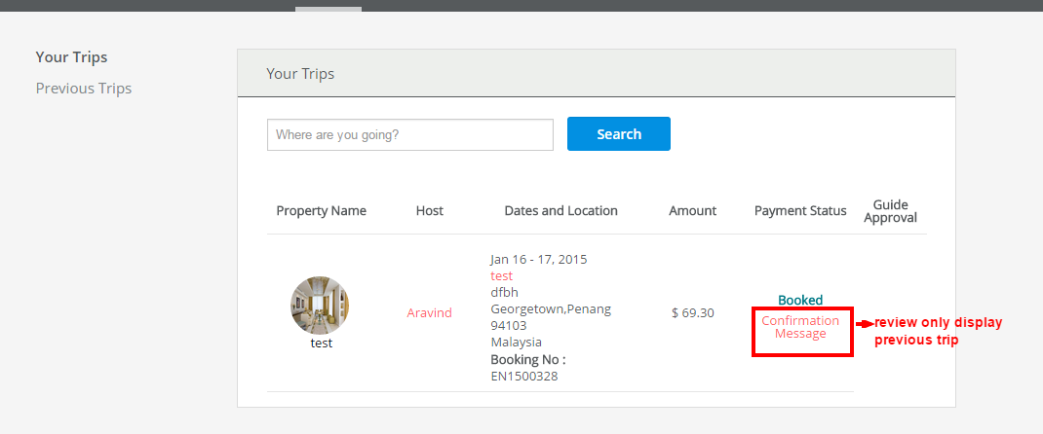
- Need Review changed to after stay Refer above img

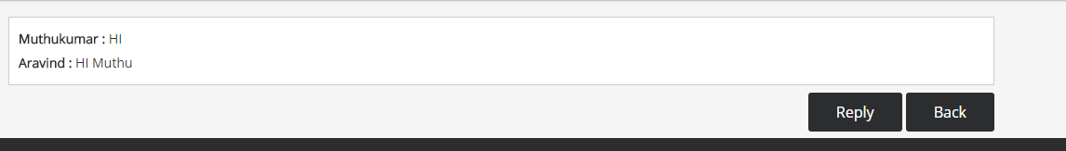
- Need email to be connected in one user-user thread. >>> Refer above img

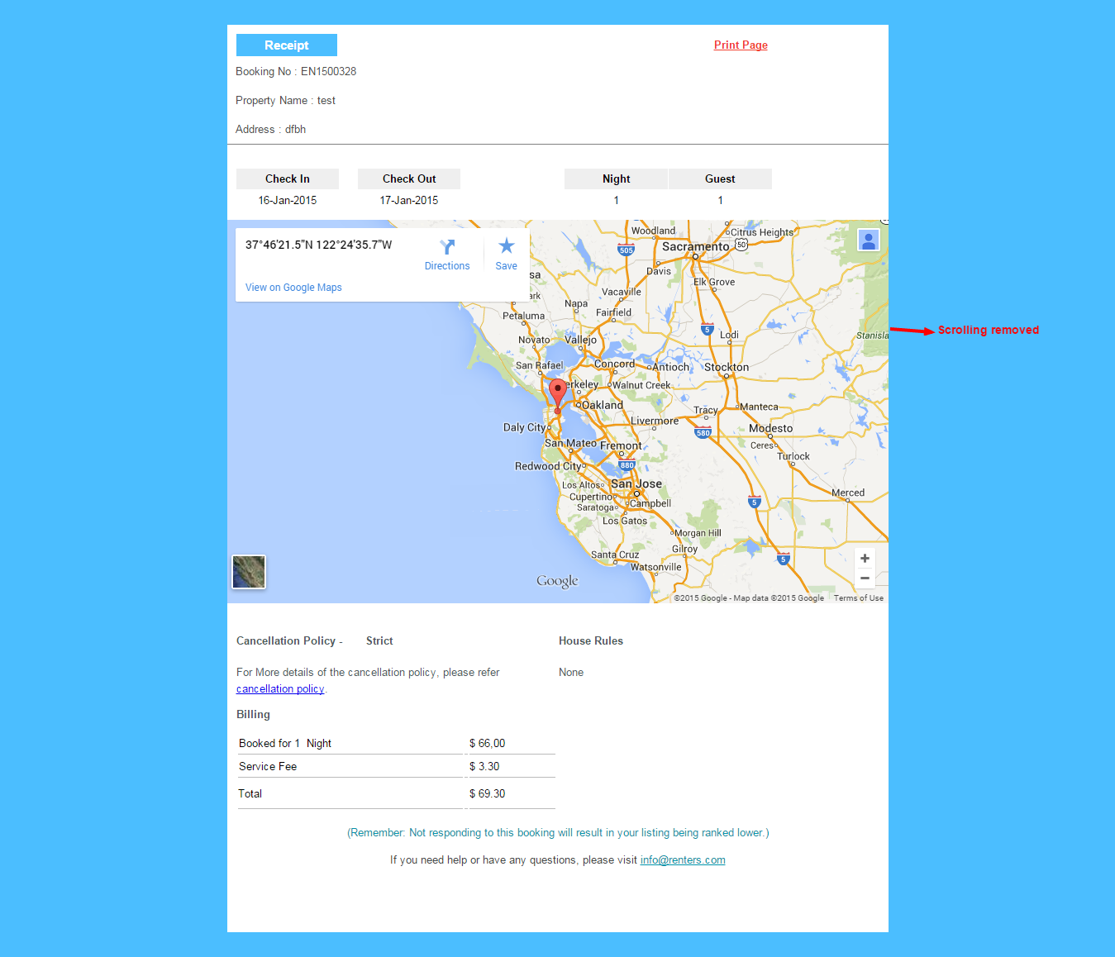

- Need map to be passive when scrolling over, and only react when clicking on it first >>>Refer above img

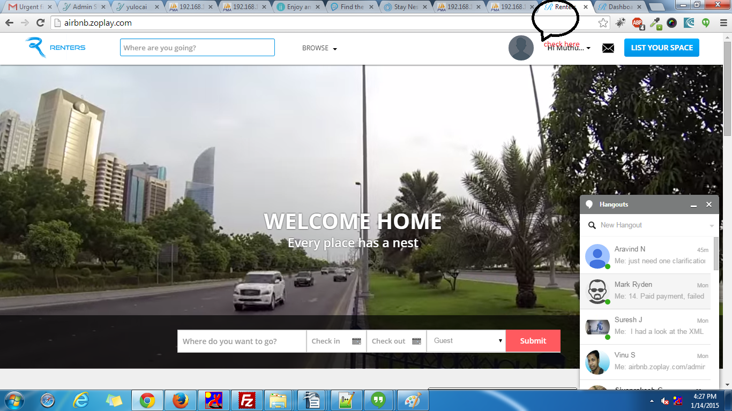

- Music off. >>>Refer above img
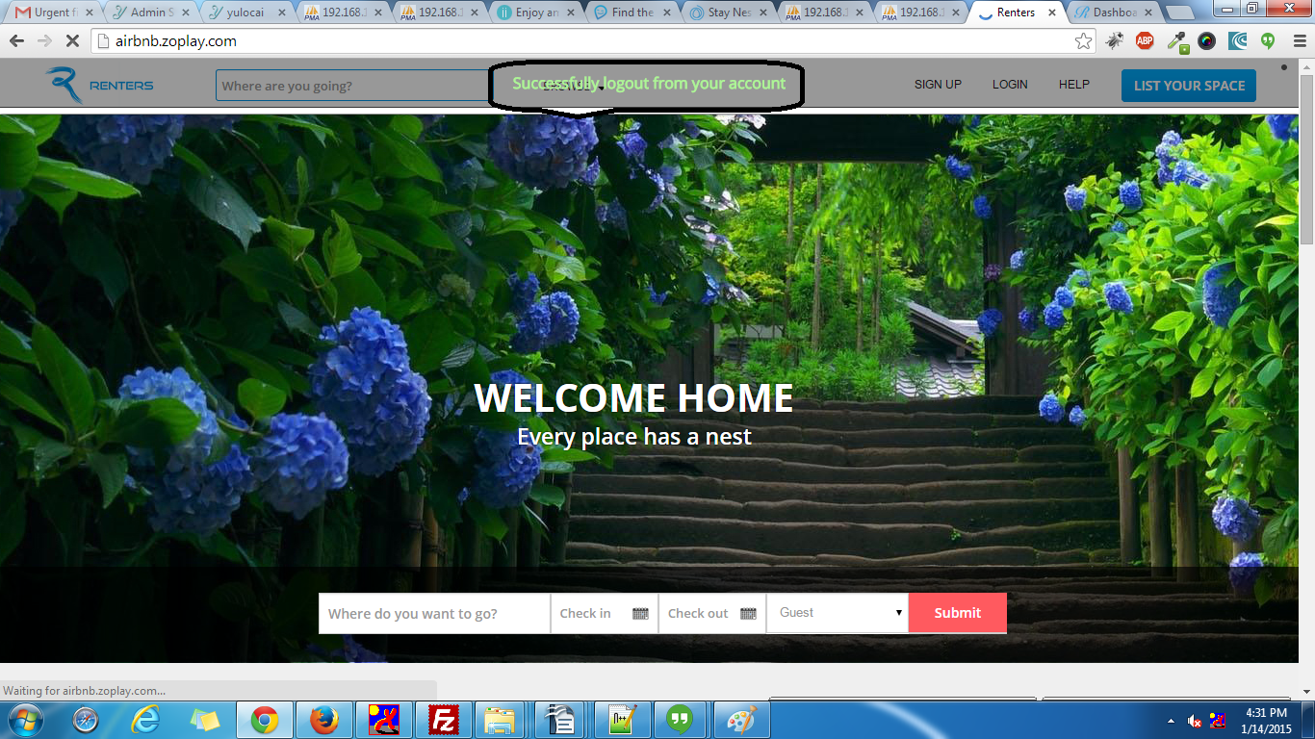
6 .Top bar messages in green test set to 5 sec >>>Refer above img

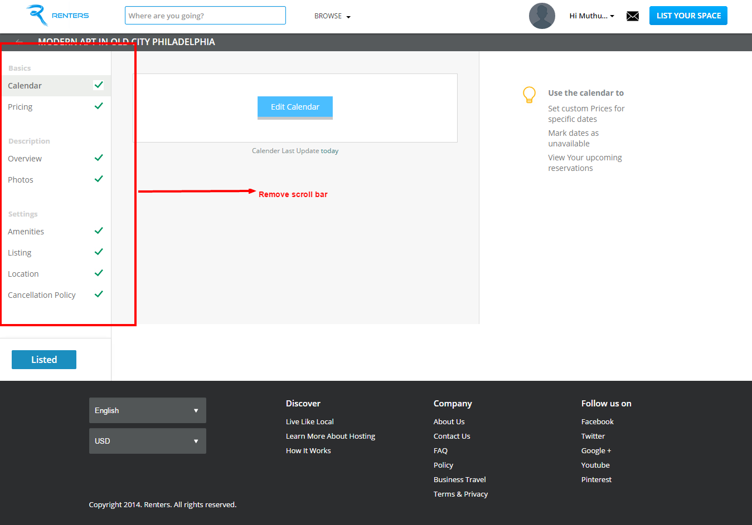

- Remove scroll bar

Pending

Need booking and onsite "email" notification on front page

