EVENTFORCE – EVENT MANAGEMENT SYSTEM
EVENT MANAGEMENT SYSTEM — FINAL PROJECT DOCUMENTATION
PROJECT AREA: Centralized event administration CORE RECORDS: Events, Clients, Vendors, Venues SUPPORTING MODULES: Event–Vendor coordination, Approvals & Flows, Feedback, Reports PRIMARY PURPOSE: Organize event information and related operational activities in one interface
1. Project Overview
EVENTFORCE is a centralized event-management application that brings event, client, vendor, venue, workflow, feedback and reporting activities into a connected interface. The project material shows a dashboard for monitoring and dedicated modules for maintaining operational records. The event record acts as the main reference point, while supporting modules provide the resources and actions associated with the event lifecycle.
2. Project Scope
- Event planning and record management.
- Client and vendor information management.
- Venue and event-resource coordination.
- Approval and feedback activities.
- Operational reporting and monitoring.
3. Main Modules
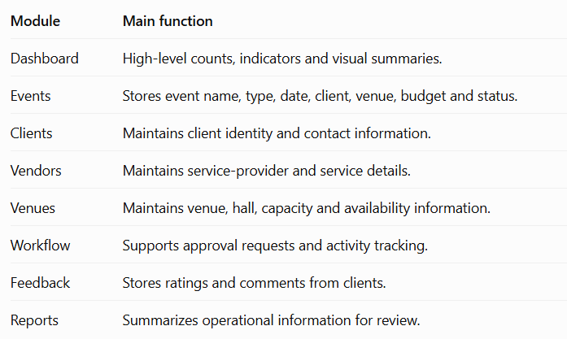
4. Working Principle
The system follows a connected-record approach: maintain people and resources, create an event, coordinate the venue and vendors, process workflow activities when required, monitor the event, capture feedback, and finally review dashboard and report information.
STEP 1 Maintain client and vendor records before event planning begins.
STEP 2 Create the event with date, type, client, venue, budget and status.
STEP 3 Connect the required venue and vendors to the event.
STEP 4 Use workflow/approval functions where review is required.
STEP 5 Monitor the event and review feedback and reports.
5. Problem Statement and Need
When event information is handled manually or across separate sources, duplicate information, delayed updates and difficulty in tracking event-related resources can occur. Users may need to check different records to understand one event. EVENTFORCE addresses this operational problem by keeping the principal event-related records within one system.
6. Need for the System
- A single location for event and client information.
- Structured vendor and service-provider records.
- Better visibility of venue and hall availability.
- A dedicated place for approval requests and workflow status.
- Feedback storage for reviewing client responses.
- Reports that summarize information already maintained by the system.
7. Objectives
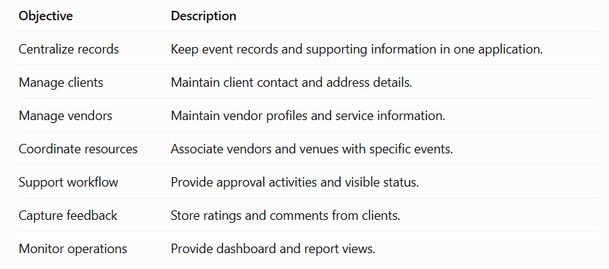
8. Conceptual Architecture

9. Process Steps
STEP 1 Open the dashboard to understand current operational activity. STEP 2 Navigate to the required record module instead of maintaining disconnected files. STEP 3 Use event information as the central reference for client, venue and vendor relationships. STEP 4 Move approval requests through visible workflow states when required. STEP 5 Use feedback and reports after the operational activity to review results.
10. Dashboard Module
The dashboard is the first monitoring layer of EVENTFORCE. It presents counts for total events, clients, vendors and venues, together with an average rating. It also provides visual summaries for upcoming events, event type versus budget and event lifecycle status.
11. Dashboard Usage Steps
STEP 1 Start from the dashboard to obtain a summarized view. STEP 2 Check event, client, vendor and venue counts. STEP 3 Review upcoming-event and budget/status visuals. STEP 4 Move to the relevant module for record-level action. STEP 5 Return to the dashboard after updates.
12. Event Management Module
The Events module is the central record-management area. The supplied interface displays event ID, event name, event type, date, client, venue, budget and status.
13. Event Record Components
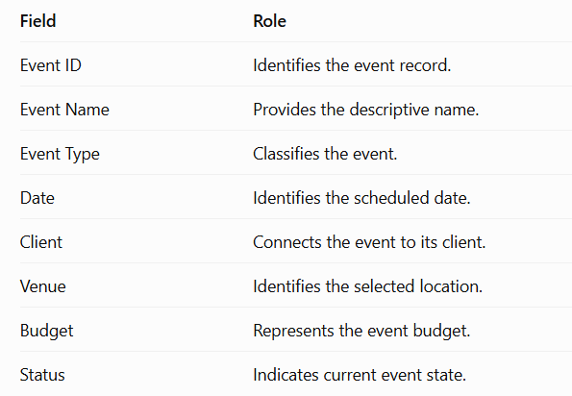
14. Event Lifecycle
STEP 1 Create or select the event record. STEP 2 Enter type, date, client, venue, budget and status. STEP 3 Coordinate supporting vendors and resources. STEP 4 Process approval/workflow activities when required. STEP 5 Monitor the event and use feedback/reporting functions.
15. Client and Vendor Management
The Client Directory maintains information required to identify and contact clients. The supplied material includes client ID, name, email, phone, city, country and address.
The Vendor module stores service-provider information such as vendor name, service type, email, phone, rating and status.
16. Why Separate Client and Vendor Modules?
Clients and vendors play different roles in an event. A client is associated with the event as the customer or organizing party, while a vendor provides a service. Keeping records separate avoids mixing different information and makes event relationships clearer.
17. Management Steps
STEP 1 Create or maintain client records with contact information. STEP 2 Create or maintain vendor records with service and status information. STEP 3 Use search/filter facilities to locate existing records. STEP 4 Connect the selected vendor to the relevant event. STEP 5 Review the event record to confirm supporting relationships.
18. Venue, Hall and Resource Coordination
Venue information supports the physical planning of an event. The supplied project material shows venue names, addresses, capacity, hall details and availability. Event–Vendor coordination connects the event to service providers.
19. Resource Coordination
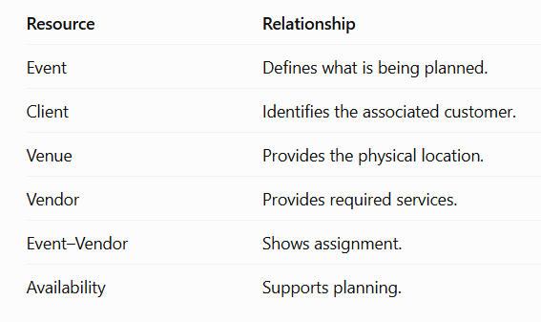
20. Coordination Steps
STEP 1 Review venue and hall information.
STEP 2 Check capacity, address and availability.
STEP 3 Select the venue associated with the event.
STEP 4 Identify required services and coordinate vendors.
STEP 5 Confirm venue and vendor relationships on the event record.
21. Custom Venue Object and Reporting
The supplied setup screenshot demonstrates creation of a custom Venue object with singular/plural labels, an object name, description and a Venue Name record field. This supports structured venue records within the application environment.
22. Reports and Analytics
The reporting area converts stored operational records into summarized information. The supplied material identifies reports for upcoming events, events by status, available venues, available vendors and client feedback.
23. Report Usage Steps
STEP 1 Open the required report from the reporting area.
STEP 2 Review the summarized operational information.
STEP 3 Use filters or the available report controls where provided.
STEP 4 Compare the report view with the maintained operational records.
STEP 5 Return to the dashboard or module for further record-level work.
24. Approvals, Feedback, Testing and Conclusion
The Approvals & Flows module provides a place for event-related requests that require review. The supplied material demonstrates visible status and approval/rejection controls. The feedback area records client ratings and comments associated with events.
25. Verification Checklist
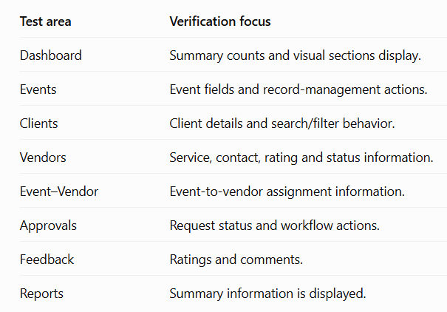.
26. Overall System Workflow
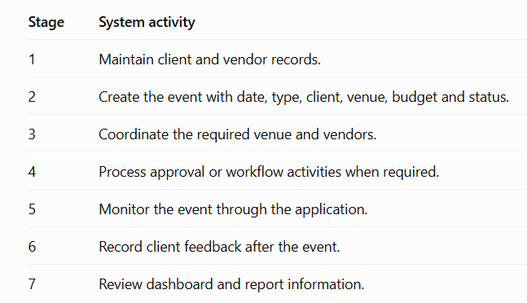.
27. Benefits
- Centralized access to event-related information.
- Structured client and vendor management.
- Clear event-resource relationships.
- Dedicated venue and availability information.
- Visible workflow activities.
- Client feedback can be reviewed.
- Dashboard and reports provide summaries.
28. Limitations
The supplied material mainly demonstrates the application interface and functional areas. It does not provide enough source evidence to document every backend technology, database schema, authentication implementation or deployment configuration. Therefore, this report describes only the functions visible in the supplied project material.
29. Future Scope
Proposed extensions include stronger role-based access control, automated notifications, richer report exports, advanced validation, expanded workflow rules and additional integrations. These are future improvements and are not presented as already implemented.
30. Final Conclusion
EVENTFORCE demonstrates a centralized approach to event management by combining event, client, vendor, venue, relationship, workflow, feedback and reporting functions. The supplied screens show how these modules can work together to organize the event lifecycle and provide structured operational information.
STEP 1 Maintain records in the appropriate module.
STEP 2 Create and update the central event record.
STEP 3 Coordinate venue and vendor resources.
STEP 4 Use workflow and approval functions when required.
STEP 5 Capture feedback and review dashboard/report information.
