**AMAZON:**

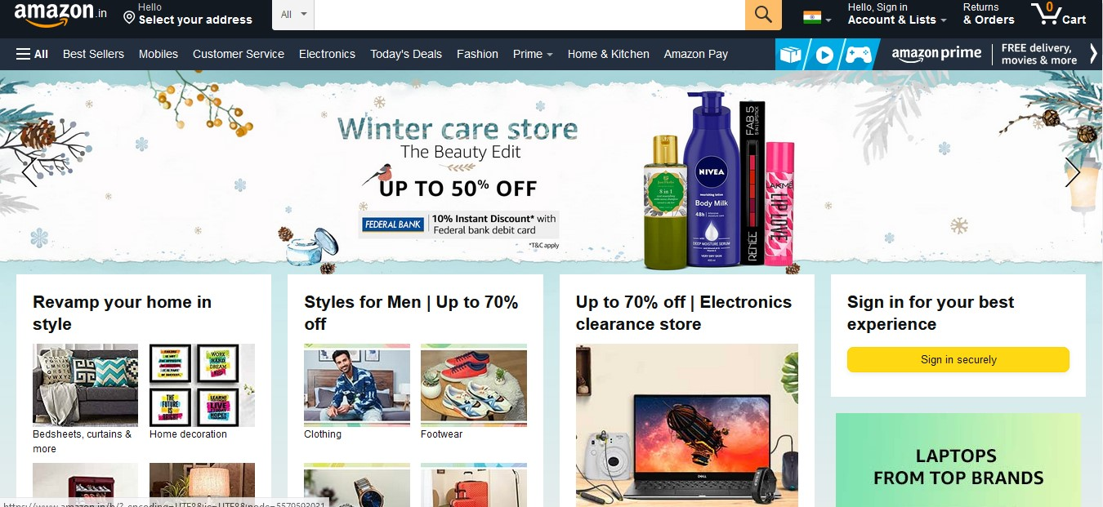

Amazon.com, Inc is an American multinational technology company which focuses on e-commerce, cloud computing, digital streaming, and artificial intelligence. It is one of the Big Five companies in the U.S. information technology industry. The company was started by jeff Bezos in 1995 and has been referred to as "one of the most influential economic and cultural forces in the world", as well as the world's most valuable brand.

**PAGES:**

Login/Signup page -> Home Page ->Listing Page ->Details page ->Cart Page

**LOGIN/SIGNUP PAGE:**

* E-mail id
* Password

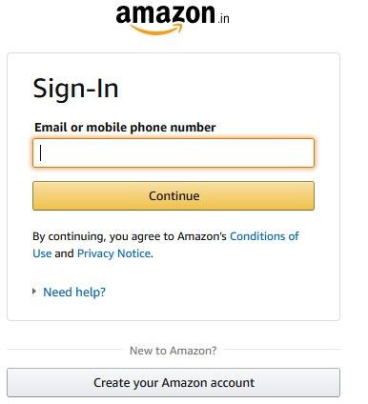

**HOME PAGE:**

* Categories
* Items added to Cart
* Search
* Offers



**LISTING PAGE:**

* Filters
* Description of the product

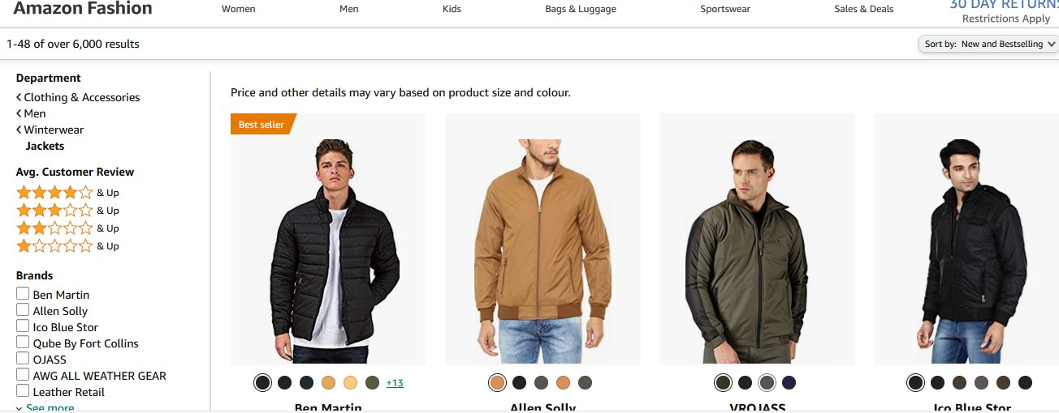

**DETAILS PAGE:**

* To view product
* Deals and colors
* Product description
* Product comparison
* Check delivery is available for the place

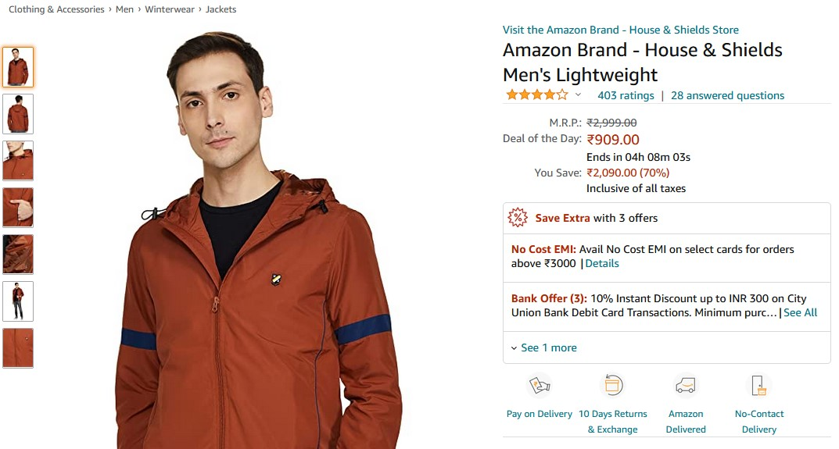

**CART Page:**

* Cart Items
* Order Summary
* Payment Method

