Contact

+91 97 9876 1927

anand14901@gmail.com

Thiruvananthapuram, India

https://www.linkedin.com/in/a nand-boojesh-r-s

Education

Bachelor of Engineering :

Computer science & Engineering

Amrita College Of Engineering & Technology 2019-2023

7.38 - CGPA

Higher Secondary : Computer Science

Mahatma Montessori Metric Hr. Secondary School (Residential)
2018-2019

56.33%

Higher Secondary : Computer Science

Mahatma Montessori Metric Hr. Secondary School (Residential)
2016-2017

77.4%

Language

English

Tamil

Telugu

Malayalam

ANAND BOOJESH R S
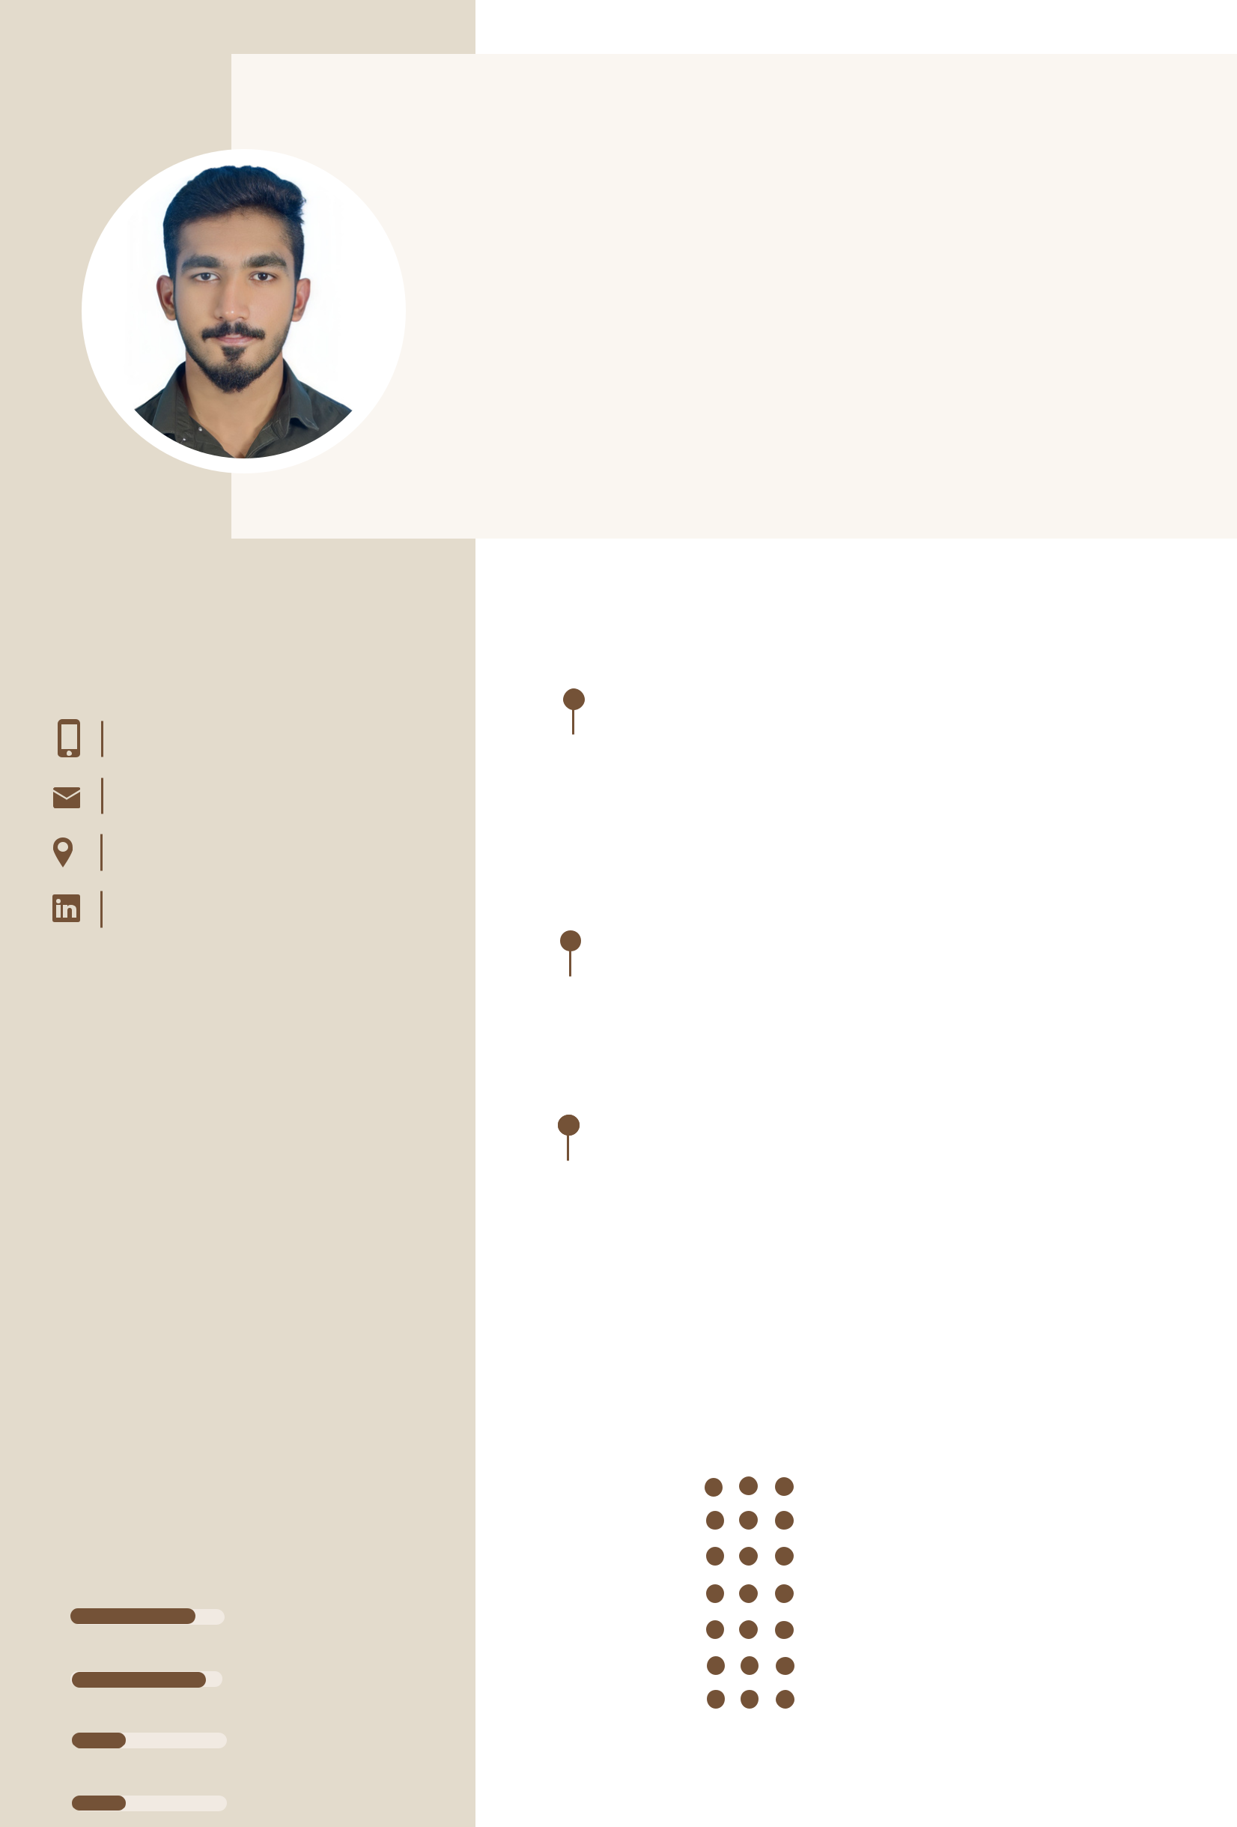

FRESHER

I'm a recent graduate with a degree in [computer science & engineering] aiming to leverage my solid theoretical foundation and hands-on experience gained through internships to contribute to a dynamic organization. I am seeking a position that offers opportunities for professional development and encourages creativity and innovation.

Project

Web application using angular

Web-developement project December 2023

This project is a web application that is designed to provide users with real-time and accurate weather information for any location worldwide. The application utilizes modern web technologies to deliver a seamless and intuitive user experience, catering to both casual users and weather enthusiasts.

Website using bootstrap

Web-developement project December 2023

This project is a website on bike lovers that is created to showcase my inovation and contribution towards those who having certain passion and intrest towards bike’s & motorcycle's.

Instagram fake id prediction using machine learning

Final year project | May 2023

The objective of this project is to develop an Random Forest model that can accurately classify Instagram profiles as real or fake based on learned patterns from the data.The research aims to train and evaluate the Random Forest modelusing a labeled dataset of Instagram profiles and compare its performance with other traditional methods for detecting fake profiles. The ultimate goal is to provide an automated tool that can effectively identify fake profiles on Instagram and contribute to the field of social media analytics.

Skills

HTML

CSS

JAVA SCRIPT

ANGULAR

BOOTSTRAP

PYTHON

DESIGNING

Certification

diplomo in web development

diplomo in angular

