Edge AI Based Intelligent Water Quality Assessment and Predictive Maintenance System Using Hybrid Anomaly Detection and LSTM-Based Forecasting

Anuli Jenn T
Department of Electrical and Electronics Engineering Amrita School of Engineering
Coimbatore, Amrita Vishwa Vidyapeetham India cb.en.p2ebs25004@cb.students.amria.edu

Dr .M .Venkateshkumar
Department of Electrical and Electronics Engineering Amrita School of Engineering
Coimbatore, Amrita Vishwa Vidyapeetham India mvenkateshkumar@cb.amrita.edu

Abstract—This paper presents a water quality assurance sys- tem (WQAS) for real-time monitoring, analysis and prediction of water quality using an intelligent data-driven methodology. It includes various water quality parameters such as turbidity (NTU), total dissolved solids (TDS in PPM) and temperature (°C) to provide an accurate classification of water quality. Anomalies are identified using Z-score analysis and forest isolation methods to identify anomalous measurements that may cause contami- nation. Water Quality Index (WQI) classification is performed using the random forest classification technique, which classifies water quality as good, fair, and poor based on defined thresholds and patterns obtained during the study. In addition, the LSTM model is used to predict filter life based on TDS, turbidity and temperature changes over time. For example, a framework is being developed to implement real-time water quality monitoring systems using the Internet of Things. The effectiveness of the proposed method was tested experimentally.
Index Terms—water quality monitoring, Isolation forest, LSTM , Random Forest, Z score
- Introduction
Water is a crucial element for our very existence - it sustains us, nourishes the crops we rely on, and fuels numerous indus- tries. However, ensuring access to clean and pure water has become an increasingly pressing issue in light of our rapidly growing global population, urbanization trends, and environ- mental pollution. The consequences of contaminated water are dire: not only does it spread diseases that threaten human health but also disrupts delicate ecosystems. Thus, monitoring the state of our water resources becomes paramount in main- taining balance and safeguarding public welfare. However, traditional methods for checking water quality involve manual sampling followed by time-consuming chemical analysis. This

Praveenraj R S
Department of Electrical and Electronics Engineering Amrita School of Engineering
Coimbatore, Amrita Vishwa Vidyapeetham India cb.en.p2ebs25024@cb.students.amria.edu

outdated approach is both labor-intensive and unable to pro- vide real-time data - highlighting the need for an intelligent automatic system capable of continuously monitoring key indicators.
By utilizing a combination of sensors, embedded technol- ogy, and cloud/edge computing capabilities, these systems can provide us with continuous information about the surround- ings. When it comes specifically to monitoring water quality, there are several crucial factors that play a significant role in determining its state and purity. These include turbidity levels (i.e., the clarity or haziness of the water), total dissolved solids content (which measures various impurities such as salts and minerals), and temperature. However, merely measuring these parameters is not enough.
Water quality monitoring systems currently prioritize data collection and basic alerts based on set limits. While these systems have their advantages, they fall short in terms of advanced analytical capabilities and adaptability to evolving conditions. Moreover, relying solely on threshold-based alarms can lead to false notifications and overlook minor fluctuations that could indicate contamination. Furthermore, the current technology lacks the ability to forecast filter lifespan or predict future water quality trends - crucial for efficient maintenance and resource utilization.
This paper aims to introduce a groundbreaking system known as the Water Quality Assurance System (WQAS). This innovative approach utilizes multiple IoT-based sensors, such as a turbidity sensor, TDS sensor, and DS18B20 temperature sensor, in order to gather data from diverse sources. The gath- ered information is then expertly processed by an Arduino Uno

R3 microcontroller. But that’s not all - this impressive system also incorporates another device: the Raspberry Pi 4. With its advanced capabilities for analytics and creating visually appealing graphical user interfaces (GUIs), it takes WQAS to the next level. By combining these cutting-edge technologies together with the expertise in water quality management,the WQAS will revolutionize how to monitor and maintain clean water systems.
The proposed WQAS system consists of three main func- tional modules. Firstly,an anomaly detection module that uti- lizes both the Z-score method and Isolation Forest approach have been implemented. This enables to efficiently detect any irregularities or contamination events within the sensors, ensuring timely intervention for optimal performance. Moving on,a water quality classification module using Random Forest technique has also been incorporated. Through analysis of sen- sor data, it accurately categorizes water into Good, Normal or Bad categories based on its quality. Such information allows to make informed decisions about further actions required. Lastly the filter life prediction module utilizing LSTM Neural Net- work technology which forecasts filter lifespan by taking into account turbidity levels,TDS level variations,and changes in water temperature.This invaluable tool aids efficient manage- mentof resources through early replacement planning,reducing potential disruptionsin operations due to malfunctioning filters. This infusion of intelligence enables the system to au- tonomously interpret data gathered by sensors without any external assistance. A real-time graphical user interface (GUI) takes user experience to new heights by presenting information
in an easily digestible and comprehensible format.
- LITERATURE SURVEY
Water quality monitoring has evolved significantly from the days of slow and laborious manual tests. Nowadays, we rely on smart automated systems equipped with sensors that gather data in real-time. This includes measuring parameters such as pH levels, turbidity, temperature, and TDS through innovative IoT technology. It is worth acknowledging that this progress was largely driven by early pioneers in the field.
For example, Mahzuza et al.’s groundbreaking work [1] involved designing a system utilizing cloud-based platforms linked to turbidity sensors. This allows for swift detection of impurities and automatic initiation of filtration processes
- an incredibly valuable feature. Another notable contribu- tion comes from Sharanya et al.[2], who integrated machine learning into their setup alongside multiple sensors. As a result, not only can they detect leaks but also predict potential issues within city water lines proactively - truly remarkable advancements. Despite these significant improvements brought about by recent developments; there were still some challenges to overcome regarding latency and reliability due to heavy reliance on cloud connections at times.
As time passed, the utilization of microcontrollers such as ESP32 for monitoring multiple parameters became prevalent. Rosa et al. [3], [8] developed a device that directly transmits sensor data to smartphone apps like Blynk. While it was
proficient in handling fundamental tasks, it lacked the ability to make autonomous decisions. Taking this concept further, Sasirekha et al.[4] integrated AI and solar power technology into their design for predicting cleaning and maintenance needs without human intervention. However, this added com- plexity resulted in increased costs which posed challenges for practical implementation.
With advancements in machine learning techniques, pre- diction emerged as a major focus when dealing with water data analysis.Chen et al.[5] employed transformer models on time series data to determine filter lifespan - aiding efficient maintenance procedures.Sahil and Urvashi[6], on the other hand,tested CNNs and LSTMs for similar predictive pur- poses,suggesting hybrid models yield greater accuracy.Xuqi Yao’s research[11] showcased promising results using BiL- STM coupled with cloud computing services,to accurately predict system status.These deep learning approaches seem essential now more than ever before.
Effective data management is crucial, and this includes proper classification and preprocessing techniques. As high- lighted by Yu et al. [9], the correct labeling of data using PCA and fuzzy logic can significantly enhance the performance of neural networks. Meanwhile, Olatinwo and Joubert [7] have explored edge-based classification utilizing BiLSTM technol- ogy in conjunction with explainable AI for on-site analysis with remarkable accuracy levels while minimizing latency. In today’s fast-paced world where timely decisions are critical, a shift towards edge computing has become increasingly sensible. This approach enables real-time decision-making capabilities that were previously unattainable.
Moreover, recent studies have attempted to integrate mul- tiple factors such as water quality monitoring alongside air pollution control measures and infrastructure maintenance efforts. For instance, Sivagurunathan et al.[10] successfully implemented a machine learning system within an edge-cloud setup that effectively scales up without compromising its preci- sion level. However, it should be noted that incorporating these advanced technologies also comes at the cost of additional resources being allocated.
It seems that many of these systems are limited to cloud processing or rely on a single model, which can be problematic as they may not always accurately classify data in real-time at the edge. There is clearly room for improvement by incorpo- rating multi-sensor information and utilizing multiple machine learning models for classification and anomaly detection, all while being processed at the edge.
- METHODOLOGY
- System Architecture
The architecture of WQAS utilizes an advanced multiple level hierarchy which consists of numerous sensors, proces- sors, and visualizers. There are three main sensors used by the WQAS architecture such as the DS18B20 temperature sensor, turbidity sensor, and TDS sensor which are fully dedicated to continuously monitor significant parameters of water quality. They ensure a continuous flow of highly accurate

analog or digital signals to the Arduino microcontroller. The Arduino microcontroller acts as a data acquisition device which is solely responsible for receiving all the unprocessed data coming from each separate sensor and processing them accordingly. It can also perform some additional functions like signal conditioning and data serial transfer to the Raspberry Pi processor. The Raspberry Pi processor plays a major role in this architecture since it acts as the principal processor where data pre-processing, ML algorithms, and decision-making pro- cesses take place. Finally, in order to enhance the functionality of the designed system, there is a real-time GUI implemented on the Raspberry Pi platform which allows users to instantly view water quality classifications, anomaly detection, and filter life expectancy prediction results.
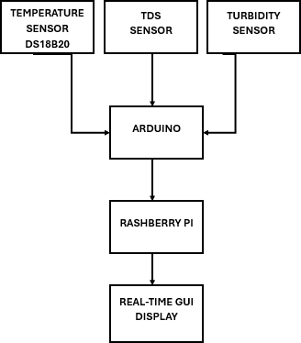
Fig. 1. Block diagram of the System

- Workflow
The proposed WQAS, as shown in Fig. 2, follows a care- fully crafted process flow that ensures optimal performance. It begins with initializing the sensors and establishing seamless communication between the Arduino board and Raspberry Pi

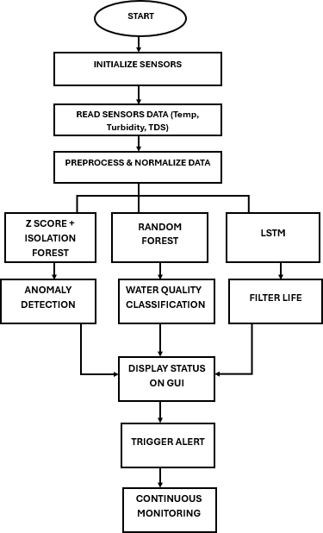

Fig. 2. Flowchart of WQAS

- Machine Learning Model Design
  - Data Preparation & Feature Handling: Before utilizing sensor data collected from temperature, turbidity, and TDS measurements for model training and inference, it undergoes crucial preprocessing. This step is important to ensure the accuracy of the models as raw data may be plagued with noise, inconsistencies or variations in scale that can hinder their performance. In order to overcome this hurdle, we employ effective data cleaning techniques such as noise filtering and validation checks. Additionally, feature scaling using Min- Max normalization is utilized to standardize all input variables within a common range.
X − X_{min}

board - setting a strong foundation for accurate data collection. In real time, the system gathers crucial information from
Xnorm = X

max
— Xmin
(1)

temperature, turbidity, and TDS sensors to provide compre- hensive insights into water quality. The collected data is normalized for improved accuracy and consistency. Next the preprocessed data is inputted into three parallel processes. The first one utilizes cutting-edge techniques such as Z-score calculation and isolation forest methods for anomaly detection. Meanwhile, the second process employs random forest algo- rithmic approach towards efficient water quality classification while maintaining top-notch standards of excellence. The third parallel process leverages LSTM technology for reliable filter life prediction.
Finally, the results are displayed on a GUI. This feature provides an overview of the current water status along with indications of any anomalies or deviations detected by each module. A built-in alert mechanism triggers immediate noti- fications should anything abnormal be flagged. In short, this remarkable system not only delivers precise results but also enhances efficiency through its multi-faceted yet seamlessly integrated functionalities.
By balancing the weights of input features, it guarantees that one aspect does not overpower the learning process due to varying levels of importance. To capture sequential patterns, the models incorporate time-series structuring by grouping input features into temporal windows. The ultimate feature selection comprises normalized measurements of turbidity (NTU), TDS (PPM), and temperature (°C) - these standardized values are utilized in all stages of learning.
  - Z Score and Isolation Forest: Anomaly detection al- gorithm involves the application of statistical and machine learning algorithms. The use of the Z-score rule ensures that the anomaly detection algorithm can detect all the anomalies perfectly. This is attributed to the fact that all the observations
(X) are compared against the mean value µ and standard deviation σ.In most scenarios, anomaly detection is feasible when values above the threshold are available. In order to increase robustness, the Isolation Forest algorithm has been employed. One of the main advantages of utilizing this al- gorithm is that it makes possible anomaly detection within

randomly partitioned data space. Anomalies are calculated using the following formula:
- Results and Discussions
The hardware components used in Fig. 3 include a DS18B20 temperature sensor, turbidity sensor, and TDS sensor, all of

c(n)
s(x, n) = 2 −
E(h(x))
(2)
which are connected to an Arduino board for sensing purpose. The Raspberry Pi will be used for the purpose of processing

The measurement used to determine anomalies is based on several features including the shortest average distance (E(h(x)) required and the normalization factor compared to the sample size (c(n)). The smaller the shortest average distance, the higher the probability of detecting the anomaly in the dataset. This method not only helps to detect anomalies in the dataset but also avoids false detection.
  - Random Forest: Random forest classifier is a useful algorithm that can classify water quality based on model-
and analysis.

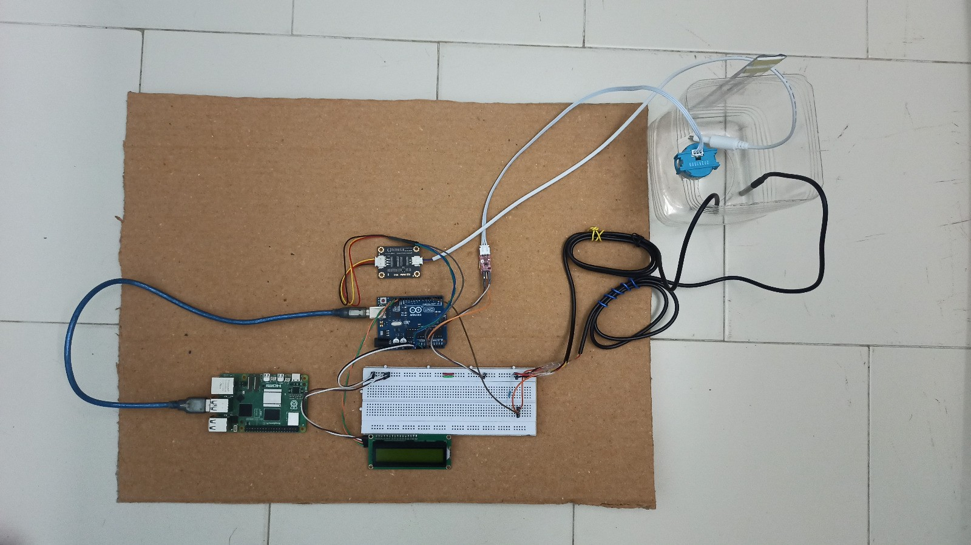

Fig. 3. Hardware Setup of WQAS System

based classification that involves several decision trees. The classification is done using different datasets in order to optimize the accuracy of the decision trees. In order for each decision tree to have optimal accuracy,
Σ
C
- Confusion Matrix Interpretation
Now coming to the results, the confusion matrices as- sociated with anomaly detection (Fig.4) and water quality classification(Fig.5). In regard to the anomaly detection anal- ysis from the graphical representation shown in Fig.4, there

G = 1 −
p
2
i
i=1
(3)
exists great accuracy in the results since 258 accurate results of normals along with 185 anomalous records have been

where pi is represents the probability of each class i. The final prediction comes from majority vote:
yˆ = mode{T₁(x), T₂(x), . . . , T_{n}(x)} (4)
This new approach enables us to categorize water quality into various categories, such as good, average, and bad based on several aspects. The new method ensures that there is high accuracy without over-fitting. In addition, this makes it more relevant in handling sensor data. In fact, the new approach offers a trade-off between classification and generalization using ensembles. Each tree is trainedon some information and then combined to achieve optimal performance. Thanks to this approach, the understanding of the data is improved, and we can get much more precise classification. While there might be certain weaknesses in other approaches, Random Forest does an outstanding job of capturing details while keeping the big picture in mind.
  - Long Short-Term Memory (LSTM) Model: LSTM model determines the trends within water quality data taking their time evolution into account. In doing so, the algorithm con- siders not only the current data but also its previous values. The formula for updating the state of the hidden layer can be presented as follows:

h_{t} = f (h_{t−1}, x_{t}) (5)

LSTM enhances the performance of classification in dy- namic environments based on water quality by analyzing the sequence of data from sensors. The LSTM improves classification performance in changing environments where water quality by looking at sequences of sensor readings.
detected. However, some instancesof misclassification can be seen, such as16 being incorrectly classified as anomalous while also mispredicting 41 actual anomalies as normal ones. On the other hand, moving onto the graphical representation of water quality classification shown in Fig.5 where there exists a good accuracy level of 84%. This indicates that majority of samples were correctly classified into either ”Bad” or ”Normal” categories. Some instances did result in incorrect classifications between ”Good” and ’Normal’.
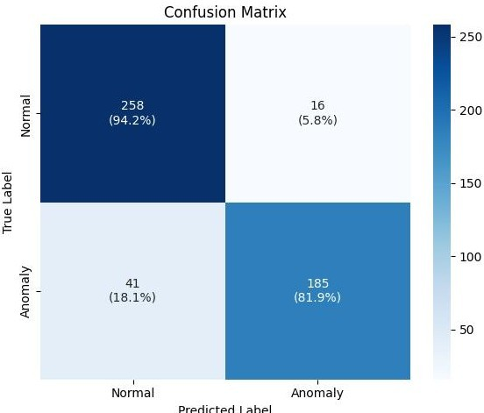
Fig. 4. Confusion Matrix for Anomaly Detection
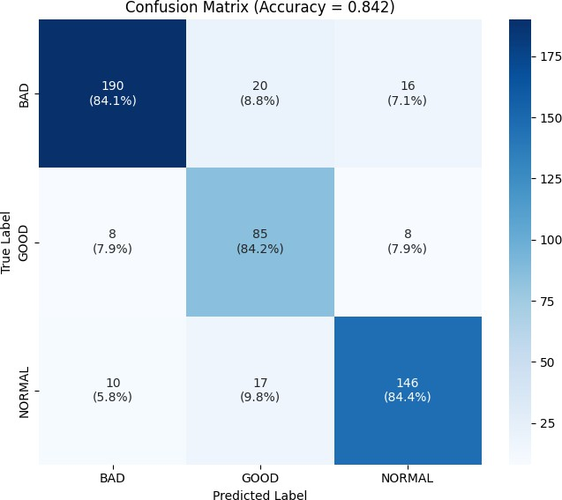

Fig. 5. Confusion Matrix for Water Quality Index model

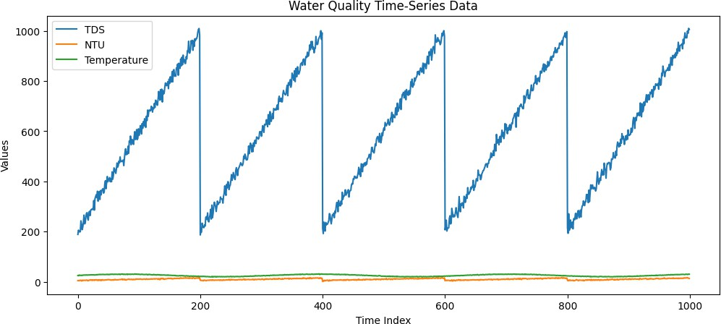

Fig. 9. Filter Life data

- Classification Report Analysis
The classification reports presented in Fig. 6 and Fig. 7 include values of precision, recall, and F1-score. In the case of anomaly detection (Fig. 6), values of precision equal to 0.86 (Normal) and 0.92 (Anomaly) demonstrate the correctness of prediction; the overall accuracy reaches approximately 89%. Recall equal to 0.82 (Anomaly) implies some anomalies being overlooked. Regarding water quality classification (Fig. 7), the overall accuracy reaches 84%. The ”Bad” class demonstrates very high precision (0.91), while the ”Good” class has lower presicion (0.70) meaning some overlap with adjacent classes.
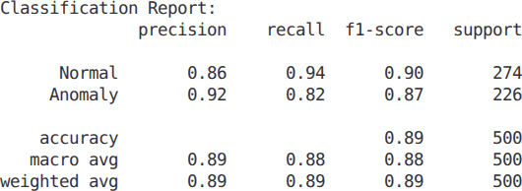

Fig. 6. Report Anomaly Detection

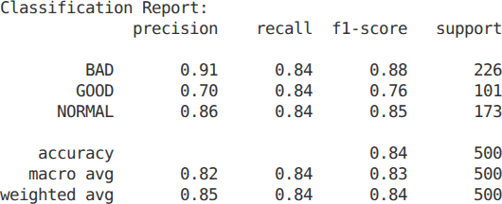

Fig. 7. Report Water Quality Model

- Graphical Analysis
The graphical analysis further confirms the performance of the system. In Fig. 8, the LSTM predicted data for TDS is compared with the actual data, and it can be seen that the predicted data is very close to the actual data, with some fluctuations. In Fig. 9, TDS, turbidity, and temperature time series data are plotted, revealing a cyclic pattern for TDS and constant behavior for the others.Fig. 10 shows the prediction error distribution, with most error mostly centered around zero, which indicates good prediction accuracy.
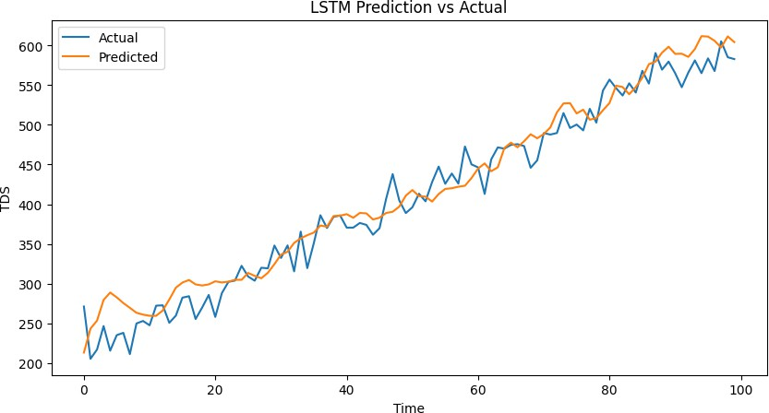
Fig. 8. Filter life prediction Vs actual

Fig. 10. Prediction Error Distribution

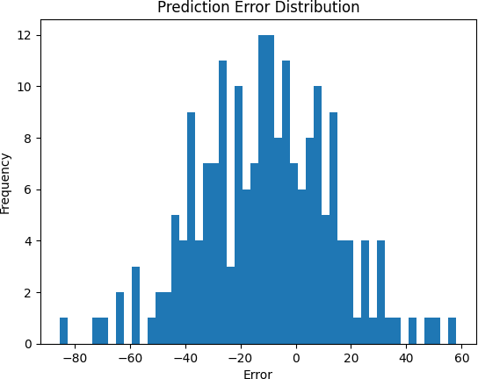
- Real-Time GUI Visualization
A real-time dashboard can be seen in Fig. 11 below which displays information on sensor data, normal or abnormal system performance, water quality score, estimated filter life expectancy, etc. It is an important instrument for checking the current status of the system.
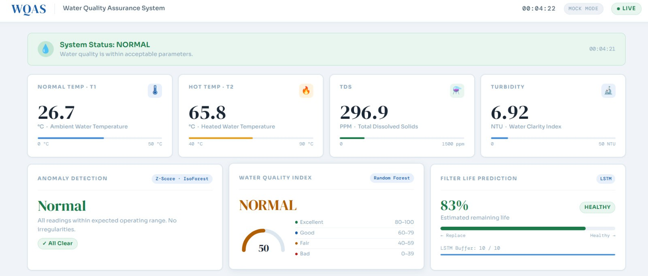

Fig. 11. Real-Time Water Quality Monitoring Dashboard

Furthermore, Fig. 12 offers a visual representation of sensor trends accompanied by an event log to track changes in TDS levels, turbidity measurements,and water quality index readings over time.This graphical depiction is complemented with detailed information regarding system operation. With these two figures combined,a comprehensive understanding of the current state and historical performance of the system can be easily attained through intuitive visualization techniques.
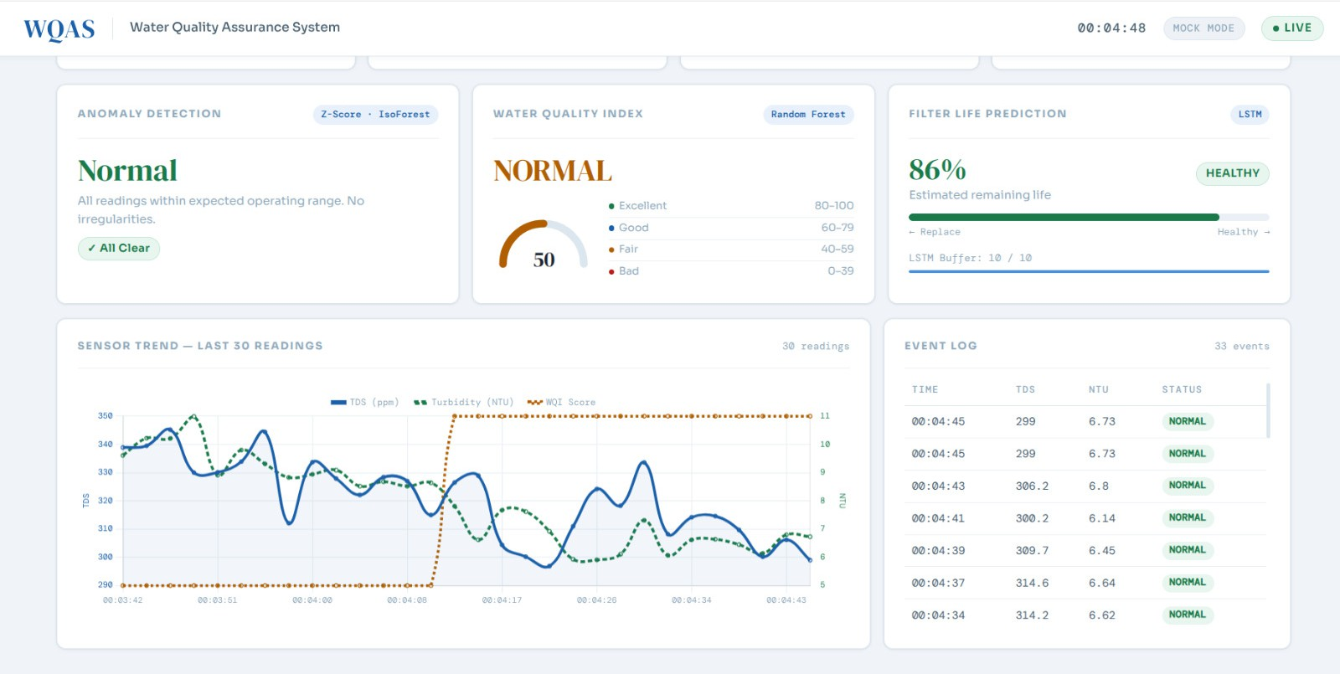

Fig. 12. Sensor Trend Analysis and Event Log Visualization

Conclusion
In conclusion, this project presents a novel approach to assessing water quality by introducing the Water Quality Assurance System (WQAS). The system uses a combination of sensors and artificial intelligence technology to provide an innovative solution to water quality assessment. By integrating temperature, turbidity, and TDS sensors with Arduino and Raspberry Pi technology, the system performs continuous data collection and real-time analysis through an intuitive inter- face.The strength of WQAS lies in its use of several learning models, which make the application more efficient. The hy- brid anomaly detection method anticipates any abnormalities

in the system at an early stage, while the Random Forest model classifies the quality of the water into relevant clusters. Additionally, our LSTM model does not only detect patterns in the sensor data; it also predicts the life expectancy of the filtering mechanism, which allows for timely maintenance to prevent any risk associated with the deterioration of the filters.Overall, this intelligent system serves as a game-changer in ensuring reliable access to safe drinking water by provid- ing comprehensive insights on overall water quality status. With WQAS’s advanced capabili- ties backed by powerful machine learning algorithms working behind the scenes 24/7 communities can rest assured knowing they have top-of-the- line protection against contaminated or subpar drinking water sources.
As we have analyzed the findings from the study, it is quite clear that the system has performed really well and proved itself to be highly accurate and practical in real world.In spite of the possible minor flaws within its framework, it can be stated without a doubt that it will consistently perform well in any form of classification or prediction operation. The project serves as a good illustration of how innovative approaches can be achieved by applying the synergy between IoT and machine learning algorithms to build efficient so- lutions. However, despite all the possibilities and benefits provided by this technology, there is still much room left for improvement. One option would be increasing the number of water quality parameters used in the model, which would improve its capabilities. To conclude, the results obtained from this particular experiment show not only their effectiveness but also the enormous potential of IoT in combination with machine learning algorithms.

References

- M. N. A. Mahzuza, R. F. Purnama, R. T. Deyantoro, and D. R. Hermanus, “IoT Sensors for Detecting and Filtering Water Impurities in Smart Water,” 2025.
- U. G. Sharanya, K. M. Birabbi, B. H. Sahana, D. M. Kumar, N. Sharmila, and S. Mallikarjunaswamy, “Design and Implementation of IoT-based Water Quality and Leakage Monitoring System,” 2024.
- S. L. Rosa, E. A. Kadir, and F. Assidiqi, “Design of Drinking Water Quality Monitoring System Based on IoT,” 2024.
- P. Sasirekha, B. S. Nathan, H. Nagendran, and I. Sadasivam, “AI- Enhanced Smart Water Purification System,” 2026.
- J. Chen, H. Zhang, C. Li, and H. Xiao, “Remaining Life Prediction of Water Purification Filter Based on Time Series,” 2024.
- S. Sahil and U. Urvashi, “Advanced Prognostic Models for Predictive Maintenance: A Comparative Analysis of Machine Learning and Deep Learning Approaches,” 2025.
- S. O. Olatinwo and T.-H. Joubert, “Water Quality Assessment Tool Using Edge AI,” 2024.
- X. Zhang, L. Yang, S. He, and M. Wang, “Design of a Water Quality Monitoring System for Self-Service Water Vending Machines Based on IoT Technology,” 2024.
- Z. Yu, Y. Sheng, H. Li, P. Li, J. Zhang, K. Xiao, L. Wang, and H. Lin, “Water Quality Classification Evaluation Based on Water Quality Monitoring Data,” 2023.
- P. T. Sivagurunathan, C. Pradeep, K. G. Ramprasath, G. Saravanakumar, and K. P. Shivaprasath, “ML-Driven Smart Monitoring System for Rural Environmental and Resource Health,” 2025.
- X. Yao, “A Predictive Model for the Operational Status of Water Con- servancy Facilities Based on Big Data Analysis and Cloud Computing,” 2025.
- N. Deeraj, R. S. Subhashree, S. V. N. M. Krishna, and M. Venkateshku- mar, “Study on anomaly detection in solar power conversion systems using machine learning technique,” Lecture Notes in Electrical Engi- neering, vol. 1485, pp. 661–670, 2026.
- D. Kavitha, M. Venkateshkumar, and S. Umashankar, “Machine learning-based approach on fault classification in microgrid,” Lecture Notes in Electrical Engineering, vol. 1485, pp. 671–687, 2026.
- L. E, M. M, M. R, M. Venkateshkumar, and S. A, “Smart Agriculture: Real-Time Environmental Monitoring and Temperature Forecasting Us- ing Machine Learning,” Proc. ICPEEV, pp. 1-6, 2024.
- H, J. J. F, L. J. V, K. K, and M. Venkateshkumar, “Heat Prediction and Control in Smart Phones Using Machine Learning,” Proc. ICISCoIS, pp. 1-6, 2026.

