## Automatic Burglar alert, Cooling, Lighting and Drapes Control system, *(A.B.C.L.A.D.S)* - by Nyalam Praveenraj

# Table of content

1. About the A.B.C.L.A.D.S
   1. Description
   2. Identifying features
   3. State of art
   4. 5W’s & 1H and S.W.O.T analysis
2. Requirements
   1. High level requirements
   2. Low level requirements
3. Block Diagram and Blocks explanation
   1. Block Diagram
   2. Sensors
   3. Actuators
   4. Micro controller and memory
   5. Sub-system and others
4. Architecture
   1. Behavioural Diagram
      1. High Level Flow chart Behavioural Diagram
      2. Low Level Flow chart Behavioural Diagram
   2. Structural Diagram

4.2.1 High Level UML Use Case Structural Diagram

* + 1. Low Level UML Use Case Structural Diagram

1. Test plan and Output
   1. High level test plan

5.2 Low level test plan

1. Application

# 1. About the A.B.C.L.A.D.S

## 1.1 Description

* This Project is an **Automatic Burglar alert, Cooling, Lighting and Drapes Control system**, *(A.B.C.L.A.D.S)* which will be useful for automatic lighting and cooling control system in home and when we are not in home we can activate Buglar alarm which will give a buzz noise alerting people around the home by buzzing noise when someone breaks the Door, When the user sets a required temperature and light intensity this system will automatically controls the Room temperature and Light intensity.

## 1.2 Identifying features

* It shall show how much %of drapes are opened according to room light intensity
* It shall dim/increase light intensity according to room light intensity variation
* It shall change the speed of fan accordingly to the temperature of the room
* When we are not at home it shall be able to sense if door is closed or broken and shall turn on a buzzer

## 1.3 State of art

* The main focus point here is the controlling the Home without even touching a single button
* And also securing our home with a reliable **Burglar system**
* Now this two features are combined and made into one product i.e. **A.B.C.L.A.D.S**
* As the world PACE-FORWARD our technology needs to catch up to the world

## 1.4 5W's & 1H and S.W.O.T analysis is in the below table

5W’s & 1H

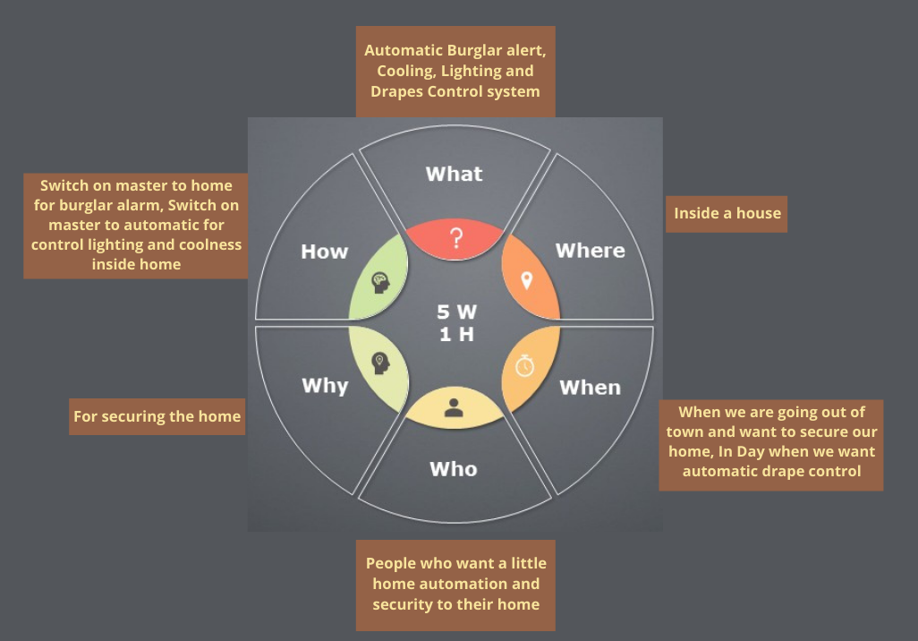

S.W.O.T analysis  
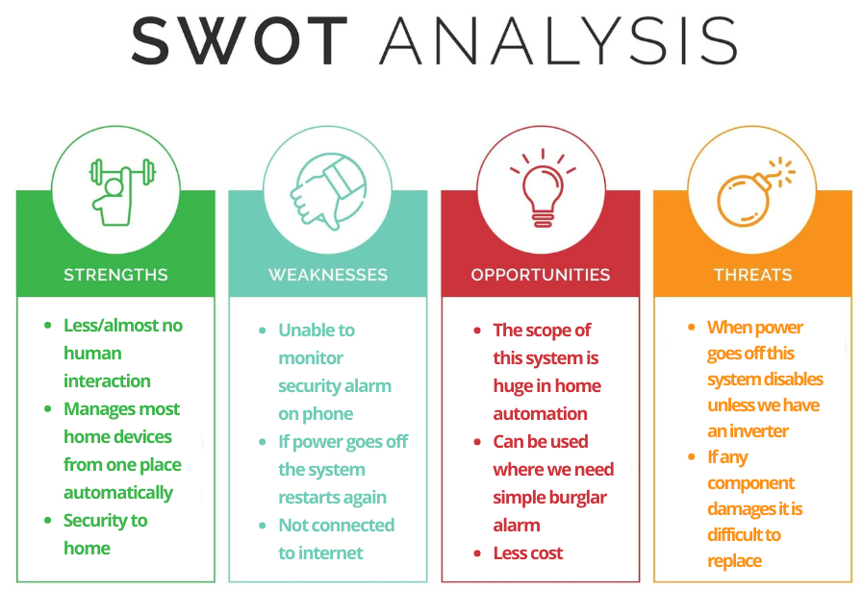

## 

## 2 Requirements

### 2.1 High Level Requirements

| **ID** | **High Level Requirements** |
| --- | --- |
| HLR1 | It shall control Lights, Fan Automatically when user selects desired light intensity and Temperature |
| HLR2 | It shall control Drapes Automatically user selects desired light intensity |
| HLR3 | It shall Sound buzzer when door is open and people are not at home |
| HLR4 | It shall display How much %of drapes are open |

### 2.2 Low Level Requirements

| **ID** | **Low Level Requirements for H1** | **ID** | **Low Level Requirements for H2** |
| --- | --- | --- | --- |
| LLR1.1 | According to the values of **LDR** and **User Light Intensity** shall control the Drapes position | LLR2.1 | According to the values of **LDR** and **User Light Intensity** shall control the lights |
| LLR1.2 | According to the values of **Thermistor** and **User Temperature** shall control speed of fan | LLR2.2 | Position of drapes shall be controlled by Stepper Motor |

| **ID** | **Low Level Requirements for H3** | **ID** | **Low Level Requirements for H4** |
| --- | --- | --- | --- |
| LLR3.1 | The **555 Timer** circuit shall send PWM signal to speaker | LLR4.1 | It shall be able display the %of drapes opened according to value of LDR |
| LLR3.2 | The micro controller shall activate buzzer circuit and turn off other systems | LLR4.2 | It shall be able to convert integer to string for displaying %of drapes |

## 3 Block Diagram and Blocks explanation

## 3.1 BLOCK DIAGRAM

## 

## 3.2 SENSORS

### Temperature Sensor (Thermistor)

* + This Thermistor is a resistor whose resistance is dependent on temperature here this change in resistance produces change in voltage, this voltage is taken as input to micro controller

### Light Intensity Sensor (LDR)

* + This LDR(Light Dependent Resistor) is a resistor whose resistance is dependent on intensity of light here this change in resistance produces change in voltage, this voltage is taken as input to micro controller

### Door Open/Closed Sensor

* + This is actually a micro switch in real world which will send data to micro controller about the door (opened/closed) in our simulation we just used a normal switch

### Master Switch

* + This switch controls the Burglar alarm and other automations as unit when this switch is on (we ON it when we want alarm)

### Potentiometer (POT)

* + This is basically used to take user input i.e. Temperature and Light Intensity

## 3.3 ACTUATORS

### FAN

* + This is a fan which control the cooling of room by increasing/decreasing it's speed

### Actuator for drapes (Stepper motor)

* + This is a motor who's direction and angle can be controlled which will inturn controls the DRAPES

### Relay

* + Here we have used Relay to switch on and off the Burglar alarm system

### Light

* + The lighting inside the room is controlled by this lights

### Display

* + Here we have used (Hd44780-26) LCD display for displaying how much %of drapes are opened and how much %of lights are on

## 3.4 MICRO CONTROLLER AND MEMORY

### EEPROM

* + Here this is actually inside the microcontroller

### Clock

* + Here we are using internal clock of our micro controller

### Micro Controller

* + This is the brain of the system here we use Atmega328 every computation is done inside this controller it converts analog to digital and maps certain values, it controls LCD display, it sends PWM signals to Fan and Stepper motor

## 3.5 SUBSYSTEM & OTHERS

### Burglar alarm

* + This system consists of **555 Timer**, some capacitors, resistors and a speaker connected in a specific way to make a buzzing sound

### Motor Driver Unit

* + This unit is different for both Drapes(we use Stepper motor driver i.e. ULN2804) and fan (we use motor driver L293183)

## 4 Architecture

## 4.1 Behavioral Diagram

### 4.1.1 High Level Flow chart Behavioral Diagram

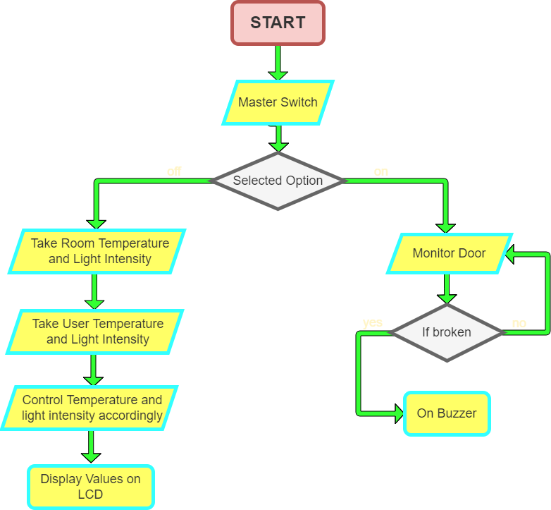

### 4.1.2 Low Level Flow chart Behavioural Diagram

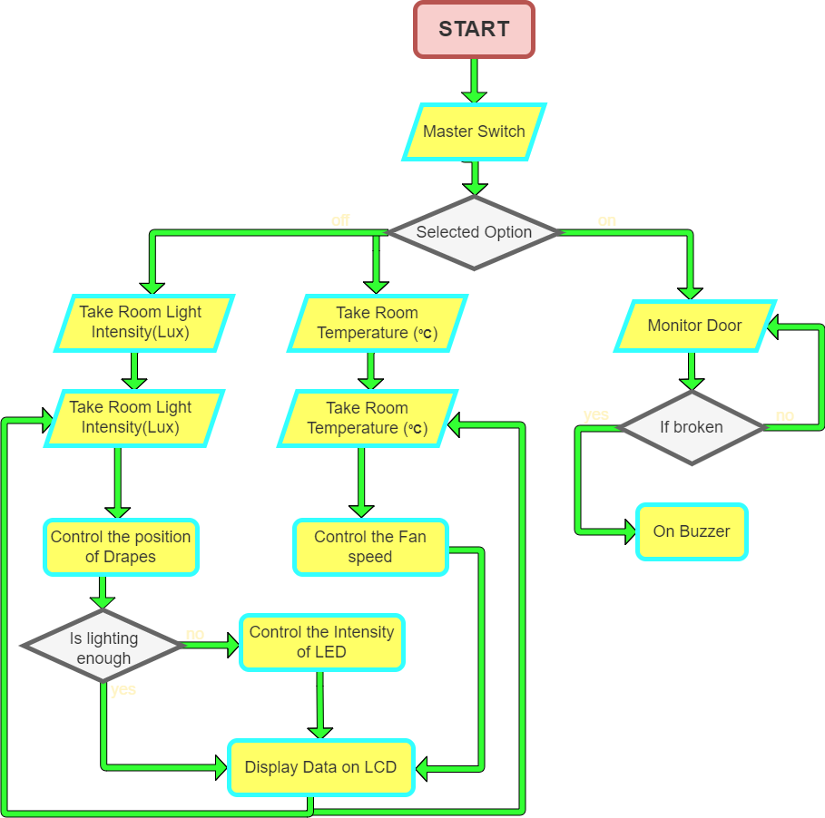

## 4.2 Structural Diagram

### 4.2.1 High Level UML Use Case Structural Diagram

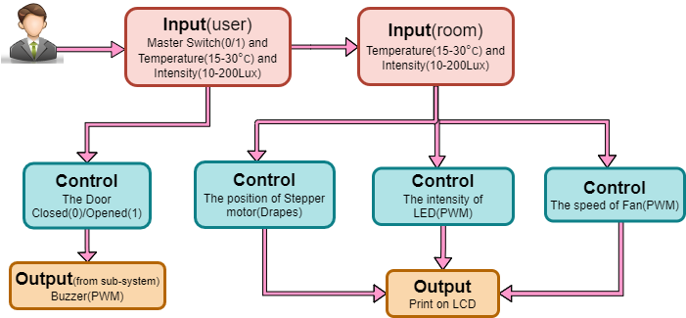

### 4.2.2 Low Level UML Use Case Structural Diagram

## 

# 5 Test plan and output

## 5.1 HIGH LEVEL TEST PLAN / Integrated test plan

| **Test ID** | **Description** | **Input** | **Expected output** | **Actual Output** | **Passed or not** |
| --- | --- | --- | --- | --- | --- |
| 01 | Temperature | 25°C(User) 30°C(room/Thermistor) | Fan speed shall change accordingly | Fan speed shall change accordingly | To be done |
| 02 | Light Intensity | 200Lux(User) 10Lux(LDR) | 100% of drapes opened | 100% of drapes opened | To be done |
| 03 | Master Switch | on(1) | Shall disable all automation(0) | Shall disable all automation(0) | To be done |
| 04 | Master Switch | off(0) | Shall disable Alarm(0) and on Automation(1) | Shall disable Alarm(0) and on Automation(1) | To be done |
| 05 | 555 Timer and buzzer | Data from Micro controller(1) | Buzzing Sound | Buzzing Sound | To be done |

| **Test ID** | **Description** | **Input** | **Expected output** | **Actual Output** | **Passed or not** |
| --- | --- | --- | --- | --- | --- |
| 01 | Door Open/Close sensor | 5v 0r 0v | shall Send 1 to Buzzer circuit | shall Send 1 to Buzzer circuit | To be done |
| 02 | LCD display | %(50) of drapes opened and %(50) of lights intensity | "%(50) of drapes opened and %(50) of lights intensity" on screen | "%(50) of drapes opened and %(50) of lights intensity" on screen | To be done |
| 03 | Motor Control For Stepper (MCFS) | Data from Micro controller( shall sends values from PORTD to Motor driver) | Data from Micro controller(shall sends values from PORTD to Motor driver) | Data from Micro controller(shall sends values from PORTD to Motor driver) | To be done |
| 04 | Motor Control For Fan (MCFF) | Data from Micro controller(PWM from Controller to Motor Driver) | shall Change speed of fan (PWM) | shall Change speed of fan (PWM) | To be done |
| 05 | Stepper motor | Data from MCFS To Stepper | shall change position of Stepper Motor | shall change position of Stepper Motor | To be done |

## 5.2 LOW LEVEL TEST PLAN / Unit test plan

| **Test ID (for LCD)** | **Description** | **Input** | **Expected output** | **Actual Output** | **passed/not** |
| --- | --- | --- | --- | --- | --- |
| 01 | Check for LCD_Char() | N | N | N | To be done |
| 02 | Check for LCD_String() | automation | automation | automation | To be done |
| 03 | Check for LCD_String() | Home | Home | Home | To be done |

| **Test ID (for ADC)** | **Description** | **Input** | **Expected output** | **Actual Output** | **passed/not** |
| --- | --- | --- | --- | --- | --- |
| 01 | Check for ADC_Read() | To be done | To be done | To be done | To be done |
| 02 | Check for ADC_Read() | To be done | To be done | To be done | To be done |

| **Test ID (for mapping, map)** | **Description** | **Input** | **Expected output** | **Actual Output** | **passed/not** |
| --- | --- | --- | --- | --- | --- |
| 01 | Check for map() | To be done | To be done | To be done | To be done |
| 02 | Check for map() | To be done | To be done | To be done | To be done |
| 03 | Check for map() | To be done | To be done | To be done | To be done |

## 6 Applications

* The scope of this project is vast in the area of home automation
* Home security and when people want automatic home lighting and cooling system along with Intruder alart
* In factories and function halls
* In Schools and Collages to save energy