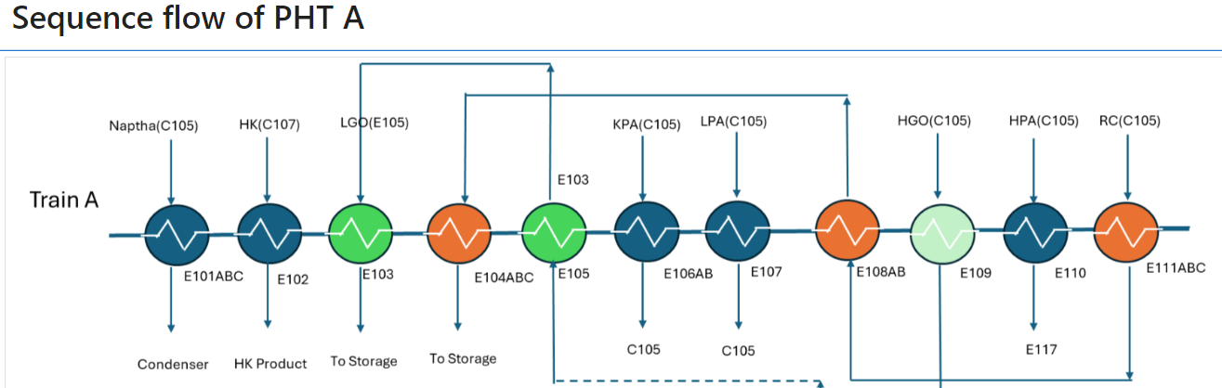

import numpy as np

from scipy.optimize import fsolve

import csv

def heat_exchanger(shell_flow_rate, tube_flow_rate, shell_inlet_temp, tube_inlet_temp, shell_density, tube_density, Area, Cp_s, Cp_t, U_dirty, initial_guess):

def equations(variables):

Th, Tc = variables

eq1 = (tube_flow_rate * tube_density * Cp_t * (Tc - tube_inlet_temp)) - (shell_flow_rate * shell_density * Cp_s * (shell_inlet_temp - Th))

eq2 = tube_flow_rate * tube_density * Cp_t * (Tc - tube_inlet_temp) - U_dirty * Area * (((shell_inlet_temp - Tc) - (Th - tube_inlet_temp)) / (np.log((shell_inlet_temp - Tc) / (Th - tube_inlet_temp))))

#print(eq1, eq2)

return [eq1, eq2]

shell_outlet_temp, tube_outlet_temp = fsolve(equations, initial_guess)

print(shell_outlet_temp, tube_outlet_temp)

return shell_outlet_temp, tube_outlet_temp

def forward_flow(conditions):

results = {} # To store the Shell and Tube outlet temperatures as a dictionary

results["E103"] = heat_exchanger(**conditions["E103"]) # E103 HX's Shell and Tube outlet temps

conditions["E104AB"]["tube_inlet_temp"] = results["E103"][1] # Passing E103 HX's tube outlet to tube inlet of E104ABC HX

# Below is the continuation of the flow from left to right after E104ABC/AB

results["E104AB"] = heat_exchanger(**conditions["E104AB"])

conditions["E105"]["tube_inlet_temp"] = (results["E104AB"][1] - 2.74)

results["E105"] = heat_exchanger(**conditions["E105"])

conditions["E106A"]["tube_inlet_temp"] = (results["E105"][1] - 8)

results["E106A"] = heat_exchanger(**conditions["E106A"])

conditions["E107"]["tube_inlet_temp"] = results["E106A"][1]

results["E107"] = heat_exchanger(**conditions["E107"])

conditions["E108AB"]["tube_inlet_temp"] = results["E107"][1]

results["E108AB"] = heat_exchanger(**conditions["E108AB"])

conditions["E109"]["tube_inlet_temp"] = results["E108AB"][1]

results["E109"] = heat_exchanger(**conditions["E109"])

conditions["E110"]["tube_inlet_temp"] = results["E109"][1]

results["E110"] = heat_exchanger(**conditions["E110"])

conditions["E111AB"]["tube_inlet_temp"] = results["E110"][1]

results["E111AB"] = heat_exchanger(**conditions["E111AB"])

return results

def process_flow(conditions):

results = forward_flow(conditions)

conditions["E108AB"]["shell_inlet_temp"] = results["E111AB"][0] # Feeding back Shell outlet to Shell inlet of E108AB

results["E108AB"] = heat_exchanger(**conditions["E108AB"]) # Updating the results of outlet temperatures after the above op

conditions["E104AB"]["shell_inlet_temp"] = results["E108AB"][0] # Feeding back Shell outlet to Shell inlet of E108AB

conditions["E103"]["shell_inlet_temp"] = results["E105"][0]

results["E103"] = heat_exchanger(**conditions["E103"]) # Updating the results of outlet temperatures after the above op

return results, conditions

def write_results_to_csv(results, iteration, csv_writer):

for exchanger, (shell_out, tube_out) in results.items():

shell_out = round(shell_out,2)

tube_out = round(tube_out,2)

csv_writer.writerow([iteration, exchanger, shell_out, tube_out])

def run_simulation(initial_conditions, num_iterations=6):

conditions = initial_conditions.copy()

#print(conditions)

all_results = []

with open('simulation_results_changed_Udirty.csv', mode='w', newline='') as file:

writer = csv.writer(file)

writer.writerow(['Iteration', 'Heat Exchanger', 'Shell Outlet Temp', 'Tube Outlet Temp'])

for i in range(num_iterations):

#print(f"Iteration {i+1}")

results, conditions = process_flow(conditions)

all_results.append(results)

write_results_to_csv(results, i+1, writer)

return all_results

# Higher E111AB U_dirty

initial_conditions = {

"E103": {"shell_flow_rate": 207.9, "tube_flow_rate": 1035, "shell_inlet_temp": 146.6, "tube_inlet_temp": 95.15,

"shell_density": 779.8, "tube_density": 875, "Area": 703.1,"Cp_s":0.566088529455742,"Cp_t":0.534213494442481,"U_dirty":225.9, "initial_guess": (100, 120)},

"E104AB": {"shell_flow_rate": 207.9, "tube_flow_rate": 519.7, "shell_inlet_temp": 212.73, "tube_inlet_temp": None,

"shell_density": 877.16, "tube_density": 875, "Area": 1955.8,"Cp_s":0.67204501,"Cp_t":0.556748477033156,"U_dirty":96.7, "initial_guess": (120, 140)},

"E105": {"shell_flow_rate": 211, "tube_flow_rate": 1039.5, "shell_inlet_temp": 208.8, "tube_inlet_temp": None,

"shell_density": 749, "tube_density": 875, "Area": 644.9,"Cp_s":0.630306413745319,"Cp_t":0.578571841535755,"U_dirty":357.5, "initial_guess": (145, 155)},

"E106A": {"shell_flow_rate": 175, "tube_flow_rate": 474, "shell_inlet_temp": 214.1, "tube_inlet_temp": None,

"shell_density": 655.7, "tube_density": 875, "Area": 819.8,"Cp_s":0.455504463120254,"Cp_t":0.582896434020995,"U_dirty":122.4, "initial_guess": (155, 165)},

"E107": {"shell_flow_rate": 179.8, "tube_flow_rate": 947.9, "shell_inlet_temp": 257.2, "tube_inlet_temp": None,

"shell_density": 661, "tube_density": 875, "Area": 537,"Cp_s":0.855037095821607,"Cp_t":0.597633677673339,"U_dirty":328.45, "initial_guess": (170, 180)},

"E108AB": {"shell_flow_rate": 199.5, "tube_flow_rate": 474, "shell_inlet_temp": 268.8, "tube_inlet_temp": None,

"shell_density": 851.9, "tube_density": 875.1, "Area": 1052.3,"Cp_s":0.907771557,"Cp_t":0.622017192077636,"U_dirty":148.6, "initial_guess": (200, 220)},

"E109": {"shell_flow_rate": 248.9, "tube_flow_rate": 947.9, "shell_inlet_temp": 298.9, "tube_inlet_temp": None,

"shell_density": 734.9, "tube_density": 875.1, "Area": 580.8,"Cp_s":0.538406851140075,"Cp_t":0.644237101745605,"U_dirty":217.87, "initial_guess": (210, 240)},

"E110": {"shell_flow_rate": 399.1, "tube_flow_rate": 947.9, "shell_inlet_temp": 299.5, "tube_inlet_temp": None,

"shell_density": 677.3, "tube_density": 875.1, "Area": 402.6,"Cp_s":0.997496898964167,"Cp_t":0.658227702331542,"U_dirty":353.7, "initial_guess": (230, 270)},

"E111AB": {"shell_flow_rate": 199.5, "tube_flow_rate": 474.0, "shell_inlet_temp": 349.3, "tube_inlet_temp": None,

"shell_density": 815.3, "tube_density": 875.1, "Area": 1153.8,"Cp_s":0.794846381463514,"Cp_t":0.684942805480957,"U_dirty":168.4, "initial_guess": (245, 260)},

}  
  
  
simulation_results = run_simulation(initial_conditions)

for i, results in enumerate(simulation_results):

print(f"\nIteration {i+1} Results:\n")

for exchanger, (shell_out, tube_out) in results.items():

print(f"{exchanger}: Shell out = {shell_out:.2f}, Tube out = {tube_out:.2f}")