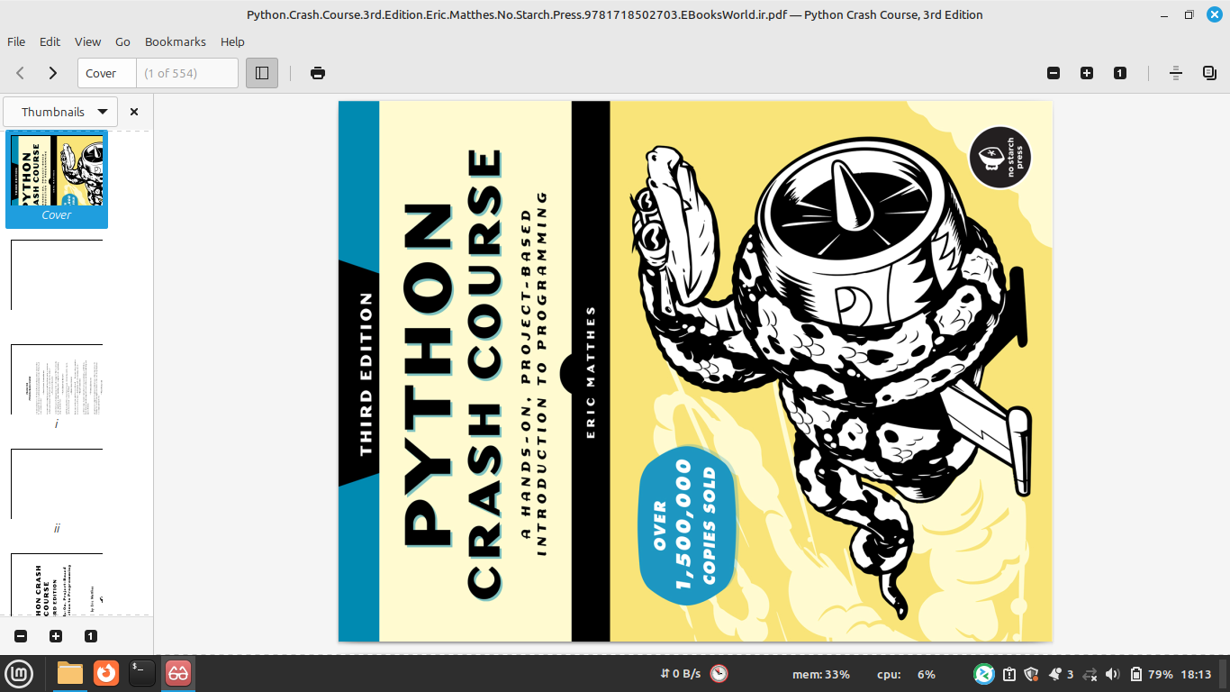
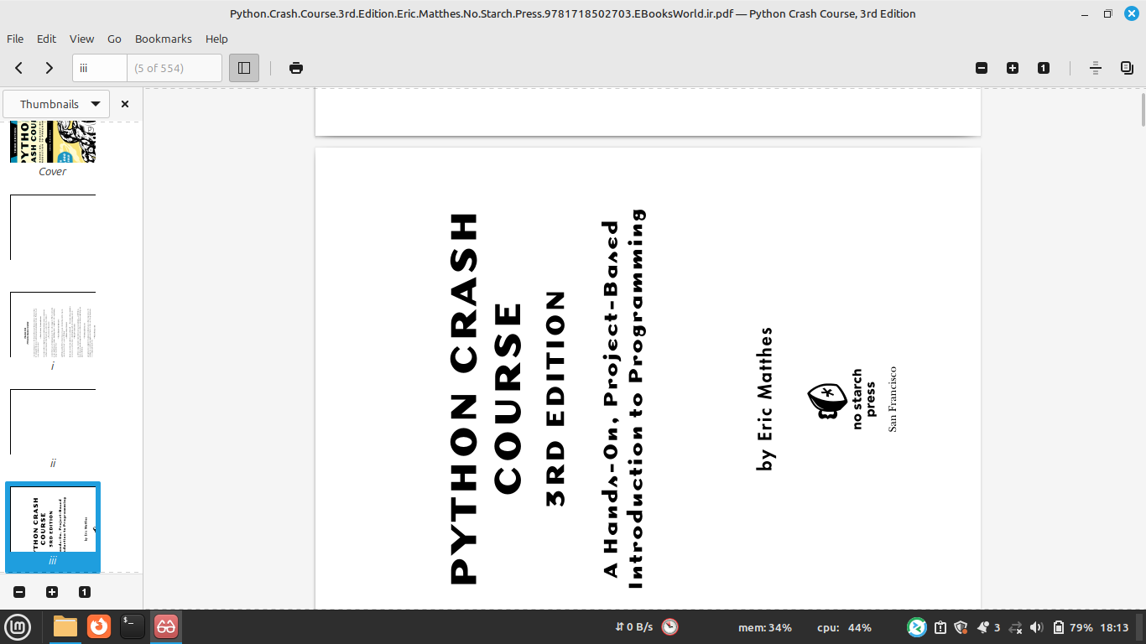
Supplementary resources are available at https://ehmatthes.github.io/pcc_3e

