Follow-Up Email Templates with The Office Memes

Email 1: Michael Scott - "Little Stitious"

Subject: Just a little stitious about my last email... 🤞

Hi Afeef,

Hope you're having a fantastic morning!

Thought you'd appreciate a little wisdom from Michael Scott today:

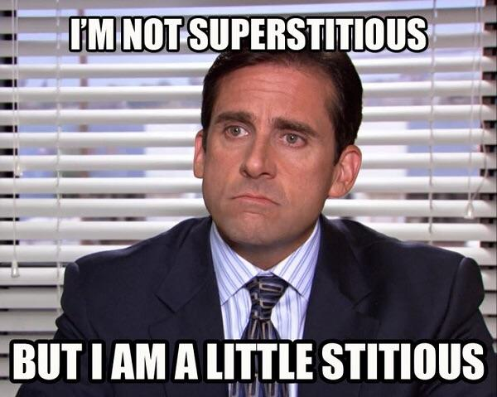

"I'm not superstitious, but I am a little stitious."

Not being superstitious myself—but sending good vibes your way just in case!

Just following up on my last email regarding the Business Analyst role at Petco. I'd love to chat when you have a moment.

Wishing you a productive (and lucky!) day ahead!

Warm regards,

Praveen

Email 2: Dwight Schrute - "Facing Challenges"

Subject: Ready for challenges (Dwight Schrute approved) 💪

Hi Afeef,

Hope your day is off to a strong start!

This morning’s motivational moment brought to you by Dwight Schrute:

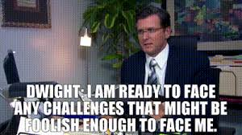

"I am ready to face any challenges that might be foolish enough to face me."

Like Dwight, I'm feeling ready and energized about the opportunity at Petco. Just checking if my earlier email about the Business Analyst role has caught your attention yet.

Would love to discuss how I can help tackle the team’s challenges—no matter how foolish they might be!

Cheers,

Praveen

Email 3: Michael Scott - "Why Are You the Way That You Are?"

Subject: Quick check-in (Michael Scott style!) 😅

Hi Afeef,

Hope your inbox is kinder today! Thought you'd enjoy a relatable moment from Michael Scott:

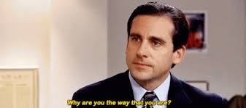

"Why are you the way that you are?"

Totally get that inboxes can be overwhelming, so I'll keep it brief—just wanted to gently bump up my previous email regarding the Business Analyst position at Petco.

Let me know if you’re free for a quick chat. Until then, wishing you manageable email loads and lots of coffee!

All the best,

Praveen