Forte Eclipse configuration

Table of contents
Table of contents 2
1 Install Check Style plugin 3
2 Apply Forte Check Style configuration 3
2.1 Apply the new configuration to an eclipse project. 6
3 Eclipse Global configuration 8
3.1 Eclipse Cleanup Settings. 8
3.2 Eclipse Formatter settings 10
3.3 Eclipse Save Action settings 12
4 Eclipse project specific configuration 13
5 Use Organize Imports, Format, Cleanup, and Save action 17
Revision record 18
End of document 18

Install Check Style plugin
- Help>Install New Software
- Click on Add
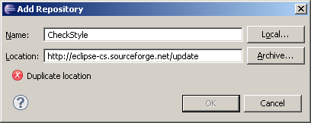
Install the latest CheckStyle Plugin

Apply Forte Check Style configuration
- Go to Window>Preferences and select CheckStyle
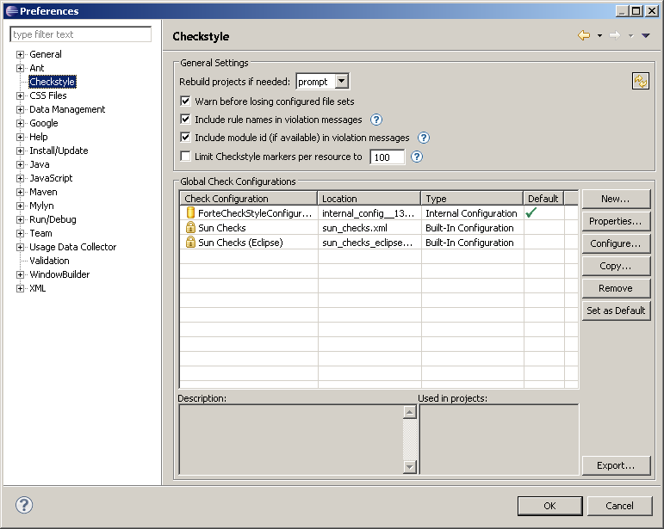
- Click on New
- Choose Remote Configuration
- Type in the below values as shown below:
Name: Forte Check Style Configuration(cached)
Location: http://forte-consultants.com/download/ForteCheckStyleConfiguration.xml
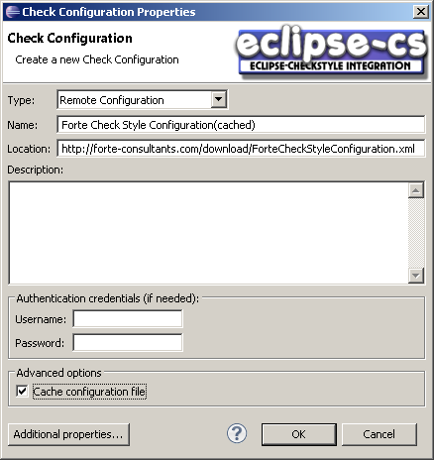
- Make sure to turn on the check box (Cache configuration file).
- Click on OK
- Set the new configuration as the default by pressing the “Set as default” button.
- 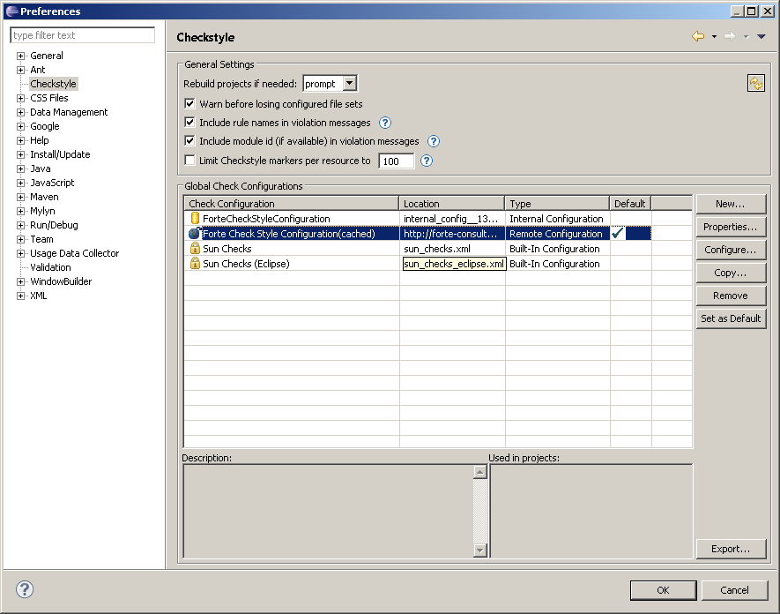

Apply the new configuration to an eclipse project.
- Right click on the project and select properties.
- Make sure the check boxes are as selected as shown below

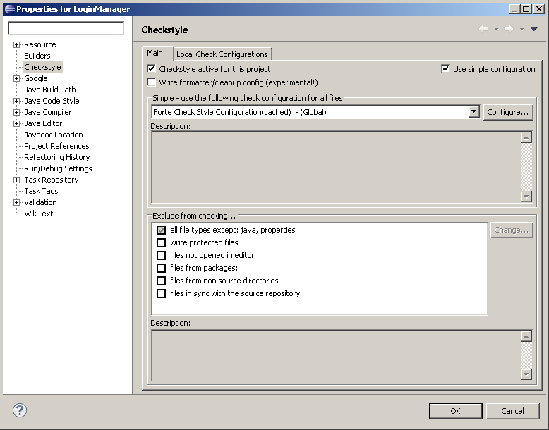
Click on OK
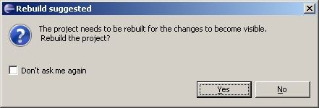
Click on Yes

Eclipse Global configuration

Eclipse Cleanup Settings.
- Window/Preferences/Java/Code Style/Cleanup
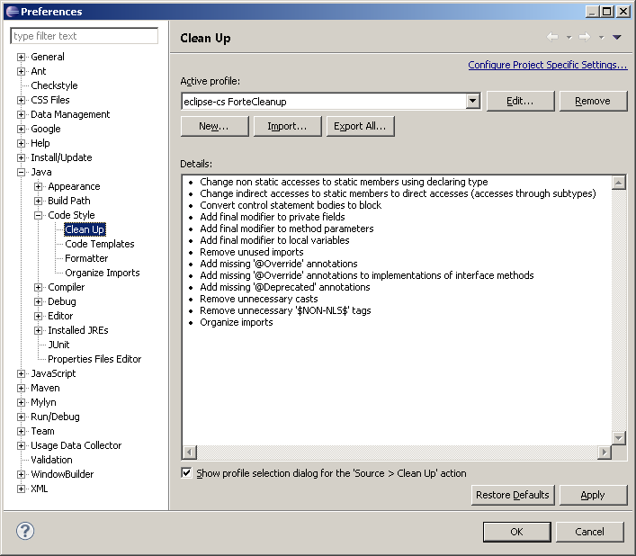
- Click on Import and paste this URL
http://forte-consultants.com/download/ForteEclipseCleanupSettings.xml
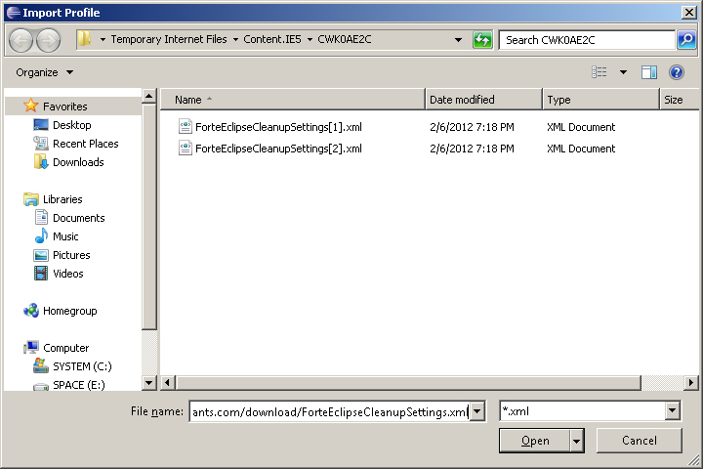
- Click on open and Apply
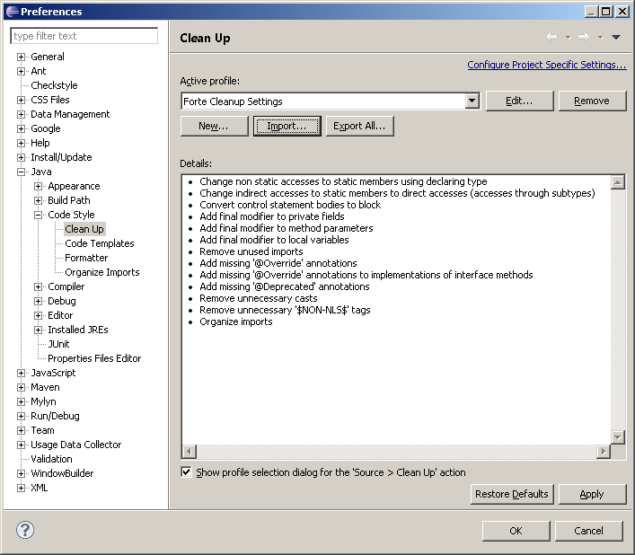

Eclipse Formatter settings
- Window/Preferences/Java/Code Style/Formatter

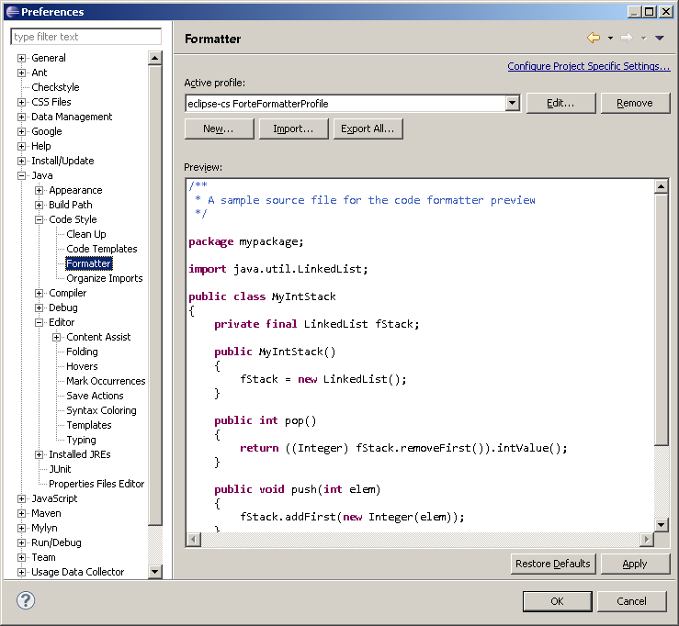
Click on Import and type in the following URL
http://forte-consultants.com/download/ForteEclipseFormatterSettings.xml
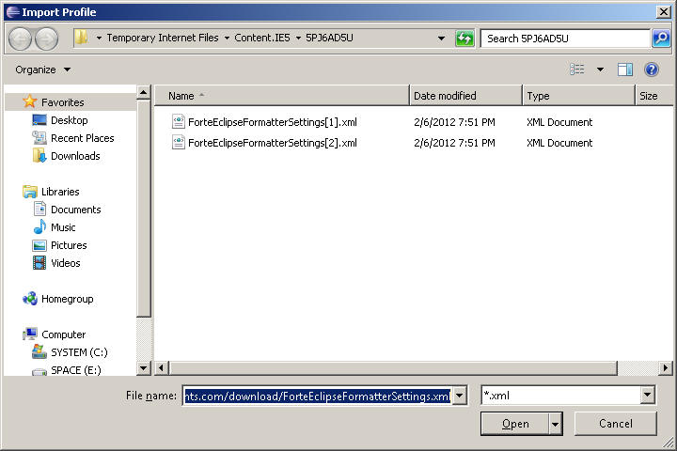
Click on Open and then apply.

Eclipse Save Action settings
- Window/Preferences/Java/Editor/Save Actions and set as shown below
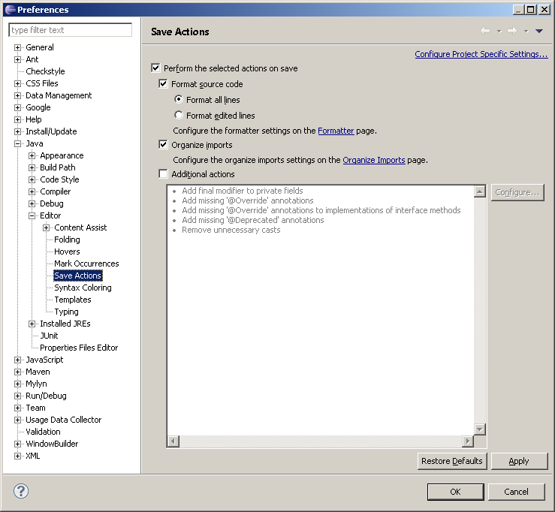

Eclipse project specific configuration
- Right click on project and go to properties
- Apply code style and other settings exactly as shown in the windows below
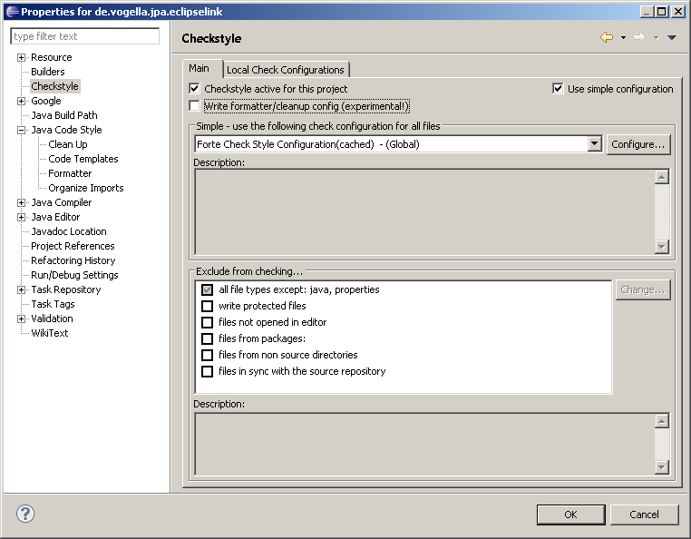
- Active profile should be Forte cleanup settings
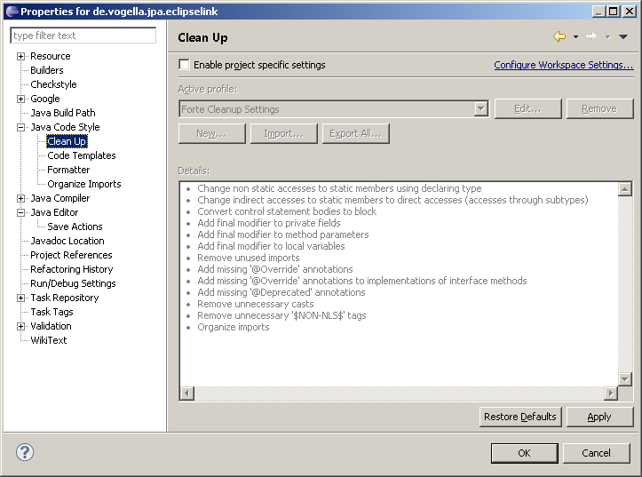

- Formatter should be Forte Formatter Profile
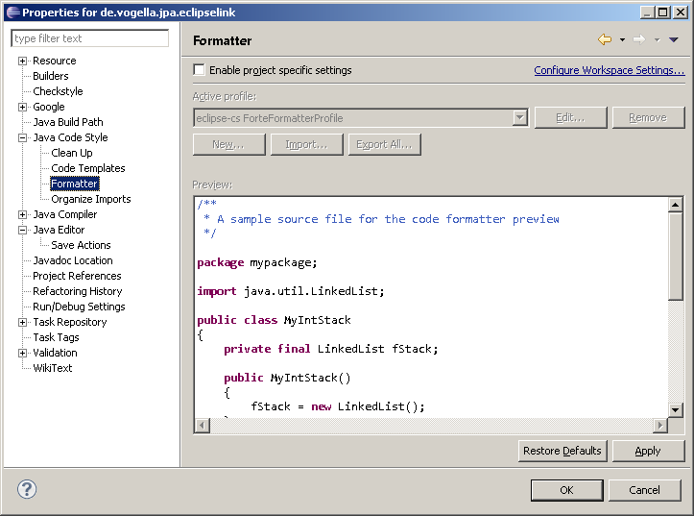

- Save action should use Workspace settings, hence there is no project specific setting.
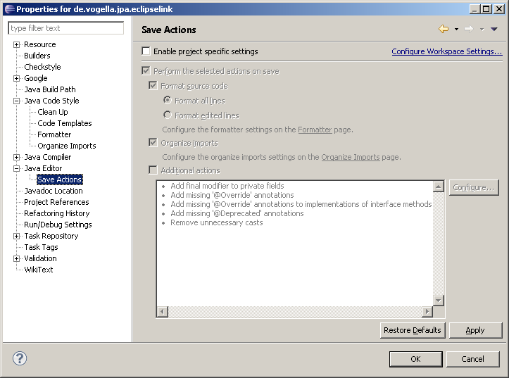

Use Organize Imports, Format, Cleanup, and Save action
Now use eclipse as a tool to automatically modify your code to confirm to coding standards.
Use all the three functions (Organize Imports, Format, Cleanup, and Save action). This should resolve most of the common problems.
Some of the Code style warning may still remain, this should be fixed manually.
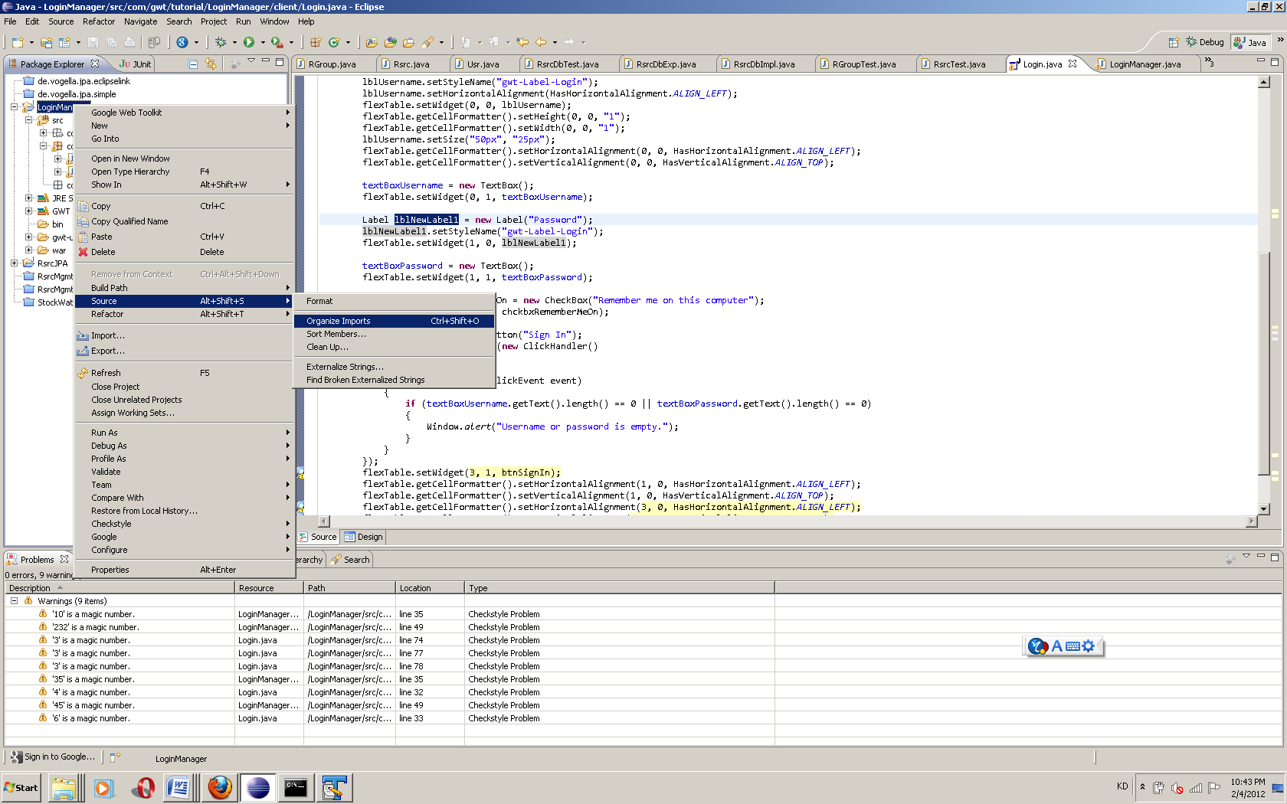

Revision record
Revision |  | Date |  | Author |  | Description |  | Sections affected
0.1 |  | 20 Jan 2012 |  | Praveen |  | First Draft |  | All

End of document

