Typescript

Angular 2.0 and vue.js are written in typescript, but react is written in javascript.

Typescript is a superset of javascript that adds static typing and other features to enhance javascript development, it was developed by microsoft.

Typescript = javascript + extra features.

It is easier to read , easier to write and easier to maintain.

Any valid javascript code is a valid typescript code .

Advantage of typescript

* Easier to read.

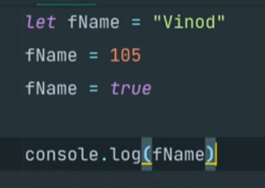

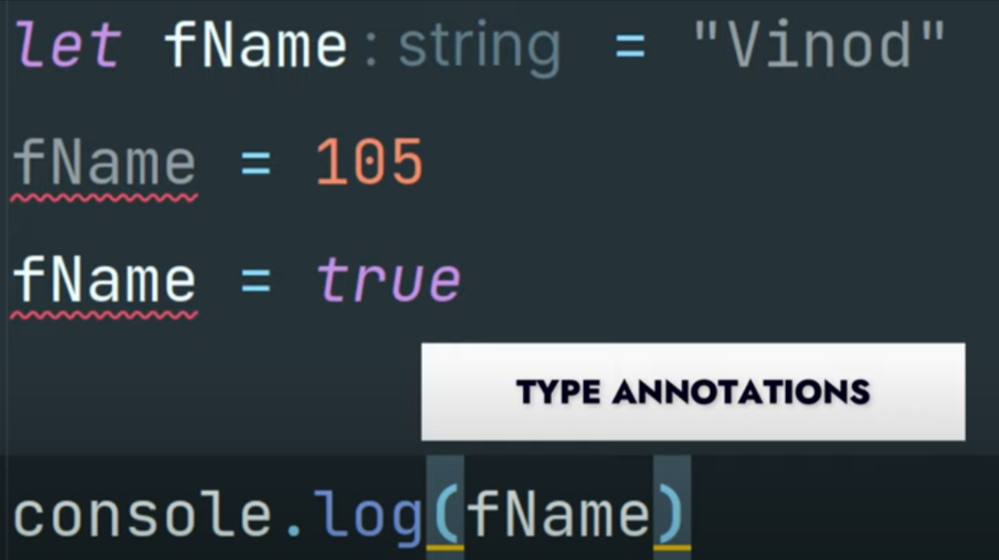

* Easier to write
* Typescript provide the feature of interfaces, tuples, enums, generic, classes etc.

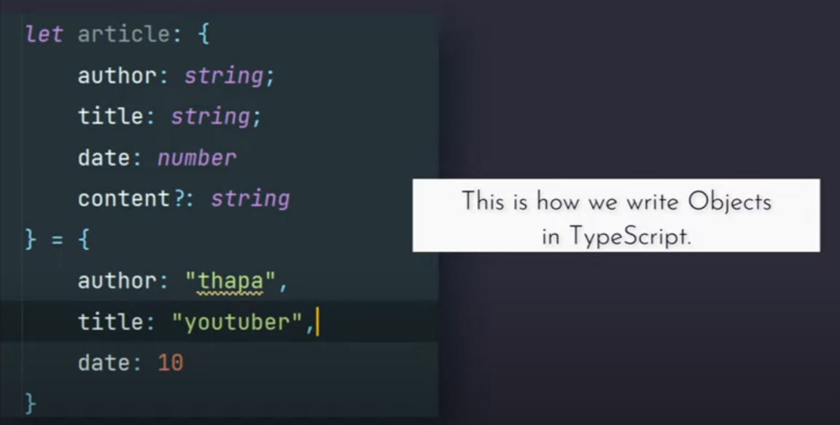

* Typescript catches errors at compile time instead of runtime, which makes debugging easier and reduces the likelihood of bugs in production.

Disadvantages of typescript

* Browser does not support typescript. What ever code I write that code must compile to javascript. Because browser understand that.

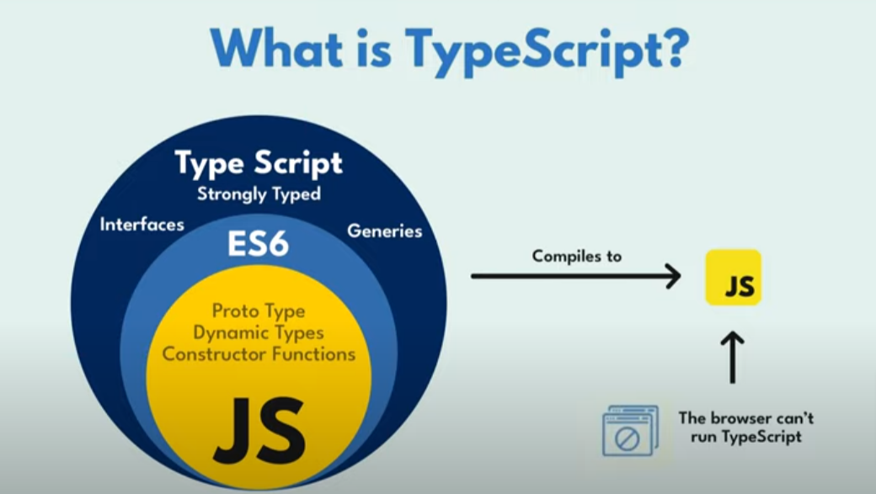

Typescript is javascript with syntax for types. It is a strongly typed programming language that build on javascript.

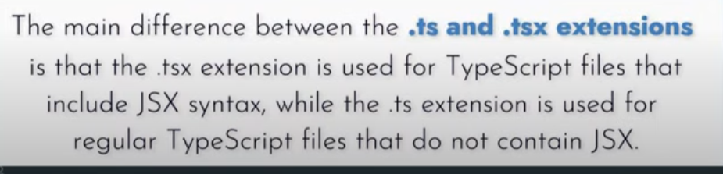

tsc file_name => it convert to javascript file corresponding to typescript file.

Project file structure for typescript

Project /

Index.ts

tsconfig.json

type annotation



