Solutions –

1. select * from citytable where countrycode='USA' and population>100000;

Output -

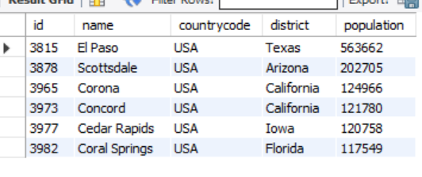

1. select name from citytable where countrycode='USA' and population>120000;

O/P -

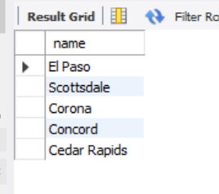

1. select * from citytable;

O/P - 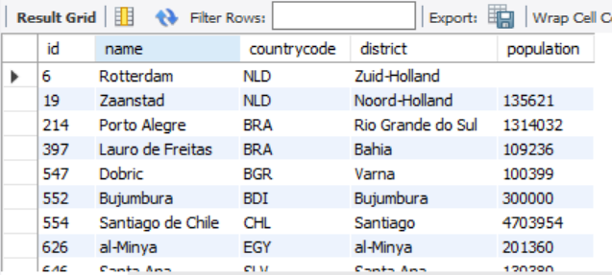

1. select * from citytable where id=1661;

O/P - 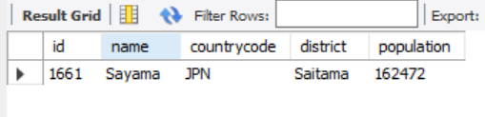

1. select * from citytable where countrycode='JPN';

O/P - 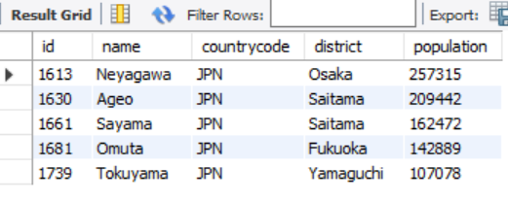

1. select name from citytable where countrycode='JPN';

O/P - 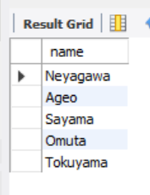

1. select City,State from stationdata;

O/P - 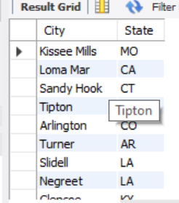

1. select distinct(City) from stationdata where mod(Id,2)=0;

o/p - 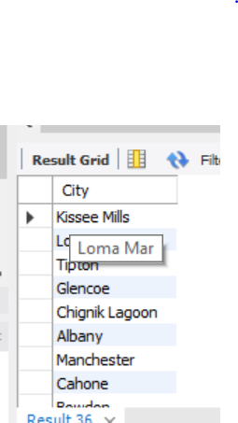

1. select (count(City)-count(Distinct(City))) as Diff_City from stationdata;

O/P - 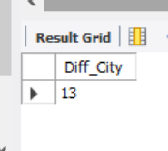

1. select City,LENGTH(City) from stationdata order by Length(City) asc, City limit 1;

select City,LENGTH(City) from stationdata order by Length(City) desc, City limit 1;

1. select distinct(City) from stationdata where REGEXP_LIKE(city,'^[aeiou]');

O/P - 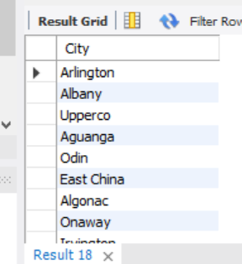

1. SELECT DISTINCT City FROM stationdata WHERE City REGEXP '[aeiou]$';

O/P - 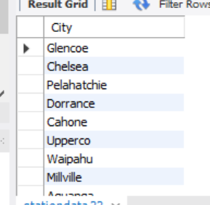

1. SELECT DISTINCT City FROM stationdata WHERE City NOT RLIKE '^[aeiou].*$';

O/P - 