

TITLE OF THE PROJECT

AGGRESSIVE DOG DETECTION SPY
By Praveen Sunkara

INTRODUCTION :
The aggressive dog detection spy system is an innovative solution designed to identify and monitor instances of aggressive dog behavior in a covert manner. It combines the power of deep learning algorithms with the compactness and versatility of Raspberry Pi, making it suitable for various environments.
The system utilizes a camera connected to the Raspberry Pi to capture images or video streams. These data are then processed and analyzed using deep learning techniques, specifically convolutional neural networks (CNNs). By training the CNN model on a dataset of labeled images or videos depicting aggressive and non-aggressive dog behavior, the system learns to recognize patterns and features associated with aggression.

COMPONENTS :
To build a project for aggressive dog detection using deep learning and Raspberry Pi, the following components are required:
• Raspberry Pi: A Raspberry Pi board serves as the main processing unit for the system. Choose a suitable model with enough processing power and memory for running the deep learning model and processing the data.
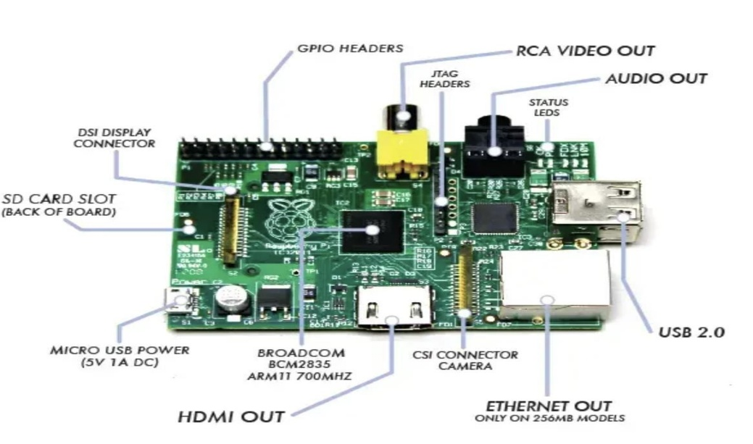

- Micro-USB Power Supply: A 5V micro USB typically powers the Raspberry Pi.
- SD Card Slot: Secure Digital Card slot (SD Card) slot is a solidstate removable storage device which is required to run operating systems on Raspberry Pi as Raspberry Pi doesn’t have any onboard memory and data storage functionality.

- USB Ports & Ethernet Port:
USB Port: The number and type of USB ports on Raspberry Pi depends on the model. The Raspberry Pi Model B is equipped with two USB 2.0 ports; the B+, 2B, 3B and 3B+ have four USB 2.0 ports. The Pi 4 has two USB 2.0 ports and two USB 3.0 ports.
Ethernet Port: In order to enable Internet connection online and to update the software’s or to install latest packages from online repositories, Raspberry Pi supports Ethernet Connection.
- HDMI (High Definition Multimedia Interface): HDMI Port enables Raspberry Pi to be connected to HDTV via HDMI cable.
- Video Out (RCA Cable): In addition to HDMI Connectivity which facilitates HD connection, Raspberry Pi also has provision to be connected to standard monitor or TV using RCA video cable.

- Status Led’s: Raspberry Pi comprise of 5 main LED’s performing the following functions:
- ACT: (Color-Green):
- PWR: (Color-Red):
- FDX: (Color-Orange):
- LNK: (Color- Orange)
- 100: (Color-Orange)
- GPIO (General Purpose Input Output): GPIO facilitates connecting all sorts of peripheral devices to Raspberry Pi.
- CSI Camera Connector: Raspberry Pi has a Mobile Industry Processor Interface (MIPI) Camera Serial Interface Type 2 (CSI-2). CSI-2 facilitates connection of small camera to Broadcom BCM 2835 processor.
- System On Chip (SoC): Raspberry Pi (System on Chip) SoC is ARM Based by Broadcom Technologies.
- Camera Module: A compatible camera module is essential for capturing images or video streams to analyze for aggressive dog behavior.
- Deep Learning Framework: Select a deep learning framework, such as TensorFlow or PyTorch, to design and train the aggressive dog detection model.
- Training Dataset: Collect or curate a labeled dataset of images or videos depicting both aggressive and non-aggressive dog behavior to train the deep learning model.
- Convolutional Neural Network (CNN) Model: Design and train a CNN model using the selected deep learning framework. The model should be capable of recognizing aggressive dog behavior based on visual cues from the input data.
- Python Programming Language: Python is widely used for deep learning tasks and is supported on Raspberry Pi.
Knowledge of Python programming is necessary for developing the system.
- OpenCV Library: OpenCV is an essential library for image and video processing, which will be used for capturing and preprocessing camera input.
- Power Supply: Provide a suitable power supply for the Raspberry Pi and other components to ensure stable operation.
- Storage: An SD card or other storage medium is required to store the trained model, datasets, and relevant files.
- Enclosure and Mounting: An enclosure is recommended to protect the Raspberry Pi and camera module, along with a mounting mechanism for easy installation.
- Internet Connectivity (Optional): If you want to incorporate cloud-based processing or access external resources, internet connectivity may be necessary. However, the system can also operate offline by processing data locally on the Raspberry Pi.

WORKING PRINCIPLE:

The project aims to develop a system that can identify aggressive dog behavior in real-time using a combination of hardware (Raspberry Pi and camera module) and deep learning algorithms (CNN). The system captures live images or video streams using the camera module and processes them locally on the Raspberry Pi. The trained CNN model analyzes the visual cues from the input data to classify whether the behavior observed is aggressive or non-aggressive.

METHODOLOGY:
Step 1: Setup Raspberry Pi and Camera Module
- Install the operating system on the Raspberry Pi (e.g., Raspbian) and connect the camera module to the appropriate interface.
- Configure the camera settings and enable it to capture images or video streams.
Step 2: Collect and Label Dataset
- Collect a dataset of images or videos that show both aggressive and non-aggressive dog behavior. Label each data instance accordingly.
Step 3: Train the Deep Learning Model
- Choose a deep learning framework (e.g., TensorFlow) and develop a convolutional neural network (CNN) architecture suitable for image classification.
- Split the dataset into training and validation sets and train the CNN model using aggressive dog images as positive samples and non-aggressive dog images as negative samples.
- Fine-tune the hyperparameters of the model to optimize its performance.
Step 4: Real-time Processing and Detection
- Develop Python code to capture live images or video streams from the camera module in real-time.
- Preprocess the captured data (resize, normalize, etc.) to prepare it for input to the CNN model.
- Deploy the trained CNN model on the Raspberry Pi and use it to classify the incoming data as aggressive or non-aggressive.
Step 5: Alert and Display
- Based on the classification results, trigger an alert or notification when aggressive dog behavior is detected. This can be in the form of a sound alarm, message, or visual indication.
- Optionally, display the live video stream with bounding boxes or indicators to highlight aggressive behavior on a connected display.
Step 6: Testing and Evaluation
- Thoroughly test the system's performance using a variety of scenarios and input data to assess its accuracy and reliability.
- Fine-tune the model and system as needed based on the testing results.
Step 7: Deployment and Ethical Considerations
- Deploy the aggressive dog detection system in the desired environment, such as public spaces, parks, or residential areas, to monitor and identify aggressive dog behavior.
- Ensure ethical considerations are met, including privacy and safety concerns for both humans and dogs involved in the project.

Downloading and Installing Raspberry Pi OS
Once you have all the components you need, use the following steps to create the boot disk you will need to set up your Raspberry Pi.
These steps should work on a using a Windows, Mac or Linux-based PC (we tried this on Windows, but it should be the same on all three).
- Insert a microSD card / reader into your computer.
- Download and install the official Raspberry Pi Imager. Available for Windows, macOS or Linux, this app will both download and install the latest Raspberry Pi OS. There are other ways to do this, namely by downloading a Raspberry Pi OS image file and then using a third-party app to “burn it,” but the Imager makes it easier.

- Click Choose OS.
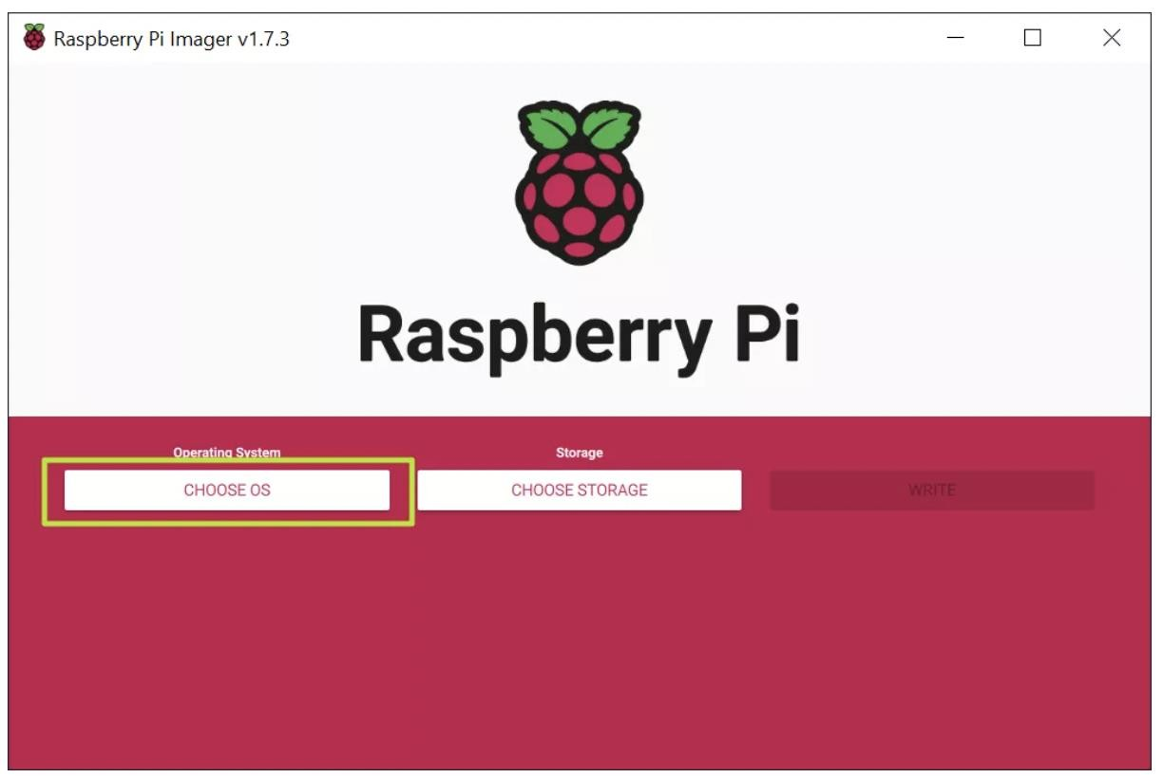

- Select Raspberry Pi OS (32-bit) from the OS menu (there are other choices, but for most uses, 32-bit is the best).

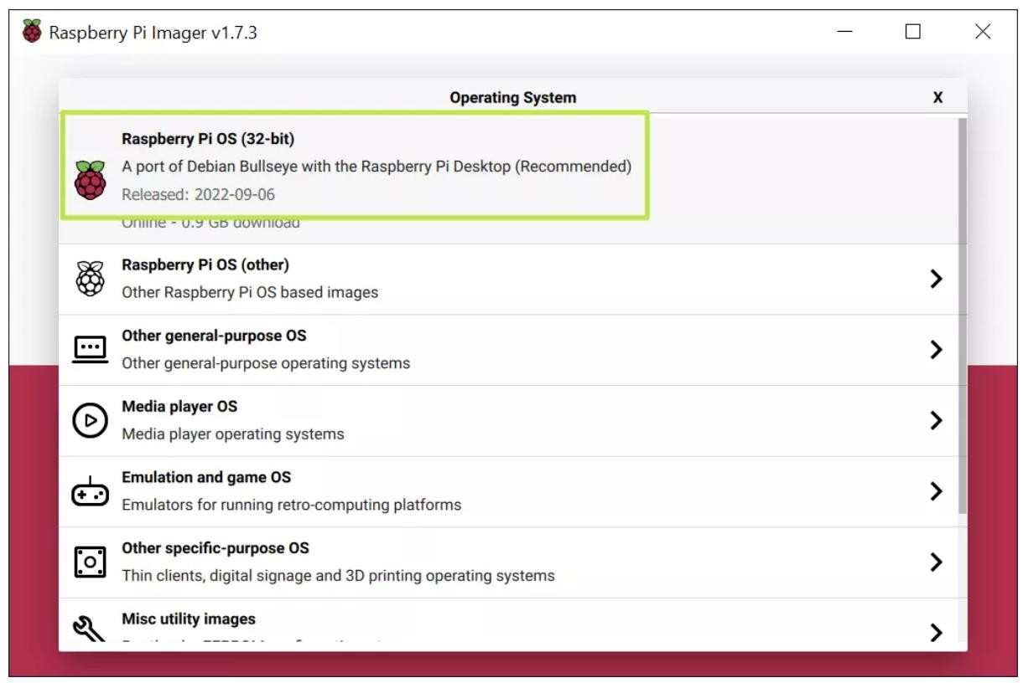

- Click Choose storage and pick the SD card you’re using.

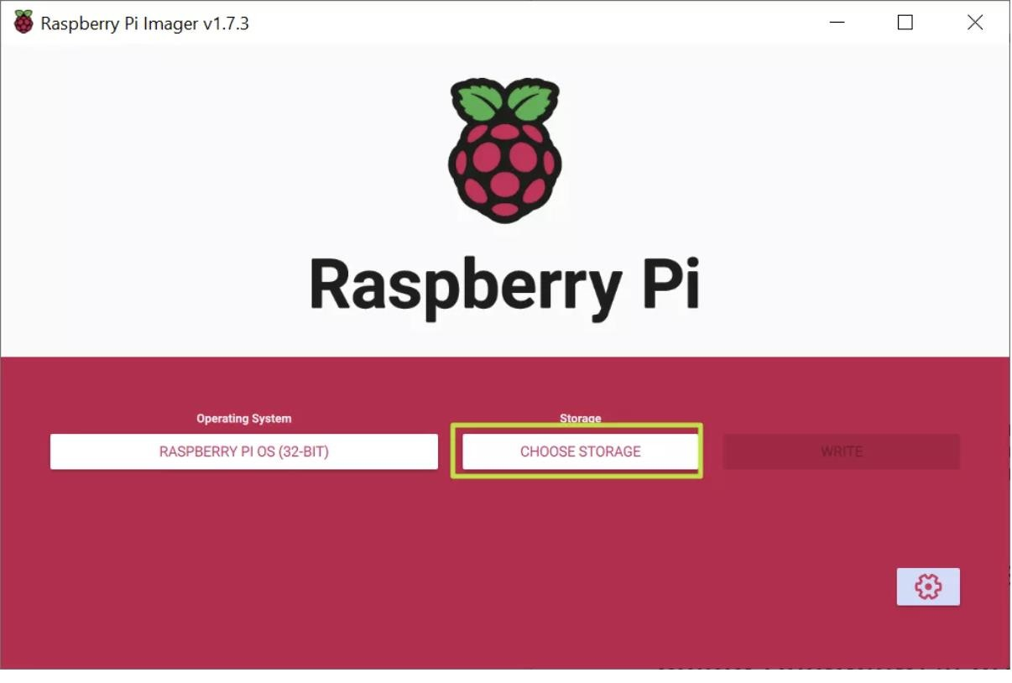

- Click the settings button or hit CTRL + SHIFT + X to enter settings.
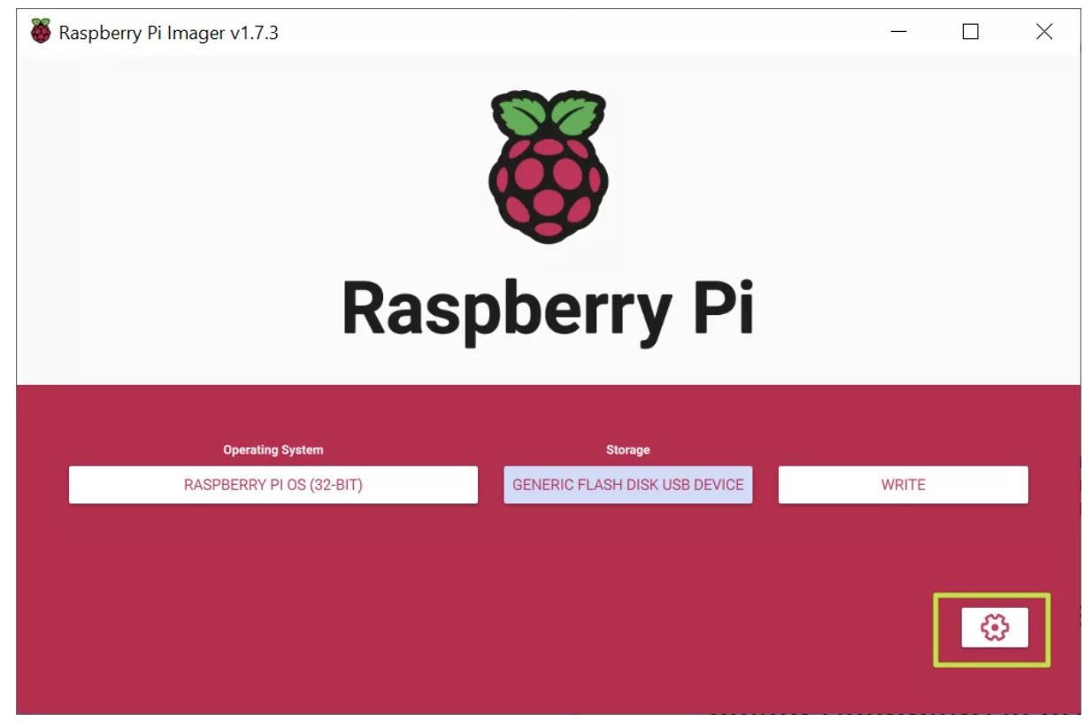

- Fill in settings fields as follows and then hit Save. All of these fields are technically optional, but highly recommended so that can get your Raspberry Pi set up and online as soon as you boot it. If you don't set a username and password here, you'll have to go through a setup wizard that asks you to create them on first boot.
  - Set hostname: the name of your Pi. It could be "raspberrypi" or anything you like.
  - Enable SSH: Allow SSH connections to the Pi. Recommended.
  - Use password authentication / public key: method of logging in via SSH
  - Set username and password: Pick the username and password you'll use for the Pi
  - Configure wireless LAN: set the SSID and password of Wi-FI network
  - Wireless LAN country: If you're setting up Wi-Fi, you must choose this.
  - Set locale settings: Configure keyboard layout and timezone (probably chosen correctly by default)
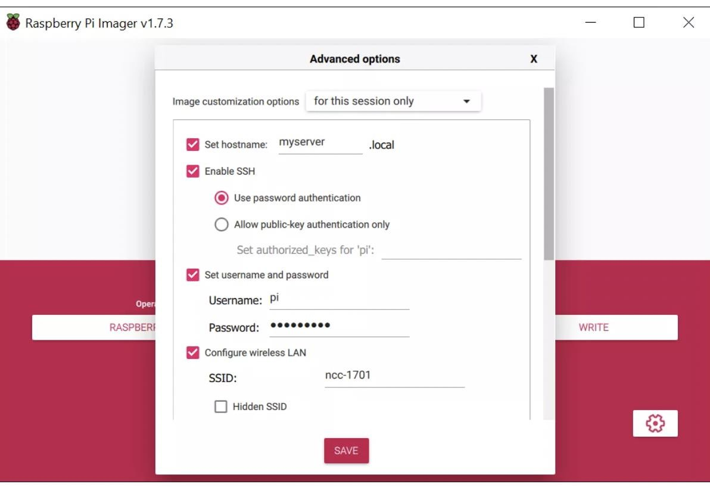

- Click Write. The app will now take a few minutes to download the OS and write to your card.

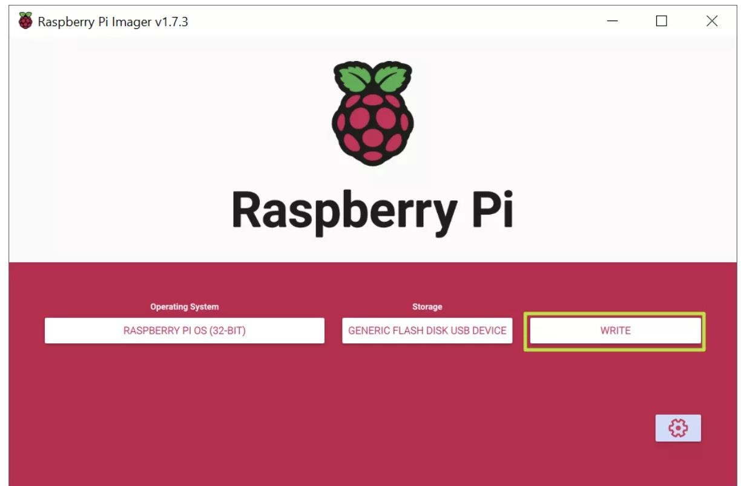

- Now open the Putty(Download it from brower). This will opens the cmd line of the raspberry pi:

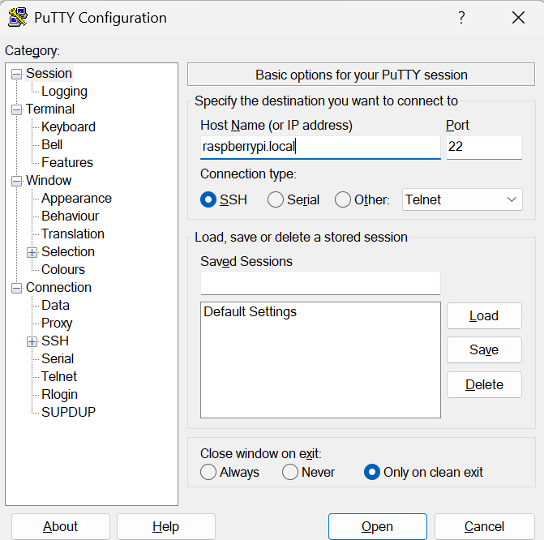

- Now enter the user name and password. Which you have entered in the step-6:
- To enable the ssh that required to open the realVNC viewer
Type sudo raspi-config

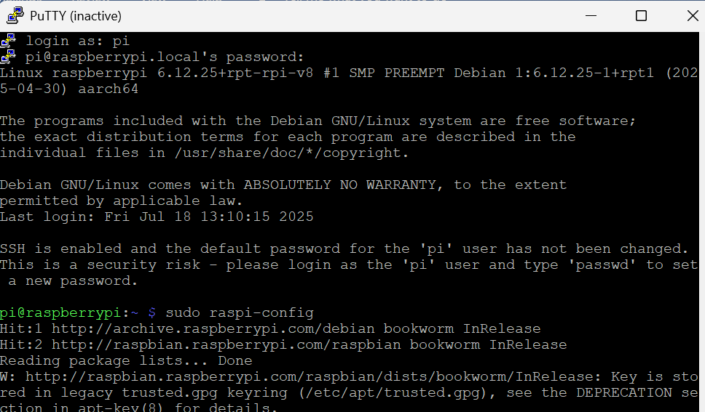

- Go to 3 Interface options by click down arrow ↓:
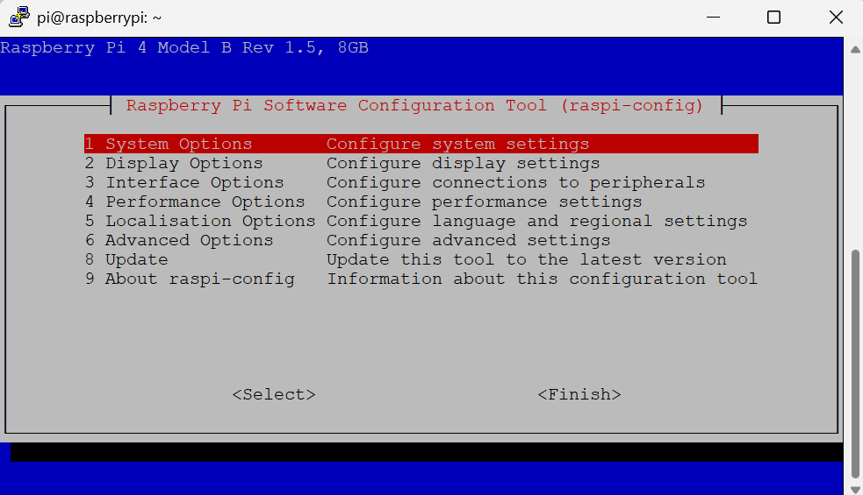

- Now Select the option by clicking “→”:
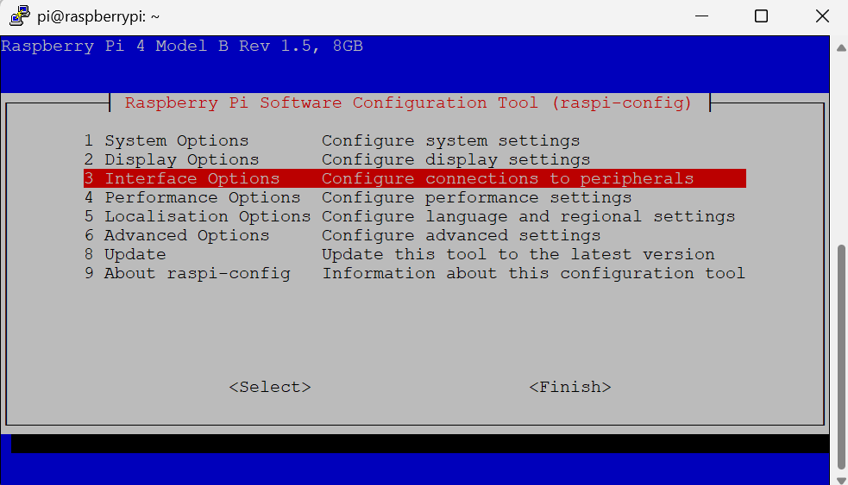

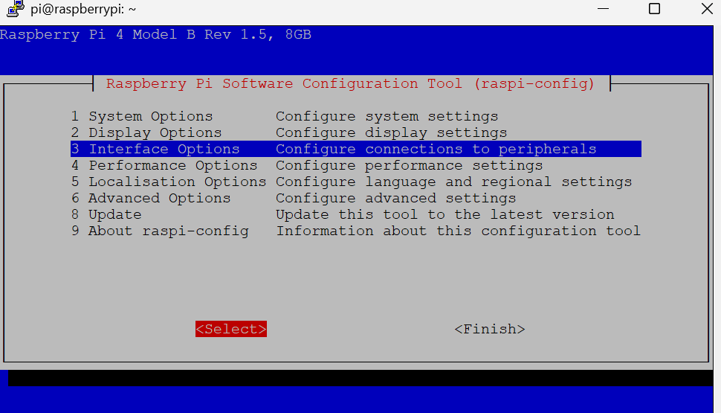

- Next go to VNC by clicking “ ↓ ”:

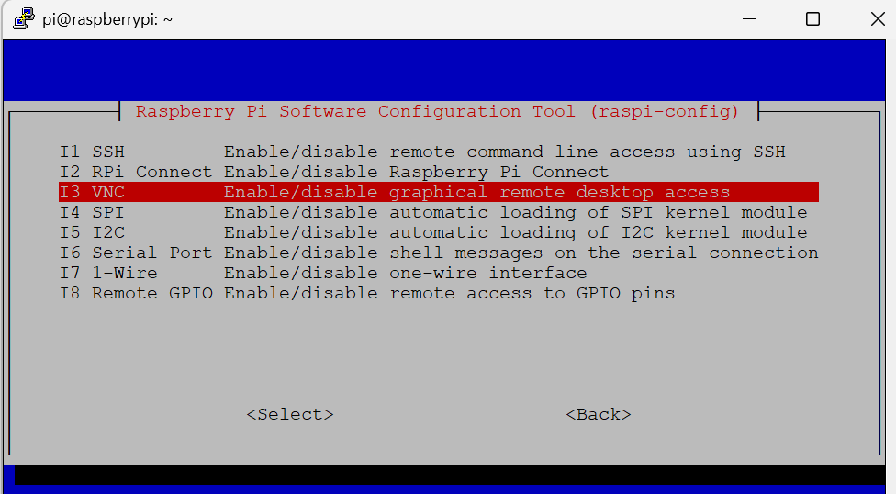

Go to “Select” to enable VNC and enter:
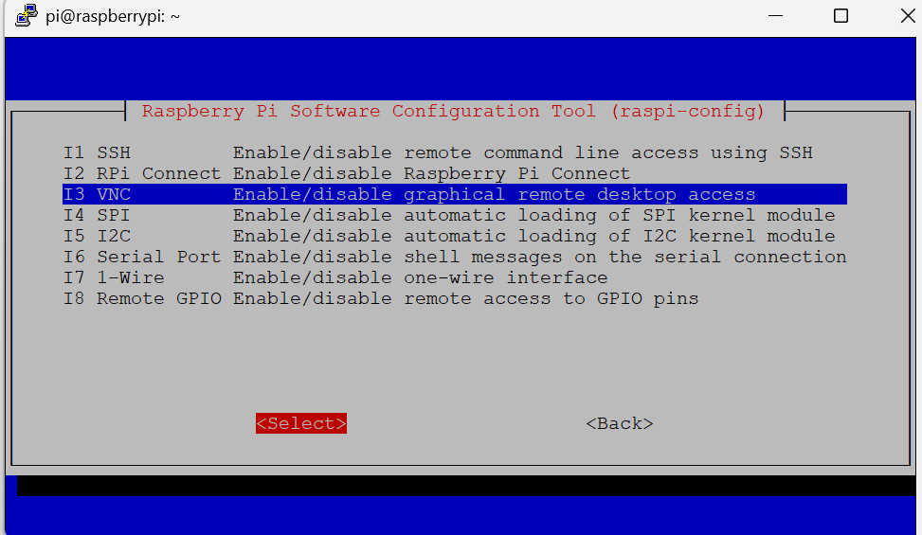

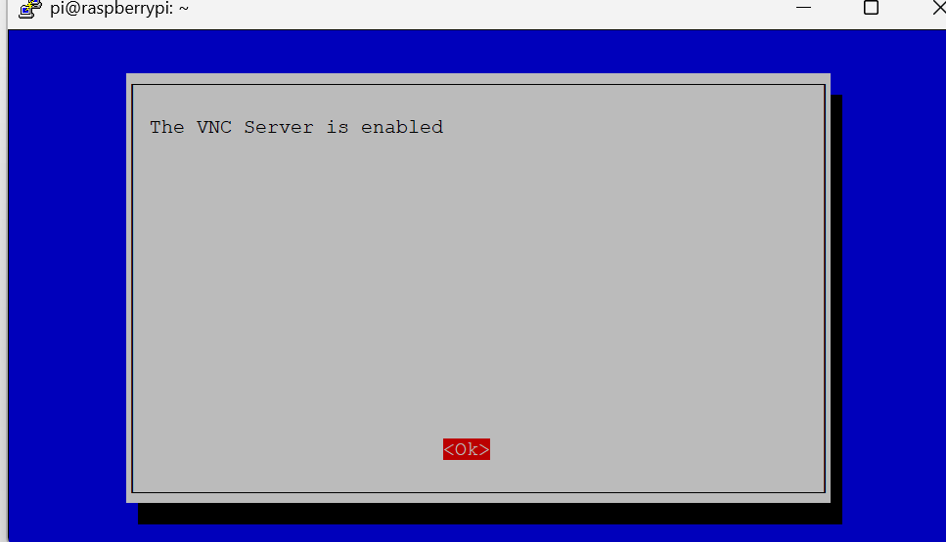

16. After selecting ok now finish the process by clicking with “→” then click enter:
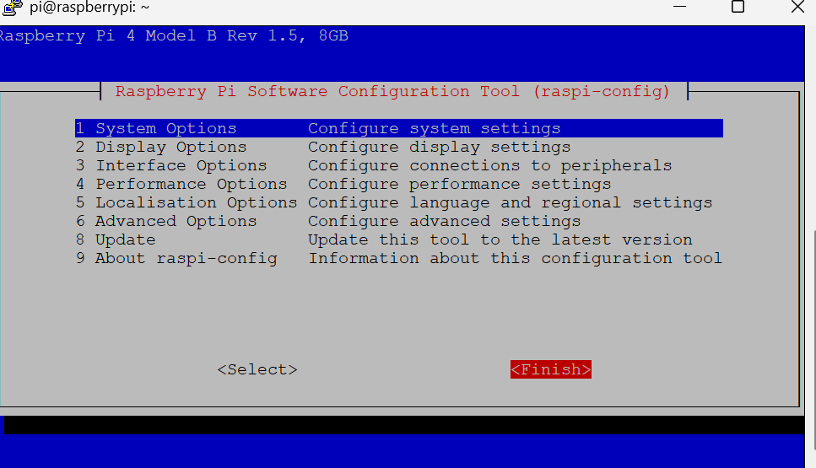

17. Now reboot the pi: type sudo reboot
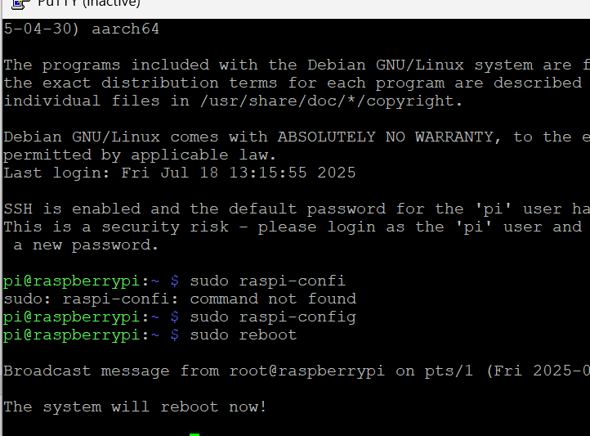
18. No open the RealVNC Viewer(download form the brower). This will opens the desktop view of the Pi:
Type raspberripi.local
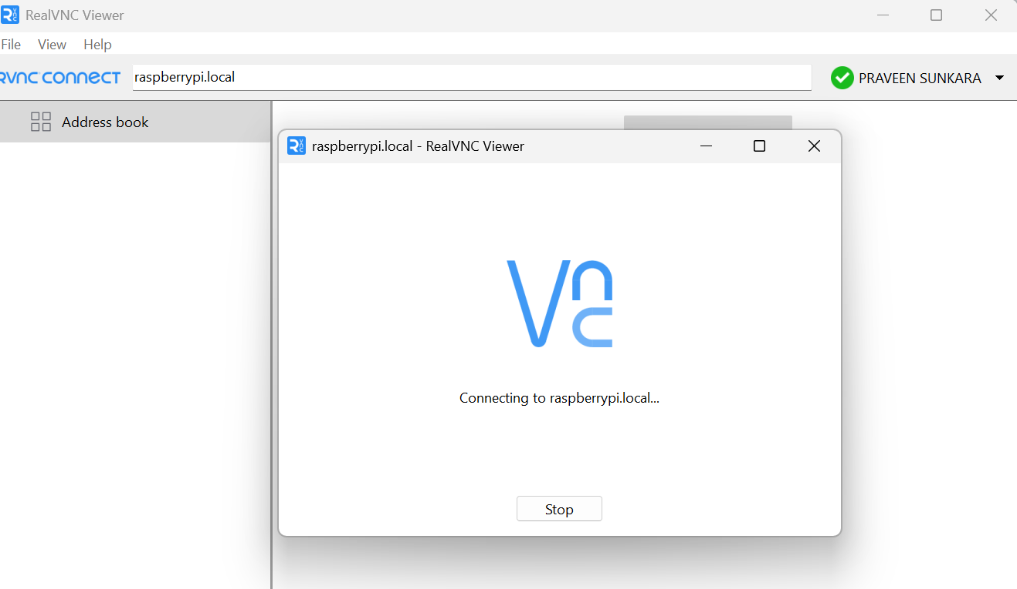
19. Now enter the username and password what you have given during the os installation from the step 6:
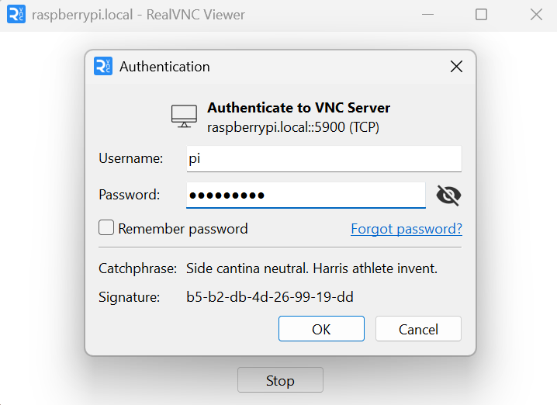

20. Now clone yolov5 repo :

Open cmd of Pi in RealVNC viewer
- clone the YOLOv5 repo:
git clone https://github.com/ultralytics/yolov5.git
- create environment and activate it:
python -m venv .venv
source .venv/bin/activate

- install required libraries and run the cmd line:
python detect11.py –source 0 –weights best.pt –config 0.25
for clear idea took into reference_images folder

BLOCK DIAGRAM :
Here's a block diagram illustrating the key components and flow of the Aggressive Dog Detection Project using Deep Learning and Raspberry Pi

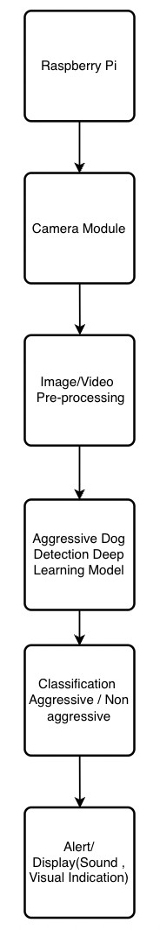

FLOWCHART :
Simplified flowchart outlining the main steps involved in the Aggressive Dog Detection Project using Deep Learning and Raspberry Pi:

