Deceased

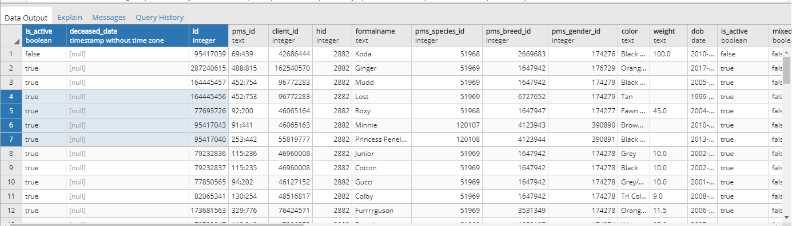
Select some patients and change its status
164445456
77693726
95417043
95417040

update public.patient
set is_active = true, deceased_date = now()
where id= 164445456;

update public.patient
set is_active = true, deceased_date = now()
where id= 77693726;

update public.patient
set is_active = true, deceased_date = now()
where id= 95417043;

update public.patient
set is_active = true, deceased_date = now()
where id= 95417040;

--RESET QUERY
update public.patient
set is_active = true, deceased_date = null
where id in (164445456,77693726,95417043,95417040)

