SURVEY ON CLUSTERING AND CLASSIFICATION ANALYSIS IN HADOOP MAHOUT
Asadi Srinivasuluª, Dr.Ch.D.V.Subbarao^{b}, Jeevan Kumar Y^{c}
ªDepartment of CSE, Research Scholar,JNTUA College of Engg,Anantapur515002,India
^{b}Department of CSE, Professor& Head,SVUCE College of Engg, Tirupathi,517501,India
^{c}Department of IT, PG Student, Sree Vidyanikethan Engg College, A.Rangampet, Tirupathi, 517102,India

Abstract
High dimensional data concerns large-volume,complex, growing data sets with multiple, autonomoussources. As the Data increasing very drastically day-to-day, itis a major issue to manage and organize the data veryefficiently. This emerged the necessity of machine learningtechniques. With the Fast development of Networking, datastorage and the data collection capacity, Machine learningcluster algorithms are now rapidly expanding in all scienceand engineering domains such as Pattern recognition, datamining, bioinformatics, and recommendation systems. So asto support the scalable machine learning framework with MapReduce and Hadoop support, we are using Apache Mahout tomanage the High Voluminous data. Various Cluster problemssuch as Cluster Tendency, Partitioning, Cluster Validity,and Cluster Performance can be easily overcome by Mahoutclustering algorithms. Mahout manages data in four steps i.e.,fetching data, text mining, clustering, classification andcollaborative filtering. In the proposed approach, various datatypes such as Numeric, Characters and Image datasets areclassified in the several categories i.e., Collaborative Filtering,Clustering, Classification or Frequent Item set Mining. Someof the Pre-clustering techniques are also implemented such asEDBE, ECCE, and Extended Co-VAT. A non-Hadoop Clusternamed Taste recommendation Frame work is alsoimplemented.

Keywords:High Dimensional Data, Machine Learning,Distributed Stream Process, Hadoop, Mahout, Clustering, Classification, Map Reduce, Recommendations, EDBE,ECCE, Extended Co-VAT.

- Introduction
The data available in World Wide Web is massive and exploding day by day. Google is estimated to index over 15 billion web pages and that’s just the tip of iceberg. In addition to web pages, the Internet has many other conventional and news sources that constantly inject with data. Social media sites and personal blogs expedited this expansion. If we can find smart ways to extract knowledge and intelligence out of it we can create many fascinating applications. The problem with this idea is that it is not easy and simple. The following properties of this web data make this notion a very tough challenge:
- Unstructured and not originally intended for machine processing
- Massively large
- Available many different formats and languages
- Distributed across the geography
- Mixed with lot of noise / bad data
- Processing requires huge amount of computing power
- No dictionary or classification
Distributed processing frameworks such as Map Reduce and scalable open source implementations of various analysis, clustering and classification algorithms, it possible now to extract the knowledge and intelligence out of this. Apache Software Foundation (ASF) introduced Apache Mahout, a new open source project with the primary goal of creating scalable machine-learning algorithms which can be use free under the Apache License. Mahout contains effective implementations for clustering, categorization, Collaborative Filtering and evolutionary programming. Furthermore, Mahout uses the Apache Hadoop library to scale effectively in the cloud. Actually, Mahout Project was introduced as an sub project by several people involved in the Apache (open source search) community which has active interest in machine learning and a desire for robust, well-documented, scalable implementations of common machine-learning algorithms for clustering and categorization. Mahout already have a large amount of functionality, particularly in relation to clustering and CF. Mahout's primary features are:
- Taste CF.Taste is an open source project for CF which was started by Sean Owen on SourceForge and later it is donated to Mahout.
- Several Map-Reduce enabled clustering implementations, including k-Means, fuzzy k-Means, Canopy, Dirichlet, and Mean-Shift.
- Distributed Naive Bayes and Complementary Naive Bayes classification implementations.
- Distributed fitness function capabilities for evolutionary programming
- Various Matrix and vector libraries.
Several approaches used to solve problems to machine learning. We'll focus on the two most commonly used ones — i.e., supervised and unsupervised learning —which are the main ones supported by Mahout. Supervised learning is tasked with learning a function from labelled training data in order to predict the value of any valid input. Common examples of supervised learning include classifying e-mail messages as spam, labelling Web pages according to their genre, and recognizing handwriting. Many algorithms are used to create supervised learners, the most common being neural networks, Support Vector Machines (SVMs), and Naive Bayes classifiers. Unsupervised learning is tasked with making sense of data without any examples of what is correct or incorrect. It is most commonly used for clustering similar input into logical groups. It also can be used to reduce the number of dimensions in a data set in order to focus on only the most useful attributes, or to detect trends. Common approaches to unsupervised learning include k-Means, hierarchical clustering, and self-organizing maps. In this paper we’ll focus on three specific machine-learning tasks that Mahout currently implements. They also happen to be three areas that are quite commonly used in real applications:
- Collaborative filtering
- Clustering
- Categorization
1.1.1Collaborative filtering: Collaborative filtering (CF) is a technique, popularized by Amazon and others, that uses user information such as ratings, clicks, and purchases to provide recommendations to other site users. CF is often used to recommend consumer items such as books, music, and movies, but it is also used in other applications where multiple actors need to collaborate to narrow down data.
1.1.2 Clustering:Given large data sets, whether they are text or numeric, it is often useful to group together, or cluster, similar items automatically. For instance, given all of the news for the day from all of the newspapers in the United States, you might want to group all of the articles about the same story together automatically; you can then choose to focus on specific clusters and stories without needing to wade through a lot of unrelated ones. Another example: Given the output from sensors on a machine over time, you could cluster the outputs to determine normal versus problematic operation, because normal operations would all cluster together and abnormal operations would be in outlying clusters.
1.1.3 Categorization: The goal of categorization (often also called classification) is to label unseen documents, thus grouping them together. Many classification approaches in machine learning calculate a variety of statistics that associate the features of a document with the specified label, thus creating a model that can be used later to classify unseen documents. For example, a simple approach to classification might keep track of the words associated with a label, as well as the number of times those words are seen for a given label. Then, when a new document is classified, the words in the document are looked up in the model, probabilities are calculated, and the best result is output, usually along with a score indicating the confidence the result is correct.

2. RELATED WORK:
As the rate at which we generate data increases, we find a greater and greater need to handle voluminous amounts of data within traditional machine learning algorithms. As a general rule of thumb, the more examples you can provide to a machine learning algorithm, the better it will be able to perform. The ability to quickly and efficiently process large amounts of data is necessary in order to effectively scale learning algorithms to match the growth of data available. Here we explore both clustering and classification algorithms, within the realm of distributed processing. To facilitate distributed processing one approach is to use the MapReduce [1] framework. Here, a large input dataset is sliced into smaller datasets, each of which is then operated upon by a different computation – these separate computations are the Mappers. The results of the processing are then fed into a Reducer (or a set of reducers) which will account for boundary conditions and combine results for further processing. For example, it is possible that a cluster center residing in one map may have points within its purview that is part of the input data to another map function. The outputs from the reducer are then fed into the appropriate mappers to begin the next round of processing. Mahout [2] is a library that implements several clustering and classification algorithms which have been modified to fit the Map-Reduce [1] model. The Mahout implementations have been deployed within Apache Hadoop [3] – a MapReduce [11] based cloud runtime. While Mahout has been designed to work specifically with Hadoop, there is nothing to preclude using the Mahout library within another processing system which supports the MapReduce [11] paradigm. Clustering algorithms are an unsupervised machine learning technique that facilitates the creation of clusters, which allow us to group similar items (also called observations) together so that these clusters are similar in some quantifiable sense. Clustering has broad applications in areas such as data mining [4], recommendation systems [5], pattern recognition [6], identification of abnormal cell clusters for cancer detections, and bioinformatics [7] among others. Clustering algorithms have certain unique characteristics. First, the algorithms often involve multiple rounds (also called iterations) of execution, where the output of the previous round is the input to the subsequent round. Second, the number of iterations of the algorithm is determined by the convergence characteristics of the algorithm. This convergence is generally based on distance measures (in n-dimensional space) and also the movement of cluster centers in successive iterations of the algorithm. To account for cases where convergence may not occur for a very large number of iterations, it is also possible to specify an upper bound on the number of iterations. Finally, the algorithm may operate on n-dimensional data and will cluster along these dimensions. Beyond the first iteration the progress of the clustering computation depends on (1) the state that it has built up in previous iteration (2) the initial set of data points that it holds, and (3) the adjustments to the cluster centers that it receives from the previous iteration.
As data volumes increase, it quickly becomes untenable to perform this clustering over a single machine. One challenge in implementing distributed clustering algorithms is that it is possible that an algorithm will get stuck in local optima, never finding the optimal solution. Attempting to converge on an optimal solution can be even more difficult when data is distributed, where no single node is fully aware of all data points. Classification algorithms, on the other hand, are a supervised machine learning technique. Where unsupervised learning techniques are not aware of the correct labels for data and need to repeatedly iterate through the inputs in order to refine observations; supervised machine learning algorithms are provided the correct answer with the training data, and only loop through the inputs once to create a statistical model. This model is then used to predict, or classify incoming data by determining the likelihood of the new, unseen data belonging to a class learned in the training phase. Classifiers can be used in BCI applications [8], bioinformatics [9], and spam filtering. The task of training a classifier becomes more monumental as the number of training sets increases. Each input needs to be read in, processed, and then used to modify the prediction model. If a single node attempted to perform this task sequentially, the training time would quickly become unfeasible. Classification provides a challenge when moving to a distributed processing environment. Several stages of model creation require all data gathered so far be collected to a single node for further processing. While this is a natural fit for a reduce stage, it also means a mandated bottleneck in processing. We have compared the efficiency of orchestrating the distributed executions of these machine learning algorithms within our distributed stream processing system, Data sets [10, 11]. Our benchmarks compare the same Mahout code running inside Data sets and Hadoop. We chose Hadoop and Data sets for this comparison as they are representative of file processing and stream processing systems, respectively. As both support the Map Reduce framework, we can use the Mahout codebase without modifications in either runtime. With the machine learning algorithms identical and unmodified, the only differences in computation speed should be a result of the lifecycle support for individual computations and the underlying communications framework.

3. CLUSTERINGALGORITHMS:
Mahout supports several clustering-algorithm implementations, all written in Map-Reduce, each with its own set of goals and criteria:
- Canopy: A fast clustering algorithm often used to create initial seeds for other clustering algorithms.
- K-Means (and fuzzy k-Means): Clusters items into k clusters based on the distance the items are from the centroid, or center, of the previous iteration.
- Mean-Shift: Algorithm that does not require any a priori knowledge about the number of clusters and can produce arbitrarily shaped clusters.
- Dirichlet: Clusters based on the mixing of many probabilistic models giving it the advantage that itdoesn't need to commit to a particular view of the clusters prematurely.
From a practical standpoint, the names and implementations aren't as important as the results they produce. With that in mind, I'll show how k-Means works and leave the others for you to explore. Keep in mind that each algorithm has its own needs for making it run efficiently. In outline (with more details to follow), the steps involved in clustering data using Mahout are:
- Prepare the input. If clustering text, you need to convert the text to a numeric representation.
- Run the clustering algorithm of choice using one of the many Hadoop-ready driver programs available in Mahout.
- Evaluate the results.
- Iterate if necessary.
First and foremost, clustering algorithms require data that is in a format suitable for processing. In machine learning, the data is often represented as a vector, sometimes called a feature vector. In clustering, a vector is an array of weights that represent the data. I'll demonstrate clustering using vectors produced from Wikipedia documents, but the vectors can come from other areas, such as sensor data or user profiles. Mahout comes with two Vector representations: DenseVector and Sparse Vector.Depending on your data, you will need to choose an appropriate implementation in order to gain good performance [40]. Generally speaking, text-based problems are sparse, making SparseVector the correct choice for them. On the other hand, if most values for most vectors are non-zero, then a DenseVector is more appropriate. If you are unsure, try both and see which one works faster on a subset of your data.

3.1 k-Means clustering:
K-Means is a rather simple but well known algorithm for grouping objects, clustering. Again all objects need to be represented as a set of numerical features. In addition the user has to specify the number of groups he wishes to identify. Each object can be thought of as being represented by some feature vector in an n dimensional space, n being the number of all features used to describe the objects to cluster. The algorithm then randomly chooses k points in that vector space, these points serve as the initial centers of the clusters. Afterwards all objects are each assigned to the center they are closest to. Usually the distance measure is chosen by the user and determined by the learning task. After that, for each cluster a new center is computed by averaging the feature vectors of all objects assigned to it. The process of assigning objects and recomputing centers is repeated until the process converges. The algorithm can be proven to converge after a finite number of iterations. Several tweaks concerning distance measure, initial center choice and computation of new average centers have been explored, as well as the estimation of the number of clusters k. Yet the main principle always remains the same.

Design of implementation: The implementation accepts two input directories: one for the data points and one for the initial clusters. The data directory contains multiple input files of Sequence File (key, Vector Writable), while the clusters directory contains one or more Sequence Files (Text, Cluster \| Canopy) containing k initial clusters or canopies. None of the input directories are modified by the implementation, allowing experimentation with initial clustering and convergence values. The program iterates over the input points and clusters, outputting a new directory "clusters-N" containing SequenceFile (Text, Cluster) files for each iteration N. This process uses a mapper/combiner/reducer/driver as follows:
- K-MeansMapper - reads the input clusters during its setup () method, then assigns and outputs each input point to its nearest cluster as defined by the user-supplied distance measure. Output key is: cluster identifier. Output value is: ClusterObservation.
- K-MeansCombiner - receives all key: value pairs from the mapper and produces partial sums of the input vectors for each cluster. Output key is: cluster identifier. Output value is ClusterObservation.
- K-MeansReducer - a single reducer receives all key: value pairs from all combiners and sums them to produce a new centroid for the cluster which is output. Output key is: encoded cluster identifier. Output value is: Cluster. The reducer encodes unconverged clusters with a 'Cn' cluster Id and converged clusters with 'Vn' clusterId.
- K-MeansDriver - iterates over the points and clusters until all output clusters have converged (VnclusterIds) or until a maximum number of iterations has been reached. During iterations, a new clusters directory "clusters-N" is produced with the output clusters from the previous iteration used for input to the next. A final optional pass over the data using the K- MeansClusterMapper clusters all points to an output directory "clusteredPoints" and has no combiner or reducer steps.
Canopy clustering can be used to compute the initial clusters for k-Means: // run the CanopyDriver job CanopyDriver.runJob("testdata", "output" ManhattanDistanceMeasure.class.getName(), (float) 3.1, (float) 2.1, false);
// now run the K-MeansDriver job
K-MeansDriver. Run Job ("testdata", "output/clusters "output", EuclideanDistanceMeasure.class.getName (), "0.001", "10", true);
After running the algorithm, the output directory will contain: 1. clusters-N: directories containing Sequence Cluster) produced by the algorithm for each iteration. The Text key is a cluster identifier string. 1. clustering enabled) a directory containing Sequence Writable, WeightedVectorWritable). The Int the clusterId. The Weighted Vector Writable containing a double weight and a Vector Writable vector where the weight indicates the probability that the vector is a member of the cluster. For k the weights are computed as 1/(1+distance) where the distance is between the cluster center and the vector using the chosen DistanceMeasure.

3.2 CANOPY CLUSTERING: Canopy Clustering is a very simple, fast and surprisingly accurate method for grouping objects into clusters. All objects are represented as a point in a multidimensional feature space. The algorithm uses a fast approximate distance metric and two distance thresholds T1 > T2 for processing. The basic algorithm is to begin with a set of points and remove one at random. Create a Canopy containing this point and iterate through the remainder of the point set. At each point, if its distance from the first point is < T1, then add t cluster. If, in addition, the distance is < T2, then remove the point from the set. This way points that are very close to the original will avoid all further processing. The algorithm loops until the initial set is empty, accumulating a se each containing one or more points. A given point may occur in more than one Canopy. Canopy Clustering is often used as an initial step in more rigorous clustering techniques, such as K-Means Clustering. By starting with an initial clustering the number of more expensive distance measurements can be significantly reduced by ignoring points outside of the initial canopies. The implementation accepts as input Hadoop Sequence Files containing multidimensional points (VectorWritable). Points may be expressed either as dense or sparse Vectors and processing is done in two phases: Canopy generation and, optionally, Clustering.

Running Canopy Clustering: The canopy clustering algorithm may be run using a command-line invocation on CanopyDriver.main or by making a Java call to Canopy Driver. Run(...). Both require several arguments: Invocation using the command line takes the form:
bin/mahoutcanopy\
-i<inputvectorsdirectory>\
-o<outputworkingdirectory>\
-dm<DistanceMeasure>\
-t1<T1threshold>\
-t2<T2threshold>\
-t3<optionalreducerT1threshold>\
-t4<optionalreducerT2threshold>\
-cf<optionalclusterfiltersize(default:0)>\
-ow<overwriteoutputdirectoryifpresent>
-cl<runinputvectorclusteringaftercomputingCanopies>
-xm<executionmethod:sequentialormapreduce>

After running the algorithm, the output directory will contain: N: directories containing Sequence Files (Text, Cluster) produced by the algorithm for each iteration. This is a cluster identifier string. 1. ClusteredPoints: (if -- clustering enabled) a directory containing Sequence File (Int Writable, WeightedVectorWritable). The Int Writable key is Writable value is a bean and a Vector where the weight indicates the probability that the vector is a member of the cluster. For k-Means clustering, the weights are computed as 1/(1+distance) where the distance is between the cluster center and the vector using the chosen DistanceMeasure.

3.3 FUZZY K-MEANS:Fuzzy K-Means (also called Fuzzy C-Means) is an extension of K-Means the popular simple clustering technique. While K-Means discovers hard clusters (a point belong to only one cluster), Fuzzy K-Means is a more statistically formalized method and discovers soft clusters where a particular point can belong to more than one cluster with certain probability. Like K-Means, Fuzzy K-Means works on those objects which can be represented in n-dimensional vector space and a distance measure is defined. The algorithm is similar to k- means.
- Initialize k clusters
- Until converged
- Compute the probability of a point belong to a cluster for every pair
- Recompute the cluster centers using above probability membership values of points to clusters .
The design is similar to K-Means present in Mahout. It accepts an input file containing vector points. User can either provide the cluster centers as input or can allow canopy algorithm to run and create initial clusters. Similar to K- Means, the program doesn't modify the input directories. And for every iteration, the cluster output is stored in a directory cluster-N. The code has set number of reduce tasks equal to number of map tasks. So, those many part-0. Files are created in cluster N directory.

Running Fuzzy k-Means Clustering: The Fuzzy k-Means clustering algorithm may be run using a command-line invocation on FuzzyK-MeansDriver. by making a Java call to Fuzzy K-Means Driver.run ( Invocation using the command line takes the form:
bin/mahoutfkmeans\
-i<inputvectorsdirectory>\
-c<inputclustersdirectory>\
-o<outputworkingdirectory>\
-dm<DistanceMeasure>\
-m<fuzzinessargument>1>\
-x<maximumnumberofiterations>\
-k<optionalnumberofinitialclusterstosamplefrominputvectors>\
-cd<optionalconvergencedelta.Defaultis0.5>\
-ow<overwriteoutputdirectoryifpresent>
-cl<runinputvectorclusteringaftercomputingClusters
-e<emitvectorstomostlikelyclusterduringclustering
-t<thresholdtouseforclusteringif-eisfalse>
-xm<executionmethod:sequentialormapreduce
Note: if the -k argument is supplied, any clusters in the directory will be overwritten and -k random points will be sampled from the input vectors to become the initial cluster centers.
. After running the algorithm, the output directory will contain: 1. clusters-N: directories containing Sequence Soft Cluster) produced by the algorithm for each iteration. The Text key is a cluster identifier string. 1. (if runClustering enabled) a directory containing Sequence File (Int Writable, WeightedVectorWritable). The Int Writable key is the clusterId. The WeightedVectorWritable value is a bean containing a double weight and a VectorWritable vector are computed as 1/(1+distance) where the distance is between the cluster center and the vector using the chosen DistanceMeasure.

4. RESULTS:
The following images illustrate k-Means clustering applied to a set of randomly-generated 2-d data points. The points are generated using a normal distribution centered at a mean location and with a constant standard deviation. The points are generated as follows:
- 500 samples m=[1.0, 1.0](1.0,-1.0.html) sd=3.0
- 300 samples m=[1.0, 0.0](1.0,-0.0.html) sd=0.5
- 300 samples m=[0.0, 2.0](0.0,-2.0.html) sd=0.1

K-Means Clustering:In the first image [ fig 4.1], the points are plotted and the 3 boundaries of their generator are superimposed.In the second image [ fig 4.2 ], the resulting clusters (k=3) are shown superimposed upon the sample data. As k-Means is an iterative algorithm, the centers of the clusters in each recent are shown using different colors. Bold red is the final clustering and previous iterations are shown in [orange, yellow, green, blue, violet and gray](orange,-yellow,-green,-blue,-violet-and-ray.html) . Although it misses a lot of the points and cannot capture the original, superimposed cluster centers, it does a decent job of clustering this data.The third image [fig 4.3 ] shows the results of running k different data which is generated using asymmetrical standard deviations. K-Means does a fair job handling this data set as well.
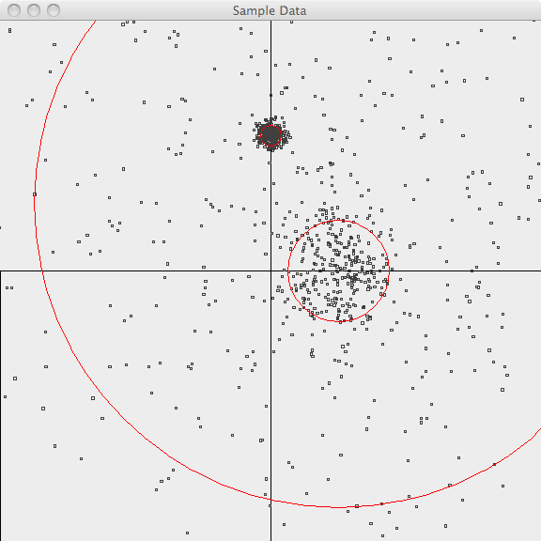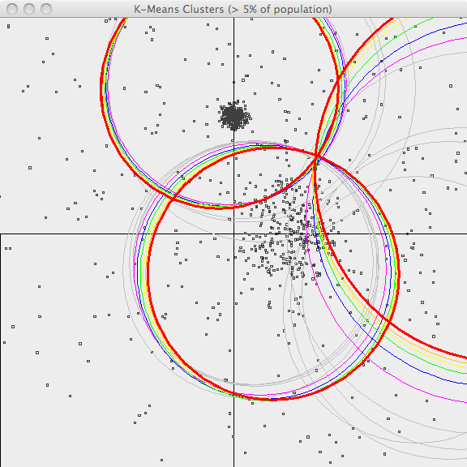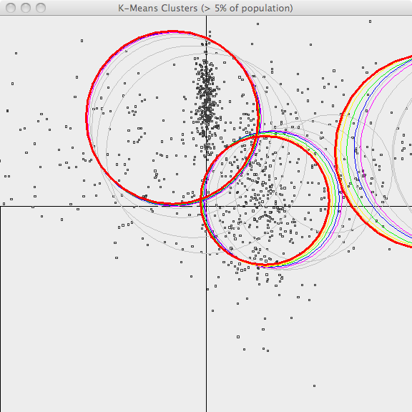
Fig 4.1 Fig 4.2 Fig 4.3
4.2 Canopy Clustering In the first image [Fig 4.4], the points are plotted and the 3 boundaries of their generator are superimposed.

In the second image [Fig 4.5], the resulting canopies are shown superimposed upon the sample data. Each canopy is represented by two circles, with radius T1 and radius T2.The third image [Fig 4.6] uses the same values of T1 and T2 but only superimposes canopies covering more than 10% of the population. This is a bit better representation of the data but it still has lots of room for improvement. The advantage of Canopy clustering is that it is single-pass and fast enough to iterate runs using different T1, T2 parameters and display thresholds.

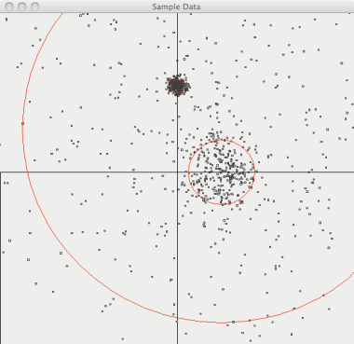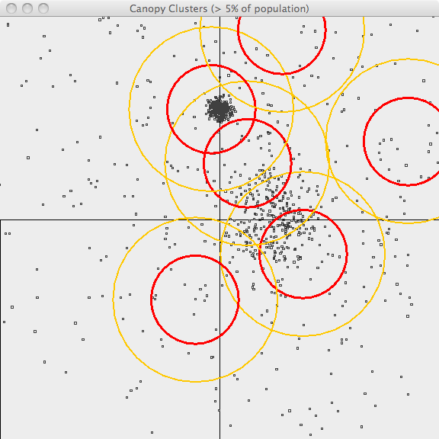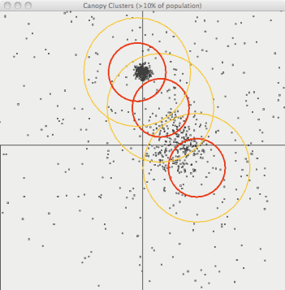
Fig 4.4 Fig 4.5 Fig 4.6
4.3 Fuzzy K-means: In the first image [Fig 4.7], the points are plotted and the 3 boundaries of their generator are superimposed.

In the second image [Fig 4.8] , the resulting clusters (k=3) are shown superimposed upon the sample data. As Fuzzy k iterative algorithm, the centers of the clusters in each recent iteration are shown using different colors. Bold red is the final clustering and previous iterations are shown in [orange, yellow, green, blue, violet and gray](orange,-yellow, blue,-violet-and-gray.html) . Although it misses a lot of the points and cannot capture the original, superimposed centers, it does a decent job of clustering this data.
The third image [Fig 4.9] shows the results of running Fuzzy k on a different data set which is generated using asymmetrical standard deviations. Fuzzy k-Means does a fair job handling this data set as well.

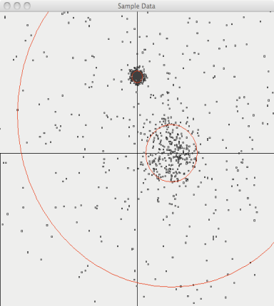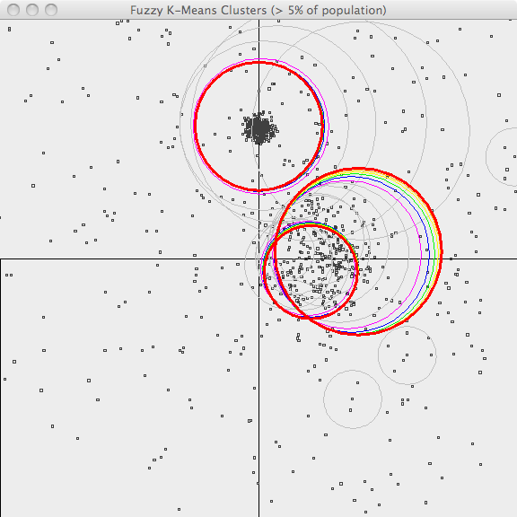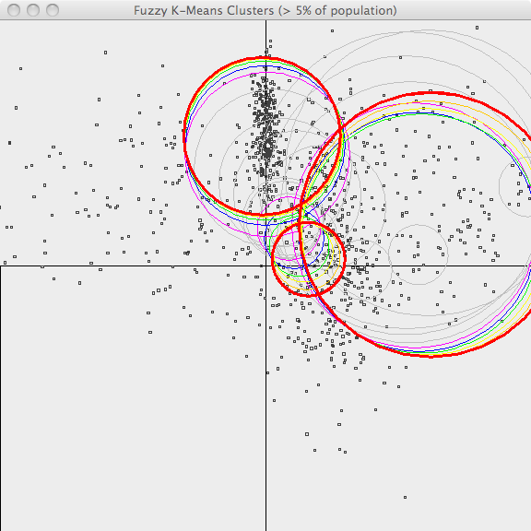
Fig 4.7 Fig 4.8 Fig 4.9

5. CONCLUSION:
This paper explains the need of machine learning algorithms to tackle very large amount of data. Mahout is capable of managing any amount of data as it supports scalability. Its clustering algorithms are well designed as it may easily such as cluster tendency, although, they are many clustering algorithms and classification algorithms in Mahout, they are refined to few but effective ones. In the earlier version of mahout it performs only 4 clustering algorithms and 2 classification algorithms. We tried to explain the top 3 clustering algorithms in Mahout by giving the Standard datasets such as Temperature and super market data as Input and showed how they performs clustering. In our proposed approach, comparing various non-functional requirements like performance, accuracy and fault tolerance among various clustering algorithms in mahout. This paper demonstrates the feasibility of using Data sets to manage the orchestration of large clustering and classification operations. Since Data sets supports computations that can execute multiple, successive rounds of execution while retaining state it is particularly well suited for clustering algorithms that are inherently iterative. The ability to stream results between stages of an execution pipeline and activating computations when such (intermediate result) streams are available allows us to support distributed implementations of the clustering algorithms in an efficient fashion. Our benchmarks show that switching to a stream-based approach can greatly improve the runtimes of iterative tasks. This streaming feature allows us to incorporate support for fault tolerance without incurring performance [4] overhead by interleaving the processing and I/O operations concurrently. In Mahout only Naïve and Complementary Bayes are currently the only fully implemented classification algorithms with distributed implementations. As more algorithms are added to Mahout, we plan to continue this analysis to determine the effects of moving from a file to streaming based framework. We also plan to explore the suite of recommendation algorithms in Mahout. Data sets ability to enter a dormant state between rounds of execution should mean a drastic increase in performance [4] for a recommender system. Recommender systems work by finding similar items a customer may be interested in. Examples include Netflix [2] and Amazon [2], where users get personalized recommendations on items to view/purchase based on their previous patterns of viewing/shopping. These algorithms need to operate quickly and efficiently in order to provide accurate recommendations in a timely matter if processing takes too long, you may miss a customer. Recommendation systems are a natural extension of clustering and classification algorithms, building on the idea of finding similar items to present to customers.

6. REFERENCES:
- J. Dean and S. Ghemawat, "Mapreduce: Simplified data processing on large clusters," ACM Commun., vol. 51, pp. 107-113, Jan. 2008.
- S. Owen, et al., Mahout in Action: Manning Publications, 2011 (est.).
- T. White, Hadoop: The Definitive Guide, 1 ed.: O'Reilly Media, 2009.
- P. Berkhin, "A Survey of Clustering Data Mining Techniques," in Grouping Multidimensional Data: Recent Advances in Clustering, J. Kogan and C. K. Nicholas, Eds., ed: Springer, 2006, pp. 25-83.
- L. Qing and K. Byeong Man, "Clustering approach for hybrid recommender system," in Web Intelligence, 2003. WI 2003. Proceedings. IEEE/WIC International Conference on, 2003, pp. 33-38.
- C. W. Anderson and J. A. Bratman, "Translating Thoughts into Actions by Finding Patterns in Brainwaves," in Fourteenth Yale Workshop on Adaptive and Learning Systems, New Haven, CT, 2008, pp. 1-6.
- K. Y. Yeung, et al., "Validating clustering for gene expression data," Bioinformatics, vol. 17, pp. 309- 318, April 1, 2001 2001.
- E. M. Forney and C. W. Anderson, "Classification of EEG during imagined mental tasks by forecasting with Elman Recurrent Neural Networks," in Neural Networks (IJCNN), The 2011 International Joint Conference on, 2011, pp. 2749-2755.
- A. C. Tan and D. Gilbert, "An empirical comparison of supervised machine learning techniques in bioinformatics," presented at the Proceedings of the
First Asia-Pacific bioinformatics conference on Bioinformatics 2003 - Volume 19, Adelaide, Australia, 2003
10 S. Pallickara, et al., "Data sets: A Lightweight, Streaming Runtime for Cloud Computing with Support for Map-Reduce," in IEEE International Conference on Cluster Computing, New Orleans, LA., 2009.
11 S. Pallickara, et al., "An Overview of the Data sets Runtime for Cloud Computing," in IEEE International Conference on e-Science, Indianapolis, 2008. 12 S. Lloyd, "Least squares quantization in PCM," Information Theory, IEEE Transactions on, vol. 28, pp. 129-137, 1982.
13 J. C. Bezdek, Pattern Recognition with Fuzzy Objective Function Algorithms. Norwell, MA: Kluwer Academic Publishers, 1981.
14 P. McCullough and J. Yang, "How many clusters?," Bayesian Analysis, vol. 3, pp. 101-120, 2008.
15 D. M. Blei, et al., "Latent dirichlet allocation," J. Mach. Learn. Res., vol. 3, pp. 993-1022, 2003.
16 D. Lewis, "Naive (Bayes) at forty: The independence assumption in information retrieval.
17 W. A. Gardner, "Learning characteristics of stochastic- gradient-descent algorithms: A general study, analysis, and critique," Signal Processing, vol. 6, pp. 113-133, 1984.
18 C.-T. Chu, et al., "Map-Reduce for Machine Learning on Multicore," in Advances in Neural Information Processing Systems (NIPS), Vancouver, Canada, 2006.
19 B. Catanzaro, et al., "Fast support vector machine training and classification on graphics processors," presented at the Proceedings of the 25th international conference on Machine learning, Helsinki, Finland, 2008.
20 Y. Yu, et al., "DryadLINQ: a system for general-purpose distributed data-parallel computing using a high- level language," presented at the Proceedings of the 8th USENIX conference on Operating systems design and implementation, San Diego, California, 2008.
21 P. Resnick and H. R. Varian, "Recommender systems," Commun. ACM, vol. 40, pp. 56-58, 1997

