**DAILY ONLINE ACTIVITIES SUMMARY**

|  |  |  |  |  |  |  |  |  |
| --- | --- | --- | --- | --- | --- | --- | --- | --- |
| **Date:** | **26/05/2020** | | | | | **Name:** | **PRAVEEN KUMAR.S** | |
| **Sem & Sec** | **6th Sem & B Sec** | | | | | **USN:** | **4a17cs063** | |
| **Online Test Summary** | | | | | | | | |
| **Subject** | | **CGV** | | | | | | |
| **Max. Marks** | | **30** | | **Score** | | | **15** | |
| **Certification Course Summary** | | | | | | | | |
| **Course** | **Big Data 101** | | | | | | | |
| **Certificate Provider** | | | **Cognitiviclass.ai**  **(IBM)** | | **Duration** | | | **03 of 06** |
| **Coding Challenges** | | | | | | | | |
| **Problem Statement:1.program in C to print all permutations of a given string using pointers. 2.Python Program to Print all Integers that Aren’t Divisible by Either 2 or 3 and Lie between 1 and 50**  **Python Program to Check if a Number is a Palindrome**  **Python Program to Count the Number of Digits in a Number**  **Python Program to Read a Number n And Print the Series "1+2+…..+n= "**  **3.Given an array A of size N where the array elements contain values from 1 to N with duplicates, the task is to find total number of subarrays which start and end with the same element.** | | | | | | | | |
| **Status:All executed** | | | | | | | | |
| **Uploaded the report in Github** | | | | | **Yes** | | | |
| **If yes Repository name** | | | | | **https://github.com/praveenyadav-code/course** | | | |
| **Uploaded the report in slack** | | | | | **Yes** | | | |

Online Test Details:First II-A test of CGV

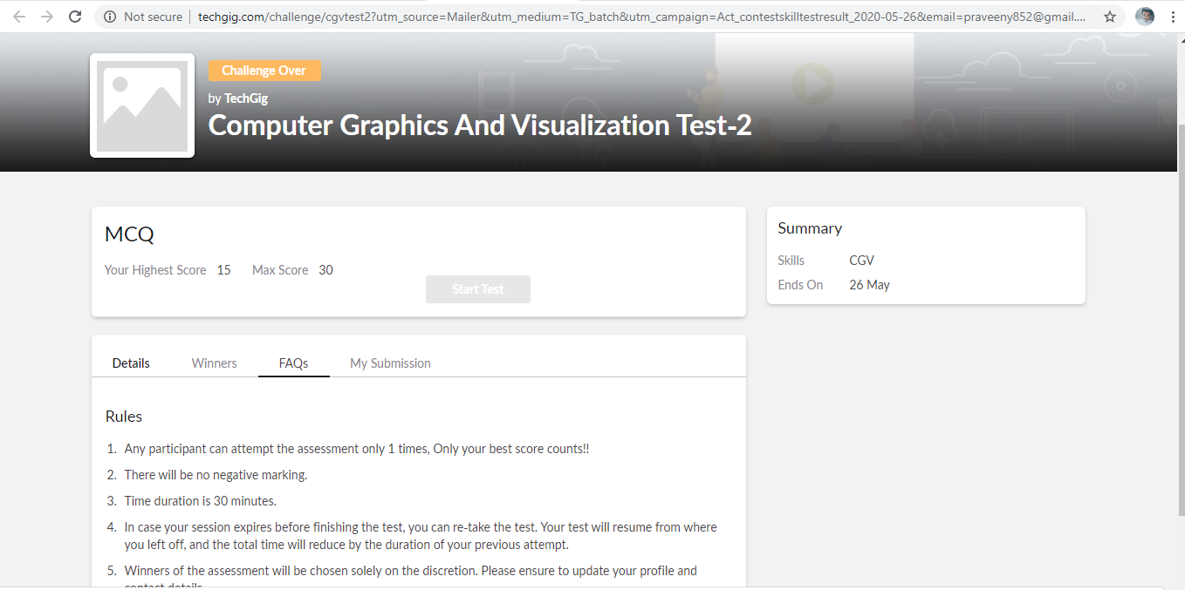

certification course snap

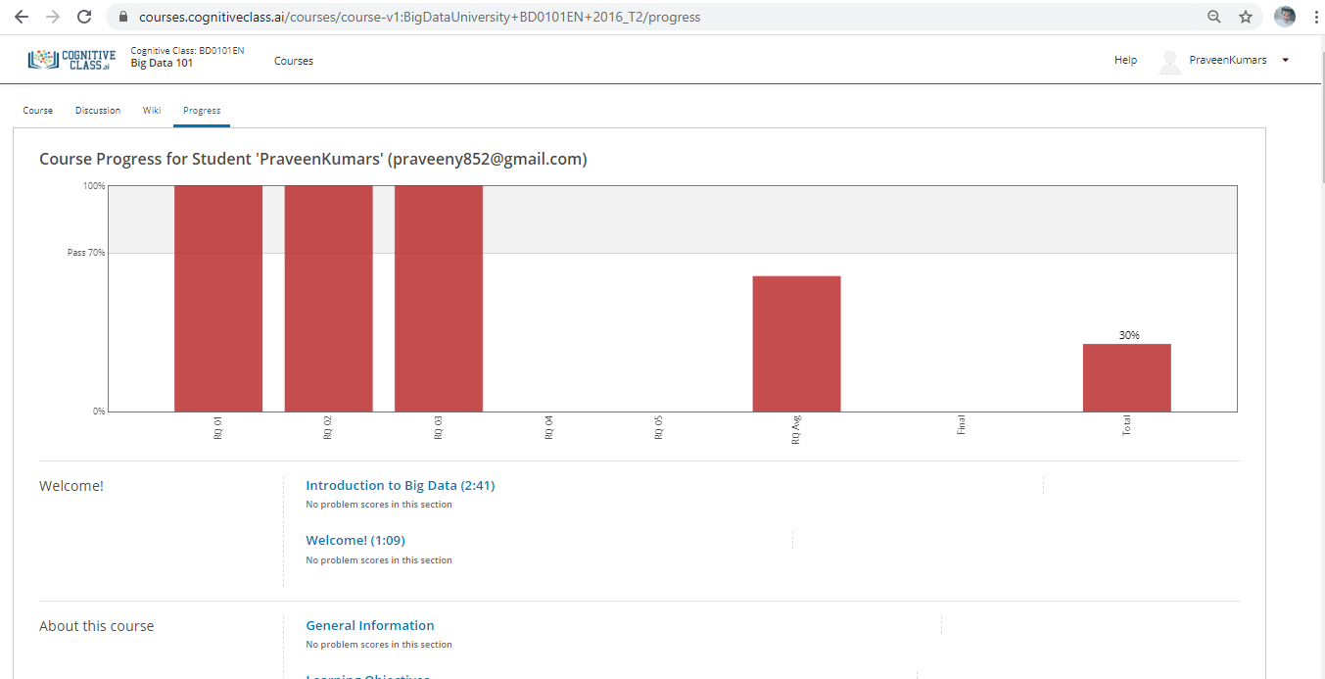

program snap

