**DAILY ONLINE ACTIVITIES SUMMARY**

|  |  |  |  |  |  |  |  |  |
| --- | --- | --- | --- | --- | --- | --- | --- | --- |
| **Date:** | **28/05/2020** | | | | | **Name:** | **PRAVEEN KUMAR.S** | |
| **Sem & Sec** | **6th Sem & B Sec** | | | | | **USN:** | **4a17cs063** | |
| **Online Test Summary** | | | | | | | | |
| **Subject** | | **OS** | | | | | | |
| **Max. Marks** | | **30** | | **Score** | | | **23** | |
| **Certification Course Summary** | | | | | | | | |
| **Course** | **Python for data science** | | | | | | | |
| **Certificate Provider** | | | **Cognitiviclass.ai**  **(IBM)** | | **Duration** | | | **03 of 06** |
| **Coding Challenges** | | | | | | | | |
| **Problem Statement: two jsp program , two java program and one python program** | | | | | | | | |
| **Status:All executed** | | | | | | | | |
| **Uploaded the report in Github** | | | | | **Yes** | | | |
| **If yes Repository name** | | | | | **https://github.com/praveenyadav-code/course** | | | |
| **Uploaded the report in slack** | | | | | **Yes** | | | |

Online Test Details:First II-A test of OS

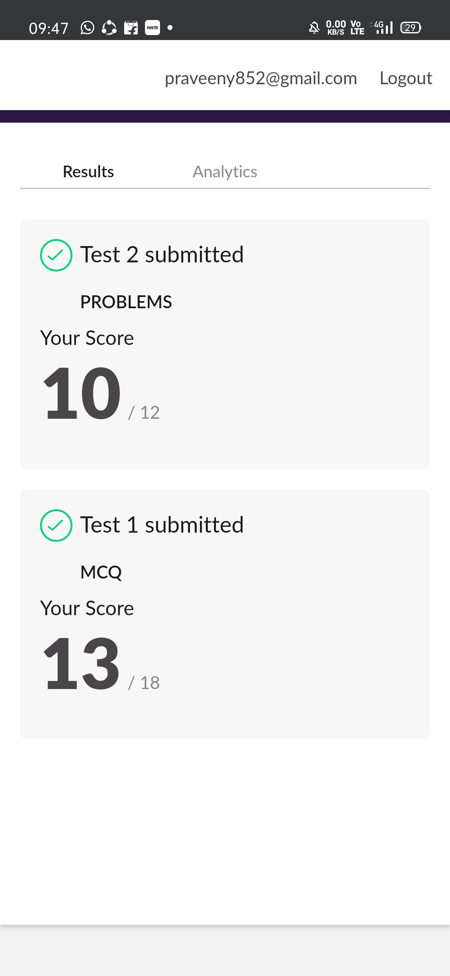

certification course snap

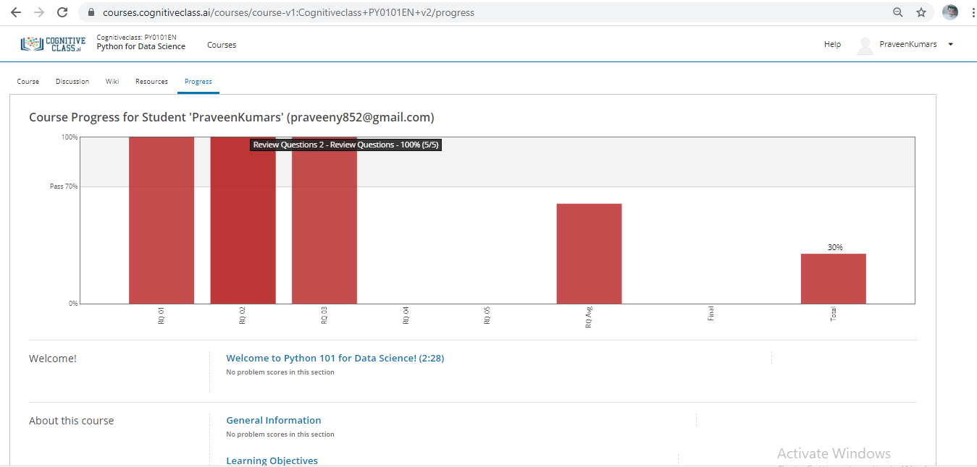

program snap

