Replace and modernize legacy VPN architectures with a cloud-native Zscaler Zero Trust solution to reduce attack surface and lateral movement

Team Profile:-

S.NO | NAME: | COLLAGE | CONTACT
1. | Shrivarsha | RD National College of Arts and Science | Shrivarshashivani  @gmail.com
2. | Praveetha | RD National College of Arts and Science | praveethashanmugam@gmail.com
3. | Salman | RD National College of Arts and Science | Salmansalmansm8899@gmail.com
4. | Varatharaj | RD National College of Arts and Science | varatharajm108  @gmail.com

Project details:-

Title:- Replace and modernize legacy VPN architectures with a cloud-native Zscaler Zero Trust solution to reduce attack surface and lateral movement

This project focuses on replacing and modernizing traditional remote access systems by transitioning from legacy Virtual Private Network (VPN) architectures to a cloud-native security solution based on Zero Trust Architecture. In many organizations, VPNs have historically been used to allow employees and remote users to securely access internal corporate resources. However, traditional VPN systems often provide broad network access once authentication is completed, which increases the organization’s attack surface and makes it easier for attackers to move laterally across systems if credentials are compromised. As businesses increasingly adopt cloud services and remote work environments, these limitations create significant security challenges. To address these issues, this project proposes the adoption of a modern Zero Trust security model implemented through cloud-based security platforms such as solutions provided by Zscaler.

The Zero Trust approach follows the principle of “never trust, always verify,” ensuring that every user and device must be continuously authenticated and authorized before gaining access to applications. Instead of providing full network access, users are granted access only to specific applications or services that are necessary for their tasks. By implementing this approach, organizations can significantly reduce their attack surface, prevent unauthorized lateral movement within networks, and improve overall security visibility and control. The cloud-native nature of the solution also allows for better scalability, easier management, and secure access to resources from any location. Ultimately, this project demonstrates how replacing legacy VPN infrastructures with a Zero Trust security model can enhance cybersecurity, support modern digital workplaces, and protect sensitive organizational data from evolving cyber threats.

Abstract:-

This project focuses on improving modern enterprise security by replacing traditional Virtual Private Network (VPN) architectures with a cloud-native security approach based on Zero Trust Architecture. Traditional VPN solutions were designed to provide remote users with secure access to corporate networks; however, they often grant broad network-level access after authentication, which increases the organization’s attack surface and exposes internal resources to potential cyber threats. If attackers gain access to compromised credentials, they can move laterally within the network and access sensitive systems or data. To address these limitations, this project explores the implementation of a Zero Trust model using cloud-based security platforms such as Zscaler. The Zero Trust approach follows the principle of “never trust, always verify,” ensuring that users and devices are continuously authenticated and authorized before accessing applications. Instead of providing access to the entire network, users are granted limited access only to the specific resources required for their work. This significantly reduces security risks and prevents unauthorized lateral movement within the organization’s infrastructure. The proposed solution enhances visibility, improves access control, and strengthens protection against modern cyber threats while supporting secure remote work environments. By adopting a cloud-native Zero Trust model, organizations can modernize their security architecture, reduce vulnerabilities associated with legacy VPN systems, and build a more scalable, secure, and efficient access framework for the digital workplace.

Use case scenario:-

Scenario 1: Secure Remote Employee Access

A remote employee needs to access the company’s HR portal from home. Instead of connecting through a traditional Virtual Private Network, the employee accesses the application through a Zero Trust Architecture platform powered by Zscale

Output:
- User identity verified before access
- Access granted only to the HR application
- Internal network remains hidden
- Reduced risk of unauthorized access

Scenario 2: Secure Remote Employee Access

An employee attempts to log in from an untrusted or unsecured device.
Output:
- Device security posture is checked
- Access blocked for non-compliant devices
- Security policy automatically enforced
- Reduced chances of malware entering the system

Scenario 3: Protecting Internal Applications
An employee needs access to a specific internal business application
Output:
- Application-level access control applied
- Only authorized users can access the application
- Internal servers remain invisible to the internet
- Reduced exposure of company resources

Scenario 4: Preventing Lateral Movement After a Breach
A hacker gains access to a compromised employee account.

Output:
- Access restricted to only one application
- Hacker cannot move to other systems
- Sensitive data remains protected
- Security monitoring detects unusual behavior
Scenario 5: Secure Access for Third-Party Vendors

A third-party vendor requires temporary access to a company application.

Output:
- Limited and time-based access granted
- Vendor cannot access the full network
- Activity monitoring and logging enabled
- Reduced risk from external users

Stage 1

Title:- Replace and modernize legacy VPN architectures with a cloud-native Zscaler Zero Trust solution to reduce attack surface and lateral movement.

Overview:

Modern organizations increasingly depend on remote access technologies to support employees working from different locations. Traditionally, companies have relied on Virtual Private Network (VPN) architectures to allow remote users to securely connect to internal corporate networks. A VPN creates an encrypted tunnel between the user and the organization’s network, allowing employees to access internal applications and resources from outside the office. While this model worked well in the past, it presents several security challenges in today’s cloud-driven and highly distributed environments. Once users authenticate through a VPN, they often receive broad access to the internal network. If attackers obtain valid credentials through phishing, malware, or other cyberattacks, they may gain entry to the network and move laterally between systems, potentially compromising sensitive data and critical infrastructure. This situation increases the organization’s attack surface and makes traditional VPN-based security less effective against modern threats.

To address these limitations, many organizations are adopting the Zero Trust Architecture security model. The Zero Trust approach follows the principle of “never trust, always verify,” meaning that every access request must be authenticated, authorized, and continuously validated regardless of the user’s location. Instead of granting full network access, Zero Trust provides users with access only to the specific applications or services they need. This significantly reduces the risk of unauthorized access and prevents attackers from moving laterally within the network.
Cloud-based security platforms offered by companies such as Zscaler enable organizations to implement Zero Trust solutions effectively. These cloud-native platforms connect users directly to applications rather than exposing the entire corporate network. By replacing legacy VPN architectures with a cloud-based Zero Trust approach, organizations can reduce their attack surface, improve visibility and control over user access, and provide secure and scalable solution for modern digital workplaces.

List Of Vulnerabilities Table:-

S.no | Vulnerability Name | CWE - No
1. | Improper Limitation of a Pathname to a Restricted Directory | CWE-22: A01 Broken Access Control
2. | Sensitive Cookie in HTTPS Session Without 'Secure' Attribute | CWE-614: A02 Security Misconfiguration
3. | Use of Unmaintained Third Party Components | CWE-1104:A03 Software Supply Chain Failures
4. | Weak Encoding for Password | CWE-261:A04 Cryptographic Failures
5. | Improper Input Validation | CWE-20:A05 Injection
6. | Unprotected Storage of Credentials | CWE-256:A06 Insecure Design
7. | Use of Hard-coded Password | CWE-259:  A07 Authentication Failures
8. | Insufficient Verification of Data Authenticity | CWE-345A08 Software or Data Integrity Failures
9. | Improper Output Neutralization for Logs | CWE-117:A09 Security Logging and Alerting
10. | Generation of Error Message Containing Sensitive Information | CWE-209:A10 Mishandling of Exceptional Conditions

REPORT:
1.Vulnerability Name:- Improper Limitation of a Pathname to a Restricted Directory
CWE-22: Broken Access Control
OWASP/SANS: A01
Description:commonly called a path traversal vulnerability, occurs when an application does not properly validate file path inputs. Attackers can manipulate directory paths using characters like “../” to access files or directories outside the intended location. This can expose sensitive files such as configuration files, system files, or user data. Because the application fails to properly restrict access to protected resources, it falls under Broken Access Control.
Business Impact:
- Unauthorized access to sensitive system files
- Exposure of confidential business data
- Possible system compromise and data leakage
Recommendations:
Validate and sanitize all file path inputs
Restrict access to authorized directories only
Implement strong access control mechanisms

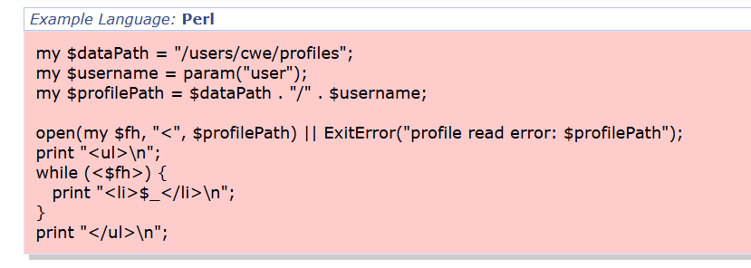
2.Vulnerability Name: Sensitive Cookie in HTTPS Session Without 'Secure' Attribute
CWE 614: A02 Security Misconfiguration
OWASP/SANS: A02
Description: occurs when cookies used in secure sessions are not marked with the “Secure” attribute. Without this attribute, cookies may be transmitted over unencrypted HTTP connections, allowing attackers to intercept session data. This vulnerability often arises due to improper system configuration and is categorized under Security Misconfiguration.
Business Impact:
Session hijacking through intercepted cookies
Unauthorized user access to applications
Increased risk of account compromise
Recommendations:
Enable the Secure attribute for cookies
Use HTTPS for all web communications
Regularly review and update security configurations

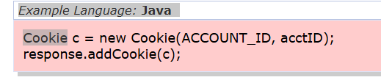
3.Vulnerability Name: Use of Unmaintained Third Party Components
CWE-1104:A03 Software Supply Chain Failures
OWASP/SANS: A03
Description:occurs when applications depend on external libraries or frameworks that are no longer maintained or updated. These outdated components may contain known vulnerabilities that attackers can exploit. Using unsupported software components increases security risks and represents a failure in managing the software supply chain.

Business Impact:
Exploitation of known vulnerabilities in outdated components
Increased risk of system compromise
Potential service disruption and security breaches

Recommendations:
Regularly update third-party libraries and frameworks
Monitor security advisories for dependencies
Replace unsupported or outdated components

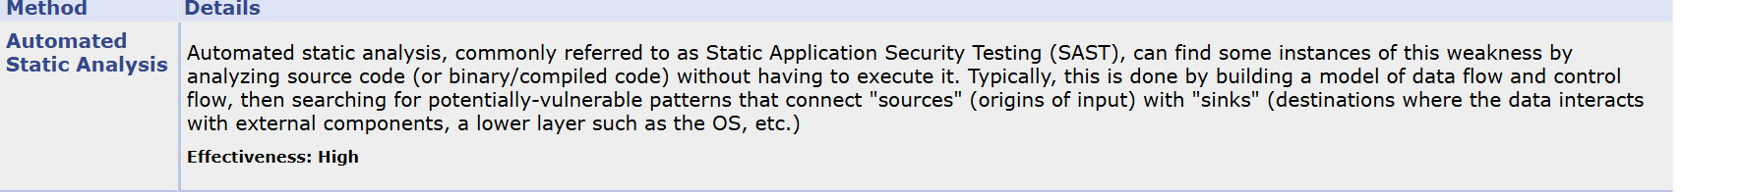
4.Vulnerability Name: Weak Encoding for Password
CWE-261: Security Misconfiguration
OWASP/SANS: A04
Description: occurs when passwords are protected using weak encoding techniques instead of strong encryption or hashing algorithms. Weak encoding can be easily reversed, allowing attackers to retrieve plaintext passwords. This leads to compromised user accounts and highlights failures in implementing proper cryptographic protections.
Business Impact:
Exposure of user credentials
Unauthorized access to user accounts
Potential financial and reputational damage

Recommendations:
Use strong hashing algorithms (e.g., bcrypt, SHA-256)
Avoid weak encoding methods for passwords
Implement proper encryption practices

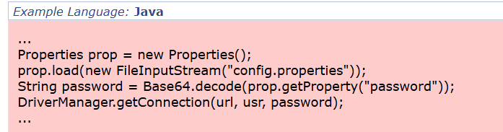

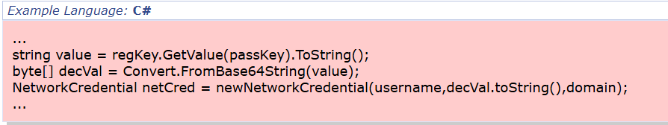

5.Vulnerability Name:Improper Input Validation
CWE-20: Injection
OWASP/SANS:A05
Description:happens when an application does not properly validate or sanitize user inputs. Attackers can exploit this weakness to inject malicious data into the system, potentially executing unauthorized commands or manipulating databases. This vulnerability is commonly associated with injection attacks such as SQL injection.

Business Impact:
Execution of malicious commands or queries
Unauthorized access or modification of databases
Data corruption and service disruption
Recommendations:
Validate and sanitize all user inputs
Use parameterized queries and prepared statements
Implement input validation controls

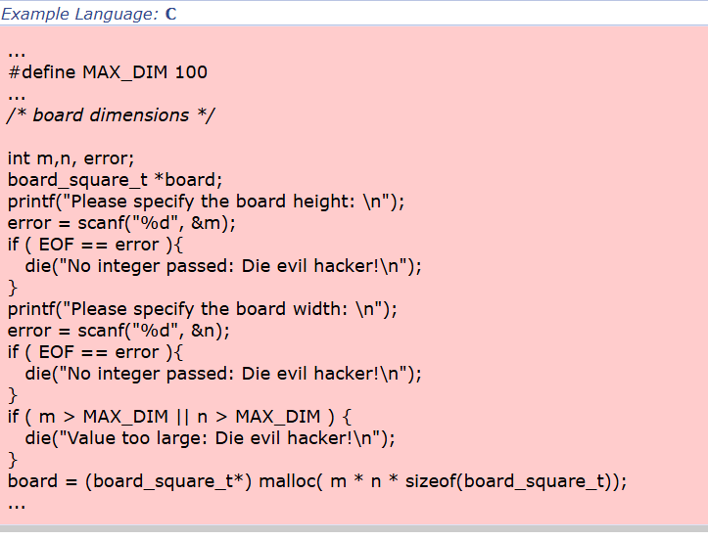

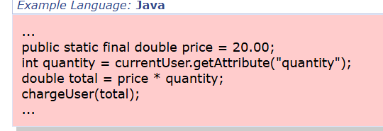

6.Vulnerability Name:Unprotected Storage of Credentials
CWE-256: Insecure Design

OWASP/SANS:A06
Description:occurs when applications store sensitive information such as usernames and passwords in plaintext or without adequate protection. If attackers gain access to the storage location, they can easily retrieve these credentials. This vulnerability reflects poor security design practices.
Business Impact:
Exposure of sensitive credentials
Unauthorized system access
Increased risk of internal and external attacks
Recommendations:
Store credentials using encryption or secure hashing
Use secure credential management systems
Restrict access to stored credentials
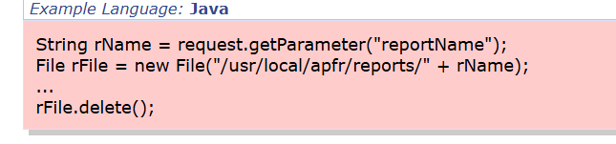

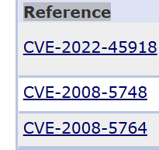
7.Vulnerability Name: Use of Hard-coded Password
CWE-259: Authentication Failures
OWASP/SANS:A07
Description:occurs when passwords are directly embedded within application code. Hard-coded credentials can be discovered by attackers through reverse engineering or code analysis.
Once exposed, they may provide unauthorized access to systems or applications.
Business Impact:
Unauthorized system access if credentials are discovered
Security risks through reverse engineering of code
Loss of control over authentication security

Recommendations:
Remove hard-coded credentials from source code
Use secure authentication mechanisms
Store credentials in protected configuration systems

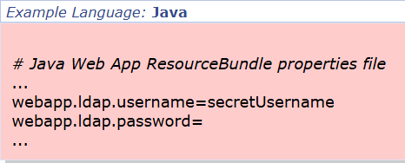

8.Vulnerability Name: Insufficient Verification of Data Authenticity
CWE-345 Software or Data Integrity Failures

OWASP/SANS:A08
Description:occurs when systems fail to properly verify the integrity or authenticity of data before processing it. Without proper validation mechanisms such as digital signatures or checksums, attackers may modify data or introduce malicious updates.
Business Impact:
Tampering with software updates or data
Installation of malicious code or files
Loss of system integrity and trust
Recommendations:
Use digital signatures to verify data authenticity
Implement integrity checks such as checksums
Validate software updates before installation

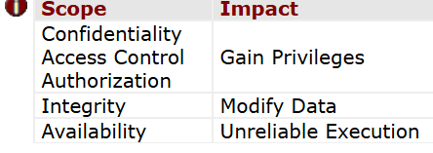

9.Vulnerability Name: Improper Output Neutralization for Logs
CWE-117: Security Logging and Alerting

OWASP/SANS:A09

Description:occurs when user-controlled data is written to log files without proper sanitization. Attackers may manipulate logs to hide malicious activity or inject misleading entries, making it difficult for administrators to detect and investigate security incidents.
Business Impact:
Manipulated logs hiding malicious activity
Difficulty in detecting security incidents
Delayed response to cyber attacks

Recommendations:
Sanitize log inputs before storing them
Implement centralized logging systems
Monitor logs regularly for suspicious activity

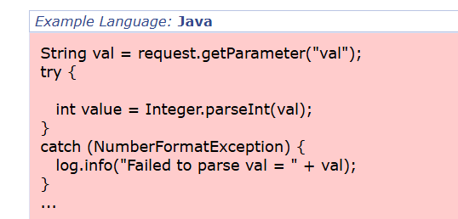

10.Vulnerability Name: Generation of Error Message Containing Sensitive Information
CWE-209: Mishandling of Exceptional Conditions

OWASP/SANS:A10
Description: occurs when applications display detailed error messages that reveal sensitive system information. These messages may expose internal file paths, database queries, or system configurations, which attackers can use to identify weaknesses in the system.
Business Impact:
Tampering with software updates or data
Installation of malicious code or files
Loss of system integrity and trust

Recommendations:
Use digital signatures to verify data authenticity
Implement integrity checks such as checksums
Validate software updates before installation
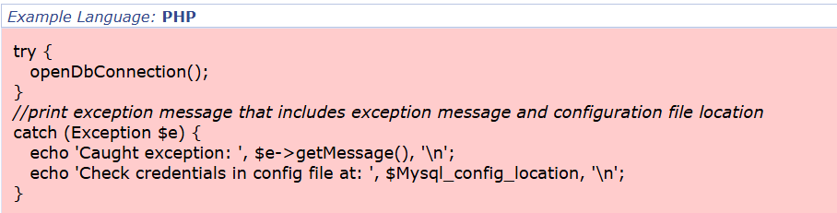

Stage 2

Overview :-
Nessus is a vulnerability scanning tool developed by Tenable, Inc.. It is a remote scanner, meaning it does not need to be installed on the target system. Nessus scans systems by sending different probes such as network traffic, OS commands, and application requests to identify security vulnerabilities. It uses a plugin-based architecture, where each plugin detects specific vulnerabilities. During a scan, Nessus first identifies the operating system and services running on the host, then runs plugins to find vulnerabilities. Finally, it generates a report showing the severity, reproduction steps, and remediation methods for each vulnerability.
Target website :-
http://testfire.net/

Target ip address:-
65.61.137.117

List of vulnerability:-

S.no | Vulnerability name | Severity | Plugins
1 | TLS Version 1.0 Protocol  Detection | MEDIUM | 104743
2 | TLS Version 1.1 Protocol  Deprecated | MEDIUM | 157288
3 | Additional DNS Hostnames | INFO | 46180
4 | Common Platform Enumeration  (CPE) | INFO | 45590
5 | HSTS Missing From HTTPS Server | INFO | 84502

REPORT:
1.Vulnerability Name:
104743 – TLS Version 1.0 Protocol Detection
Severity: Medium
Plugin:104743
Port: 443
Description:
The remote service supports connections using TLS 1.0, which contains several cryptographic weaknesses. Modern security standards recommend using TLS 1.2 or TLS 1.3 because they provide stronger protection. Many major browsers and vendors no longer fully support systems that rely only on TLS 1.0. In addition, PCI DSS v3.2 requires TLS 1.0 to be disabled due to security risks.
Solution:
Disable TLS 1.0 and enable TLS 1.2 and TLS 1.3 on the server.
Business Impact:
Using TLS 1.0 increases the risk of cyber attacks and data breaches. It may also lead to non-compliance with PCI DSS standards, possible regulatory penalties, compatibility issues with modern browsers, and loss of customer trust. Updating to newer TLS versions helps maintain security and system reliability.

2.Vulnerability Name:
157288 – TLS Version 1.1 Protocol Deprecated
Severity: Medium
Plugin: 157288
Port: 443
Description:
The remote service supports TLS 1.1, which is outdated and does not support modern and recommended cipher suites or advanced encryption methods. As of March 31, 2020, systems that do not support TLS 1.2 or higher may not function properly with major web browsers and vendors.
Solution:
Disable TLS 1.1 and enable TLS 1.2 and/or TLS 1.3.
Business Impact:Using TLS 1.1 increases security risks and the possibility of cyberattacks or data breaches. It may also cause compatibility issues with modern browsers and vendors, affecting user experience and business operations. Upgrading to newer TLS versions improves security and system compatibility.

3.Vulnerability Name:
46180 – Additional DNS Hostnames
Severity: Info
Plugin: 46180
Port: 0
Description:
Nessus detected additional DNS hostnames that point to the same remote host. These hostnames may be related to web servers using name-based virtual hosting.
Solution:
If needed, re-scan the host using the vhost syntax (e.g., www.example.com [IP address]) to test the specific hostname.
Business Impact:
This does not pose a direct security risk. It only provides information about additional hostnames associated with the server and can help in understanding the system’s configuration.

4.Vulnerability Name:
45590 – Common Platform Enumeration (CPE)
Severity: Info
Plugin: 45590
Port: 0
Description:
This plugin identifies CPE (Common Platform Enumeration) details for hardware and software detected on the host during the scan. If an official CPE is not available, Nessus estimates the closest match based on the scan information.
Solution:
N/A
Business Impact:
This is not a security risk. It helps identify the hardware and software components in the system, which is useful for asset management, inventory tracking, and system maintenance.

5.Vulnerability Name:
84502 – HSTS Missing From HTTPS Server
Severity: Info
Plugin: 84502
Port: 443
Description:
The HTTPS server does not enforce HTTP Strict Transport Security (HSTS). HSTS ensures that browsers communicate only through HTTPS, improving security. Without HSTS, the server may be vulnerable to downgrade attacks, SSL-stripping attacks, and cookie hijacking.
Solution:
Configure the web server to enable HSTS.
Business Impact:
The absence of HSTS can weaken data security and expose users to certain attacks. Enabling HSTS improves protection of data transmitted between users and the server.

Stage – 3

Title:
Modernizing Legacy VPN with Cloud-Native Zscaler Zero Trust to Reduce Attack Surface and Lateral Movement

Introduction
In modern organizations, remote access to internal applications has become an essential requirement due to hybrid work environments and distributed networks. Traditionally, organizations relied on Virtual Private Network (VPN) architectures to allow remote users to connect securely to internal networks. While VPN technology was effective in earlier network environments, it presents several security and operational limitations in today's cloud-based infrastructure.
Cyber threats have evolved significantly, and attackers often exploit weaknesses in traditional VPN architectures to gain unauthorized access to internal networks. Once an attacker gains VPN access, they may move laterally across the network and compromise multiple systems. To address these challenges, modern security frameworks such as Zero Trust Architecture (ZTA) have been introduced.
Zero Trust is a security model that assumes no user or device should be trusted by default, regardless of whether they are inside or outside the network. Cloud-based platforms such as Zscaler Zero Trust provide a secure and scalable approach to replacing legacy VPN solutions. This stage focuses on understanding the limitations of legacy VPN architectures and how Zscaler Zero Trust solutions help reduce attack surfaces and prevent lateral movement.

Legacy VPN Architecture
Legacy VPN architecture enables remote users to connect to an organization’s internal network through encrypted tunnels. Once the user successfully authenticates using credentials such as a username and password, the VPN server grants access to the internal network.
This approach is based on the “authenticate once, trust always” principle. After authentication, users are assigned an internal IP address and become part of the organization's internal network. This means the user device is treated as if it were physically present inside the organization's network infrastructure.
Legacy VPN solutions typically rely on hardware VPN appliances such as VPN concentrators that manage remote connections. These appliances act as gateways between external users and the internal network. Remote users connect to the VPN gateway through the internet, and once authenticated, they gain access to internal resources such as file servers, databases, and enterprise applications.
While this model worked well when most applications were hosted inside corporate data centers and employees worked within office environments, it has become inefficient and risky in modern distributed networks where cloud applications and remote work are common.

Limitations of Legacy VPN
Legacy VPN solutions present several limitations that affect both security and performance in modern network environments.

1. Excessive Network Access
Once users connect through a VPN, they gain network-level access to internal systems. If a user's device becomes compromised by malware or attackers steal user credentials, the attacker can access multiple internal systems within the network.

2. Increased Attack Surface
VPN gateways must be exposed to the internet so remote users can connect. These publicly accessible VPN servers can become targets for attackers who attempt to exploit vulnerabilities or perform brute-force login attempts.

3. Lateral Movement Risks
After gaining VPN access, attackers can move laterally within the network to find sensitive systems such as databases, administrative servers, or research data repositories. This significantly increases the impact of a security breach.

4. Performance Issues
Traditional VPN architectures often route traffic through centralized data centers before accessing cloud services. This process, known as traffic hair-pinning, increases network latency and reduces application performance.

5. Scalability Limitations
VPN hardware appliances have limited capacity for handling concurrent users. During peak usage periods, such as remote work surges, organizations may experience connection failures or slow performance.

Zero Trust Architecture
Zero Trust Architecture is a modern security framework designed to address the limitations of traditional network security models. Instead of trusting users once they enter the network, Zero Trust continuously verifies users and devices before granting access to applications.
The core principle of Zero Trust is “Never Trust, Always Verify.”
Key principles of Zero Trust include:

1. Verify Every Access Request
Each access request is authenticated and authorized based on user identity, device security status, and contextual information such as location or network behavior.

2. Least Privilege Access
Users are granted only the minimum level of access required to perform their tasks. This limits the potential damage if an account becomes compromised.

3. Assume Breach
Zero Trust assumes that attackers may already be present inside the network. Security controls are designed to prevent attackers from spreading within the environment.

4. Continuous Monitoring
User activity and network behavior are continuously monitored to detect suspicious activities and potential security threats.

Zscaler Zero Trust Solution
Zscaler provides a cloud-native security platform that implements Zero Trust principles without relying on traditional VPN infrastructure. Instead of connecting users directly to the internal network, Zscaler connects users only to the specific applications they are authorized to access.
This model significantly reduces the risk of unauthorized access and lateral movement.

Key Components of Zscaler Architecture

1. Zscaler Client Connector
Zscaler Client Connector is a lightweight software agent installed on user devices such as laptops, desktops, and mobile devices. It securely forwards user traffic to the Zscaler cloud platform where security policies are applied.

2. Zscaler Private Access (ZPA)
ZPA provides secure access to internal applications without exposing them to the internet. Users are connected directly to applications based on identity-based access policies.

3. Zscaler Internet Access (ZIA)
ZIA protects users by inspecting internet traffic and blocking malicious websites, malware downloads, and other cyber threats.

4. Zscaler App Connector
App Connectors are deployed within the organization's data center or cloud environment. They establish outbound connections to the Zscaler cloud, enabling secure communication between users and internal applications without exposing internal servers.

Reducing Attack Surface with Zscaler
One of the major benefits of the Zscaler Zero Trust model is the elimination of exposed infrastructure. Traditional VPN systems require publicly accessible servers, which increases the attack surface.
Zscaler removes this risk by ensuring that internal applications are not directly exposed to the internet. Instead, connections are established through secure outbound connections initiated by App Connectors.
This approach ensures that:
- Internal applications remain hidden from external attackers
- No inbound firewall ports are required
- Attackers cannot discover internal services through port scanning
As a result, organizations significantly reduce the number of potential entry points for cyberattacks.

Preventing Lateral Movement
Another major security advantage of Zero Trust is the prevention of lateral movement within the network.
In traditional VPN environments, once attackers gain access, they can explore the internal network and attempt to compromise additional systems. Zscaler eliminates this risk by ensuring that users are never placed directly on the internal network.
Instead, Zscaler creates secure application-level connections between users and specific applications. This means users cannot scan or access other systems beyond the applications they are authorized to use.
This application-level segmentation ensures that even if an account is compromised, attackers cannot easily move across the network to reach critical systems.

Integration with Security Tools
Zscaler can integrate with various security tools used by organizations to enhance threat detection and monitoring capabilities.

Identity Provider Integration
Zscaler integrates with identity providers such as Azure Active Directory or Okta to provide secure authentication and multi-factor authentication (MFA).

SIEM Integration
Security logs generated by Zscaler can be forwarded to Security Information and Event Management (SIEM) systems such as Splunk or Microsoft Sentinel. This allows security teams to monitor user activity and detect suspicious behavior.

Deployment Approach
Implementing Zscaler Zero Trust solutions typically involves a phased deployment approach.
1.Assessment Phase – Identify internal applications, user groups, and existing access requirements.
2.Infrastructure Deployment – Deploy Zscaler App Connectors and integrate identity providers.
3.Policy Configuration – Define application access policies based on user roles.
4.Pilot Deployment – Test the solution with a small group of users to validate functionality.
5.Full Deployment – Gradually migrate all users from the legacy VPN to the Zscaler platfor6.Optimization – Continuously monitor logs and refine security policies.

Conclusion
Replacing legacy VPN architectures with Zscaler Zero Trust solutions significantly enhances organizational security. By eliminating network-level access and implementing identity-based application access, organizations can reduce attack surfaces and prevent lateral movement within their infrastructure.
Zscaler’s cloud-native architecture provides scalable, secure, and efficient remote access without relying on traditional VPN hardware. As cyber threats continue to evolve, adopting Zero Trust principles ensures that organizations maintain a strong and resilient cybersecurity posture while supporting modern remote work environments.

