Sovereign AI at Scale: Cutting Inference Cost by 30%+ with llm-d on Heterogeneous Clusters
Table of Contents

Sovereign AI at Scale: Cutting Inference Cost by 30%+ with llm-d on Heterogeneous Clusters
A joint proof-of-concept by IBM Research, Red Hat, and NxtGen Cloud Technologies, India.

Why this matters now
As enterprises and governments deploy large language models at scale, on-premises and sovereign AI is becoming a strategic imperative — driven by data residency mandates, regulatory frameworks, the need for greater control over core business operations, air-gapped security for sensitive workloads, and the long-term economics of hosting high-volume inference traffic on sovereign and neo-clouds.
Yet the operational reality is hard: enterprises struggle with underutilized GPUs, rising inference costs, and high latency from monolithic pipelines, while being locked into single cloud and GPU stacks. Expensive hardware is overused for peak loads while cheaper compute sits idle. Production clusters are rarely homogeneous — they span NVIDIA, AMD, Intel, and other accelerator vendors, and span multiple generations of hardware acquired across procurement cycles. Treating this heterogeneity as a first-class advantage rather than an operational liability unlocks real value: lower-cost accelerators absorb prefill-heavy or batch-tolerant workloads, premium hardware is reserved for latency-sensitive paths, stranded capacity gets reclaimed, and the organization avoids single-vendor lock-in at the infrastructure layer.

The proof point
IBM Research, Red Hat, and NxtGen Cloud Technologies came together on NxtGen’s sovereign cloud to put this thesis under pressure: can a single Kubernetes-native serving layer take a heterogeneous fleet of NVIDIA, AMD, and Intel accelerators and deliver state-of-the-art performance — without the application ever knowing what it’s running on?
The serving layer is llm-d, an open-source CNCF-sandbox project that pairs vLLM (high-performance inference engine) with a Kubernetes-native control plane. llm-d delivers three capabilities that together make heterogeneous inference clusters practical at scale:
- Prefix-Cache-Aware Scheduling — routes each request to the GPU most likely to already hold the relevant KV cache in memory, dramatically cutting redundant computation.
- Prefill/Decode (P/D) Disaggregation — separates the compute-heavy prefill phase from the memory-bandwidth-heavy decode phase onto dedicated pools, eliminating resource contention.
- Hardware-Agnostic Operation — presents a single API endpoint regardless of whether the request lands on an NVIDIA H100, AMD MI325X, or Intel Gaudi3, enabling true multi-vendor clusters with no application changes.
We built a 20-GPU heterogeneous pool spanning 4× NVIDIA H100-NVL + 8× AMD MI325X + 8× Intel Gaudi3 on NxtGen’s sovereign infrastructure, served granite-4.1-8b and sarvam-30b (multilingual MoE) on it, and compared llm-d against plain Kubernetes round-robin under a realistic prefill-heavy workload (long shared system prompts plus short questions — typical of RAG, citizen services, and chat).

Headline results
Across every pool we tested — single-vendor and heterogeneous — llm-d’s prefix-cache-aware routing consistently and significantly beat plain Kubernetes round-robin on both throughput and time-to-first-token (TTFT):
Pool | Throughput edge (llm-d vs k8s) | TTFT edge
4× NVIDIA H100 | +25–36% | 16×
8× AMD MI325X | +79% | 21×
8× Intel Gaudi3 | +34% | 18×
12 GPUs (NVIDIA + AMD) | +85% | 3.4–5.6×
20 GPUs (NVIDIA + AMD + Gaudi) | +91% at peak load | 5.4×
The win grows with heterogeneity. Round-robin spreads requests evenly regardless of pod speed, so a single slow vendor becomes a queueing sink that drags total throughput down. llm-d’s prefix-cache-aware scheduler routes around saturated pods and concentrates cache hits on warm ones, so heterogeneity is no longer a penalty.
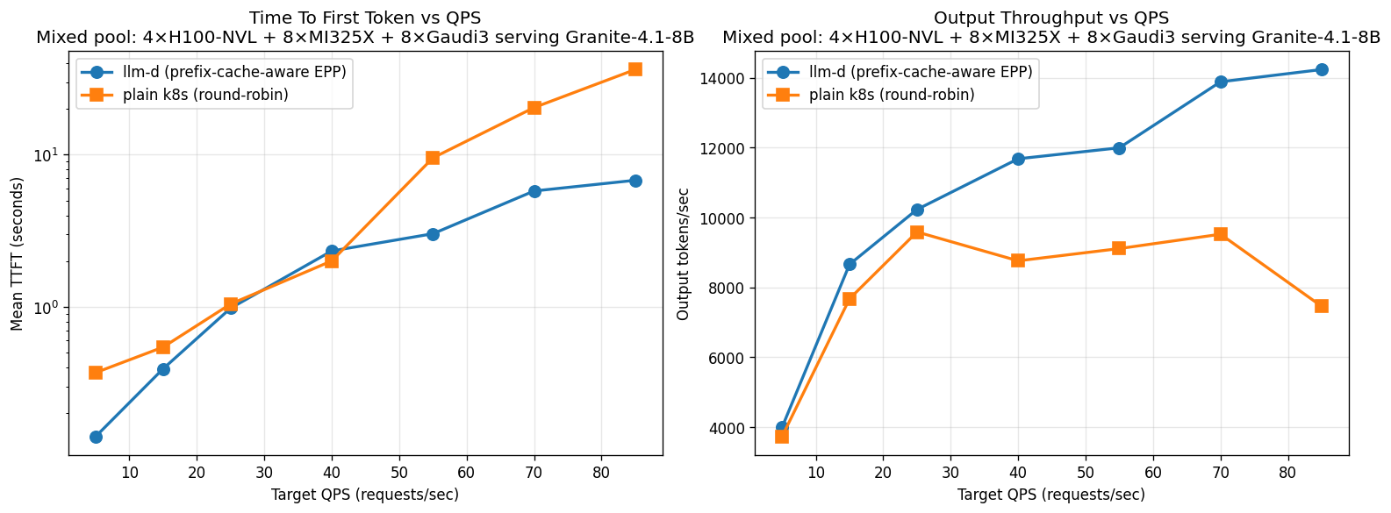
20-pod 3-vendor pool — llm-d vs k8s round-robin
On the 20-pod 3-vendor pool, plain Kubernetes saturates at ~9.6 K output tokens/sec at moderate load and declines to 7.5 K under heavier traffic as queue depth dominates. llm-d keeps scaling cleanly to 14.2 K output tokens/sec — and end-user TTFT at peak load drops from 36 seconds with k8s to under 7 seconds with llm-d.

Prefill/Decode disaggregation: dramatically smoother latency under load
LLM inference has two very different phases: prefill (compute-bound, processes the prompt in parallel) and decode (memory-bandwidth-bound, generates tokens one at a time). When both share a GPU, a long prefill blocks decode from emitting tokens and spikes time-to-first-token for everyone else on that pod. P/D disaggregation — llm-d’s second core capability — routes the two phases onto separate GPU pools so they no longer collide.
We benchmarked this on a single 8-GPU AMD MI325X node serving sarvam-30b on a prefill-heavy workload, comparing 4 prefill + 4 decode replicas (P/D) against 8 monolithic vLLM replicas behind a round-robin service. Throughput per dollar lands in the same ballpark, but the tail-latency picture changes completely:
- At moderate load (rate 75 req/s): TTFT 5× lower with P/D (0.46 s vs 2.4 s).
- At saturating load (rate 100): TTFT 8× lower with P/D (0.59 s vs 4.8 s).
- Inter-token latency is also 30–50% lower under load — streaming feels noticeably smoother.
For interactive applications where TTFT is the SLO that matters, P/D turns “the cluster is melting” into “the cluster is fine” without adding hardware.

What it means in dollars
Because llm-d squeezes more tokens out of every GPU, you need fewer GPUs to serve the same load.
Example: serving granite-4.1-8b at 5,000 requests/sec peak — the kind of traffic profile a national-scale citizen-services chatbot or large enterprise RAG application generates:
- Plain Kubernetes round-robin: ~520 GPUs to keep up.
- llm-d: ~350 GPUs for the same throughput.
- Saving: ~170 GPUs ≈ $3.7 M / year at a representative ~$2.50/GPU-hour blended sovereign rate.
At a fixed accelerator budget, the same advantage shows up the other way: llm-d serves ~50% more concurrent users with 3–5× faster response time — directly improving the experience without scaling the cluster.

Why this matters for the business
This proof point shows that llm-d can serve as the backbone for AI adoption by enabling sovereign, population-scale deployment on locally hosted, compliant infrastructure while leveraging enterprise-grade open technologies. Concretely, it lets sectors like BFSI, government, telecom, and manufacturing scale GenAI use cases — multilingual citizen services, real-time financial systems, industrial copilots — without prohibitive costs:
- Data residency, regulatory alignment, and air-gapped security remain intact, because everything runs on locally hosted infrastructure.
- Existing GPU investments stop being stranded. Older or alternative-vendor accelerators get reclaimed into productive serving capacity instead of sitting under-utilized.
- Single-vendor lock-in evaporates. The serving layer is hardware-agnostic; the procurement strategy is no longer hostage to one supplier’s roadmap or pricing.
- Cost-per-token drops by 30%+ on realistic enterprise workloads, with the savings compounding across every production deployment in the organization.

What’s next
We are extending the work in two directions:
- Cross-accelerator P/D — running prefill on one vendor’s GPUs and decode on another’s, picking each phase’s hardware on its dominant resource. Active development is happening in the llm-d community on cross-vendor KV-cache transfer; we plan to benchmark this once it lands. Larger models (120 B+) on bigger clusters are the natural next target — P/D’s tail-latency advantage scales with model size and context length.
- Continued Intel Gaudi tuning — Gaudi3 is already integrated and contributing to the heterogeneous pool; we are working with the Habana / vLLM-Gaudi communities on closing the per-pod gap to NVIDIA and AMD on hybrid-architecture (Mamba/SSM) models.

In short
llm-d makes heterogeneous, sovereign-scale LLM inference practical, faster, and meaningfully cheaper — without forcing organizations to standardize on one vendor or rewrite a single line of application code. For enterprises and governments deploying GenAI at population scale, that combination is hard to ignore.

References
- llm-d project: https://github.com/llm-d/llm-d
- llm-d KV-cache wins blog: https://llm-d.ai/blog/kvcache-wins-you-can-see
- vLLM project: https://github.com/vllm-project/vllm

