Software Requirements Specification (SRS)

# Project Title: Campus Expense Reimbursement Portal (CERP)

# 1. Introduction

## 1.1 Purpose

This SRS defines the requirements for the development of the Campus Expense Reimbursement Portal (CERP). The system is designed to digitize and streamline the reimbursement process for campus-related expenses, enabling transparent and efficient submission, tracking, and approval of claims.

## 1.2 Intended Audience

**•** **Development Team**: Frontend and backend developers

• **Quality Assurance**: Testers and reviewers

• **Stakeholders**: Faculty, HODs, Principal, and College Administration

• **Future Maintainers**: Developers responsible for future upgrades and maintenance

## 1.3 Scope

CERP enables users (students and faculty) to submit expense reimbursement claims. Requests go through a two-stage approval process — HOD followed by the Principal. The portal supports uploading documents, tracking claim status, and managing approvals securely and efficiently.

## 1.4 Definitions

| **Term** | **Definition** |
| --- | --- |
| Claim | An expense reimbursement request |
| Requester | A student or faculty member submitting a claim |
| HOD | Head of Department; first-level approver |
| Principal | Final approving authority |

# 2. System Overview

The system architecture includes the following key components:

* **Role-based authentication**: Separate interfaces for Student/Faculty, HOD, and Principal
* **Expense claim module**: Submit claims with expense details and document upload
* **Approval workflow**: HOD reviews and forwards approved claims to the Principal
* **Claim tracking**: Requesters can view the real-time status of their claims
* **Audit trail**: Logs of actions with timestamps and comments
* **Notifications** (Optional): Via email or in-app alerts for status updates

**3.Functional Requirements**

**3.1 User Authentication & Roles**

* FR1: Users must log in with their credentials and are assigned roles (Student, Faculty, HOD, Principal).
* FR2: Unauthorized users should not access other roles’ dashboards.

**3.2 Claim Submission**

* FR3: Users can submit claims by filling in expense details and uploading proof (PDF/image).
* FR4: Each claim must include date, category, amount, description, and file upload.

**3.3 Approval Process**

* FR5: HODs can view, approve, or reject claims from their department.
* FR6: Principals can only view claims approved by HODs and either approve or reject them.
* FR7: Approvers can add comments during approval/rejection.

**3.4 Claim Tracking**

* FR8: Users can view the current status of their claim (Pending, Approved, Rejected).
* FR9: Claims are listed chronologically with status and timestamps.

**3.5 Audit and Logs**

* FR10: The system logs every action (claim submission, approval, rejection) with timestamp and actor.
* FR11: Logs must be viewable by admins (optional future enhancement).

**3.6 Notifications**

* FR12: Users receive notifications when claim status changes (email or in-app if enabled).

**3. Non Functional Requirements**

**4.1 Performance**

* NFR1: The system must respond to user actions within 2 seconds under normal load.
* NFR2: It should support up to 500 concurrent users without performance degradation.

**4.2 Security**

* NFR3: User data, especially claims and documents, must be securely stored and encrypted.
* NFR4: Only authorized users should beable to access their specific data.

**4.3 Usability**

* NFR5: UI must be responsive and accessible across devices (mobile, tablet, desktop).
* NFR6: The system should be intuitive with minimal training required for end users.

**4.4 Maintainability**

* NFR7: The system should be modular to support future enhancements like admin dashboard, analytics, etc.
* NFR8: The backend must follow standard RESTful principles for easy debugging and extension.

**4.5 Availability**

* NFR9: System should maintain 99.5% uptime during working hours (9 AM – 6 PM IST).

5.Data Design

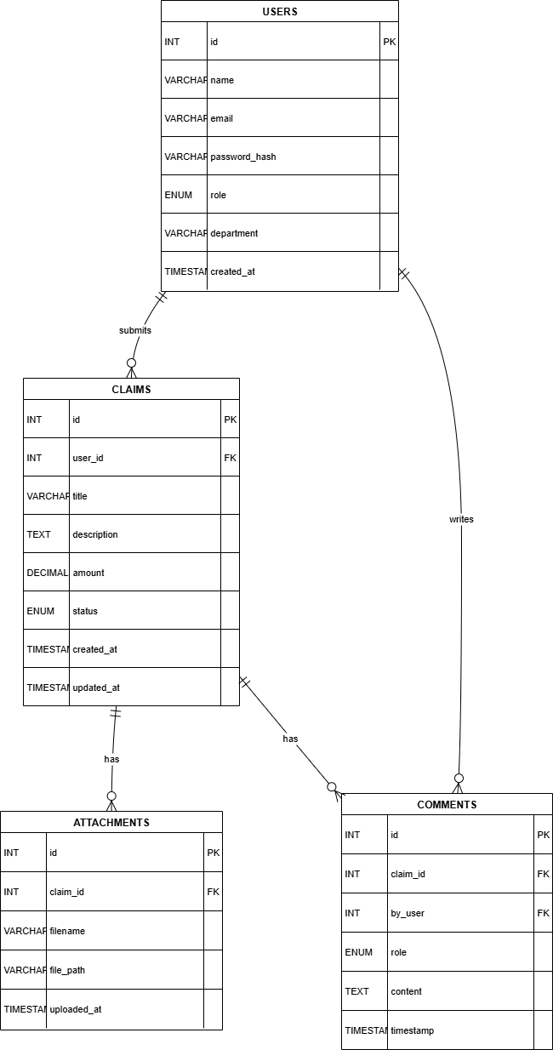

# 6 Use Case Diagram

**Conclusion**:

The Campus Expense Reimbursement Portal (CERP) aims to digitize and streamline the reimbursement process within an academic environment by providing an efficient, transparent, and secure platform. This SRS document has outlined the project's goals, scope, system overview, and detailed functional and non-functional requirements.

By implementing role-based access, a structured approval workflow, real-time claim tracking, and robust audit logging, the portal will significantly reduce manual effort, eliminate bottlenecks, and enhance accountability in the expense management process. The documented requirements serve as a foundation for system design, development, testing, and future enhancements, ensuring that the final product aligns with the expectations of all stakeholders.