

Analytics Medical – Out of Channel Allocation

DOCUMENT CONTROL INFORMATION
Process/Project Name | Out Of Channel Allocation
Prepared By (G) | Praven Kumar
Reviewed By (CAH) | Irfan Ahmed
SOP Storage Location | \\cardinalhealth.net\applications\OH001\AnalyticsInfoMgmt\Teams\Performance Optimization\Projects\OOC_Allocation \SOP_Doc
Business Stakeholder | Doug Helmreich

Contents
DOCUMENT CONTROL INFORMATION 1
Contents 1
1 Contextual overview 2
2 Process Overview & Procedure 3
3 Policy & Control 7
4 Process Cadence 8
5 Process Contact Information 9
6 Record Retention 10
7 Sign off 10

1 Contextual overview

1.1 End to End Process Overview
Executive Summary:
Cardinal Health currently lacks a consistent and scalable way to quantify true customer purchasing potential across product categories and locations.
As a result, pricing decisions and contract benefits are often based on incomplete visibility, leading to:
- Revenue leakage
- Misaligned pricing tiers
- Reduced contract compliance
The Out of Channel Allocation solution addresses this by:
- Estimating total market opportunity at customer level
- Comparing actual vs expected purchases
- Identifying underperforming customers
This enables data-driven actions such as:
- Pricing correction
- Contract enforcement
- Targeted growth strategies

Problem Statement:
Cardinal Health currently does not have a unified view of customer-level market potential and purchasing behaviour across product categories and locations.
This creates three critical gaps:
- Incomplete Market Visibility
Total addressable spend is not directly observable from internal sales data alone
- Contract Misalignment
Customers may receive pricing benefits without meeting committed purchase thresholds
- Revenue Leakage
Opportunity remains unrecognized due to lack of granular allocation and benchmarking
As a result, business decisions related to pricing, contracting, and sales strategy are made without a reliable estimate of true customer opportunity.

Objective:
To develop a scalable and data-driven framework that:
- Estimates total addressable spend for each customer
- Allocates opportunity across:
  - Product categories (UNSPSC)
  - Facilities (ShipTo)
  - Customer hierarchy (SoldTo)
- Identifies gaps between:
  - Actual purchases (Cardinal sales)
  - Expected purchases (modeled opportunity)
- Enables business teams to:
  - Improve contract compliance
  - Drive revenue growth
  - Optimize pricing strategies

Methodology:
Bayesian Model (Core Engine)
What it does:
Estimates total spend (market size) for each customer
Why needed:
Actual sales data is incomplete → model fills gaps

Neural Network
What it does:
Splits total spend into product category proportions (UNSPSC)
Why needed:
Different customers buy different product mixes

Allocation Logic:
Step 1: ZIP → Facility
- Market demand at ZIP level is distributed to hospitals
Step 2: Facility → UNSPSC
- Demand split across product categories
Step 3: Redistribution Loop
- Fixes negative or unrealistic allocations
- Iteratively balances values

Key Concepts
Binary Transformation
Converts values like:
- Yes → 1
- No → 0
Makes data usable for modelling

Missing Value Handling
- Missing beds → set to 0
- Missing sales → set to 0

UNSPSC Alignment
- Only common product categories between datasets are used
(Ensures consistency)

Convertible vs Non-Convertible
- Convertible: Opportunity that can shift to Cardinal
- Non-convertible: Locked or unavailable spend

Overview of Approach

1.2 Tools/Systems Required

Name | Description | Location/Path/URL
EDDIE workbench | Jupyter notebook to be used within the EDDIE workbench for all editing | https://console.cloud.google.com/vertex-ai/workbench/locations/us-central1-a/instances/med-ai-pwr-pytorch?project=edd-trn-mdai-pr-cah
GitHub | All code to be parked in the GitHub repository | https://github.com/cardinal-health/eddie-mlops-ita

2 Process Overview & Procedure

2.1 Inputs & Outputs

Source Data:
Project id | edna-data-pr-cah
Dataset id | D2_MED_MSADM_CMRL_CMBN_SRC
Table id |  | SHIPTO_LEVEL_SALES_DATA
Dataset id |  | VW_MED_AI_ML_ITA
Table id |  | CORP_WRK_DAY_PUBLIC_HCM__CARDINAL_WORKDAY_DATA_CV

AD groups:
aa-cloud-eddie-med-ai-ita-nprd
a-cloud-eddie-med-ai-ita-prd
a-bd-edna-read-prd
a-bd-med-msadm-cmrl-cmbn-src-prd

Output:
Project id | edna-data-pr-cah
Dataset id |  | D2_MED_AI_ML_ITA
Table id |  | ITA_output

2.2 Roles & Responsibilities

Roles | Responsibilities
Data Scientist | To run the end-to-end solution in EDDIE in the following environments:  EDDIE Dev  EDDIE Stg  EDDIE Prod

2.3 Acronymns:

Term | Meaning
UNSPSC | Product category
GHX | Market sales data
ShipTo | Delivery location
SoldTo | Billing customer

2.4 Process Flow chart:

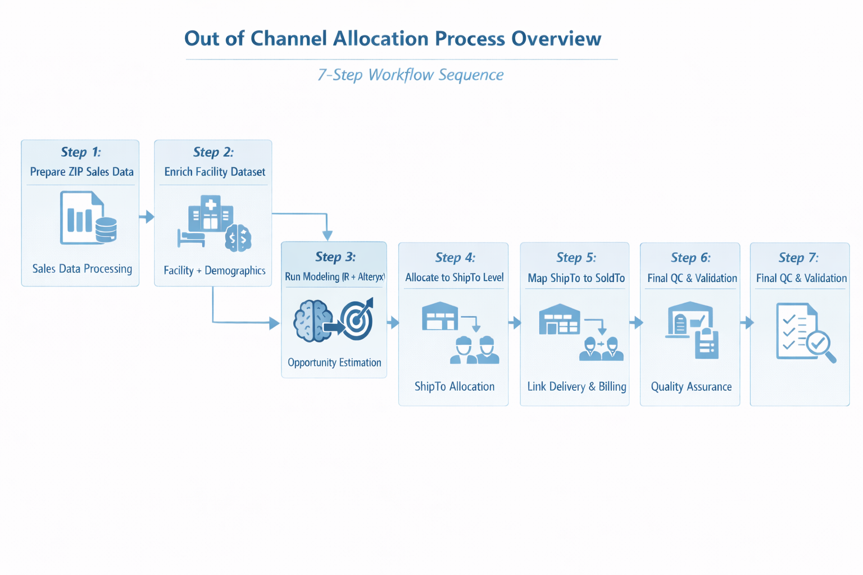

2.5 Codebase Structure & Module Explanation
(We have one R script to run)

R Script Module Explanation
Data Preparation
- Cleans and standardizes data
- Converts categorical → numeric

Feature Engineering
- Creates hospital-level features
- Aligns UNSPSC categories

Bayesian Prediction
- Estimates total spend
- Uses facility attributes

Neural Network Allocation
- Splits spend across products

Iterative Redistribution Loop
- Fixes negative allocations
- Ensures logical consistency

2.6 Process Steps

File Paths
Network folder:

\\cardinalhealth.net\Applications\OH001\AnalyticsInfoMgmt\Teams\Performance Optimization\AdamTransition\ClarivateAllocation
Step 1: copy_clarivate.yxmd
Purpose
Prepare ZIP-level sales data
Inputs
- sales_distributed_transaction.yxdb
- MaterialLevelEnginuity.yxdb
What Happens
- Filters last 4 quarters
- Aggregates sales by ZIP and product
- Converts into pivot format
Output
- Clarivate_Data.yxdb
How to Run
- Open workflow
- Click Run
- Wait for completion

Step 2: Clarivate_Step01.yxmd
Purpose
Create master hospital dataset

Inputs
- IQVIA data
- Financial data
- Bed data
What Happens
- Builds detailed hospital profiles
- Adds financial + demographic attributes
Output
- Enriched facility dataset
How to Run
- Open workflow
- Click Run

Step 3: Clarivate_Step02.yxmd
Purpose
Merge facility data with sales
What Happens
- Joins ShipTo and SoldTo
- Aligns customers with facilities
Output
- Combined dataset

Step 3: Clarivate_Step_03.yxmd (or workaround.R)
Purpose
Run the core modelling logic (Bayesian + Neural Network)
What this step achieves (Simple)
- Estimates total customer spend (market size)
- Distributes spend across product categories
- Prepares modelled opportunity for allocation

Two Ways to Run This Step
Option 1: Using Alteryx (Recommended)
- Workflow: Clarivate_Step_03.yxmd
- Contains embedded R code
Option 2: Using R Script
- File: workaround.R
- Same logic executed outside Alteryx

Inputs
- Output from Step 3 (combined dataset with facility + sales data)

What Happens (Simplified)
- Converts categorical values into numeric (Yes/No → 1/0)
- Handles missing values (fills with 0 where needed)
- Aligns product categories (UNSPSC matching)
- Runs Bayesian model to estimate total spend
- Uses neural network to distribute spend
- Applies redistribution logic to correct inconsistencies

Output
- Modelled opportunity dataset (used in next step)

How to Run (Alteryx Method)
- Open Clarivate_Step_03.yxmd
- Ensure input paths are correct
- Click Run
- Wait for completion (R tool may take time)
How to Run (R Script Method)
- Open RStudio
- Load file: workaround.txt
- Update file paths if required
- Run entire script
- Save output in designated location

Step 4: Clarivate_Step04.yxmd
Purpose
Allocate opportunity to ShipTo
What Happens
- Distributes opportunity across ShipTo
- Filters valid records
Output
- ShipTo allocation dataset

Step 5: CreateNew_ShipTo_SoldTo.yxmd
Purpose
Map ShipTo → SoldTo
What Happens
- Links delivery location to billing entity

Step 6: soldto_rollup.yxmd
Purpose
Aggregate to SoldTo level
What Happens
- Sums sales and opportunity by SoldTo

Step 7: Final QC Workflow
Purpose
Validate outputs
What Happens
- Removes invalid values
- Ensures totals match

HOW TO RUN FULL PIPELINE
Execution Order
Step 1 → Step 2 → Step 3 → Step 3 → Step 4 → Step 5 → Step 6 → Step 7

2.7 OUTPUT FILES — BUSINESS INTERPRETATION
File 1: soldto_UNSPSC_denominator
Total market size (final adjusted)

File 2: Shipto_MarketingView_Allocation
Opportunity by marketing category

File 3: Shipto_Unspsc_Allocation
Product-level opportunity

File 4: Bayes_Soldto_Unspsc_Opportunity
Pure model output

3 Policy & Control

3.1 Segregation of Duties – Documents and Risks

Process step | Activity Code | SOD Description
Monitor MLOps pipeline | 001 | Genpact offshore team
Code modfification/changes based on stakeholder feedback | 002 | Genpact offshore team

3.2 SOX Controls

N/A

3.3 Operational Controls

Output check:
- No negative values
- Totals match across levels
- All customers mapped

3.4 Process Risk & Mitigation

Process Risk:
- Airflow DAG run in production: airflow DAG can stop running due to data issues in source D2 or EDDIE pipeline back-end changes.

Mitigation Strategy:

- Monitor the emails from Airflow DAG/check manually to ensure the process is running smoothly and reach out to EDDIE team for any issues.

3.5 Policies

N/A

3.6 Process Performance Parameters – SLA/KPI

N/A

4 Process Cadence

4.1 Activity Calendar

Process Description (Activity) | Activity Objective | Frequency | Workday Due
Airflow DAG run  (Automated) | To run the MLOps pipeline in production | Quarterly | 15th Business Day of the month

4.2 References
Process reference documents like forms, templates, checklists can be embedded here:
Name/Description of the appendix item | Artifact/Link of the document
Network Folder | \\cardinalhealth.net\Applications\OH001\AnalyticsInfoMgmt\Teams\Performance Optimization\AdamTransition\ClarivateAllocation

5 Process Contact Information

5.1 Issues/ Query related to process or applications/systems

System/Application/Process | Contact Name | Contact Details
ITA MLOps | Praven Kumar | Praven Kumar:  praven.kumar@cardinalhealth.com

5.2 Capture escalation contact point for partner Operations team and Cardinal Health

Escalation level | Contact Name | Contact Details
Level 1 | Praven Kumar | Praven Kumar: praven.kumar@cardinalhealth.com  Sagar Virmani:  sagar.virmani@cardinalhealth.com
Level 2 | Mayank Manu | mayank.manu@cardinalhealth.com
Level 3 | Sourav Banik | sourav.banik@genpact.com

5.3 Key Contact Details

Contact Name | Role | Contact Details
Doug Helmreich | Dir, Data Science  GMPD Commercial and Product Strategy | doug.helmreich@cardinalhealth.com
Irfan Ahmed | Mgr, Data & Analytics Management  US MED Distribution Commercial Digital Partner | irfan.ahmed@cardinalhealth.com
Pooja Malhotra | Sr. Data Engineer, Data Engineering  Med Global Planning & Procurement  Digital Partner | pooja.malhotra01@cardinalhealth.com
Praven Kumar | Data Scientist | praven.kumar@cardinalhealth.com

