Master

* Scheme Common master
  + There must be scheme type in common master listing so we can bifurcate scheme type wise.

Add Scheme

* Common Issues
* Once scheme is activated then restrict changes or updation.
* De- activated schemes can’t show at schemes list if one wants to see De-activated schemes then there must be an option to see.
* Active scheme can’t be deleted.
* Purpose of the schemes.
* benefit of the schemes
* Scheme Details
* in Contact Person Details section nodal department is not mapped with all admin department.
* Scheme Description must be multiline text box.
* There must be a option of save as draft and next if we move on 2nd or 3rd tab then page get refreshed then all data get reset.
* check email and ssoid validation.
* There is no scheme start date.
* No edit facility of nodal details.
* Scheme/Service Owned By -> in case of both state and center contribution must be in percentage(Display message)
* In contact person details(Nodal) -> Nodal details are mandatory such as name , mobile.
* Scheme Expiry
* If scheme is not having any expiry date or duration then selection must not be compulsory.
* check the spell of First Appeallate and second Appeallate.
* scheme creation and expiry date can’t be same date.
* in case of renewal Validate Time of validity (in Months) and scheme expires on (in Months). scheme expires on (in Months) should not be greater than Time of validity (in Months).
* Who eligible
* There must not be an option of **Not Available** in Cast Category.
* Plus button to add Eligibility add blank data if we don’t select any eligibility and click on add (check duplicate data also entered).
* How to apply
* Mode of Appling is online or both then user can apply from both of mode e-mitra and department website if it is available. (must be multi select).
* Helpline no. limit is 10 digit if there is any toll free no. then how do I enter.
* No edit facility of List of required documents only after delete I have to enter again.
* What will Beneficiary Get
* how do I enter beneficiary like this

“• इस योजना के लक्षित लाभार्थी राज्य के छोटे और सीमांत किसान हैं।

• राजस्थान वृद्धजन कृषक सम्मान पेंशन की लागत 990 करोड़ रुपये है।

• किसान पेंशन योजना से लगभग 11 लाख किसान लाभवंतित होंगे।

• इस योजना से वृद्धावस्था छोटे और सीमांत किसानों को वित्तीय सहायता मिलेगी।

• महिला किसान जिनकी आयु 55 वर्ष से अधिक है, उन्हें 750 रुपये प्रति माह मिलेंगे।

• पुरुष किसान जिनकी आयु 58 वर्ष से अधिक है, उन्हें 750 रुपये प्रति माह मिलेंगे।

• सभी किसान जिनकी आयु 75 वर्ष से अधिक है, उन्हें प्रति माह 1000 रुपये पेंशन के रूप में दिए जायेंगे।“

“रैफरल ट्रांसपोर्ट सुविधा जननी एक्सप्रेस एंबुलेंस द्वारा महिलाओं एवं 30 दिवस तक के नवजात शिशुओं को निकटतम राज्य के चिकित्सा केंद्र तक यथाशीघ्र पहुंचा कर, उन्हें स्वास्थ्य सुविधाएं उपलब्ध करवाना।“

**“लाभाविंत**  : दूर दराज के गावों में रहने वाले लोग”

* Validate Delivery payment details and payment disbursement frequency in installments. Delivery payment details can’t be less then payment disbursement frequency in installments.
* Other Document
* list of other document entered blank.
* No edit facility of other documents only after delete I have to enter again.

1. On Add Scheme Page, Next button should have dark background color so user can see it to go on next screen.

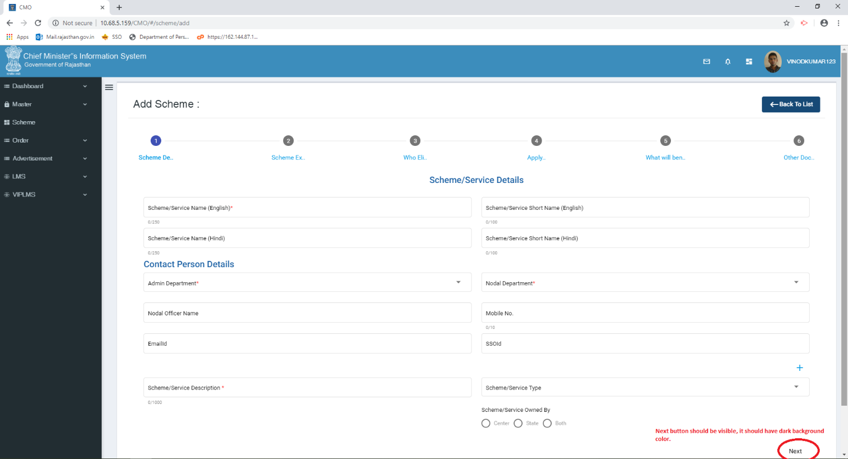

1. If scheme service free is not applicable in that case it is also asking HOW TO PAY FEEs

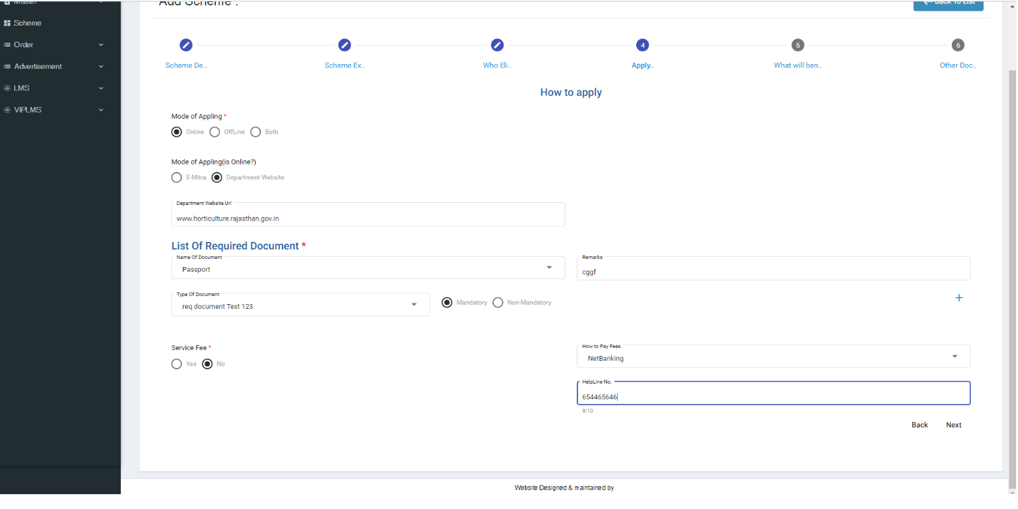

1. Mostly time NEXT button does not work in single click.
2. Scheme Delivarable dropdown should be multiple select dropdown.

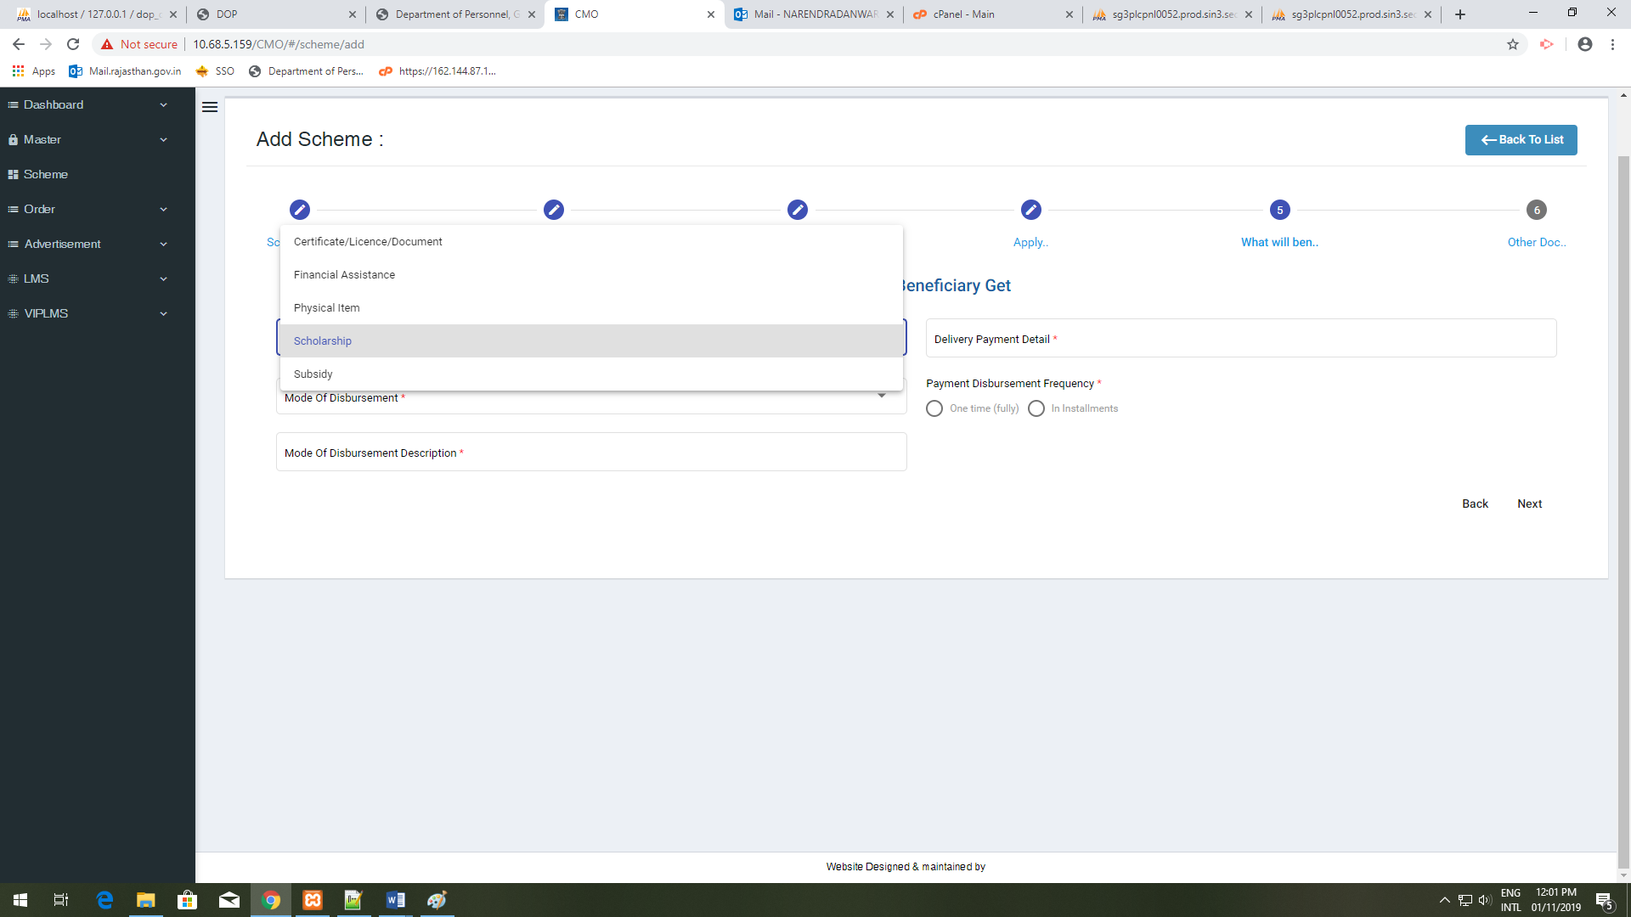

1. Why there is a blank image box in Other Document page.

