Assignment - ASE

Component - 1

Pravesh Pansari

2020

Contents

Simple Programming Environment 2

Interface: 2

Functions: 2

Commands: 3

Program Design 4

UML Class Diagram 4

Version Control – GitHub 5

Repository: 5

Commits: 6

Test Cases 7

Summary: 7

All tests pass (not including var & while): 7

All tests fail 7

Results: 8

Shape Factory Test – Rectangle 8

Shape Factory Test – Triangle 8

Command Test – Move to 9

Command Test – Draw To 9

Command Test – Reset Command 10

Command Test – Pen Command 10

Command Test – Var command 11

Command Test – While Command 11

# Simple Programming Environment

## Interface:

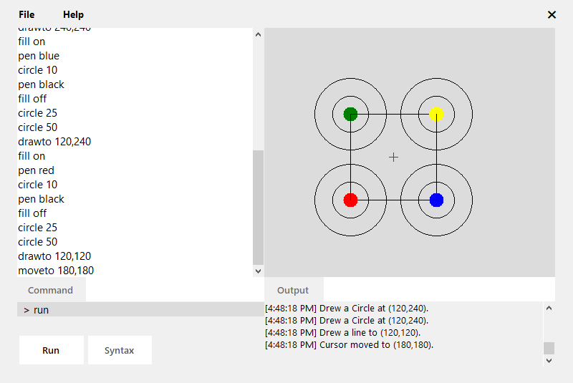

Figure 1: The GUI of Simple Programming Environment

This program creates a simple programming environment, where commands can be used to manipulate shapes and lines on an artboard. The artboard is the place where all drawings and the cursor are rendered. The menu allows access to different file operations, exit, and the about information. The current position of the cursor on the artboard is represented by the red cross. The command line runs single commands while the code editor can run multiple commands where every command is on a new line. Commands can be executed using the run button. The output box displays the log information and error information for the commands.

## Functions:

Four types of shapes can be drawn: rectangle, square, circle and triangle. And a line can be drawn given a destination position. The shapes can be drawn outlined or filled. The color of shapes and lines can be changed. The cursor can be reset to top left, moved to center or any position in the artboard. The board can be cleared, which removes all drawings on it. The file menu allows the user to create new file, save the code, open a file and exit the program. The help menu consists of information about the program.

## Commands:

* **drawto** int x, int y – Draws a line from current position to (x, y)
* **moveto** int x, int y – Moves the cursor to (x, y)
* **pen** string color – Changes the Pen color to color
* **fill** string input – Sets the fill of the shapes (on or off)
* **rect** int width, int height – Draws a rectangle of width and height
* **square** int size – Draws a square of length size
* **circle** int radius – Draws a circle of radius
* **triangle** int base, int height – Draws a triangle with base and height
* **clear** – Clears the drawing area
* **reset** – Reset the circle position to (0, 0)
* **tocenter** – Moves the cursor to center

# Program Design

## UML Class Diagram

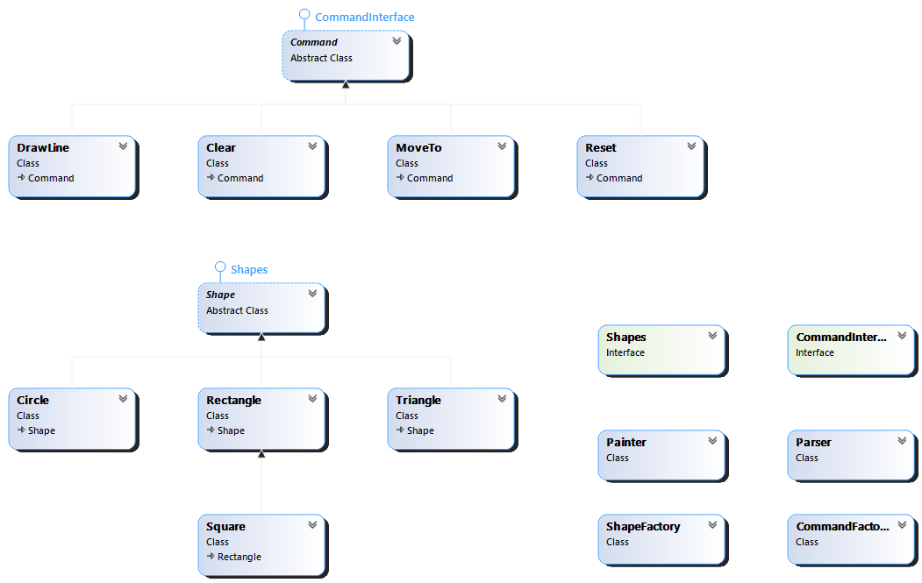

# Version Control – GitHub

## Repository:

#### Link: <https://github.com/praveshpansari/PLEnvironment>

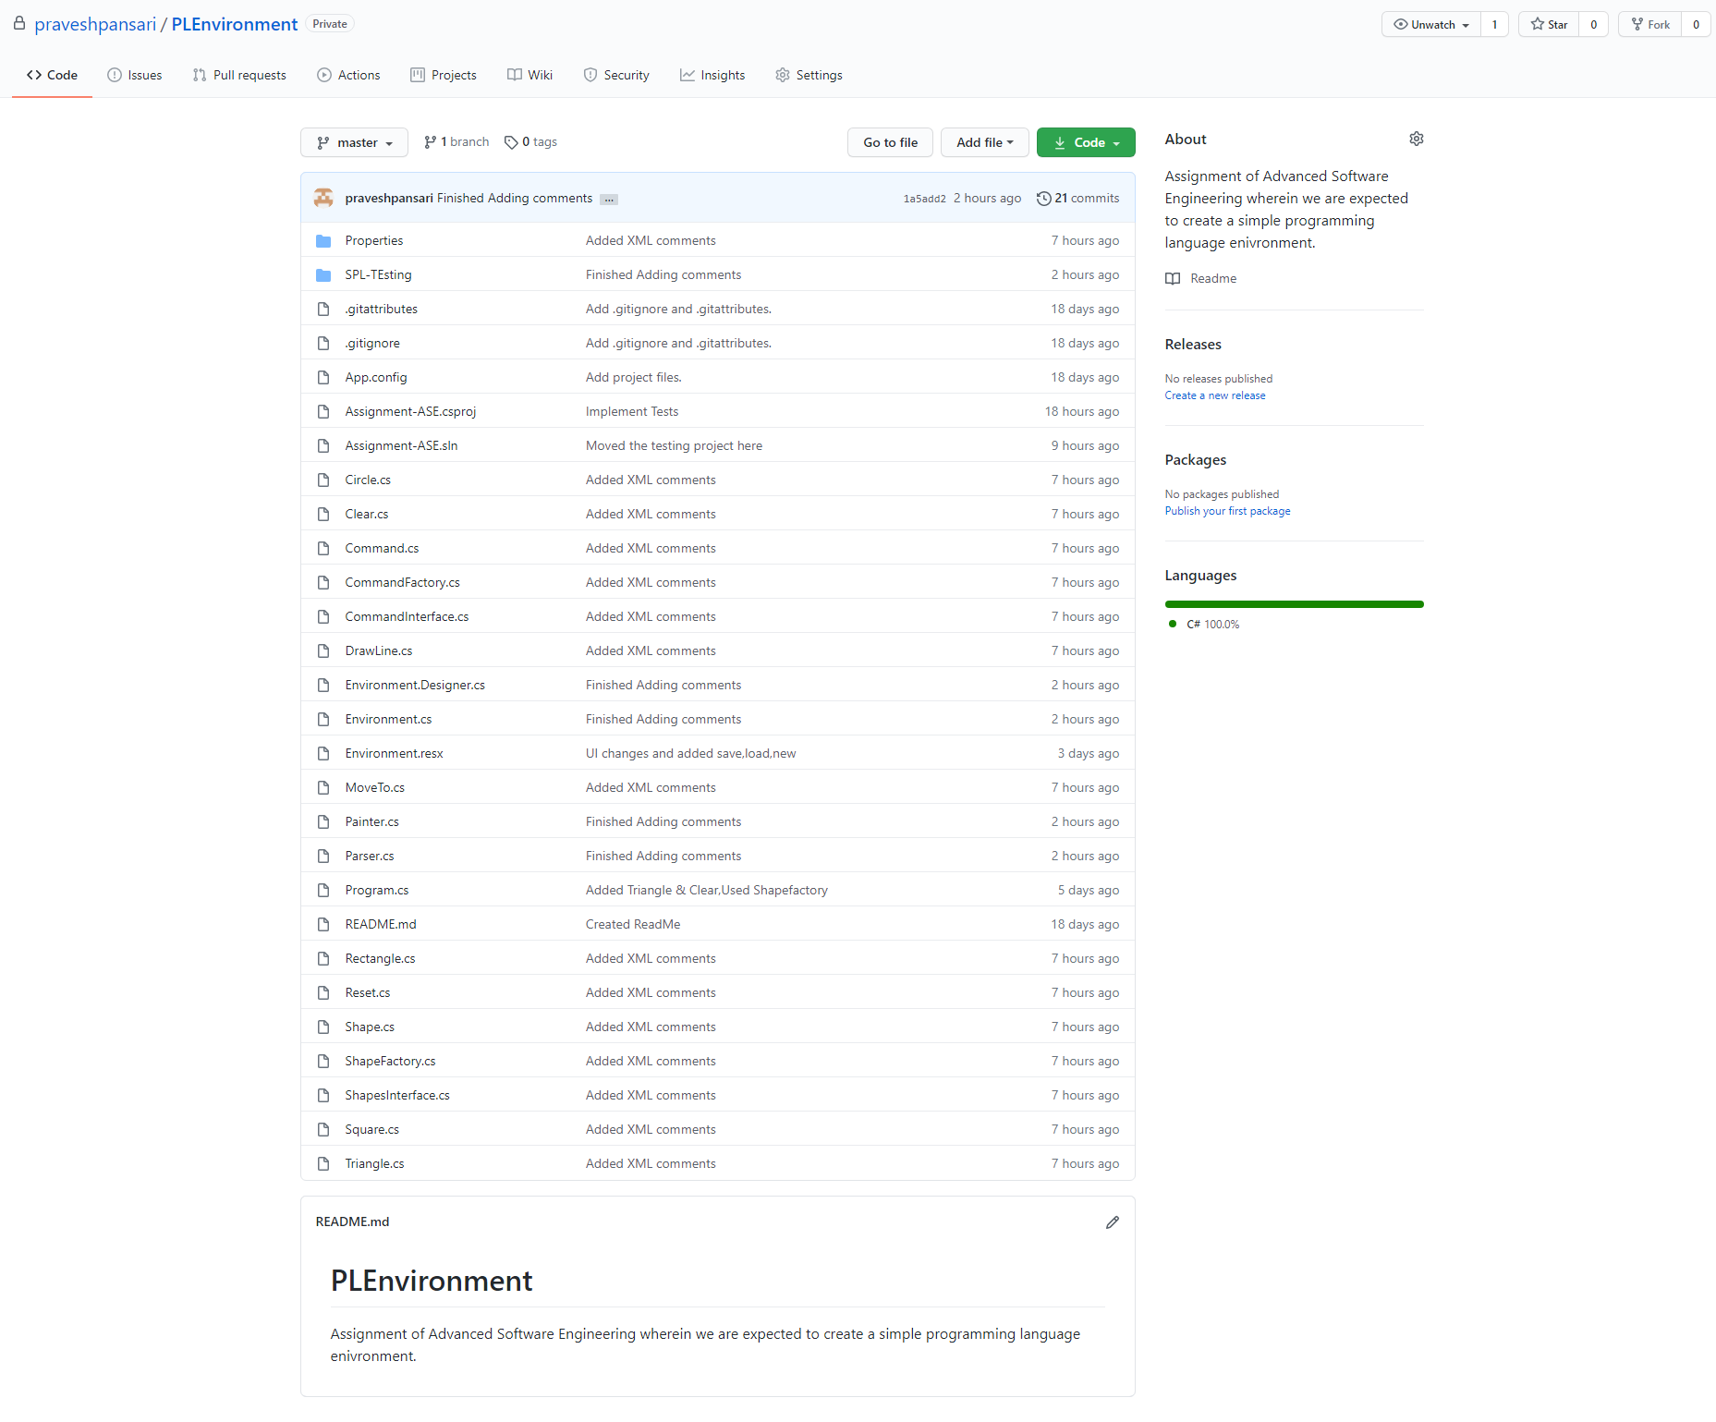

## Commits:

## 

# Test Cases

## Summary:

### All tests pass (not including var & while):

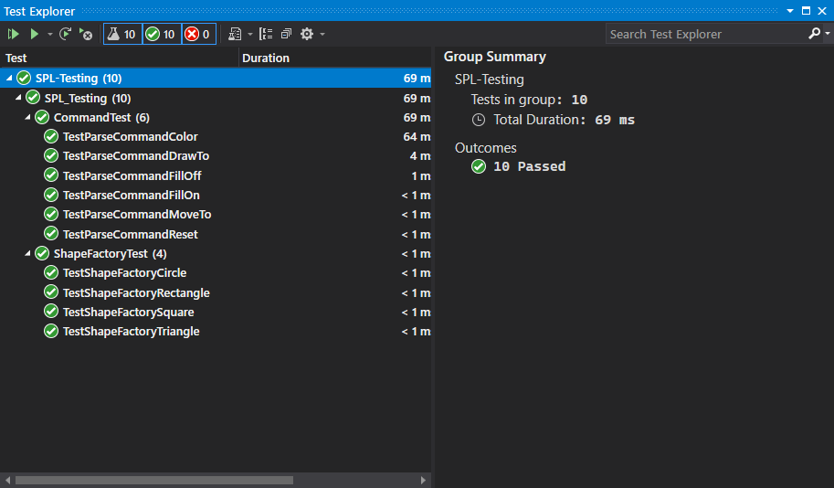

### All tests fail

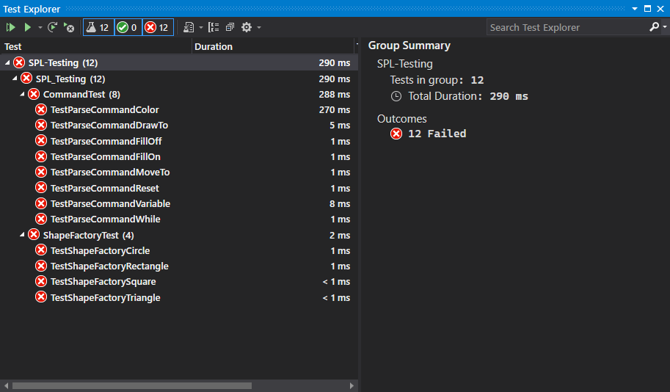

## Results:

### Shape Factory Test – Rectangle

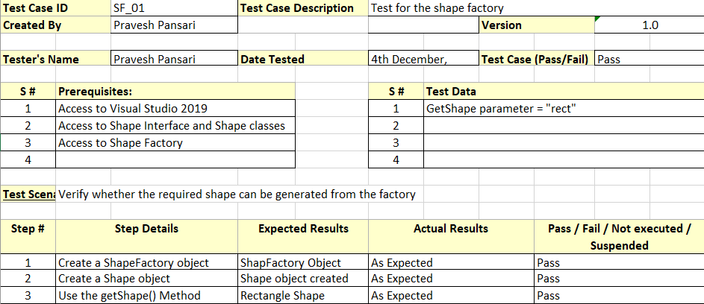

### Shape Factory Test – Triangle

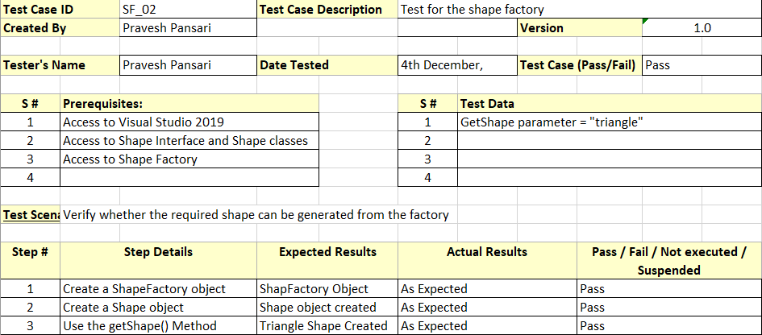

### Command Test – Move to

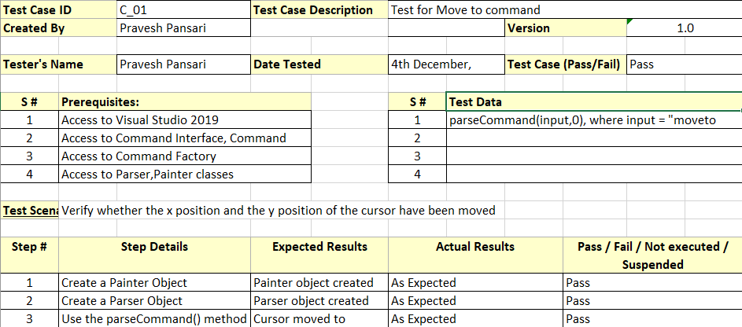

### Command Test – Draw To

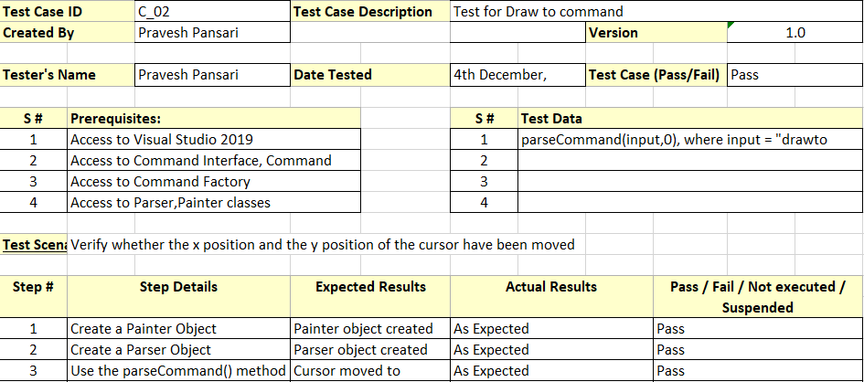

### Command Test – Reset Command

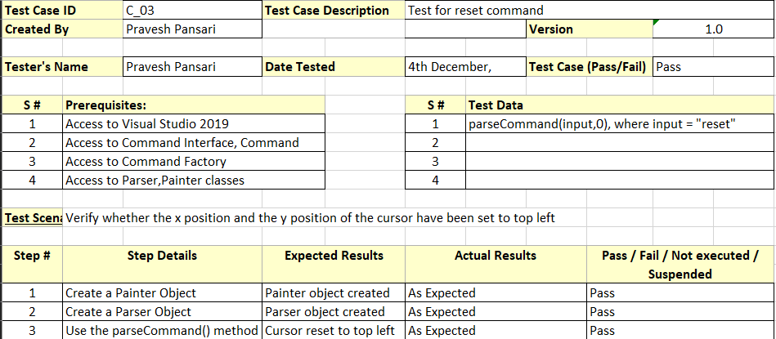

### Command Test – Pen Command

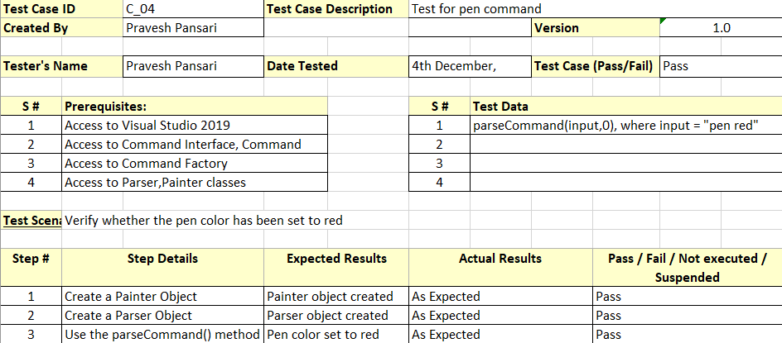

### Command Test – Var command

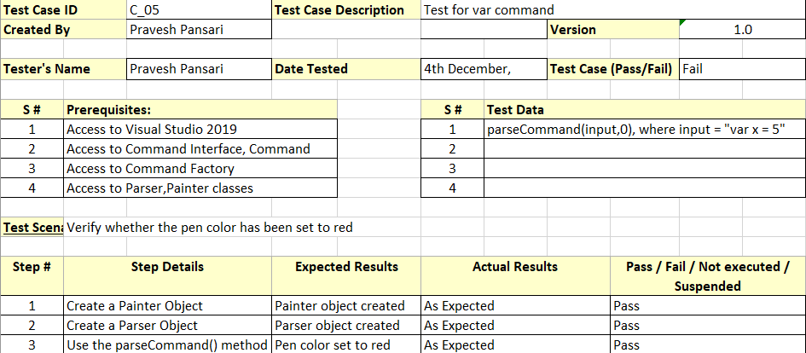

### Command Test – While Command

