

SLA Calculator Bot– Readme

Version: 1.0

Date: 23th July 2020

Bot Overview

This Bot is designed for getting SLA deadline, transaction processing time, SLA completed hours and SLA missed hours, excluding configured weekends and holidays.

This bot performs the following:

* It takes queue name as input, if multiple queues are involved in a process it takes first and the last queue
* It calculates the SLA deadline, transaction processing time and SLA missed/completed hours for each transaction in the queue common by reference id

# Pre-Requisites

* + UiPath Studio
  + Excel
  + Set up all Input parameters.
    - in_HolidayList
    - in_DayOfWeekEnd1
    - in_DayOfWeekEnd2
    - in_EndTime
    - in_StartTime
    - in_SLA
    - in_ExcelFullPath
    - in_QueueName

# Installation

* Download the bot from Bot Store.
* Extract the zip file.

# This is the folder structure of the content:

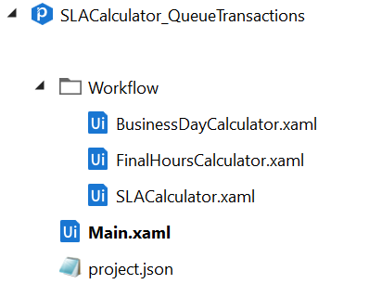

How to Use the BOT?

This utility is based on the execution time of the transaction. This utility can be called at any time of processing. This bot uses all the configurations input parameters, start time and end time of working day. Bot calculate SLA deadline on the basis of transaction creation time, excluding weekend and holiday list, which provided in the input parameters.

|  |  |  |  |
| --- | --- | --- | --- |
| **Parameter Name** | **Type** | **Direction** | **Additional Info** |
| in_HolidayList | List<DateTime> | Input | Holidays dates are passed as a list of Dates. Eg “new list(of DateTime) from {new DateTime(2020,07,17)}” |
| in_DayOfWeekEnd1 | System.DayOfWeek | Input | Passing the weekend 1 day.  Eg. “DayOfWeek.Saturday” |
| in_DayOfWeekEnd2 | System.DayOfWeek | Input | Passing the weekend 2 day.  Both the weekend parameters are optional |
| in_StartTime | TimeSpan | Input | This is the start time of the working day Eg. “new TimeSpan(13,00,00)” as HH:mm:ss |
| in_EndTime | TimeSpan | Input | This is the end time of the working day Eg. “new TimeSpan(22,00,00)” as HH:mm:ss |
| in_SLA | TimeSpan | Input | This parameter stores the input SLA time for each transaction eg. “new TimeSpan(25,00,00)” as HH:mm:ss |
| in_ ExcelFullPath | String | Input | Path of excel file on which output data will be stored |
| in_QueueName | String[] | Input | This array of string which takes queue name as its value , if multiple queues are involved in the process – pass the first and last queue. Eg. {"Test","MYQueue"} |

# Bot Dependency Files Details:

* Add UiPath.WebAPI.Activities

Error Handling

* + The automation captured all the exceptions and logged those exceptions. Each workflow is surrounded by try catch block on which it logs the exception and rethrow it to the main workflow.

Sample Output:

