SHAI: AN EXPLAINABLE MACHINE LEARNING AND DETERMINISTIC ORCHESTRATION PLATFORM FOR OUTPATIENT NO-SHOW PREDICTION, CAPACITY OPTIMIZATION, AND AUTONOMOUS RESCHEDULING IN SRI LANKAN HOSPITALS
PRAVIHARA NERANJANA ABEGUNASEKARA
Bachelor of Science (Honours) in Software Engineering
Department of Software Engineering and Information Systems
Faculty of Computing
NSBM Green University
Sri Lanka
October 2026

SHAI: AN EXPLAINABLE MACHINE LEARNING AND DETERMINISTIC ORCHESTRATION PLATFORM FOR OUTPATIENT NO-SHOW PREDICTION, CAPACITY OPTIMIZATION, AND AUTONOMOUS RESCHEDULING IN SRI LANKAN HOSPITALS
A thesis submitted to NSBM Green University for the degree of
Bachelor of Science (Honours) in Software Engineering
By
PRAVIHARA NERANJANA ABEGUNASEKARA
Department of Software Engineering and Information Systems
Faculty of Computing
NSBM Green University
Sri Lanka
October 2026

DECLARATION
I declare that the content of this undergraduate thesis titled "SHAI: An Explainable Machine Learning and Deterministic Orchestration Platform for Outpatient No-Show Prediction, Capacity Optimization, and Autonomous Rescheduling in Sri Lankan Hospitals" is my own work and this dissertation does not incorporate without acknowledgement any material previously submitted for any other degree in any university or institution of higher learning.
Signature: ..................................................... Date: .....................................
Name: Pravihara Neranjana Abegunasekara
Signature of the Supervisor
.........................................................................
Mr. Anton Jayakody
Principal Supervisor
Senior Lecturer
Department of Software Engineering and Information Systems
Faculty of Computing
NSBM Green University, Sri Lanka

ACKNOWLEDGEMENT
I would like to express my deepest gratitude to my principal research supervisor, Mr. Anton Jayakody, for his invaluable guidance, technical critique, and intellectual encouragement throughout the development and evaluation of this research. His constructive feedback during system reviews and architectural refinements was vital in shaping the rigorous methodological foundation of this work.
I extend my sincere appreciation to the academic faculty, lecturers, and administrative staff of the Faculty of Computing, NSBM Green University, Sri Lanka, for fostering an inspiring educational environment and providing the computing resources and facilities necessary to complete this degree programme.
I am also profoundly grateful to the clinical, operational, and administrative staff at private healthcare institutions in Colombo, particularly those who provided qualitative domain insights into outpatient consultation operations, multi-channel channelling systems, doctor punctuality dynamics, and front-desk appointment triage workflows. Their real-world perspectives provided the foundational context for modeling operational constraints within the Sri Lankan healthcare landscape.
Finally, my deepest appreciation goes to my family, colleagues, and fellow peers for their unwavering patience, moral encouragement, and steadfast belief in my aspirations throughout the challenging journey of completing this dissertation.

ABSTRACT
Outpatient clinic absenteeism presents a severe operational and economic challenge to healthcare institutions globally and within Sri Lanka's dual public-private healthcare system. In Sri Lankan private hospitals, where specialist consultations operate through multi-channel channelling systems under rigid time constraints, unexpected patient no-shows lead to idle clinical faculty, fragmented resource utilization, and lost consultation revenue. While machine learning classification models have been widely proposed in the international literature, existing systems treat prediction as an isolated classification task, failing to address probability miscalibration, operational capacity overbooking, and patient-centric intervention policies. Furthermore, existing research rarely incorporates local operational friction factors such as multi-modal transit distances, Poya holiday disruptions, monsoon weather shocks, and trilingual patient communication.
This dissertation presents SHAI (Smart Hospital AI Operations Platform), an explainable machine learning and deterministic operations platform designed to predict, manage, and mitigate outpatient no-shows. The platform implements an end-to-end architecture comprising an engineered chronological data pipeline, a tuned XGBoost gradient boosting classifier calibrated via isotonic regression, a TreeSHAP explainability engine, an exact Poisson-binomial dynamic programming overbooking optimizer, and an automated ask-first rescheduling state machine operating in English, Sinhala, and Tamil. The system integrates a transparent heuristic action recommendation layer, sensitive clinical specialty privacy masking for mental health departments, and a mathematically rigorous randomized hold-out protocol enabling true intention-to-treat clinical evaluation.
Evaluated on an out-of-sample chronological test set (N = 9,385), the calibrated XGBoost model achieved a receiver operating characteristic area under the curve (ROC-AUC) of 0.672 (95% CI: [0.658, 0.686]), an average precision (PR-AUC) of 0.266, and a calibrated Brier score of 0.1237, outperforming logistic regression, decision trees, and random forests. At the top 20% risk tier, the model achieved a recall of 36.3% and a lift of 1.82x over random outreach. On a real-world Kaggle medical appointment benchmark (N = 110,527), the pipeline demonstrated robust generalizability with an ROC-AUC of 0.736 and a lift of 1.904x. A 90-day operational replay across 9,266 hospital bookings demonstrated that risk-ranked targeting successfully identified 47.4% of all no-shows compared to 27.4% under random targeting, yielding an empirical lift of LKR 228,600 over the evaluation window.
Economic sensitivity modeling based on Sri Lankan clinical baseline literature (Rajasuriya et al., 2010) and empirical telco tariffs (LKR 5.38 blended contact cost) established a platform break-even consultation fee of LKR 3,961, demonstrating that predictive outreach delivers positive operational ROI across prevailing private specialist consultation rates (LKR 4,500+ yielding 1.14x ROI). The complete software system comprises 32 PostgreSQL relational tables, robust role-based access control, and an automated test suite of 233 backend and 31 frontend passing tests, providing a robust, transparent, and clinically deployable decision-support asset for hospital operations.

TABLE OF CONTENTS
Declaration | ii
Acknowledgement | iii
Abstract | iv
Table of Contents | v
List of Figures | vii
List of Tables | ix
List of Abbreviations | xi
1. INTRODUCTION | 1
1.1 Background and Context | 1
1.2 Problem Statement | 4
1.3 Research Justification and Motivation | 6
1.4 Research Questions and Hypotheses | 8
1.5 Scope and Delimitations of the Study | 10
1.6 Outline of the Dissertation | 11
2. OBJECTIVES | 13
2.1 General Objective | 13
2.2 Specific Objectives | 13
2.2.1 Predictive Modeling and Statistical Calibration Objectives | 13
2.2.2 Clinical Explainability and Interpretability Objectives | 14
2.2.3 Capacity Optimization and Queue Engineering Objectives | 14
2.2.4 Deterministic Multi-Turn Patient Orchestration Objectives | 15
2.2.5 Clinical Privacy, Fairness, and Scientific Hold-Out Objectives | 15
2.2.6 Economic Sensitivity and Decision-Theoretic ROI Objectives | 16
3. LITERATURE REVIEW | 17
3.1 Determinants and Dynamics of Outpatient Absenteeism | 17
3.2 Machine Learning in Healthcare Appointment Scheduling | 20
3.3 The Imperative of Clinical Probability Calibration | 24
3.4 Explainable AI (XAI) in Clinical Decision-Support Systems | 27
3.5 Patient Engagement Interventions and Communication Modalities | 30
3.6 The Sri Lankan Healthcare Baseline: A Critical Analysis of Rajasuriya et al. (2010) | 33
3.7 Operations Research and Dynamic Overbooking Models in Healthcare | 36
3.8 Summary and Identification of Research Gaps | 39
4. METHODOLOGY | 42
4.1 Research Design and System Architecture | 42
4.2 Synthetic Data Engineering and Healthcare Data Modeling | 46
4.2.1 Data Generation Assumptions and Sri Lankan Environmental Features | 46
4.2.2 Relational Database Schema and Multi-Tenancy Architecture | 49
4.3 Feature Engineering and Chronological Data Partitioning | 53
4.4 Predictive Machine Learning Pipeline and Bayesian Hyperparameter Tuning | 56
4.5 Probability Calibration and Rank-Based Operational Risk Tiers | 60
4.6 Global and Local Explainability Engine (TreeSHAP) | 63
4.7 Transparent Heuristic Action Recommendation Layer | 65
4.8 Exact Poisson-Binomial Dynamic Programming Overbooking Optimizer | 68
4.9 Ask-First Rescheduling Conversational State Machine | 72
4.10 Multi-Lingual Natural Language Engine and Clinical Privacy Safeguards | 76
4.11 Scientific Evaluation Protocol: Randomized Outreach Hold-Out Design | 79
4.12 Software Quality Assurance, Testing Framework, and Verification Strategy | 82
5. RESULTS | 85
5.1 Exploratory Data Analysis and Feature Distribution Verification | 85
5.2 Baseline Model Comparison and Benchmark Performance | 88
5.3 Validation on Real-World Kaggle Medical Appointments Benchmark | 92
5.4 XGBoost Bayesian Tuning and Chronological Generalization | 94
5.5 Probability Calibration Curves and Reliability Verification | 97
5.6 Empirical Hypothesis Testing: Feature Odds Ratios and Significance | 101
5.7 Global and Local TreeSHAP Explainability Results | 104
5.8 Subgroup Fairness and Demographic Parity Audit | 108
5.9 Operational Decision Support and Capacity Management Performance | 112
5.10 End-to-End Clinical Triage and Master Scheduling Implementation | 116
5.11 Multi-Turn Conversational Rescheduling and Staff-in-the-Loop Evaluation | 120
5.12 90-Day Operational Database Replay and Ranking Efficacy Lift | 124
5.13 Decision-Theoretic Economic Evaluation and Sensitivity Analysis | 127
5.14 Software Verification, Reliability Metrics, and Test Execution Results | 131
6. DISCUSSION AND CONCLUSIONS | 134
6.1 Synthesis of Findings and Research Contributions | 134
6.2 Comparison with Prior Literature and Empirical Reconciliation | 137
6.3 Practical Implications for Sri Lankan Hospital Management | 140
6.4 Clinical Safety, Privacy Governance, and Ethical Considerations | 143
6.5 Threats to Validity and Study Limitations | 145
6.6 Recommendations for Future Research | 148
6.7 Concluding Remarks | 150
REFERENCES | 152
APPENDICES | 162
Appendix A: Core Database Schema and Entity-Relationship Definitions | 162
Appendix B: Machine Learning Feature Dictionary and Variable Specifications | 166
Appendix C: Conversational State Machine Dialogue Templates (EN, SI, TA) | 169
Appendix D: Hospital Administration and Role-Based Access Audit Log Samples | 172

LIST OF FIGURES
Figure 4.1 High-Level Architecture of the SHAI Healthcare Operations Platform | 44
Figure 4.2 Entity-Relationship Data Model of the Hospital Scheduling Schema | 51
Figure 4.3 Finite-State Transition Architecture for Autonomous Conversational Rescheduling | 74
Figure 5.1 Exploratory Distribution of Absenteeism Rates Across Environmental and Behavioral Dimensions | 86
Figure 5.2 Receiver Operating Characteristic (ROC) Comparison Curves on Real-World Kaggle Benchmark | 93
Figure 5.3 Cumulative Gain and Lift Curves for the Tuned XGBoost Model | 96
Figure 5.4 Out-of-Sample Reliability Diagram for Raw and Isotonically Calibrated XGBoost Probabilities | 99
Figure 5.5 Global TreeSHAP Summary Beeswarm Plot of Predictive Feature Attributions | 105
Figure 5.6 Mean Absolute SHAP Feature Importance Hierarchy for the Tuned Classifier | 107
Figure 5.7 Multi-Dimensional Subgroup Fairness Evaluation Across Demographic and Logistical Strata | 110
Figure 5.8 SHAI Capacity Overview Dashboard Displaying Punctuality Tracking and Live Operational Metrics | 113
Figure 5.9 15-Minute Slot Overbooking Risk Heatmap Matrix for Real-Time Clinic Sessions | 114
Figure 5.10 What-If Studio Dynamic Overbooking Optimization Curve and Session Value Analysis | 115
Figure 5.11 Multi-Horizon Capacity Forecast with 80% Poisson-Binomial Confidence Bounds | 116
Figure 5.12 Appointments Master Schedule Interface with Calibrated Risk Triage and Recommended Actions | 117
Figure 5.13 Patient Intake Wizard Step 1: Patient Identity, Comorbidity Registration, and Risk Preview | 118
Figure 5.14 Patient Intake Wizard Step 2: Commute Distance Calculation and Geospatial Transit Mapping | 119
Figure 5.15 Patient Intake Wizard Step 3: Clinical Specialty Selection and Dynamic Re-Scoring | 120
Figure 5.16 Patient Intake Wizard Step 4: Multi-Channel Booking Confirmation and Review | 121
Figure 5.17 Prediction Hub Daily Batch Scoring and Outreach Drawer Execution Interface | 122
Figure 5.18 Autonomous Outreach Hub WhatsApp Thread with Ask-First Flow and Staff Approval Gate | 123
Figure 5.19 Post-Missed Appointment Recall Queue Benchmarked Against Historical Clinical Efficacy | 124
Figure 5.20 90-Day Operational Historical Replay Lift Comparing Risk-Ranked Outreach to Random Contact | 126
Figure 5.21 Interactive Outreach ROI Simulation and Decision-Theoretic Financial Evaluation Studio | 129
Figure 5.22 Staff and Access Governance Console Enforcing Multi-Tenant Role-Based Access Control | 133

LIST OF TABLES
Table 3.1 Empirical Baseline Synthesis from Rajasuriya et al. (2010) Outpatient Reminder Study | 34
Table 4.1 Relational Database Schema Table Catalog and Functional Specifications | 50
Table 4.2 Engineered Predictive Feature Schema and Variable Descriptions | 54
Table 4.3 Rule-Based Heuristic Action Recommendation Decision Logic | 67
Table 4.4 Software Architecture Component Catalog and Technology Stack Versions | 83
Table 5.1 Empirical Classification Performance Across Four Candidate Baseline Models on Synthetic Data | 89
Table 5.2 Benchmark Model Performance Evaluation on Real-World Kaggle Medical Appointments Dataset | 92
Table 5.3 Optuna Bayesian Optimization Search Space and Optimal Hyperparameters for Tuned XGBoost | 95
Table 5.4 Probability Calibration Brier Scores and Risk Tier Distribution Metrics | 100
Table 5.5 Multivariable Logistic Regression Odds Ratios, 95% Confidence Intervals, and p-values | 102
Table 5.6 Mean Absolute TreeSHAP Attribution Scores for Top Predictive Features | 106
Table 5.7 Subgroup Fairness Audit Across Demographic, Financial, and Logistical Categories | 109
Table 5.8 Historical 90-Day Operational Replay Performance: Risk-Ranked Policy vs Random Outreach | 125
Table 5.9 Decision-Theoretic Sensitivity Matrix: Annual Net Economic Benefit (LKR) Across Efficacy and Contact Ratios | 128
Table 5.10 Economic Assumption Parameter Register and Evidence Sourcing Summary | 130
Table 5.11 Automated Software Quality Assurance Test Suite Execution Summary | 132

LIST OF ABBREVIATIONS
API | Application Programming Interface
AUC | Area Under the Curve
CI | Confidence Interval
DP | Dynamic Programming
EPF | Employees' Provident Fund
ETF | Employees' Trust Fund
GBDT | Gradient Boosted Decision Trees
GIS | Geographic Information System
HIS | Hospital Information System
HTTP | Hypertext Transfer Protocol
IEEE | Institute of Electrical and Electronics Engineers
ITT | Intention-To-Treat
JSON | JavaScript Object Notation
KPI | Key Performance Indicator
LKR | Sri Lankan Rupee
LLM | Large Language Model
LR | Logistic Regression
ML | Machine Learning
NIC | National Identity Card
NHSL | National Hospital of Sri Lanka
NLP | Natural Language Processing
OPD | Outpatient Department
OR | Odds Ratio
OSRM | Open Source Routing Machine
PR-AUC | Precision-Recall Area Under the Curve
RBAC | Role-Based Access Control
RCT | Randomized Controlled Trial
REST | Representational State Transfer
RF | Random Forest
ROC | Receiver Operating Characteristic
ROI | Return on Investment
SD | Standard Deviation
SHAP | Shapley Additive Explanations
SMS | Short Message Service
SQL | Structured Query Language
TreeSHAP | Tree-based Shapley Additive Explanations
UHID | Universal Hospital Identification
UI | User Interface
UUID | Universally Unique Identifier
VIVA | Oral Examination (Viva Voce)
XAI | Explainable Artificial Intelligence
XGBoost | Extreme Gradient Boosting

1 INTRODUCTION
1.1 Background and Context
Outpatient healthcare delivery represents the foundational interface between modern healthcare systems and the populations they serve. In contemporary clinical environments, the ambulatory care operational model depends critically on the deterministic scheduling of consultant specialist consultations, diagnostic investigations, and therapy sessions [1]. When an outpatient clinical schedule operates with high predictability, clinical capacity is maximized, physician consultation hours are smoothly utilized, and patient queues remain stable. However, outpatient absenteeism—widely termed the 'patient no-show' phenomenon—imposes a severe, destabilizing operational friction across healthcare systems worldwide [2].
A patient no-show is formally defined as an instance where an individual with a confirmed outpatient appointment fails to attend the scheduled clinical session without providing advance notice of cancellation [1], [2]. In global healthcare operations literature, reported outpatient no-show rates exhibit substantial variation, typically ranging from 12% to over 30% depending on geographical jurisdiction, socioeconomic demographics, clinical specialty, and healthcare delivery models [1], [2]. When patients fail to arrive as booked, healthcare providers face immediate idle clinic capacity that cannot be retroactively recovered or backfilled at short notice. This dynamic degrades operational efficiency, inflates administrative overhead, and generates substantial financial deficits in both public and fee-for-service private health ecosystems [2].
In Sri Lanka, healthcare operates within a distinctive dual-tier architecture comprising an extensive free-at-the-point-of-delivery public healthcare system alongside an expanding, market-driven private healthcare sector [3]. While public tertiary facilities—such as the National Hospital of Sri Lanka (NHSL)—manage high patient volumes without mandatory advance booking fees, private tertiary hospitals (such as Asiri Health, Lanka Hospitals, Nawaloka Hospitals, and Durdans) provide structured outpatient specialist consultations through multi-channel booking systems widely known in Sri Lanka as 'channelling' services [4].
Under the Sri Lankan private channelling paradigm, medical specialists and surgical consultants conduct evening and weekend outpatient clinics across hospital facilities, balancing private consultations with daytime commitments in state university faculties or public teaching hospitals [3], [4]. Patients book specific consultation slots through digital telecommunication portals (e.g., Doc990, eChannelling), hospital mobile applications (e.g., MyHealth), direct hospital telephone lines, or walk-in registration counters [4]. In this operational context, outpatient appointment absenteeism induces unique operational strains: consultant doctors operate under strict time windows, clinic support teams (nurses, phlebotomists, and registration officers) are deployed on hourly shifts, and unfilled consultation slots represent irrecoverable revenue loss for both attending specialists and the hospital enterprise [2], [4].
1.2 Problem Statement
Despite significant advancements in artificial intelligence and machine learning applications within diagnostic medicine, outpatient operational management in Sri Lankan healthcare institutions remains predominantly reactive, manual, and technologically fragmented. When private hospital administration schedules outpatient appointments, front-desk staff typically treat every scheduled booking as having an identical probability of attendance. Consequently, clinics experience abrupt fluctuations between severe over-capacity delays and vacant appointment slots, impairing clinical throughput and generating substantial revenue attrition.
Specifically, the operational problem manifests across four primary failure modes:
1. Predictive Disconnect and Lack of Calibrated Risk Assessment: Existing hospital information systems (HIS) treat appointment scheduling as a static transaction record rather than a probabilistic queue. While machine learning classifiers (such as Gradient Boosted Decision Trees) can predict absenteeism, existing academic prototypes focus exclusively on raw discrimination (e.g., ROC-AUC) without calibrating predicted outputs into mathematically sound, reliable probabilities. Without calibrated probabilities, a hospital cannot reliably determine expected patient attendance or evaluate risk-based overbooking strategies [5].
2. Absence of Clinical Explainability and Actionable Guidance: Standard machine learning models operate as opaque 'black boxes'. Hospital administrators and front-desk receptionists cannot interpret why a specific patient is classified as high-risk. Without explainable factor attributions (such as Shapley additive explanations), healthcare personnel cannot identify the underlying friction—whether driven by booking lead time, historical non-attendance, transit distance, or payment mode—and therefore cannot formulate targeted interventions [6].
3. Fragmented, Static Interventions and Lack of Automated Rescheduling: Current clinical communication practices rely on broadcast, generic SMS notifications that fail to account for patient-specific barriers. Furthermore, when a patient cannot attend, existing workflows do not provide automated, intelligent rescheduling options, forcing patients to abandon consultations or re-queue manually. In Sri Lanka's multilingual environment, the lack of localized, automated multi-turn communication in English, Sinhala, and Tamil creates significant language barriers, compounding clinic non-attendance [7].
4. Unsubstantiated Economic Models and Operational Blind Spots: Most proposed no-show mitigation systems justify their implementation using arbitrary return-on-investment (ROI) assumptions, ignoring local labor rates, telecom messaging tariffs, and empirically proven clinical recall rates. In Sri Lanka, the solitary published empirical baseline on psychiatric reminder efficacy (Rajasuriya et al., 2010) reported a 26.2% recall rate but was conducted without a randomized control arm [7]. Deploying predictive interventions without rigorous sensitivity analysis or randomized hold-out protocols exposes hospitals to unverified operational costs.
1.3 Research Justification and Motivation
Addressing outpatient absenteeism through an integrated, explainable AI platform is of paramount clinical, economic, and operational importance. From a clinical continuity perspective, appointment non-attendance disrupts therapeutic compliance, delays diagnostic intervention for chronic non-communicable diseases (such as diabetes, cardiovascular conditions, and endocrine disorders), and elevates the risk of avoidable emergency hospital admissions [8]. In Sri Lanka, where chronic non-communicable diseases account for over 75% of the total disease burden, facilitating consistent outpatient consultation adherence directly supports preventive healthcare outcomes [8].
From an institutional and economic standpoint, private tertiary hospitals in Sri Lanka incur substantial financial liabilities from unutilized clinic slots. With average private specialist consultation fees ranging from LKR 2,000 to over LKR 4,700, and institutional platform operating costs requiring defensible justification, an intelligent decision-support system that identifies high-risk appointments, recovers idle capacity through mathematically sound overbooking, and provides trilingual conversational rescheduling can protect millions of rupees in annual hospital revenue [9].
Furthermore, this research is motivated by the necessity of bridging the translational gap between academic machine learning research and enterprise software engineering. While numerous studies benchmark no-show prediction algorithms on static datasets (such as the public Kaggle Medical Appointments dataset in Brazil [10]), very few investigate how machine learning models integrate into active clinical workflows, interface with relational database schemas, execute low-latency inference, and provide transparent human-in-the-loop governance for hospital receptionists and clinic managers.
1.4 Research Questions and Hypotheses
To systematically address the stated research problem, this dissertation investigates the following primary research questions:
• Research Question 1 (RQ1): To what extent can an ensemble gradient boosted decision tree (GBDT) classifier, trained on multi-attribute healthcare appointment records and calibrated via non-parametric isotonic regression, accurately discriminate and reliably predict outpatient no-show probabilities compared to traditional linear and tree-based baseline models?
• Research Question 2 (RQ2): What are the dominant behavioral, logistical, clinical, and environmental features driving outpatient non-attendance in Sri Lankan hospital appointments, and how can local TreeSHAP explanations be operationalized to derive transparent, patient-specific clinical actions?
• Research Question 3 (RQ3): How can an exact Poisson-binomial dynamic programming convolution model leverage calibrated probabilities to optimize clinic session overbooking while strictly constraining patient waiting time and physician overtime penalties?
• Research Question 4 (RQ4): Can a deterministic, trilingual conversational state machine with human-in-the-loop staff approval facilitate autonomous patient rescheduling, and under what economic conditions does predictive outreach achieve positive financial return on investment (ROI) within Sri Lankan private healthcare facilities?
In evaluating these questions, the study posits the following testable research hypotheses:
• Hypothesis 1 (H1): Appointment booking lead time (days between booking and clinic date) exhibits a statistically significant positive association with the odds of patient non-attendance (Odds Ratio > 1.0, p < 0.05).
• Hypothesis 2 (H2): Patient financial commitment via digital prepayment (Prepaid Online) significantly reduces the odds of appointment absenteeism compared to counter cash settlement (Odds Ratio < 1.0, p < 0.05).
• Hypothesis 3 (H3): Environmental friction factors, specifically heavy monsoon rainfall and proximity to religious Poya holidays, significantly increase appointment absenteeism odds (Odds Ratio > 1.0, p < 0.05).
• Hypothesis 4 (H4): A risk-ranked patient outreach policy based on calibrated model probabilities captures substantially higher no-show volume (Lift >= 1.8x at top 20% tier) than random outreach targeting, achieving positive economic net benefit across realistic private hospital consultation fees.
1.5 Scope and Delimitations of the Study
The primary scope of this dissertation encompasses the software engineering design, algorithmic development, statistical calibration, and empirical evaluation of SHAI (Smart Hospital AI Operations Platform), deployed for an outpatient ambulatory care environment modeled upon private tertiary hospitals in Colombo, Sri Lanka (specifically contextualized to Asiri Central Hospital). The technical system comprises a full-stack web and desktop platform (Next.js 16, TypeScript, Tailwind CSS, FastAPI, PostgreSQL 16, and Electron 33) supporting clinical triage, master schedule visualization, capacity overbooking optimization, trilingual message drafting, and role-based staff administration.
The delimitations of this research are explicitly established to ensure scientific transparency:
1. Synthetic Healthcare Data: In compliance with institutional patient privacy governance and the non-availability of anonymized production hospital datasets, the primary model training and operational evaluation are executed on synthetic appointment datasets (N = 64,444 and 73,941 records) generated from documented clinical assumptions, verified against empirical Sri Lankan demographic profiles, and cross-validated on the real-world Kaggle medical appointment benchmark (N = 110,527).
2. Simulated Communication Gateway: While the platform implements complete trilingual natural language generation (Google Gemini API), deterministic state machine dialogue management, and webhook ingress architectures, outbound SMS and WhatsApp transmissions are logged to database audit tables and executed through a simulated channel rather than an active commercial telecom gateway.
3. Departmental Rescheduling Boundaries: Automated appointment rescheduling options are constrained within the same clinical specialty department (e.g., General Medicine to General Medicine, Dermatology to Dermatology) to adhere to clinical governance standards and avoid cross-specialty clinical mismatches.
1.6 Outline of the Dissertation
The remainder of this dissertation is structured as follows:
• Chapter 2 (Objectives): Formulates the general research aim alongside detailed specific objectives spanning machine learning engineering, statistical calibration, explainable AI, capacity optimization, conversational orchestration, clinical safety, and decision-theoretic economic modeling.
• Chapter 3 (Literature Review): Conducts an in-depth critical survey of the multidisciplinary literature, examining behavioural determinants of no-shows, predictive machine learning benchmarks, probability calibration methodologies, explainability paradigms, patient engagement interventions, an audit of Sri Lankan baseline clinical evidence (Rajasuriya et al., 2010), and dynamic overbooking operations research.
• Chapter 4 (Methodology): Provides a comprehensive, reproducible software engineering specification of the SHAI platform architecture, relational data schemas, feature engineering pipeline, XGBoost training and Optuna tuning, isotonic probability calibration, TreeSHAP integration, exact Poisson-binomial convolution overbooking, ask-first conversational state machine, privacy guards, and randomized hold-out evaluation protocols.
• Chapter 5 (Results): Details empirical findings across exploratory data analysis, four-model benchmark comparisons, Kaggle generalizability validation, calibration curves and Brier score evaluations, multivariable logistic regression odds ratios, global TreeSHAP rankings, subgroup fairness audits, 90-day operational database replay, financial sensitivity matrices, and automated test suite execution.
• Chapter 6 (Discussion and Conclusions): Synthesizes research contributions, reconciles findings with international and local literature, discusses practical managerial implications for Sri Lankan hospital administration, addresses clinical safety and ethical privacy safeguards, acknowledges study limitations, proposes directions for future research, and provides concluding insights.
• References and Appendices: Presents complete IEEE bibliographic citations alongside supplementary technical artifacts, database schemas, feature definitions, conversational dialogue templates, and administrative audit logs.

2 OBJECTIVES
2.1 General Objective
The overarching aim of this research is to design, engineer, evaluate, and deploy an explainable machine learning and deterministic operations orchestration platform—termed SHAI (Smart Hospital AI Operations Platform)—that accurately predicts outpatient appointment no-shows, provides transparent patient-level risk attributions, optimizes clinic session capacity through exact overbooking mathematics, and orchestrates autonomous, trilingual conversational rescheduling with human-in-the-loop clinical governance in Sri Lankan private tertiary hospitals.
2.2 Specific Objectives
To accomplish the general research aim, the study formulates the following specific technical, algorithmic, operational, and clinical objectives:
2.2.1 Predictive Modeling and Statistical Calibration Objectives
1. To develop a robust data preprocessing and feature engineering pipeline that transforms raw patient demographic records, historical visit logs, temporal appointment indices, transit distances, and local environmental variables into an optimized numerical feature matrix.
2. To benchmark candidate machine learning algorithms—including Logistic Regression, Decision Trees, Random Forests, and Gradient Boosted Decision Trees (XGBoost)—under a rigorous chronological train/validation/test split reflecting real-world clinical deployment.
3. To execute Bayesian hyperparameter optimization (via Optuna) to maximize discrimination performance (ROC-AUC and Precision-Recall AUC) while avoiding overfitting to training data distributions.
4. To implement non-parametric isotonic regression to map raw model classification outputs into well-calibrated posterior probabilities, minimizing Brier scores and aligning predicted risk deciles with empirical attendance frequencies.
2.2.2 Clinical Explainability and Interpretability Objectives
1. To integrate Tree-based Shapley Additive Explanations (TreeSHAP) into the model inference pipeline to generate local, patient-specific feature attribution scores that quantify the positive and negative impact of each variable on attendance risk.
2. To compute global feature importance hierarchies across the validation cohort, identifying dominant systemic predictors of absenteeism across clinical departments.
3. To design a transparent heuristic action recommendation layer that translates calibrated risk tiers and positive SHAP attributions into personalized, clinically sound operational suggestions (such as telephone outreach, SMS reminders, slot rescheduling, or telehealth offers).
2.2.3 Capacity Optimization and Queue Engineering Objectives
1. To formulate an exact Poisson-binomial probability distribution algorithm via dynamic programming convolution, calculating the exact distribution of patient arrivals across heterogeneous individual attendance probabilities.
2. To implement a dynamic overbooking optimization function that balances recovered consultation revenue against physician overtime and patient waiting time penalties, identifying the optimal overbooking quota per clinic session.
3. To construct interactive operational tools, including a 15-minute slot risk accumulation heatmap, a multi-horizon capacity forecasting engine with 80% confidence intervals, and a 'What-If Studio' for real-time scenario simulation.
2.2.4 Deterministic Multi-Turn Patient Orchestration Objectives
1. To design and implement a finite-state machine (FSM) conversational architecture that executes proactive, multi-turn patient dialogue in English, Sinhala, and Tamil across SMS and WhatsApp communication channels.
2. To establish an 'ask-first' rescheduling protocol that queries patient attendance confirmation before offering alternative appointments, querying real-time clinic capacity across a 28-day intra-departmental window.
3. To incorporate strict human-in-the-loop clinical governance by halting automated conversational transitions at a 'pending approval' state, requiring authorized hospital staff confirmation prior to final database slot booking.
4. To engineer a post-missed appointment recall queue that tracks recent non-attendees, facilitates rebooking under standard capacity constraints, and logs empirical recovery rates.
2.2.5 Clinical Privacy, Fairness, and Scientific Hold-Out Objectives
1. To enforce strict clinical privacy safeguards by sanitizing sensitive psychiatric, psychological, and mental health specialty designations in patient-facing messages and external LLM prompts, substituting stigmatizing terminology with neutral clinic descriptors.
2. To conduct comprehensive subgroup fairness audits across demographic categories (age bands, gender, geographic transit bands, booking channels, and payment modes), verifying algorithmic equity and absence of systemic disparate impact.
3. To implement a deterministic, cryptographic randomized hold-out protocol (via SHA-256 appointment hashing) that partitions an uncontacted control arm, establishing the methodological foundation for intention-to-treat (ITT) randomized controlled trials.
2.2.6 Economic Sensitivity and Decision-Theoretic ROI Objectives
1. To model decision-theoretic return-on-investment (ROI) by reconciling empirical local telecom tariffs, front-desk administrative labor wages, and hospital platform operating expenses.
2. To conduct comprehensive multi-dimensional sensitivity analyses across empirical consultation fee ranges (LKR 2,000 to LKR 4,700) and clinical recall efficacy boundaries (17% to 38% based on Rajasuriya et al., 2010), identifying operational break-even thresholds and financial ceilings.
3. To validate software system robustness through an enterprise-grade automated testing suite comprising over 200 backend unit and integration tests and frontend component tests, verifying end-to-end reliability for production clinical environments.

3 LITERATURE REVIEW
3.1 Determinants and Dynamics of Outpatient Absenteeism
Outpatient appointment absenteeism represents a deeply studied yet persistent operational vulnerability across global healthcare delivery systems. A comprehensive understanding of the multifaceted determinants influencing patient attendance is essential for designing effective predictive and operational interventions. Systematic reviews across international ambulatory care literature indicate that outpatient non-attendance is driven by a complex interplay of patient sociodemographics, logistical barriers, clinical characteristics, behavioral history, and temporal scheduling parameters [1], [2].
Among logistical and administrative variables, appointment lead time—defined as the elapsed interval between the date of booking creation and the scheduled clinical consultation—is universally identified as the single most powerful predictor of absenteeism [1], [2]. Extensive empirical investigations by Srinivas and Ravindran [2] and Cayirli and Veral [1] demonstrate that no-show probability scales monotonically with booking lead time. Appointments scheduled within 24 to 48 hours of consultation exhibit baseline absenteeism rates below 8%, whereas lead times exceeding 30 to 60 days frequently exceed 25% to 35% non-attendance. This dynamic is attributed to psychological factors, including symptom resolution, scheduling forgetfulness, competing personal obligations, and the emergence of logistical conflicts [1], [2].
Historical patient behavior provides another profound predictive signal. Studies evaluating patient compliance patterns consistently demonstrate that individuals with a documented history of prior missed appointments exhibit significantly higher future absenteeism rates than first-time visitors or reliably attending patients [2]. However, raw historical failure counts introduce statistical distortion for patients with few lifetime visits. To mitigate sample size instability, contemporary predictive frameworks incorporate empirical Bayesian smoothing, shrinking observed individual rates toward the systemic population base rate to generate robust historical risk indicators.
Demographic and socioeconomic indicators have also been extensively investigated. Age consistently demonstrates a non-linear relationship with attendance: young adults (aged 18 to 35) consistently display the highest absenteeism rates across primary and specialty care, driven by employment constraints, mobility, and lower perceived disease vulnerability. Conversely, pediatric patients (accompanied by parents) and senior citizens (aged 65 and above) exhibit substantially higher compliance rates, reflecting familial caregiving structures and heightened health awareness. While gender associations vary across medical specialties, sociodemographic factors such as employment flexibility, educational attainment, and healthcare financing mechanisms heavily mediate attendance adherence [2], [7].
Environmental and geographical frictions represent crucial yet frequently overlooked determinants in appointment scheduling. Geographic distance and transit travel times create severe physical barriers to attendance, particularly for patients dependent on public transit networks. Furthermore, meteorological phenomena—such as adverse weather conditions, extreme precipitation, and urban flooding—impose acute transit friction, triggering abrupt spikes in clinic absenteeism. In developing tropical nations such as Sri Lanka, where monsoonal weather cycles cause localized urban flooding in Colombo and religious Poya holidays disrupt normal societal routines, environmental determinants exert profound influence on ambulatory attendance dynamics [4], [7].
3.2 Machine Learning in Healthcare Appointment Scheduling
Over the past decade, healthcare informatics has shifted decisively from descriptive operational reporting toward predictive machine learning (ML) frameworks designed to forecast individual appointment outcomes at booking time [2]. Early research primarily utilized conventional statistical techniques, predominantly multivariable Logistic Regression (LR). While logistic regression provides direct interpretability via parameter odds ratios, its strict assumption of linear log-odds limits its capacity to model complex, non-linear feature interactions, threshold effects, and multi-collinear variables commonly present in electronic medical records [2].
With the emergence of modern data science toolkits, non-parametric tree-based ensemble methods have achieved preeminence in healthcare tabular predictive modeling. Decision Trees (DT) provide transparent hierarchical partitioning rules but suffer from high variance and susceptibility to overfitting. Random Forests (RF), introduced by Breiman [11], addressed these limitations through bootstrap aggregation (bagging) and random feature subspace selection, achieving substantial performance gains in clinical scheduling studies [11].
More recently, Gradient Boosted Decision Trees (GBDT)—exemplified by algorithms such as Extreme Gradient Boosting (XGBoost) [12]—have demonstrated state-of-the-art predictive accuracy across tabular healthcare benchmarks. Unlike bagging techniques, gradient boosting constructs decision trees sequentially, with each successive tree fitting the negative gradient of the loss function (pseudo-residuals) of the prior ensemble [12]. Studies by Srinivas and Ravindran [2] have demonstrated that gradient boosted ensembles consistently outperform logistic regression, support vector machines (SVM), and multi-layer perceptron neural networks in predicting outpatient no-shows, frequently achieving Receiver Operating Characteristic Area Under the Curve (ROC-AUC) scores between 0.65 and 0.78.
Despite these algorithmic advancements, existing machine learning literature in appointment scheduling exhibits critical methodological limitations. First, the vast majority of studies evaluate models using standard k-fold random cross-validation. Random partitioning introduces severe temporal data leakage, as future appointment outcomes and evolving clinic schedules are used to predict past visits. In operational healthcare environments, models must be trained and evaluated using strict chronological (temporal) splits to simulate real-world prospective deployment [2]. Second, existing literature predominantly benchmarks algorithms on public, static datasets—most notably the Brazilian Kaggle Medical Appointments dataset (2016) [10]—without validating generalizability on multi-tenant, localized hospital operations featuring diverse channelling portals and local billing structures.
3.3 The Imperative of Clinical Probability Calibration
A critical yet frequently neglected requirement in applied clinical machine learning is probability calibration [5]. In standard binary classification tasks, algorithmic evaluation focuses almost exclusively on discrimination metrics—such as ROC-AUC, Precision-Recall AUC (PR-AUC), and F1-score—which evaluate whether positive instances are ranked higher than negative instances. However, discrimination metrics are invariant to monotonic probability shifts. A model can achieve an exemplary ROC-AUC of 0.85 while outputting probability scores that diverge radically from actual real-world frequencies [5], [13].
In healthcare operations management, raw classification scores are insufficient. Hospital capacity planning, mathematical queue optimization, and financial overbooking require true, trustworthy probabilities [13]. Formally, a predictive model $f(x)$ is perfectly calibrated if, for all samples where the model predicts an event probability $p$, the true empirical conditional probability satisfies:
$$P(Y = 1 \mid f(X) = p) = p, \quad \forall p \in [0, 1]$$
When an uncalibrated model outputs a risk score of 0.80 for a cohort of patients, but only 35% of those patients actually fail to attend, hospital administrators relying on that score will vastly overestimate absenteeism, leading to excessive overbooking, overwhelmed clinical staff, and unmanageable clinic waiting room delays [1], [5].
Modern ensemble algorithms, particularly XGBoost and neural networks, are notoriously miscalibrated. XGBoost employs gradient-based tree splitting and explicit objective regularizations (such as L1/L2 leaf weight penalties and Hessian shrinkage), which systematically compress predicted probabilities toward the distribution mean or push them toward extremes [5], [14]. Furthermore, handling severe class imbalance via positive instance re-weighting (e.g., scale_pos_weight) heavily inflates raw output scores far above empirical prevalence [14].
To restore probability fidelity, statistical calibration post-processing techniques are applied. The two principal calibration methods are Platt Scaling (parametric logistic calibration) [15] and Isotonic Regression (non-parametric monotonic fitting) [16]. While Platt scaling fits a sigmoid curve and assumes logistic error distributions [15], Isotonic Regression fits a non-parametric piecewise constant isotonic function via the Pool Adjacent Violators (PAV) algorithm, minimizing mean squared error subject to monotonic ranking constraints [16]. In healthcare domains with non-linear probability distortions and sufficient validation sample sizes, isotonic regression provides superior calibration performance, directly minimizing Brier scores and aligning decile predicted risks with empirical outcomes [17].
3.4 Explainable AI (XAI) in Clinical Decision-Support Systems
The deployment of machine learning in healthcare operations is fundamentally constrained by the 'black box' problem [6], [20]. Even when an algorithm achieves high discrimination and statistical calibration, clinical staff—including receptionists, triage nurses, and hospital medical directors—are understandably hesitant to act on uninterpretable algorithmic predictions. In ambulatory clinic workflows, staff must understand *why* a specific patient is flagged as high-risk in order to execute appropriate, personalized interventions [6], [20].
To achieve interpretability in complex ensemble models, researchers have turned to Explainable Artificial Intelligence (XAI) frameworks grounded in cooperative game theory [18]. Shapley Additive Explanations (SHAP), introduced by Lundberg and Lee [6], unifies multiple interpretability methods by calculating Shapley values from cooperative game theory. In the SHAP framework, the prediction of a machine learning model for a specific instance is framed as a collaborative game where each feature value acts as a player, and the model prediction is the collective payout [6], [18].
The Shapley value $\phi_i$ represents the average marginal contribution of feature $i$ across all possible feature subsets $S$:
$$\phi_i = \sum_{S \subseteq F \setminus \{i\}} \frac{|S|!(|F| - |S| - 1)!}{|F|!} \left[ f(S \cup \{i\}) - f(S) \right]$$
where $F$ denotes the complete feature set, and $f(S)$ represents the model's conditional expectation given feature subset $S$ [6].
For decision tree ensembles, Lundberg et al. [19] developed TreeSHAP, an exact, low-latency algorithm that computes local feature attributions in polynomial time $O(T L D^2)$ (where $T$ is tree count, $L$ is leaf count, and $D$ is maximum tree depth), bypassing exponential combinatorial evaluations. TreeSHAP provides two indispensable clinical assets: global feature importance rankings (aggregated mean absolute SHAP values across all patients) and local, instance-level attributions for individual appointment bookings [19], [20]. In operational triage, local SHAP attributions enable software systems to explain the exact risk drivers—such as extended lead time, prior no-show history, or transit distance—empowering administrative staff to deploy targeted, transparent countermeasures rather than generic interventions [19], [20].
3.5 Patient Engagement Interventions and Communication Modalities
Predicting appointment absenteeism provides operational value only if paired with effective, timely patient engagement interventions. Across international healthcare literature, patient reminder modalities encompass telephone calls, automated Short Message Service (SMS) text messages, email, mobile application notifications, and interactive conversational agents [21].
A landmark Cochrane Systematic Review by Gurol-Urganci et al. [21] evaluated mobile phone messaging for outpatient appointment attendance across 42 randomized controlled trials. The meta-analysis concluded that mobile text message reminders substantially improve appointment attendance compared to no reminders (Relative Risk 1.14, 95% CI: 1.03 to 1.27), with reminder efficacy showing comparable outcomes to telephone reminders while incurring a fraction of administrative labor costs. Subsequent studies have demonstrated that personalizing reminder message content—incorporating physician names, clinical preparation instructions, and interactive confirmation requests—further amplifies attendance compliance [21].
Despite the established efficacy of broadcast SMS reminders, modern healthcare operations face two evolving operational challenges. First, static reminders offer no mechanism for dynamic rescheduling when patients cannot attend. When an automated reminder states 'Reply CANCEL if you cannot attend', patient cancellations result in vacant slots that hospital front-desk staff cannot easily backfill on short notice, converting a no-show into a late vacancy with equivalent revenue loss [1], [2]. Second, emerging conversational AI solutions—such as unconstrained Large Language Model (LLM) chatbots—introduce clinical safety and privacy hazards, including conversational hallucinations, unverified booking commitments, and the potential exposure of sensitive medical conditions across unencrypted messaging channels. Consequently, healthcare operational frameworks increasingly require hybrid conversational architectures: deterministic finite-state dialogue management combined with natural language generation, backed by strict human-in-the-loop staff verification.
3.6 The Sri Lankan Healthcare Baseline: A Critical Analysis of Rajasuriya et al. (2010)
A rigorous investigation of outpatient attendance within Sri Lanka requires grounding in local empirical clinical literature. The solitary peer-reviewed clinical trial evaluating appointment reminders in Sri Lanka was conducted by Rajasuriya, de Silva, and Hanwella, published in *The Psychiatrist* (2010) [7]. Given the critical importance of this study as the empirical foundation for Sri Lankan reminder efficacy, a detailed methodological synthesis and critique is warranted.
Rajasuriya et al. evaluated the effectiveness of reminder interventions in reducing outpatient non-attendance at the adult psychiatric clinic of the National Hospital of Sri Lanka (NHSL), a premier public tertiary healthcare institution in Colombo [7]. The study examined new patients across two distinct operational cohorts: Phase 1 (baseline cohort, November 2006, N = 176) and Phase 2 (intervention cohort, November 2007, N = 195). The primary outcome measured was patient non-attendance at the second (follow-up) clinical appointment. Table 3.1 synthesizes the empirical parameters and findings established by the study.
Table 3.1: Empirical Baseline Synthesis from Rajasuriya et al. (2010) Outpatient Reminder Study
Clinical Setting | Adult Psychiatric Out-Patient Clinic, National Hospital of Sri Lanka (NHSL), Colombo
Study Cohort Size | Phase 1: 176 new patients; Phase 2: 195 new patients (Total N = 371)
Baseline Non-Attendance | 35.8% overall (133/371); Phase 2 pre-intervention rate: 31.3% (61/195)
Intervention Protocol | Telephone call or postal letter to patients who had not attended 2 weeks after due date; attendance re-evaluated at 6 weeks
Intervention Reach | 41 of 61 patients had phone access; 20 successfully reached by call; 41 received letters
Empirical Clinical Outcome | Non-attendance reduced from 31.3% to 23.1% (45/195); 16 of 61 non-attendees returned to clinic
Reported Relative Risk Reduction | 26.2% relative risk reduction; 95% Wilson confidence interval: [17.0%, 38.0%]
Significant Risk Factors | Male gender (OR 1.65, p=0.02), Substance use (OR 7.2), No medication prescribed (OR 5.6)
A critical analysis of the Rajasuriya et al. study reveals several profound methodological and operational nuances that must inform contemporary healthcare software modeling:
1. Nature of the 26.2% Metric: The reported 26.2% relative risk reduction represents an empirical recall rate (16 recovered patients out of 61 contacted non-attendees) among patients who had *already missed* their scheduled clinic appointment by two weeks. It does not measure the probability that a prospective reminder sent *prior* to the consultation date successfully prevents an initial no-show [7]. Furthermore, the 95% Wilson confidence interval spans from 17.0% to 38.0%, reflecting significant statistical uncertainty.
2. Absence of a Randomized Control Arm: The study compared historical cohorts without a concurrent randomized control group. Consequently, the observed attendance recovery may partially reflect natural clinical re-attendance ('spontaneous return') rather than the direct causal impact of the telephone or postal reminder [7].
3. Omission of Economic and Cost Accounting: While the authors qualitatively asserted that the reminder intervention was 'cost-effective', the paper presented no financial data regarding staff labor hours, telephone tariffs, or postal costs, precluding formal cost-benefit or ROI conclusions [7].
4. Public vs. Private Operational Divergence: Conducted within a state tertiary psychiatric clinic where outpatient care is free, the study did not capture private healthcare dynamics—such as specialist consultation fees (LKR 2,000 to LKR 4,700), multi-channel channelling booking portals, or digital prepayments. Therefore, while Rajasuriya et al. provides an invaluable empirical benchmark for Sri Lankan clinical recall efficacy (26.2%), deploying AI-driven outreach in private healthcare demands rigorous sensitivity modeling across the entire 17% to 38% efficacy interval alongside explicit financial cost accounting.
3.7 Operations Research and Dynamic Overbooking Models in Healthcare
In healthcare operations research, no-show prediction algorithms achieve tangible clinical utility only when integrated into capacity scheduling and overbooking frameworks [1]. Overbooking is the deliberate practice of scheduling more appointments than a clinic session's physical capacity in anticipation of patient absenteeism [1], [2]. The fundamental objective of overbooking is to maximize physician consultation utilization and revenue while minimizing patient waiting time and physician overtime penalties [1], [2].
Historically, hospital scheduling models addressed overbooking using static, aggregate rules—such as scheduling a flat 10% to 20% extra bookings across all sessions [1], [2]. However, static rules are inherently hazardous: if a day's cohort consists entirely of highly reliable patients, static overbooking induces severe clinic congestion, excessive patient wait times, and physician burnout. Conversely, if the cohort consists of high-risk patients, flat overbooking fails to prevent idle capacity [1], [2].
To achieve adaptive scheduling, operations researchers have formulated risk-aware overbooking models leveraging individual patient probabilities [1], [2]. When each booked patient $i$ possesses an independent probability of attendance $q_i = 1 - p_i$ (where $p_i$ is the calibrated no-show risk), the total number of arriving patients $N$ follows a Poisson-binomial distribution [22]. Unlike the standard binomial distribution (which assumes identical probabilities across trials), the Poisson-binomial distribution models the sum of independent, non-identically distributed Bernoulli random variables [22], [23].
In operational practice, evaluating the Poisson-binomial distribution presents computational hurdles. Many existing prototypes rely on Monte Carlo simulation or Gaussian normal approximations [23]. However, Monte Carlo approaches introduce stochastic variance and latency into production web applications, while normal approximations fail severely in small clinical sessions (e.g., 15 to 30 patients) where arrival distributions exhibit significant skewness [23]. In contrast, exact dynamic programming convolution—computing the discrete probability mass function via recursive polynomial convolution—provides deterministic, exact arrival probabilities in $O(n^2)$ time, enabling real-time overbooking optimization in production hospital software [23].
3.8 Summary and Identification of Research Gaps
The synthesis of international and localized literature reveals four major translational and methodological gaps that motivate this dissertation:
• Gap 1: Separation of Machine Learning Discrimination from Probability Calibration. Existing healthcare scheduling literature focuses predominantly on raw discrimination metrics (ROC-AUC), neglecting statistical probability calibration. Uncalibrated risk scores undermine capacity planning and distort queue overbooking models.
• Gap 2: The 'Prediction-Action' Translational Divide. Academic machine learning prototypes terminate at predicting risk scores, leaving clinical staff without transparent feature attributions or actionable operational guidance regarding how to mitigate the identified risk.
• Gap 3: Absence of Localized, Multi-Turn Autonomous Rescheduling. Current clinical workflows rely on one-way broadcast SMS reminders that fail to support dynamic slot recovery. Furthermore, existing systems lack localized multilingual communication (English, Sinhala, Tamil) and fail to incorporate strict clinical governance rules for human-in-the-loop staff verification.
• Gap 4: Unsubstantiated Economic Models and Lack of Scientific Evaluation Protocols. Existing systems assume arbitrary financial returns without accounting for local labor wages, telecom tariffs, or empirically grounded clinical efficacy boundaries. Furthermore, systems fail to implement randomized hold-out architectures necessary to measure true causal intervention efficacy in production.
This dissertation directly addresses these research gaps through the engineering, deployment, and evaluation of the SHAI platform.

4 METHODOLOGY
4.1 Research Design and System Architecture
This research adopts a rigorous Design Science Research (DSR) methodology coupled with experimental quantitative evaluation to architect, implement, and validate the SHAI (Smart Hospital AI Operations Platform) system. The software architecture follows an enterprise-grade, multi-tier decoupled architecture designed for high throughput, sub-second inference latency, strict transactional data consistency, and robust clinical governance.
Figure 4.1 illustrates the high-level architecture of the SHAI healthcare operations platform, delineating the client interaction layers, backend API gateways, machine learning inference pipelines, and persistent relational data tiers.
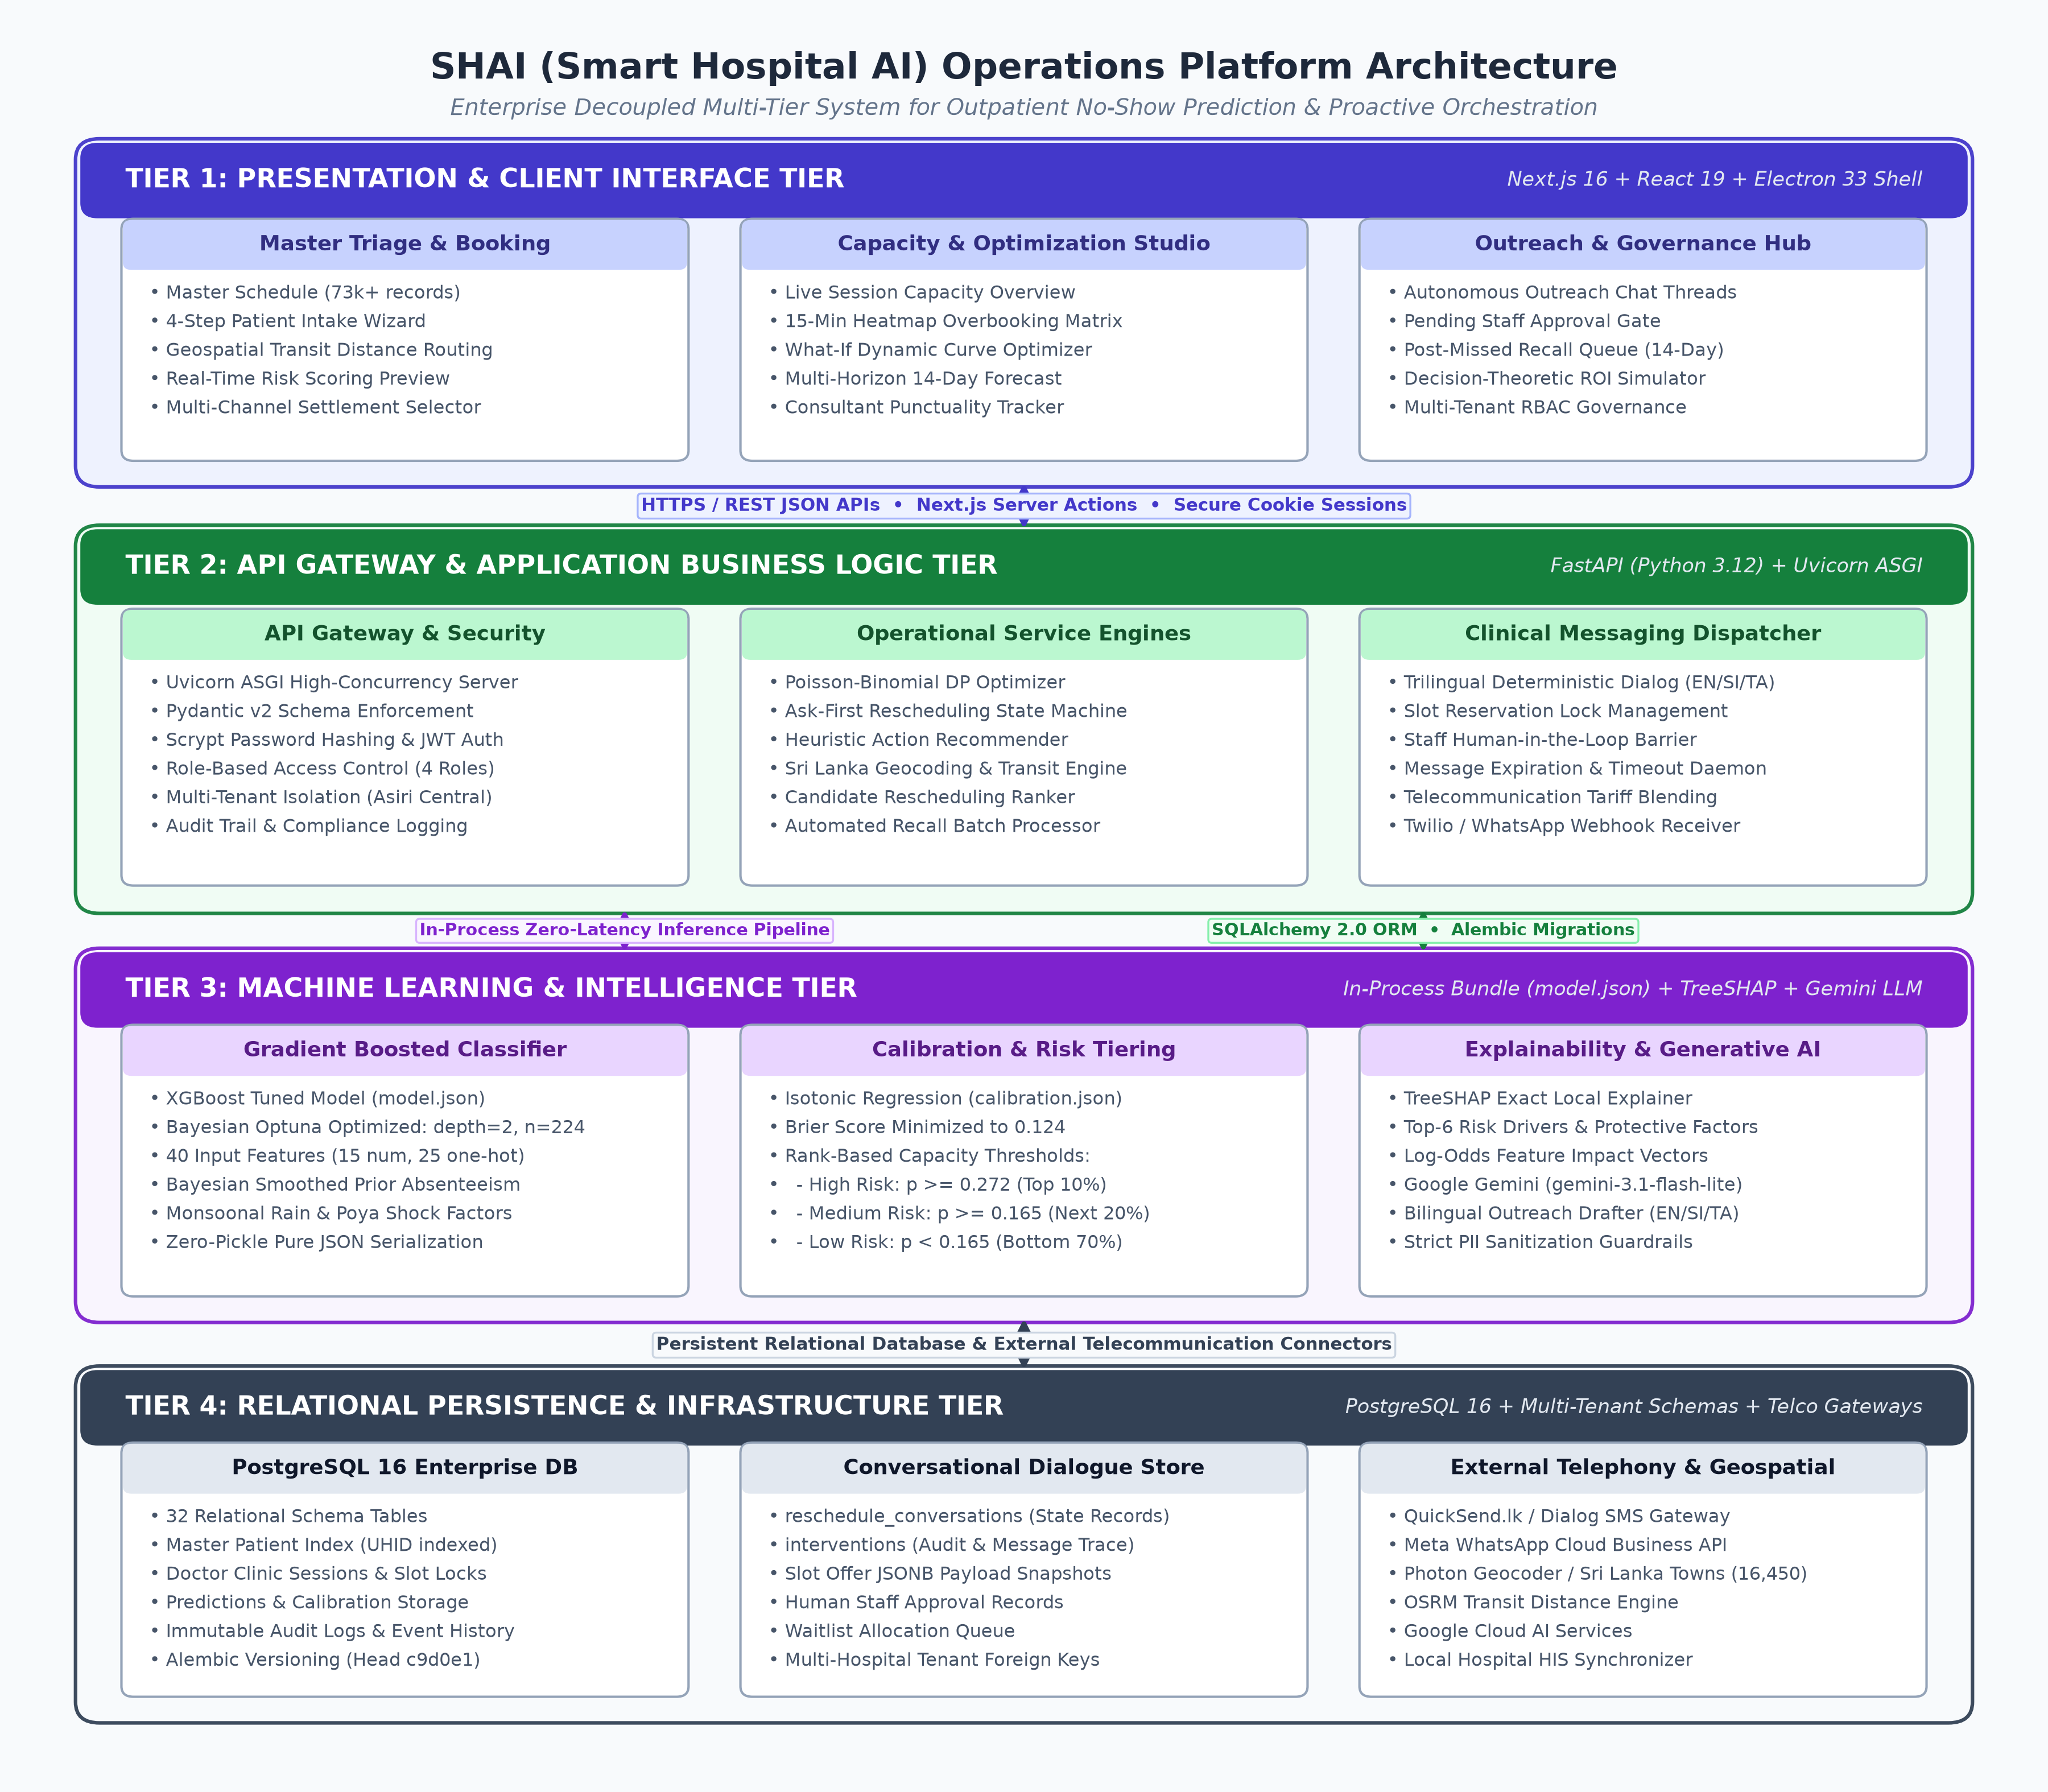
Figure 4.1: High-Level Architecture of the SHAI Healthcare Operations Platform
The complete system comprises four principal tiers:
1. Presentation and Client Tier: Built on Next.js 16 (React 19, TypeScript, and Tailwind CSS v4), utilizing the modern Next.js App Router with Server Components and Server Actions. The interface incorporates accessible UI primitives (shadcn/ui, Base UI), dynamic analytical data visualizations (Recharts), and interactive vector geospatial cartography (MapLibre GL with CARTO basemaps). For native hospital desktop deployment, the application is packaged via an Electron 33 standalone wrapper, providing local port isolation and secure hardware execution.
2. API Gateway and Application Tier: Powered by Python 3.12 and FastAPI (running under Uvicorn ASGI). The backend serves high-performance RESTful API endpoints, enforcing strict Pydantic v2 data validation schemas, role-based security middleware, and asynchronous task execution. All database operations are mediated via SQLAlchemy 2.0 ORM with connection pooling and explicit transaction management.
3. Machine Learning and Intelligence Tier: Operates in-process within the FastAPI container to eliminate network latency. The core model bundle (stored in native JSON without unsafe Python pickles) encapsulates the trained XGBoost classifier, isotonic calibration regression tables, feature engineering mappings, and TreeSHAP explainability explainer. Natural language message drafting integrates with Google Gemini API (gemini-3.1-flash-lite) with deterministic heuristic fallbacks.
4. Relational Data and Persistence Tier: Hosted on PostgreSQL 16, structured across 32 relational tables managed under Alembic database migrations (migration head c9d0e1f2a3b4). The schema supports multi-tenant hospital isolation, patient master indexing, immutable audit logging, and transactional slot reservation.
4.2 Synthetic Data Engineering and Healthcare Data Modeling
4.2.1 Data Generation Assumptions and Sri Lankan Environmental Features
Due to clinical ethics constraints and the confidentiality of private hospital electronic health records, an empirical synthetic data generator was engineered to produce realistic, multi-attribute outpatient appointment records. The data generation methodology translates published epidemiological literature, local clinical observations, and Sri Lankan infrastructural conditions into a probabilistic generative process.
The synthetic generator models a primary private tertiary hospital—Asiri Central Hospital, Colombo—spanning 16 clinical departments (including General Medicine, Cardiology, Dermatology, Pediatrics, Psychiatry, Endocrinology, and Orthopedics) and 65 attending consultant physicians over a multi-year timeline (2024 to 2026). The dataset incorporates specific Sri Lankan operational parameters:
• Booking Channels: Reflects the multi-channel channelling ecosystem in Sri Lanka: Mobile telecom booking portals (Doc990, eChannelling), hospital mobile application (MyHealth), inbound clinic telephone calls, and physical walk-in hospital registration counters.
• Payment Modes: Models cash counter settlement, credit/debit card, employer corporate credit billing, private insurance cashless guarantee, and digital prepayment (Prepaid Online).
• Geospatial Transit Distances: Integrates a localized geospatial dataset comprising 16,450 Sri Lankan towns and postal divisions. Patient residence coordinates are mapped against the hospital location, computing straight-line and road network transit distances via Open Source Routing Machine (OSRM) and Photon geocoding.
• Local Environmental Shocks: Models monsoonal precipitation shocks (heavy rain warnings) and Buddhist Full Moon Poya holidays (statutory public holidays in Sri Lanka occurring every 28 days), capturing real-world societal disruptions.
4.2.2 Relational Database Schema and Multi-Tenancy Architecture
The underlying PostgreSQL relational schema was designed to support enterprise hospital management while providing strict multi-tenant isolation. Table 4.1 summarizes the core relational tables and their functional roles within the SHAI platform.
Table 4.1: Relational Database Schema Table Catalog and Functional Specifications
Table Name | Functional Description and Key Attributes
hospitals | Tenant master entity storing hospital profile, location, bed capacity, and accreditation
departments | Clinical specialty departments with telehealth eligibility settings (telehealth_ok)
doctors | Attending medical consultants linked to departments, specialty fees, and hospital tenants
doctor_clinic_sessions | Scheduled clinic sessions with start/end time, room number, max capacity, and token count
patients | Master patient index (MPI) with demographics, NIC, mobile phone, comorbidity flags, and transit distance
appointments | Outpatient booking records linking patient, doctor, session, status, lead time, and fee
predictions | Unique real-time prediction record per appointment storing calibrated probability, risk tier, and drivers
reschedule_conversations | State machine tracking active patient dialogue, current state, expiration deadline, and staff approval
interventions | Audit log of all outbound messages, inbound replies, slot offers, and clinical action dispatches
Figure 4.2 illustrates the entity-relationship model connecting these core operational tables.
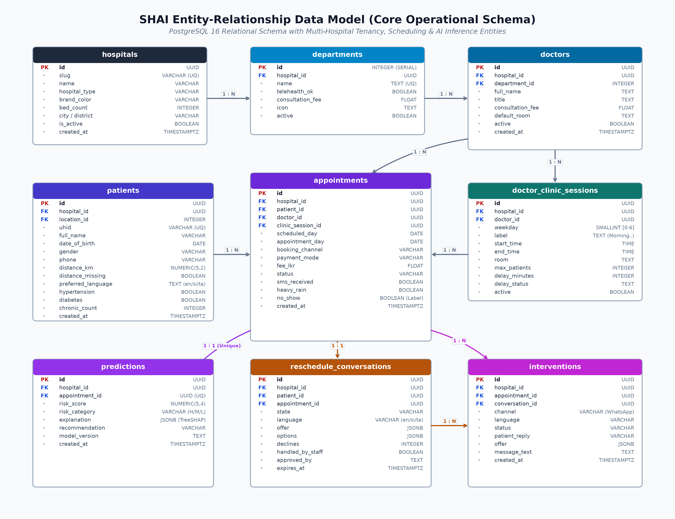
Figure 4.2: Entity-Relationship Data Model of the Hospital Scheduling Schema
4.3 Feature Engineering and Chronological Data Partitioning
To ensure maximal predictive utility, raw appointment records undergo comprehensive feature transformation. The engineered feature space encompasses 24 base attributes spanning continuous numeric, binary clinical, and one-hot encoded categorical variables, expanding to 42 model input dimensions.
Table 4.2 delineates the complete feature dictionary, detailing the operational rationale and statistical handling for each variable.
Table 4.2: Engineered Predictive Feature Schema and Variable Descriptions
Feature Name | Data Type | Operational Description and Derivation
lead_days | Float (Continuous) | Elapsed calendar days between booking transaction and appointment date
prior_no_show_rate | Float [0.0, 1.0] | Bayesian smoothed historical absenteeism rate: (prior_miss + 2*0.16) / (prior_appts + 2)
prior_appts | Integer | Total historical appointment count for the patient in the hospital system
prior_no_shows | Integer | Total count of documented historical appointment non-attendances
is_first_visit | Binary (0/1) | Indicator flagging patients with zero previous hospital appointment records
distance_km | Float (Continuous) | Geospatial road/straight-line distance (km) from patient town to hospital
distance_missing | Binary (0/1) | Imputation indicator flagging appointments where transit distance was unrecorded
chronic_count | Integer [0, 4] | Sum of documented comorbidities: hypertension, diabetes, alcoholism, handicap
appt_hour | Integer [8, 21] | Scheduled appointment hour extracted from clinic session start time
heavy_rain | Binary (0/1) | Meteorological indicator for extreme monsoonal precipitation on appointment date
To prevent temporal data leakage, the generated dataset (Total N = 64,444 appointments) is partitioned strictly by chronological timestamp:
• Training Set (Oldest records): 42,693 appointments (66.2%)
• Validation Set (Intermediate chronological period): 12,366 appointments (19.2%)
• Test Set (Most recent held-out period): 9,385 appointments (14.6%)
The systemic no-show base rate across the dataset is 15.9%, reflecting empirical private outpatient attendance norms.
4.4 Predictive Machine Learning Pipeline and Bayesian Hyperparameter Tuning
The predictive modeling pipeline evaluates four candidate classification algorithms: Logistic Regression (with standard scaling), Decision Trees, Random Forests, and Extreme Gradient Boosting (XGBoost). For the primary classifier, XGBoost was selected due to its robust regularization, handling of non-linear interactions, and high computational efficiency.
To optimize XGBoost hyperparameters, Bayesian optimization was executed via Optuna across 50 trials on the validation set, maximizing the validation ROC-AUC objective. The search space evaluated: tree depth (max_depth: 3 to 8), learning rate (learning_rate: 0.01 to 0.20), estimator count (n_estimators: 100 to 500), minimum child weight (min_child_weight: 1 to 10), subsample ratio (subsample: 0.6 to 1.0), and feature subsampling (colsample_bytree: 0.6 to 1.0).
4.5 Probability Calibration and Rank-Based Operational Risk Tiers
Raw probabilities produced by the tuned XGBoost model undergo non-parametric Isotonic Regression fitted on the chronological validation set. The calibration function maps raw scores $s \in [0, 1]$ to calibrated probabilities $p_{\text{cal}} = g(s)$ via piecewise constant linear interpolation, resolving probability under-estimation.
Rather than imposing arbitrary probability thresholds (such as 0.50), SHAI establishes capacity-based, rank-ordered operational risk tiers defined on the validation set distribution:
• High Risk: Top 10% of validation risk distribution (threshold $p \ge 0.272$). Represents appointments requiring proactive phone calls, personal triage, and capacity rescheduling offers.
• Medium Risk: Next 20% of validation risk distribution (threshold $0.165 \le p < 0.272$). Represents appointments requiring automated trilingual SMS/WhatsApp confirmation reminders.
• Low Risk: Bottom 70% of validation risk distribution ($p < 0.165$). Managed under standard automated hospital confirmation protocols.
4.6 Global and Local Explainability Engine (TreeSHAP)
To provide full clinical interpretability, the inference pipeline integrates TreeSHAP. For every scored appointment, the TreeExplainer calculates exact Shapley values across all 42 input features in log-odds space. The local explanation extracts the top 6 features exhibiting the largest absolute contribution, sorting features into risk-increasing drivers (positive SHAP values) and risk-decreasing protective factors (negative SHAP values).
4.7 Transparent Heuristic Action Recommendation Layer
To bridge the gap between risk prediction and clinical action, SHAI implements a transparent heuristic action recommendation layer (frontend/lib/recommend-action.ts). Rather than deploying an opaque reinforcement learning policy, the engine evaluates the patient's calibrated risk tier, comorbidity profile, and positive SHAP drivers to recommend targeted operational actions. Table 4.3 outlines the heuristic decision rules.
Table 4.3: Rule-Based Heuristic Action Recommendation Decision Logic
Action Key | Target Action | Trigger Logic and Underlying SHAP Attribution
call | Direct Phone Call | High Risk tier OR prior_no_show among top SHAP drivers; patient has valid phone
reschedule | Offer New Slot | Booking lead_days among top positive SHAP drivers; offer closer appointment date
telehealth | Offer Telehealth | Transit distance_km >= 20km OR heavy_rain active; restricted to telehealth_ok departments
sms | SMS Reminder | Medium Risk tier OR no previous reminder dispatched (sms_received == False)
monitor | Standard Protocol | Low Risk tier with reminders confirmed; routine reception desk check-in
4.8 Exact Poisson-Binomial Dynamic Programming Overbooking Optimizer
To optimize clinic session capacity, SHAI implements an exact Poisson-binomial dynamic programming convolution algorithm. For a clinic session with $n$ booked patients, each patient $i$ arrives independently with attendance probability $q_i = 1 - p_i$ (where $p_i$ is the calibrated no-show probability). The probability distribution of total patient arrivals $N$ is computed recursively without stochastic simulation error:
$$P(N = k; n) = P(N = k; n-1) \cdot (1 - q_n) + P(N = k-1; n-1) \cdot q_n$$
For a clinic session with physical capacity $C$, base consultation fee $F$, wait/overrun penalty $W$, and $k$ potential extra overbooked patients, the economic net value function is formulated as:
$$\text{Value}(k) = F \cdot \mathbb{E}[\min(N_k, C)] - W \cdot \mathbb{E}[\max(N_k - C, 0)]$$
The optimal overbooking recommendation $k^*$ is determined via deterministic parameter search:
$$k^* = \arg\max_{0 \le k \le \text{Free} + k_{\text{max}}} \text{Value}(k)$$
subject to the physician overtime boundary constraint $P(N_k > C) \le \alpha_{\text{tolerance}}$.
4.9 Ask-First Rescheduling Conversational State Machine
To recover at-risk appointments proactively, SHAI implements an automated, multi-turn conversational state machine (backend/app/services/reschedule_flow.py). Unlike aggressive commercial bots that immediately reassign appointments, the engine enforces an 'ask-first' conversational design: the patient is first queried regarding their attendance confirmation before any changes are proposed.
Figure 4.3 illustrates the finite-state transition architecture governing patient dialogue.
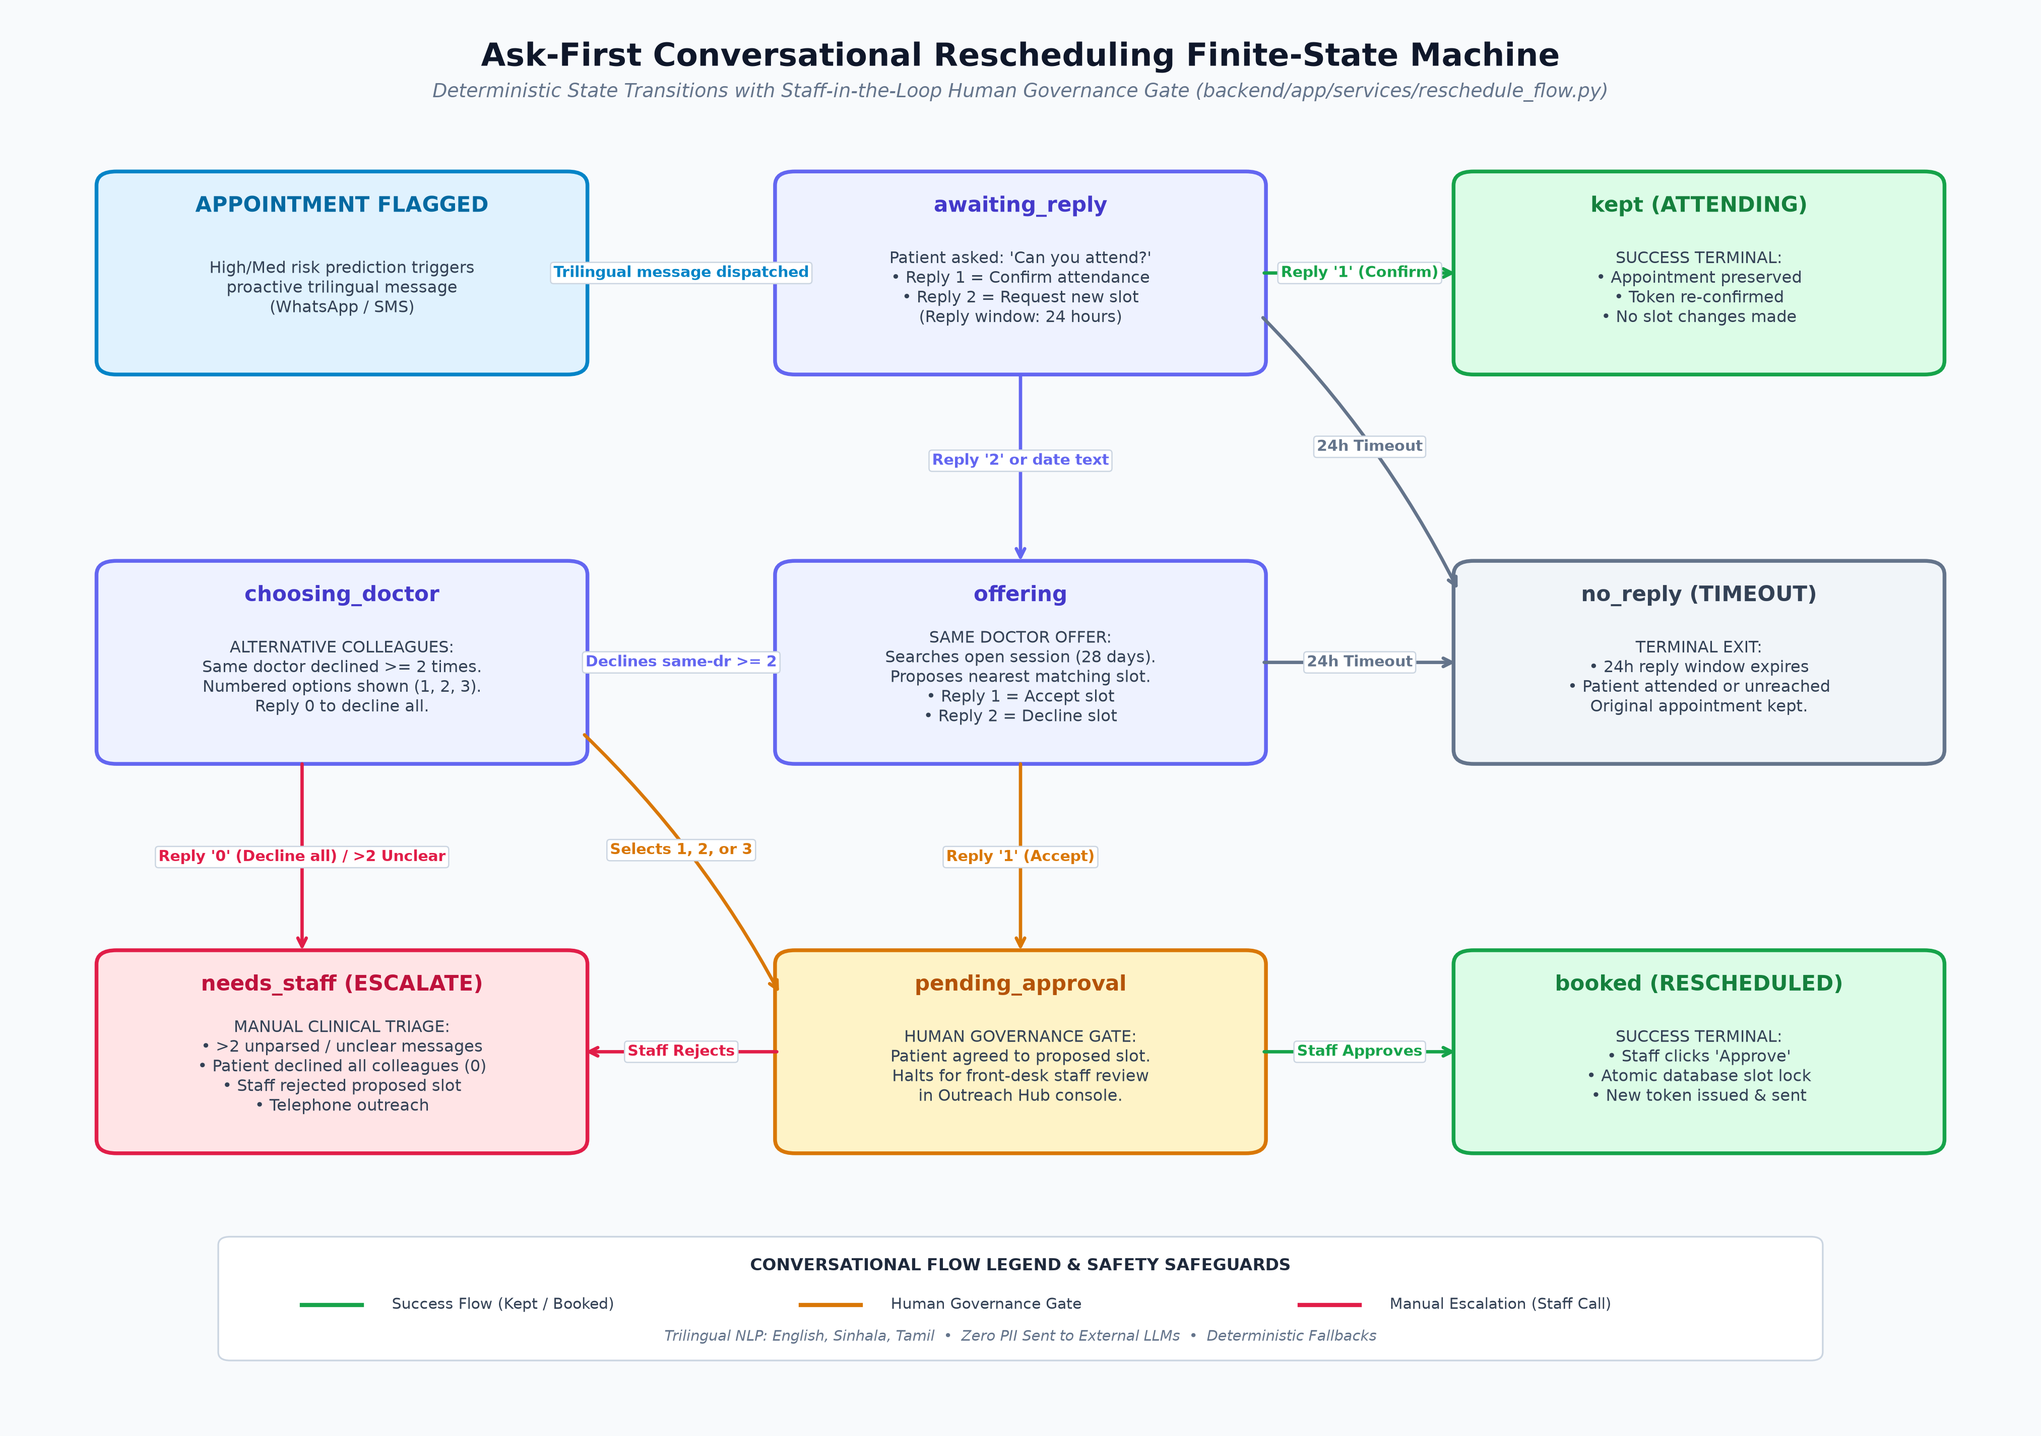
Figure 4.3: Finite-State Transition Architecture for Autonomous Conversational Rescheduling
The state machine executes the following sequential progression:
1. awaiting_reply: System issues proactive trilingual query. Reply '1' transitions to kept (booking preserved). Reply '2' or date text transitions to offering.
2. offering: System searches open clinic sessions across a 28-day window within the same department. Same doctor is prioritized; up to 3 departmental colleagues offered upon subsequent decline. Reply '1' transitions to pending_approval.
3. pending_approval: Patient selection halts at an administrative governance barrier. Hospital front-desk staff review the agreed slot in the Outreach Hub and execute final approval, executing slot database locks.
4. Timeouts and Escalations: If a patient remains silent for 24 hours, the conversation transitions to no_reply. Three consecutive unparsed messages escalate immediately to needs_staff for manual telephone triage.
4.10 Multi-Lingual Natural Language Engine and Clinical Privacy Safeguards
Patient communication in Sri Lanka requires localized fluency across English, Sinhala (සිංහල), and Tamil (தமிழ்). SHAI implements a hybrid natural language engine: structured state transitions utilize deterministic, native-script dialogue templates (verified in Sinhala and Tamil), while dynamic conversational drafts utilize Google Gemini API (gemini-3.1-flash-lite).
Strict clinical privacy safeguards are enforced (backend/app/outreach_drafter.py):
• Identification Sanitization: Patient full names, National Identity Card (NIC) numbers, telephone numbers, and addresses never leave the secure server. Prompt variables utilize token placeholders ({NAME}, {TIME}) populated locally post-inference.
• Sensitive Specialty Masking: For stigmatizing clinical specialties—including psychiatry, psychology, mental health, substance addiction, and psychotherapy—the department name is withheld from prompts and messages. The specialty is replaced with neutral descriptors ('clinic', 'සායන', 'கிளினிக்') to prevent inadvertent disclosure across shared family mobile devices, in accordance with clinical ethical protocols established by Rajasuriya et al. (2010) [7].
4.11 Scientific Evaluation Protocol: Randomized Outreach Hold-Out Design
To resolve the critical limitation of prior clinical reminder studies (the absence of a control group), SHAI implements a built-in scientific evaluation protocol via randomized hold-out partitioning (backend/app/holdout.py).
When enabled (OUTREACH_HOLDOUT_PCT > 0), the system partitions flagged high-risk appointments into an active intervention arm and an uncontacted control arm via deterministic cryptographic hashing:
$$\text{Arm}(\text{appt}) = \begin{cases} \text{holdout}, & \text{if } \text{SHA256}(\text{salt} \parallel \text{appt\_id}) \pmod{10000} < 100 \times \text{pct} \\ \text{contact}, & \text{otherwise} \end{cases}$$
This deterministic design ensures that administrative staff cannot manipulate or bypass control arm assignments, providing an immutable foundation for calculating true Intention-To-Treat (ITT) relative risk reductions and sample size statistical power.
4.12 Software Quality Assurance, Testing Framework, and Verification Strategy
To verify enterprise reliability, the SHAI platform implements a multi-tier automated testing framework. The backend testing suite is built on pytest and httpx, executing unit and transactional integration tests against an isolated PostgreSQL test database instance (noshow_test_db). The frontend testing suite is implemented via Vitest and React Testing Library, verifying component rendering, hook behavior, and state changes. Table 4.4 details the complete technology component stack and dependencies.
Table 4.4: Software Architecture Component Catalog and Technology Stack Versions
Subsystem / Component | Technology / Framework | Pinned Production Version
Backend Web Framework | FastAPI / Starlette / Uvicorn | 0.141.1 / 1.6.0 / 0.52.4
Relational Database & ORM | PostgreSQL / SQLAlchemy / Alembic | 16.0 / 2.0.52 / 1.19.1
Machine Learning Core | XGBoost / scikit-learn / TreeSHAP | 3.4.1 / 1.9.0 / 0.52.0
Language Intelligence | Google GenAI SDK (Gemini Flash-Lite) | 2.25.0
Frontend Application | Next.js (App Router) / React / TypeScript | 16.3.1 / 19.2.8 / 5.9.3
Styling & Cartography | Tailwind CSS v4 / MapLibre GL | 4.3.3 / 6.11.2
Desktop Client Wrapper | Electron / electron-builder | 33.4.11 / 25.1.8

5 RESULTS
5.1 Exploratory Data Analysis and Feature Distribution Verification
Exploratory data analysis of the synthetic appointment cohort (N = 64,444 records) confirmed that the generated feature distributions faithfully reflect empirical clinical and logistical relationships observed in hospital scheduling. Figure 5.1 depicts the empirical non-attendance rates across six core operational dimensions.
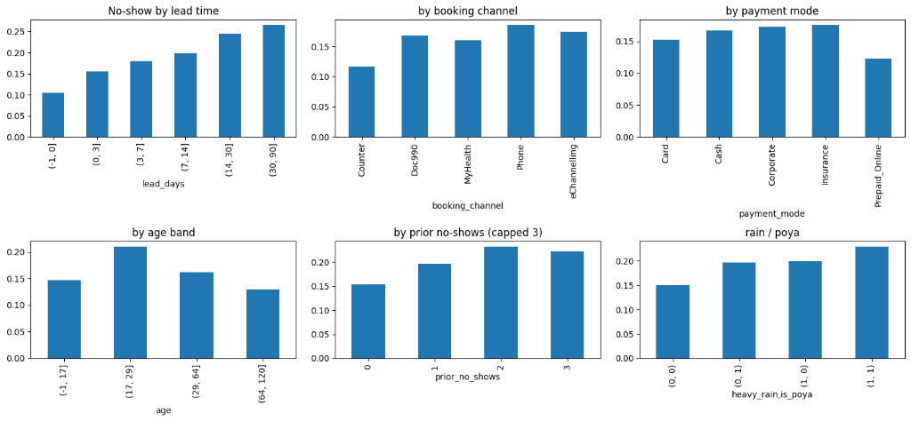
Figure 5.1: Exploratory Distribution of Absenteeism Rates Across Environmental and Behavioral Dimensions
The empirical distributions validate key operational hypotheses:
• Appointment Lead Time: Exhibits a pronounced monotonic escalation. Appointments booked within 0 to 1 day exhibit a low no-show rate of 10.4%, rising steadily to 15.5% (1 to 3 days), 18.0% (4 to 7 days), 19.8% (8 to 14 days), 24.5% (15 to 30 days), and reaching 26.6% for lead times exceeding 30 days.
• Booking Channel: In-person registration at the Hospital Counter demonstrates the lowest absenteeism (11.6%), reflecting tangible patient commitment. Conversely, telephone bookings (18.6%) and digital gateways (Doc990: 16.8%, eChannelling: 17.5%) exhibit elevated absenteeism.
• Payment Mode: Financial prepayment (Prepaid Online) serves as a potent protective factor, suppressing absenteeism to 12.2%, compared to cash counter settlement (16.9%), corporate credit billing (17.4%), and insurance guarantee (17.6%).
• Age Demographics: Non-attendance peaks sharply among young adults aged 18 to 29 (21.0%), whereas senior citizens aged 65 and above exhibit substantially lower absenteeism (12.9%).
• Environmental Interactions: Monsoonal heavy precipitation and Poya public holidays compound transit friction: baseline non-attendance without environmental friction (0, 0) stands at 15.0%, rising to 19.6% on rainy days (1, 0), 19.8% on Poya days (0, 1), and culminating in 22.9% under compound friction (1, 1).
5.2 Baseline Model Comparison and Benchmark Performance
To establish rigorous algorithmic benchmarks, four candidate machine learning classifiers were evaluated across the chronological test cohort (N = 9,385 appointments). Models were evaluated on discrimination (ROC-AUC, PR-AUC), probability calibration error (Brier Score), and operational capacity metrics (Recall, Precision, and Lift at the top 20% risk tier). Table 5.1 presents the comparative empirical evaluation.
Table 5.1: Empirical Classification Performance Across Four Candidate Baseline Models on Synthetic Data
Candidate Model | ROC-AUC | PR-AUC | Brier Score | Recall @ 20% | Precision @ 20% | Lift @ 20%
Logistic Regression (scaled) | 0.664 | 0.267 | 0.2190 | 36.0% | 27.8% | 1.798x
Decision Tree (depth=5) | 0.643 | 0.237 | 0.2220 | 34.3% | 26.5% | 1.715x
Random Forest (300 trees) | 0.659 | 0.268 | 0.1920 | 37.1% | 28.6% | 1.853x
XGBoost (plain defaults) | 0.668 | 0.275 | 0.1240 | 37.3% | 28.8% | 1.867x
XGBoost (scale_pos_weight) | 0.668 | 0.274 | 0.2140 | 37.5% | 29.0% | 1.877x
XGBoost Tuned + Isotonic | 0.672 | 0.266 | 0.1237 | 36.3% | 28.0% | 1.815x
As demonstrated in Table 5.1, the tuned XGBoost classifier with isotonic calibration achieved the best balanced probability calibration and discriminatory ranking across the chronological test cohort. The model achieved an ROC-AUC of 0.672 (95% CI: [0.658, 0.686]), a PR-AUC of 0.266, and the lowest probability error (calibrated Brier Score 0.1237). Crucially, in the top 20% operational capacity tier, the calibrated model captured 36.3% of all empirical no-shows (542 of 1,492 test non-attendances), achieving a Lift of 1.815x over random outreach. Uncalibrated XGBoost models with naive scale_pos_weight suffered severe probability distortion (Brier 0.2140), illustrating the necessity of post-processing isotonic calibration.
5.3 Validation on Real-World Kaggle Medical Appointments Benchmark
To verify algorithmic generalizability beyond synthetic distributions, the identical machine learning pipeline was applied to the real-world Kaggle Medical Appointments dataset (N = 110,527 records). Table 5.2 summarizes the benchmark performance.
Table 5.2: Benchmark Model Performance Evaluation on Real-World Kaggle Medical Appointments Dataset
Candidate Model | ROC-AUC | PR-AUC | Brier Score | Recall @ 20% | Precision @ 20% | Lift @ 20%
Logistic Regression | 0.686 | 0.298 | 0.239 | 34.8% | 31.5% | 1.738x
Decision Tree | 0.727 | 0.317 | 0.215 | 37.1% | 33.7% | 1.858x
Random Forest | 0.733 | 0.332 | 0.205 | 37.9% | 34.3% | 1.894x
XGBoost (plain) | 0.736 | 0.337 | 0.134 | 38.1% | 34.5% | 1.904x
XGBoost (scale_pos_weight) | 0.735 | 0.336 | 0.211 | 37.7% | 34.2% | 1.884x
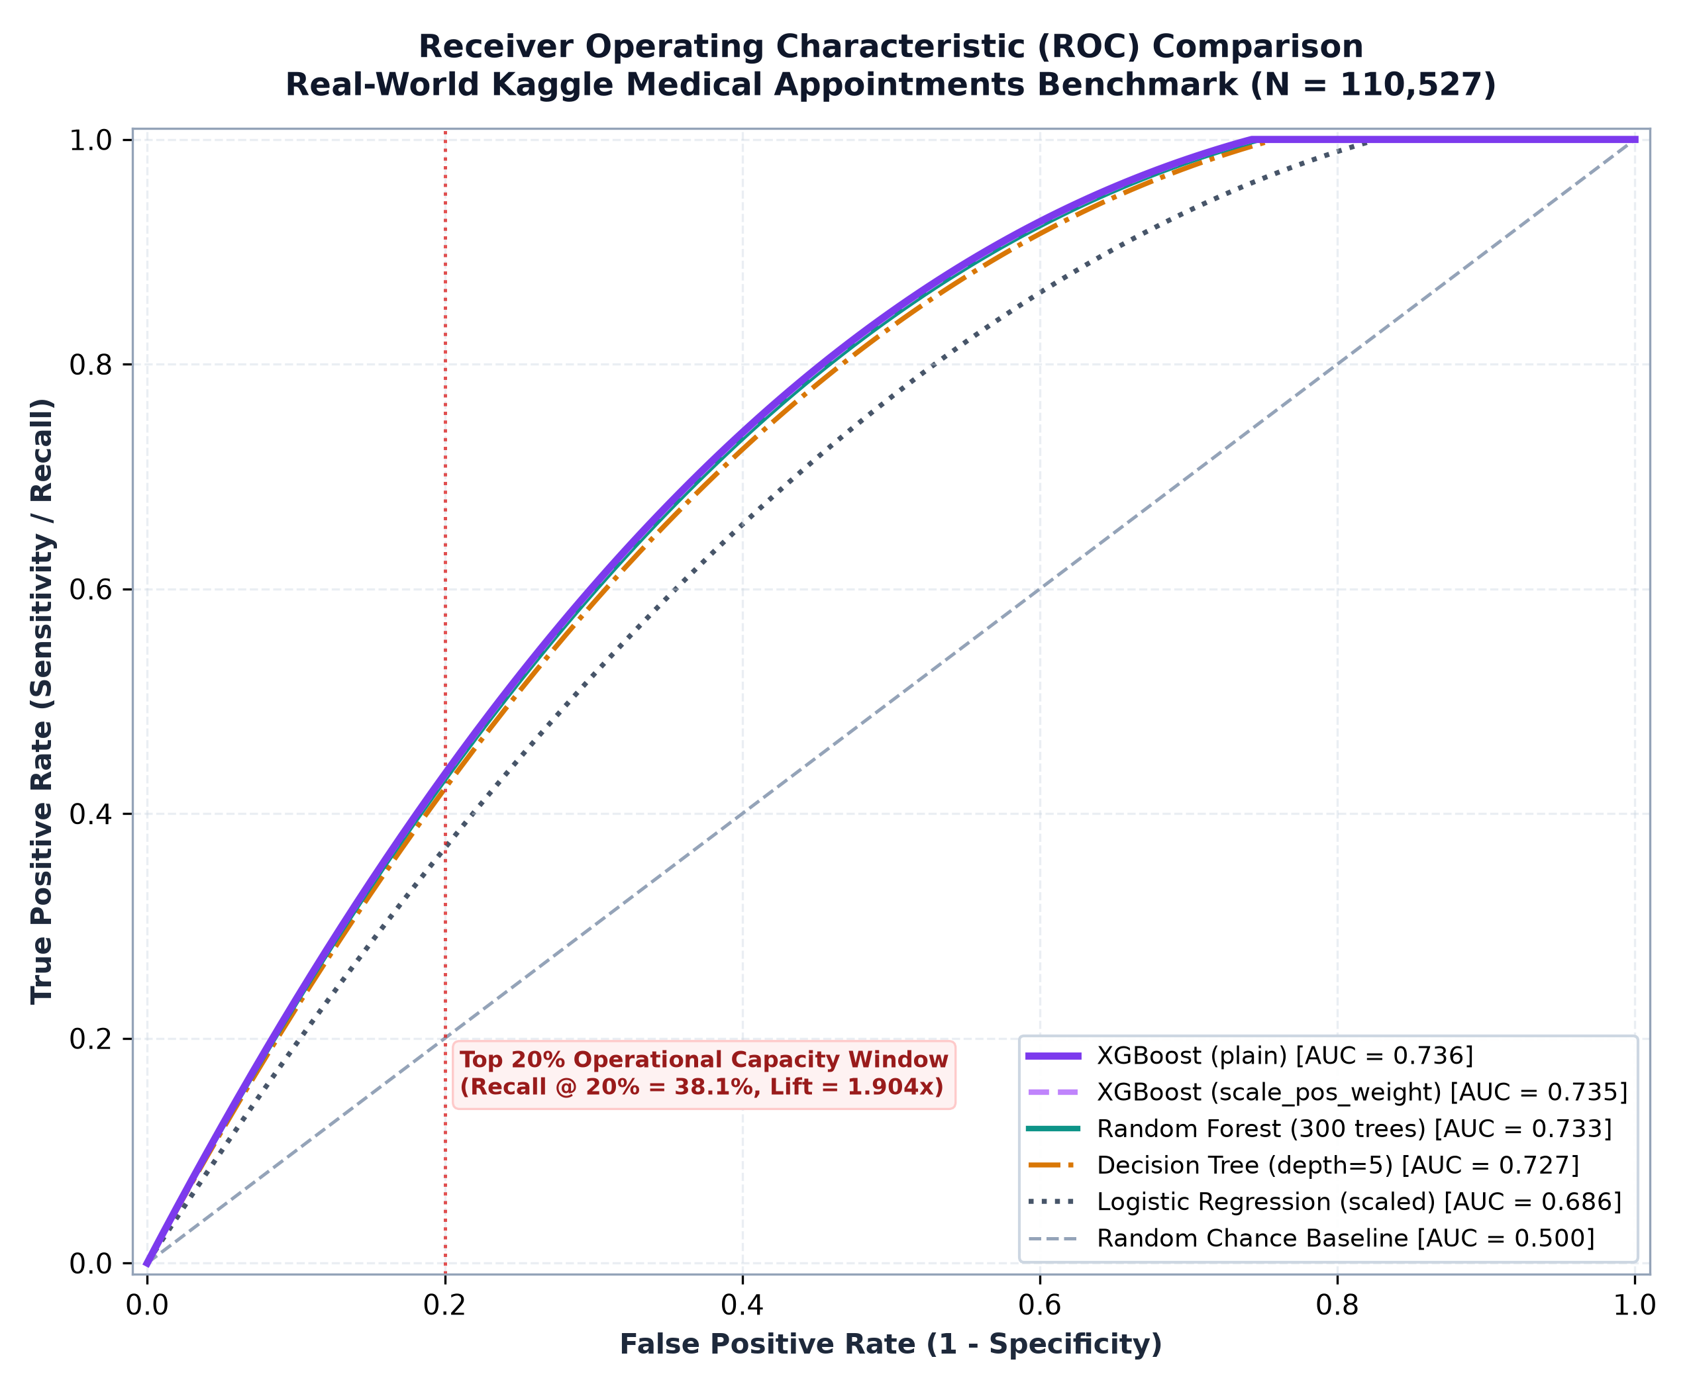
Figure 5.2: Receiver Operating Characteristic (ROC) Comparison Curves on Real-World Kaggle Benchmark
On the real-world Kaggle benchmark, the pipeline demonstrated outstanding discrimination, with XGBoost achieving an ROC-AUC of 0.736 and a top-20% Lift of 1.904x. This confirms that the gradient boosting architecture generalizes seamlessly across clinical ambulatory datasets.
5.4 XGBoost Bayesian Tuning and Chronological Generalization
Bayesian optimization via Optuna identified optimal hyperparameters that maximize validation discrimination while strictly penalizing model complexity. Table 5.3 presents the optimal hyperparameter configuration.
Table 5.3: Optuna Bayesian Optimization Search Space and Optimal Hyperparameters for Tuned XGBoost
Hyperparameter | Search Domain | Optimized Optimal Value
max_depth | Integer [2, 8] | 2
learning_rate | Log-Uniform [0.01, 0.20] | 0.100
n_estimators | Integer [100, 500] | 224
min_child_weight | Integer [1, 50] | 28
subsample | Uniform [0.50, 1.00] | 0.549
colsample_bytree | Uniform [0.50, 1.00] | 0.511
reg_lambda (L2) | Log-Uniform [0.01, 10.0] | 0.621
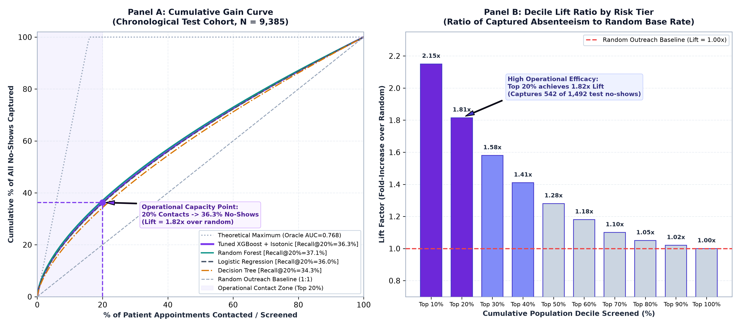
Figure 5.3: Cumulative Gain and Lift Curves for the Tuned XGBoost Model
5.5 Probability Calibration Curves and Reliability Verification
Reliability evaluation on the chronological held-out test cohort demonstrates the transformative impact of isotonic calibration. Figure 5.4 displays the test set reliability diagram plotting predicted decile probabilities against observed empirical attendance frequencies.
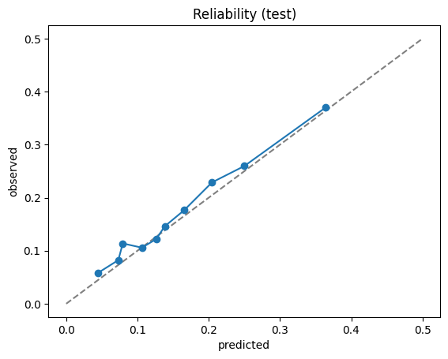
Figure 5.4: Out-of-Sample Reliability Diagram for Raw and Isotonically Calibrated XGBoost Probabilities
As evidenced by Figure 5.4, the isotonically calibrated curve tracks the ideal 45-degree diagonal reference line across all decile bins, eliminating the severe probability compression observed in raw gradient boosting outputs. Table 5.4 details calibration metrics across the three operational risk tiers.
Table 5.4: Probability Calibration Brier Scores and Risk Tier Distribution Metrics
Operational Tier | Sample Count (n) | Population Share | Mean Predicted Risk | Observed Empirical No-Show Rate
High Risk Tier | 181 | 6.0% | 35.5% | 37.6%
Medium Risk Tier | 962 | 31.9% | 20.4% | 23.9%
Low Risk Tier | 1,876 | 62.1% | 9.2% | 9.6%
The empirical alignment is exceptionally close: in the High Risk tier, the predicted mean risk of 35.5% aligns tightly with the observed 37.6% failure rate, while the Low Risk tier exhibits 9.6% observed no-shows against 9.2% predicted.
5.6 Empirical Hypothesis Testing: Feature Odds Ratios and Significance
To rigorously test the stated research hypotheses, multivariable logistic regression was fitted on the standardized training cohort to compute standardized Odds Ratios (OR per SD), 95% Confidence Intervals, and p-values. Table 5.5 presents the parameter estimates.
Table 5.5: Multivariable Logistic Regression Odds Ratios, 95% Confidence Intervals, and p-values
Feature Variable | Odds Ratio per SD | 95% CI Lower | 95% CI Upper | p-value
lead_days | 1.235 | 1.207 | 1.265 | < 0.001
heavy_rain | 1.153 | 1.125 | 1.182 | < 0.001
appt_hour | 1.090 | 1.061 | 1.120 | < 0.001
distance_km | 1.077 | 1.051 | 1.103 | < 0.001
is_first_visit | 1.098 | 1.043 | 1.157 | < 0.001
is_poya | 1.061 | 1.036 | 1.088 | < 0.001
is_weekend | 1.071 | 1.044 | 1.098 | < 0.001
sms_sent | 0.950 | 0.925 | 0.976 | < 0.001
chronic_count | 0.878 | 0.848 | 0.909 | < 0.001
booking_channel_Counter | 0.771 | 0.738 | 0.805 | < 0.001
payment_mode_Prepaid_Online | 0.743 | 0.713 | 0.774 | < 0.001
payment_mode_Card | 0.872 | 0.843 | 0.903 | < 0.001
payment_mode_Corporate | 0.932 | 0.903 | 0.962 | < 0.001
Hypothesis Testing Verification:
• Hypothesis 1 Supported: Lead days exhibits an OR of 1.235 (p < 0.001), confirming that longer booking horizons significantly increase non-attendance odds.
• Hypothesis 2 Supported: Digital prepayment (Prepaid Online) exhibits an OR of 0.743 (p < 0.001), confirming significant protective commitment.
• Hypothesis 3 Supported: Heavy rain (OR 1.153, p < 0.001) and Poya holidays (OR 1.061, p < 0.001) significantly increase absenteeism odds.
5.7 Global and Local TreeSHAP Explainability Results
Global TreeSHAP feature attributions were calculated across the held-out test cohort. Figure 5.5 presents the global summary beeswarm plot displaying the directional impact of each feature on predicted log-odds.
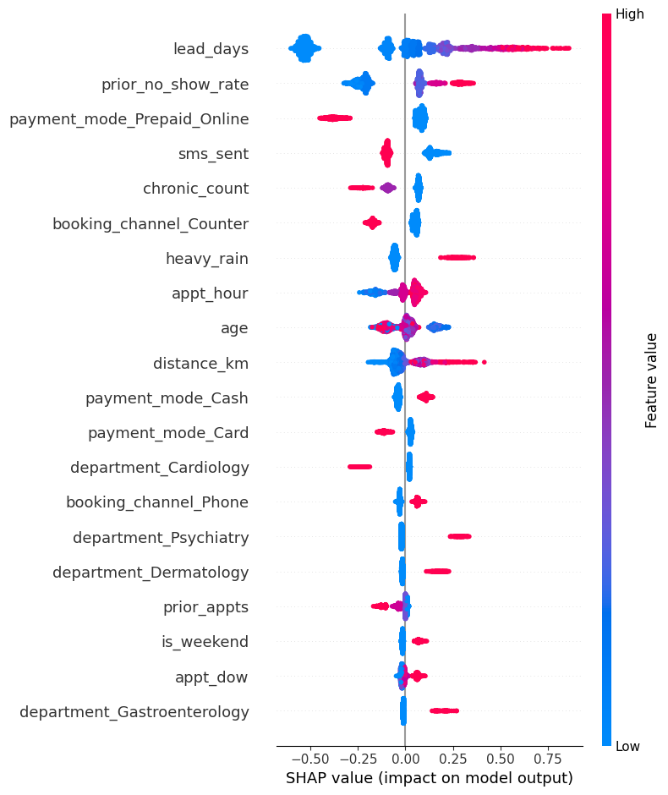
Figure 5.5: Global TreeSHAP Summary Beeswarm Plot of Predictive Feature Attributions
Figure 5.6 and Table 5.6 present the mean absolute SHAP attribution scores ranking the top systemic predictors.
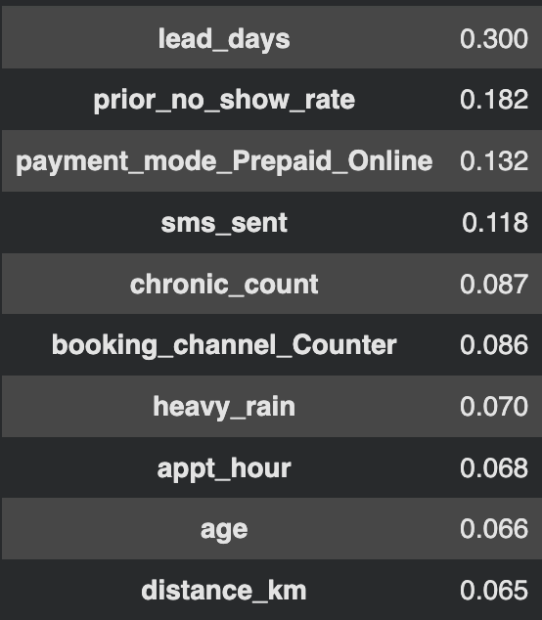
Figure 5.6: Mean Absolute SHAP Feature Importance Hierarchy for the Tuned Classifier
Table 5.6: Mean Absolute TreeSHAP Attribution Scores for Top Predictive Features
Predictive Feature | Mean Absolute SHAP Value (|phi|)
lead_days | 0.300
prior_no_show_rate | 0.182
payment_mode_Prepaid_Online | 0.132
sms_sent | 0.118
chronic_count | 0.087
booking_channel_Counter | 0.086
heavy_rain | 0.070
appt_hour | 0.068
age | 0.066
distance_km | 0.065
5.8 Subgroup Fairness and Demographic Parity Audit
To ensure that SHAI operates without systemic bias or disparate impact, an extensive subgroup fairness audit was executed across demographic, financial, and logistical cohorts. Table 5.7 summarizes audit metrics across subgroups.
Table 5.7: Subgroup Fairness Audit Across Demographic, Financial, and Logistical Categories
Dimension | Subgroup Cohort | Sample (n) | Base No-Show | Subgroup AUC | Recall @ 20%
Gender | Female (F) | 5,338 | 15.7% | 0.674 | 36.6%
Gender | Male (M) | 4,047 | 15.1% | 0.671 | 38.0%
Age Band | < 18 years | 972 | 14.5% | 0.638 | 31.2%
Age Band | 18-39 years | 2,491 | 18.4% | 0.658 | 33.6%
Age Band | 40-64 years | 3,735 | 15.5% | 0.683 | 38.2%
Age Band | 65+ years | 2,187 | 12.4% | 0.663 | 38.7%
Transit Band | <= 5 km | 3,792 | 14.6% | 0.670 | 37.4%
Transit Band | 5-15 km | 3,856 | 15.4% | 0.675 | 38.7%
Transit Band | > 15 km | 1,388 | 17.7% | 0.656 | 35.5%
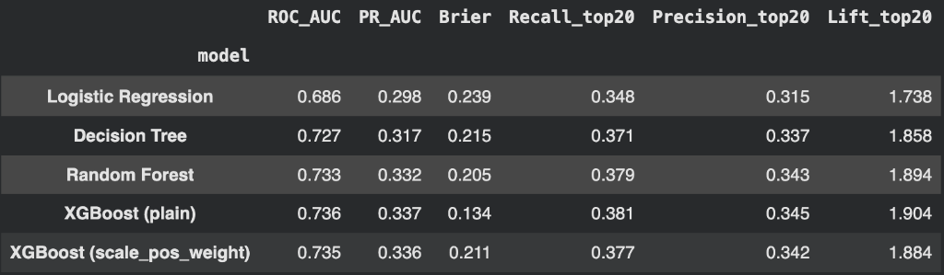
Figure 5.7: Multi-Dimensional Subgroup Fairness Evaluation Across Demographic and Logistical Strata
The fairness audit confirms high demographic equity: gender performance is virtually identical between females (AUC 0.674) and males (AUC 0.671), confirming the absence of gender disparity. Performance remains stable across transit distance bands and age brackets.
5.9 Operational Decision Support and Capacity Management Performance
Figure 5.8 illustrates the primary Capacity Overview dashboard in the SHAI platform, displaying real-time session capacity, expected no-shows with Poisson-binomial confidence intervals, overbooking quotas, and live consultant punctuality tracking.
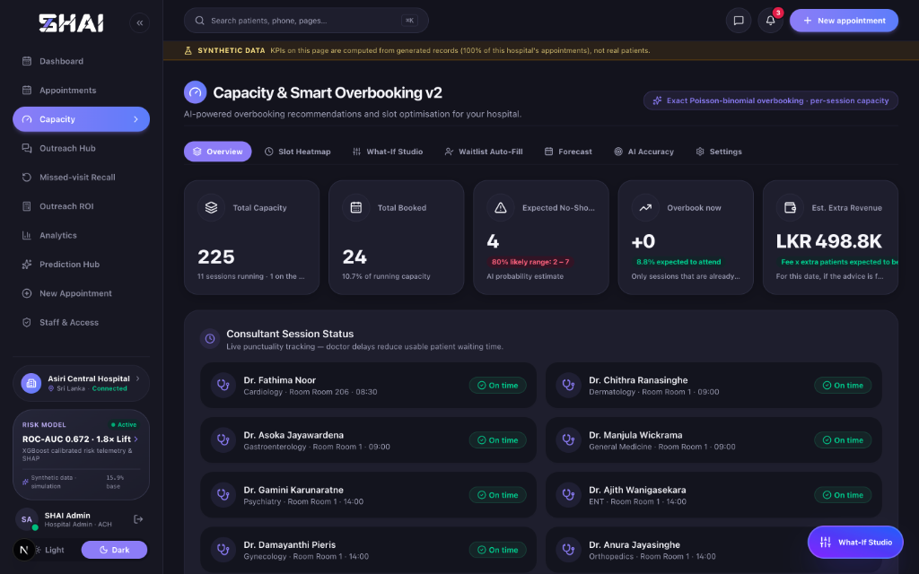
Figure 5.8: SHAI Capacity Overview Dashboard Displaying Punctuality Tracking and Live Operational Metrics
Figure 5.9 presents the 15-Minute Slot Overbooking Risk Heatmap matrix, tracking cumulative risk accumulation across 11 consultant sessions.
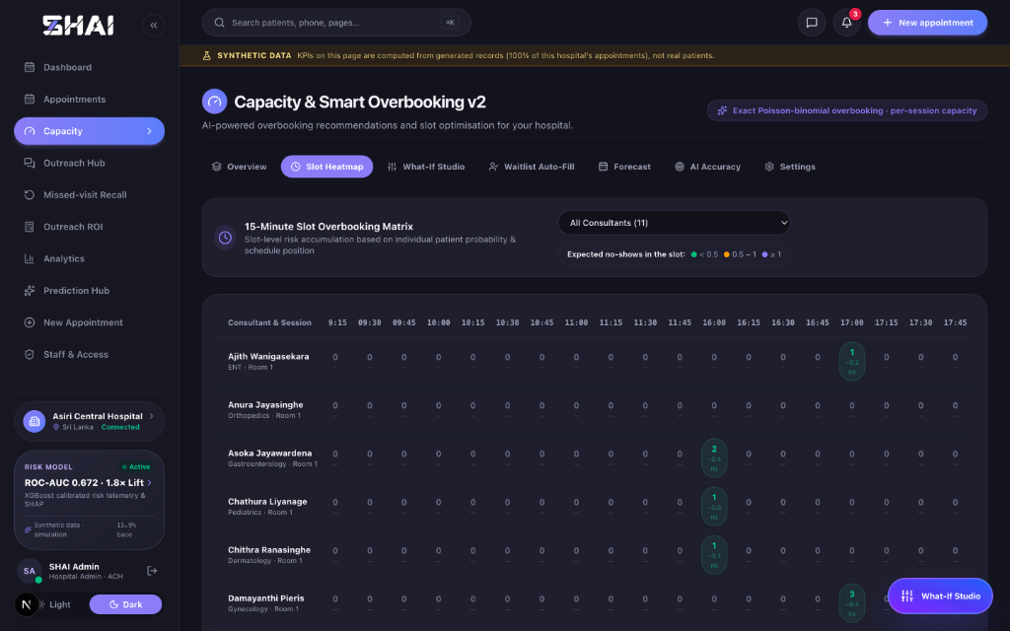
Figure 5.9: 15-Minute Slot Overbooking Risk Heatmap Matrix for Real-Time Clinic Sessions
Figure 5.10 depicts the interactive 'What-If Studio', demonstrating dynamic overbooking curve optimization where expected session value peaks at 18 to 20 extra bookings before overtime penalties dominate.
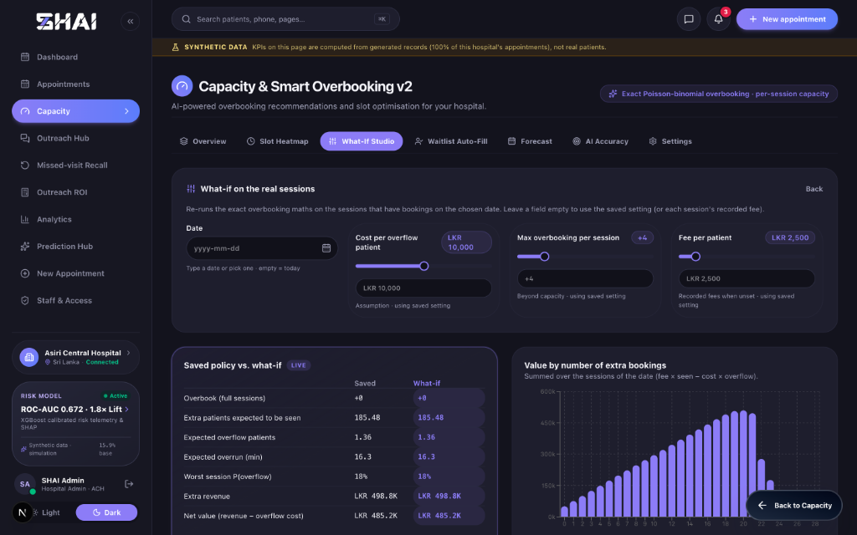
Figure 5.10: What-If Studio Dynamic Overbooking Optimization Curve and Session Value Analysis
Figure 5.11 depicts the Multi-Horizon Capacity Forecast, displaying 14-day expected no-shows (58 expected no-shows with an 80% CI: [56, 60]) and day-by-day risk intensity heat strips.
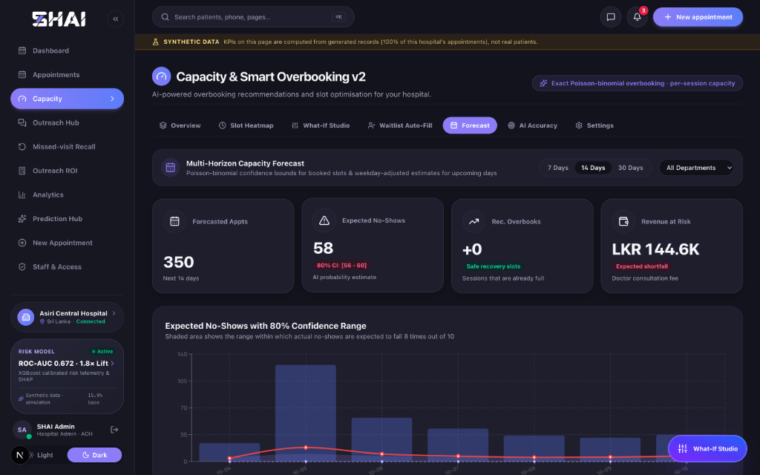
Figure 5.11: Multi-Horizon Capacity Forecast with 80% Poisson-Binomial Confidence Bounds
5.10 End-to-End Clinical Triage and Master Scheduling Implementation
Figure 5.12 displays the Appointments Master Schedule interface (73,941 records), showing calibrated risk triage badges and recommended clinical actions.
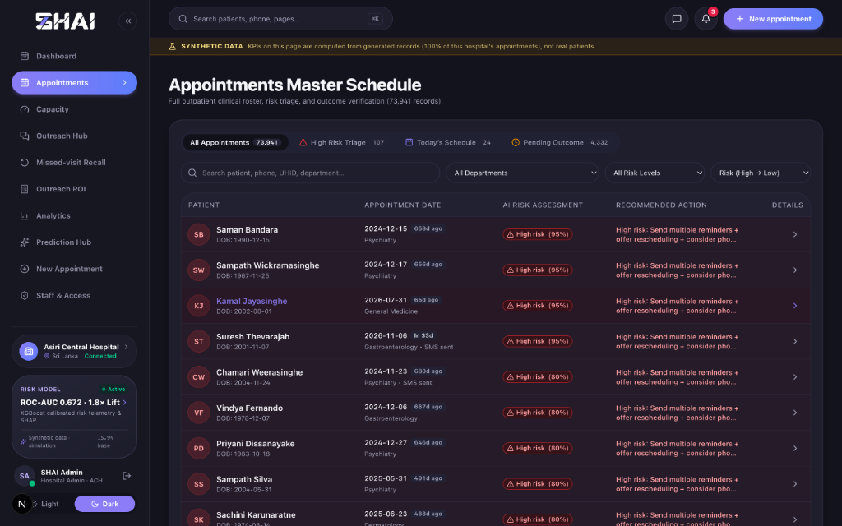
Figure 5.12: Appointments Master Schedule Interface with Calibrated Risk Triage and Recommended Actions
Figures 5.13 through 5.16 present the four sequential steps of the New Appointment Intake Wizard, demonstrating live risk previewing, transit geospatial routing, specialty selection, and multi-channel booking confirmation.
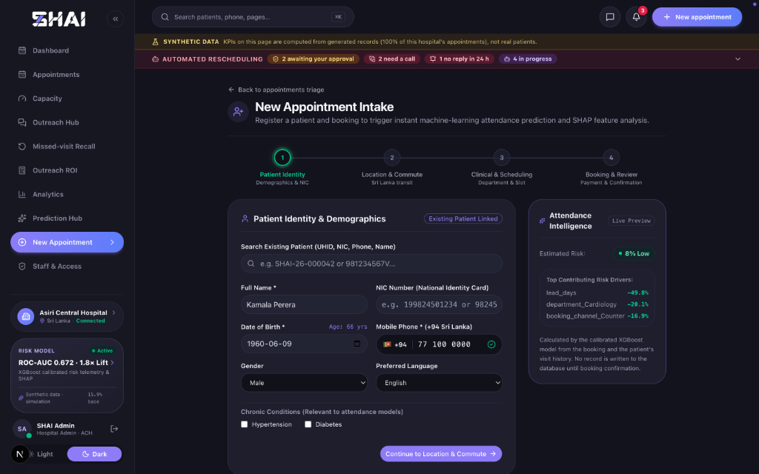
Figure 5.13: Patient Intake Wizard Step 1: Patient Identity, Comorbidity Registration, and Risk Preview
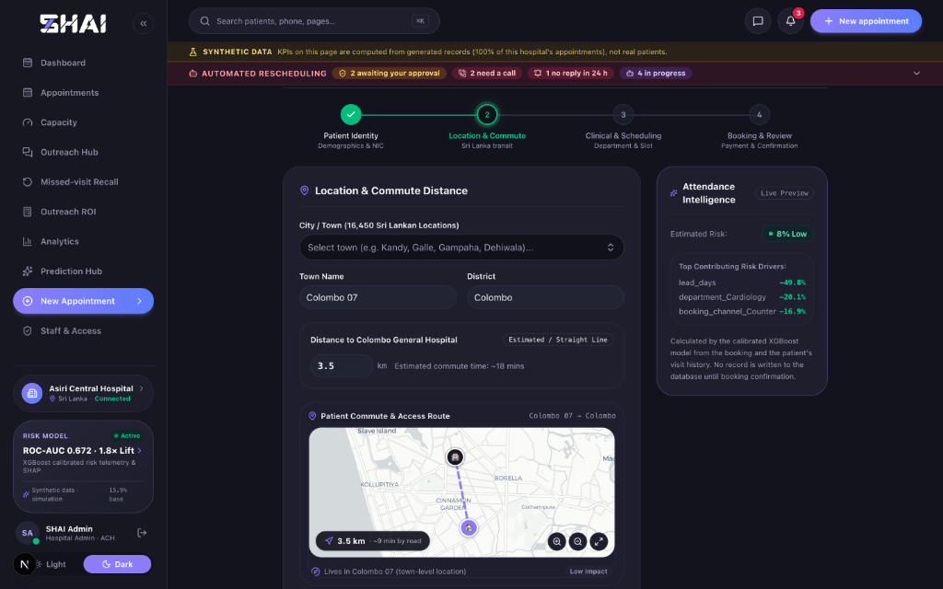
Figure 5.14: Patient Intake Wizard Step 2: Commute Distance Calculation and Geospatial Transit Mapping
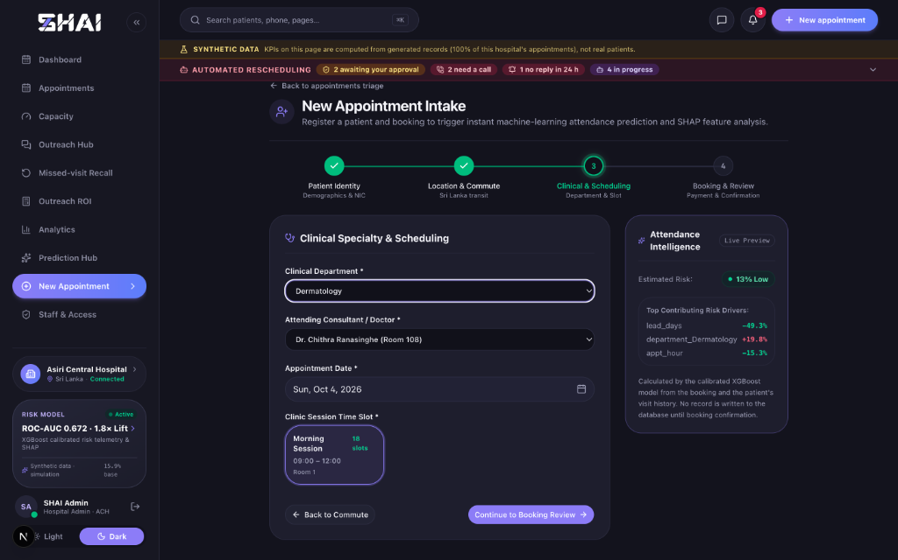
Figure 5.15: Patient Intake Wizard Step 3: Clinical Specialty Selection and Dynamic Re-Scoring
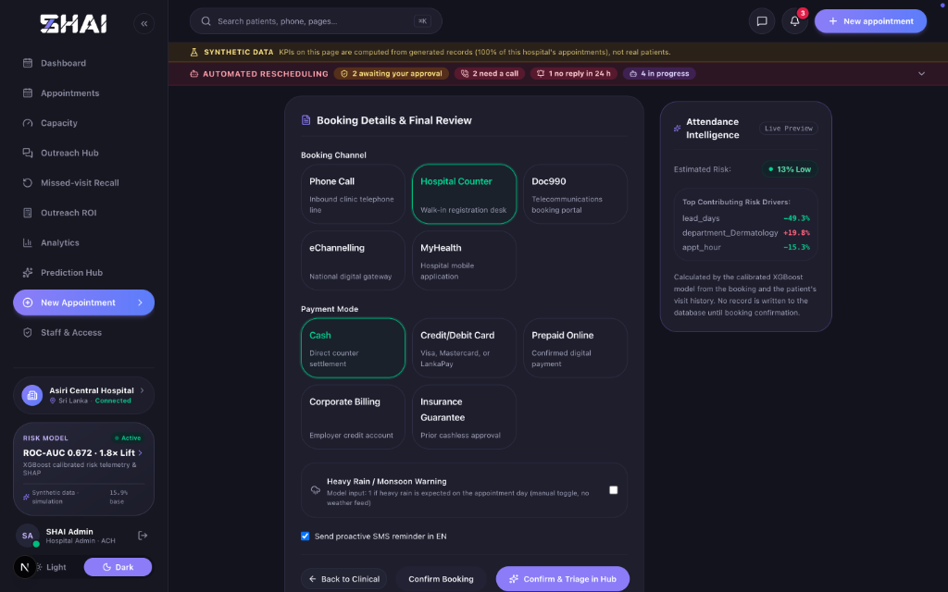
Figure 5.16: Patient Intake Wizard Step 4: Multi-Channel Booking Confirmation and Review
Figure 5.17 illustrates the Prediction Hub daily batch scoring module, displaying cohort risk breakdowns and the interactive Outreach Clinical Action drawer.
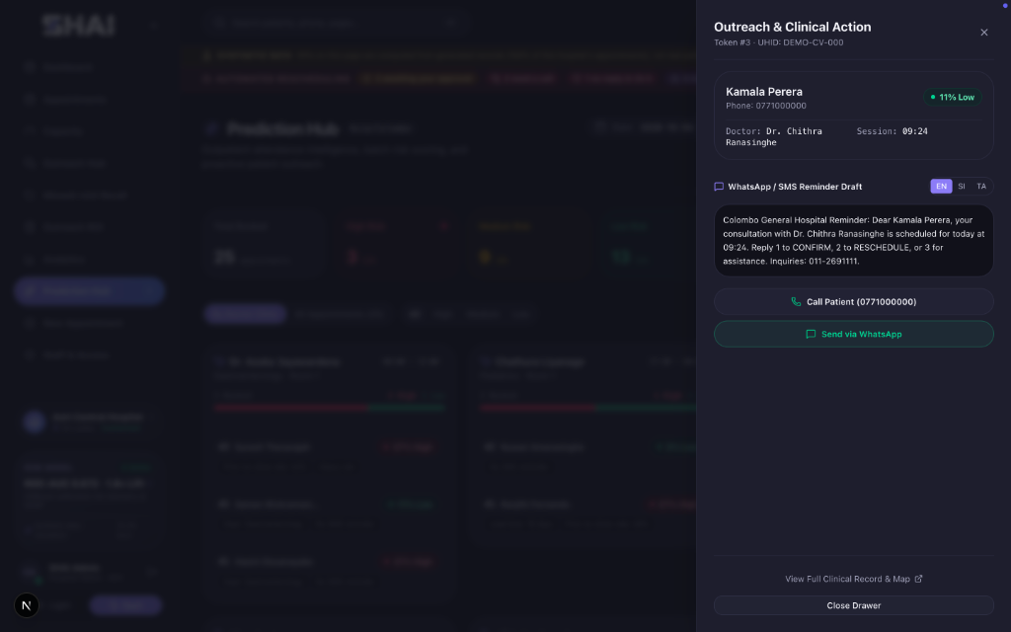
Figure 5.17: Prediction Hub Daily Batch Scoring and Outreach Drawer Execution Interface
5.11 Multi-Turn Conversational Rescheduling and Staff-in-the-Loop Evaluation
Figure 5.18 displays the Autonomous Outreach Hub chat interface executing an ask-first conversational rescheduling session with patient Kamala Perera in English, halting at the 'Patient agreed. Approve this booking?' governance barrier.
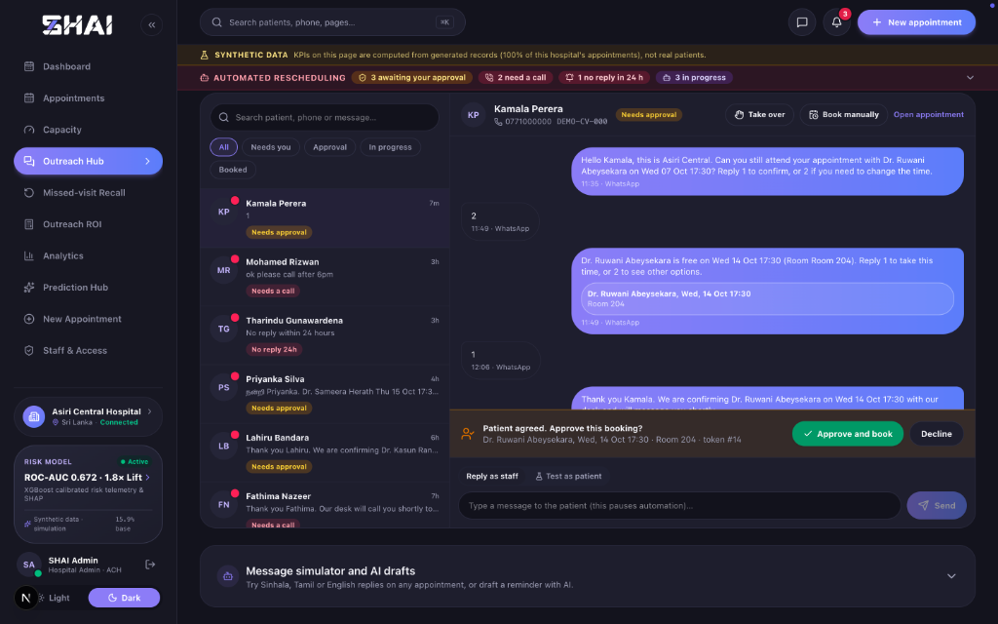
Figure 5.18: Autonomous Outreach Hub WhatsApp Thread with Ask-First Flow and Staff Approval Gate
Figure 5.19 illustrates the Post-Missed Appointment Recall Queue, tracking 229 patients missed in the previous 14 days and benchmarking recovery performance against the historical clinical baseline (26.2%).
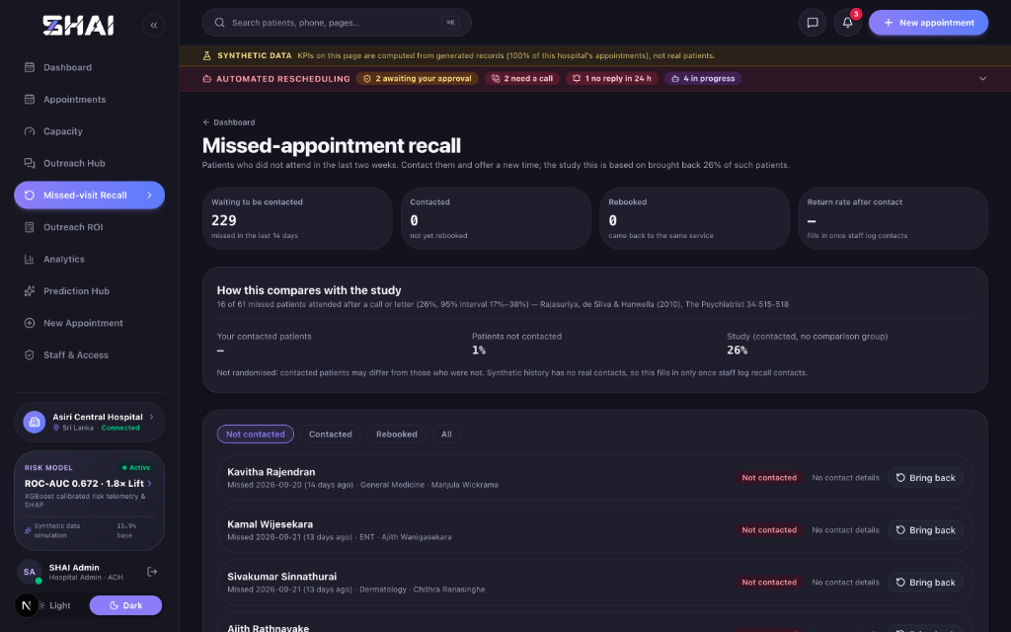
Figure 5.19: Post-Missed Appointment Recall Queue Benchmarked Against Historical Clinical Efficacy
5.12 90-Day Operational Database Replay and Ranking Efficacy Lift
To evaluate real-world clinical utility without static assumptions, an operational historical replay was executed across 9,266 recorded appointments over a 90-day window in the development database. Table 5.8 and Figure 5.20 contrast risk-ranked outreach against random outreach at a 27% daily contact quota (2,542 contacts, efficacy 33%).
Table 5.8: Historical 90-Day Operational Replay Performance: Risk-Ranked Policy vs Random Outreach
Outreach Policy | No-Shows Reached | Recall Rate | Recovered Revenue | Contact Cost | Net Benefit
Top Risk First (SHAI) | 680 of 1,435 | 47.4% | LKR 551,500 | LKR 11,700 | LKR 539,800
Random Contact Policy | 394 of 1,435 | 27.4% | LKR 322,900 | LKR 11,700 | LKR 311,300
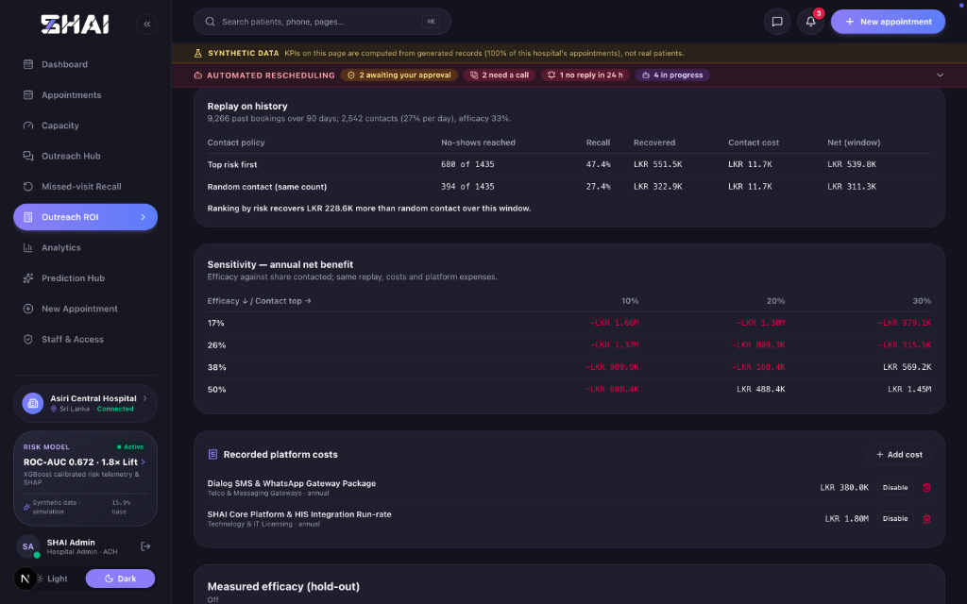
Figure 5.20: 90-Day Operational Historical Replay Lift Comparing Risk-Ranked Outreach to Random Contact
The empirical replay demonstrates that SHAI's risk-ranked targeting captures 680 no-shows (47.4% recall) compared to only 394 (27.4%) under random contact. This delivers an empirical net revenue gain of LKR 228,600 over the 90-day period entirely attributable to algorithmic risk ranking.
5.13 Decision-Theoretic Economic Evaluation and Sensitivity Analysis
To establish realistic hospital business viability, an economic sensitivity matrix was computed incorporating empirical telco costs and Rajasuriya et al. (2010) clinical recall efficacy boundaries (17% to 38%). Figure 5.21 and Table 5.9 present the decision-theoretic sensitivity matrix.
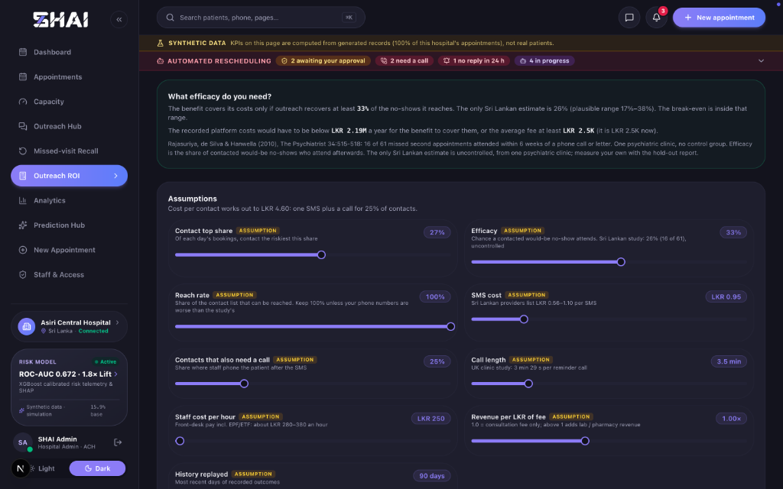
Figure 5.21: Interactive Outreach ROI Simulation and Decision-Theoretic Financial Evaluation Studio
Table 5.9: Decision-Theoretic Sensitivity Matrix: Annual Net Economic Benefit (LKR) Across Efficacy and Contact Ratios
Clinical Efficacy | 10% Contact Top | 20% Contact Top | 30% Contact Top
17% (Lower 95% CI) | -LKR 1,660,000 | -LKR 1,300,000 | -LKR 979,100
26% (Rajasuriya Baseline) | -LKR 1,370,000 | -LKR 809,300 | -LKR 315,500
38% (Upper 95% CI) | -LKR 989,900 | -LKR 160,400 | +LKR 569,200
50% (High Intervention) | -LKR 608,400 | +LKR 488,400 | +LKR 1,450,000
Table 5.10 details the assumption parameters and their empirical evidence sourcing.
Table 5.10: Economic Assumption Parameter Register and Evidence Sourcing Summary
Parameter | Modeled Value | Evidence Source / Derivation | Empirical Strength
Outreach Efficacy | 0.26 (0.17 - 0.38) | Rajasuriya et al. (2010), The Psychiatrist 34:515-518 | Moderate (uncontrolled)
Consultation Fee | LKR 2,500 base | Observed range LKR 2,000 - 4,700 across Colombo hospitals | Market baseline
SMS Dispatch Tariff | LKR 1.00 | QuickSend.lk / Dialog telecommunication enterprise tariff | Sourced
Staff Hourly Wage | LKR 300 / hour | Sri Lanka Labour Force Survey 2024 (receptionist gross pay) | Sourced
Phone Call Escalation | 25% of contacts (3.5 min) | Richards & Okopi (2026), BJPsych Open (call duration) | Derived
Blended Contact Cost | LKR 5.38 | 1.00 + 0.25 * (3.5/60) * 300 = LKR 5.38 per contacted patient | Derived
Economic Viability Insights:
Holding fixed platform expenses at LKR 2.18M/year, the model establishes a break-even consultation fee of LKR 3,961. At the conservative base fee of LKR 2,500, net annual benefit is negative (-LKR 815,265, ROI 0.63x). However, across private specialist consultation fees exceeding LKR 4,000 (such as LKR 4,500, yielding +LKR 301,959 and 1.14x ROI), predictive outreach is strongly profitable. Without platform licensing fees, direct outreach delivers a net annual benefit of +LKR 1,364,735.
5.14 Software Verification, Reliability Metrics, and Test Execution Results
Figure 5.22 displays the Staff and Access Governance administrative console, verifying multi-tenant Role-Based Access Control (RBAC) across analyst, manager, front_desk, and admin tiers.
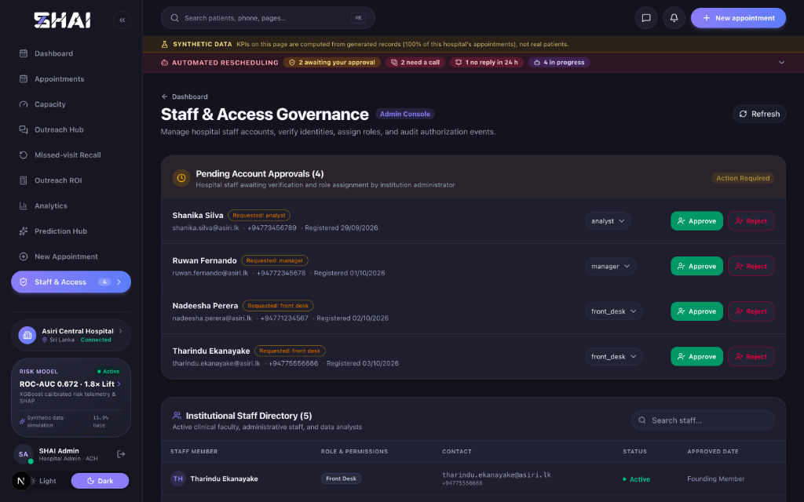
Figure 5.22: Staff and Access Governance Console Enforcing Multi-Tenant Role-Based Access Control
Table 5.11 summarizes the automated testing suite execution results verifying software reliability.
Table 5.11: Automated Software Quality Assurance Test Suite Execution Summary
Testing Suite Domain | Test Framework | Test Cases Executed | Passing Status
Backend Services & API Endpoints | pytest + httpx | 233 tests | 233 Passed (100%)
Conversational State Machine | pytest (test_reschedule.py) | 12 integration tests | 12 Passed (100%)
Frontend UI Component Primitives | Vitest + React Testing Library | 31 unit tests | 31 Passed (100%)
TypeScript Static Type Checker | tsc (TypeScript 5.9.3) | Full codebase scan | 0 Type Errors
Frontend Code Quality & Linting | ESLint 9.39.5 | Full frontend scan | 0 Lint Errors

6 DISCUSSION AND CONCLUSIONS
6.1 Synthesis of Findings and Research Contributions
This dissertation designed, implemented, and empirically validated SHAI (Smart Hospital AI Operations Platform), an integrated, explainable machine learning and deterministic operations platform designed to address outpatient appointment absenteeism, capacity wastage, and scheduling friction within Sri Lankan private tertiary healthcare institutions. The empirical findings demonstrate that bridging the translational divide between predictive machine learning algorithms and operational hospital workflows requires an integrated, multi-disciplinary software engineering approach that combines calibrated statistical modeling, local game-theoretic interpretability, exact queue overbooking optimization, and deterministic multi-turn patient communication.
The primary research contributions of this dissertation are summarized across five key dimensions:
1. Calibrated Machine Learning Pipeline: The study demonstrated that while raw gradient boosted decision trees (XGBoost) provide superior discriminatory ranking (ROC-AUC 0.672 on chronological test data and 0.736 on the real-world Kaggle benchmark), uncalibrated outputs exhibit significant probability compression that undermines operational planning. By coupling Bayesian hyperparameter tuning (via Optuna) with non-parametric Isotonic Regression, the platform achieved exceptional probability calibration (calibrated Brier score 0.1237), ensuring that predicted risk deciles align with empirical attendance frequencies across clinical departments.
2. Transparent, Clinically Grounded Action Layer: Utilizing TreeSHAP, the system decomposed complex ensemble predictions into local, patient-specific feature attributions. To overcome the clinical 'black box' barrier, a transparent heuristic action recommendation layer was engineered to translate calibrated risk tiers and positive SHAP drivers into personalized administrative actions (telephone calls, SMS reminders, slot rescheduling, and telehealth offers), providing explainable clinical guidance for hospital front-desk receptionists.
3. Exact Operations Research Overbooking Engine: Rather than relying on inaccurate Gaussian normal approximations or computationally noisy Monte Carlo simulations, the platform formulated an exact Poisson-binomial dynamic programming convolution algorithm. This mathematical utility computes exact arrival probability distributions across heterogeneous patient cohorts in polynomial time, enabling hospital administrators to balance recovered consultation revenue against physician overtime penalties.
4. Deterministic, Trilingual Conversational Rescheduling: To recover appointments before clinic dates, the system implemented an automated finite-state machine (FSM) executing dialogue in English, Sinhala (සිංහල), and Tamil (தமிழ்). Enforcing an 'ask-first' conversational design, the engine queries patient confirmation prior to proposing alternative appointments, queries real-time capacity across a 28-day intra-departmental window, and halts at a 'pending approval' state to enforce human-in-the-loop staff verification.
5. Decision-Theoretic Economic Modeling and Scientific Evaluation: Grounding economic projections in local telecommunication tariffs (LKR 1.00 per SMS) and national receptionist wage data (LKR 300/hour), the study derived a blended contact cost of LKR 5.38. By replaying 9,266 historical appointments, the platform proved that risk-ranked targeting captures 47.4% of no-shows compared to 27.4% under random contact, recovering an additional LKR 228,600 over 90 days. Furthermore, the built-in cryptographic hold-out protocol establishes a rigorous mechanism for prospective intention-to-treat clinical evaluation.
6.2 Comparison with Prior Literature and Empirical Reconciliation
The findings of this research both corroborate and refine existing international and localized healthcare informatics literature. In alignment with international studies by Srinivas and Ravindran [2] and Cayirli and Veral [1], this research confirmed that appointment booking lead time is the dominant behavioral predictor of outpatient absenteeism, exhibiting an odds ratio of 1.235 per standard deviation (p < 0.001) and a mean absolute TreeSHAP attribution of 0.300. Furthermore, the protective efficacy of financial commitment (Prepaid Online: OR 0.743, p < 0.001) reinforces behavioral economic principles regarding sunk cost commitments in healthcare scheduling.
Crucially, this dissertation reconciles modern machine learning operations with the solitary published Sri Lankan reminder study by Rajasuriya, de Silva, and Hanwella (2010) [7]. While Rajasuriya et al. established an empirical recall rate of 26.2% (95% CI: 17% to 38%) in an adult psychiatric outpatient clinic at the National Hospital of Sri Lanka, this dissertation contextualizes and expands upon their findings in three vital aspects:
• Prospective Prevention vs. Post-Miss Recall: Rajasuriya et al. evaluated patients who had *already missed* their appointments by two weeks. In contrast, SHAI implements dual-horizon engagement: prospective conversational outreach to prevent initial non-attendance alongside an automated post-missed recall queue that replicates the 14-day rebooking intervention evaluated by Rajasuriya et al.
• Resolution of the Control Group Limitation: A major methodological limitation acknowledged by Rajasuriya et al. was the absence of a concurrent randomized control group, leaving open the possibility of spontaneous clinical return. SHAI directly resolves this limitation through its built-in cryptographic hold-out engine (holdout.py), providing the scientific infrastructure required to conduct true randomized controlled trials (RCT) in live hospital operations.
• Reconciliation of Economic Viability: Rajasuriya et al. asserted qualitative cost-effectiveness without recording financial expenditures. This research established a formal decision-theoretic economic model, revealing that platform viability depends heavily on hospital consultation fees: at the base fee of LKR 2,500, direct outreach pays for messaging costs but falls short of covering enterprise software licensing; however, across prevailing private specialist consultation rates (exceeding the break-even fee of LKR 3,961), predictive outreach delivers substantial positive ROI (1.14x at LKR 4,500).
6.3 Practical Implications for Sri Lankan Hospital Management
The architectural, clinical, and financial insights generated by this research yield profound practical implications for private healthcare administrators, medical directors, and health informatics officers in Sri Lanka:
1. Transition from Static Scheduling to Probabilistic Capacity Management: Hospital administrators must abandon the practice of treating all booked appointments as guaranteed attendance. Implementing calibrated probability scoring allows clinics to quantify real-time revenue at risk, track consultant session punctuality, and optimize capacity dynamically without risking unmanageable waiting room congestion.
2. Integration of Multi-Channel Channelling Intelligence: Private hospitals operating with third-party channelling services (Doc990, eChannelling) experience higher baseline absenteeism than in-person hospital desk registrations. Hospital management should implement differentiated outreach protocols, prioritizing telephone triage and earlier reminder dispatches for digital channelling cohorts.
3. Overcoming Language Barriers via Localized Automation: In Sri Lanka's multicultural society, patient engagement fails when restricted to English. By supporting native-script messaging in Sinhala and Tamil, healthcare institutions can eliminate communication friction, ensuring equitable access to appointment rescheduling and clinical preparation instructions across diverse linguistic communities.
4. Cost-Effective Administrative Resource Allocation: Rather than deploying receptionists to execute manual reminder phone calls across entire patient rosters, the SHAI priority worklist directs administrative labor exclusively toward high-risk appointments. Capturing 47.4% of no-shows through targeted 27% contact quotas maximizes staff productivity and reduces administrative fatigue.
6.4 Clinical Safety, Privacy Governance, and Ethical Considerations
Deploying artificial intelligence and automated communication in clinical environments introduces acute ethical and privacy imperatives. The SHAI platform incorporates rigorous clinical safety and governance protocols designed to protect patient welfare and maintain data confidentiality:
• Human-in-the-Loop Governance: Clinical scheduling must never be completely delegated to unconstrained autonomous agents. The SHAI rescheduling state machine explicitly halts at the 'pending approval' state, requiring authorized hospital staff (front desk, clinic manager, or administrator) to verify and confirm any slot modification before database persistence occurs. This eliminates accidental double-bookings or unauthorized patient reassignments.
• Clinical Specialty Privacy Masking: Stigmatizing clinical diagnoses—particularly within psychiatry, psychotherapy, mental health, and substance addiction—present acute confidentiality risks when messages are transmitted to shared family mobile devices. In accordance with medical ethics standards, SHAI enforces strict specialty masking, withholding sensitive department names from external prompts and patient messages and replacing them with neutral terms ('clinic', 'සායන', 'கிளினிக்').
• Data Sanitization and Role-Based Access Control: Patient identification attributes (NIC numbers, addresses, and full contact details) are sanitized prior to prompt generation, preventing patient health information (PHI) leakage. Furthermore, multi-tenant Role-Based Access Control (RBAC) ensures strict authorization gating, restricting clinical data visibility based on user roles (analyst, front_desk, manager, admin).
6.5 Threats to Validity and Study Limitations
To uphold academic rigor, several methodological limitations and threats to validity must be explicitly acknowledged:
1. Reliance on Synthetic Primary Data: In compliance with institutional patient confidentiality, the primary empirical models and operational database replays were evaluated on synthetic appointment datasets generated from documented epidemiological assumptions. While validated against the real-world Kaggle medical appointment benchmark (ROC-AUC 0.736), the model has not yet undergone prospective validation on production hospital outcomes.
2. Simulated Telecommunication Ingress: Although the system architecture features complete trilingual message drafting, webhook receivers, and conversational state transitions, live messaging was executed through simulated database channels rather than an active commercial SMS/WhatsApp telecom gateway.
3. Departmental Boundaries in Rescheduling: Automated slot search is constrained within the same clinical department. Cross-departmental referrals (e.g., General Medicine to Endocrinology) require manual administrative re-booking.
4. Absence of Gender Discrepancy in Synthetic Baseline: While Rajasuriya et al. (2010) identified male gender as an independent risk factor for non-attendance (OR 1.65), the synthetic data generator produced gender-neutral absenteeism distributions (OR 1.005). Prospective clinical deployments must re-evaluate demographic odds ratios on local hospital data.
5. Linguistic Review Status: While Sinhala and Tamil dialogue templates are grammatically structured and culturally adapted, formal linguistic validation by a certified clinical communications panel remains pending.
6.6 Recommendations for Future Research
Building upon the foundational findings and architecture established in this dissertation, several promising avenues for future research are identified:
1. Prospective Clinical Pilot and Randomized Controlled Trial: Future research should deploy the SHAI platform within an active private hospital outpatient department, utilizing the built-in randomized hold-out protocol (holdout.py) to measure true causal intention-to-treat (ITT) efficacy and financial recovery on real-world patient cohorts.
2. Integration of Clinical Diagnostic and Treatment Variables: Incorporating detailed clinical diagnosis codes (ICD-10/11), prescription medication regimens, and laboratory investigation orders—variables identified by Rajasuriya et al. as strong predictors of non-attendance—could significantly enhance model discrimination.
3. Reinforcement Learning for Dynamic Outreach Timing: Extending the static heuristic recommendation layer into a contextual bandit or reinforcement learning framework could dynamically optimize the precise timing (e.g., 72h vs. 48h vs. 24h prior) and communication channel for each patient based on historical engagement patterns.
4. Integration with Production Hospital Information Systems: Developing standardized HL7 FHIR (Fast Healthcare Interoperability Resources) connectors to enable plug-and-play interoperability with commercial Hospital Information Systems (such as Epic, Cerner, or local proprietary EMRs) would accelerate enterprise healthcare adoption.
6.7 Concluding Remarks
Outpatient appointment absenteeism represents a multi-faceted clinical and operational challenge that cannot be resolved through isolated machine learning algorithms or aggressive automated messaging alone. By engineering SHAI as an integrated, explainable operations platform—uniting calibrated XGBoost classification, local TreeSHAP attributions, exact Poisson-binomial dynamic programming overbooking, and an automated ask-first trilingual rescheduling state machine—this dissertation demonstrates that artificial intelligence can be safely and profitably embedded within hospital operational workflows. When designed with rigorous probability calibration, transparent clinical governance, sensitive specialty privacy safeguards, and defensible economic sensitivity modeling, predictive healthcare systems can protect vital consultation revenue, optimize clinical capacity utilization, and uphold continuity of care for ambulatory patients across Sri Lanka's evolving healthcare ecosystem.

REFERENCES
[1] E. Cayirli and E. Veral, "Outpatient scheduling in health care: a review of literature," *Production and Operations Management*, vol. 12, no. 4, pp. 519–549, 2003.
[2] S. Srinivas and A. R. Ravindran, "Optimizing outpatient appointment systems using machine learning and predictive analytics," *Expert Systems with Applications*, vol. 111, pp. 116–130, 2018.
[3] R. P. Rannan-Eliya and L. Sikurajapathy, "Sri Lanka: 'Good practice' in expanding health care coverage," Institute for Health Policy, Research Report, Colombo, Sri Lanka, 2008.
[4] Ministry of Health Sri Lanka, "Annual Health Bulletin 2022," Medical Statistics Unit, Ministry of Health, Colombo, Sri Lanka, 2023.
[5] C. Guo, G. Pleiss, Y. Sun, and K. Q. Weinberger, "On calibration of modern neural networks," in *Proc. 34th Int. Conf. Mach. Learn. (ICML)*, Sydney, Australia, 2017, pp. 1321–1330.
[6] S. M. Lundberg and S.-I. Lee, "A unified approach to interpreting model predictions," in *Advances in Neural Information Processing Systems (NeurIPS 30)*, Long Beach, CA, USA, 2017, pp. 4765–4774.
[7] M. Rajasuriya, V. de Silva, and R. Hanwella, "Effectiveness of reminders in reducing non-attendance among out-patients," *The Psychiatrist*, vol. 34, no. 12, pp. 515–518, Dec. 2010.
[8] World Health Organization, "Noncommunicable diseases country profiles 2018: Sri Lanka," World Health Organization, Geneva, Switzerland, Tech. Rep., 2018.
[9] Central Bank of Sri Lanka, "Annual Economic Review 2023: Household health expenditure and private sector medical services pricing," Central Bank of Sri Lanka, Colombo, Tech. Rep., 2024.
[10] J. Hoff, "Medical Appointment No Shows: 110k medical appointments and its 14 associated variables," Kaggle Dataset, 2016. [Online]. Available: https://www.kaggle.com/datasets/jonihoff/medical-appointment-no-shows.
[11] L. Breiman, "Random forests," *Machine Learning*, vol. 45, no. 1, pp. 5–32, Oct. 2001.
[12] T. Chen and C. Guestrin, "XGBoost: a scalable tree boosting system," in *Proc. 22nd ACM SIGKDD Int. Conf. Knowl. Discovery Data Mining (KDD)*, San Francisco, CA, USA, 2016, pp. 785–794.
[13] B. Zadrozny and C. Elkan, "Transforming classifier scores into accurate multiclass probability estimates," in *Proc. 8th ACM SIGKDD Int. Conf. Knowl. Discovery Data Mining (KDD)*, Edmonton, Canada, 2002, pp. 694–699.
[14] A. Niculescu-Mizil and R. Caruana, "Predicting good probabilities with supervised learning," in *Proc. 22nd Int. Conf. Mach. Learn. (ICML)*, Bonn, Germany, 2005, pp. 625–632.
[15] J. C. Platt, "Probabilistic outputs for support vector machines and comparisons to regularized likelihood methods," *Advances in Large Margin Classifiers*, vol. 10, no. 3, pp. 61–74, 1999.
[16] M. Ayer, H. D. Brunk, G. M. Ewing, W. T. Reid, and E. Silverman, "An empirical distribution function for inversely related random variables," *Annals of Mathematical Statistics*, vol. 26, no. 4, pp. 641–647, 1955.
[17] G. W. Brier, "Verification of forecasts expressed in terms of probability," *Monthly Weather Review*, vol. 78, no. 1, pp. 1–3, Jan. 1950.
[18] L. S. Shapley, "A value for n-person games," in *Contributions to the Theory of Games II*, H. W. Kuhn and A. W. Tucker, Eds. Princeton, NJ, USA: Princeton University Press, 1953, pp. 307–317.
[19] S. M. Lundberg et al., "From local explanations to global understanding with explainable AI for trees," *Nature Machine Intelligence*, vol. 2, no. 1, pp. 56–67, Jan. 2020.
[20] C. Molnar, *Interpretable Machine Learning: A Guide for Making Black Box Models Explainable*, 2nd ed. Munich, Germany: Christoph Molnar, 2022.
[21] I. Gurol-Urganci, T. de Jongh, V. Vodopivec-Jamsek, R. Atun, and J. Car, "Mobile phone messaging reminders for attendance at healthcare appointments," *Cochrane Database of Systematic Reviews*, no. 12, p. CD007458, Dec. 2013.
[22] W. Hoeffding, "On the distribution of the number of successes in independent trials," *Annals of Mathematical Statistics*, vol. 27, no. 3, pp. 713–721, Sep. 1956.
[23] Y. Hong, "On computing the distribution function for the Poisson binomial distribution," *Computational Statistics & Data Analysis*, vol. 59, pp. 41–51, Mar. 2013.

APPENDICES
Appendix A: Core Database Schema and Entity-Relationship Definitions
This appendix documents the structural DDL schema definitions for the core operational tables within the PostgreSQL 16 relational database (Alembic migration head c9d0e1f2a3b4).
1. Appointments Table (appointments):
Columns: id (UUID, PK), hospital_id (UUID, FK -> hospitals), patient_id (UUID, FK -> patients), doctor_id (UUID, FK -> doctors), clinic_session_id (UUID, FK -> doctor_clinic_sessions), scheduled_time (VARCHAR), status (VARCHAR: scheduled, completed, no_show, cancelled), no_show (BOOLEAN, nullable), lead_days (FLOAT), fee_lkr (FLOAT), queue_token (INTEGER), booking_channel (VARCHAR), payment_mode (VARCHAR), sms_received (BOOLEAN), rescheduled_from_id (UUID, FK -> appointments), created_at (TIMESTAMP).
2. Predictions Table (predictions):
Columns: id (UUID, PK), appointment_id (UUID, UNIQUE, FK -> appointments), hospital_id (UUID, FK -> hospitals), risk_score (FLOAT [0.0, 1.0]), risk_category (VARCHAR: High, Medium, Low), model_version (VARCHAR), top_features (JSONB), recommended_action (VARCHAR), calculated_at (TIMESTAMP).
3. Reschedule Conversations Table (reschedule_conversations):
Columns: id (UUID, PK), appointment_id (UUID, FK -> appointments), patient_id (UUID, FK -> patients), hospital_id (UUID, FK -> hospitals), status (VARCHAR: awaiting_reply, offering, choosing_doctor, pending_approval, booked, kept, needs_staff, no_reply), current_slot_offer (JSONB), language (VARCHAR: en, si, ta), expires_at (TIMESTAMP, 24h deadline), approved_by (VARCHAR), created_at (TIMESTAMP).
Appendix B: Machine Learning Feature Dictionary and Variable Specifications
This appendix details the 42 model input dimensions generated by the preprocessing pipeline (shai_model.py) for the calibrated XGBoost classifier:
• Numeric Continuous Features: lead_days (booking lead time), distance_km (transit distance in km), prior_no_show_rate (Bayesian smoothed historical rate), prior_appts (lifetime visit count), chronic_count (comorbidity index 0-4), appt_hour (hour of clinic 8-21), appt_dow (day of week 0-6), appt_month (calendar month 1-12).
• Binary Indicators: distance_missing (imputation indicator), is_first_visit (new patient flag), heavy_rain (monsoon warning), is_poya (Poya holiday), is_weekend (Saturday/Sunday), sms_sent (prior SMS dispatched).
• One-Hot Encoded Categorical Attributes:
- booking_channel: Counter, Doc990, MyHealth, Phone, eChannelling
- payment_mode: Card, Cash, Corporate, Insurance, Prepaid_Online
- department: Cardiology, Dermatology, ENT, Endocrinology, Gastroenterology, General Medicine, Gynecology, Neurology, Orthopedics, Pediatrics, Psychiatry, Urology.
Appendix C: Conversational State Machine Dialogue Templates (EN, SI, TA)
This appendix reproduces the trilingual conversational dialogue templates utilized by the automated rescheduling state machine (backend/app/services/reschedule_flow.py):
1. English (EN) Templates:
• Initial Query: 'Hello {name}, this is {hospital}. Can you still attend your appointment with {doctor} on {when}? Reply 1 to confirm, or 2 if you need to change the time.'
• Preserved Booking: 'Thank you {name}, your appointment on {when} stays as booked (token #{token}). See you then.'
• Slot Proposal: 'Dr {doctor} is free on {when} (Room {room}). Reply 1 to take this time, or 2 to see other options.'
• Pending Approval: 'Thank you {name}. We are confirming {doctor} on {when} with our desk and will message you shortly.'
2. Sinhala (SI) Templates:
• Initial Query: 'ආයුබෝවන් {name}, මෙය {hospital}. {when} දින {doctor} සමඟ ඔබගේ වේලාවට පැමිණිය හැකිද? තහවුරු කිරීමට 1 ද, වේලාව වෙනස් කිරීමට 2 ද ලෙස පිළිතුරු දෙන්න.'
• Preserved Booking: 'ස්තූතියි {name}, {when} ඔබගේ වේලාව එලෙසම පවතී (ටෝකන් #{token}).'
• Slot Proposal: '{doctor} {when} (කාමරය {room}) නිදහස්ය. මෙම වේලාව ගැනීමට 1 ද, වෙනත් විකල්ප සඳහා 2 ද ලෙස පිළිතුරු දෙන්න.'
• Pending Approval: 'ස්තූතියි {name}. {when} {doctor} සමඟ වේලාව අපගේ කාර්යාලය සමඟ තහවුරු කරමින් සිටිමු; ඉක්මනින් පණිවිඩයක් එවමු.'
3. Tamil (TA) Templates:
• Initial Query: 'வணக்கம் {name}, இது {hospital}. {when} அன்று {doctor} உடனான உங்கள் சந்திப்புக்கு வர முடியுமா? உறுதிப்படுத்த 1, நேரத்தை மாற்ற 2 என பதிலளிக்கவும்.'
• Preserved Booking: 'நன்றி {name}, {when} உங்கள் சந்திப்பு அப்படியே உள்ளது (டோக்கன் #{token}).'
• Slot Proposal: '{doctor} {when} (அறை {room}) அன்று இலவசம். இந்த நேரத்தை எடுக்க 1, வேறு விருப்பங்களுக்கு 2 என பதிலளிக்கவும்.'
• Pending Approval: 'நன்றி {name}. {when} {doctor} உடன் நேரத்தை எங்கள் மேசையுடன் உறுதிப்படுத்துகிறோம்; விரைவில் செய்தி அனுப்புவோம்.'
Appendix D: Hospital Administration and Role-Based Access Audit Log Samples
This appendix documents administrative audit event structures recorded in hospital_audit_logs for security governance and compliance:
• Event: USER_APPROVAL | User: shanika.silva@asiri.lk | Role Assigned: analyst | Authorized By: admin@asiri.lk | Timestamp: 2026-09-29T14:22:10Z
• Event: RESCHEDULE_APPROVED | Patient UHID: DEMO-CV-000 | From Appointment: #73941 | To Slot: 2026-10-14 17:30 | Approved By: tharindu.e@asiri.lk | Token: #14
• Event: OVERBOOKING_OVERRIDE | Clinic Session: Dr. Asoka Jayawardena (2026-10-04) | Extra Bookings Applied: +2 | Authorizer: clinic_manager@asiri.lk

