STUDENT ENROLLMENT & COURSE MANAGEMENT SYSTEM
(SECMS)
SALESFORCE PROJECT REPORT

User Story
The Student Enrollment & Course Management System (SECMS) is a Salesforce application created to organize and automate the academic enrollment activities of an educational institution. It brings student information, course offerings, instructor details, enrollment records, approvals, payments, and reporting together in one platform. Administrators, enrollment staff, and instructors can use the system to manage these activities efficiently.

1. INTRODUCTION

1.1 Project Overview
SECMS is a Salesforce-based solution for maintaining student, course, instructor, and enrollment information in a structured manner. It provides a centralized location for academic records and supports the complete enrollment process.
The application uses Salesforce capabilities such as custom objects, fields, relationships, validation rules, flows, reports, dashboards, and security controls to manage the required information and processes.

1.2 Purpose
The purpose of SECMS is to make student enrollment and course administration simpler and more automated. By reducing repetitive manual work, the system helps improve data consistency and makes important student and course information easier to access.

1.3 Objectives
The key goals of the system are:
- Keep student details in a centralized and organized database.
- Maintain information about courses and instructors.
- Make the student enrollment process easier to manage.
- Connect students, courses, and enrollment records through appropriate relationships.
- Check student and course data using validation rules.
- Automate activities associated with enrollment.
- Provide meaningful reports and dashboards for monitoring.

2. IDEATION PHASE

2.1 Problem Statement
Educational institutions may depend on manual records or multiple disconnected systems for handling students, courses, instructors, and enrollments. Such approaches can create duplicate information, make enrollment tracking difficult, delay updates, and make report preparation time-consuming. A centralized system is therefore needed to manage these academic activities in an efficient and consistent way.

2.2 Empathy Map
Students
- Think: Which courses can I choose from?
- Feel: The enrollment procedure should be simple.
- Say: I need to check whether my enrollment is confirmed.
- Do: Choose courses and submit the required personal information.
Administrator
- Think: How can student records be maintained without difficulty?
- Feel: The information must remain accurate and well organized.
- Say: Enrollment details should be available whenever required.
- Do: Maintain student, course, and enrollment records.

2.3 Ideation and Grouping
Step 1 – Ideas considered:
- Automated spreadsheet-based management
- Independent online enrollment portal
- Integration with an ERP system
- Enrollment management using Salesforce
Step 2 – Classification:
- Manual approaches
- Partially automated approaches
- Completely automated cloud-based approaches

3. REQUIREMENT ANALYSIS PHASE

3.1 Customer Journey Map
The enrollment journey considered for the system includes the following stages:
- Awareness and registration
- Selecting a course
- Submitting an enrollment request
- Completing fee payment
- Obtaining approval
- Assigning an instructor

3.2 Functional Requirements
The application is expected to support the following functions:
- Creating and maintaining student records.
- Creating and maintaining course records.
- Managing instructor information.
- Creating enrollment records.
- Maintaining the relationship between students and courses.
- Applying validation rules to data.
- Running automated workflows.
- Supporting an approval process.
- Producing reports.
- Displaying dashboards.
- Controlling access through user security.

3.3 Non-Functional Requirements
- Security: System information must be accessible only to authorized users.
- Reliability: Records should be maintained correctly and consistently.
- Usability: Users should be able to operate the application easily.
- Performance: Records and reports should respond efficiently.
- Scalability: The solution should accommodate growth in students and course offerings.

4. PROJECT DESIGN PHASE

4.1 Problem-Solution Fit
Problem-solution fit means connecting the identified user difficulties with a solution that is practical, achievable, and useful for the intended users.

4.2 Proposed Solution
The proposed SECMS solution uses Salesforce to bring the major enrollment activities into one centralized application. The system supports organized data storage, automation, approval handling, reporting, and controlled access.

4.3 Solution Architecture
SECMS follows a layered architecture implemented on the Salesforce platform. The architecture brings together student, course, enrollment, and instructor information with automation flows, approval processes, dashboards, and security features.

5. PROJECT PLANNING AND SCHEDULING

5.1 Project Planning
Project planning involves defining the implementation approach, dividing the work into user stories or activities, assigning story points where required, and organizing the development work into manageable stages or sprints.

8. PROJECT DEVELOPMENT PHASE
The project is implemented through the following sequence of milestones:
- Salesforce developer account and login setup
- Creation of custom objects for Student, Course, Enrollment, and Instructor
- Creation of custom tabs
- Development of the Lightning application
- Creation of required fields
- Establishment of object relationships
- Customization of page layouts
- Configuration of validation rules
- Creation of automation flows
- Configuration of the approval process
- Preparation of reports
- Creation of dashboards
- Configuration of security
- Project conclusion

Milestone 1: Salesforce Login Page
The Salesforce Developer environment is used as the working platform for developing, testing, and demonstrating SECMS. A Salesforce Developer Org provides the environment required to create custom objects, tabs, applications, flows, reports, and dashboards. The following screenshots show the login and initial access steps used for the project.
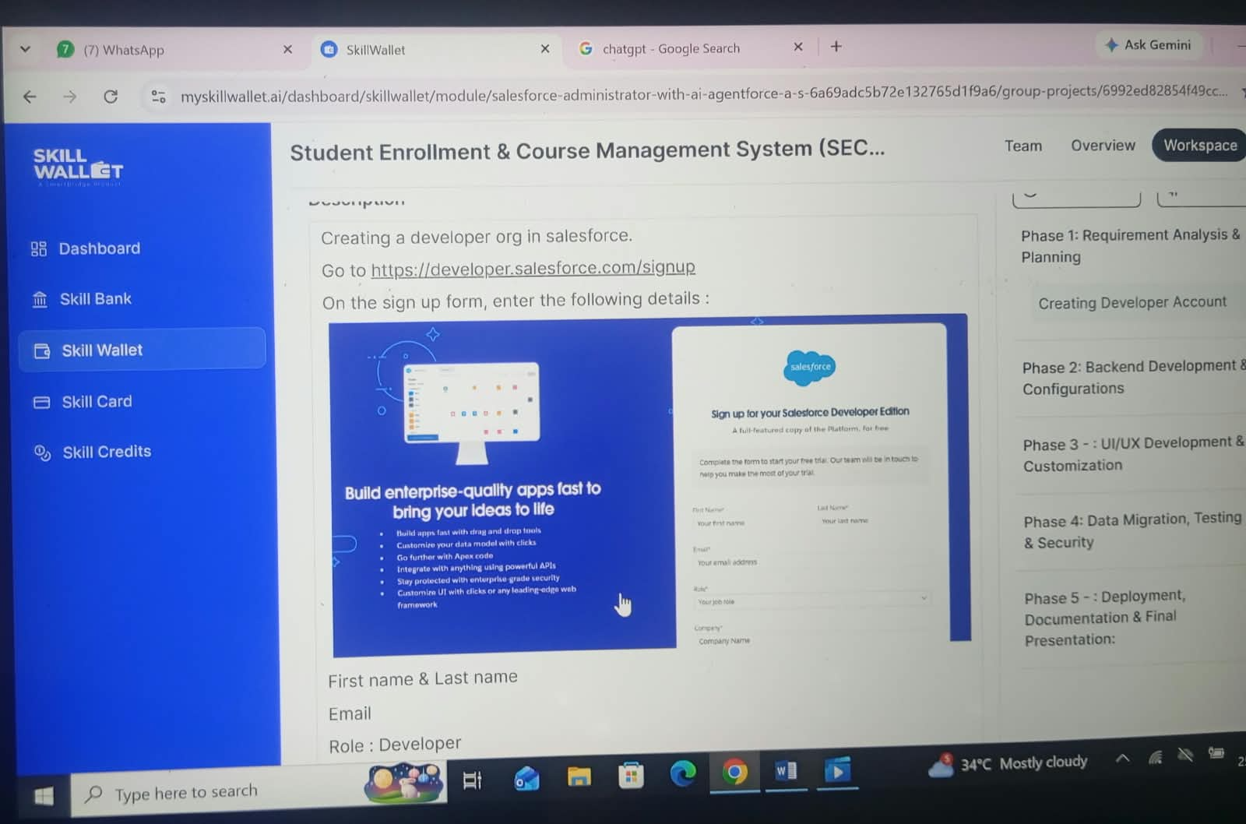
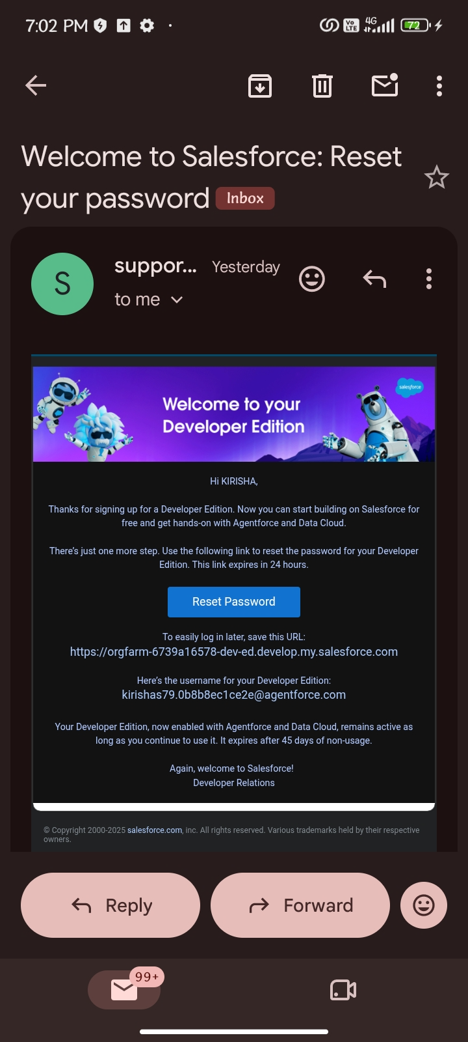
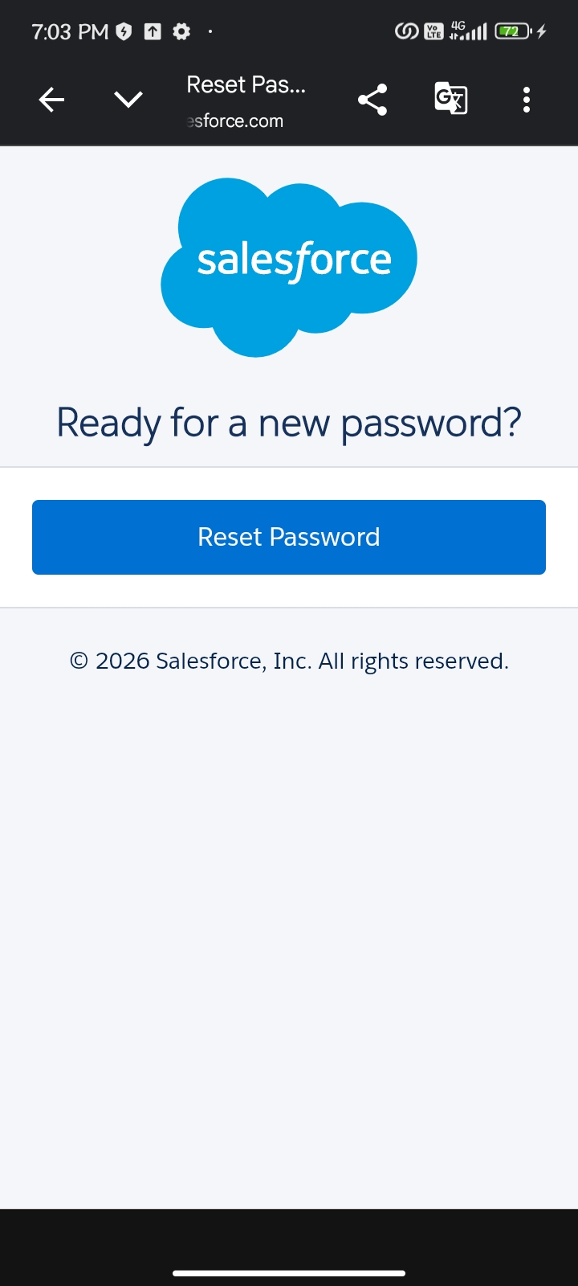

Milestone 2 – Custom Object Creation

Activity 1: Creating the Student Object
The Student custom object is used to keep personal, contact, and enrollment-related information for each student.
Procedure:
- Open Salesforce Setup.
- Navigate to Object Manager.
- Choose Create and then Custom Object.
- Enter the object information shown below.
- Save the object.
- Label: Student
- Plural Label: Students
- Object Name: Student
- Record Name: Student Name
- Data Type: Text
- Enable Allow Reports, Allow Activities, and Track Field History
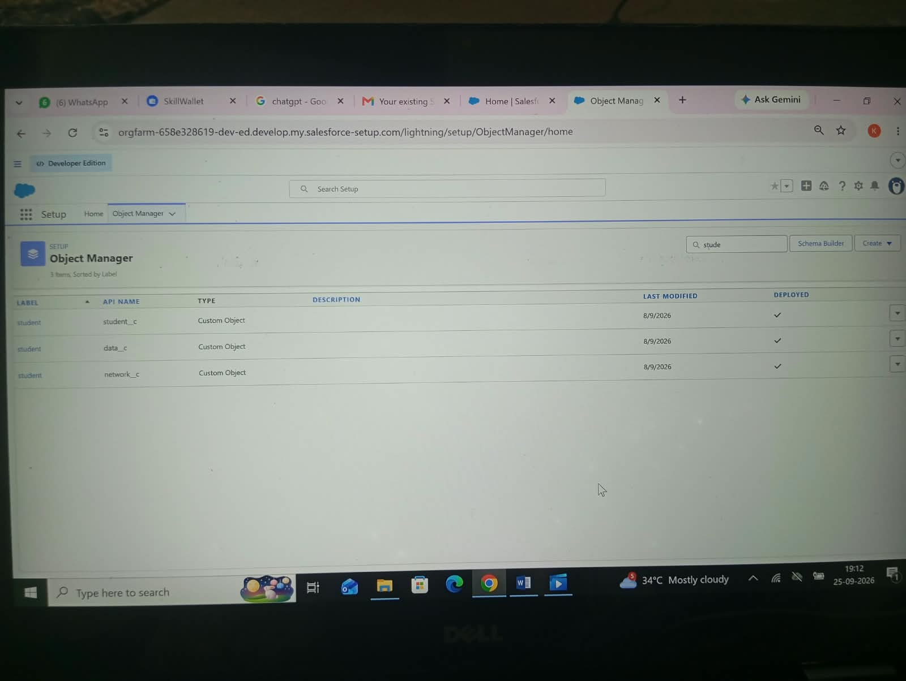

Activity 2: Creating the Course Object
The Course custom object stores details about the courses offered by the institution, including information such as course name, duration, fees, and description.
Procedure:
- Go to Setup and open Object Manager.
- Select Create and then Custom Object.
- Provide the course object details.
- Save the configuration.
- Label: Course
- Plural Label: Courses
- Record Name: Course Name
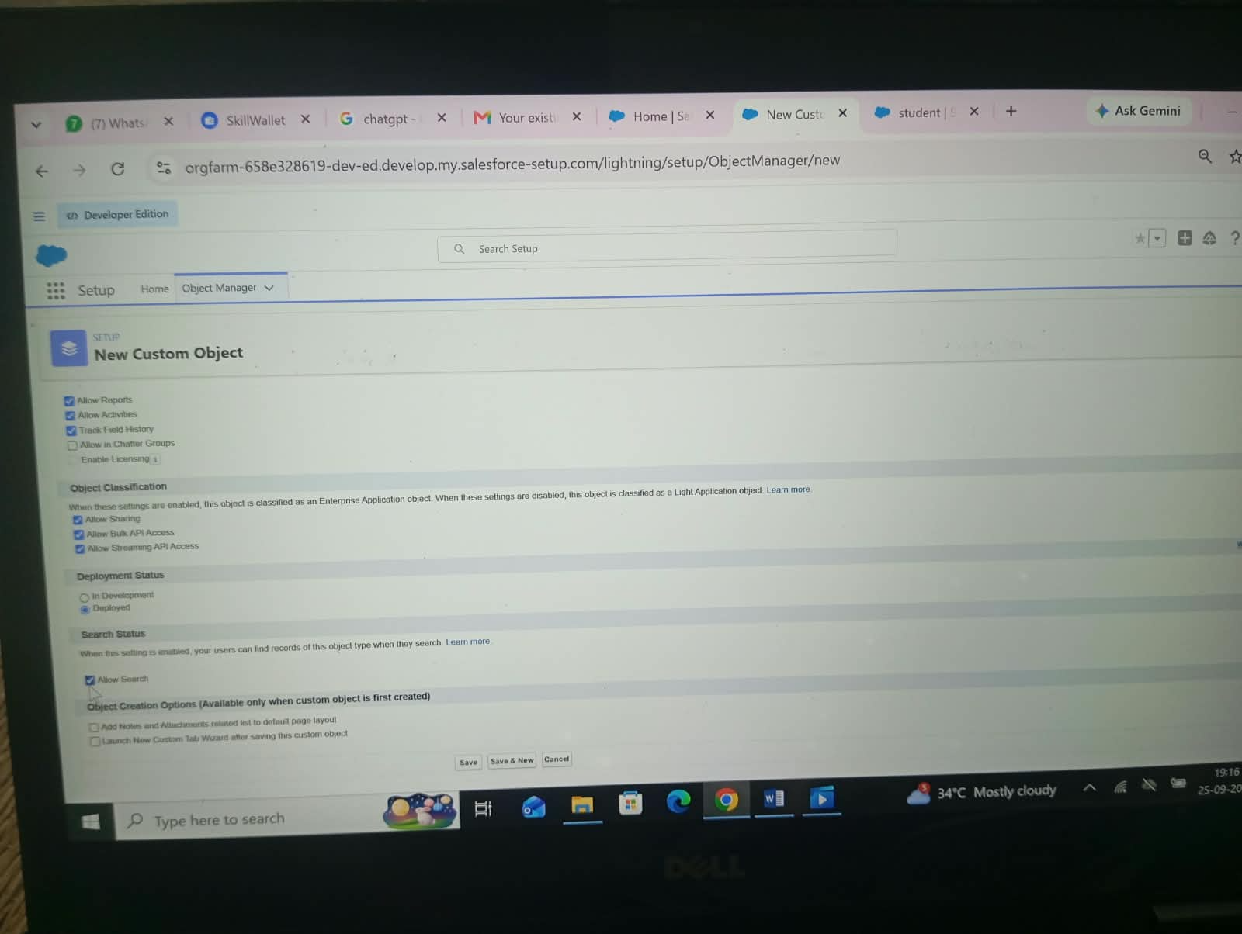
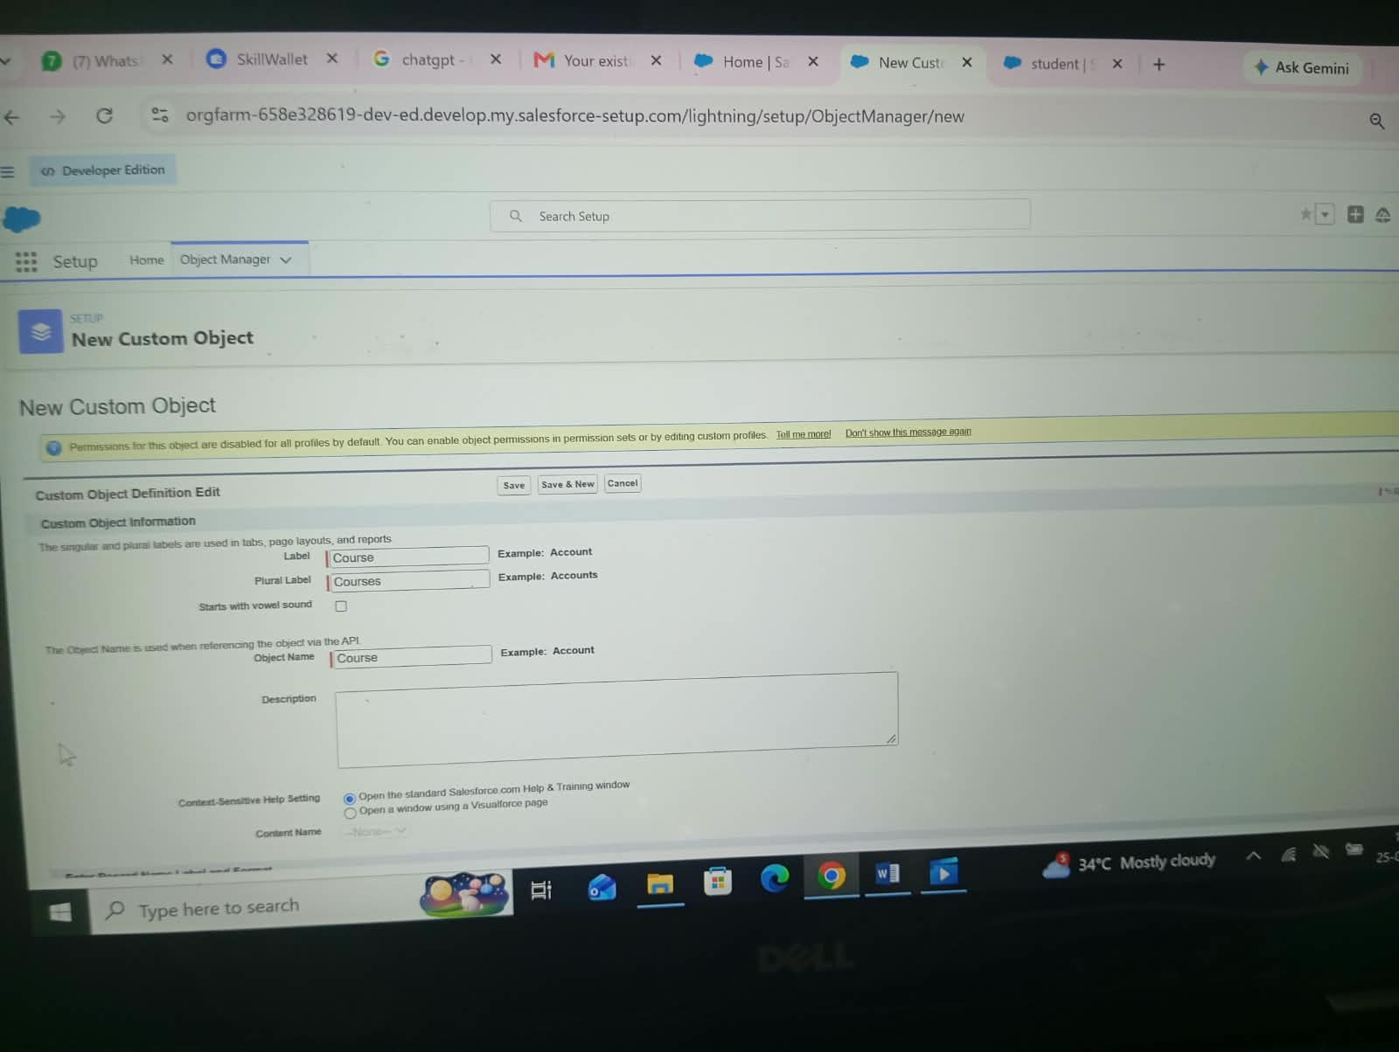
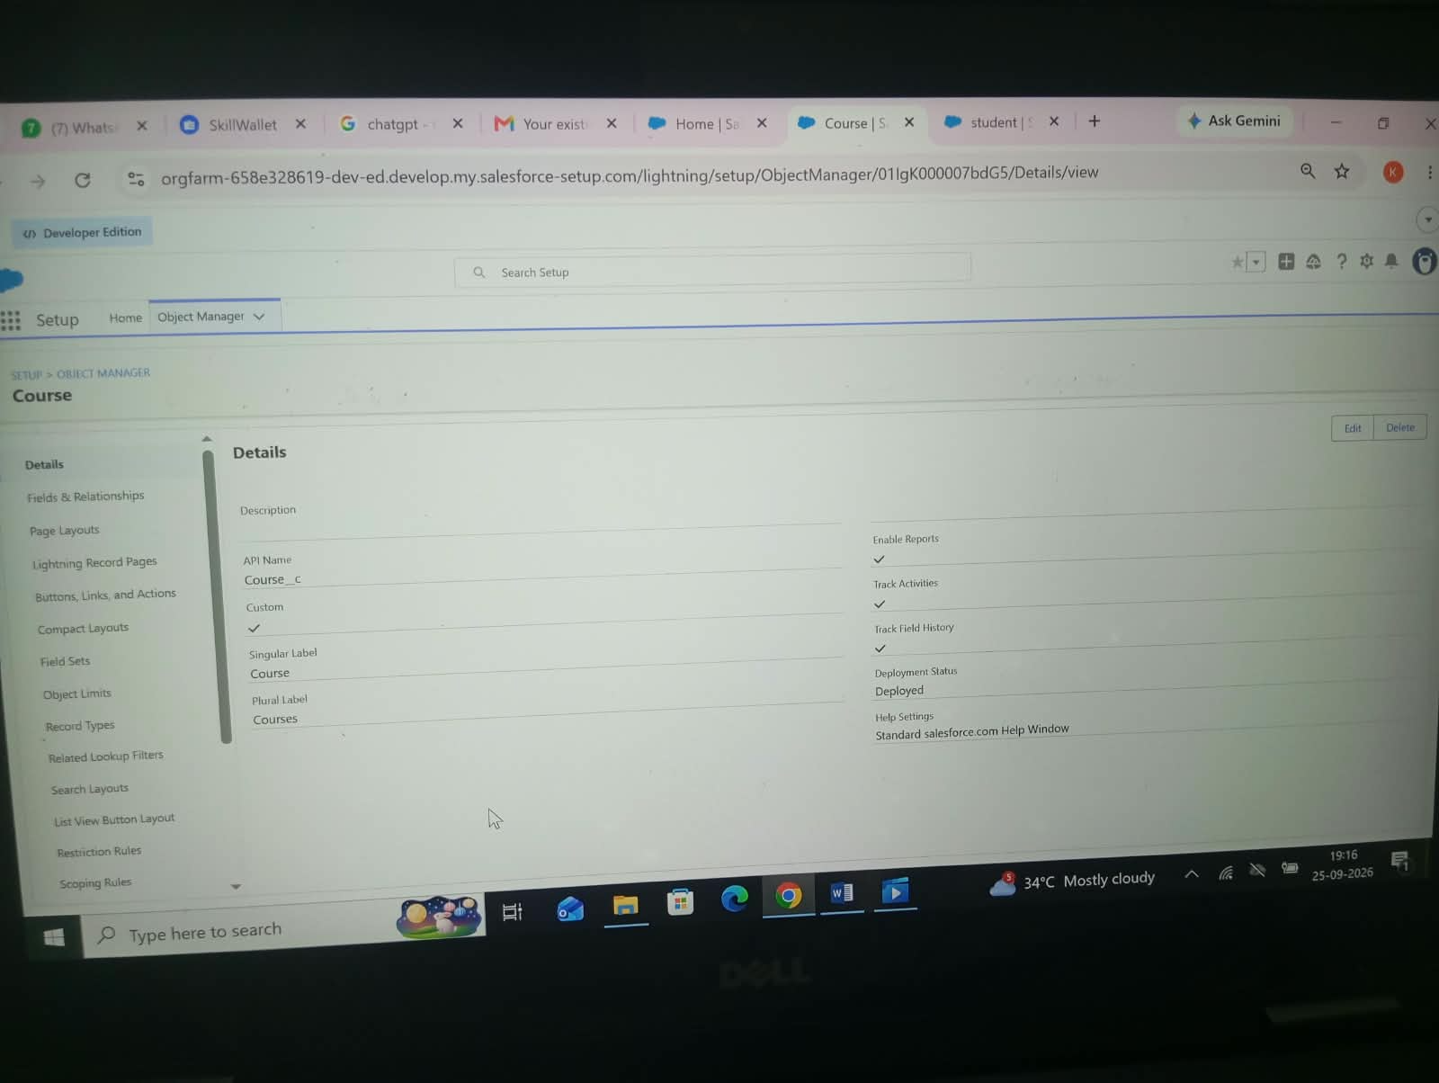

Activity 3: Creating the Instructor Object
The Instructor custom object is intended to maintain instructor information, including name, area of expertise, and contact details.
- Label: Instructor
- Plural Label: Instructors
- Record Name: Instructor Name
After entering the required information, save the object.
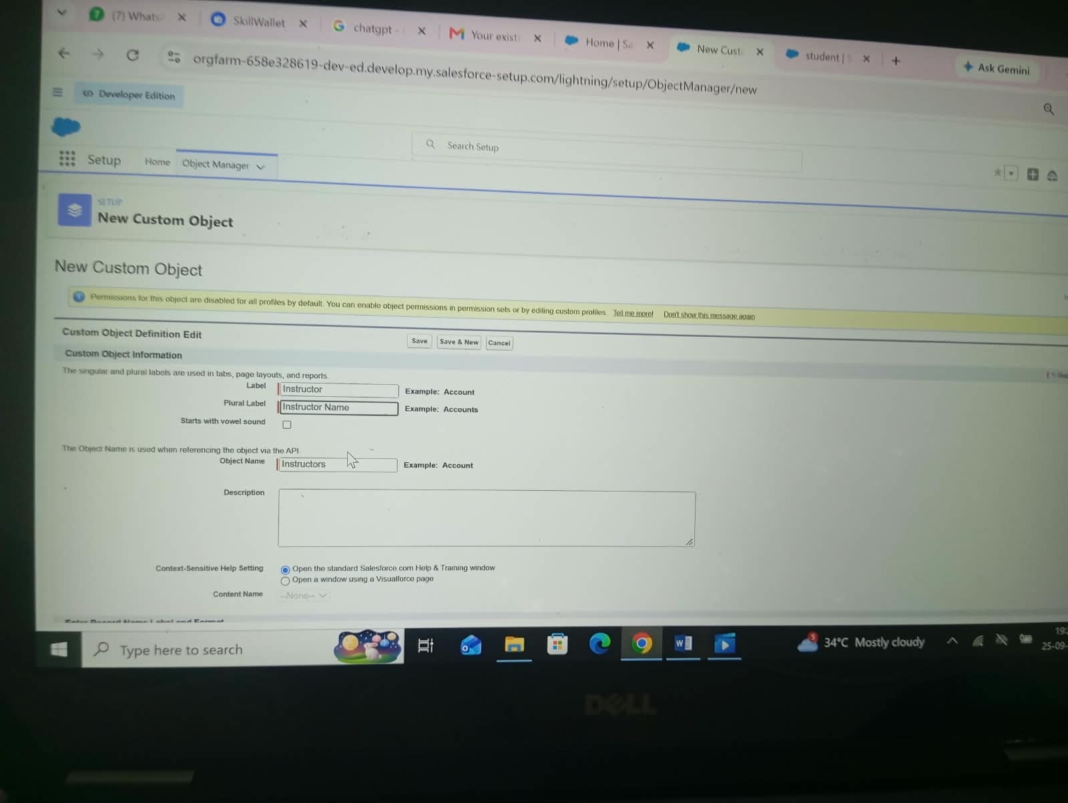

Activity 4: Creating the Enrollment Object
The Enrollment object records the connection between a student and a course. It works as the junction object that links Student and Course records.
- Label: Enrollment
- Plural Label: Enrollments
- Record Name: Enrollment Number
- Data Type: Auto Number
- Format: EN-{0000}
Save the object after completing the configuration.
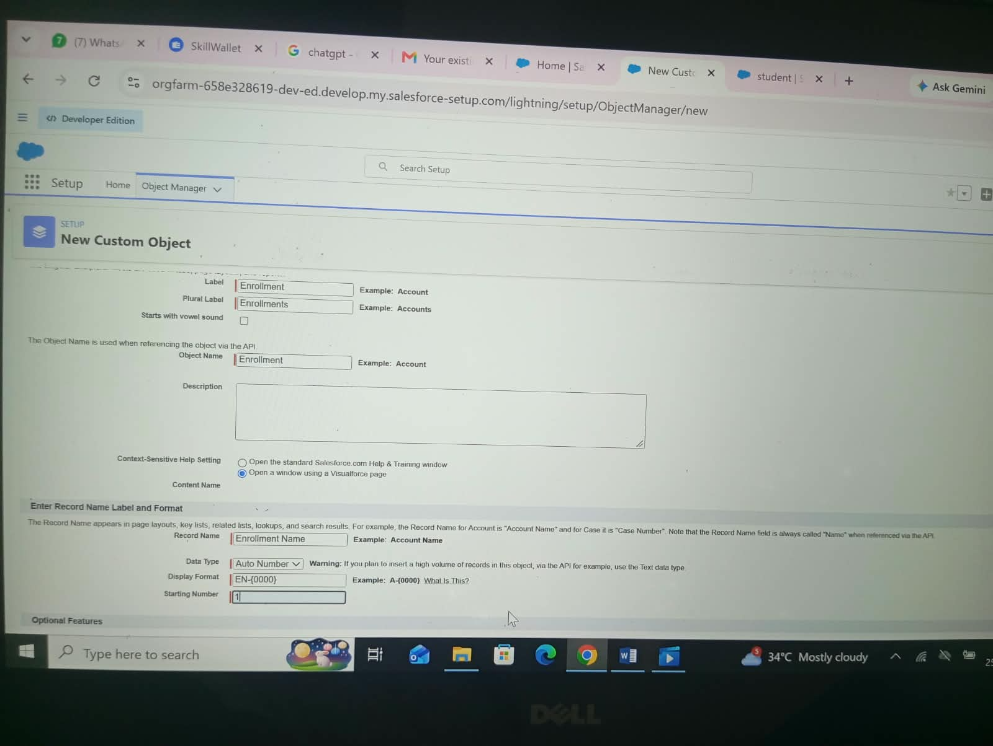

Milestone 3: Tabs Creation

Activity 1: Creating the Student Tab
The Student tab gives users a convenient way to open and manage Student records directly from the application navigation.
Procedure:
- Open Salesforce Setup.
- Search for Tabs in Quick Find and select Tabs.
- Under Custom Object Tabs, click New.
- Choose Student as the object.
- Select a suitable tab style or icon.
- Click Next, Next, and then Save.
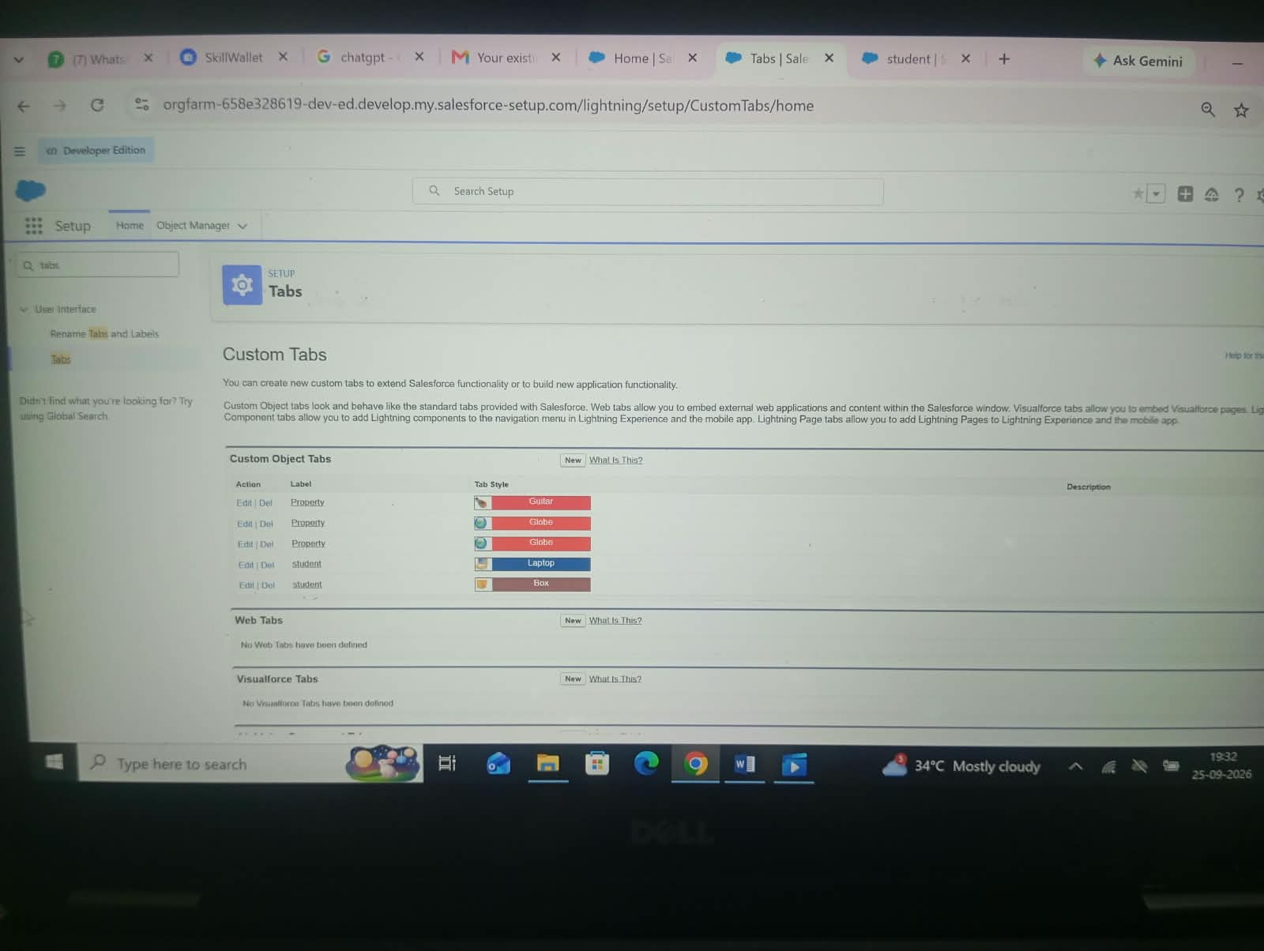

Activity 2: Creating the Course Tab
The Course tab provides quick access to course records so that users can view and maintain course information.
- Open Setup and go to Tabs.
- Under Custom Object Tabs, select New.
- Choose Course as the object.
- Select a tab style.
- Click Next, Next, and Save.
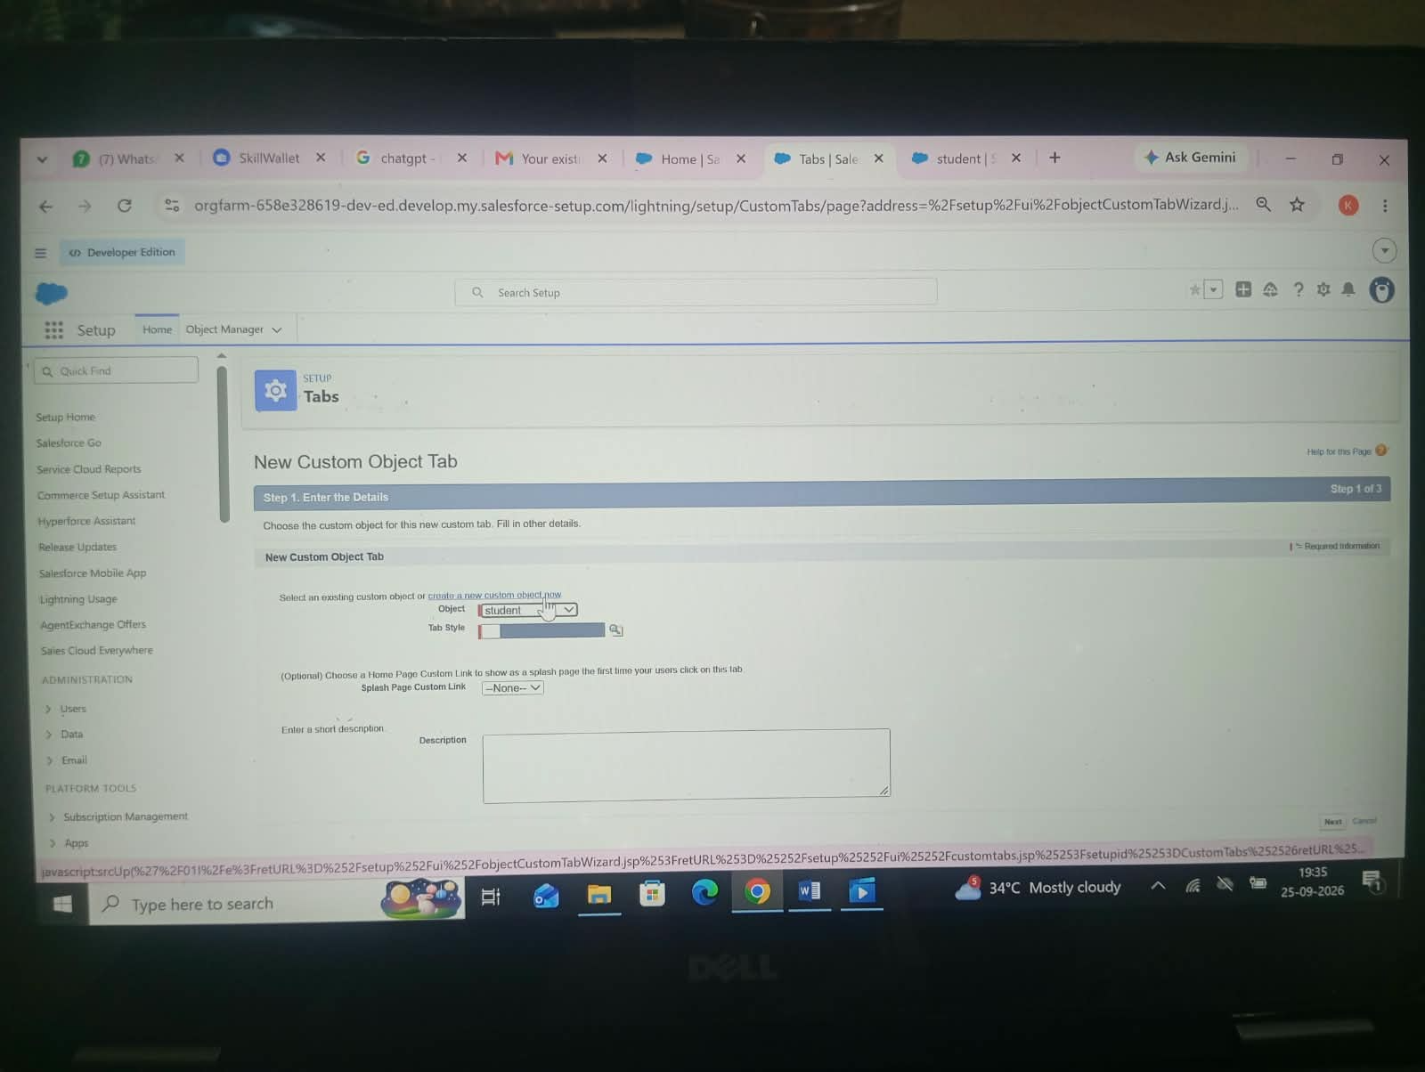

Activity 3: Creating the Enrollment Tab
The Enrollment tab allows users to access and manage enrollment records that connect students with their selected courses.
- Open Setup and select Tabs.
- Click New under the relevant custom object tab section.
- Select Enrollment as the object.
- Choose the required tab style.
- Click Next, Next, and Save.
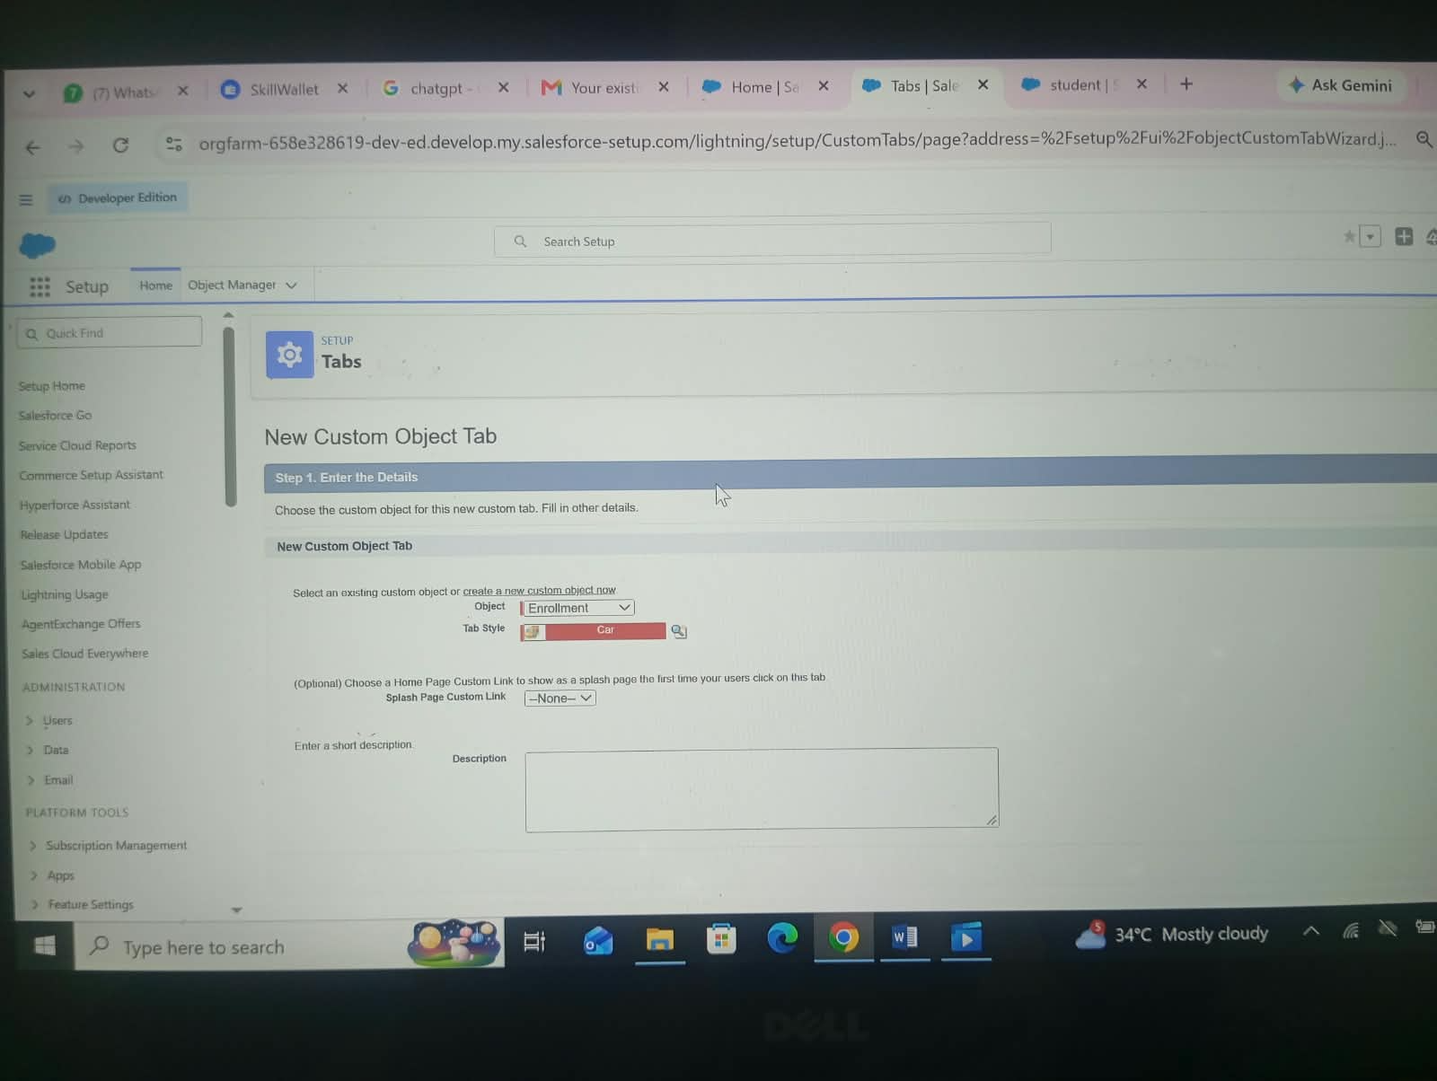

Conclusion
The Student Enrollment & Course Management System developed on Salesforce provides a structured approach to managing academic enrollment activities. During the project, four custom objects—Student, Course, Instructor, and Enrollment—were created along with custom fields, tabs, the Lightning application, object relationships, flows, reports, and dashboards. The implementation demonstrates how a complete CRM-style application can be developed on Salesforce with configuration-based features rather than traditional programming.

PROJECT TEAM DETAILS
Team Lead:
PK - PRAVIKA K
pravika0612@gmail.com
Team Members:
PK - POORVISHA K - poorvisha943@gmail.com
MTK - MONIKA TK - monikatk00@gmail.com
NT - NIVETHA T - tnivetha423@gmail.com
PS - PRIYASHA A - anbupriyasha4@gmail.com
Guided By:
Department of Data Science
Kamban College of Arts and Science for Women
Academic Year: 2024–2027

