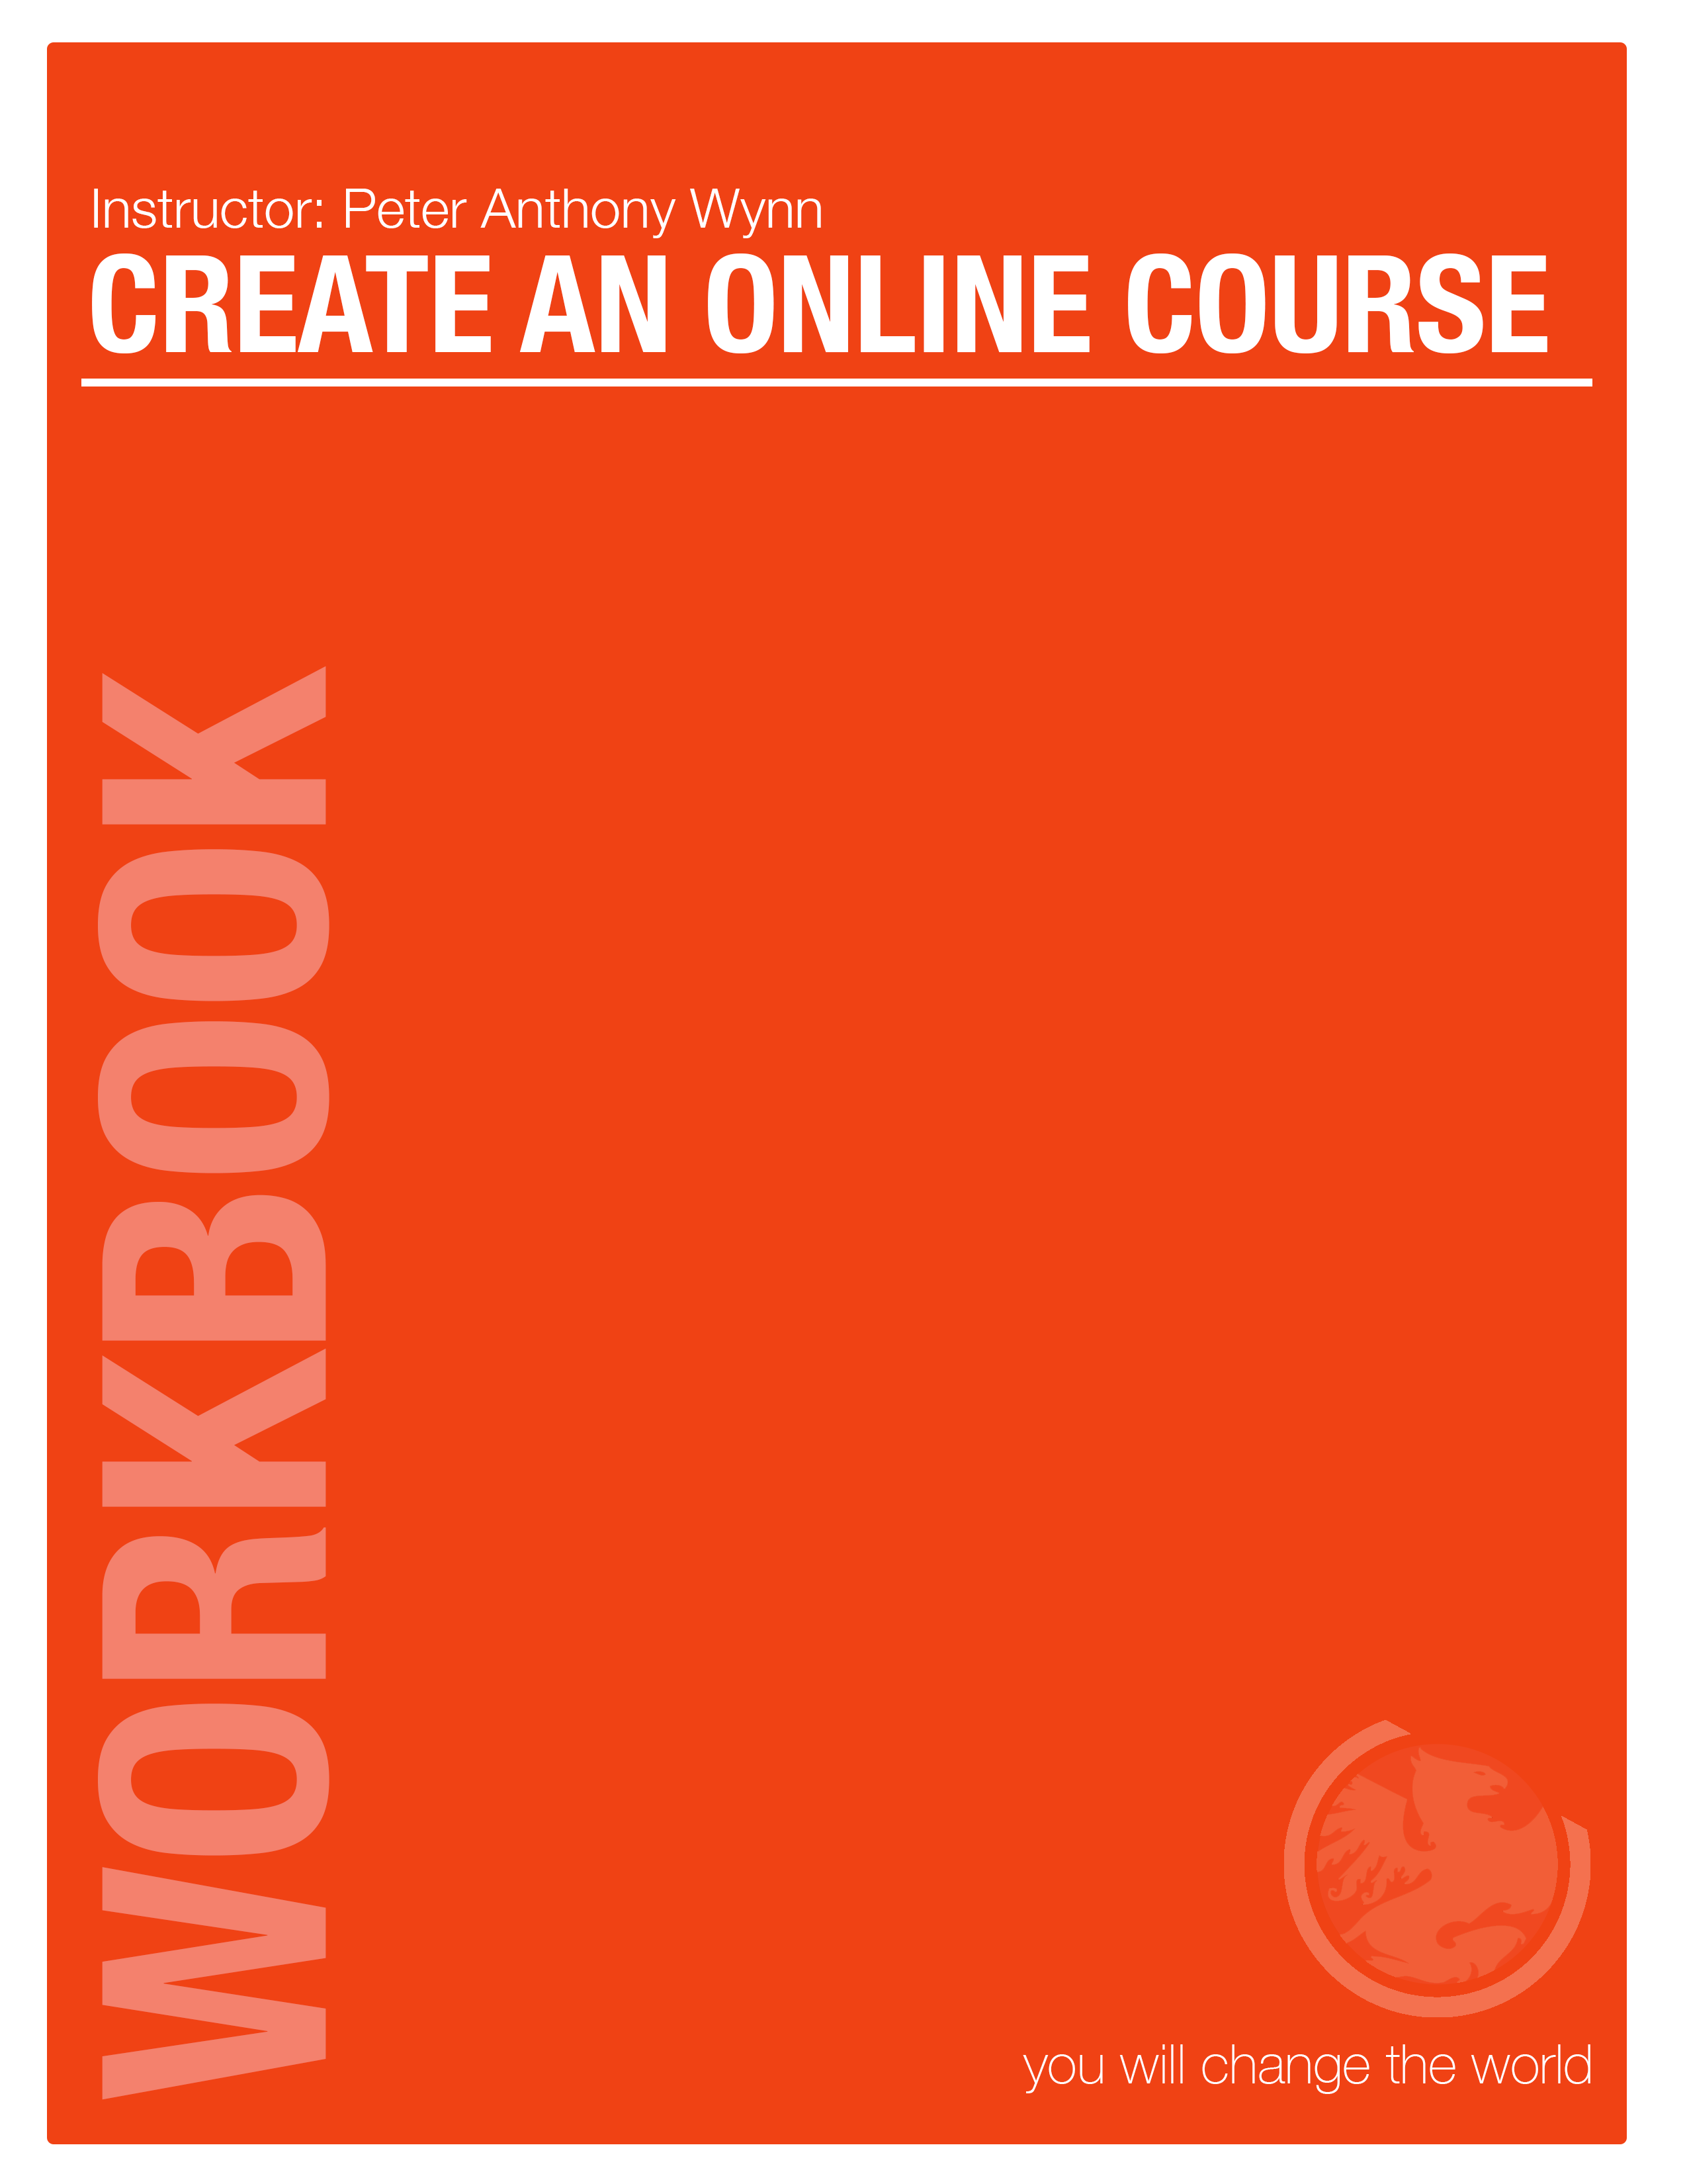

**BEFORE YOU START…**

**PLEASE SAVE THIS DOCUMENT WITH YOUR NAME AND YOUR COURSE TITLE HERE. THIS IS THE FIRST THING YOU WILL DO!**

|  |  |
| --- | --- |
| **NAME:** |  |
| **COURSE TITLE:** |  |

**PREPARATION AND REQUIRED ITEMS**

**TRAILER:** If you are part of the “The Sizzle Reel & Sales mastery Blast Off Package” this applies.

Trailer (this was purchased separately). We will include one generic clip of music, along with captions introducing your course/book. This trailer will be a maximum of 30 - 45 seconds. Please list any of your own elements you will be providing, such as photos, music, captions or voiceovers. If you would like to have any additional slides, pictures or text inserted into your video, we can easily create those transitions. As this changes the type of editing and the time of the editing process, we must know in advance so we can outline if there will be any additional costs associated. Photos should be a high-res jpeg file. Send all elements to: pm@youwillchangetheworld.com

**Your Trailer Elements (supplied by you or us, please be clear for billing purposes):**

* Music: _________________________________________________________________
* Photos: ________________________________________________________________
* Previous Video Footage: __________________________________________________
* Hi Res Logo: ____________________________________________________________

**WORKBOOKS:**

Workbooks should be created before filming to coordinate with your lessons. Please provide a PDF file to make available for download for each workbook. Workbooks will be found throughout the site in TWO PLACES:

• ONE - in the beginning of the COURSE, the entire workbook/manual should be available for download

• TWO - at the beginning of each lesson

Brainstorm elements you will include in your workbooks in the space below.

|  |
| --- |
|  |
|  |
|  |
|  |
|  |
|  |
|  |
|  |
|  |
|  |
|  |
|  |
|  |
|  |
|  |
|  |

**SLIDES & INSERTS:**

We will include one generic clip of intro music in your lesson videos, along with a title introducing the lesson. If you would like to have any additional slides, pictures or text inserted into your video, we can easily create those transitions. As this changes the type of editing and the time of the editing process, we must know in advance so we can outline if there will be any additional costs associated. Please list any of these elements and where they belong in the course.

**Your Lesson Video Elements:**

|  |  |
| --- | --- |
| **Element:** | **Where does it go?** |
|  |  |
|  |  |
|  |  |
|  |  |
|  |  |
|  |  |
|  |  |
|  |  |
|  |  |
|  |  |
|  |  |
|  |  |
|  |  |
|  |  |

**TESTS & QUIZZES:**

Are you going to include tests or quizzes? Each “SECTION” may be followed by a short quiz (we recommend NO MORE then 20 questions T/F, MC are the easiest). Once you have outlined the entire course, the final TEST is simply a reflection of the bullet points that are within each of the “LESSONS”. These assets are only needed if you feel they will ad value to YOUR COURSE. These should also be available in PDF form for downloading.* Send all files to: pm@youwillchangetheworld.com

**Your Tests and Quizzes**

|  |  |
| --- | --- |
| **Test/Quiz Title** | **Where does it go?** |
|  |  |
|  |  |
|  |  |
|  |  |
|  |  |
|  |  |
|  |  |
|  |  |
|  |  |
|  |  |
|  |  |
|  |  |
|  |  |

**CHALLENGES:**

We love engaging the students in challenges within a “LESSON”.

A challenge may be listed below the video and should be included and covered in the outline AS WELL.

Now here is your blank canvas… have fun creating!

|  |  |
| --- | --- |
|  |  |
|  |  |
|  |  |
|  |  |
|  |  |
|  |  |
|  |  |
|  |  |
|  |  |
|  |  |
|  |  |
|  |  |
|  |  |
|  |  |

**PITCH VIDEO (AKA TRAILER)**

**THE COURSE:**

(Place name of your course here, working title only)

Here is where the COURSE “WELCOME” VIDEO will be - simply an overview of amazing expectations that will be met during your student’s time with you. This should simply explain the entire course USING THE BULLET POINTS OF SECTION TITLES ONLY and thank people for choosing to take the journey with you. This video is an OVERVIEW where you LIGHTLY touch on the headings of each section and the importance of taking your time with each lesson and working on the challenges and actions items that they will need to succeed. 2-4 minutes total.

|  |
| --- |
|  |
|  |
|  |
|  |
|  |
|  |
|  |
|  |
|  |
|  |
|  |
|  |
|  |
|  |
|  |
|  |

**FREE COURSE INTRO VIDEO**

(write your course name here)

This Video is a simple teaser Video that will be in the front of the “FREE” course which is only three lessons. The free course is the ‘1st date’. It is here where you seduce

|  |  |
| --- | --- |
| BULLET POINT: |  |
| BULLET POINT: |  |
| BULLET POINT: |  |
| BULLET POINT: |  |
| BULLET POINT: |  |
| BULLET POINT: |  |
| BULLET POINT: |  |
| BULLET POINT: |  |

**FREE COURSE LESSON 1**

|  |
| --- |
| (write your lesson name here) |

This is a bonus session, it should excite people about what you are doing and how you are doing it … give them a meditation through the bonus. 2 -3 bonus videos lessons. 4-6 minute videos.

|  |  |
| --- | --- |
| BULLET POINT: |  |
| BULLET POINT: |  |
| BULLET POINT: |  |
| BULLET POINT: |  |
| BULLET POINT: |  |
| BULLET POINT: |  |
| BULLET POINT: |  |
| BULLET POINT: |  |

**DESCRIPTION:**

You must create a 3 sentence description for EVERY lesson before shooting.

|  |
| --- |
|  |
|  |
|  |
|  |

**FREE COURSE LESSON 2**

|  |
| --- |
| (write your lesson name here) |

This is a bonus session, it should excite people about what you are doing and how you are doing it … give them a meditation through the bonus. 2 -3 bonus videos lessons. 4-6 minute videos.

|  |  |
| --- | --- |
| BULLET POINT: |  |
| BULLET POINT: |  |
| BULLET POINT: |  |
| BULLET POINT: |  |
| BULLET POINT: |  |
| BULLET POINT: |  |
| BULLET POINT: |  |
| BULLET POINT: |  |

**DESCRIPTION:**

You must create a 3 sentence description for EVERY lesson before shooting.

|  |
| --- |
|  |
|  |
|  |
|  |

**FREE COURSE LESSON 3**

|  |
| --- |
| (write your lesson name here) |

This is a bonus session, it should excite people about what you are doing and how you are doing it … give them a meditation through the bonus. 2 -3 bonus videos lessons. 4-6 minute videos.

|  |  |
| --- | --- |
| BULLET POINT: |  |
| BULLET POINT: |  |
| BULLET POINT: |  |
| BULLET POINT: |  |
| BULLET POINT: |  |
| BULLET POINT: |  |
| BULLET POINT: |  |
| BULLET POINT: |  |

**DESCRIPTION:**

You must create a 3 sentence description for EVERY lesson before shooting.

|  |
| --- |
|  |
|  |
|  |
|  |

This concludes your course! Prior to shooting you will need to have rehearsed each section several times and the presupposition is that ***you are an expert*** at each component. The most experiences presenters are the ones that have the most challenges as they are used to being more ‘scripted’ and tend to be seen as LESS sincere. The quality of your course is NOT in the complete polish of your product but rather the vulnerability of the product. Allowing the audience to see you in such a way that they can relate to you and making sure you are connecting to them in this way. Look at the MOST POPULAR you tube people, they are the least polished and the most “AVERAGE”.

**KEY HINT #1:** People do not know WHAT YOU FORGOT to share, they only know what you have shared. Worry less about being perfect and more about being sincere and sharing what will MAKE A DIFFERENCE. The reason we use bullet points and NOT SCRIPTS is because the stories you share and the lessons should be something that YOU HAVE PRACTICED. This is your leadership role and it is important.