Software Requirements Specification
for
Event Management System
Version 1.0 approved
Prepared by:
Devanshish Ganatra
Riya Gattani
Pravin Jadhao
Prasad Ingle
Pranav Ingle>
Department of Information Technology
Vishwakarma Institute of Technology College of Engineering, Pune
24/02/26
Table of Contents
Table of Contents ii
Revision History ii
1. Introduction 1
1.1 Purpose 1
1.2 Document Conventions 1
1.3 Intended Audience and Reading Suggestions 1
1.4 Product Scope 1
1.5 References 1
2. Overall Description 2
2.1 Product Perspective 2
2.2 Product Functions 2
2.3 User Classes and Characteristics 2
2.4 Operating Environment 2
2.5 Design and Implementation Constraints 2
2.6 User Documentation 2
2.7 Assumptions and Dependencies 3
3. External Interface Requirements 3
3.1 User Interfaces 3
3.2 Hardware Interfaces 3
3.3 Software Interfaces 3
3.4 Communications Interfaces 3
4. System Features 4
4.1 System Feature 1 4
4.2 System Feature 2 (and so on) 4
5. Other Nonfunctional Requirements 4
5.1 Performance Requirements 4
5.2 Safety Requirements 5
5.3 Security Requirements 5
5.4 Software Quality Attributes 5
5.5 Business Rules 5
6. Other Requirements 5
Appendix A: Glossary 5
Appendix B: Analysis Models 5
Appendix C: To Be Determined List 6

Revision History
Name | Date | Reason For Changes | Version

Introduction

Purpose
This Software Requirements Specification (SRS) document describes the requirements for the Event Management System (EMS), Version 1.0.
The system is a web-based application designed to help administrators and event organizers create, manage, and monitor events, while allowing users to browse, register, and book tickets for events.
This SRS defines the functional and non-functional requirements of the complete system, including user authentication, event management, booking, and notification features. The document serves as a reference for developers, testers, and stakeholders during system design, implementation, and testing.

Document Conventions
In this document, requirements for the Event Management System are numbered sequentially (REQ-1, REQ-2, etc.) to clearly identify each system function such as registration, event creation, booking, and notifications. Each system feature is organized under Section 4 and divided into description, interaction flow, and functional requirements for clarity.
The term “shall” is used to indicate mandatory system behavior. User roles such as Admin, Organizer, and Attendee are consistently referenced throughout the document. Functional requirements are grouped feature-wise to reflect the modular structure of the system.

Intended Audience and Reading Suggestions
This document is intended for the development team building the Event Management System, the project guide/supervisor reviewing the project, testers validating event-related functionalities, and future maintainers of the system. Organizers and administrators may also refer to this document to understand system capabilities such as event creation, booking management, and reporting features.
The document is structured to first explain the overall working of the Event Management System, followed by detailed descriptions of features such as user registration, event management, booking, and notifications. Readers should begin with the Introduction and Overall Description to understand the system’s purpose, then review the System Features section for detailed functional behavior, and finally refer to Non-Functional Requirements for performance and security constraints.

Product Scope
The Event Management System (EMS) is a web-based application designed to simplify the process of creating, managing, and participating in events. The system enables organizers to schedule events, manage registrations, and communicate with attendees, while users can browse events, book tickets, and receive notifications.
The primary objective of the system is to improve event organization efficiency, reduce manual work, and enhance user experience through centralized event management. The system supports institutional and organizational goals by providing a scalable digital platform for managing events and increasing participation.

References
The following documents and standards were referred to while preparing this SRS:
- IEEE Software Requirements Specification Template by Karl E. Wiegers, Version 1999
- UML Modeling Standards for system design diagrams
- Software Engineering textbooks and lecture notes used for academic reference
- Use Case and System Design documents prepared for the Event Management System project

Overall Description

Product Perspective
The Event Management System (EMS) is a new, standalone web-based application developed to automate and simplify event organization and participation processes. It replaces traditional manual methods of event registration and management by providing a centralized digital platform for organizers and attendees.
The system interacts with external components such as a database for storing event and user information, email services for notifications, and optional payment gateways for ticket processing. EMS functions as an independent system but can be integrated with institutional websites or mobile applications for broader accessibility.

Product Functions
The Event Management System provides the following major functions:
- User registration and login for secure access
- Event creation, modification, and cancellation by organizers
- Browsing and searching events by users
- Online event registration and ticket booking
- Sending notifications and reminders to participants
- Admin management of users, events, and system data

User Classes and Characteristics
The Event Management System supports the following user classes:
- Admin: Has full system access, manages users, events, and system settings. Requires moderate technical knowledge and uses the system frequently.
- Event Organizer: Creates, updates, and monitors events and registrations. Requires basic technical skills and is a primary user of the system.
- Attendee/User: Browses events, registers, and books tickets. Requires minimal technical knowledge and interacts with the system occasionally.

Operating Environment
The Event Management System operates in a web-based environment accessible through standard web browsers such as Chrome, Edge, and Firefox. The system can run on hardware platforms including desktop computers, laptops, and mobile devices with internet connectivity.
The backend server operates on operating systems such as Windows or Linux and uses a relational database (e.g., MySQL) for data storage. The system is designed to coexist with external services such as email servers and optional payment gateways for notifications and transaction processing.

Design and Implementation Constraints
The development of the Event Management System is subject to certain constraints, including the requirement to be implemented as a web-based application using standard web technologies and a relational database such as MySQL. The system must support secure authentication and follow basic security practices for data protection.
Additional constraints include limited hosting resources, compatibility with multiple browsers and devices, and integration with external services such as email notifications and optional payment gateways. The system should also follow standard programming conventions and institutional guidelines for maintainability and scalability.

User Documentation
The Event Management System will include the following user documentation to assist different users:
- A User Manual describing system features and usage steps
- An Admin Guide explaining administrative operations and system management
- Online Help and FAQs integrated within the application interface

Assumptions and Dependencies
The development of the Event Management System assumes that users have stable internet connectivity and access to compatible web browsers for system usage. It is also assumed that organizers possess basic technical knowledge to create and manage events effectively.
The system depends on external components such as database servers for data storage, email services for notifications, and optional payment gateway integration for ticket transactions. Any changes or unavailability of these external services may impact system functionality and performance.

External Interface Requirements

User Interfaces
The Event Management System provides a web-based graphical user interface accessible through standard browsers. The interface includes login and registration pages, event listing screens, event creation forms for organizers, booking interfaces for users, and an admin dashboard for system management.
The UI follows a simple and responsive design with standard navigation menus, form validation, and error message displays to ensure usability. Common elements such as help options, confirmation messages, and consistent layout are provided across all screens. Detailed UI design specifications and screen mockups are documented separately.

Hardware Interfaces
The Event Management System interacts with standard hardware devices including desktop computers, laptops, and mobile devices used by administrators, organizers, and attendees. The system operates through web browsers and requires input devices such as keyboards, touchscreens, and pointing devices for user interaction.
On the server side, the system interfaces with hosting hardware that manages data processing and storage through a database server. No specialized hardware components are required, and communication between client devices and the server occurs via standard internet protocols.

Software Interfaces
The Event Management System interfaces with several software components to support its functionality. The system connects to a relational database (e.g., MySQL) for storing user details, event information, and booking records. It operates on server-side platforms such as Windows or Linux and utilizes standard web technologies and libraries for application development.
The system may integrate with external email services to send notifications and optional payment gateway APIs for ticket transactions. Data exchanged between these components includes user credentials, event details, booking confirmations, and notification messages, communicated through secure web protocols and API calls.

Communications Interfaces
The Event Management System communicates with users and external services through standard web technologies. Interaction between client devices and the server is carried out using HTTP/HTTPS protocols via web browsers. The system also uses email services to send notifications such as registration confirmations, booking details, and event reminders.
Data exchanged between system components is formatted in standard web formats (e.g., JSON/HTML) and transmitted securely using encryption mechanisms such as HTTPS. Reliable network connectivity is required to ensure proper synchronization of event data and real-time updates across users and system modules.

System Features

User Registration and Login
4.1.1 Description and Priority:
This feature allows users to create accounts and log in to the system.
Priority: High
4.1.2 Stimulus / Response Sequences:
- User action → System response
- User enters login details → System validates credentials.
- User enters wrong password → System displays error message.
4.1.3 Functional Requirements:
REQ-1: The system shall allow users to register.
REQ-2: The system shall validate login credentials.
REQ-3: The system shall display error message for invalid input.

Event Management
4.2.1 Description and Priority:
This feature allows organizers to create, update, and cancel events in the system. It enables management of event details such as date, time, venue, and capacity.
Priority: High
4.2.2 Stimulus / Response Sequences:
- Organizer enters event details → System validates and saves event
- Organizer updates event information → System updates database
- Organizer cancels event → System notifies registered users
4.2.3 Functional Requirements
REQ-5: The system shall allow organizers to create new events.
REQ-6: The system shall allow organizers to edit event details.
REQ-7: The system shall allow organizers to delete or cancel events.
REQ-8: The system shall validate mandatory event fields before saving.

Event Booking

Description and Priority:
This feature allows users to browse available events and book tickets online. It ensures confirmation and proper record maintenance of bookings.
Priority: High

Stimulus / Response Sequences:
User selects event → System displays event details
User clicks “Book” → System processes booking
Booking successful → Confirmation message displayed

Functional Requirements:
REQ-9: The system shall allow users to view available events.
REQ-10: The system shall allow users to book tickets for events.
REQ-11: The system shall generate booking confirmation.
REQ-12: The system shall prevent booking if event capacity is full.

Notification System

Description and Priority:
This feature sends notifications and reminders to users regarding bookings and upcoming events.
Priority: Medium

Stimulus / Response Sequences:
Booking confirmed → System sends confirmation email
Event date approaching → System sends reminder

Functional Requirements
REQ-13: The system shall send booking confirmation emails.
REQ-14: The system shall send event reminder notifications.
REQ-15: The system shall notify users if an event is cancelled.

Other Nonfunctional Requirements

Performance Requirements
Metric | Target
API Response Time | < 2 seconds under normal load
Concurrent Users Supported | 100,000+
QR Scan Latency (if applicable) | < 500 ms

Safety Requirements
The Event Management System must ensure the safety and security of users, event data, and system operations. Key requirements include:
- Data Security: Personal and payment information must be encrypted and protected against unauthorized access.
- Access Control: Only authenticated users with appropriate roles may perform sensitive actions (e.g., create, modify, or cancel events).
- System Reliability: The system must prevent data loss during high traffic periods or unexpected failures.
- Regulatory Compliance: The system must adhere to relevant data protection laws and IT security standards.
- Preventive Measures: Actions that may compromise user safety or privacy must be restricted.

Security Requirements
- AES-256 encryption for all stored sensitive data
- TLS 1.3 for all data in transit
- Role-based access control (RBAC) enforced at both middleware and API level
- Compliance with OWASP Top-10 security guidelines
- Passwords stored only as bcrypt hashes; plaintext storage is prohibited

Software Quality Attributes
The Event Management System shall meet the following quality standards:
- Usability: Intuitive interface; ≥90% of users complete key tasks without assistance.
- Reliability/Availability: Operational ≥98% of the time; minimal downtime during peak periods.
- Performance: Page loads and transactions ≤2 seconds under normal load.
- Security: Role-based access; sensitive data encrypted; compliant with privacy regulations.
- Maintainability: Modular design with documentation for easy updates and bug fixes.
- Portability: Compatible with major web browsers and mobile devices.
- Interoperability: Integrates with payment gateways, notifications, and calendar services.
- Robustness: Handles invalid inputs or network failures without crashes.
- Testability: Supports automated testing for verification of correctness.
Priority: Ease of use and data security are prioritized over other attributes.

Business Rules
- Role-Based Actions: Only admins can approve events, manage user accounts, and generate system reports. Organizers can create, update, or cancel events they own. Attendees can register for events but cannot modify event details.
- Event Registration Limits: Attendees cannot register for events beyond the maximum capacity defined by the organizer.
- Payment Enforcement: Events requiring payment must be confirmed only after successful transaction completion.
- Cancellation Policy: Organizers may cancel events only within defined deadlines; attendees can request refunds according to the event’s cancellation policy.
- Notification Rules: The system shall notify users about event changes, registration confirmations, or cancellations via email/SMS.
- Data Privacy Compliance: Users’ personal and payment information must be handled according to applicable privacy regulations (e.g., GDPR).

Other Requirements
- The system shall use MySQL as the backend database to store user, event, booking, and payment data.
- The application shall be developed using Java (Spring Boot) for backend and HTML, CSS, and JavaScript for frontend.
- The system shall implement role-based access control for Admin, Event Organizer, and Attendee.
- All users must authenticate before accessing booking and management features.
- User passwords shall be stored in encrypted format.
- The system shall integrate with a secure third-party payment gateway for processing transactions.
- Event browsing pages shall load within 3 seconds under normal conditions.
- The system shall support at least 300 concurrent users.
- Ticket confirmation shall be generated immediately after successful payment.
- The system shall maintain transaction records for audit and reference purposes.

Appendix A: Glossary
Admin – System administrator responsible for managing users, approving events, generating reports, and monitoring the system.
- Event Organizer – User who creates, updates, and manages events.
- Attendee – User who browses events and books tickets.
- SRS – Software Requirements Specification document.
- UI – User Interface of the Event Management System.
- ID – Unique Identifier assigned to users and events.
- Authentication – Process of verifying user identity using login credentials.
- Authorization – Process of granting access rights based on user role.
- Payment Gateway – External third-party service used to process online payments.
- Booking – Process of reserving tickets for an event.
- Ticket Confirmation – Confirmation generated after successful payment.
- Seat Availability – Status indicating whether tickets are available for booking.
- Transaction – Record of a completed payment process.
- Activity Diagram – UML diagram representing the workflow of the ticket booking and payment process.
- Use Case Diagram – UML diagram representing interactions between actors and the system.
- CRUD – Create, Read, Update, Delete operations performed on events.
Appendix B: Analysis Models
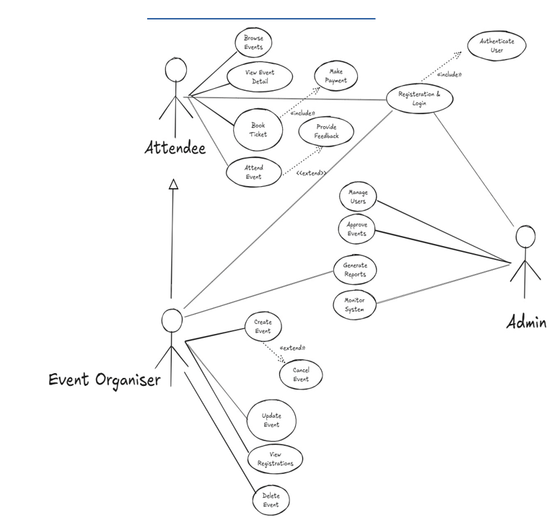

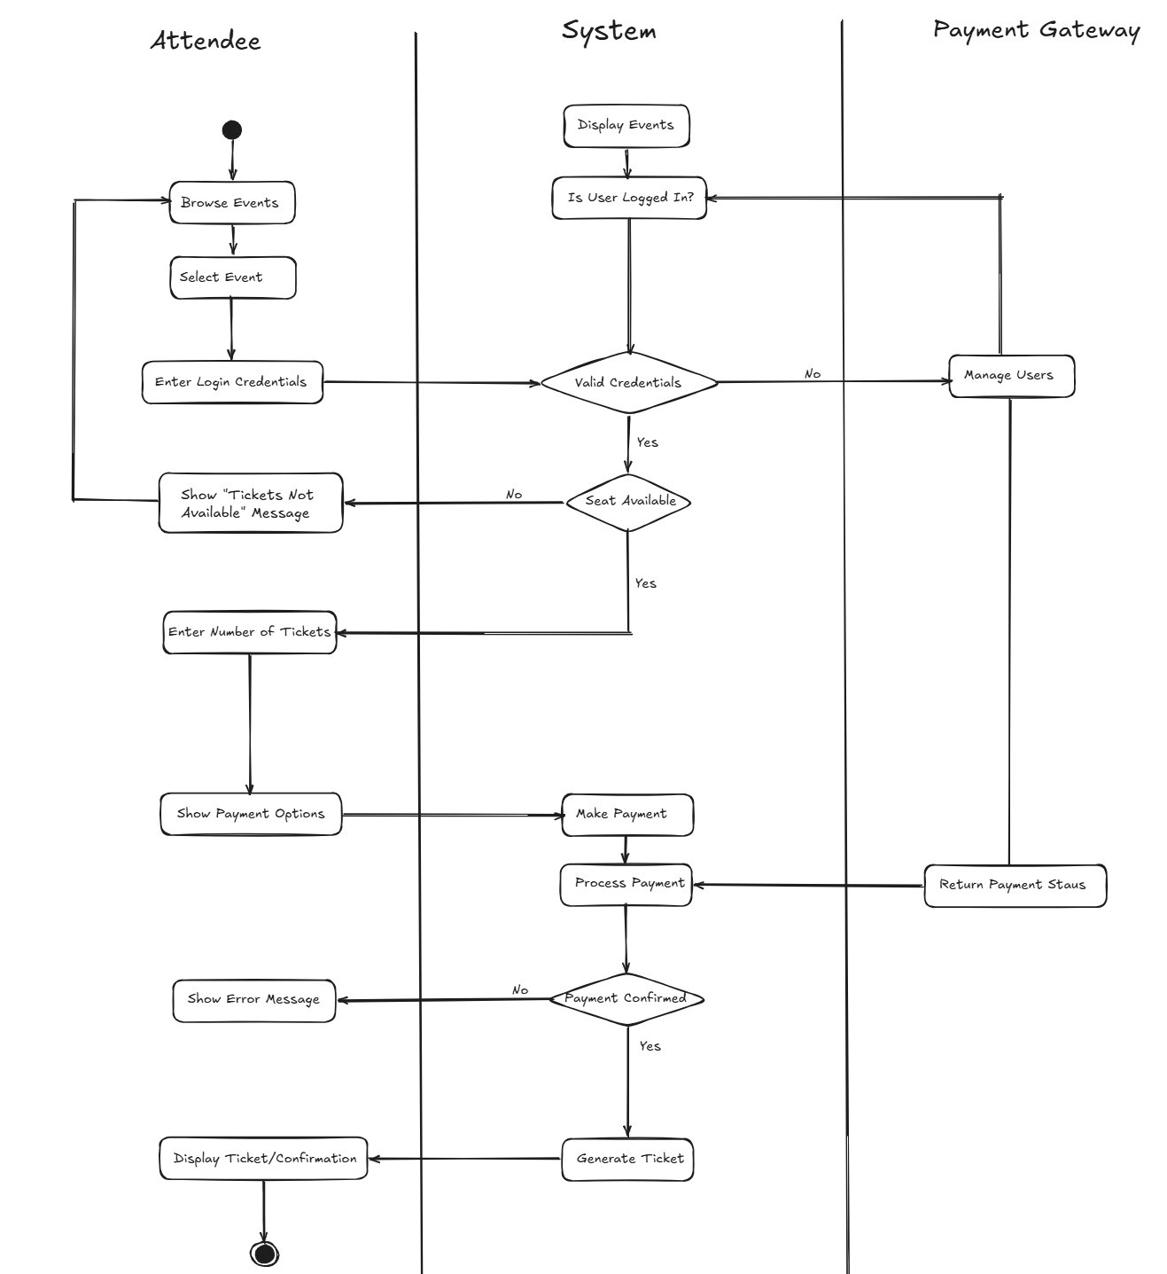

Appendix C: To Be Determined List
- Final selection of payment gateway provider (e.g., Razorpay, Stripe, PayPal).
- Maximum number of concurrent users the system must support in production.
- Cloud hosting platform selection (AWS, Azure, or local server deployment).
- Email/SMS notification integration for ticket confirmation and event updates.
- Refund policy implementation for cancelled tickets.
- Advanced reporting features for Admin (analytics dashboard).
- Mobile application version development (future enhancement).
- Multi-language support for the user interface.
- Implementation of QR code generation for ticket verification.
- Data retention duration for transaction and user records.

