MediAssist AI Project Documentation
Plain language guide for students, faculty, and clinicians
Code version reviewed 5 October 2026. This document describes the repository, not a clinically validated or live deployed service.
MediAssist AI lets a patient enter symptoms or upload a skin image or chest X ray, see an AI screening result, and find nearby care. A doctor can request access with the Patient ID after an in person visit. The patient must approve that request before the doctor can review records or add notes. AI never confirms a diagnosis or writes a prescription.

1 Problem and purpose
Patients often struggle to describe symptoms, understand whether a result needs prompt attention, and carry information between a self check and a doctor visit. This project places those steps in one prototype. Its purpose is to support a conversation with a qualified professional, not to replace that professional.
- Patient first: the patient runs the AI screening and sees the result before any doctor joins.
- Clear next step: the app shows a decision tier and nearby mapped care locations when review may be needed.
- Connected follow up: a patient approved doctor account can review the case and send written notes back to the patient portal.

2 Main workflow
- The patient creates an account and receives a unique Patient ID beginning with PAT.
- The patient enters symptoms, speaks into the browser microphone, or uploads a supported skin image or chest X ray. A red flag checklist asks about emergency warning signs before symptom analysis.
- The React portal sends the input to the local Flask AI service. The service uses the appropriate model and returns ranked outputs, a model score, an explanation when available, and a decision tier.
- The patient sees guidance. For critical results, the app says to seek emergency care rather than wait online. For high urgency, moderate, or uncertain results, nearby care search is available.
- The patient chooses a real world doctor or clinic and visits. OpenStreetMap listings do not prove that a professional is registered in this app or licensed.
- At the visit, the doctor enters the Patient ID in a doctor role account. This sends a request to the patient portal. It does not reveal the medical record yet.
- The patient checks the requesting account name and approves or declines it. After approval, the doctor can review the case and add follow up, checkup, or report notes. The patient can read these notes and later revoke access.
The request states are requested, accepted, completed, and cancelled. A doctor can complete an accepted visit; the patient can decline a pending request or revoke an active one. Completed and cancelled requests no longer provide new record access.

3 Architecture
The browser interface is built with React. Flask handles AI inference and map queries. Supabase stores accounts, submissions, access requests, notes, and private medical files. OpenStreetMap supplies the mapped care locations. The models are separate; the application does not train one joint multimodal model.
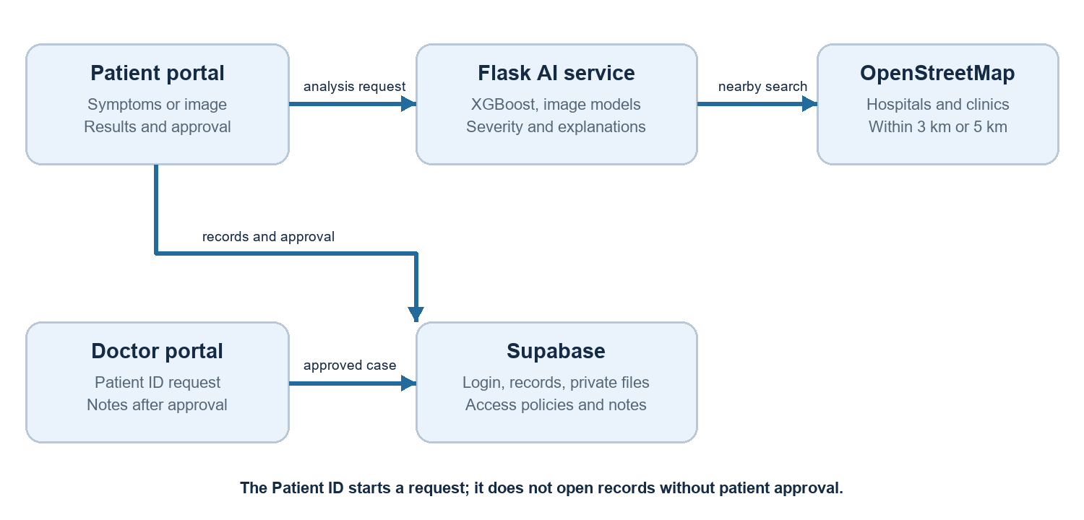

4 What each AI model does
Input | Model and output | Explanation
Symptoms | XGBoost classifies a vector of supported symptoms into one of 41 dataset condition labels. | Tree SHAP shows which recognized symptom features influenced the selected class.
Skin image | MobileNetV2 predicts among seven skin lesion classes from a resized image. | Grad CAM heatmap highlights image regions influencing the selected class.
Chest X ray | DenseNet 121 produces 14 separate finding scores from a resized image. | Grad CAM highlights regions influencing a chosen finding.

The symptom model recognizes only its saved vocabulary of 131 symptom features. If no entered terms match, it returns an error instead of inventing a prediction. The skin and chest models work on 224 by 224 pixel images. Browser speech input uses the browser's speech recognition; a separate local Whisper audio endpoint also exists, but is not the browser microphone path.
The three datasets are separate and unpaired. The optional case synthesis endpoint can list their results and select the highest reported urgency tier. It does not create a combined disease probability or a new multimodal diagnosis.

5 Model scores and severity
A displayed model score describes how strongly a model ranked one of its learned classes for that input. It is not a measured chance that the person has the disease. A doctor must consider history, examination, vital signs, and tests.
Score or finding | Project decision rule
Below 0.40 | For symptom and skin models, mark the result uncertain.
0.40 to below 0.50 | Treat the signal as borderline or uncertain.
0.50 or higher | Use the predicted condition's configured risk category for the tier.
Chest X ray | Evaluate each finding separately. A finding at or above 0.50 can enter the risk map; ambiguous patterns become uncertain.

The 0.40 and 0.50 values are project chosen engineering cutoffs in decision_support_service.py. They were not selected by a clinical trial, validated for patient safety, or calibrated to disease prevalence. The risk map is a manually configured label to tier mapping, not a separate severity prediction model. CRITICAL, HIGH URGENCY, MODERATE, MILD, UNCERTAIN, and OBSERVATIONAL are the app's tiers. Support Devices on an X ray is observational and does not itself mean disease urgency.
The checked in symptom metadata reports 4,920 curated training rows, 131 symptoms, 41 conditions, and a development validation accuracy of 1.0. That figure is from the curated dataset split and does not show real clinic accuracy. Different patient wording, missing symptoms, image quality, and dataset bias can change performance.

6 Nearby care search
The portal asks the browser for GPS permission and calls the Flask nearby care endpoint. The backend queries live OpenStreetMap Overpass data. Hospital mode searches hospital tags; doctor mode searches doctor office and clinic tags. It begins within 3 km. The user can explicitly widen the search to 5 km. Results are sorted by straight line distance and link to directions.
A map result may be missing, outdated, closed, or not the right level of care. A listing is not proof of licence, current availability, emergency capability, or a connection to a doctor account in MediAssist. In an emergency, do not delay care to use the map or wait for the portal.

7 Security and access control
Control | What it means in this project
Supabase login | The user signs in before opening a patient or doctor portal.
Patient ID | The ID locates a patient for a request; it is not a password and does not open records by itself.
Patient approval | A doctor role account sees records only while its particular request is accepted.
Row level security | Database policies limit rows by the signed in user and the accepted doctor connection.
Private image storage | Medical files use a private bucket and patient folder paths. Doctor reads depend on accepted access.
Short image links | The doctor portal creates signed image links with a 60 second lifetime for review.

Approval and revocation are enforced in Supabase SQL, not only by hiding buttons. The latest migration defines the doctor request, patient list, status change, and patient lookup functions. A doctor cannot search records by Patient ID before acceptance. Completed or cancelled requests end new access. A previously issued signed link may still work until its short expiry.
Important limits: anyone can currently choose the doctor role at signup; this prototype does not verify identity or medical registration. The local Flask AI endpoints allow cross origin requests and have no patient authentication layer. The local setup and example database are therefore not appropriate for real patient information or clinical deployment. A production version needs verified professional onboarding, encrypted transport, audited backend access, rate limits, consent logs, retention rules, and security testing.

8 How a patient and doctor use it

Patient
Sign up as Patient and log in. On the dashboard, read the emergency checklist, then submit supported symptoms or an image. Review recognized symptoms, the score, the decision tier, and the explanation. If the app suggests medical review, choose the hospital or doctor and clinic map view. At an in person visit, share your Patient ID. In the portal, open Doctor connections, check the requesting account name, then approve or decline. Notes appear below the requests. Revoke access when needed.

Doctor
Sign up as Doctor and log in. During a patient visit, enter the Patient ID and select Find or request access. Ask the patient to approve the request in their portal. Search again after approval to load submissions. Review AI results as supporting information, write your own follow up or checkup note, and save a report summary if appropriate. Complete the visit to close new record access. The portal does not check a medical licence or issue a formal e prescription.

9 How to run the project
Install Node.js 20 or later and a compatible 64 bit Python environment. In the project root, install the front end packages with npm install. Create a Python virtual environment under backend, activate it, install backend requirements, then start backend/ai/server.py. In a second terminal, run npm run dev and open the local address printed by Vite.
Create .env.local with VITE_SUPABASE_URL and VITE_SUPABASE_PUBLISHABLE_KEY from your Supabase project. For a new database, apply supabase/schema.sql and migrations in filename order. For an existing database, apply missing migrations. The current doctor workflow requires 20261005010000_patient_id_doctor_connection.sql. Do not put a Supabase service role key in the browser. The app's local Flask URL is http://localhost:8000; the frontend and backend must both be running for AI and map features.

10 Project files and verification
Location | Purpose
src/pages | Patient and doctor screens, authentication, and landing page.
src/components | Severity display, AI explanations, and nearby care search.
backend/ai | Flask API, predictors, decision rules, map service, and tests.
models | Saved symptom, skin, and chest X ray model files.
supabase | Database schema, historical migrations, and latest access rules.

The React production build and nearby care unit tests passed during repository work. The latest Supabase migration has not been verified against the user's live database in this documentation review. A successful local build does not establish medical accuracy, security, or deployment readiness.

11 Known limitations and next steps
- Clinical performance is not established for real patients. The symptom development result is not an external validation study.
- The score cutoffs and condition risk categories need independent cases, clinician review, calibration, and safety testing before any clinical use.
- Doctor role registration is self declared. Formal prescriptions and online clinical care require additional professional verification and governance that this prototype does not provide.
- OpenStreetMap coverage varies. Nearby doctor results are mapped offices or clinics, not verified professionals registered in MediAssist.
- Privacy and operational controls still need improvement, especially backend authentication, audit logs, rate limits, secure deployment, backup, and retention policy.

12 Short glossary
AI screening: a model generated suggestion for review, not a diagnosis. Model score: a ranking signal from a model, not a confirmed disease probability. Row level security: database rules that decide which records a signed in user may read or write. SHAP: a method that estimates which symptom features influenced a model output. Grad CAM: a heatmap showing which image regions influenced an image model. Consent request: a doctor initiated access request that the patient can approve or decline.
Document basis: current project README, React screens, Flask services, model metadata, and Supabase SQL migrations. For the ethical design principle of human control and privacy, see World Health Organization, Ethics and governance of artificial intelligence for health (2021), https://www.who.int/publications/i/item/9789240029200.

