Banking Data Analytics Dashboard
Tech Stack
Python: Core programming and automation
MySQL: Banking data storage
Pandas: Data extraction, cleaning, transformation, and analysis
Matplotlib: Data visualization and reporting
Schedule: Automated daily execution using the Python schedule library
OS and Datetime: Folder management, timestamps, and dynamic report filenames

Project Summary
I developed a Banking Data Analytics Dashboard using Python and MySQL to extract, process, analyze, and visualize banking data. The project works with five tables: branches, customers, accounts, transactions, and loans.
The system retrieves data from the MySQL database, performs data cleaning and transformation using Pandas, enriches the data with additional analytical columns, and generates visual reports using Matplotlib.
Data Extraction: Connected Python with MySQL using mysql.connector and retrieved data from the branches, customers, accounts, transactions, and loans tables.
Data Processing: Used Pandas to inspect data, identify missing values and duplicates, convert date columns into datetime format, and create additional analytical columns such as customer age, age group, account balance category, transaction amount category, and loan amount category.
Data Integration: Combined transaction data with account, customer, and branch information using Pandas merge operations.
Visualization: Created four charts to analyze daily transaction trends, transaction amounts by type, transaction distribution by mode, and the top five customers by transaction amount.
Automation: Used the Python schedule library to execute the banking analytics job automatically every day at the configured time of 3:04 PM.
Output: Saved the generated charts as PNG image files in the bank_charts folder for reporting and future reference.

Key Value
- Reduced the effort required to prepare banking transaction reports manually.
- Improved data organization by processing information from multiple banking tables.
- Enabled monitoring of daily transaction trends and transaction amounts by type.
- Helped identify customers with the highest total transaction amounts.
- Provided a clearer understanding of transaction distribution across different modes.
- Improved reporting consistency through scheduled chart generation.
- Created a foundation for future banking analytics and dashboard development.

Database Connectivity (ETL – Extract Step)
The project uses MySQL as the primary data source and Python as the data processing environment.
The mysql.connector library establishes a connection between Python and the banking_db database.
The pd.read_sql() function retrieves records from the following five tables:
- Branches: Contains branch details such as branch ID, branch name, city, and state.
- Customers: Contains customer information such as customer ID, name, gender, date of birth, city, occupation, registration date, and branch ID.
- Accounts: Contains account information such as account ID, customer ID, account type, balance, and opening date.
- Transactions: Contains transaction details such as transaction ID, account ID, transaction date, transaction type, amount, mode, and status.
- Loans: Contains loan information such as loan ID, customer ID, loan date, and loan amount.
Each table is loaded into a Pandas DataFrame for further processing and analysis.
After retrieving the data, the database connection is closed to release database resources.

Data Cleaning and Transformation (Transform Step)
Pandas is used to inspect, clean, and transform the banking data before visualization.
1. Branches Table
The branches table is analyzed to understand its structure and data quality.
The following operations are performed:
- Display the first few records using head().
- Check the number of rows and columns using shape.
- Inspect column data types using info().
- Review numerical statistics using describe().
- Identify missing values using isnull().sum().
- Remove duplicate rows using drop_duplicates().
These operations help improve the reliability of branch information used in the analysis.
2. Customers Table
The customers table is processed to prepare customer information for analysis.
The following transformations are performed:
- Convert date_of_birth into datetime format.
- Convert registration_date into datetime format.
- Check the table structure, descriptive statistics, and missing values.
- Remove duplicate rows.
- Check duplicate customer IDs.
- Create a customer_type column with the default value Regular.
- Calculate customer age using the date of birth.
- Create an age_group column based on the calculated age.
The age and age group columns provide additional information that can be used for customer segmentation.
3. Accounts Table
The accounts table is analyzed to understand account balances and account details.
The following operations are performed:
- Inspect the first few records and table dimensions.
- Check data types and descriptive statistics.
- Identify missing values.
- Remove duplicate rows.
- Convert opening_date into datetime format.
- Create a min_bal column using the account balance.
- Create a highest category based on the balance threshold.
The balance classification helps distinguish accounts with lower and higher balances according to the selected threshold.
4. Transactions Table
The transactions table is the main source for transaction analysis and chart generation.
The following operations are performed:
- Display transaction records and inspect the table structure.
- Review descriptive statistics and missing values.
- Remove duplicate rows.
- Convert transaction_date into datetime format.
- Create a high_amt column using the transaction amount.
- Create a highest category to classify transaction amounts as low or super based on a threshold of ₹45,000.
These transformations prepare transaction data for aggregation and visualization.
5. Loans Table
The loans table is processed to understand loan amounts and loan dates.
The following operations are performed:
- Inspect the first few records and table dimensions.
- Review data types and descriptive statistics.
- Identify missing values.
- Remove duplicate rows.
- Convert loan_date into datetime format.
- Create a total_amount column using the loan amount.
- Create a highest category based on a loan amount threshold of ₹5,50,000.
These operations support basic loan data analysis and classification.
Data Enrichment
Data enrichment involves adding new columns derived from existing data to improve analytical value.
The project creates additional information such as:
- Customer age and age group.
- Customer type.
- Account balance classification.
- Transaction amount classification.
- Loan amount classification.
These enriched columns can be used in future reports for customer segmentation, account analysis, transaction monitoring, and loan portfolio analysis.

Data Integration and Analysis
After the extraction and transformation steps, Pandas is used to combine transaction data with related banking information.
The transactions table is merged with the accounts table using account_id.
The resulting data is merged with the customers table using customer_id, followed by the branches table using branch_id.
Left joins are used to retain transaction records even when matching information is unavailable in the related tables.
The combined DataFrame provides a more complete view of banking transactions by bringing together transaction amounts, transaction dates, account information, customer details, and branch information.
This integrated dataset is used to generate transaction reports and identify important patterns in banking activity.
The loans table is retrieved and transformed separately. Loan records can be analyzed independently or connected to customer information in a separate loan analysis. Care must be taken when joining loans to transactions because a customer may have multiple loans, which can duplicate transaction records and affect calculated totals.

Visualization (Reporting Step)
Matplotlib is used to generate four charts from the combined banking transaction data.
1. Daily Transaction Trend
A line chart is generated to display the total transaction amount for each transaction date.
The transaction data is grouped by transaction_date, and the transaction amounts are summed for each date.
Purpose:
- Monitor daily transaction activity.
- Identify increases or decreases in transaction amounts.
- Understand changes in transaction patterns over time.

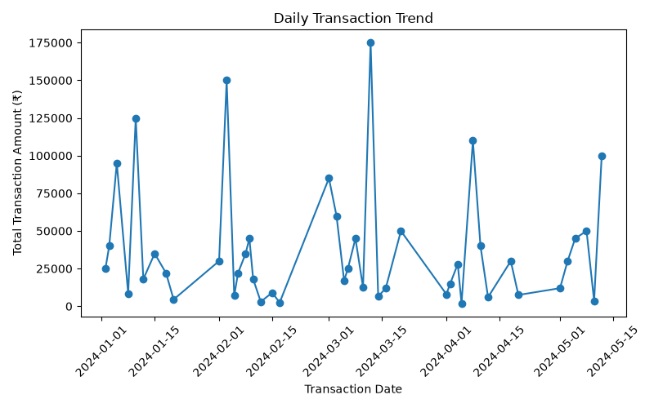

2. Transaction Amount by Type
A bar chart is generated to compare total transaction amounts across transaction types.
The transaction data is grouped by transaction type, and the amounts are summed for each group.
Purpose:
- Compare transaction amounts across different transaction types.
- Identify transaction types contributing the highest total amounts.
- Support further investigation of banking transaction patterns.

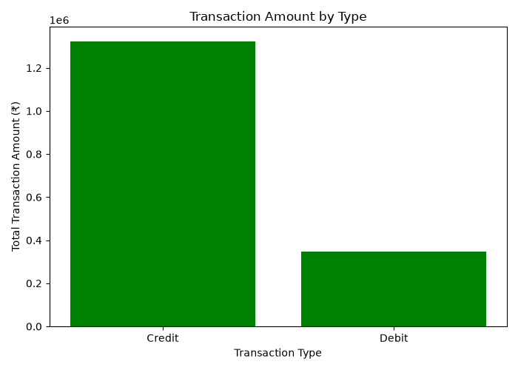

3. Transactions by Mode
A pie chart is generated to show the percentage distribution of transactions by transaction mode.
The number of transactions is counted for each mode, and the results are displayed as percentage shares.
Purpose:
- Understand the distribution of transaction activity across different modes.
- Identify the most frequently used transaction modes.
- Support analysis of customer transaction preferences.

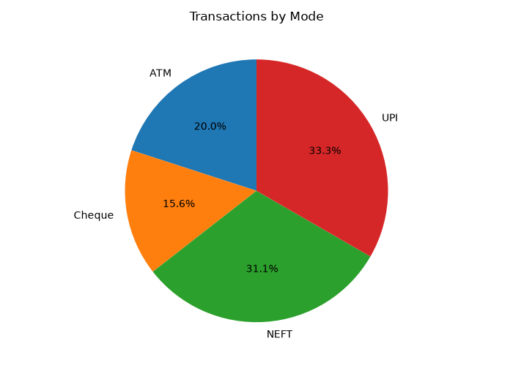

4. Top Five Customers by Transaction Amount
A bar chart is generated to identify the five customers with the highest total transaction amounts.
The data is grouped by customer name, transaction amounts are summed, and the results are sorted in descending order. The top five records are then selected.
Purpose:
- Identify customers with the highest total transaction amounts.
- Understand transaction activity across customers.
- Support further customer relationship and transaction analysis.
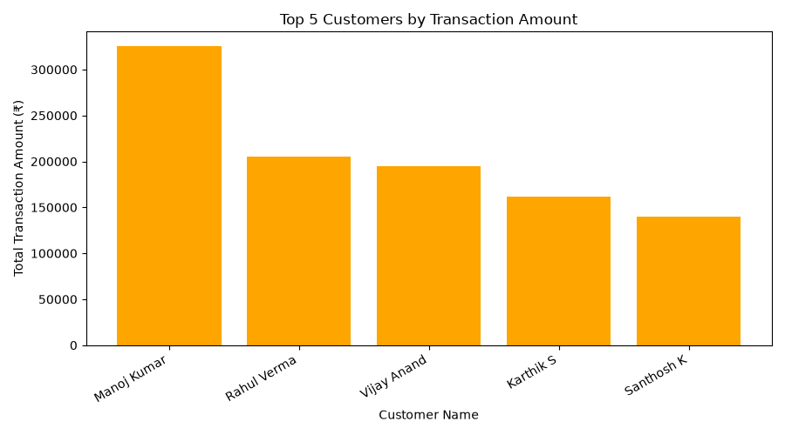

Chart Export
All four charts are saved as PNG files in the bank_charts directory.
The os.makedirs() function creates the output folder if it does not already exist.
The datetime module is used to generate dynamic filenames based on the current date.
The plt.savefig() function exports each chart, and plt.close() releases the plotting resources after saving.
These image files can be used in reports, presentations, and future dashboard development.
Automation
The project uses the Python schedule library to automate the execution of the banking analytics process.
A function named run_job() is defined to perform the required workflow:
- Fetch the latest records from the MySQL banking database.
- Perform data cleaning and transformation.
- Combine transaction data with account, customer, and branch information.
- Generate the four banking analytics charts.
- Save the charts in the bank_charts folder.
The schedule is configured using the following statement:
schedule.every().day.at("15:04").do(run_job)
This configuration schedules the job to execute daily at 3:04 PM according to the computer's local time.
The schedule.run_pending() function checks whether a scheduled job is due, while time.sleep(1) pauses briefly between checks.
The program runs continuously so that the scheduled task can execute at the configured time.
The automation reduces the need to manually run the reporting process every day. However, the Python program and computer must remain running for the in-process schedule to work.

Business Problem
Scenario
A banking organization maintains large amounts of data relating to branches, customers, accounts, transactions, and loans.
The organization needs to analyze transaction activity, understand customer transaction behavior, compare transaction types, monitor transaction trends, and identify customers with high transaction amounts.
The goal is to improve visibility into banking operations and support informed business decisions through consistent data analysis and reporting.
However, banking data is stored across multiple database tables. Manually collecting, combining, analyzing, and preparing reports from these tables can be time-consuming and may introduce inconsistencies.
The organization therefore requires a solution that can extract banking data from MySQL, process it using Python, and generate useful visual reports automatically.
Specific Issues
- Difficulty in combining information from multiple banking tables.
- Lack of a simple visual overview of daily transaction amounts.
- Difficulty in comparing total transaction amounts by type.
- Limited visibility into transaction distribution by mode.
- Difficulty in identifying customers with the highest total transaction amounts.
- Manual effort required to prepare recurring reports.
- Need for consistent data cleaning and date conversion.
- Need for a repeatable reporting process that can run automatically.

Proposed Solution
To address these issues, an Automated Banking Data Analytics Dashboard and Reporting System is developed using Python, MySQL, Pandas, Matplotlib, and the schedule library.
The system extracts data from the banking database, performs data quality checks and transformations, integrates related transaction information, and produces four visual reports.
The reporting process can be scheduled to execute every day, helping users obtain updated analytical outputs without manually generating each chart.
Key Features of the Solution
Automated Data Fetching
The system connects to the banking_db MySQL database using mysql.connector.
It retrieves data from the branches, customers, accounts, transactions, and loans tables and loads the records into Pandas DataFrames.
This approach provides a repeatable method of accessing banking data for analysis.
Data Cleaning and Transformation
Pandas is used to inspect the data, remove duplicate rows, convert date fields, and identify missing values.
Additional columns are created to support analysis, including customer age, age group, account balance category, transaction amount category, and loan amount category.
These transformations improve the usability of the data for reporting.
Integrated Banking Data
The transactions table is combined with account, customer, and branch information using Pandas merge operations.
This integration allows transaction records to be analyzed alongside relevant customer and branch details.
The loans table is also processed and is available for separate loan-related analysis.
Visual Insights with Charts
The system generates four charts:
- Daily Transaction Trend: A line chart showing total transaction amounts by date.
- Transaction Amount by Type: A bar chart comparing transaction amounts across transaction types.
- Transactions by Mode: A pie chart showing the percentage distribution of transactions by mode.
- Top Five Customers: A bar chart displaying the five customers with the highest total transaction amounts.
These charts simplify the interpretation of transaction data and help identify patterns that may require further analysis.
Scheduled Reporting
The schedule library is used to configure automatic daily execution at 3:04 PM.
When the scheduled job runs, the system retrieves and processes the data, generates the charts, and saves them as PNG files.
The program must remain active for the schedule to operate. For execution when the Python program is not already running, Windows Task Scheduler can be configured to launch the script automatically.
Data-Driven Decision Making
The generated reports can support banking teams in:
- Transaction Monitoring: Reviewing changes in transaction amounts over time.
- Customer Analysis: Identifying customers with high total transaction amounts.
- Transaction Channel Analysis: Understanding how transaction activity is distributed across modes.
- Operational Review: Comparing transaction types and investigating unusual changes.
- Future Planning: Using historical transaction data as a starting point for more advanced analysis.
The charts support decision-making, but additional checks are needed before using them for fraud detection, risk scoring, or other high-impact banking decisions.
Automated and Expandable System
The project establishes a foundation for automated banking data reporting.
Future improvements can include loan portfolio dashboards, branch-wise performance analysis, account balance analysis, customer segmentation, failed transaction monitoring, and interactive dashboards using tools such as Power BI or Tableau.
The system can also be expanded to include logging, error notifications, data validation, and more reliable operating-system-level scheduling.
Reliable Reporting
By automating the data retrieval and chart generation process, the system reduces repeated manual effort and promotes consistency.
Data cleaning and transformation steps provide a structured process for preparing banking data before analysis.
Further validation and exception handling can improve the reliability of reports when database connections fail or unexpected data is encountered.
Performance Tracking and Optimization
The charts allow users to review transaction activity, compare transaction types, understand transaction mode distribution, and identify customers with the highest total transaction amounts.
For example, a significant change in daily transaction totals can be investigated further to determine whether it is related to normal customer activity, a business event, or a data quality issue.
This process provides a starting point for more detailed banking performance analysis.

Benefits of the Solution
1.Time and Resource Efficiency
The automated process reduces the effort required to repeatedly extract, clean, combine, and visualize banking data.
The charts are generated by Python rather than being prepared manually for each reporting cycle.
This allows users to spend more time interpreting results and investigating business questions.
2.Faster Decision-Making
The daily transaction trend and transaction type charts help users review transaction activity more quickly.
The customer ranking chart makes it easier to identify customers with the highest total transaction amounts.
These insights can help teams decide which patterns require additional investigation.
3.Improved Data Organization
The project brings together transaction information with related account, customer, and branch data.
This creates a more useful dataset for analyzing transaction activity across different business dimensions.
4.Consistent Reporting
The schedule configuration supports recurring report generation at a fixed time.
The generated PNG files provide a consistent output format that can be shared, reviewed, or included in documentation.
5.Better Customer and Transaction Insights
The combined data and visualizations help users understand transaction behavior, compare transaction types, and identify customers with high transaction amounts.
These insights can be used as a starting point for deeper customer and operational analysis.
6.Expandability
The project can be extended to support additional banking reports, loan analysis, branch performance comparisons, and interactive dashboards.
Additional validation and scheduling mechanisms can be added as the reporting requirements become more complex.
Conclusion
The Banking Data Analytics Dashboard demonstrates how Python and MySQL can be combined to build an automated data processing and reporting solution.
The project extracts information from five banking tables, performs data cleaning and transformation using Pandas, integrates transaction data with related account, customer, and branch information, and generates four charts using Matplotlib.
The schedule library provides a mechanism for running the reporting job automatically at a configured time.
Overall, the project demonstrates practical skills in database connectivity, data cleaning, data transformation, data integration, exploratory analysis, visualization, and automation. It provides a foundation for further development into a more comprehensive banking analytics dashboard.

